**Computer Vision-Based Method for Quantifying Iron-Related Defects in Silicon Solar Cells**

Oleg Olikh, Oleksii Zavhorodnii, Yulia Perets

*Taras Shevchenko National University of Kyiv, 64/13, Volodymyrska Street, Kyiv, 01601, Ukraine*

olegolikh@knu.ua

**SUPPLEMENTARY MATERIAL**

I. *Initial hyperparameter search space*

Abbreviations to denote visual models and their feature extraction outputs:

ENB7:CL - EfficientNetB7, classifier layer output (1000-D).

ENB7:FE - EfficientNetB7, feature extractor output (2560-D).

ENB7:FE:P - EfficientNetB7, feature extractor output with PCA reduction (39-D).

MNV2:CL - MobileNetV2, classifier layer output (1000-D).

MNV2:FE - MobileNetV2, feature extractor output (1280-D).

MNV2:FE:P - MobileNetV2, feature extractor output with PCA reduction (124-D).

NAS:CL - NASNetLarge, classifier layer output (1000-D).

NAS:CL:P - NASNetLarge, classifier layer output with PCA reduction (30-D).

NAS:FE - NASNetLarge, feature extractor output (4032-D).

R152:CL - ResNet152V2, classifier layer output (1000-D).

R152:FE - ResNet152V2, feature extractor output (2048-D).

XCP:CL - Xception, classifier layer output (1000-D).

XCP:FE - Xception, feature extractor output (2048-D).

YL:FE1 - YOLOv4 (CSPDarknet53 backbone), raw feature extractor (top layer, 86528-D).

YL:FE1:P - YOLOv4 (CSPDarknet53 backbone), raw feature extractor with PCA (137-D).

YL:FE2 - CSPDarknet53 backbone, raw feature extractor (top & penultimate layers, 433640-D).

YL:FE2:P - CSPDarknet53 backbone, raw feature extractor with PCA (142-D).

YL:FP1 - YOLOv4, global average pooled features from the top layer (512-D).

YL:FP2 - YOLOv4, concatenated pooled features from the top & penultimate layers (1024-D)

Table S1. Search space of hyperparameters for RF

|  |  |
| --- | --- |
| Hyperparameter | Values |
| # estimators | [100; 1200] |
| max depth | [10; 95] |
| min samples leaf | [1; 15] |
| min samples split | [2; 16] |
| bootstrap | True, False |
| max features | 'log2', 'sqrt', [0.05; 1.0] |

Table S2. Search space of hyperparameters for GB

|  |  |
| --- | --- |
| Hyperparameter | Values |
| # estimators | [100; 1200] |
| max depth | [15; 90] |
| min samples leaf | [1; 15] |
| min samples split | [2, 16] |
| learning rate | [10-3, 10-1] |
| max features | 'log2', 'sqrt', [0.05; 1.0] |

Table S3. Search space of hyperparameters for SVR

|  |  |
| --- | --- |
| Hyperparameter | Values |
| kernel | linear, poly, rbf, sigmoid |
| Degree* | [2; 6] |
| C0 | [0; 15] |
| Tolerance | [10-6; 10-2] |
| C | [10-2; 15] |
| Epsilon | [10-3; 1] |
| * for poly kernel only | |

Table S4. Search space of hyperparameters for XGB

|  |  |
| --- | --- |
| Hyperparameter | Values |
| booster | gbtree, gblinear, dart |
| max depth* | [2, 10] |
| min split loss* | [0; 5] |
| min child weight* | [0; 5] |
| subsample* | [0.1; 1.0] |
| сolsample by tree* | [0.1; 1.0] |
| # estimators | [200; 1700] |
| learning rate | [10-5; 1] |
| L1 | [10-9; 1] |
| L2 | [10-8; 1] |
| * for all boosters except gblinear | |

Table S5. Search space of hyperparameters for DNN

|  |  |
| --- | --- |
| Hyperparameter | Values |
| hidden layers configuration | [512, 256, 128, 64] |
| activation function* | ReLu, sigmoid, tanh, SELU, ELU |
| Optimizer* | SGD, RMSprop, Adam, Adadelta, Adagrad, Adamax, Nadam, Ftrl |
| learning rate | [10-5; 10-2] |
| weight initializer* | Xavier Normal (XN), Xavier Uniform (XU), He Normal (HN), He Uniform (HU), Random Normal (RN), Random Uniform (RU) |
| Regularizer | None, L1, L2 |
| RegRate** | [10-5; 10-1] |
| DropoutNeeded | True, False |
| DropRate*** | [0.1; 0.5] |
| LayerNormalization | True, False |
| * all activation functions, optimizers, and weight initializations used in this work correspond to standard implementations available in the Keras deep learning framework  **for Regularizer ≠ None  ***for DropoutNeeded = True | |

II. *Selected hyperparameter combinations*

Table S6. Chosen rational hyperparameter combinations for RF models

|  |  |  |  |  |  |  |
| --- | --- | --- | --- | --- | --- | --- |
| Visual Model | Hyperparameter | | | | | |
| # estimators | max depth | min sample split | min sample leaf | max features | bootstrap |
| ENB7:CL | 750 | 35 | 3 | 2 | 0.2 | False |
| ENB7:FE | 900 | 40 | 4 | 2 | 0.2 | False |
| ENB7:FE:P | 460 | 54 | 4 | 1 | 1 | True |
| MNV2:CL | 450 | 20 | 4 | 1 | 0.1 | False |
| MNV2:FE | 460 | 50 | 3 | 1 | 0.05 | False |
| MNV2:FE:P | 500 | 85 | 5 | 3 | 0.5 | False |
| NAS:CL | 395 | 59 | 2 | 1 | 0.2 | False |
| NAS:CL:P | 1175 | 70 | 2 | 1 | 0.4 | False |
| NAS:FE | 750 | 10 | 2 | 1 | 0.1 | False |
| R152:CL | 640 | 40 | 4 | 2 | 0.4 | False |
| R152:FE | 367 | 38 | 2 | 1 | sqrt | False |
| XCP:CL | 640 | 90 | 2 | 1 | 0.2 | False |
| XCP:FE | 820 | 48 | 4 | 1 | 0.1 | False |
| YL:FP1 | 960 | 75 | 4 | 1 | 0.4 | False |
| YL:FP2 | 650 | 70 | 2 | 1 | 0.2 | False |
| YL:FE2:P | 475 | 45 | 3 | 1 | 0.5 | False |
| YL:FE1:P | 425 | 45 | 10 | 1 | 0.5 | False |

Table S7. Chosen rational hyperparameter combinations for GB models

|  |  |  |  |  |  |  |
| --- | --- | --- | --- | --- | --- | --- |
| Visual Model | Hyperparameter | | | | | |
| # estimators | max depth | min sample split | min sample leaf | max features | LR |
| ENB7:CL | 750 | 20 | 7 | 11 | 0.1 | 3.4e-02 |
| ENB7:FE | 750 | 50 | 6 | 9 | 0.3 | 4.2e-02 |
| ENB7:FE:P | 680 | 25 | 4 | 15 | 1 | 3.9e-02 |
| MNV2:CL | 1100 | 40 | 10 | 3 | sqrt | 1.0e-02 |
| MNV2:FE | 890 | 50 | 12 | 2 | sqrt | 1.4e-02 |
| MNV2:FE:P | 575 | 60 | 4 | 12 | 0.6 | 2.8e-02 |
| NAS:CL | 850 | 70 | 13 | 15 | 0.3 | 4.8e-02 |
| NAS:CL:P | 675 | 80 | 11 | 13 | 0.4 | 3.8e-02 |
| NAS:FE | 650 | 67 | 5 | 3 | 0.1 | 1.3e-02 |
| R152:CL | 700 | 55 | 8 | 1 | 0.4 | 1.1e-01 |
| R152:FE | 640 | 85 | 3 | 7 | sqrt | 2.3e-02 |
| XCP:CL | 470 | 25 | 2 | 6 | sqrt | 5.2e-02 |
| XCP:FE | 760 | 75 | 10 | 4 | 0.1 | 2.9e-02 |
| YL:FP1 | 1160 | 75 | 2 | 8 | 0.1 | 3.9e-02 |
| YL:FP2 | 900 | 54 | 3 | 6 | 0.2 | 2.3e-02 |
| YL:FE2:P | 750 | 55 | 4 | 7 | 0.4 | 1.9e-02 |
| YL:FE1:P | 850 | 55 | 2 | 10 | 0.7 | 1.2e-02 |

Table S8. Chosen rational hyperparameter combinations for XGB models

|  |  |  |  |  |  |  |  |  |  |  |
| --- | --- | --- | --- | --- | --- | --- | --- | --- | --- | --- |
| Visual Model | Hyperparameter | | | | | | | | | |
| booster | max depth | min split loss | min child weight | sub  sample | сolsample bytree | # estimators | LR | L1 | L2 |
| ENB7:CL | gblinear | 3 | -- | -- | -- | -- | 1080 | 1.1e-1 | 1.8e-7 | 8.4e-4 |
| ENB7:FE | gblinear | 3 | -- | -- | -- | -- | 1150 | 3.2e-1 | 3.8e-8 | 2.6e-3 |
| ENB7:FE:P | gblinear | 3 | -- | -- | -- | -- | 1640 | 1.6e-1 | 5.9e-9 | 1.4e-2 |
| MNV2:CL | gblinear | 3 | -- | -- | -- | -- | 1040 | 7.0e-2 | 5.7e-7 | 3.1e-3 |
| MNV2:FE | gblinear | 3 | -- | -- | -- | -- | 600 | 1.4e-1 | 6.1e-8 | 1.9e-2 |
| MNV2:FE:P | gblinear | 3 | -- | -- | -- | -- | 1150 | 7.4e-2 | 1.0e-8 | 1.0e-1 |
| NAS:CL | gblinear | 3 | -- | -- | -- | -- | 1050 | 2.6e-1 | 9.9e-9 | 2.3e-3 |
| NAS:CL:P | gblinear | 3 | -- | -- | -- | -- | 800 | 3.8e-2 | 5.0e-9 | 1.4e-2 |
| NAS:FE | gblinear | 3 | -- | -- | -- | -- | 700 | 6.9e-2 | 8.5e-9 | 6.1e-2 |
| R152:CL | gbtree | 8 | 7.9e-3 | 5.7e-1 | 0.4 | 0.9 | 825 | 2.2e-2 | 1.9e-8 | 3.3e-3 |
| R152:FE | gblinear | 6 | -- | -- | -- | -- | 500 | 4.4e-1 | 1.1e-8 | 1.5e-2 |
| XCP:CL | gblinear | 3 | -- | -- | -- | -- | 550 | 2.0e-1 | 1.4e-6 | 1.7e-4 |
| XCP:FE | gblinear | 3 | -- | -- | -- | -- | 390 | 2.2e-1 | 3.7e-6 | 9.9e-2 |
| YL:FP1 | gblinear | 3 | -- | -- | -- | -- | 520 | 9.4e-2 | 4.7e-5 | 2.0e-2 |
| YL:FP2 | gblinear | 3 | -- | -- | -- | -- | 650 | 1.7e-1 | 8.1e-9 | 1.9e-2 |
| YL:FE2:P | gbtree | 5 | 6.4e-2 | 3.6 | 0.9 | 0.5 | 1275 | 8.1e-3 | 1.9e-8 | 4.9e-3 |
| YL:FE1:P | gbtree | 2 | 3.2e-1 | 2.5 | 0.8 | 0.9 | 525 | 3.5e-2 | 2.1e-8 | 6.7e-3 |

Table S9. Chosen rational hyperparameter combinations for SVR models

|  |  |  |  |  |  |
| --- | --- | --- | --- | --- | --- |
| Visual Model | Hyperparameter | | | | |
| kernel | C0 | Tolerance | C | Epsilon |
| ENB7:CL | linear | 7.79 | 6.9e-06 | 2.5 | 2.2e-05 |
| ENB7:FE | linear | 8.29 | 3.0e-05 | 2.6 | 3.5e-05 |
| ENB7:FE:P | linear | 10.57 | 8.4e-04 | 13.7 | 2.9e-04 |
| MNV2:CL | rbf | 6.80 | 3.9e-04 | 10.9 | 9.6e-05 |
| MNV2:FE | linear | 6.54 | 4.9e-04 | 6.7 | 7.1e-05 |
| MNV2:FE:P | linear | 7.31 | 5.2e-04 | 4.6e-03 | 8.7e-04 |
| NAS:CL | linear | 6.60 | 4.9e-04 | 4.6 | 1.5e-04 |
| NAS:CL:P | rbf | 7.17 | 5.5e-03 | 11.7 | 1.5e-04 |
| NAS:FE | linear | 5.31 | 6.5e-04 | 5.9 | 2.6e-05 |
| R152:CL | linear | 6.66 | 4.2e-03 | 2.3 | 5.4e-05 |
| R152:FE | linear | 6.65 | 1.3e-04 | 5.2 | 1.4e-04 |
| XCP:CL | rbf | 8.27 | 7.2e-03 | 13.8 | 3.5e-04 |
| XCP:FE | linear | 11.24 | 2.5e-03 | 9.1 | 3.8e-04 |
| YL:FP1 | rbf | 12.61 | 2.4e-03 | 6.9 | 5.6e-05 |
| YL:FP2 | rbf | 8.30 | 1.9e-04 | 9.2 | 1.4e-05 |
| YL:FE1 | linear | 8.62 | 5.3e-04 | 7.9 | 1.6e-05 |
| YL:FE2 | rbf | 11.5 | 2.3e-05 | 4.6 | 6.3e-06 |
| YL:FE2:P | linear | 9.18 | 3.9e-03 | 2.2 | 2.4e-04 |
| YL:FE1:P | rbf | 7.04 | 2.7e-03 | 2.6 | 2.5e-04 |

Table S10. Chosen rational hyperparameter combinations for DNN models

|  |  |  |  |  |  |  |  |  |  |
| --- | --- | --- | --- | --- | --- | --- | --- | --- | --- |
| Visual Model | Hyperparameter | | | | | | | | |
| LR | optimizer | activ. func. | w.  init. | Regul. | RegRate | Drop.  Need. | Drop.  Rate | LayerNorm. |
| ENB7:CL | 3.0e-03 | Adam | ELU | HN | None | -- | False | -- | True |
| ENB7:FE | 1.4e-03 | Adamax | SELU | RN | L2 | 1.0e-03 | False | -- | True |
| ENB7:FE:P | 1.4e-04 | Nadam | SELU | RU | L2 | 1.0e-03 | False | -- | True |
| MNV2:CL | 2.4e-03 | Nadam | SELU | RN | L2 | 1.7e-03 | True | 0.5 | True |
| MNV2:FE | 2.8e-03 | Nadam | ELU | RN | None | -- | False | -- | False |
| MNV2:FE:P | 1.3e-04 | Adam | tanh | RU | L2 | 6.4e-04 | True | 0.4 | False |
| NAS:CL | 1.4e-04 | Adamax | sigmoid | XU | None | -- | False | -- | False |
| NAS:CL:P | 3.9e-04 | Nadam | tanh | RU | None | -- | False | -- | True |
| NAS:FE | 4.4e-04 | Nadam | SELU | RU | None | -- | False | -- | True |
| R152:CL | 3.3e-04 | Adamax | ELU | RN | L2 | 2.2e-03 | False | -- | True |
| R152:FE | 1.1e-03 | Nadam | ReLu | HN | None | -- | False | -- | True |
| XCP:CL | 1.5e-04 | Adamax | ReLu | HU | L1 | 9.7e-04 | False | -- | True |
| XCP:FE | 2.1e-04 | Nadam | sigmoid | XN | L2 | 8.5e-04 | False | -- | True |
| YL:FP1 | 5.2e-05 | Adam | tanh | RU | None | -- | False | -- | True |
| YL:FP2 | 6.9e-04 | Adam | SELU | RU | None | -- | False | -- | True |
| YL:FE2:P | 4.1e-04 | Adam | sigmoid | XN | L1 | 1.3e-04 | True | 0.2 | True |
| YL:FE1:P | 4.3e-04 | RMSprop | ELU | XU | L1 | 5.4e-05 | False | -- | True |

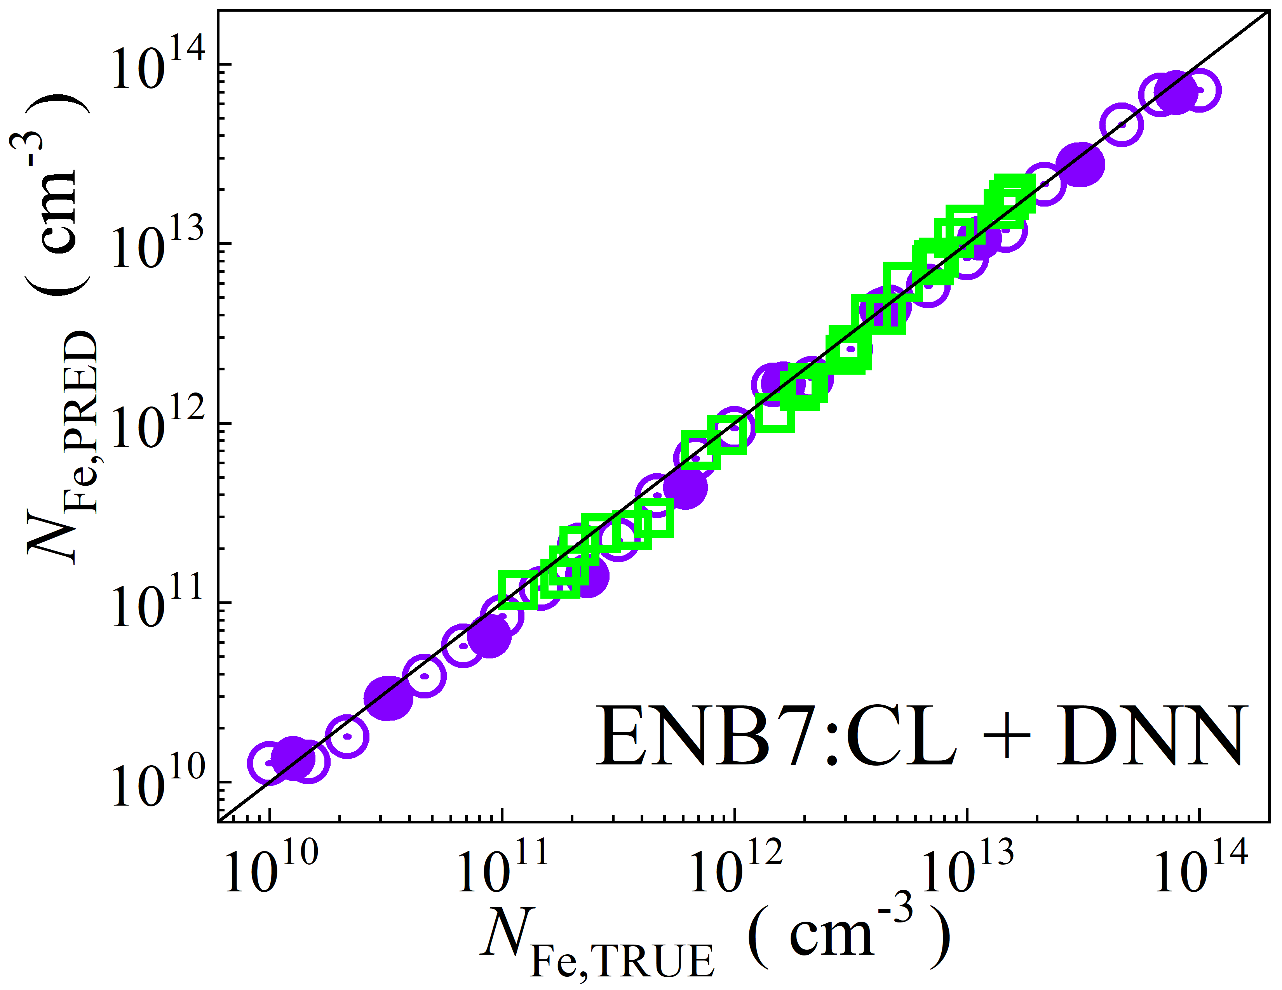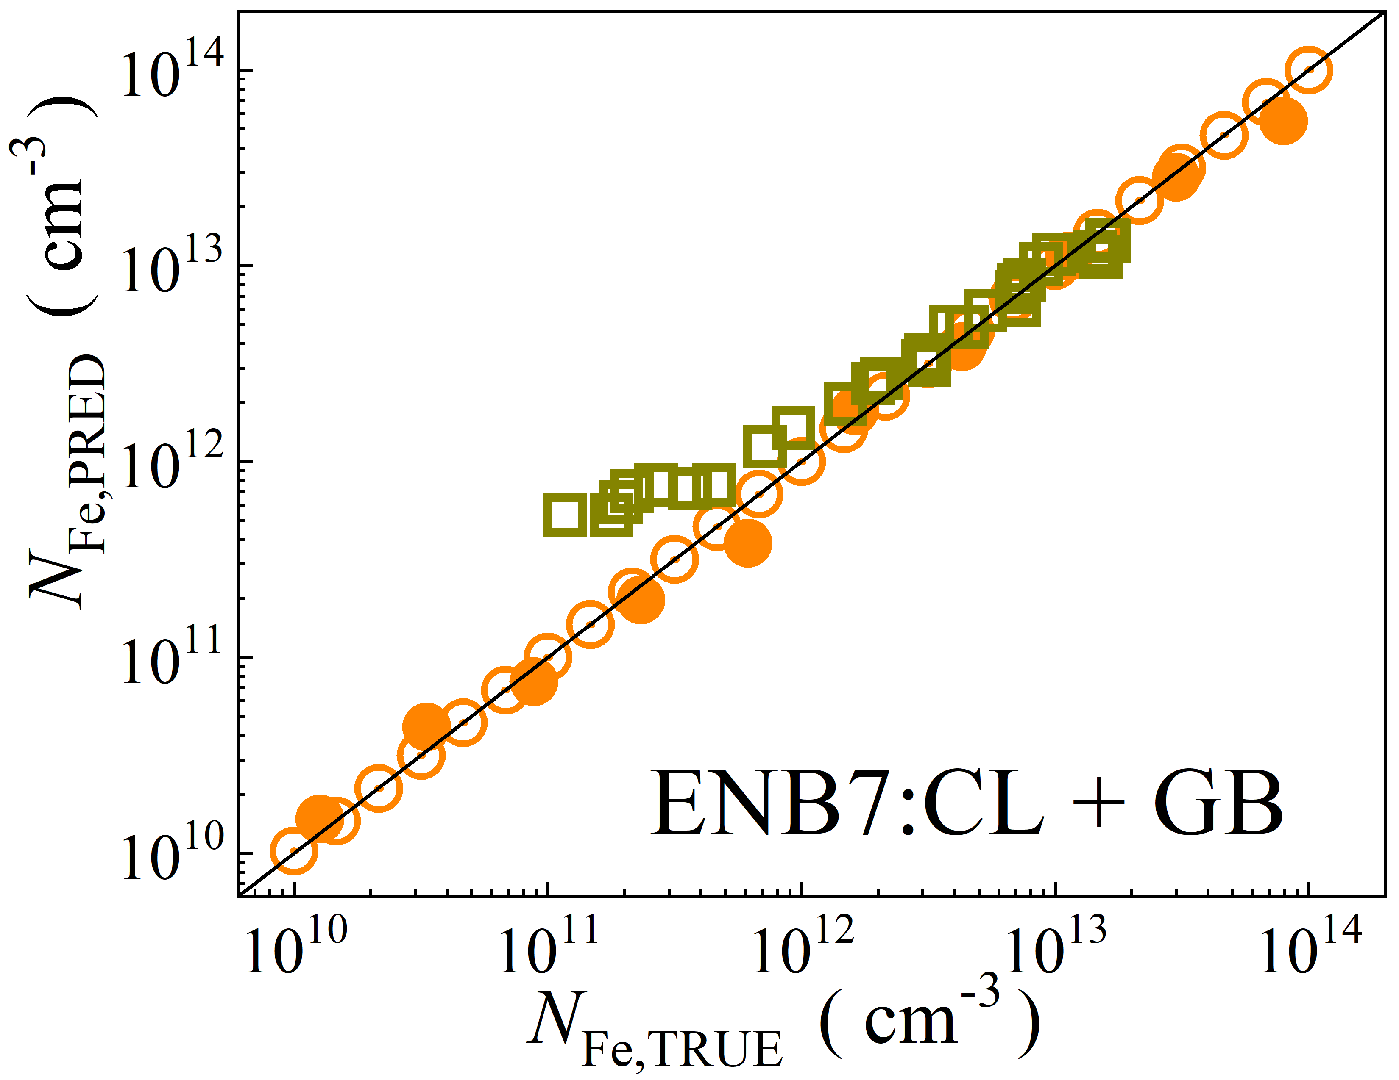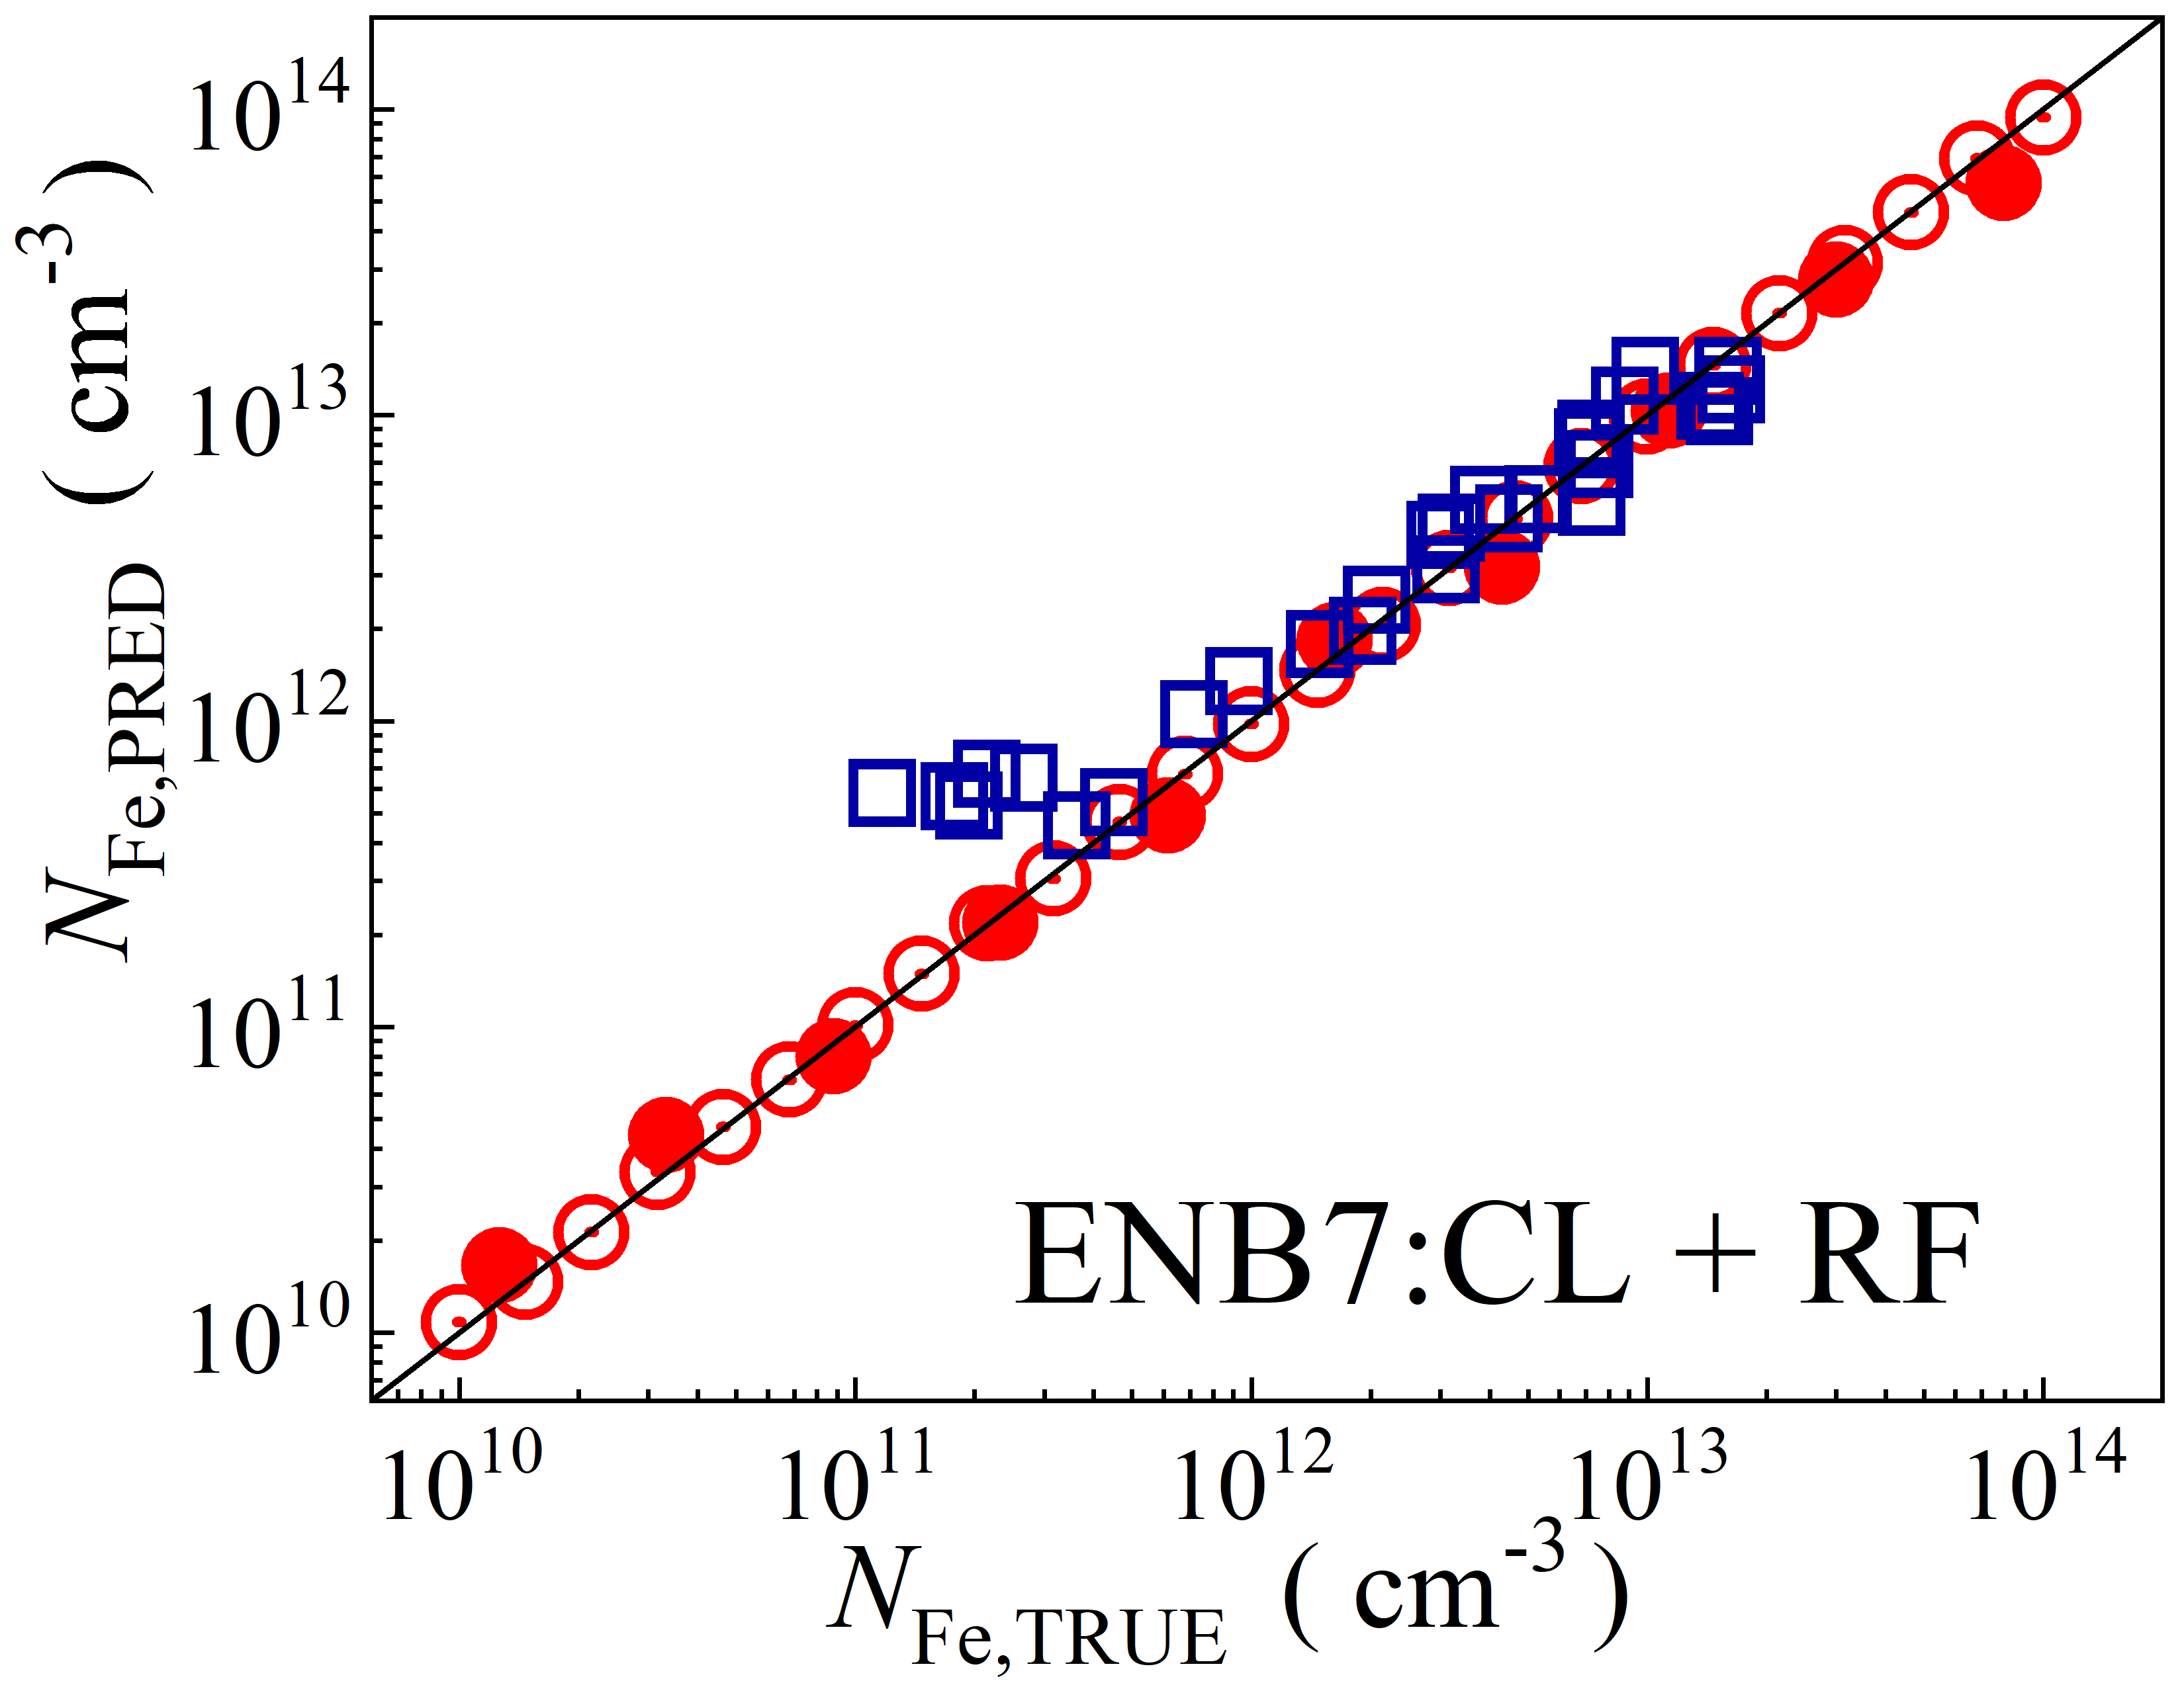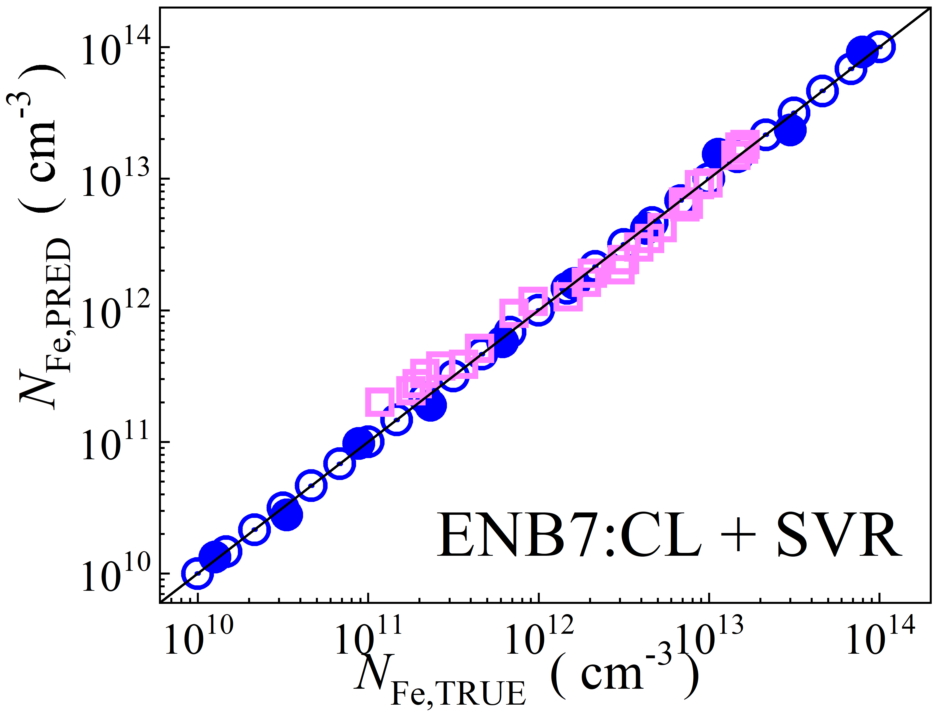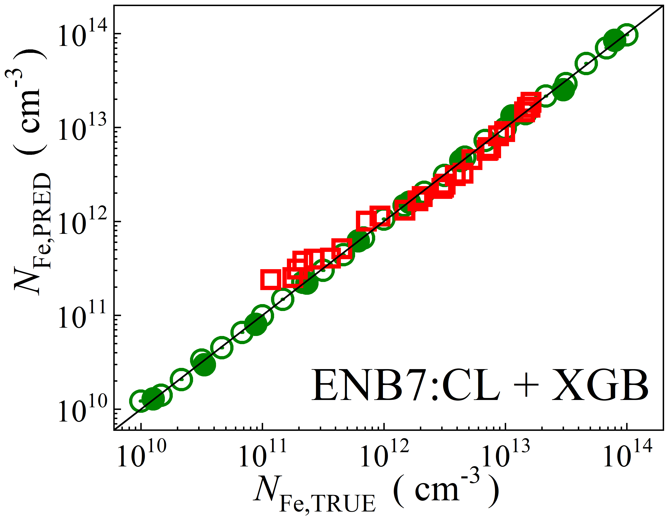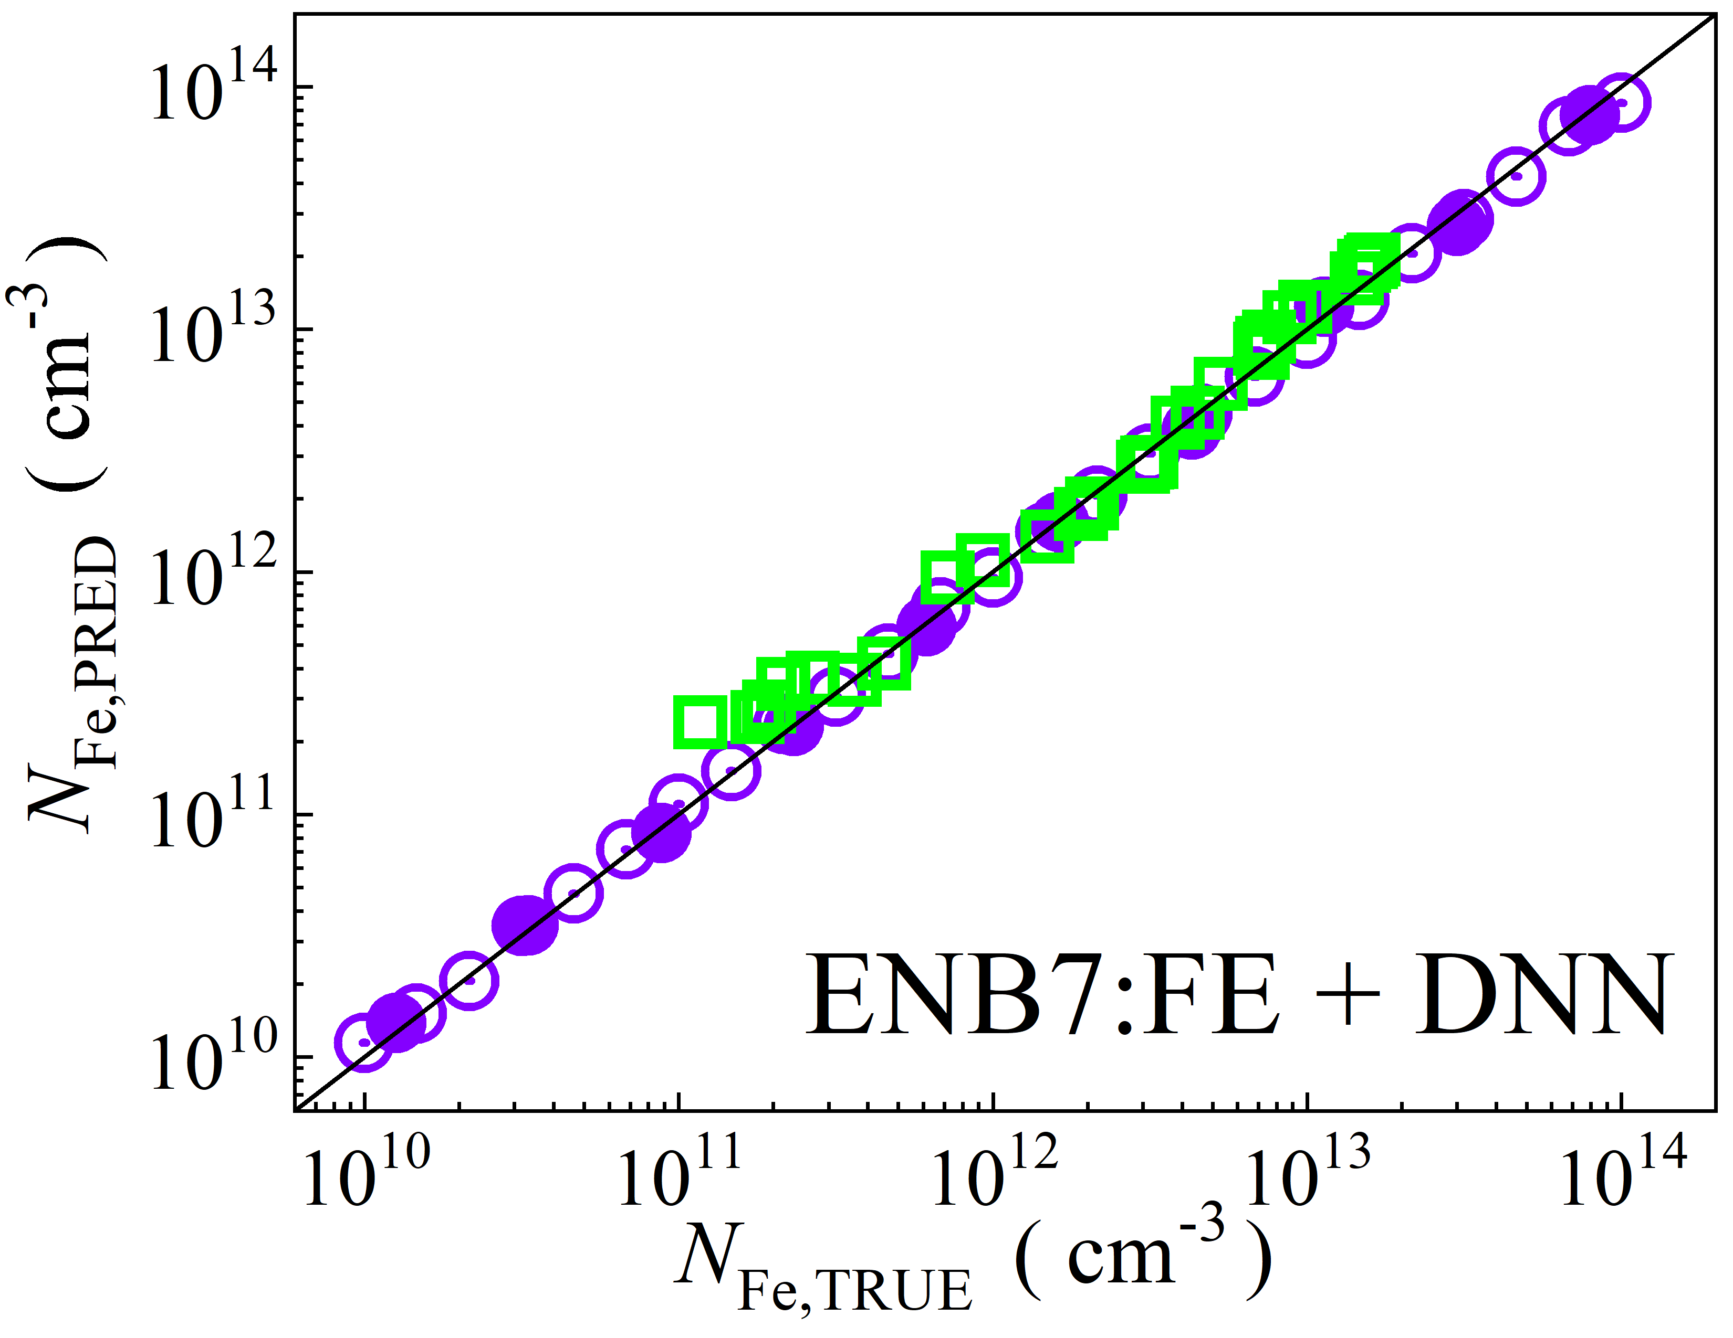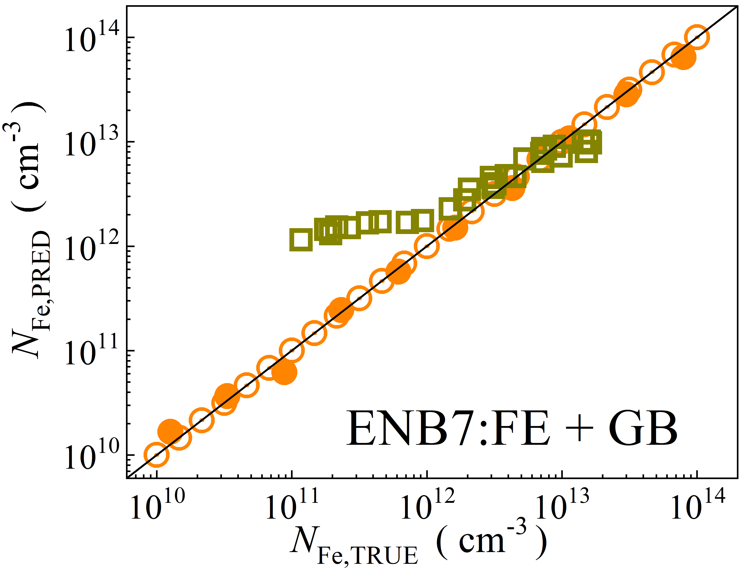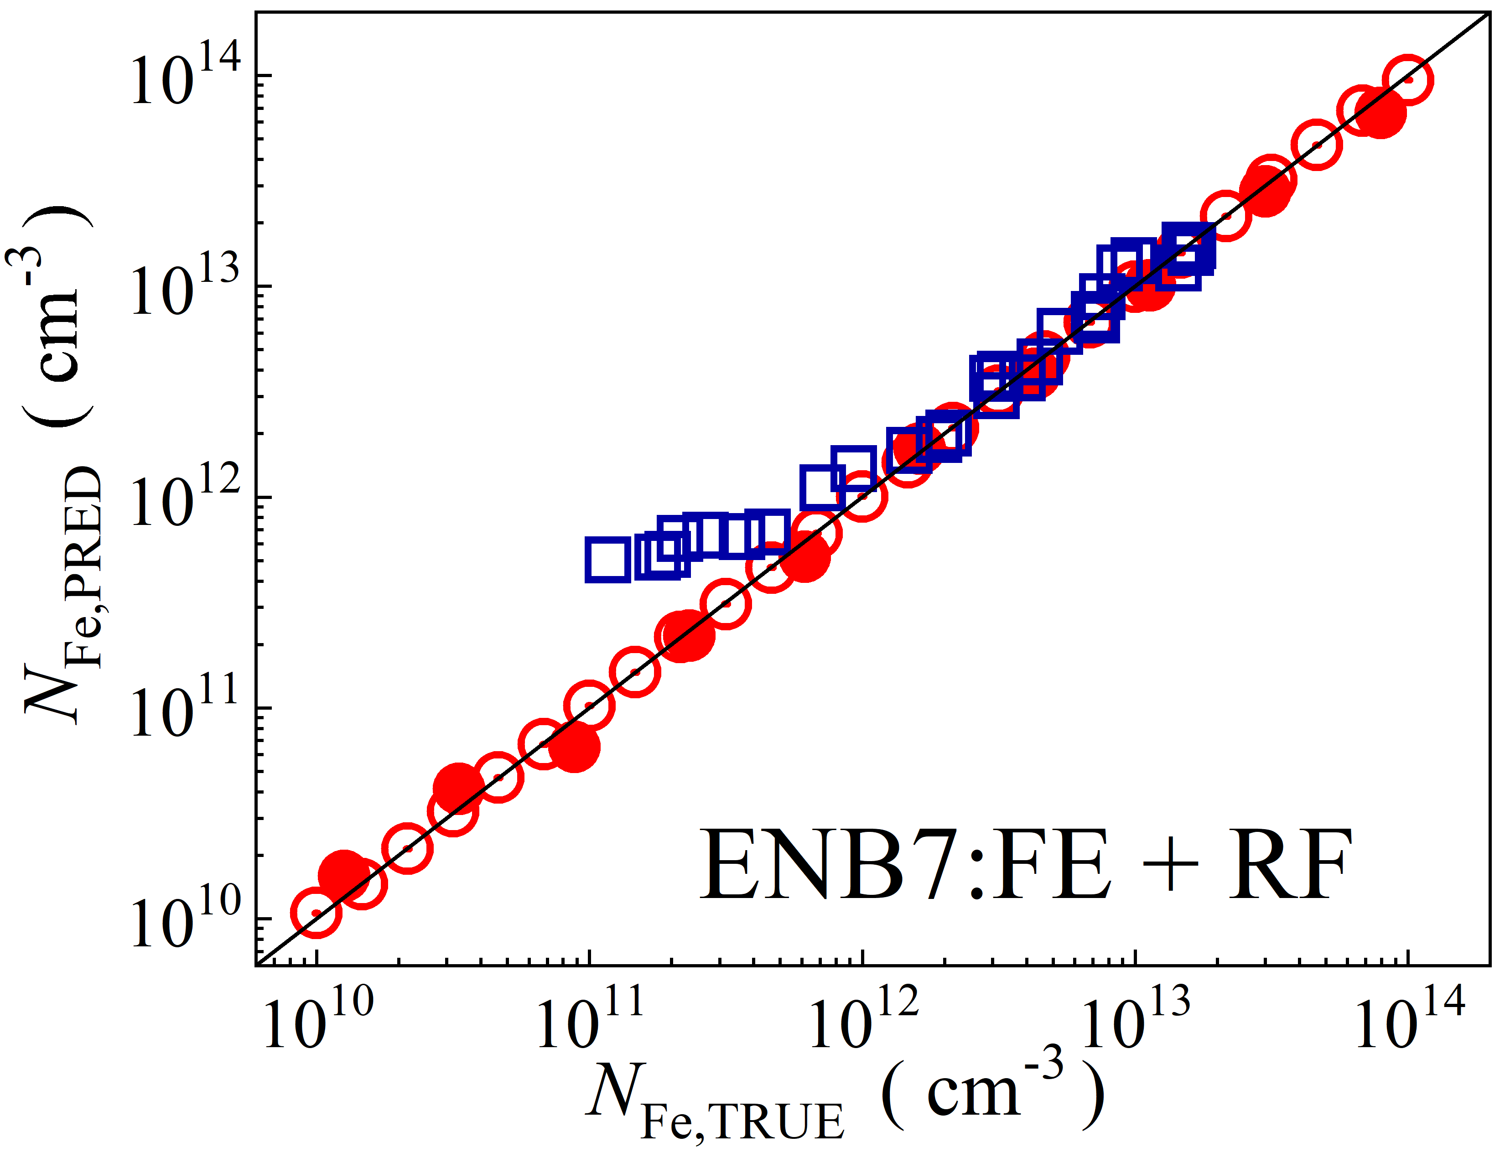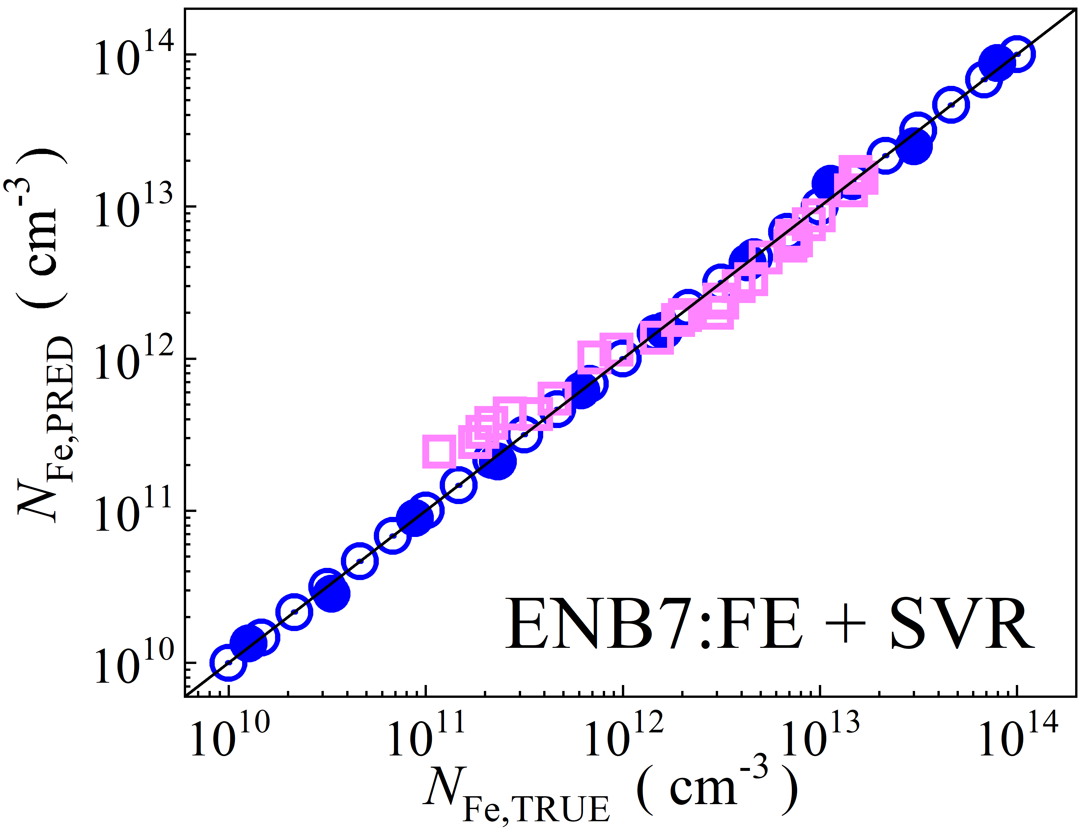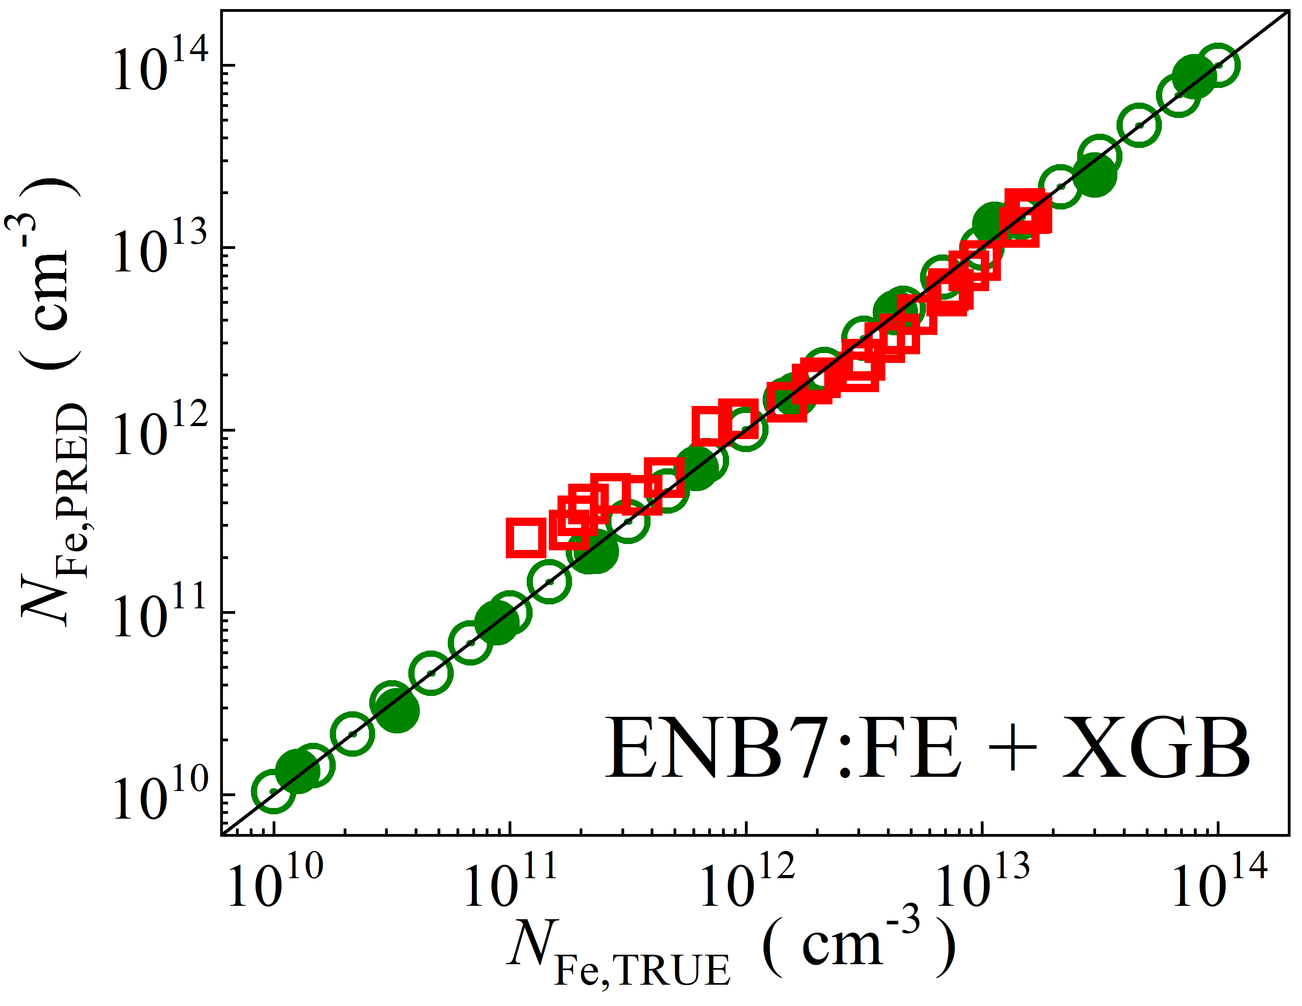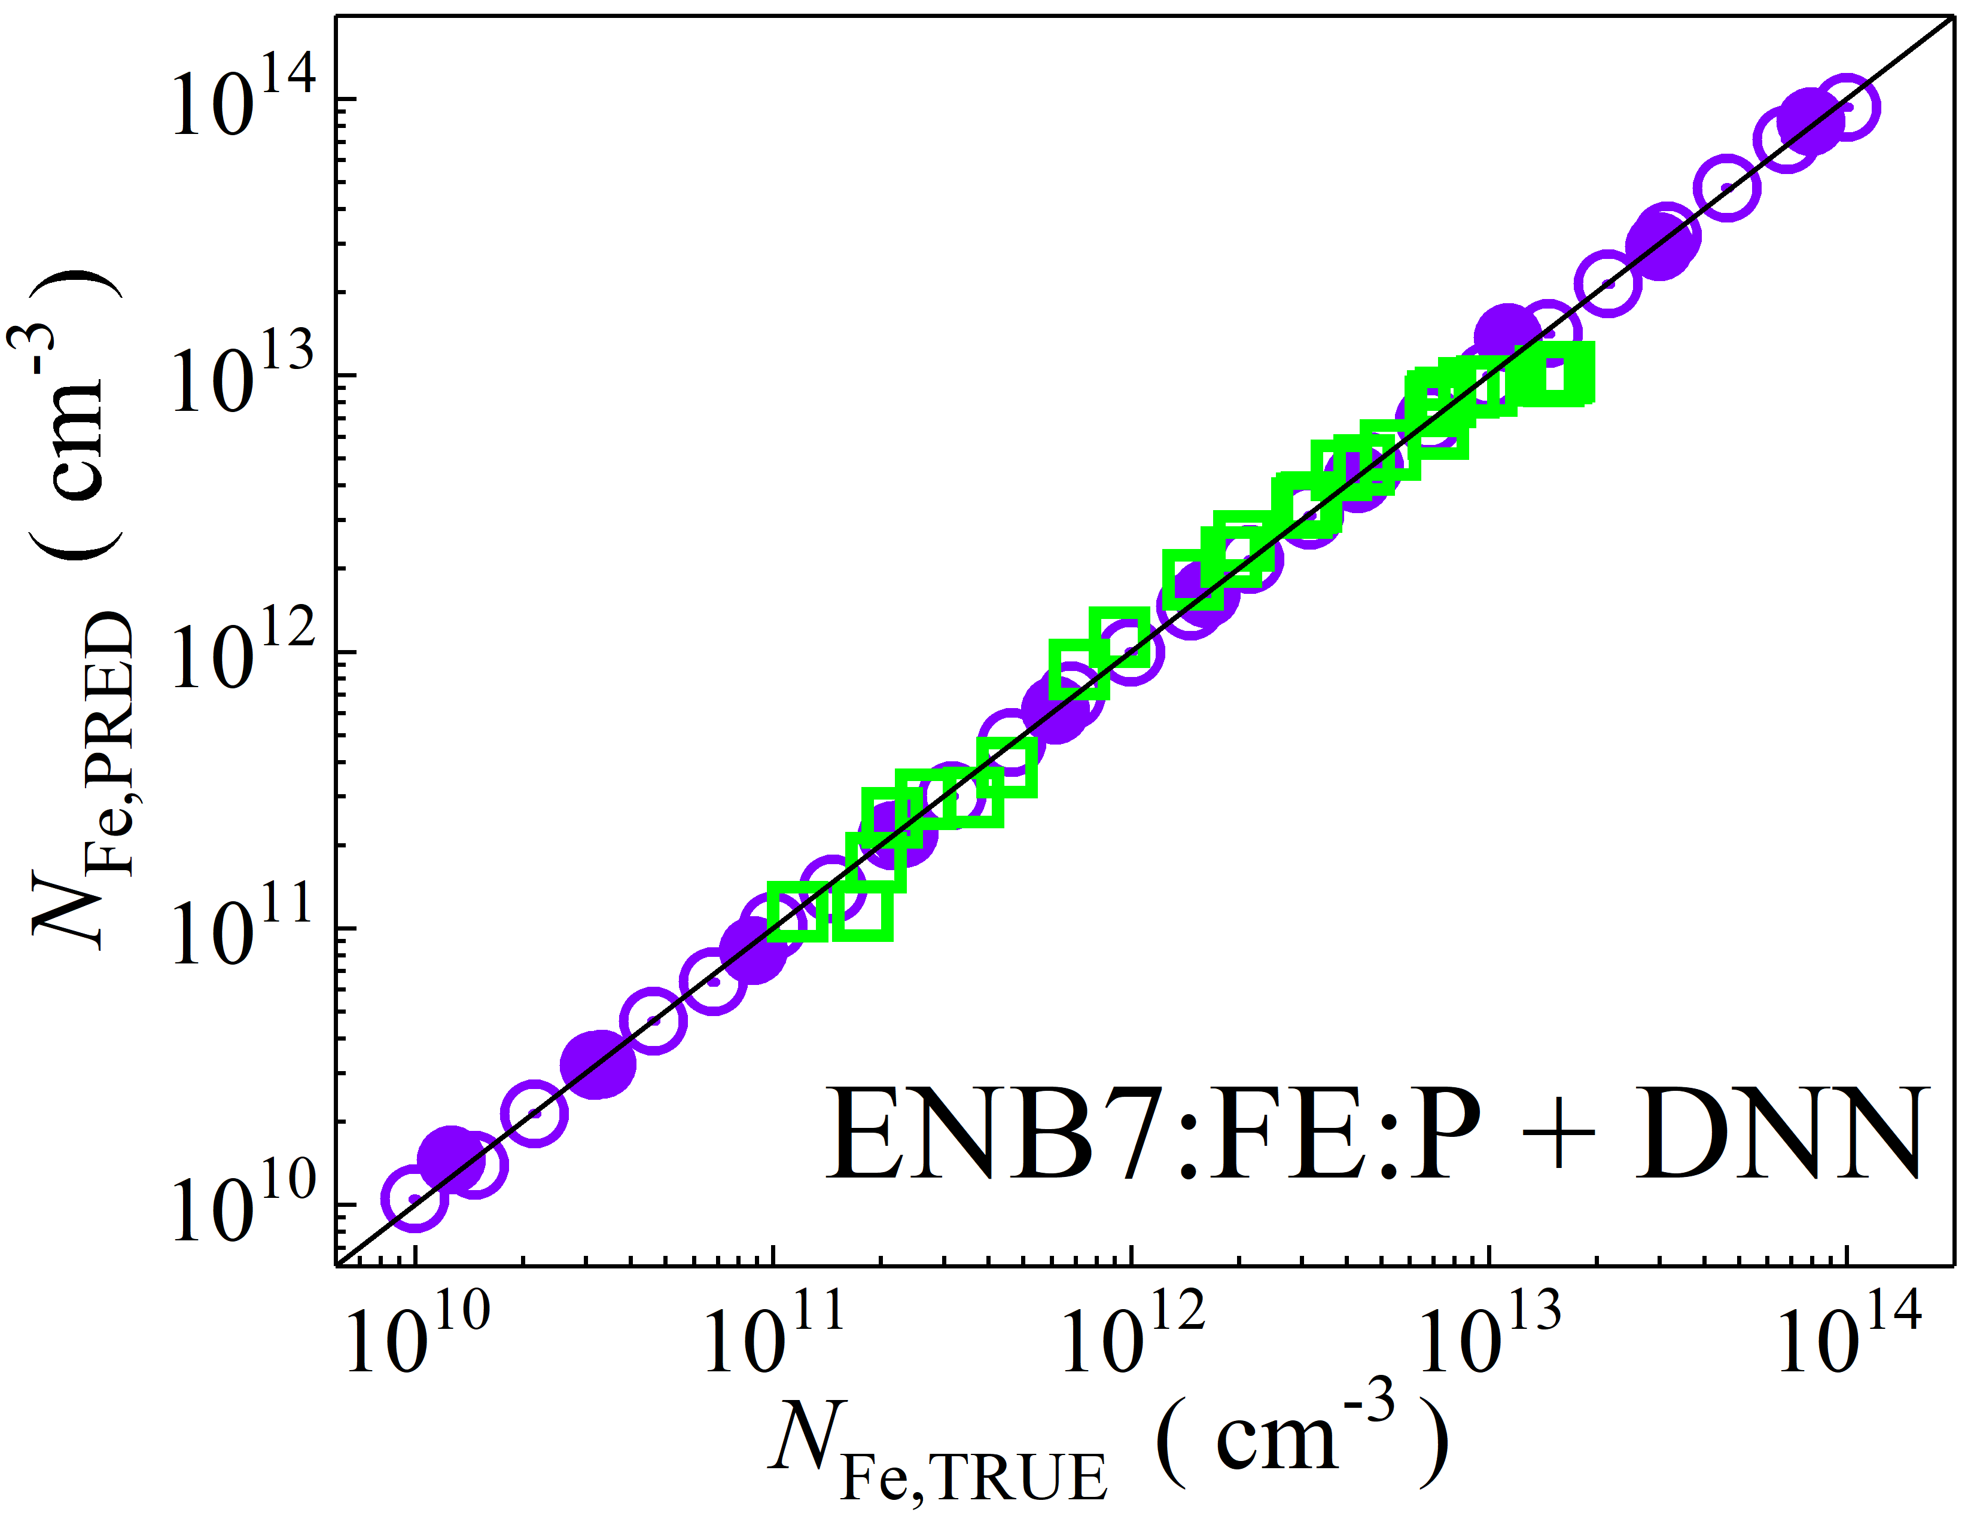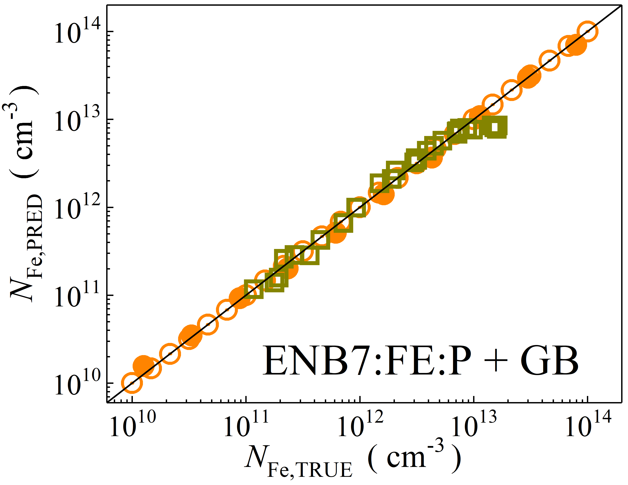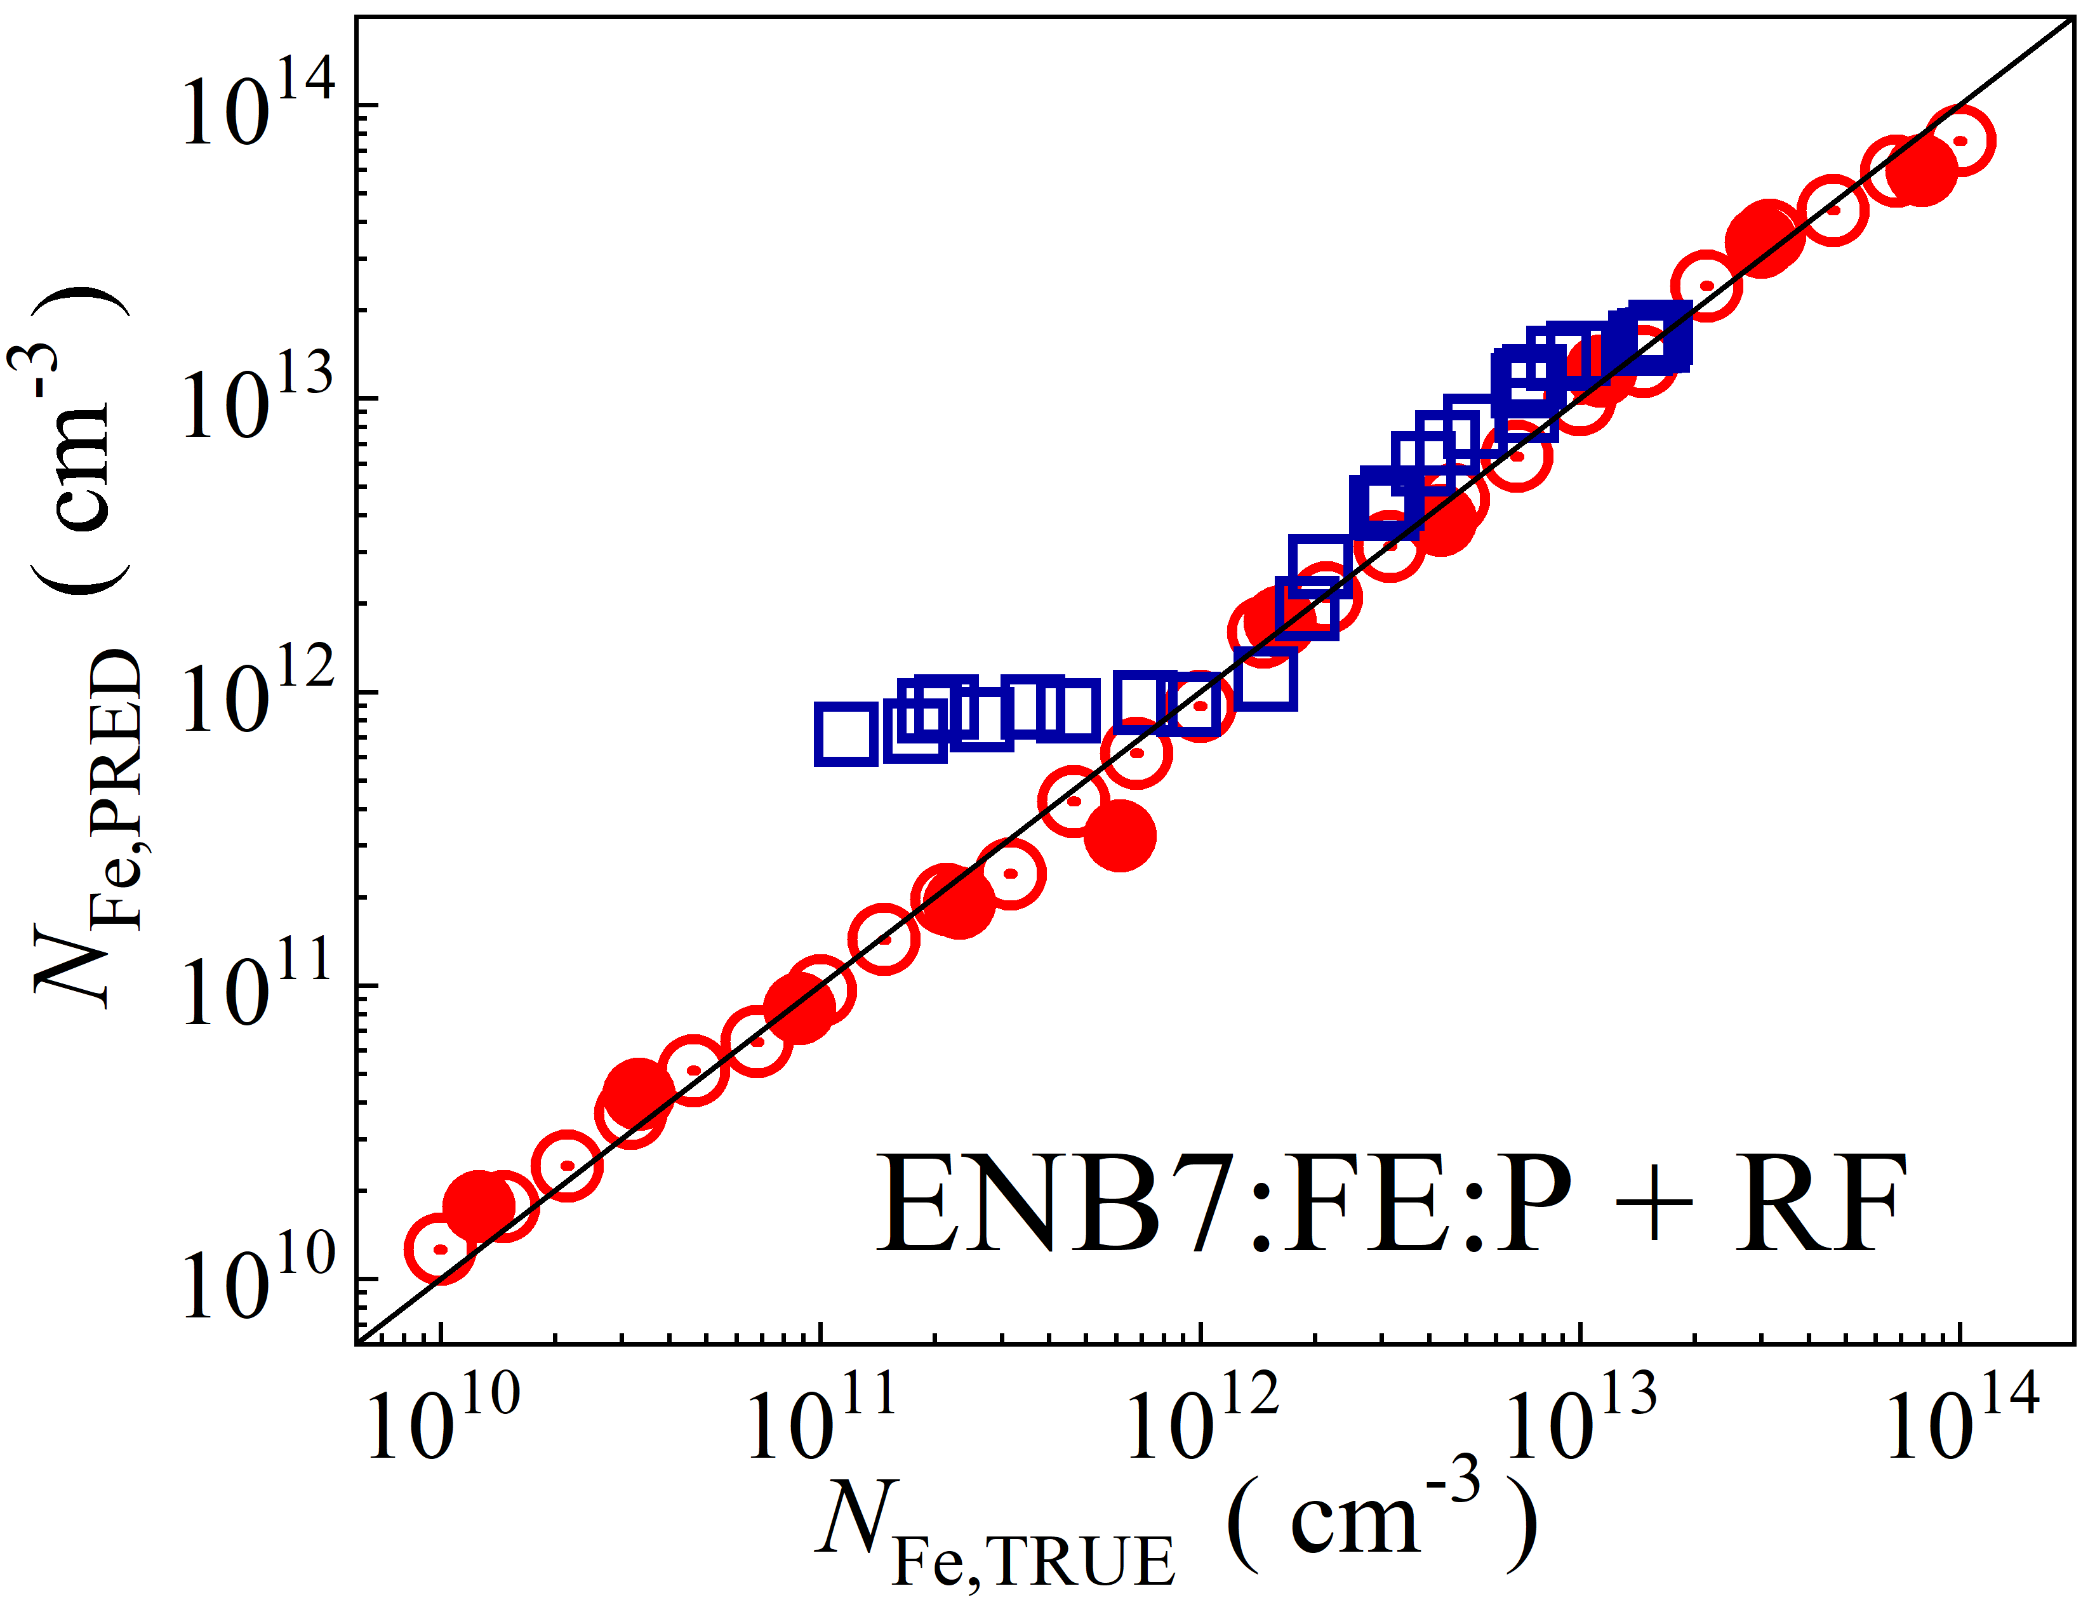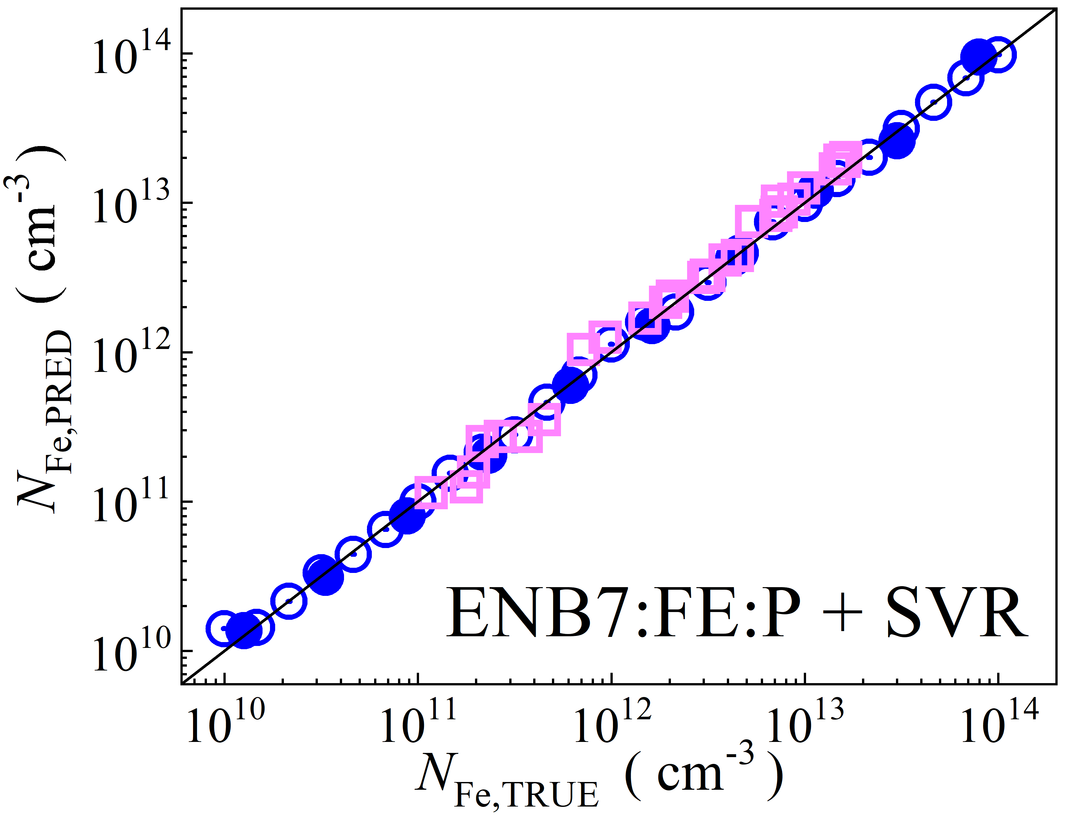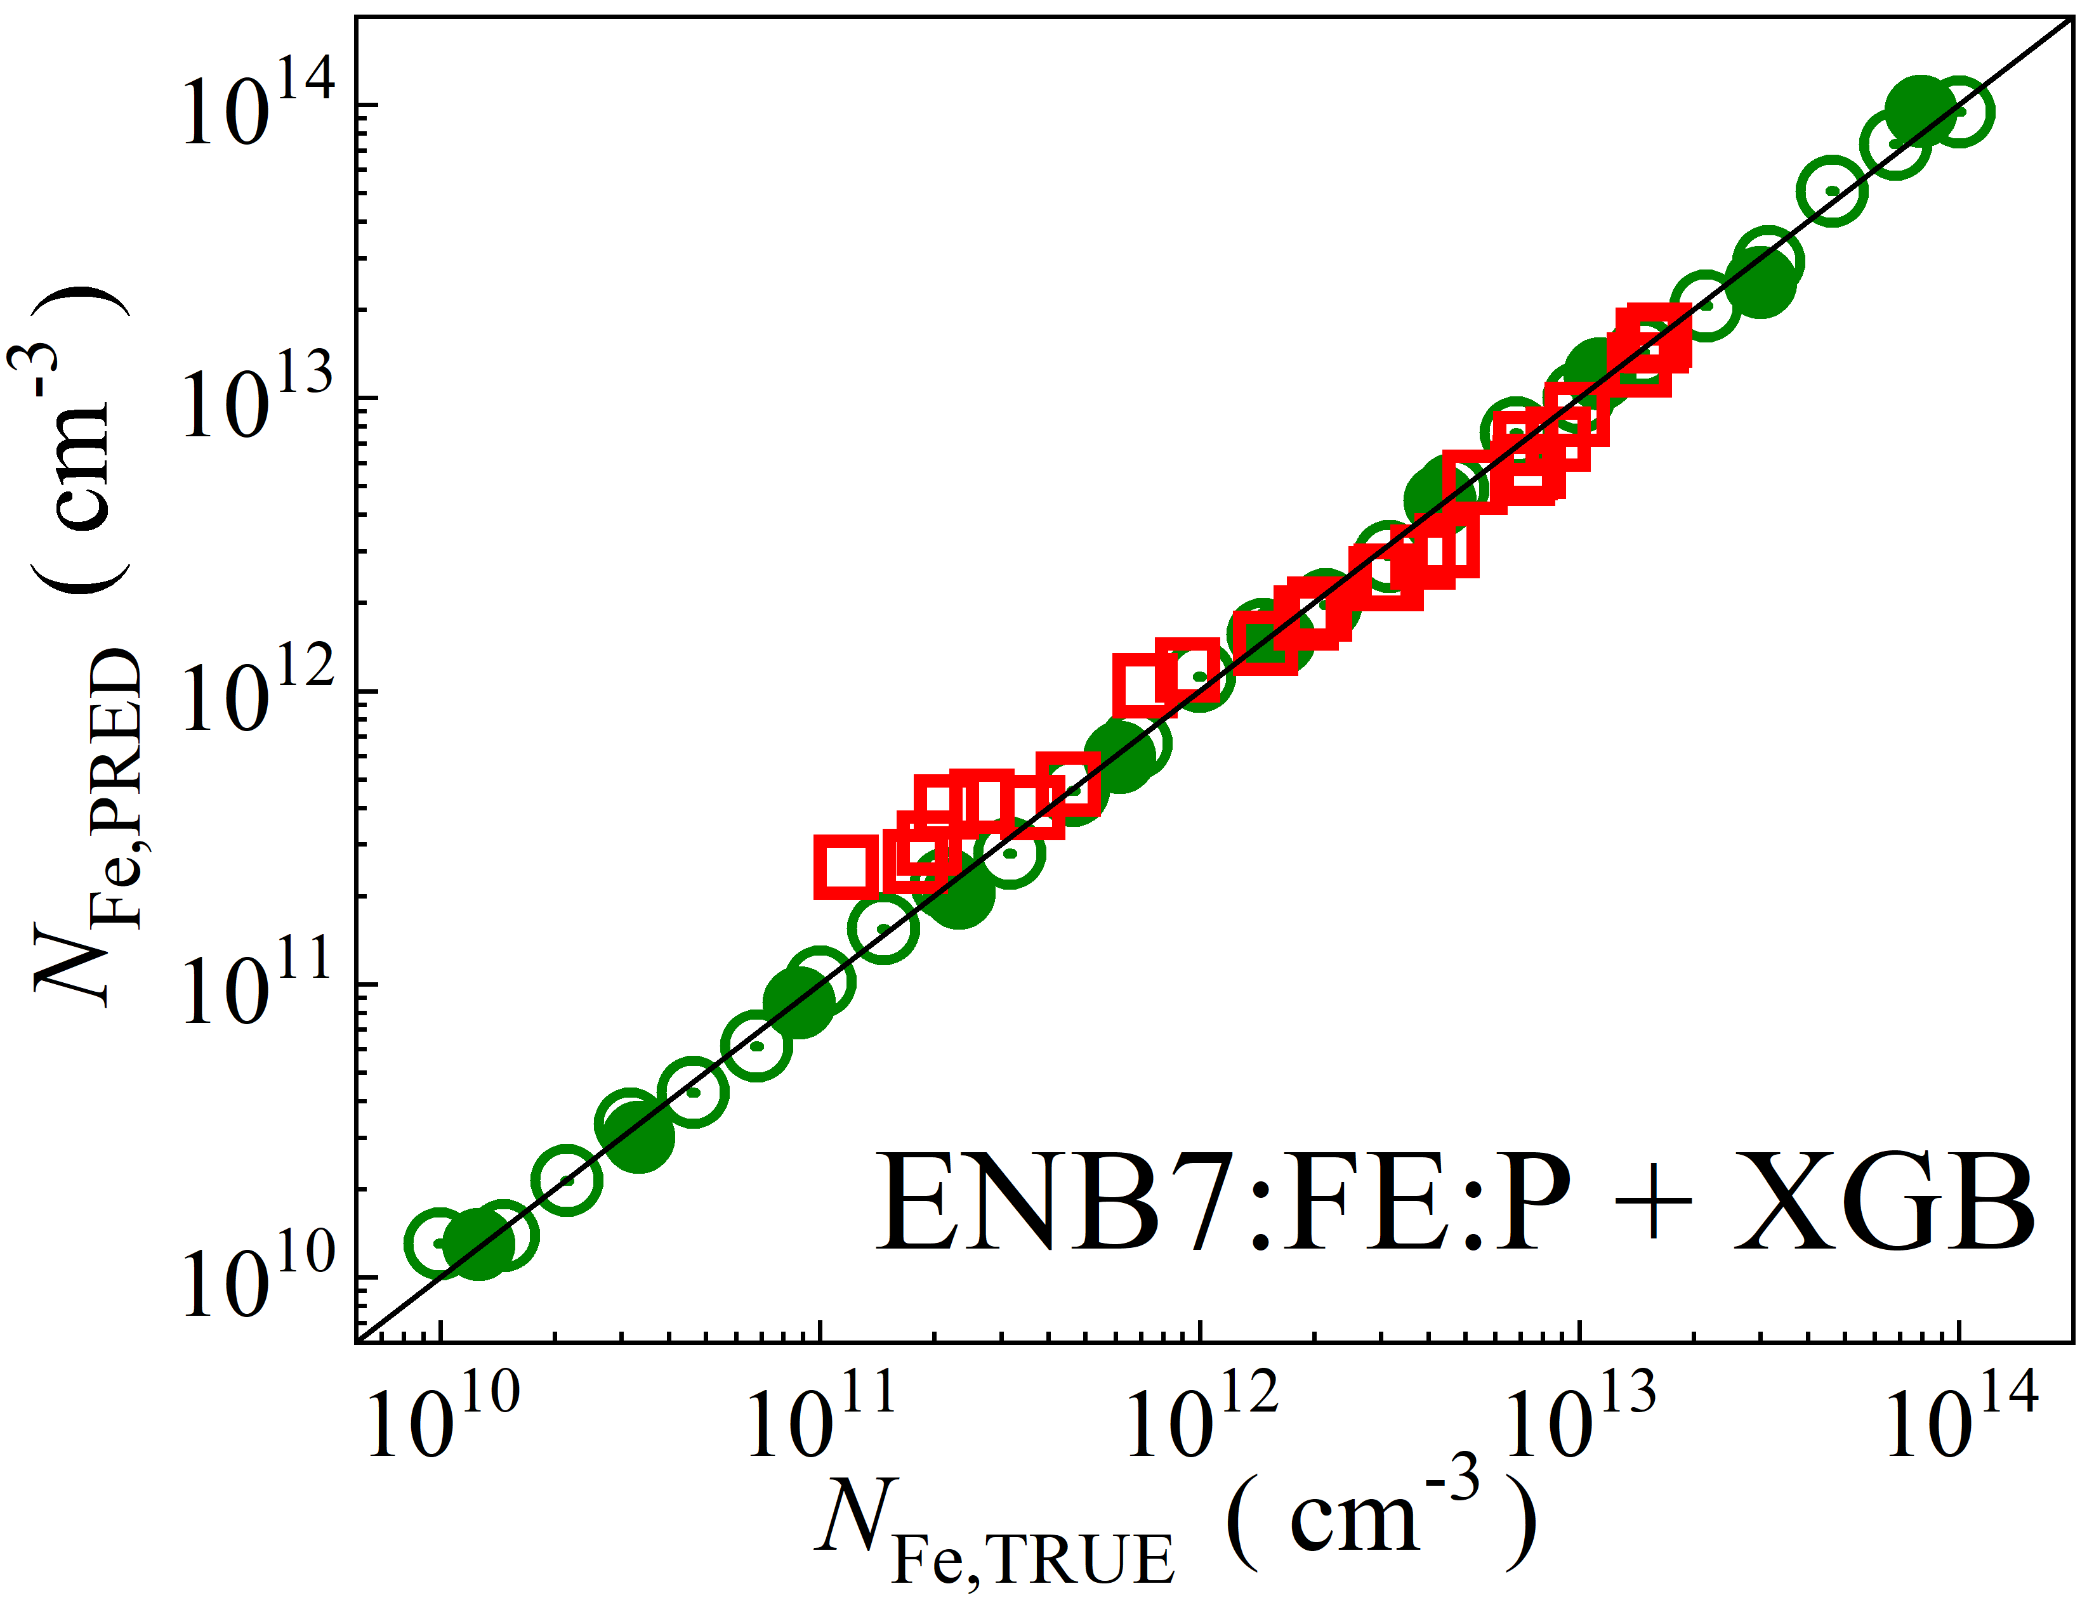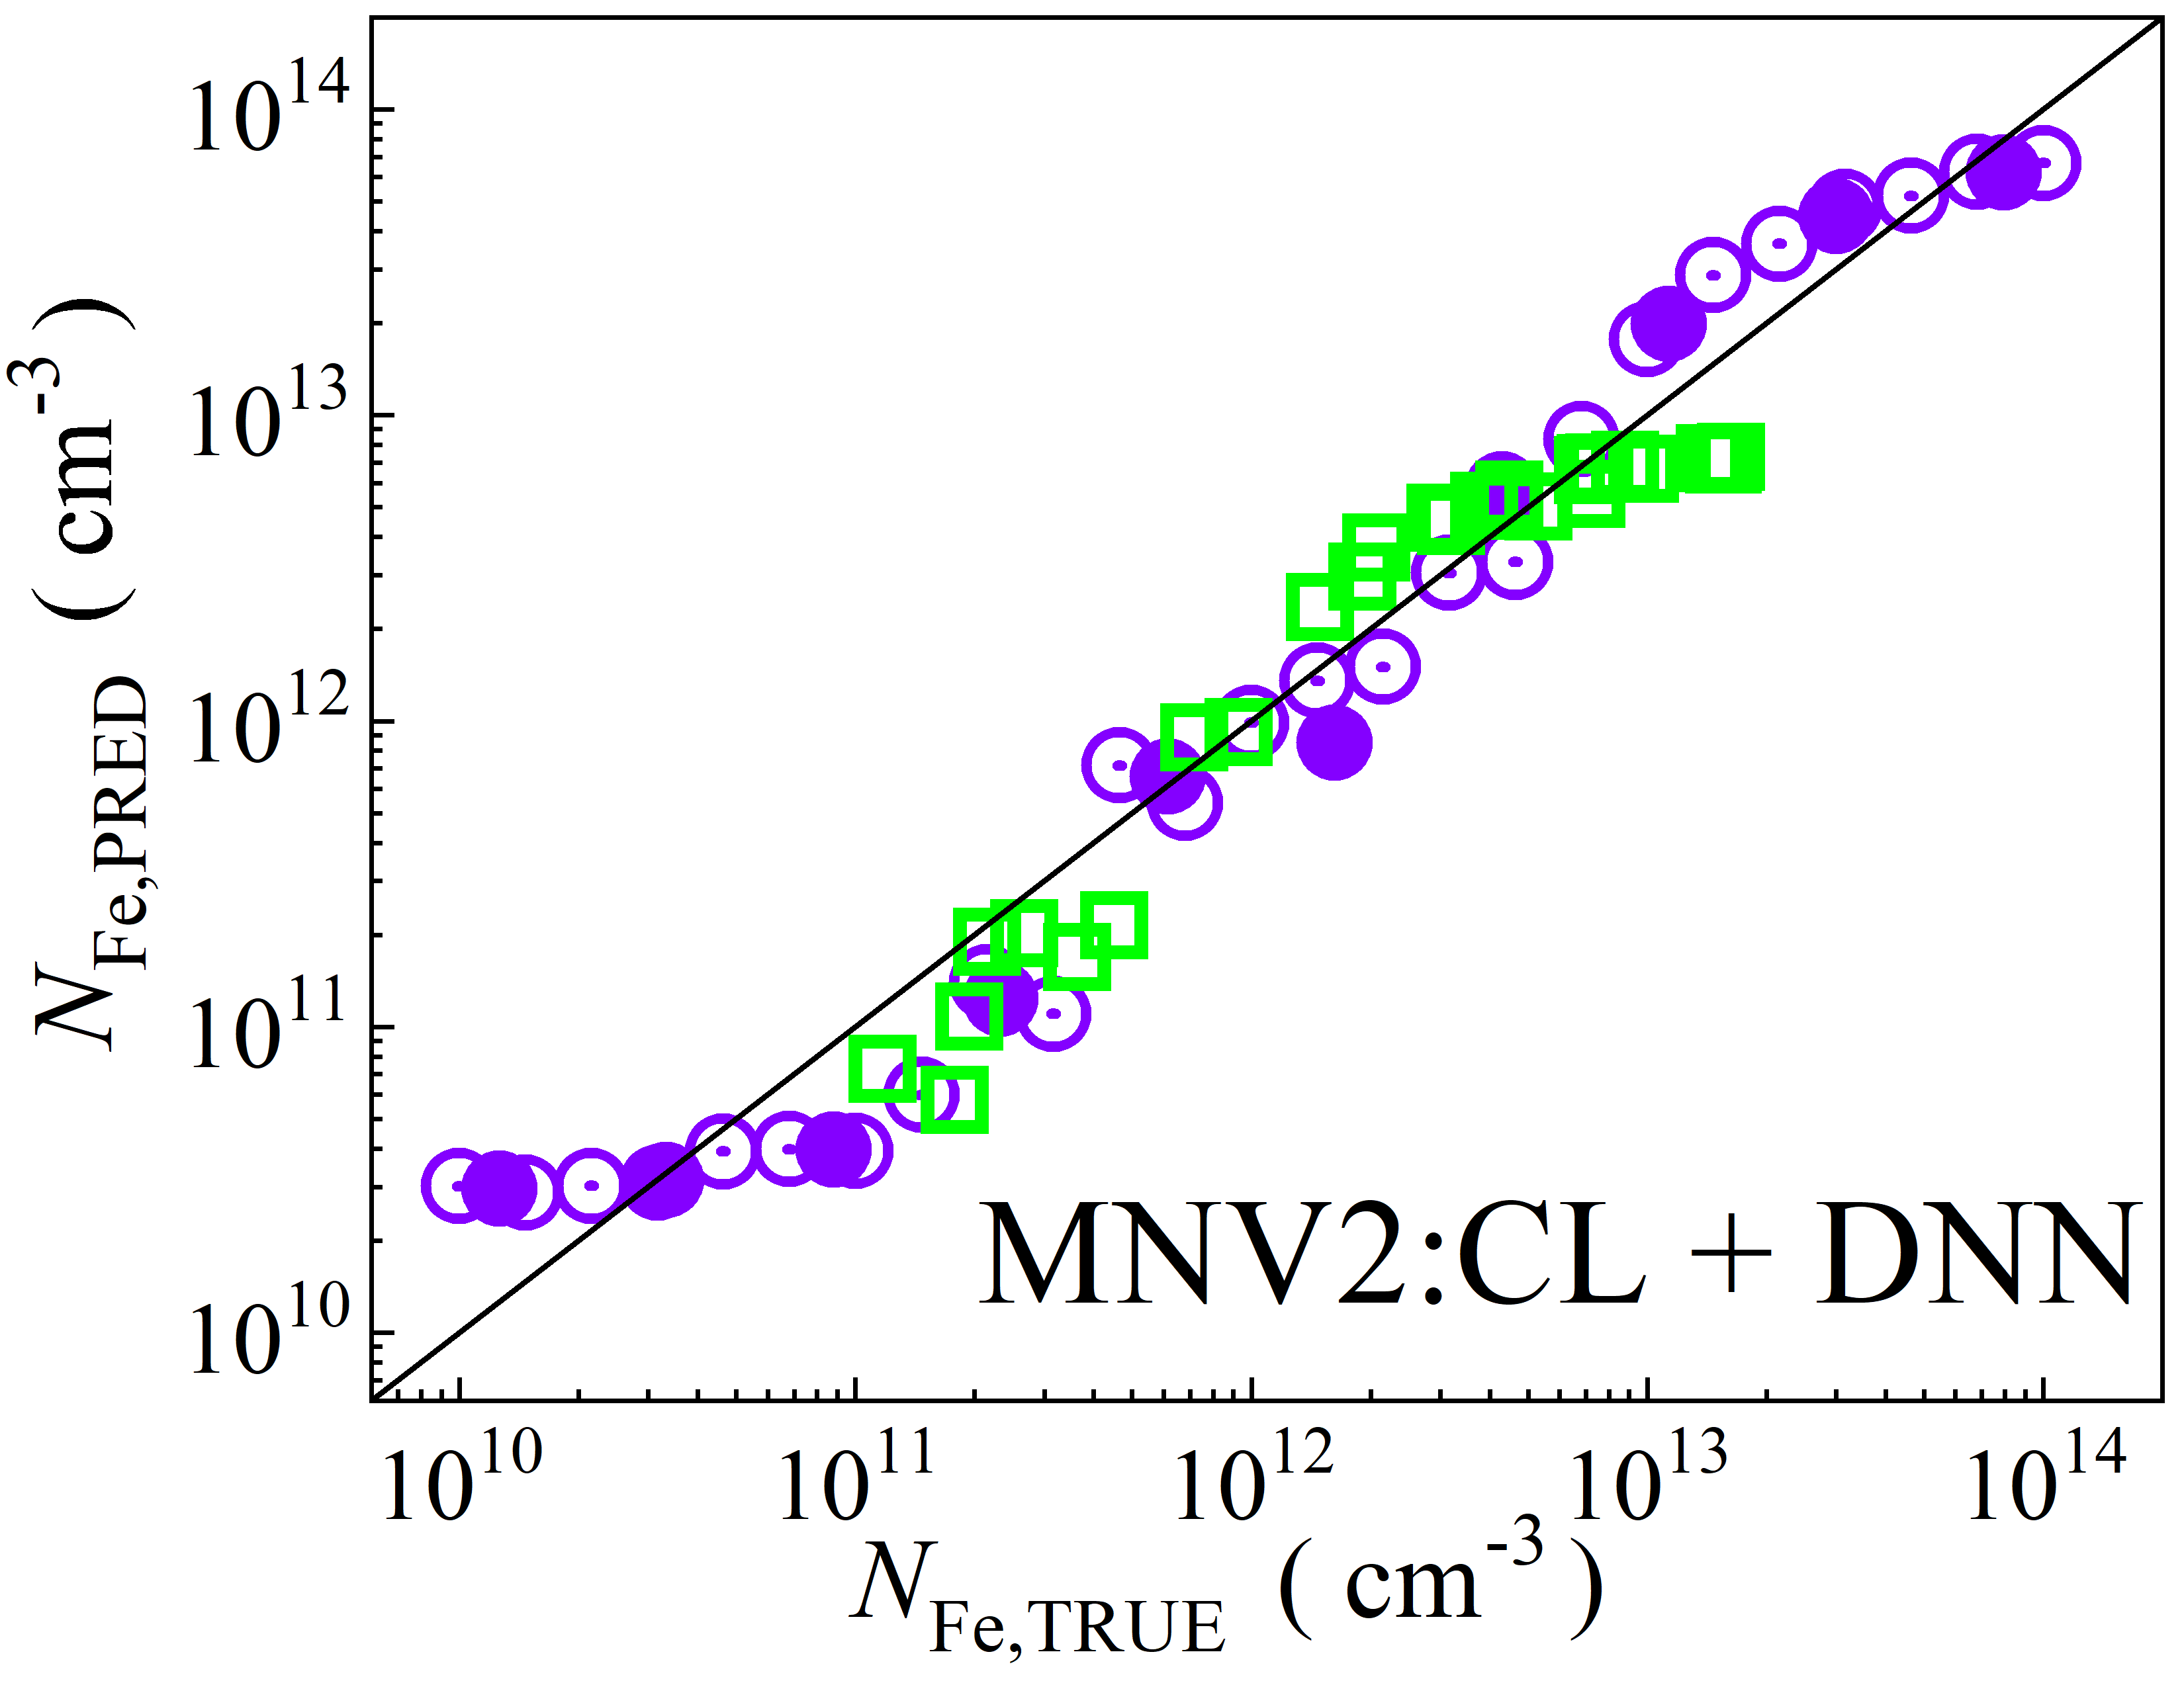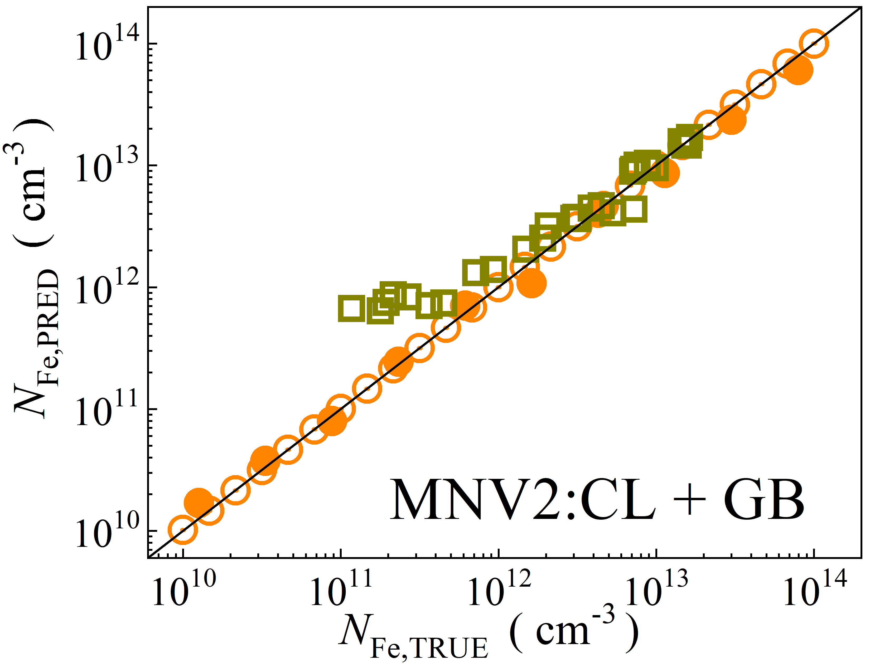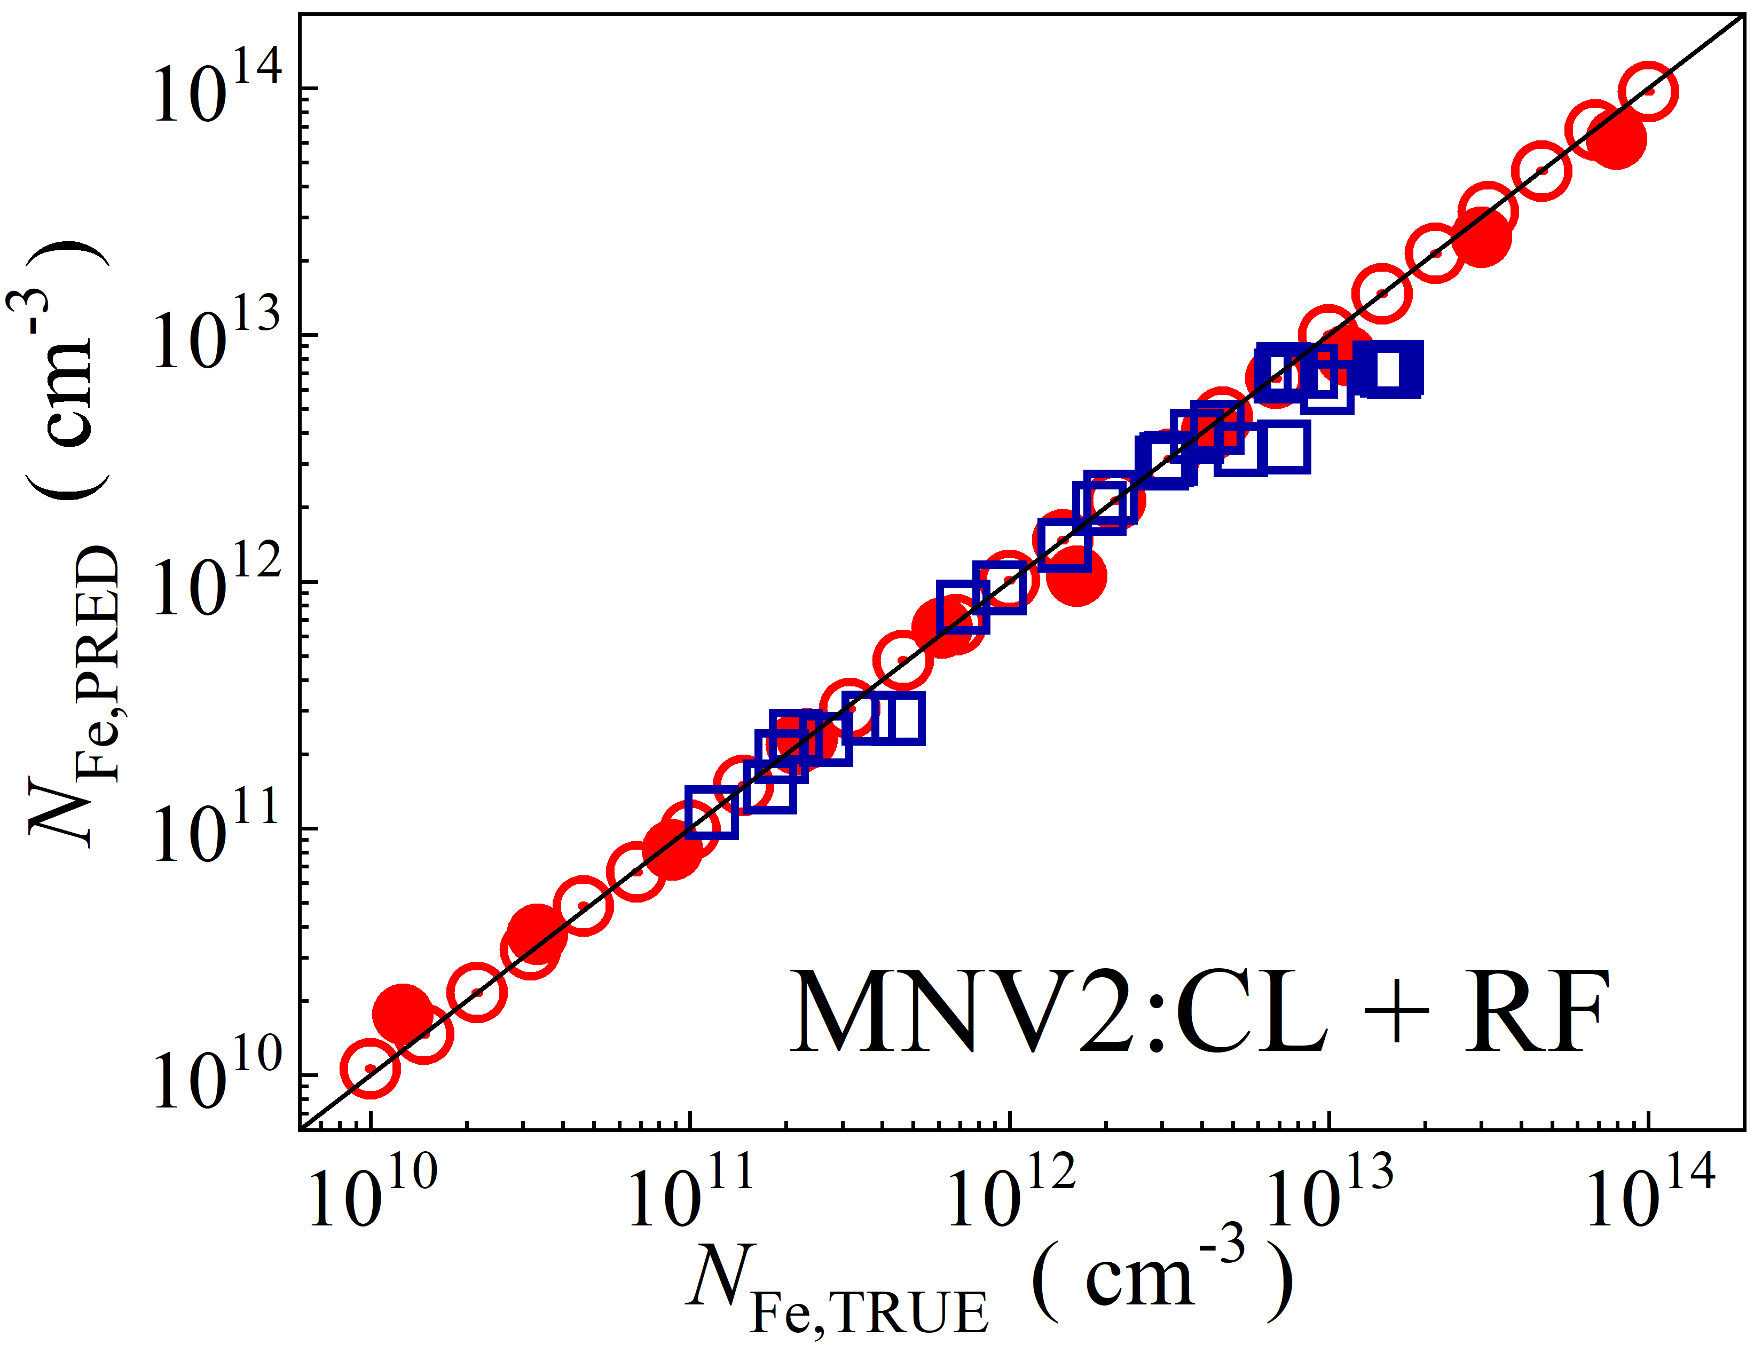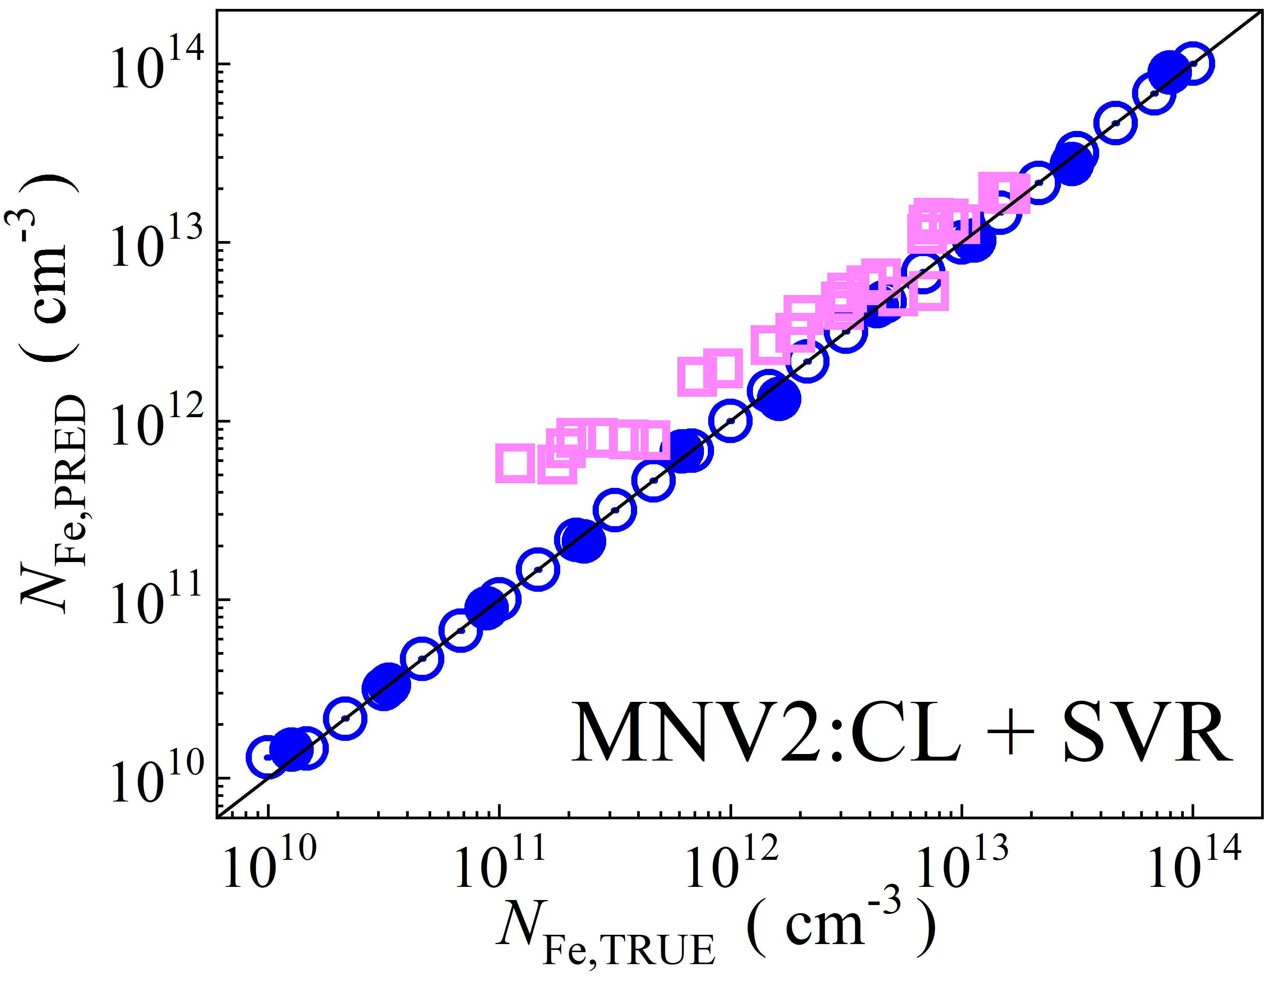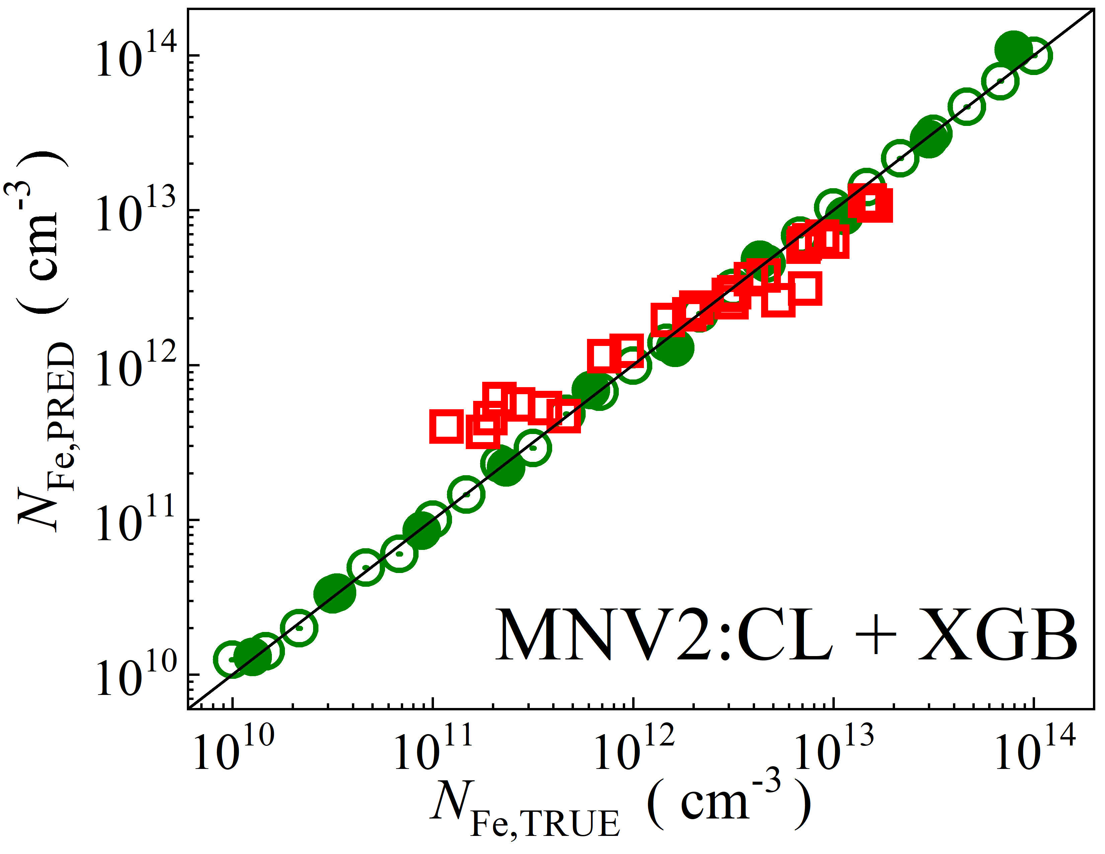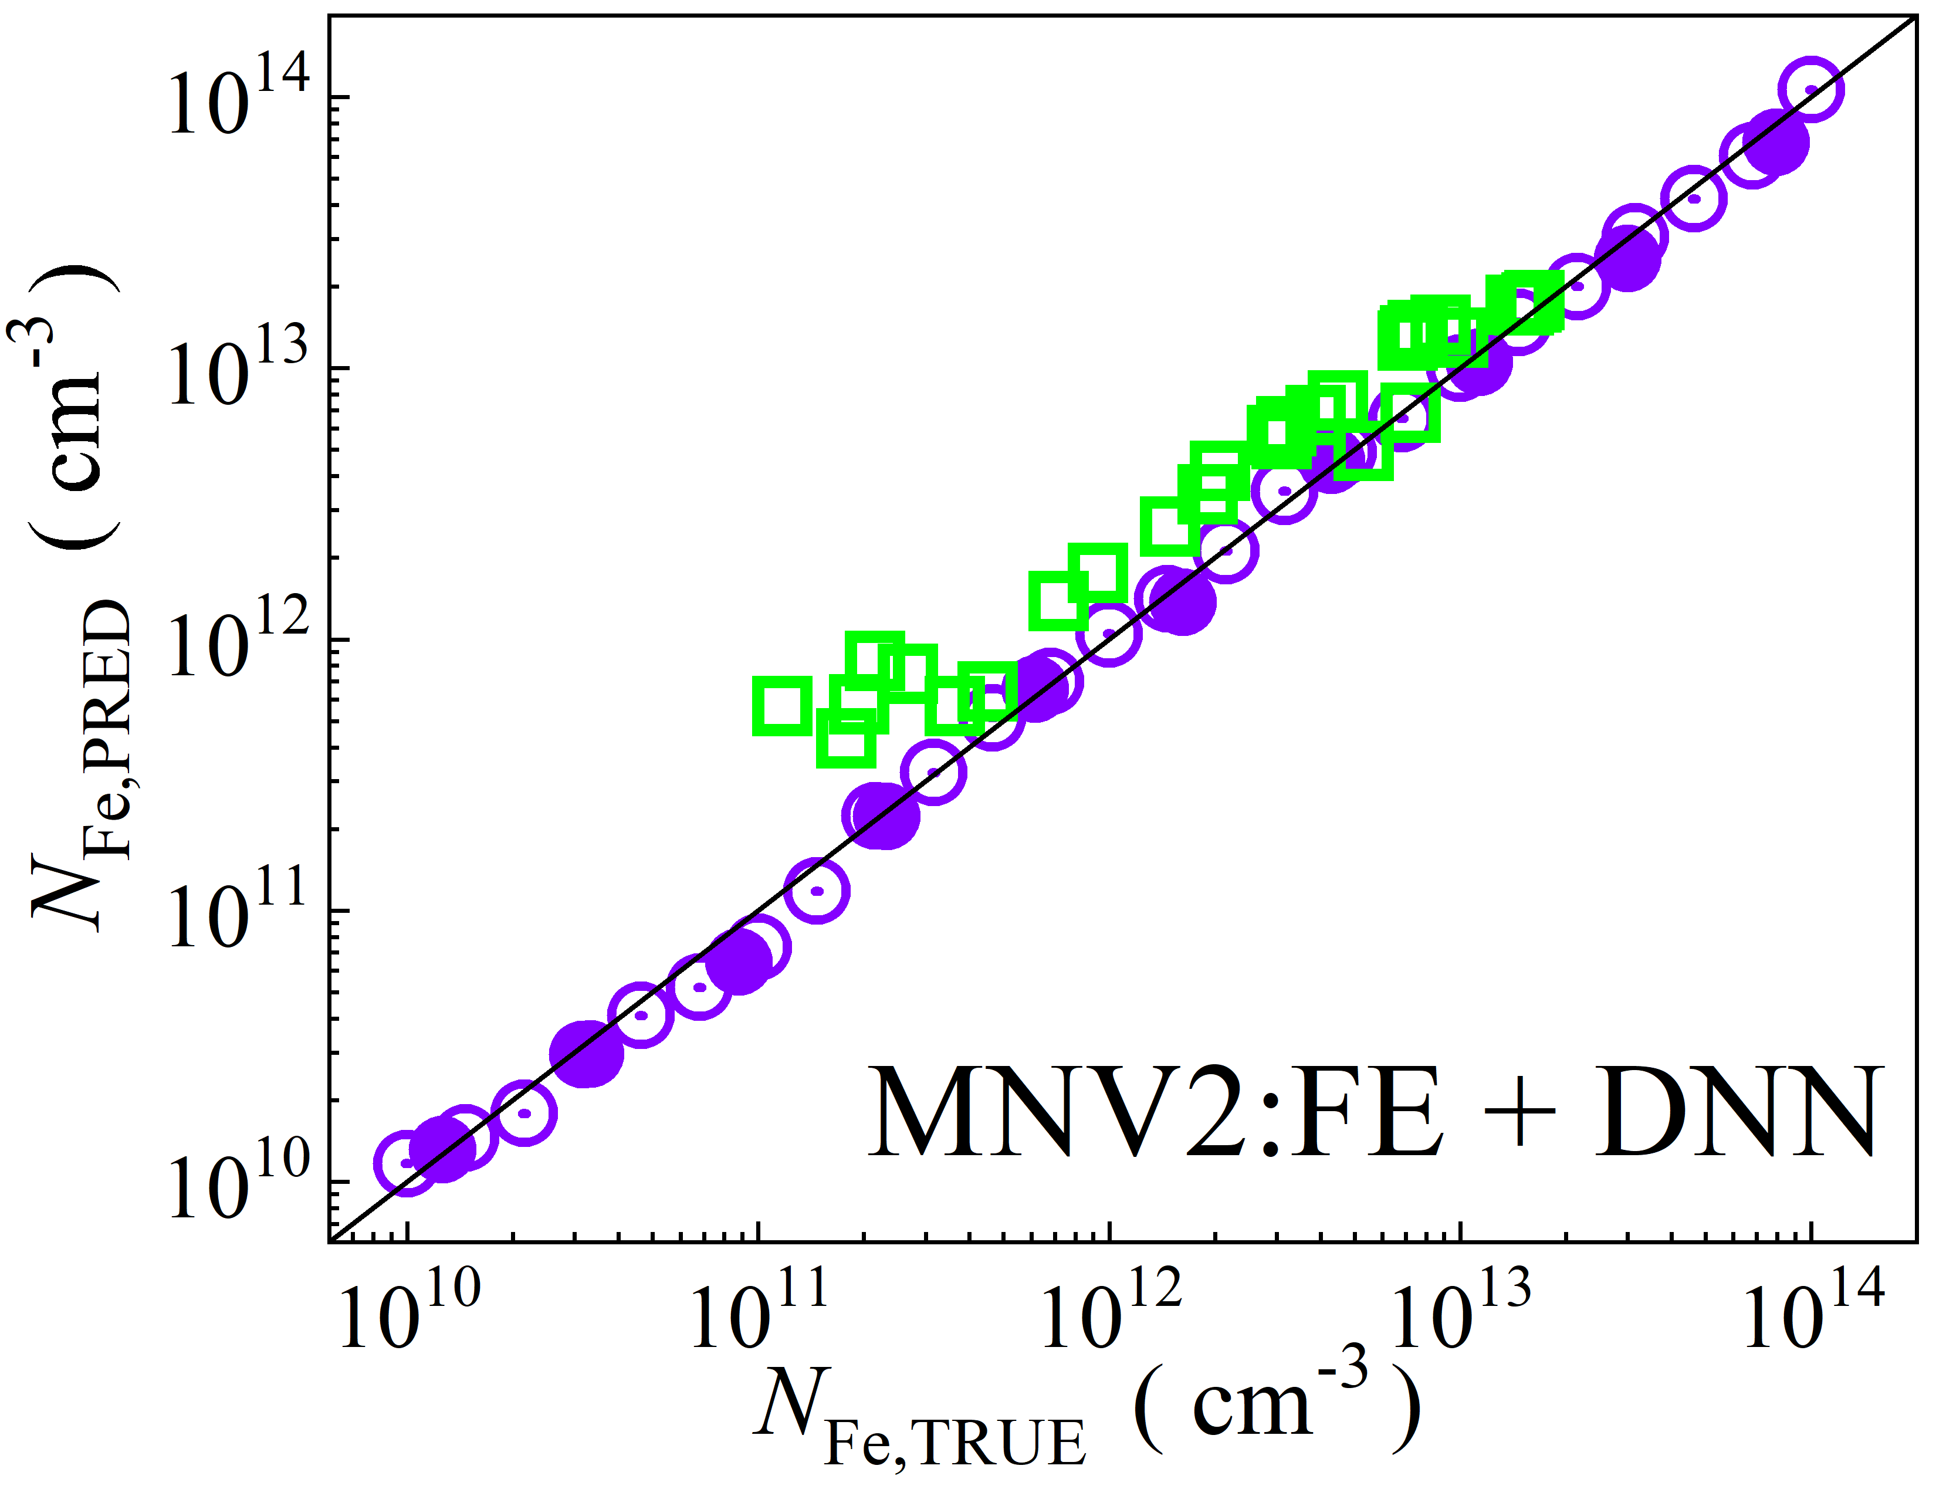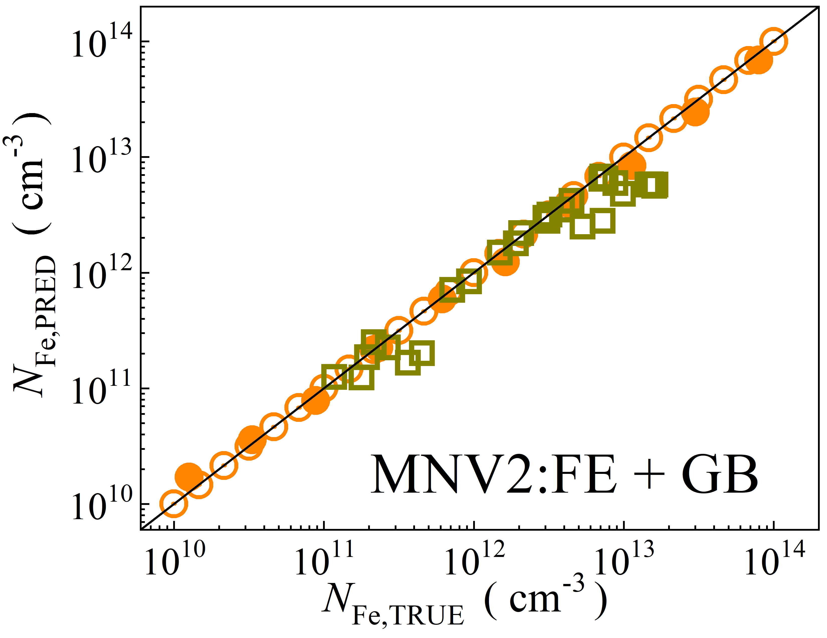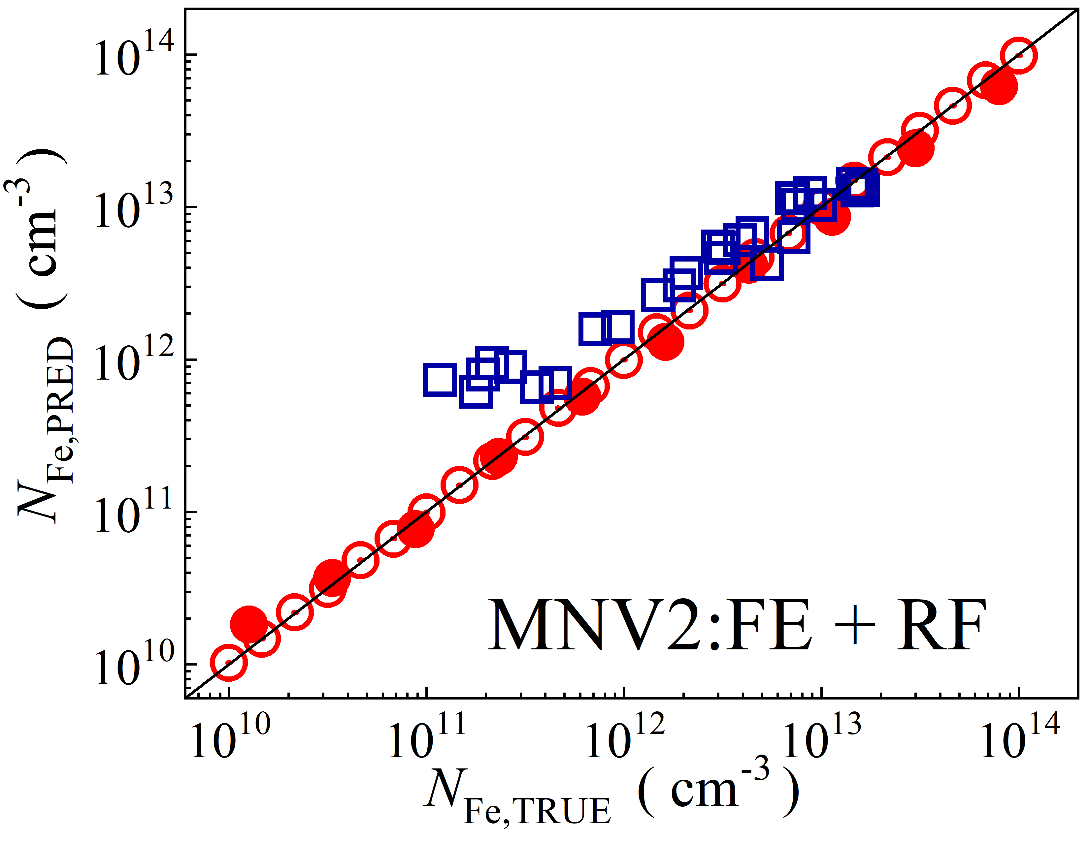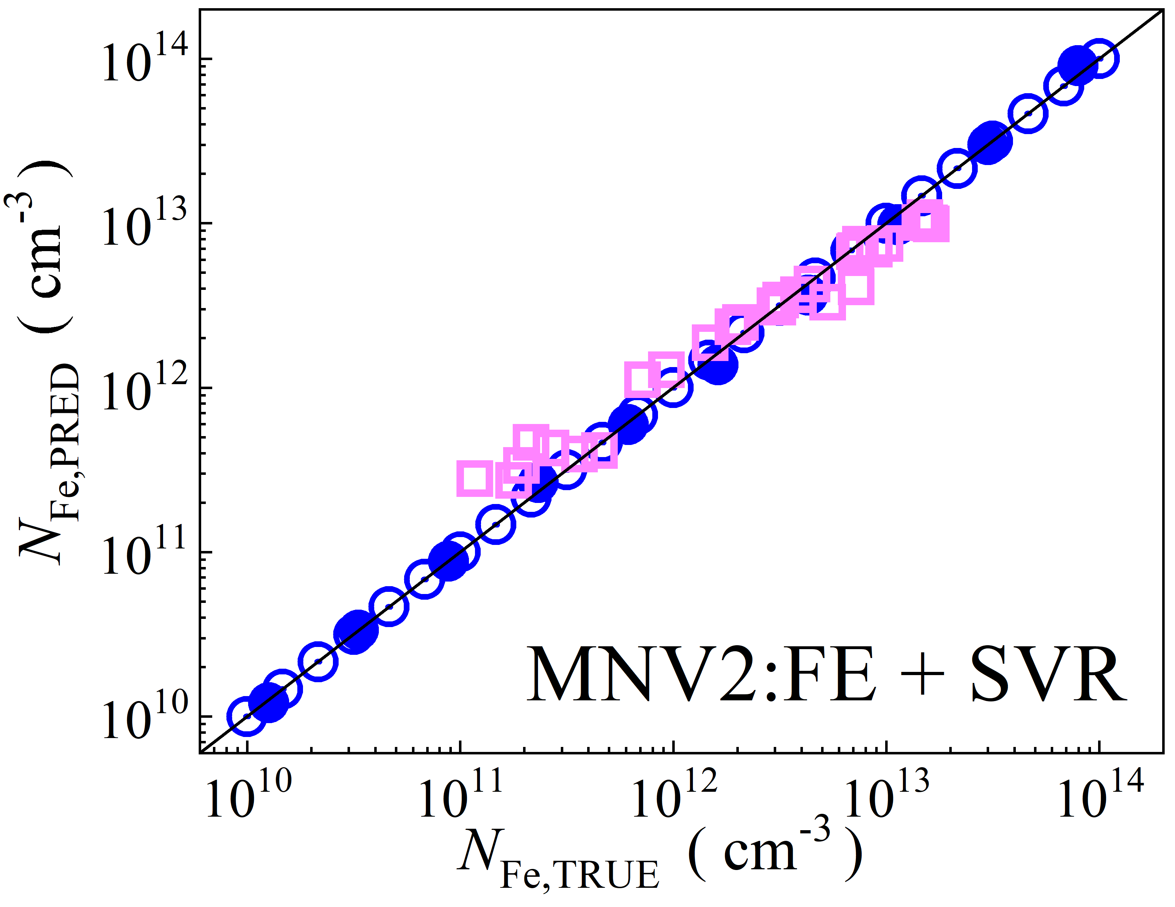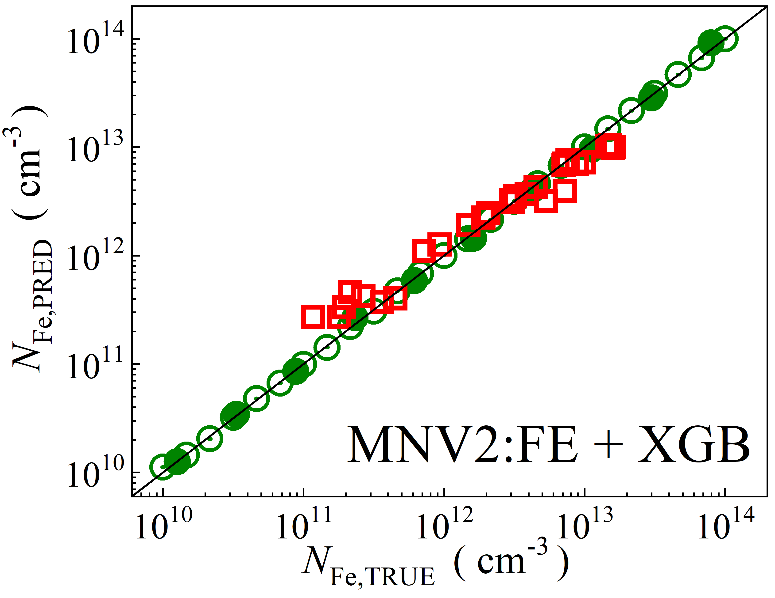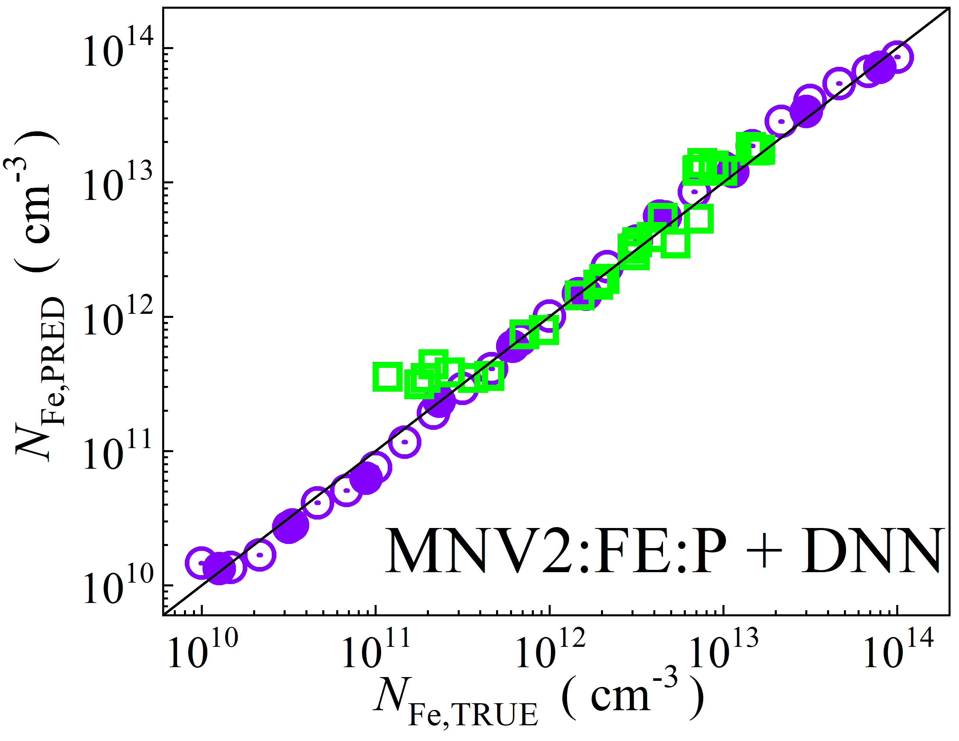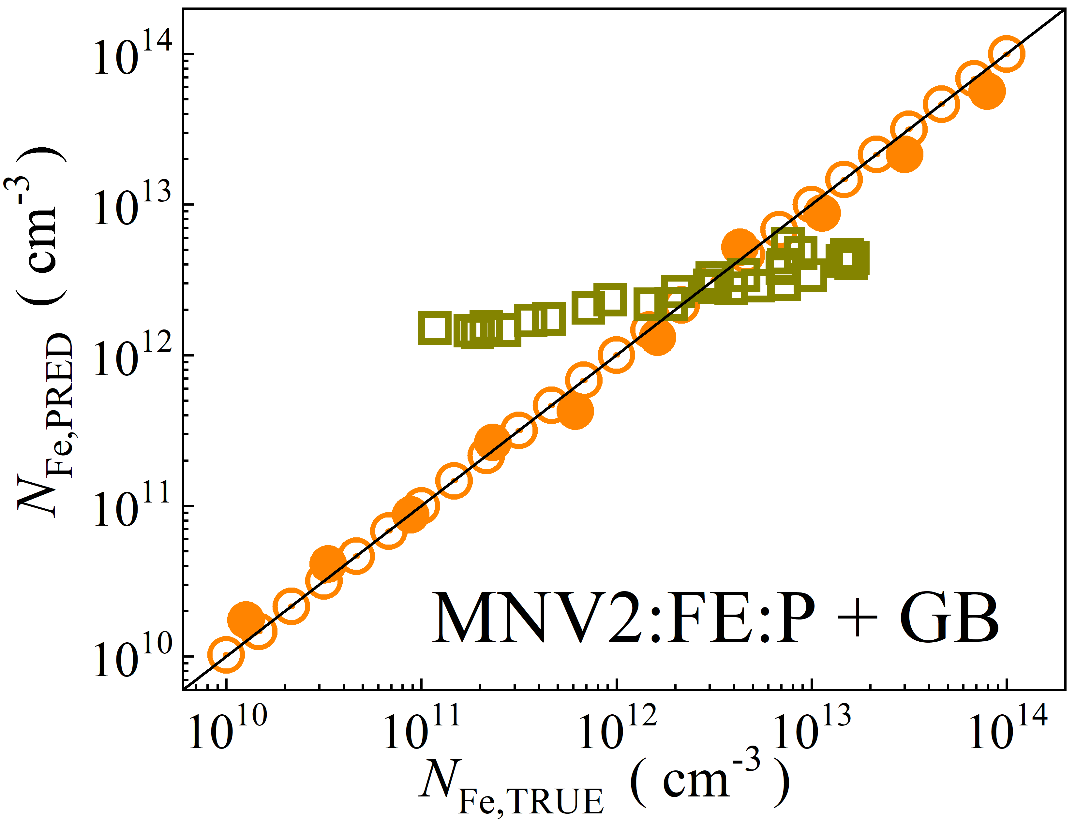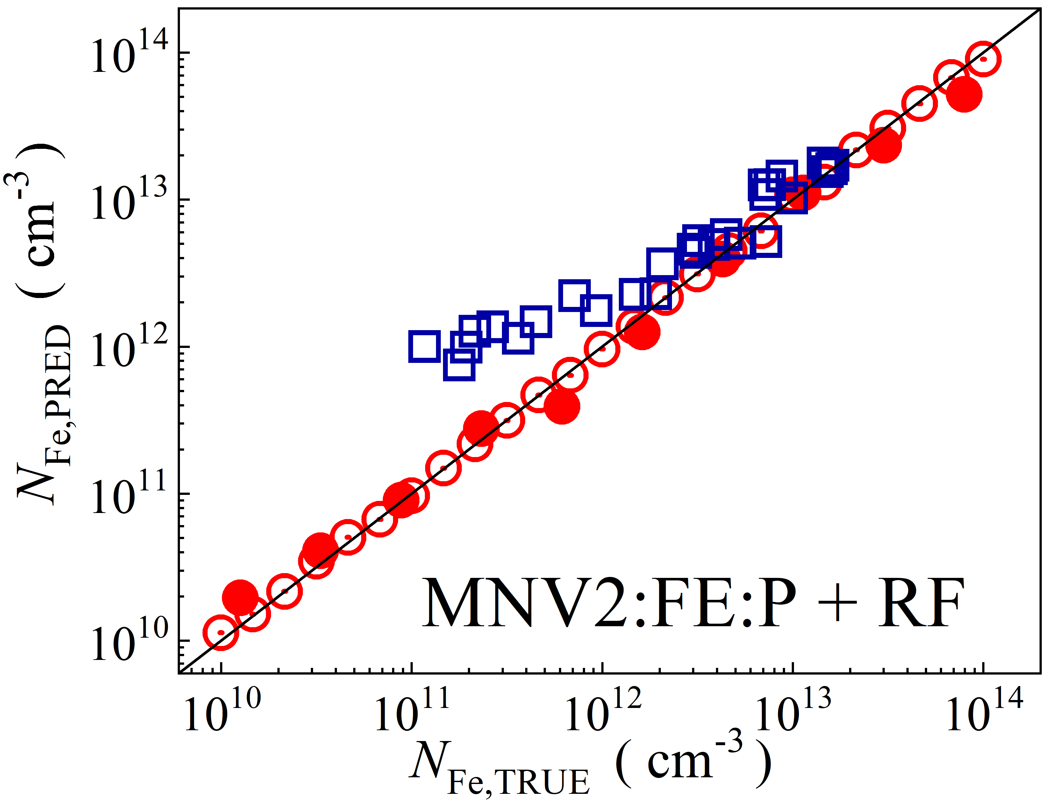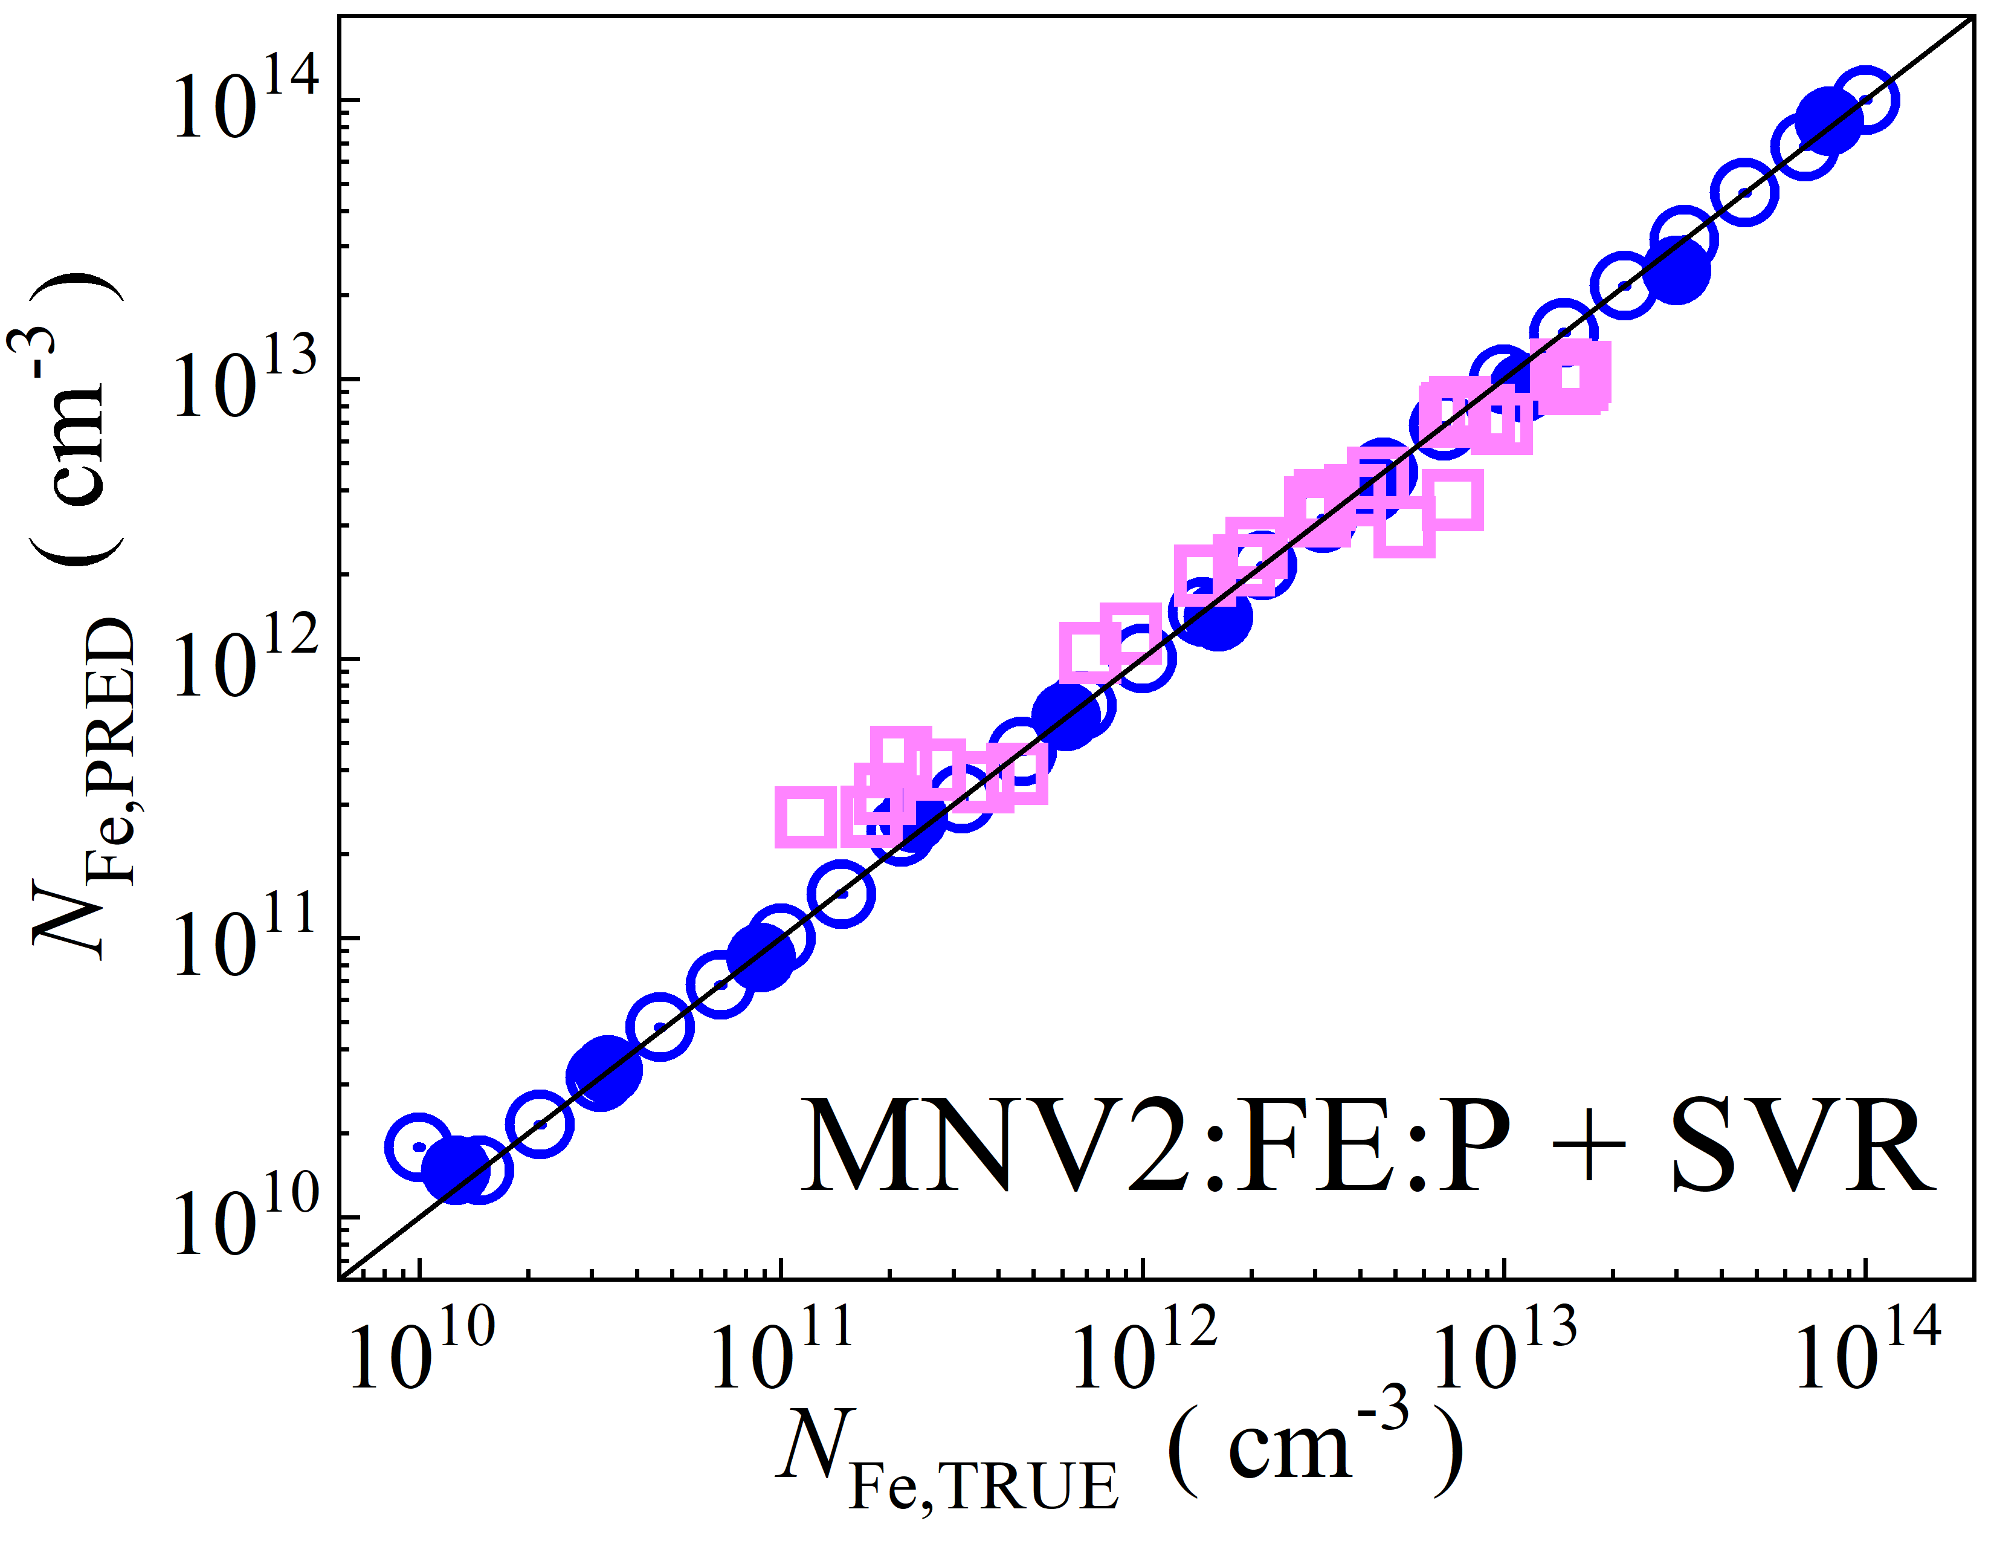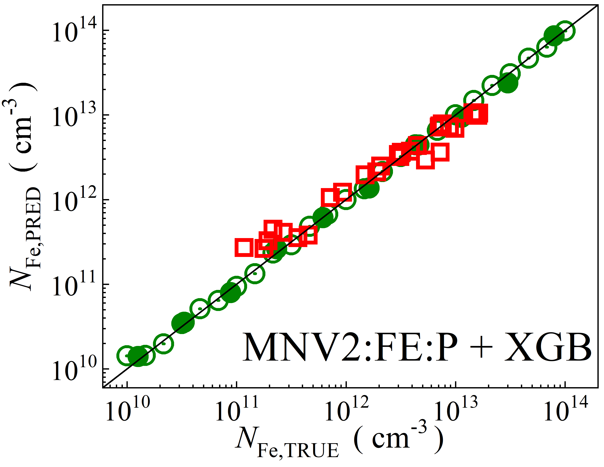

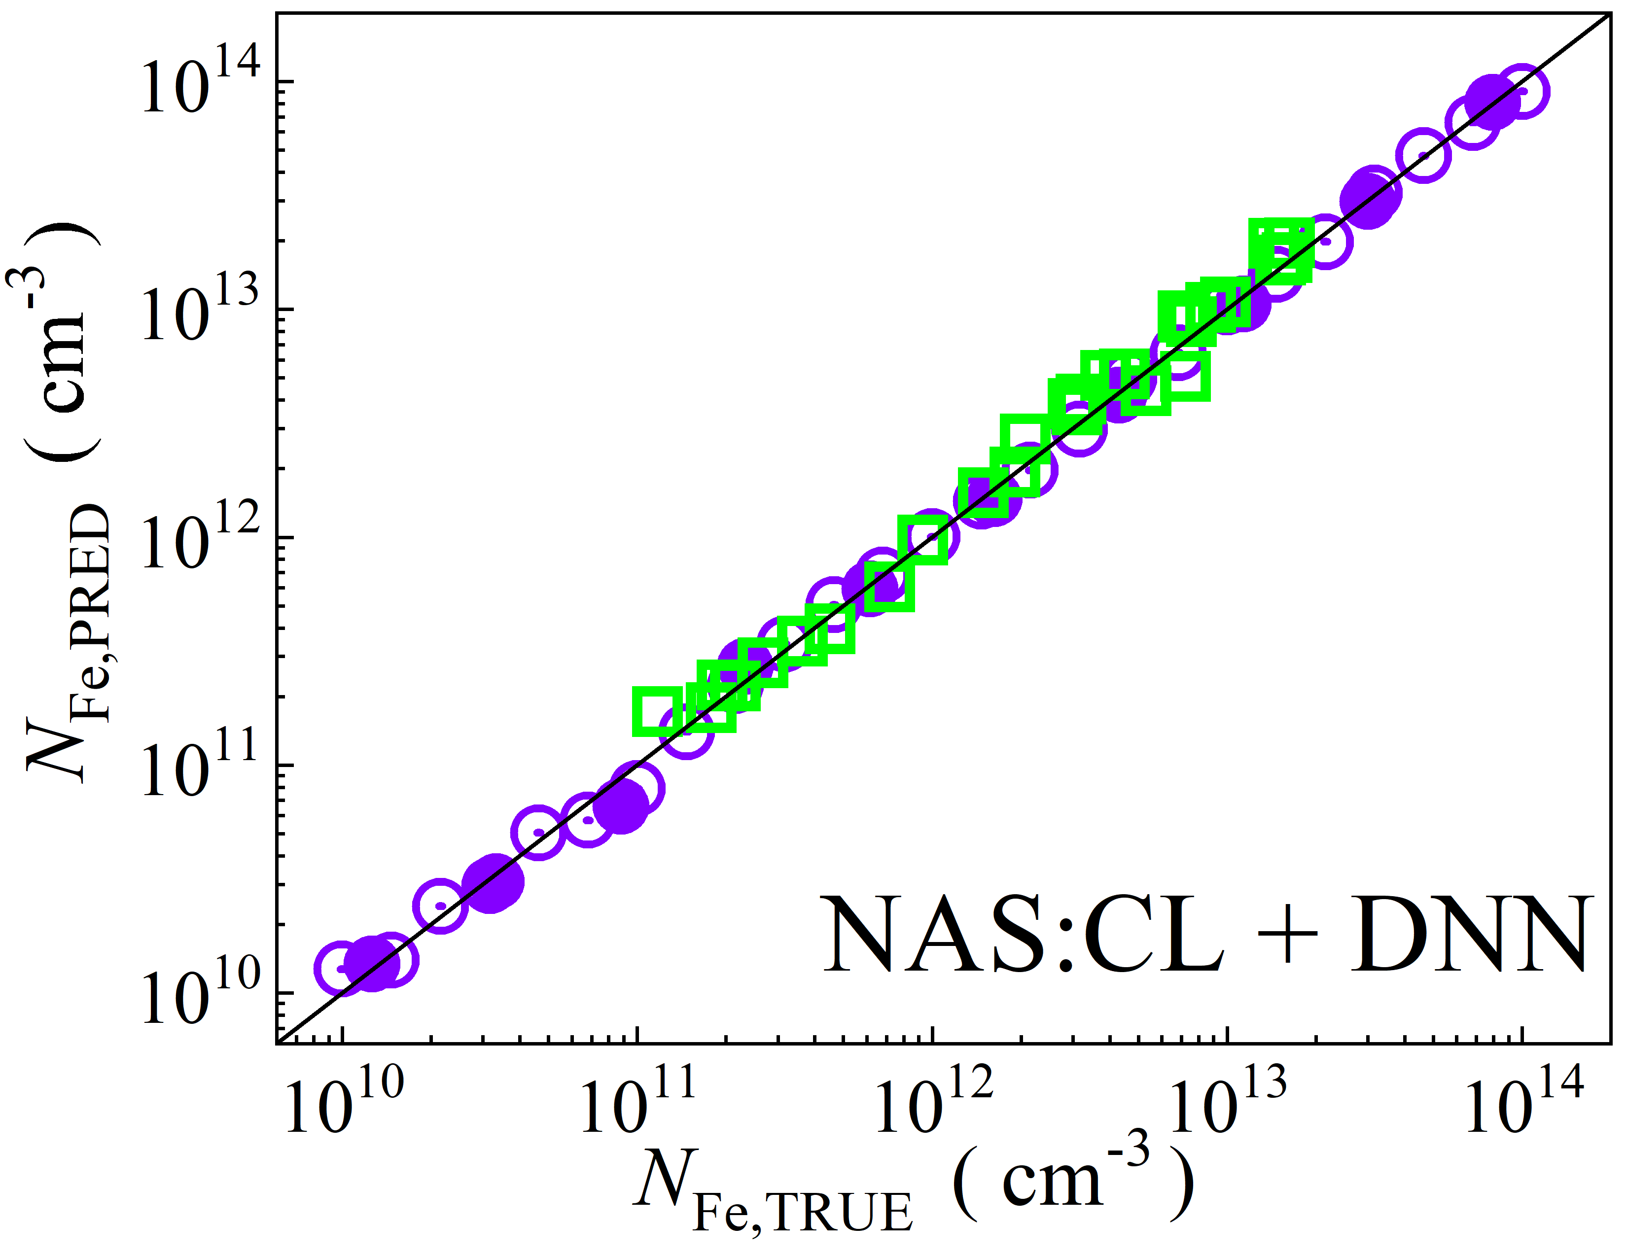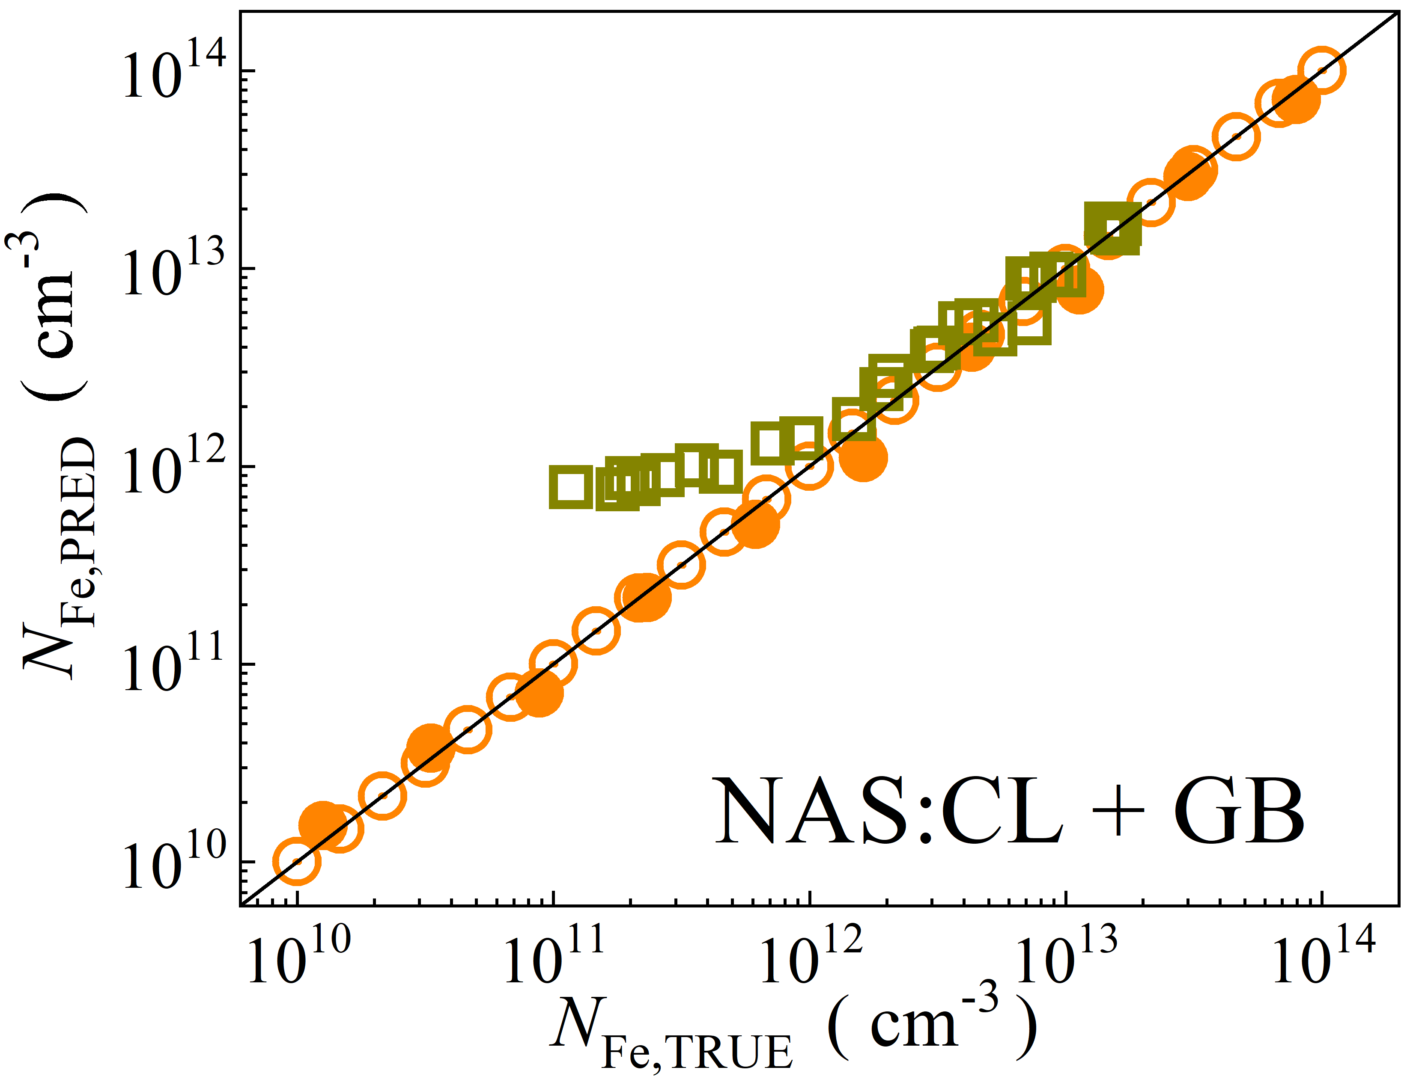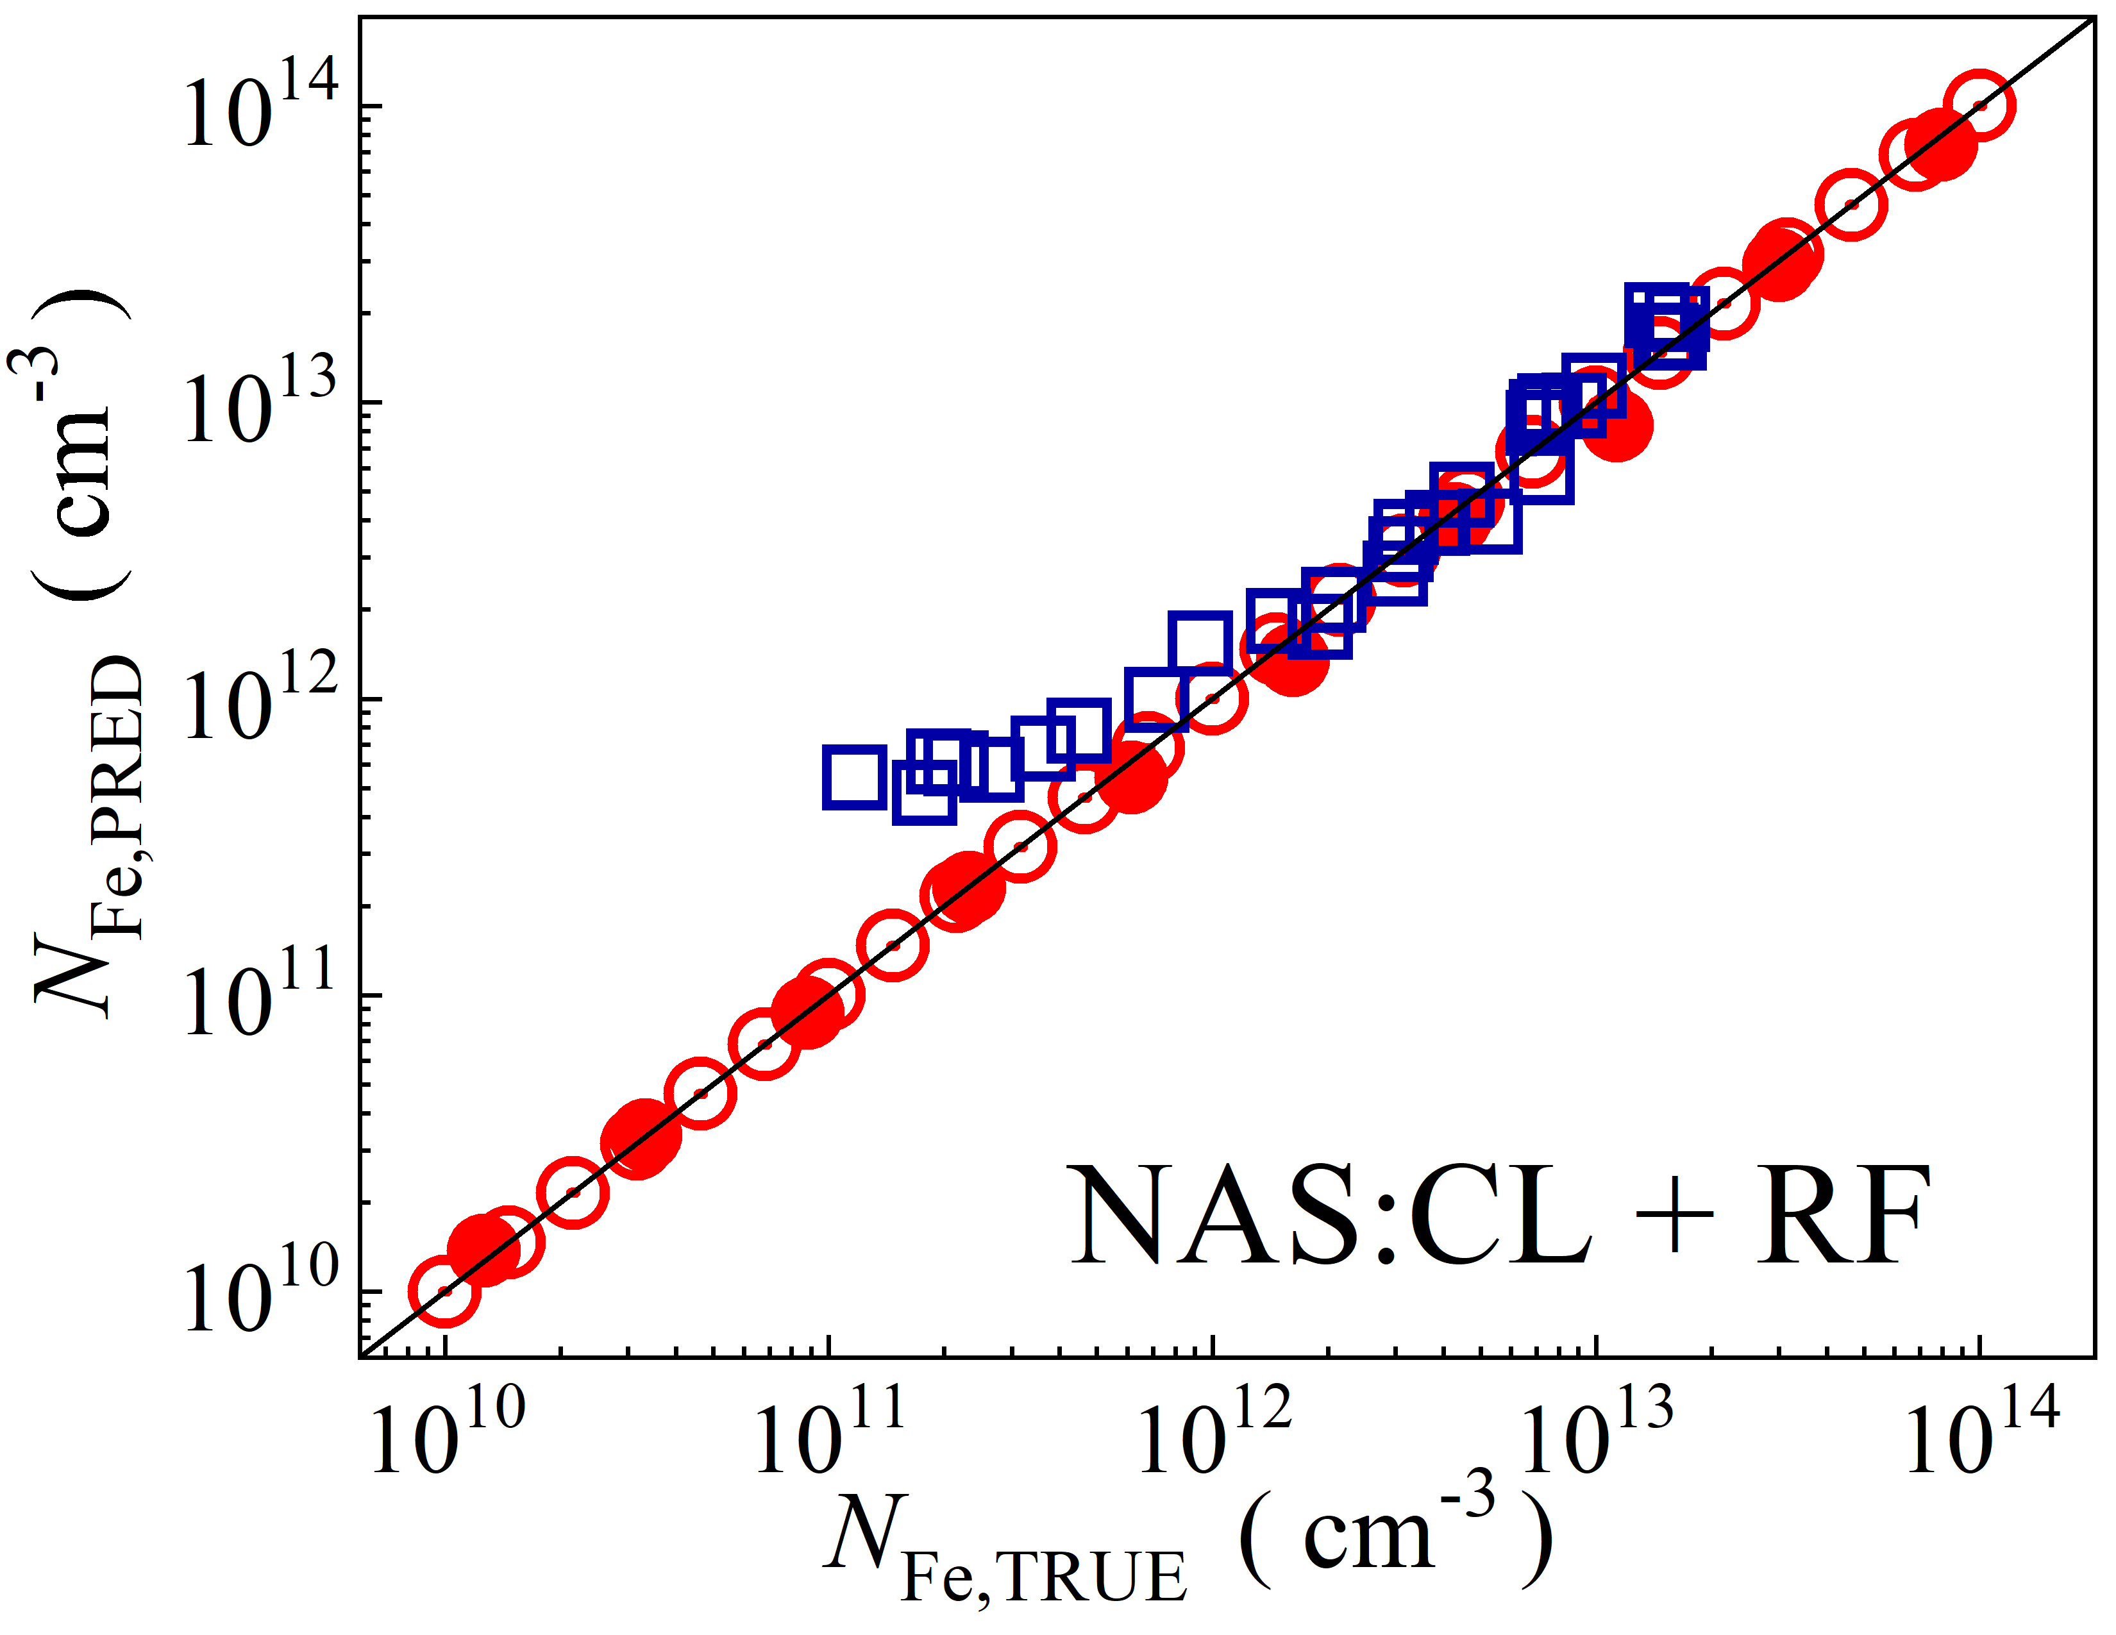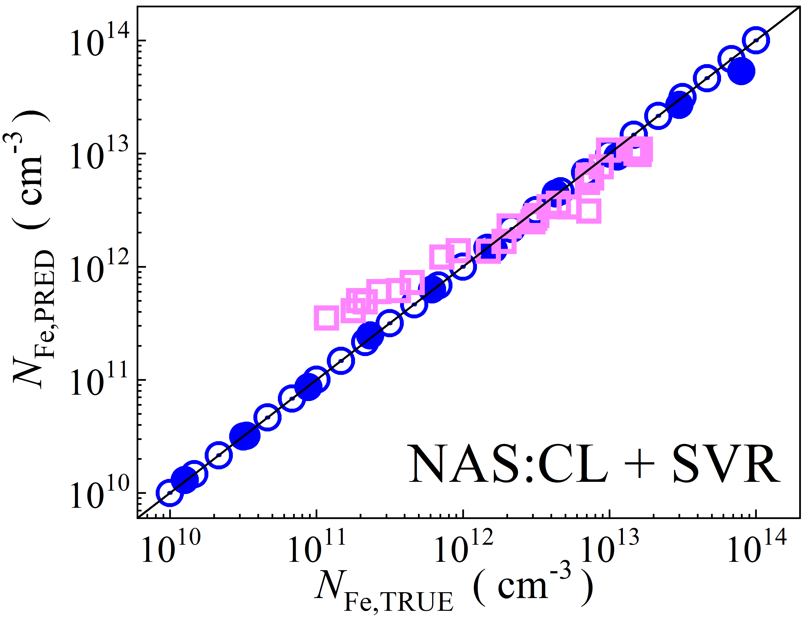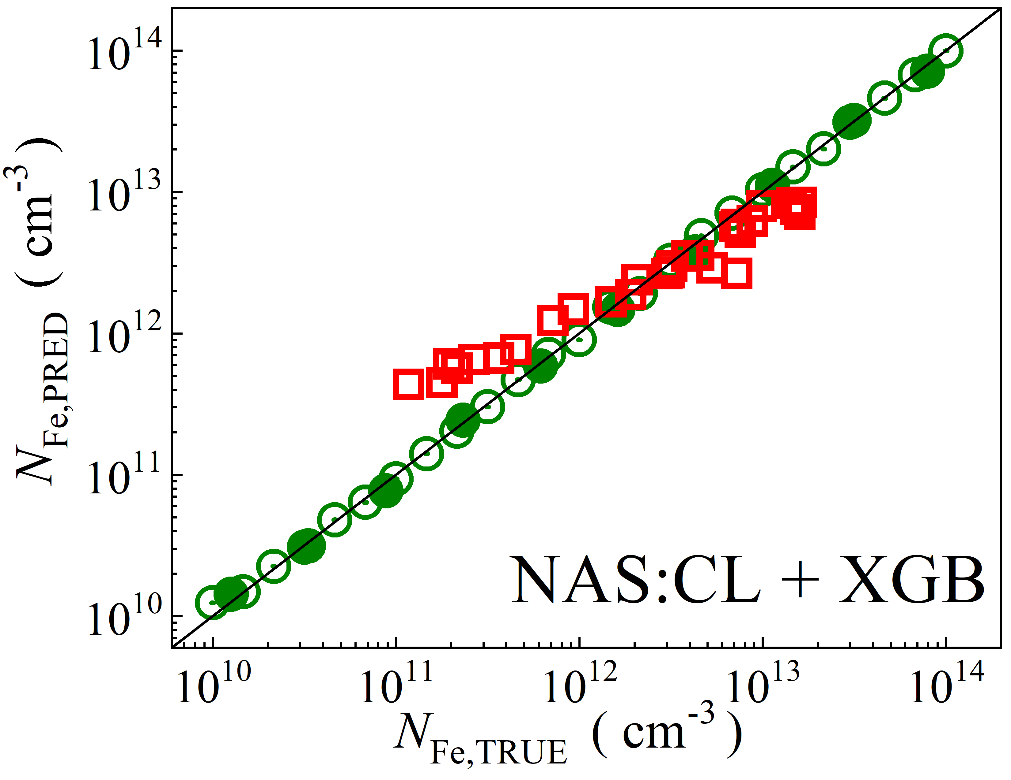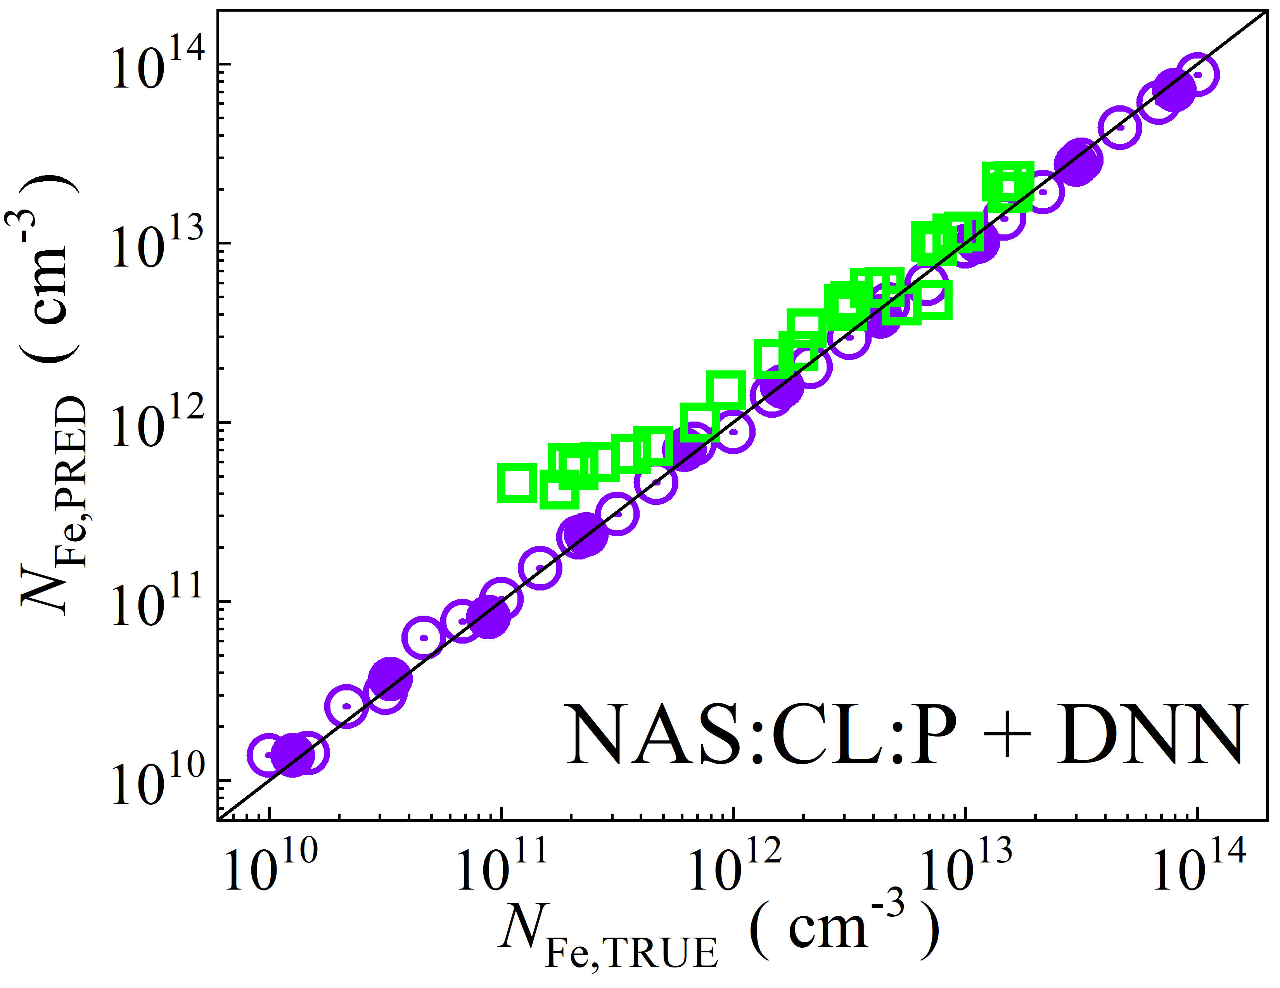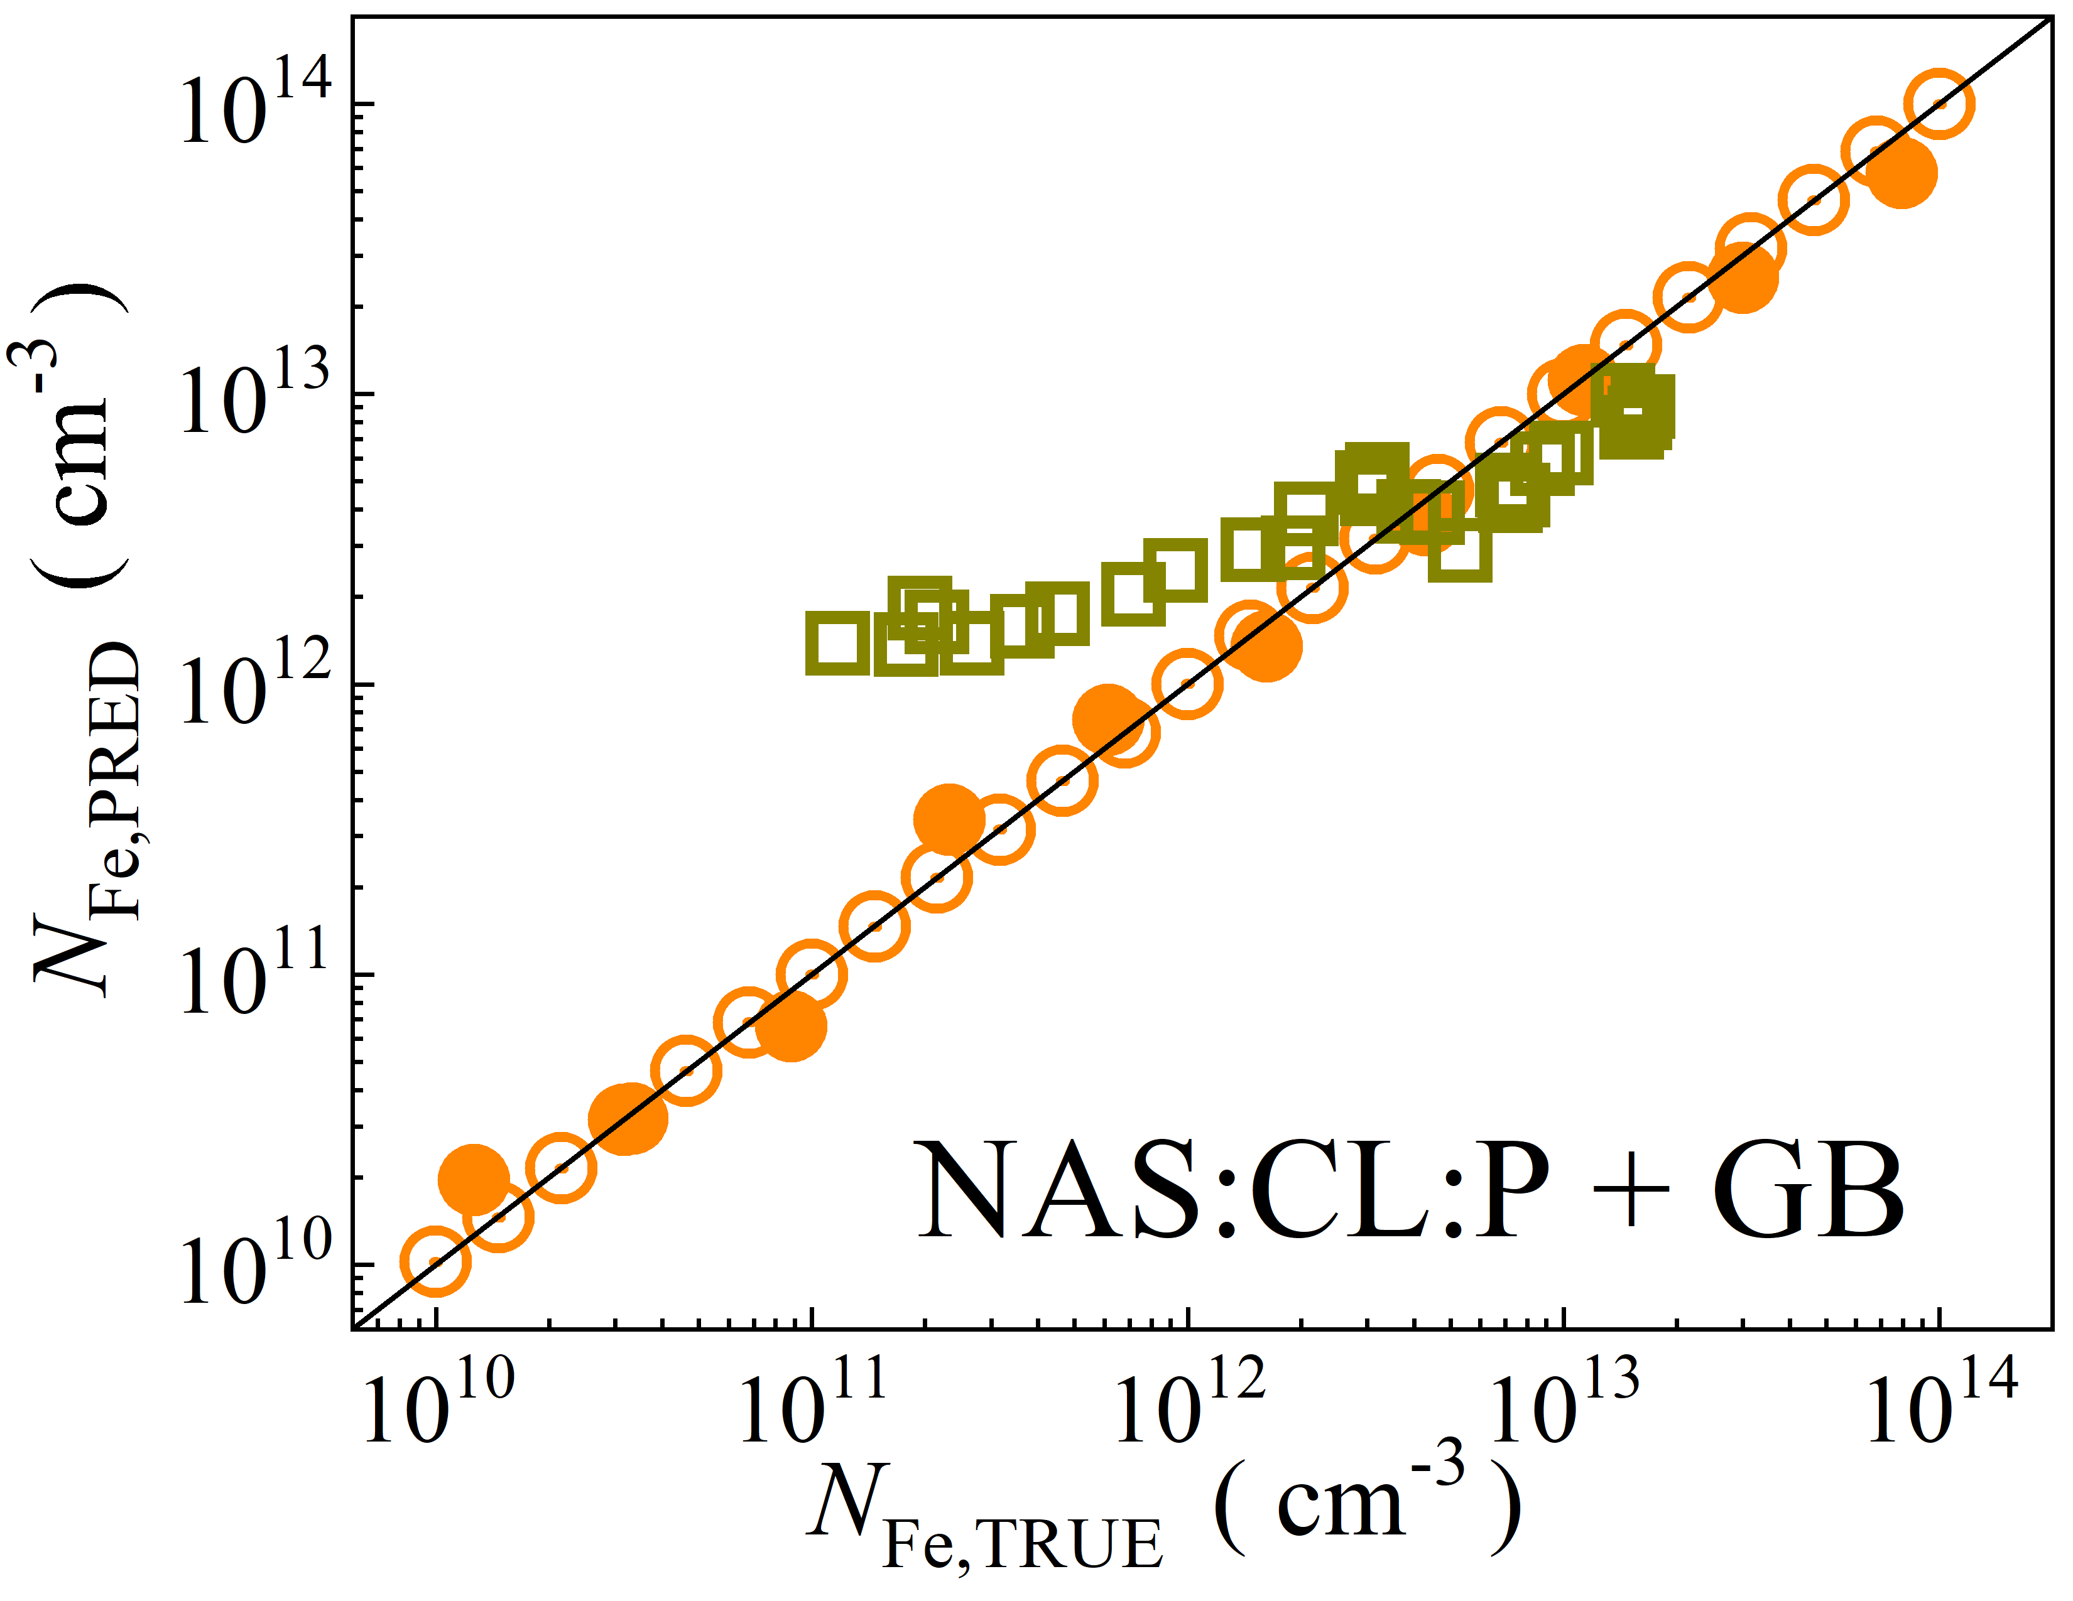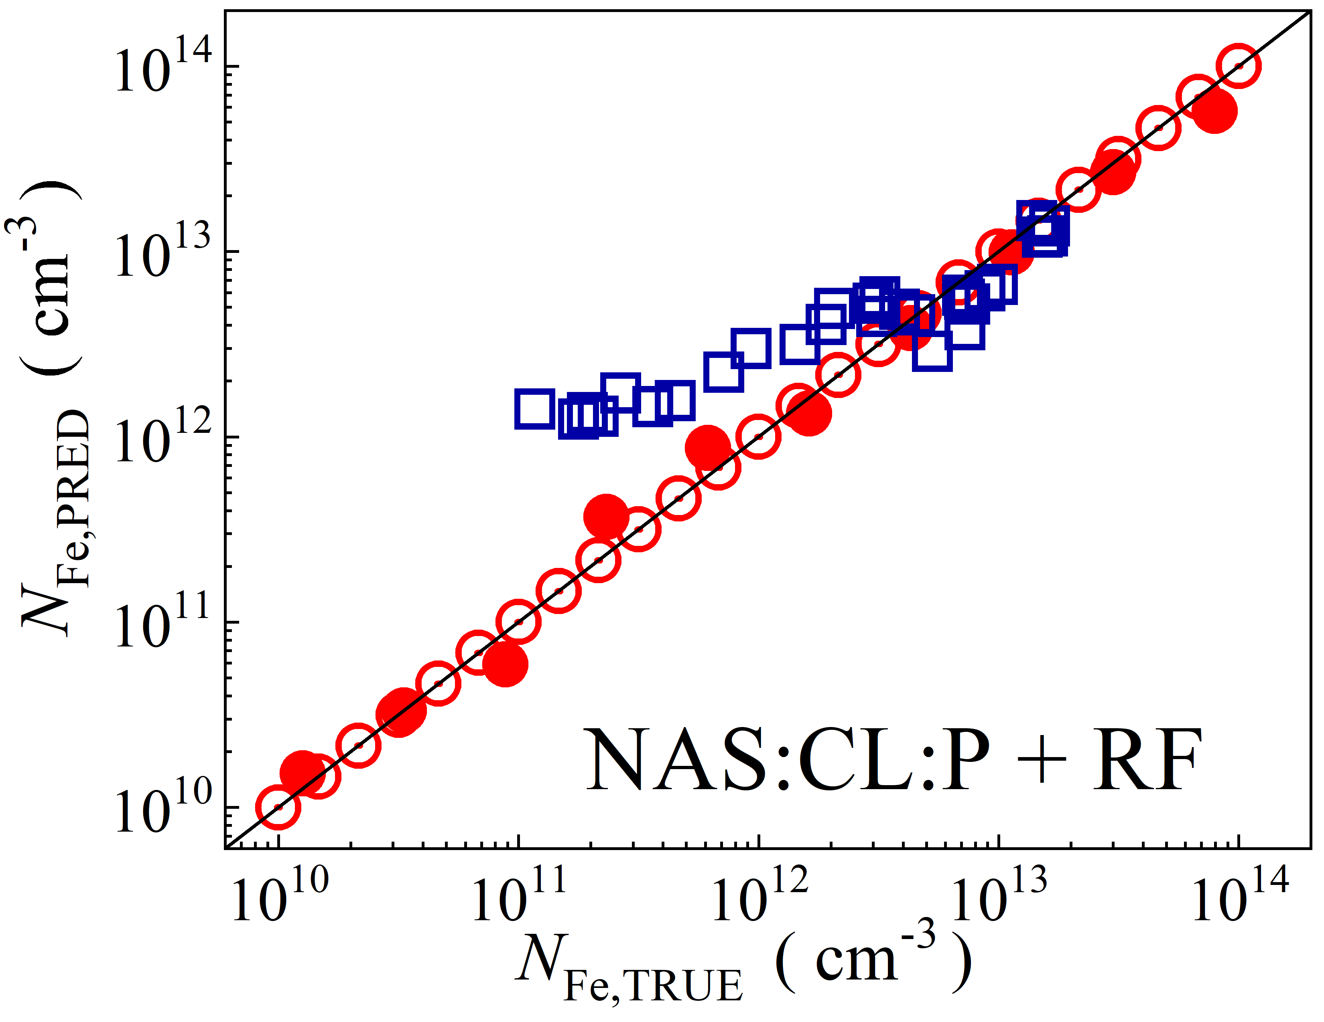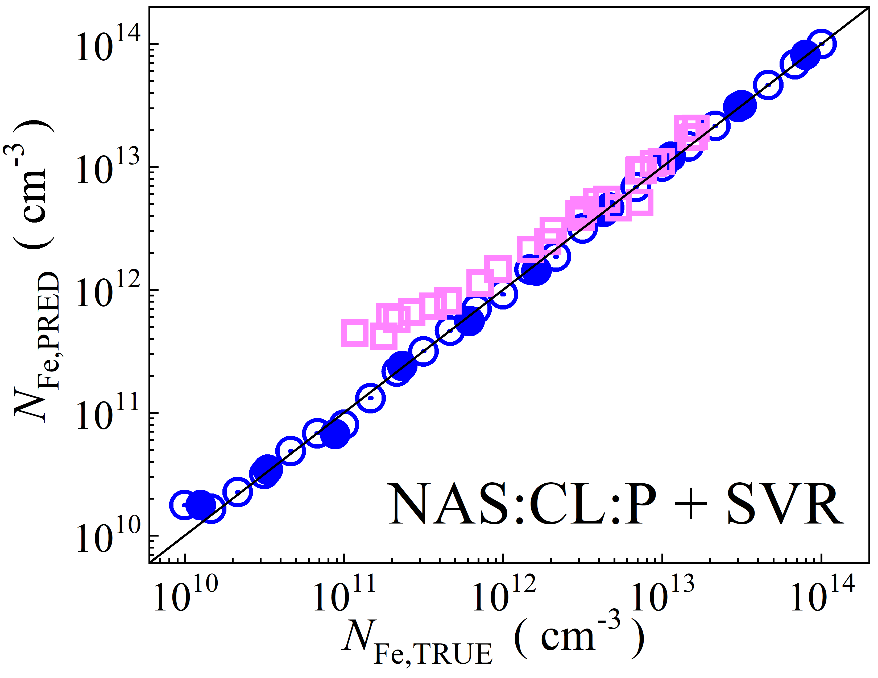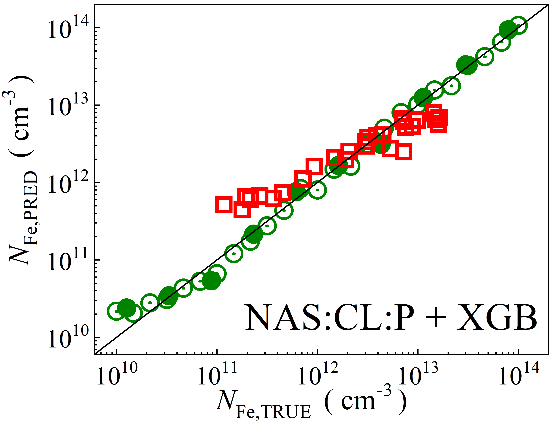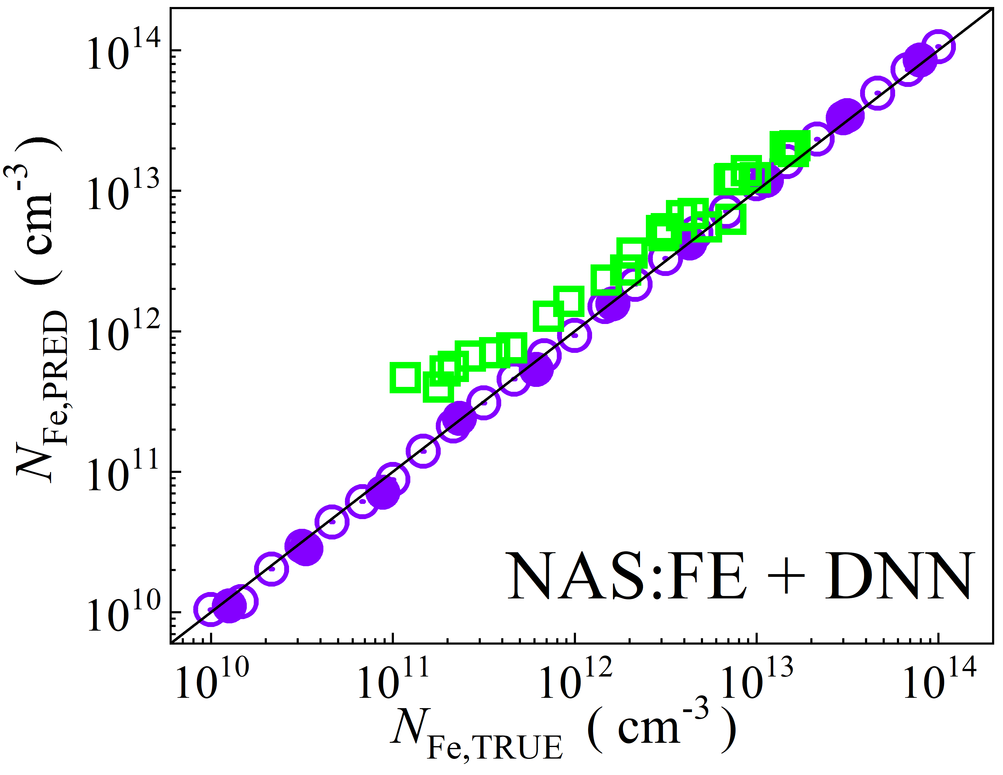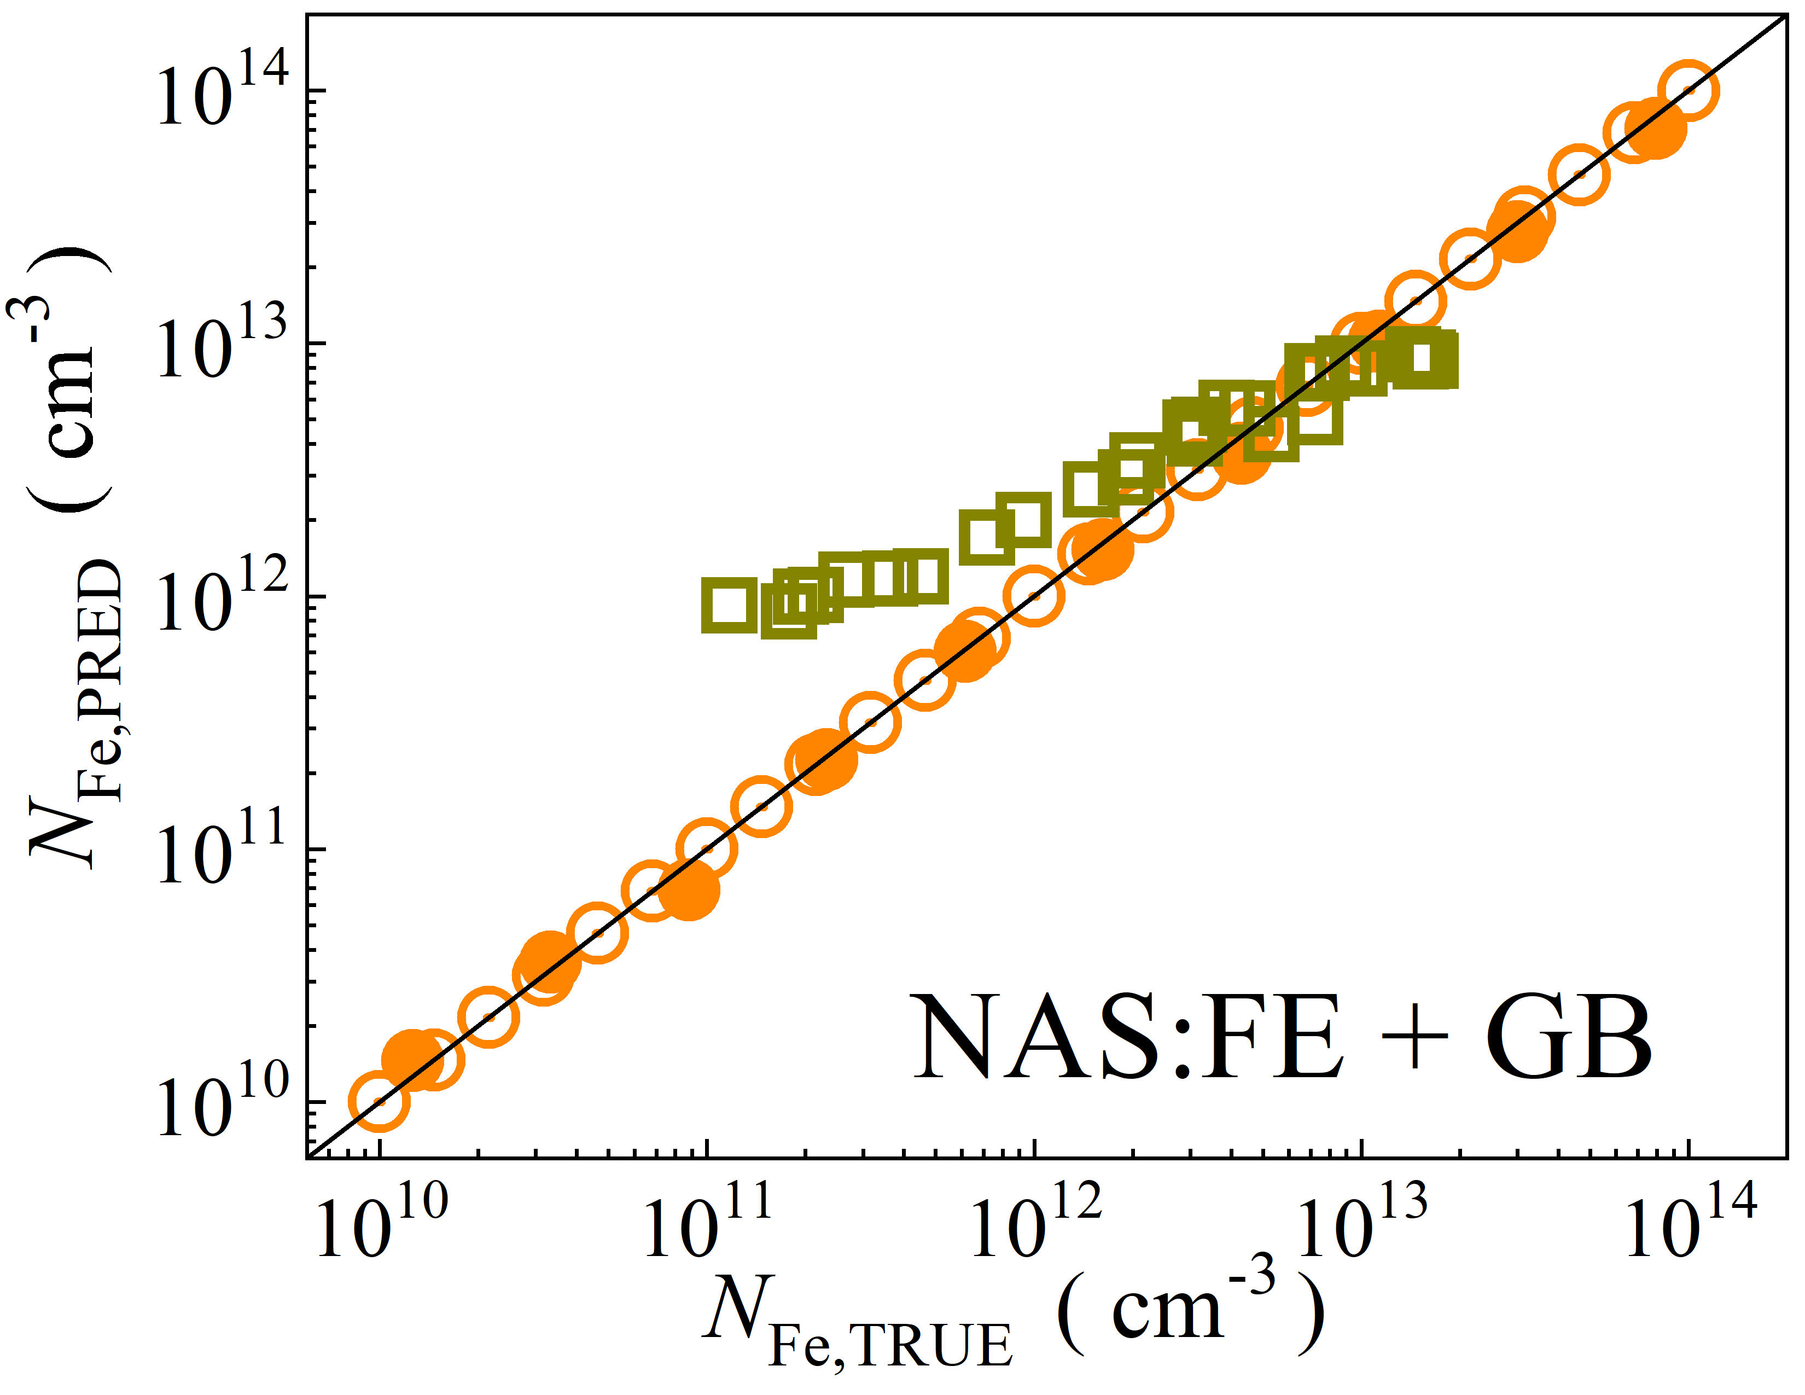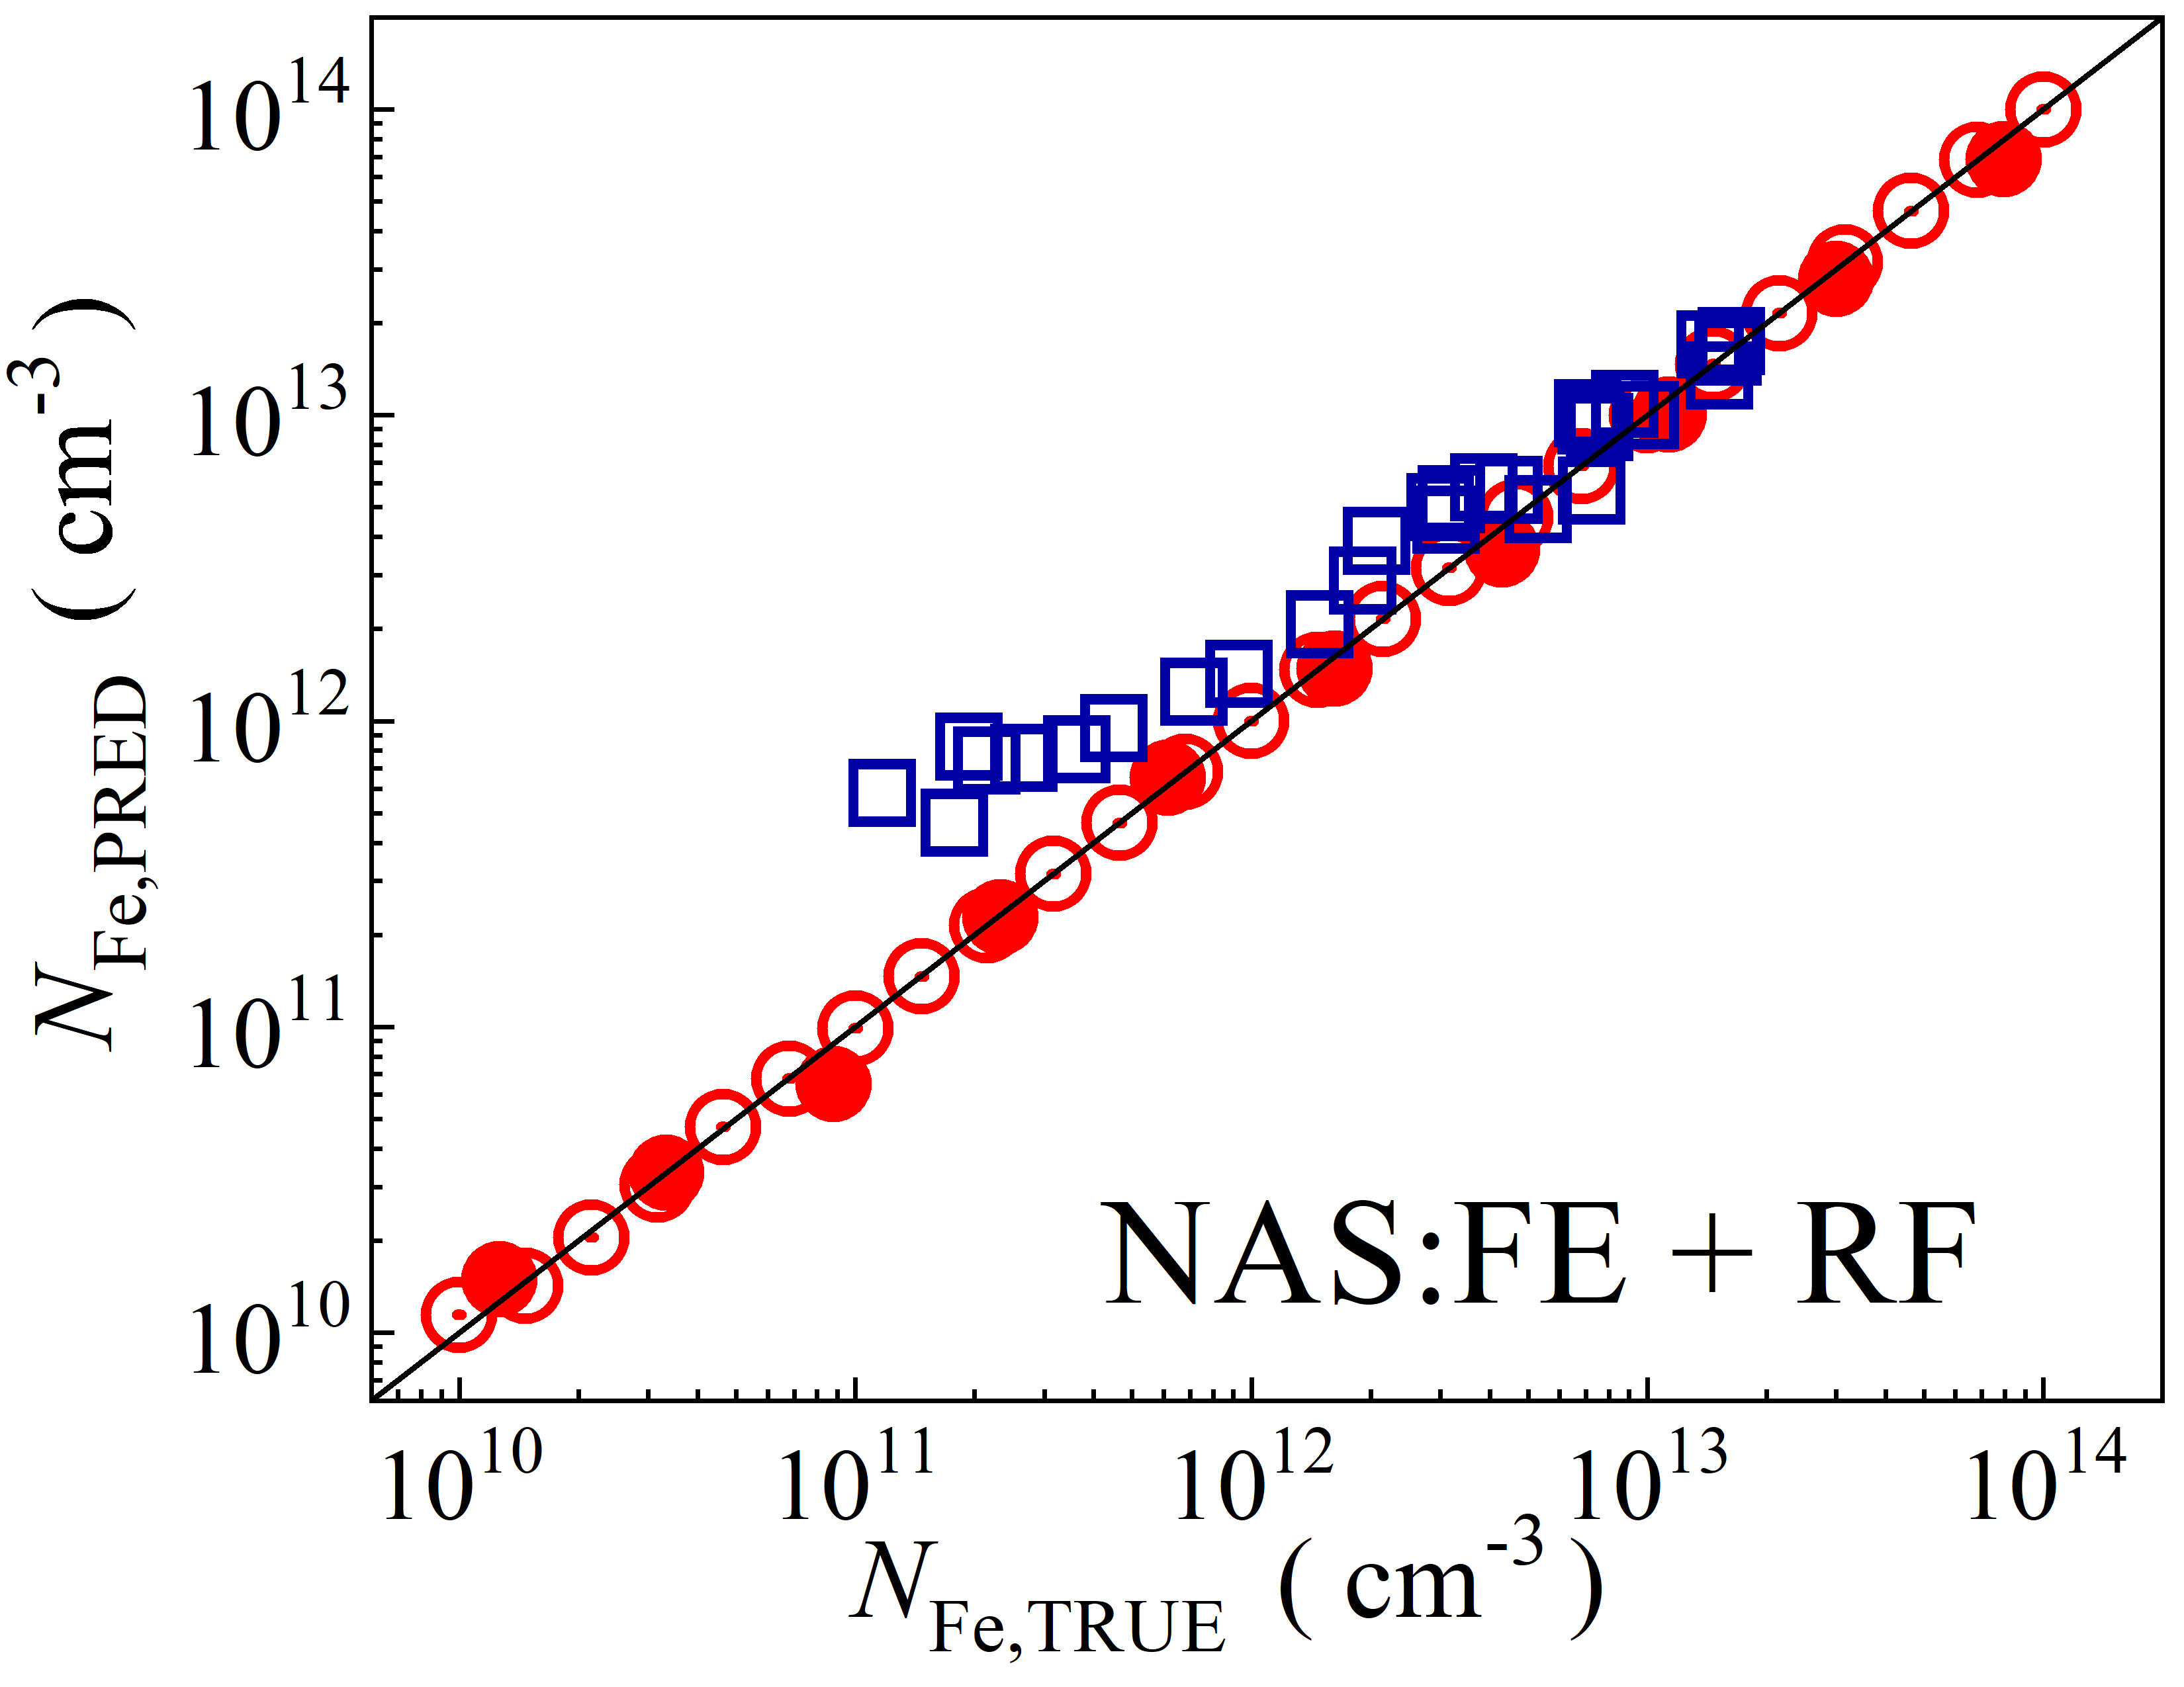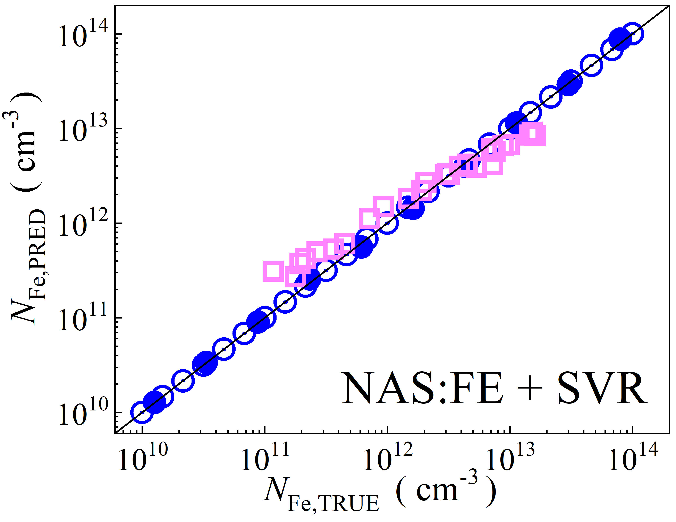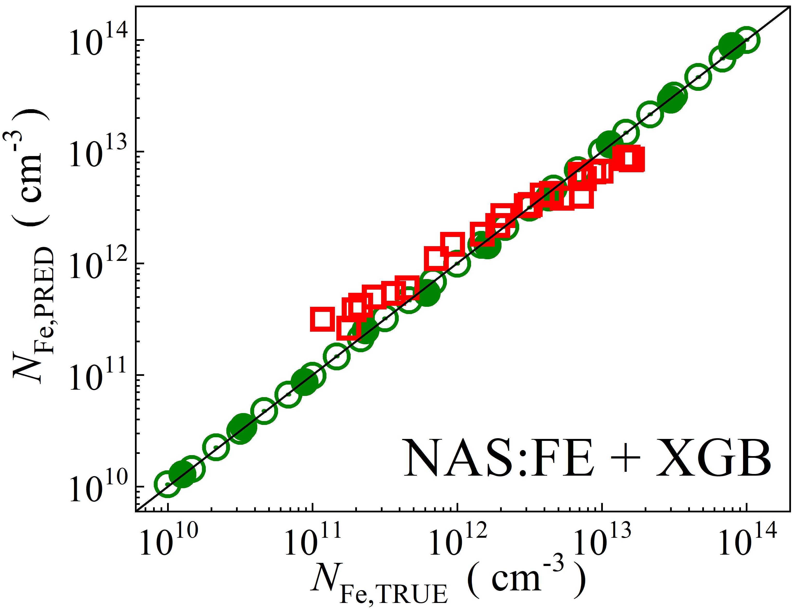

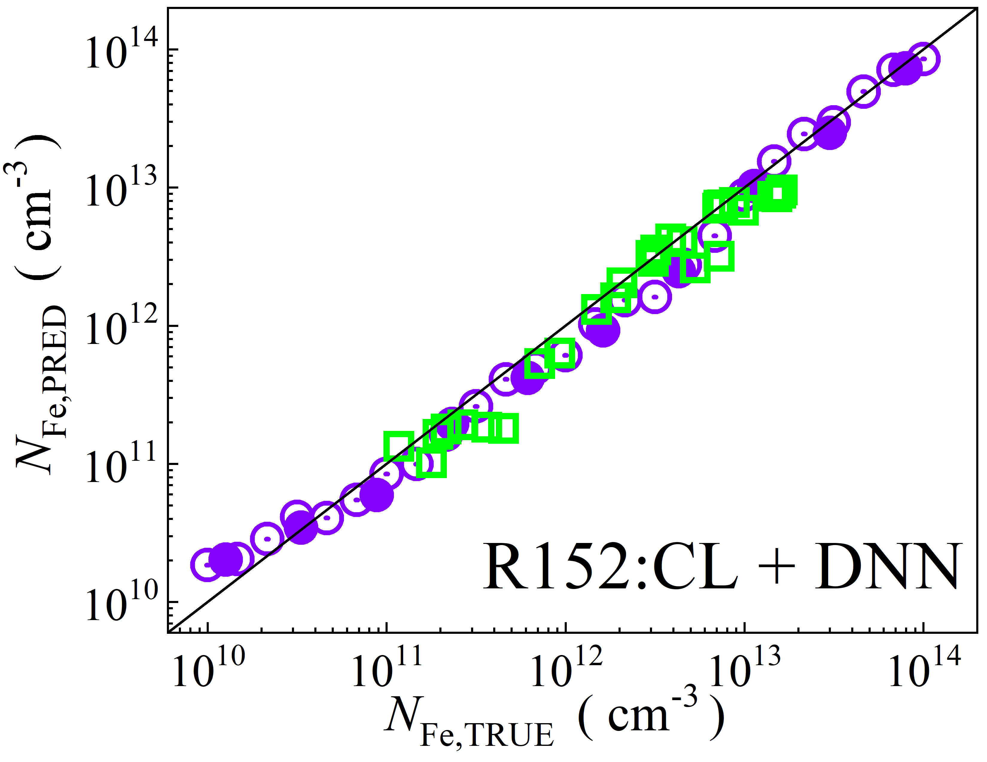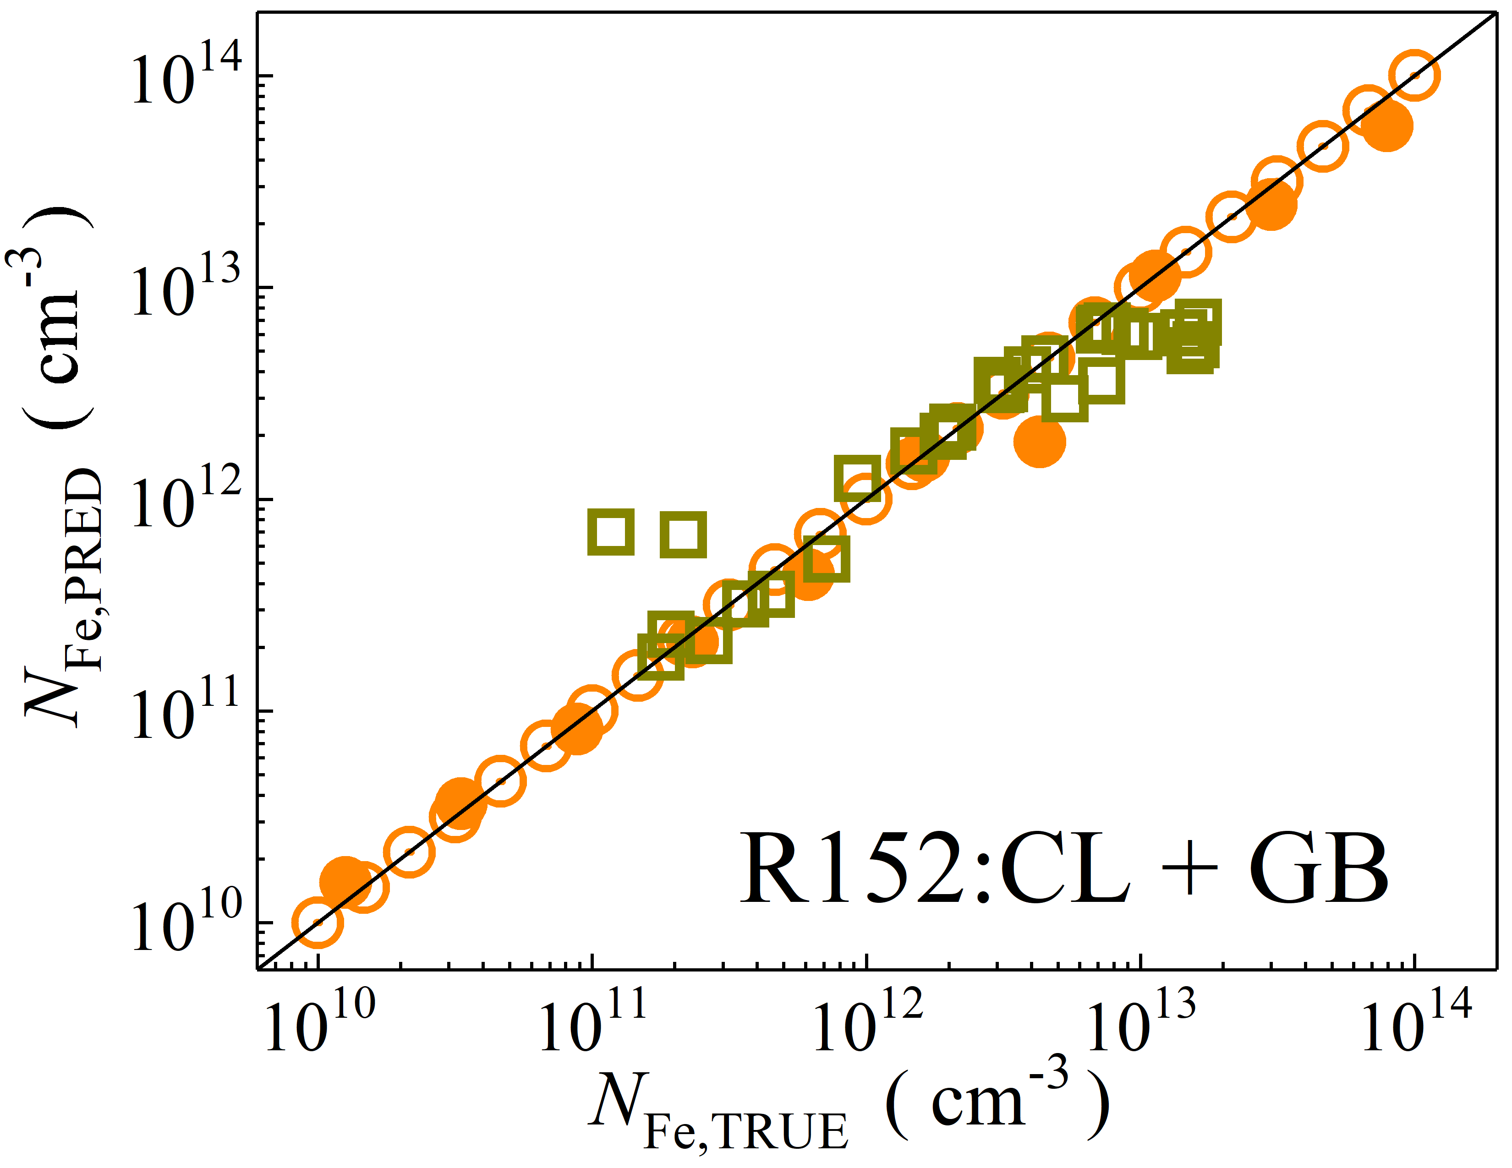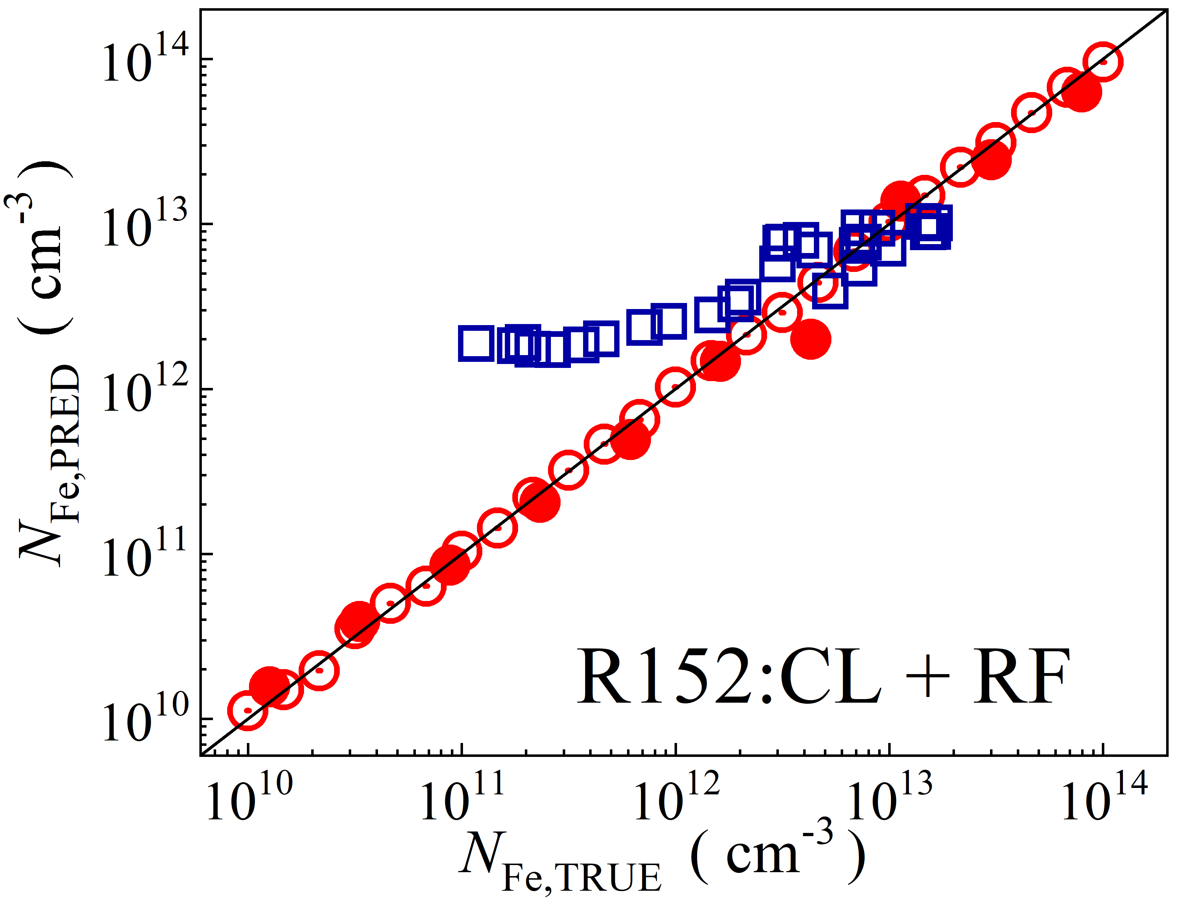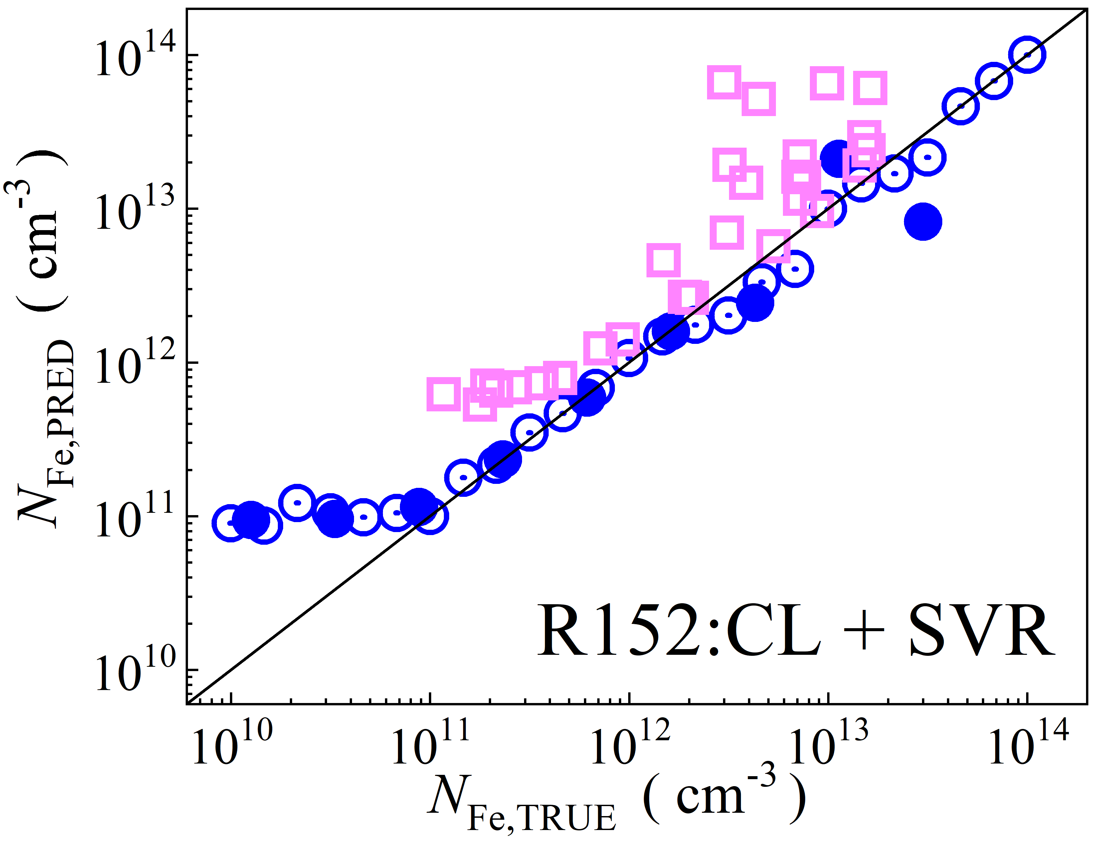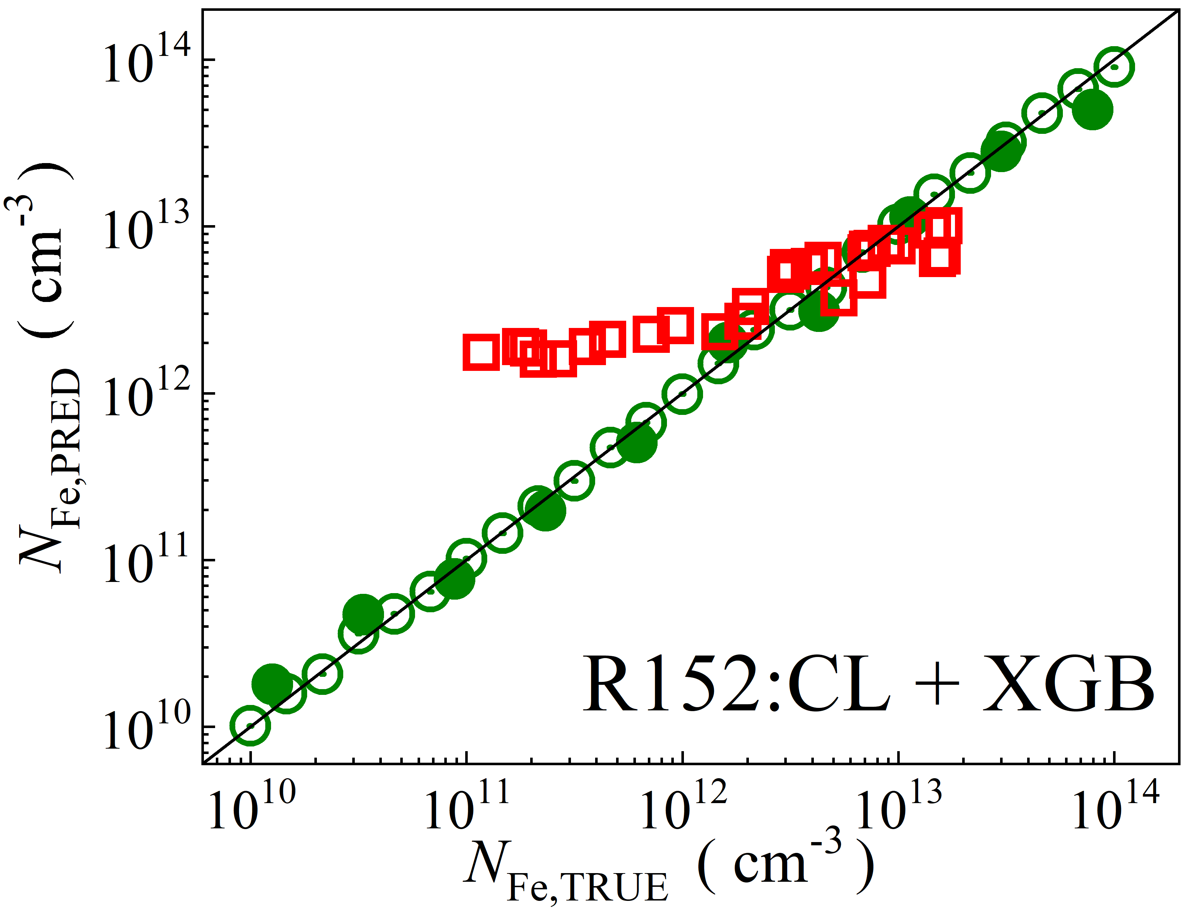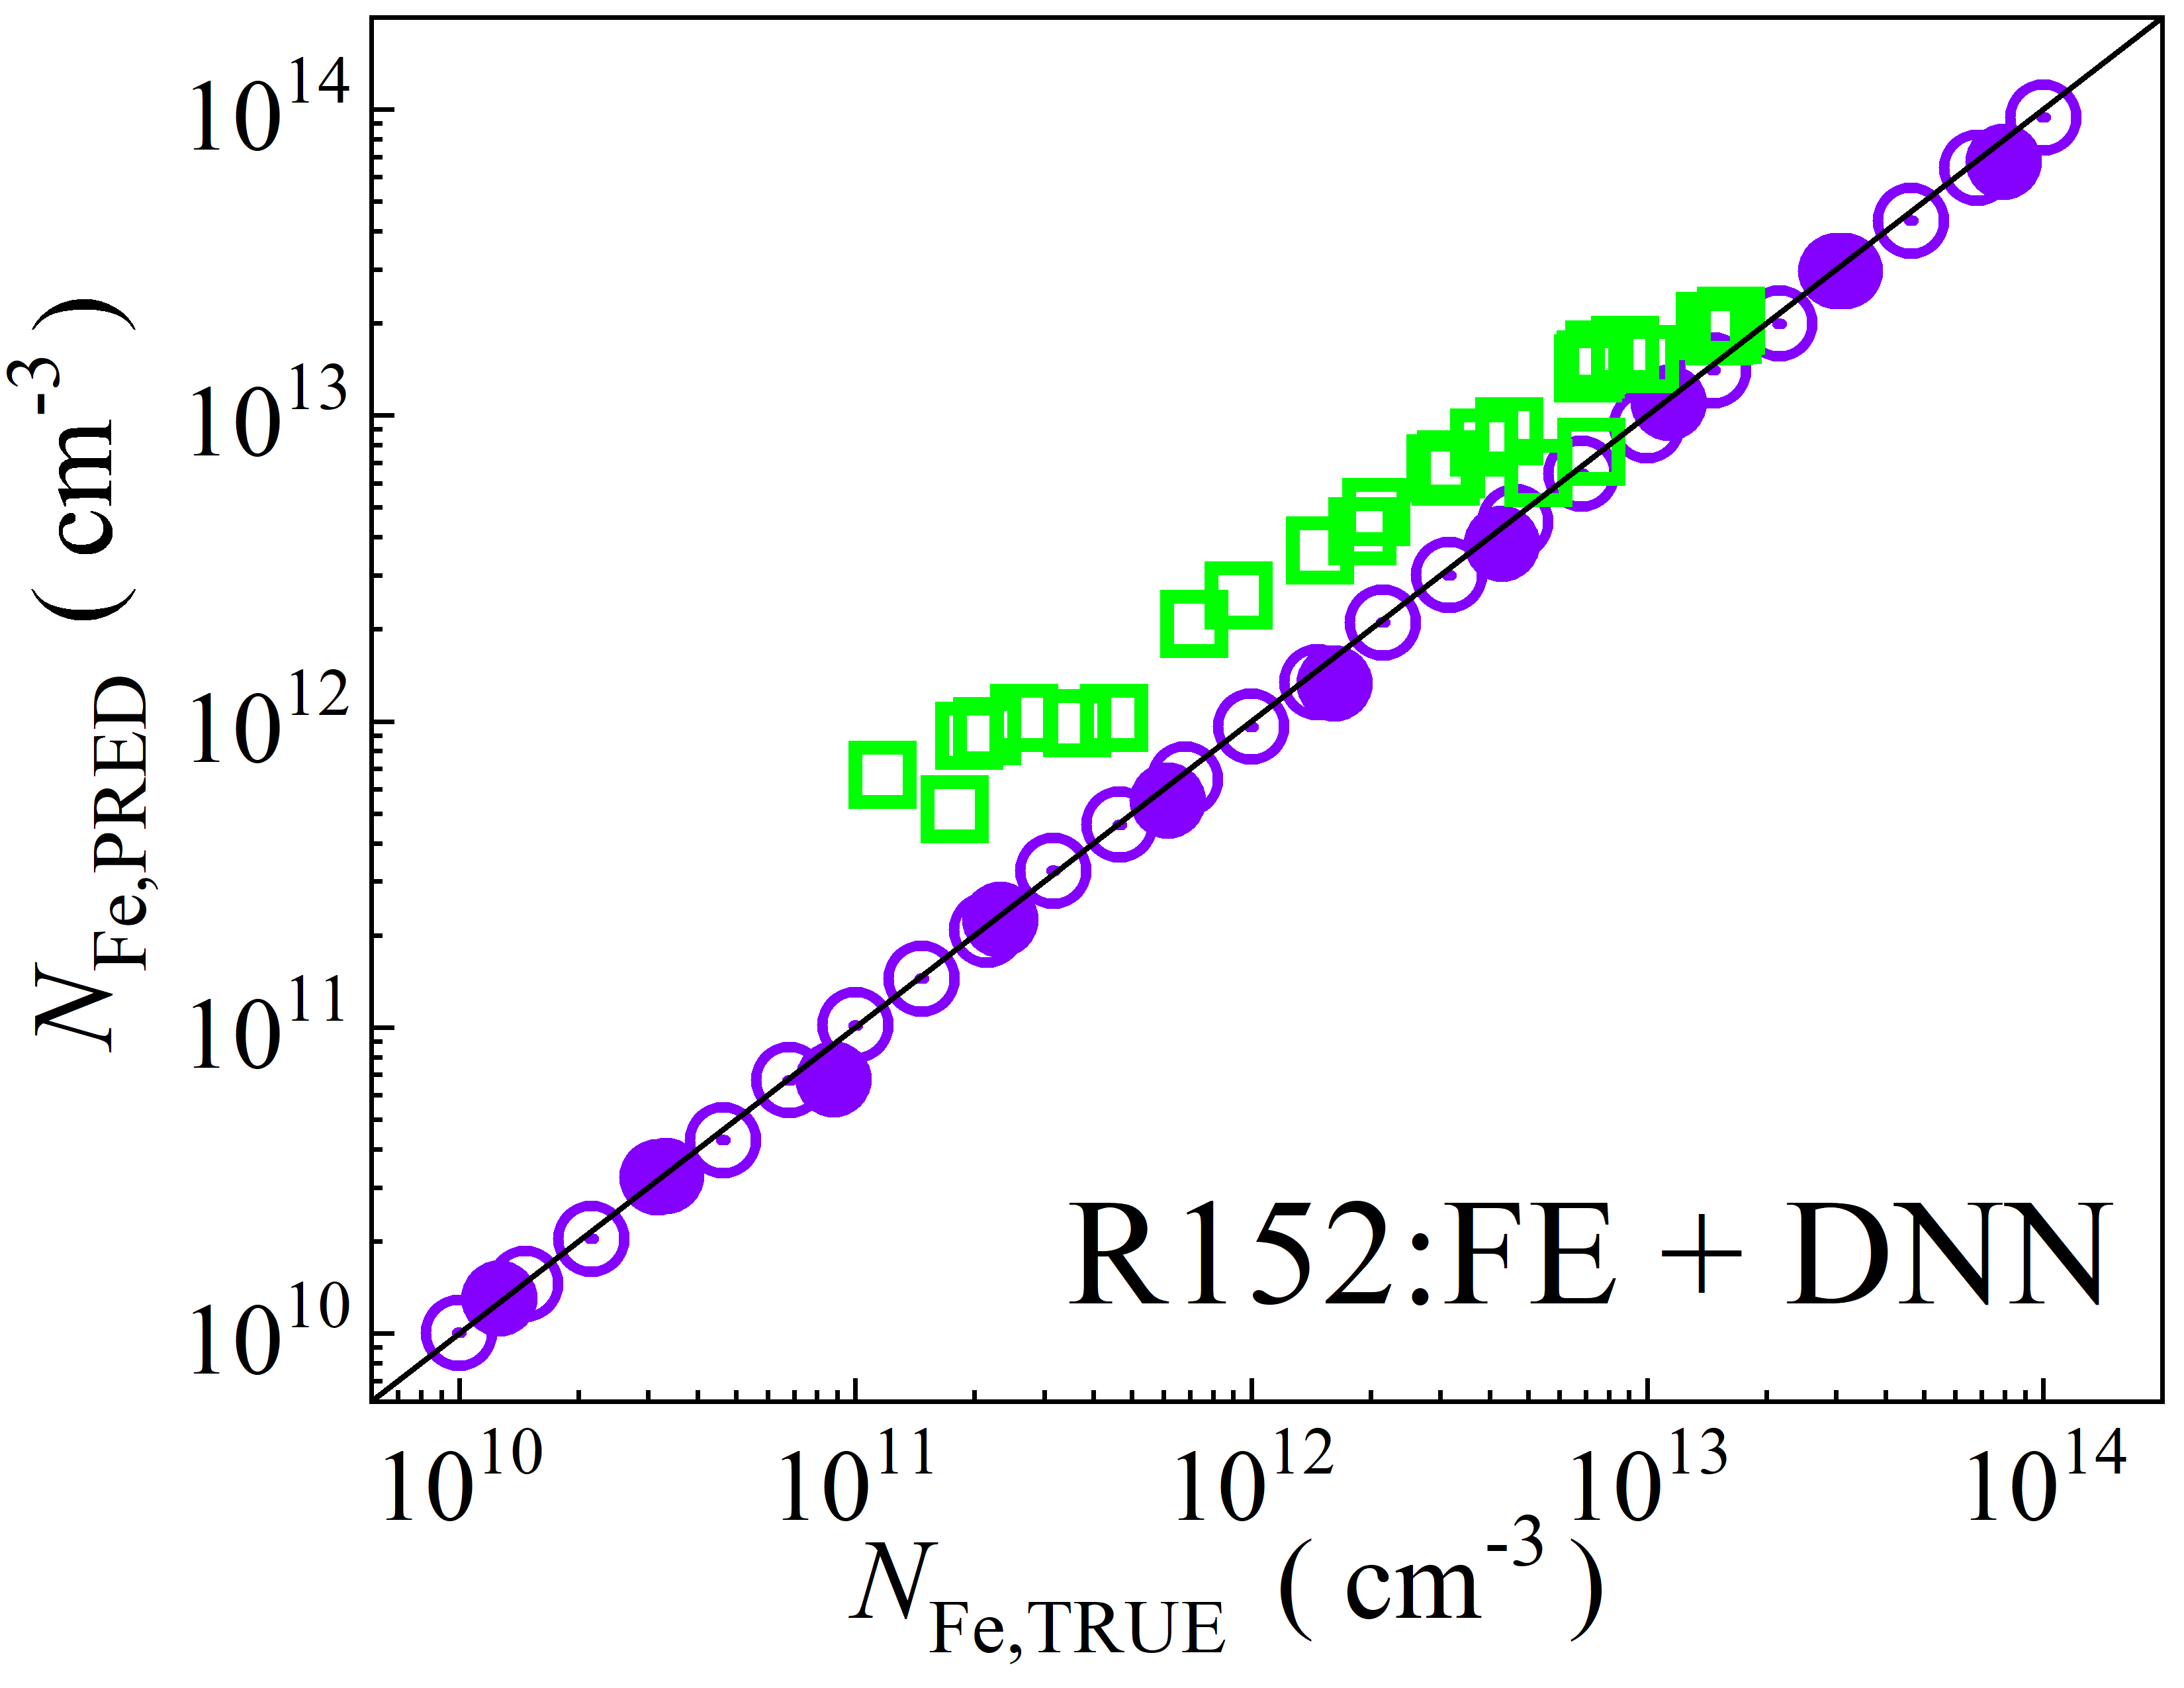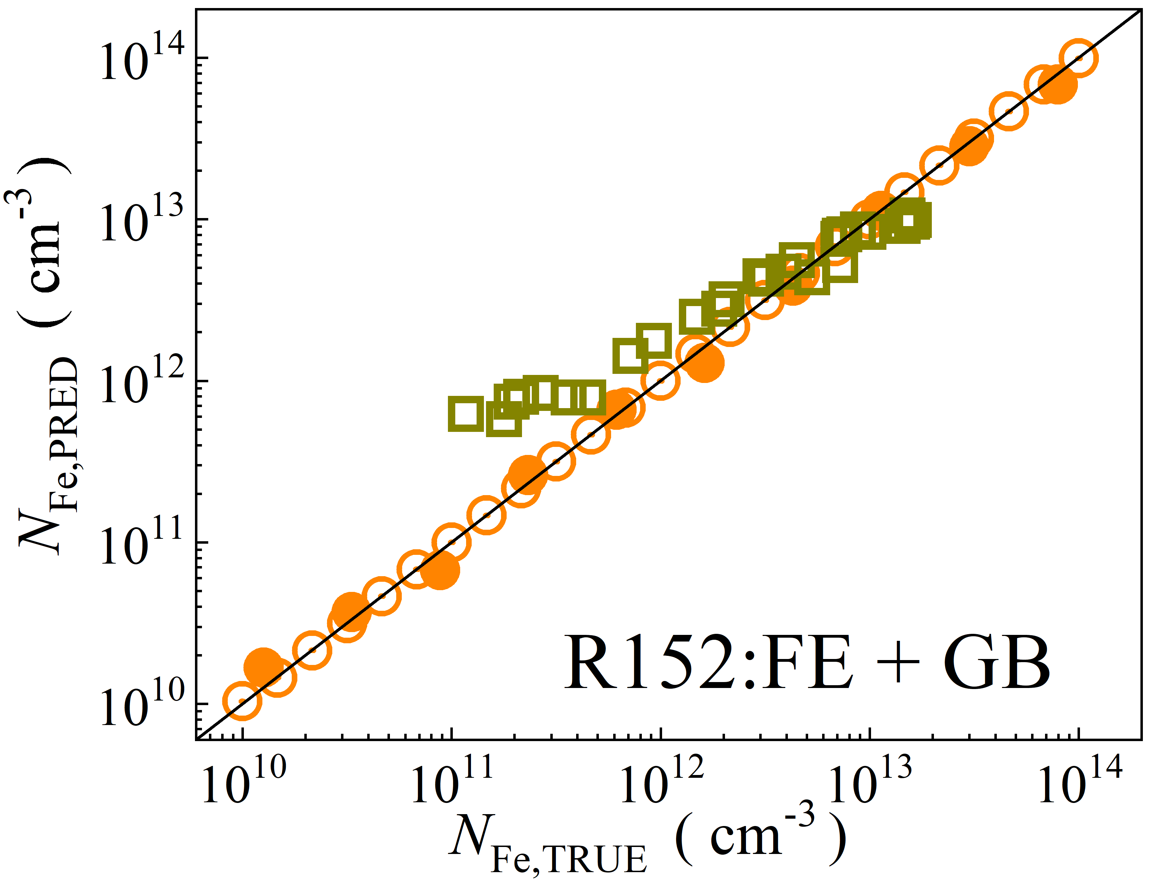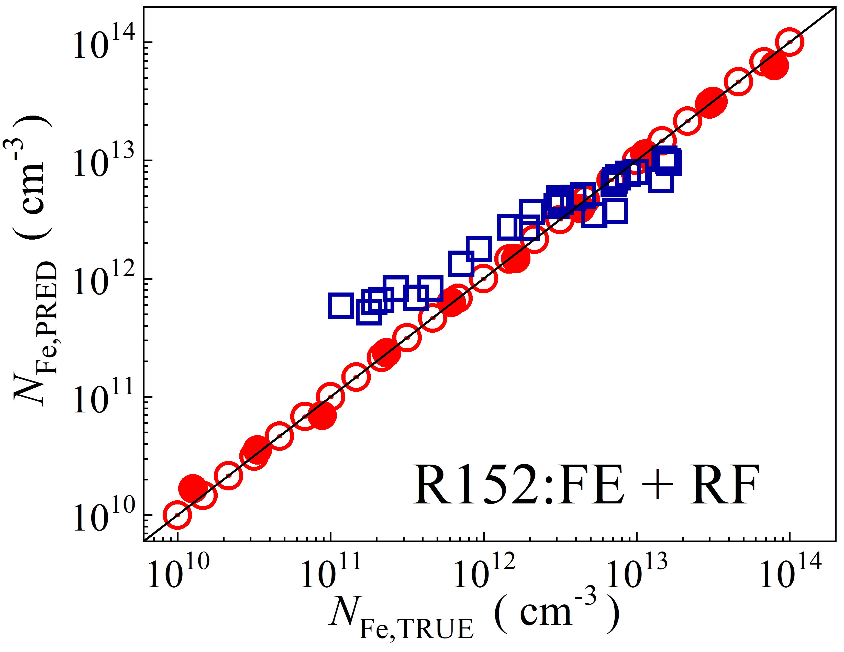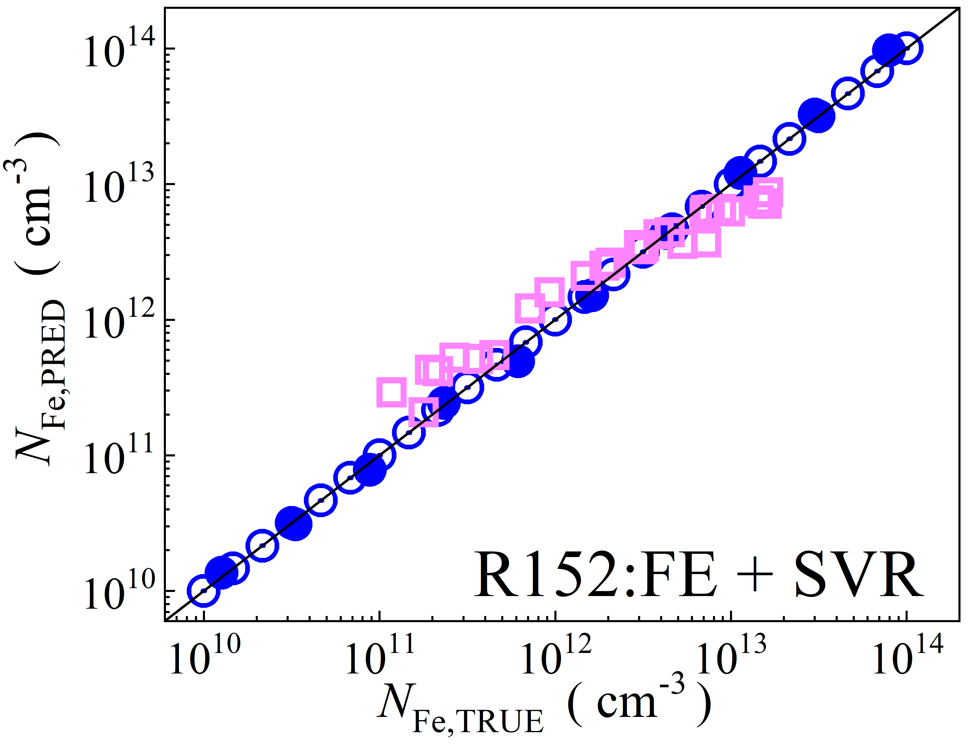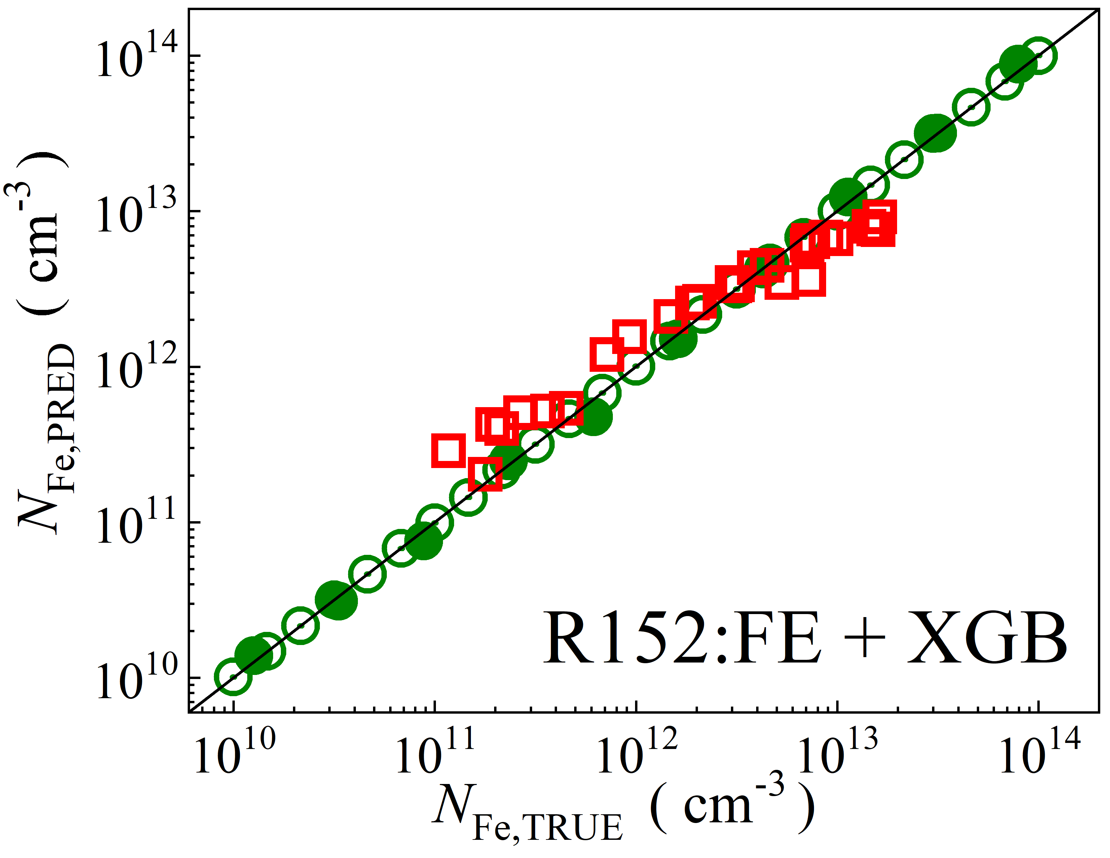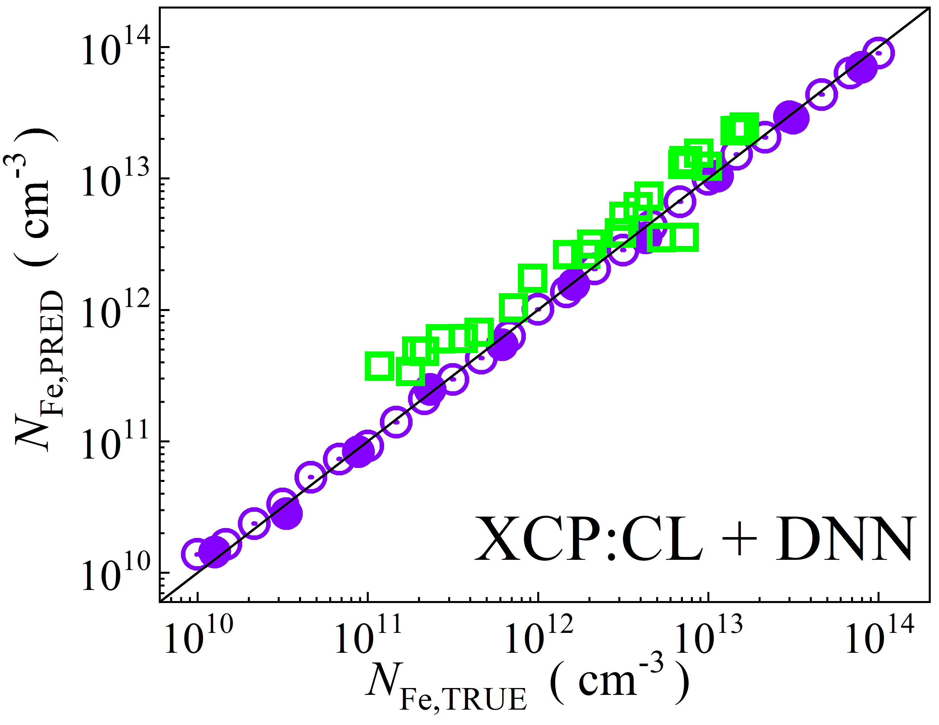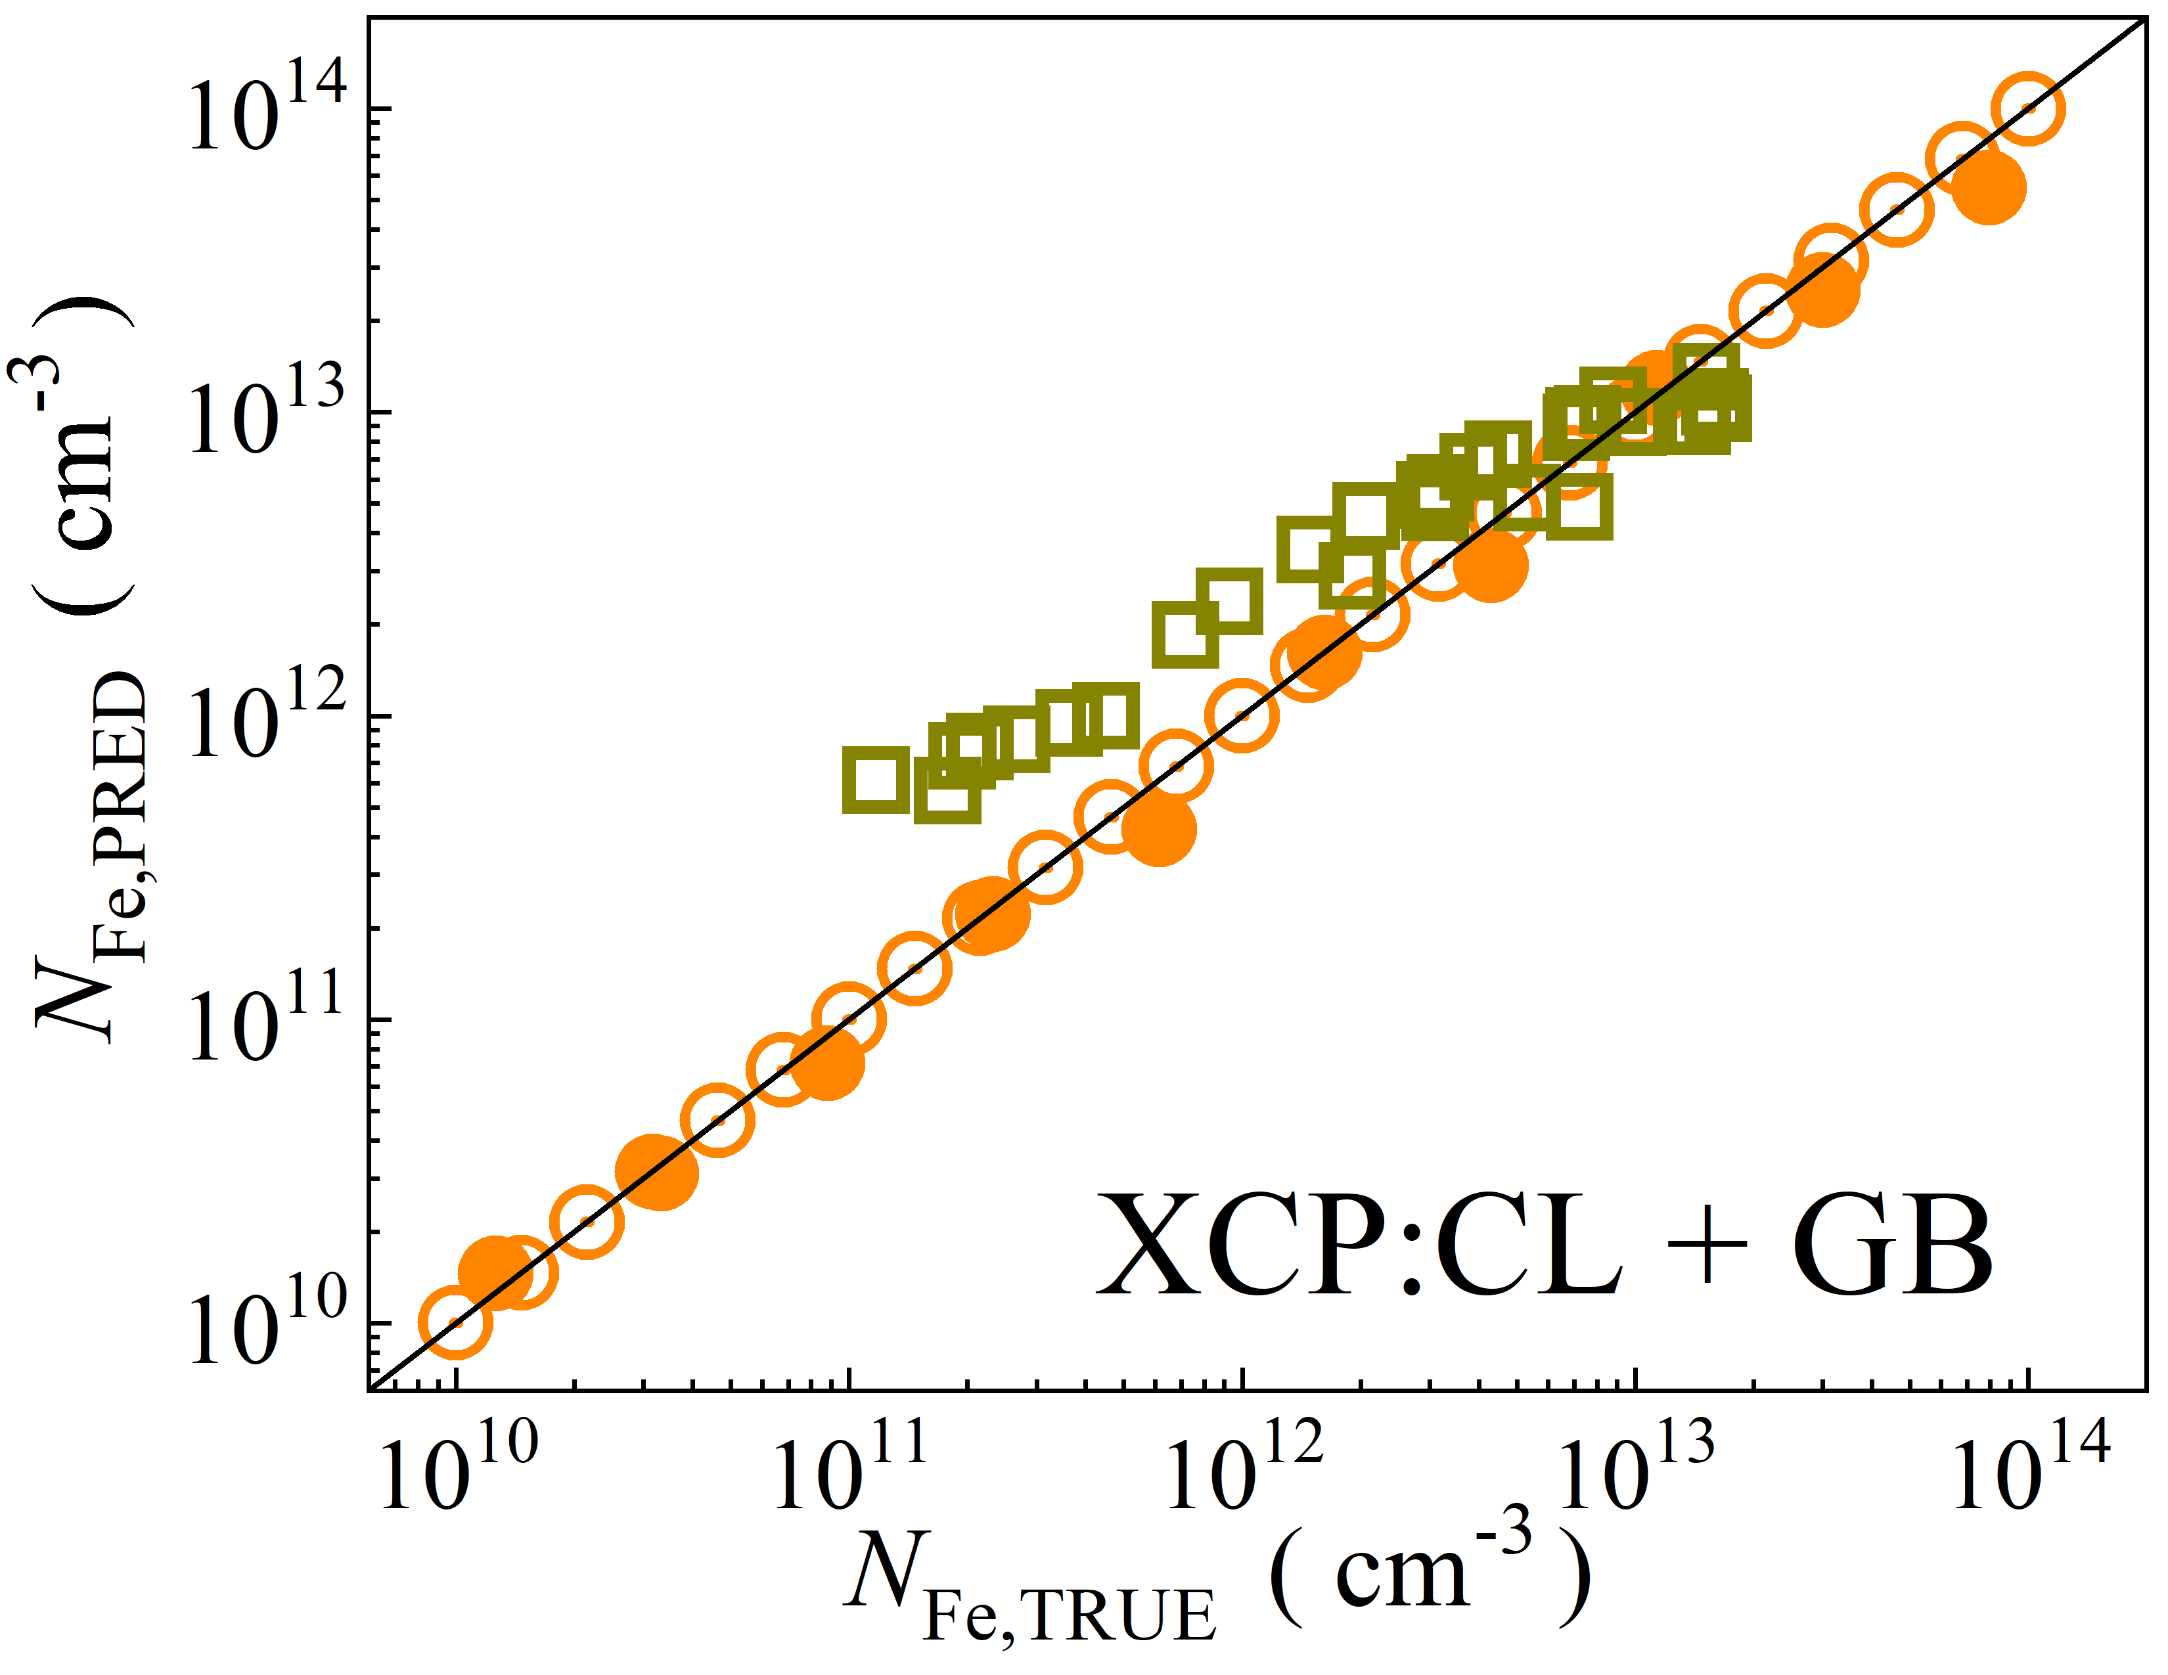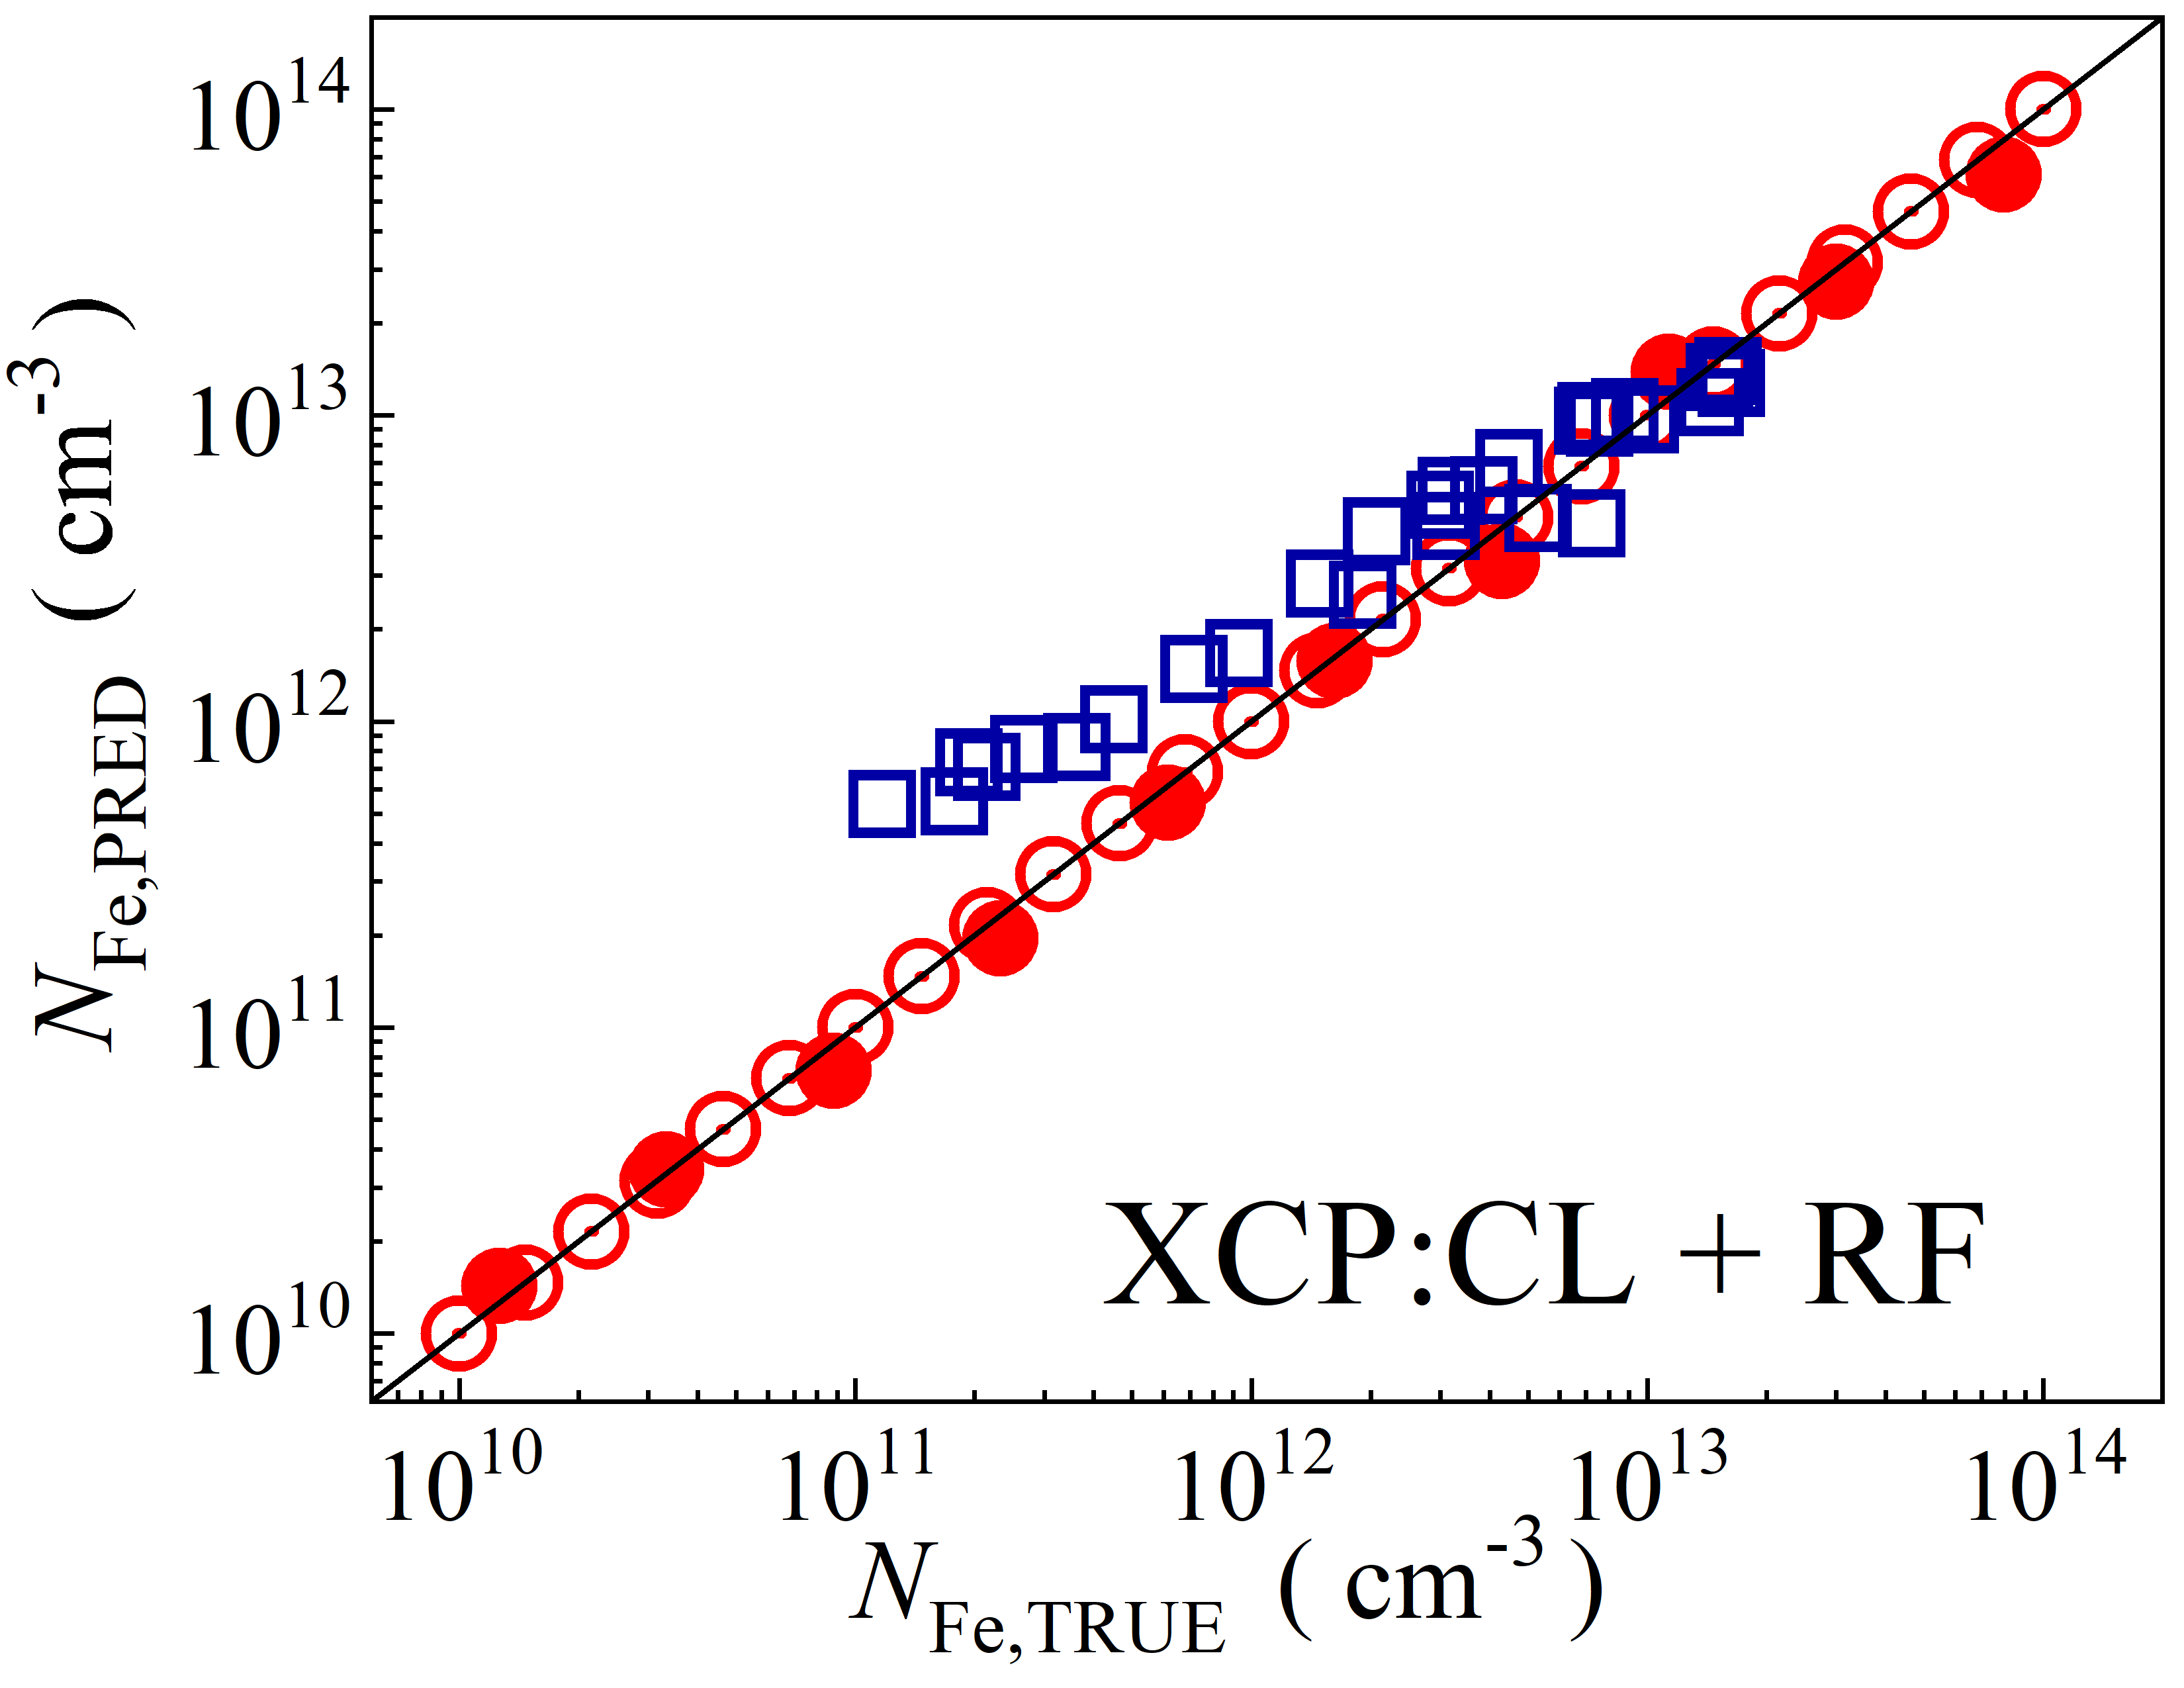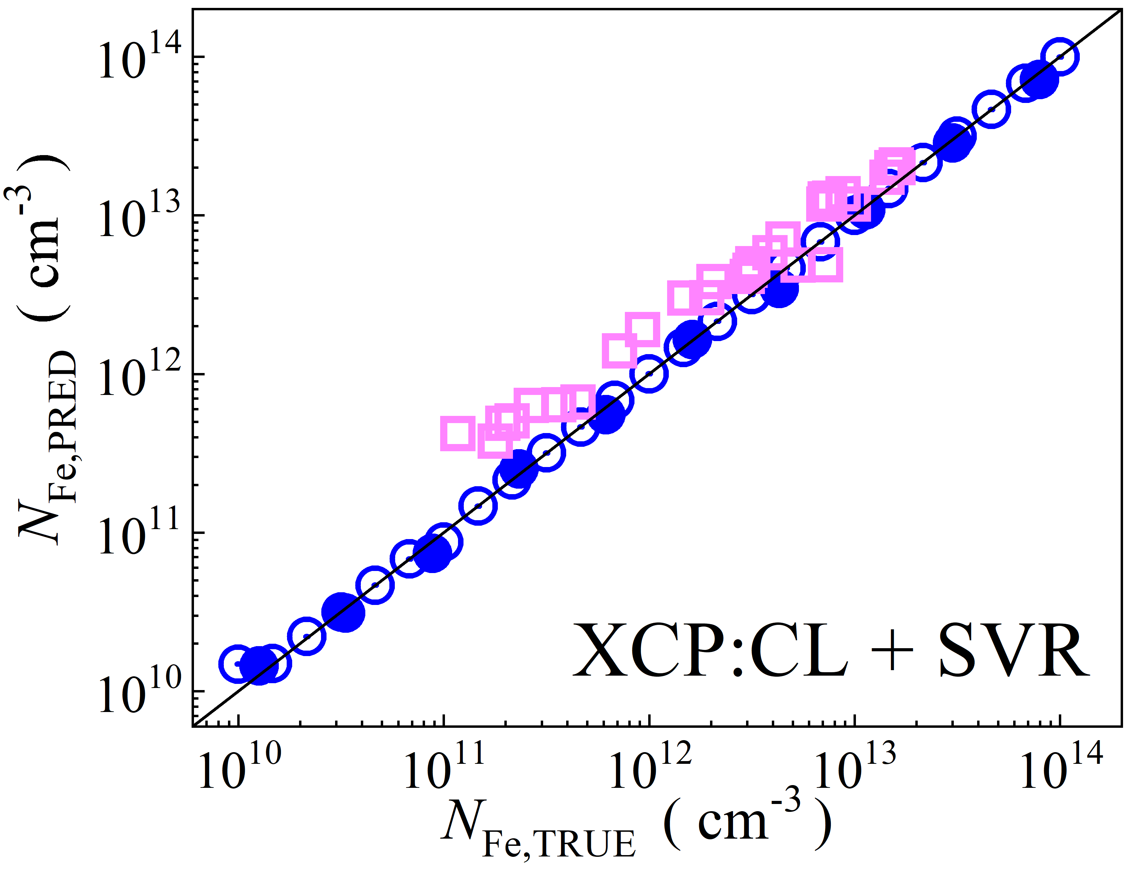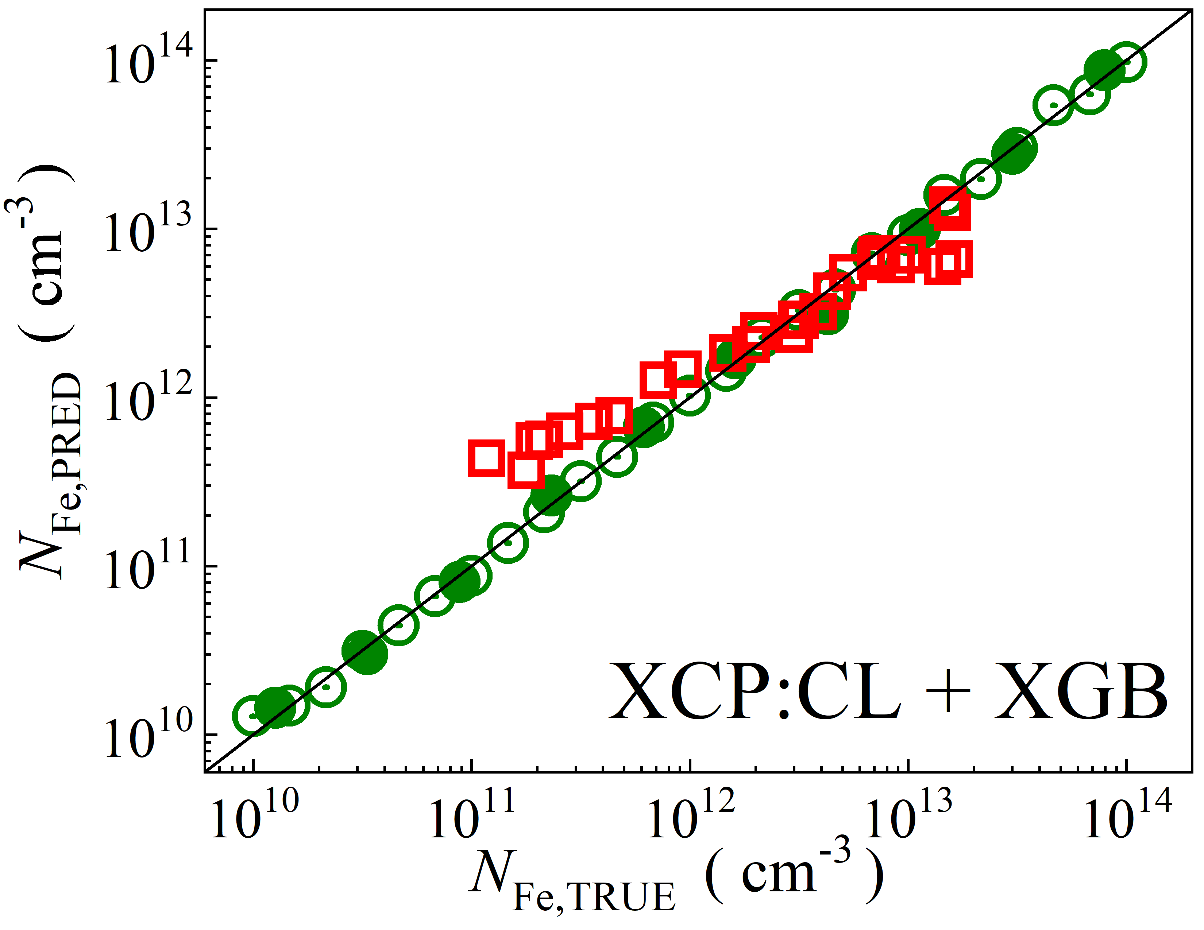

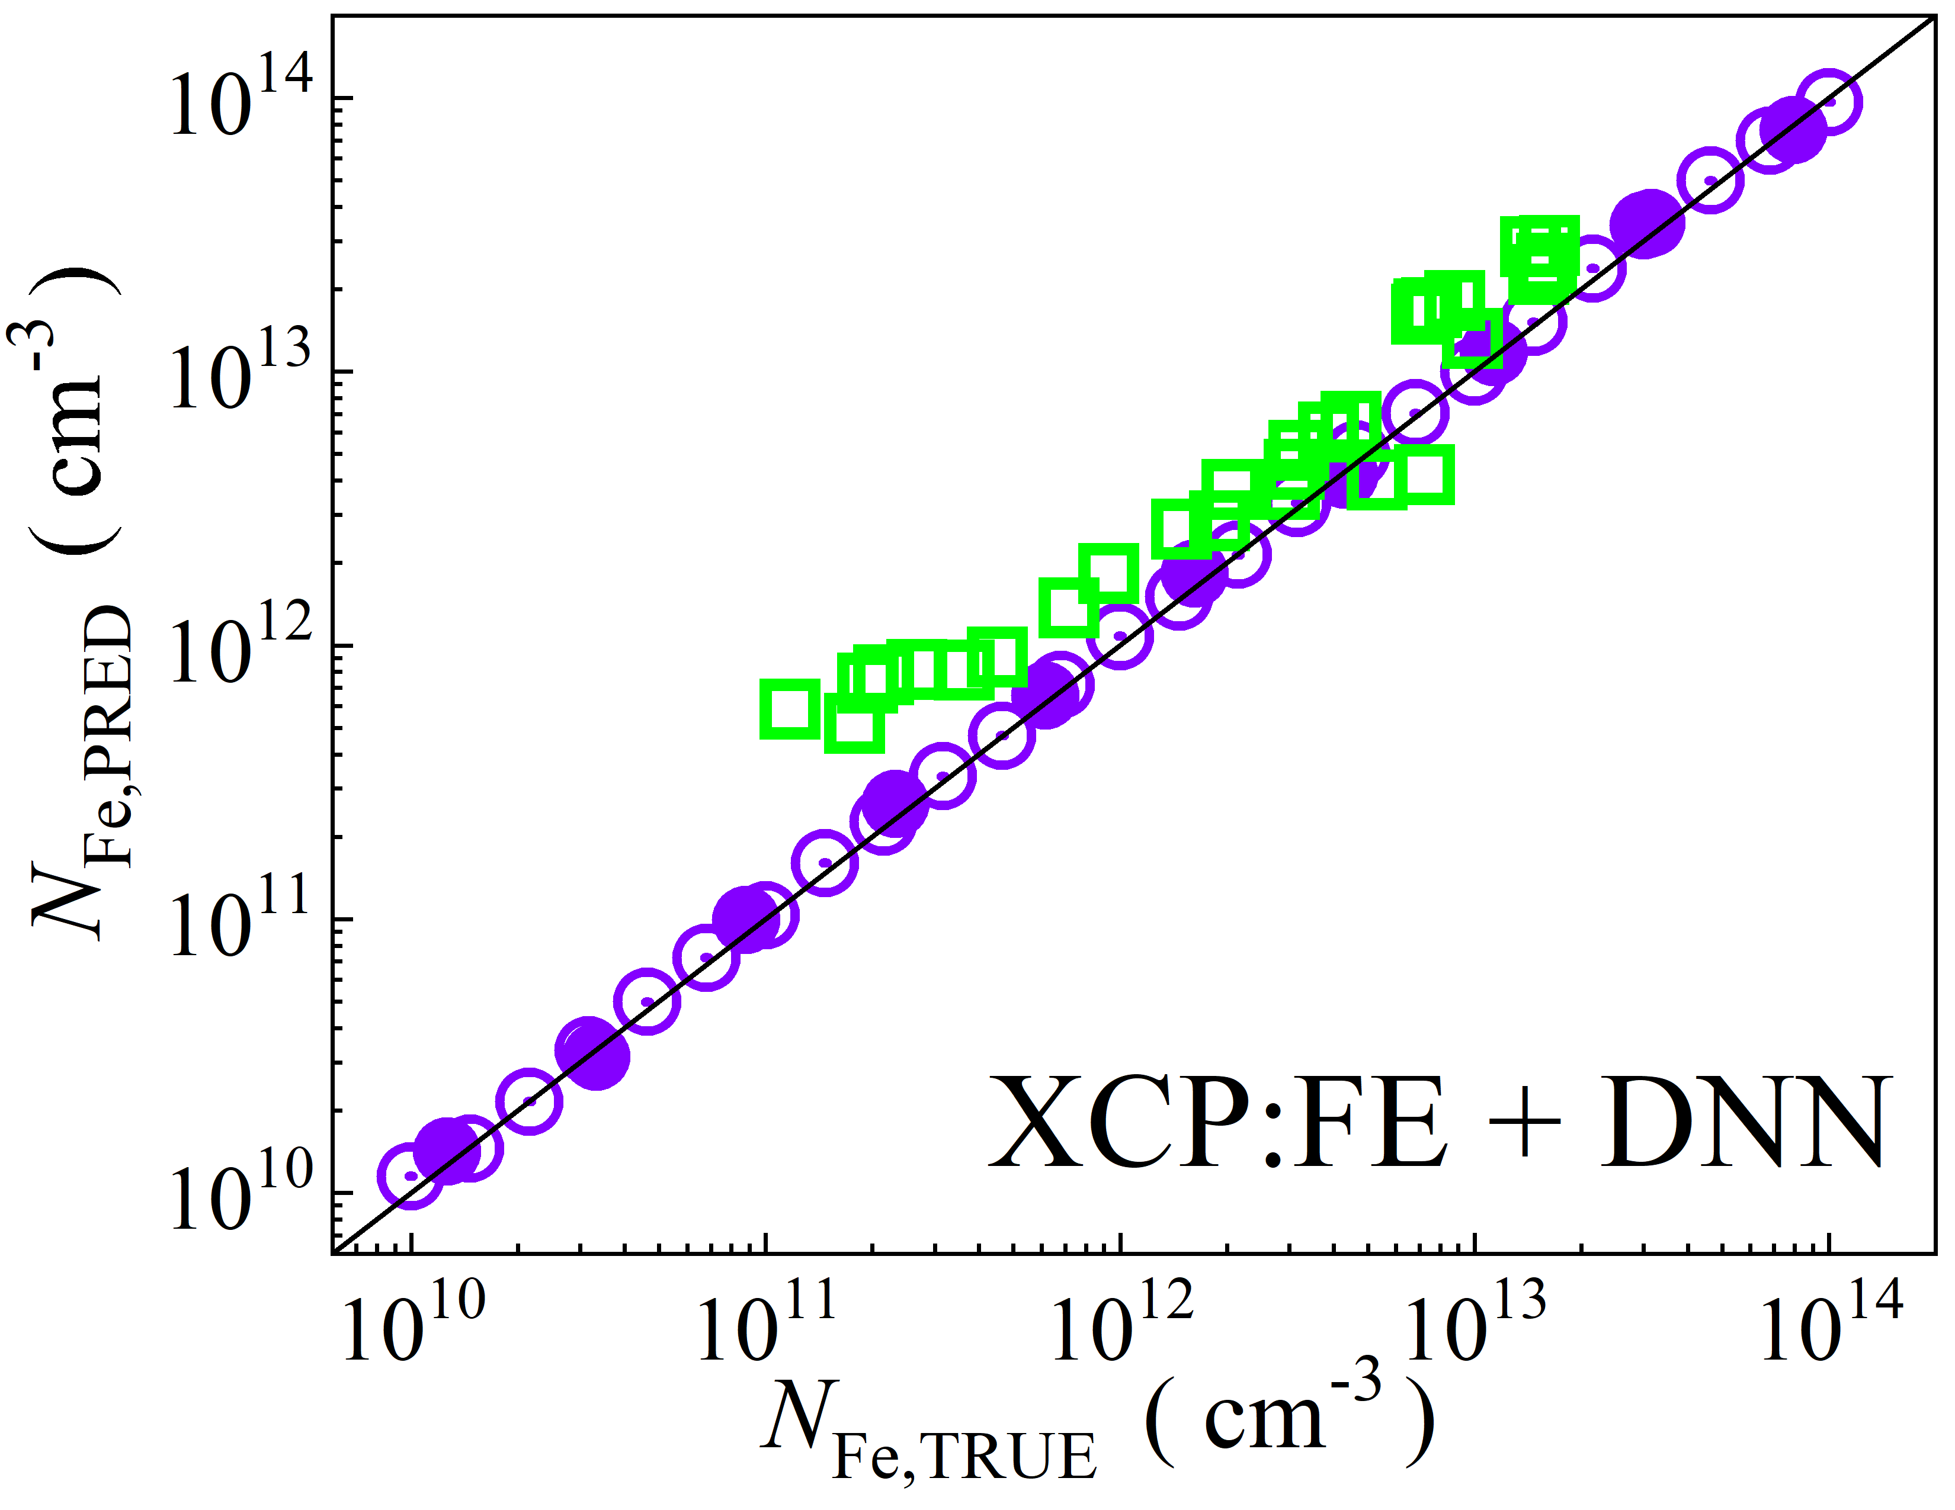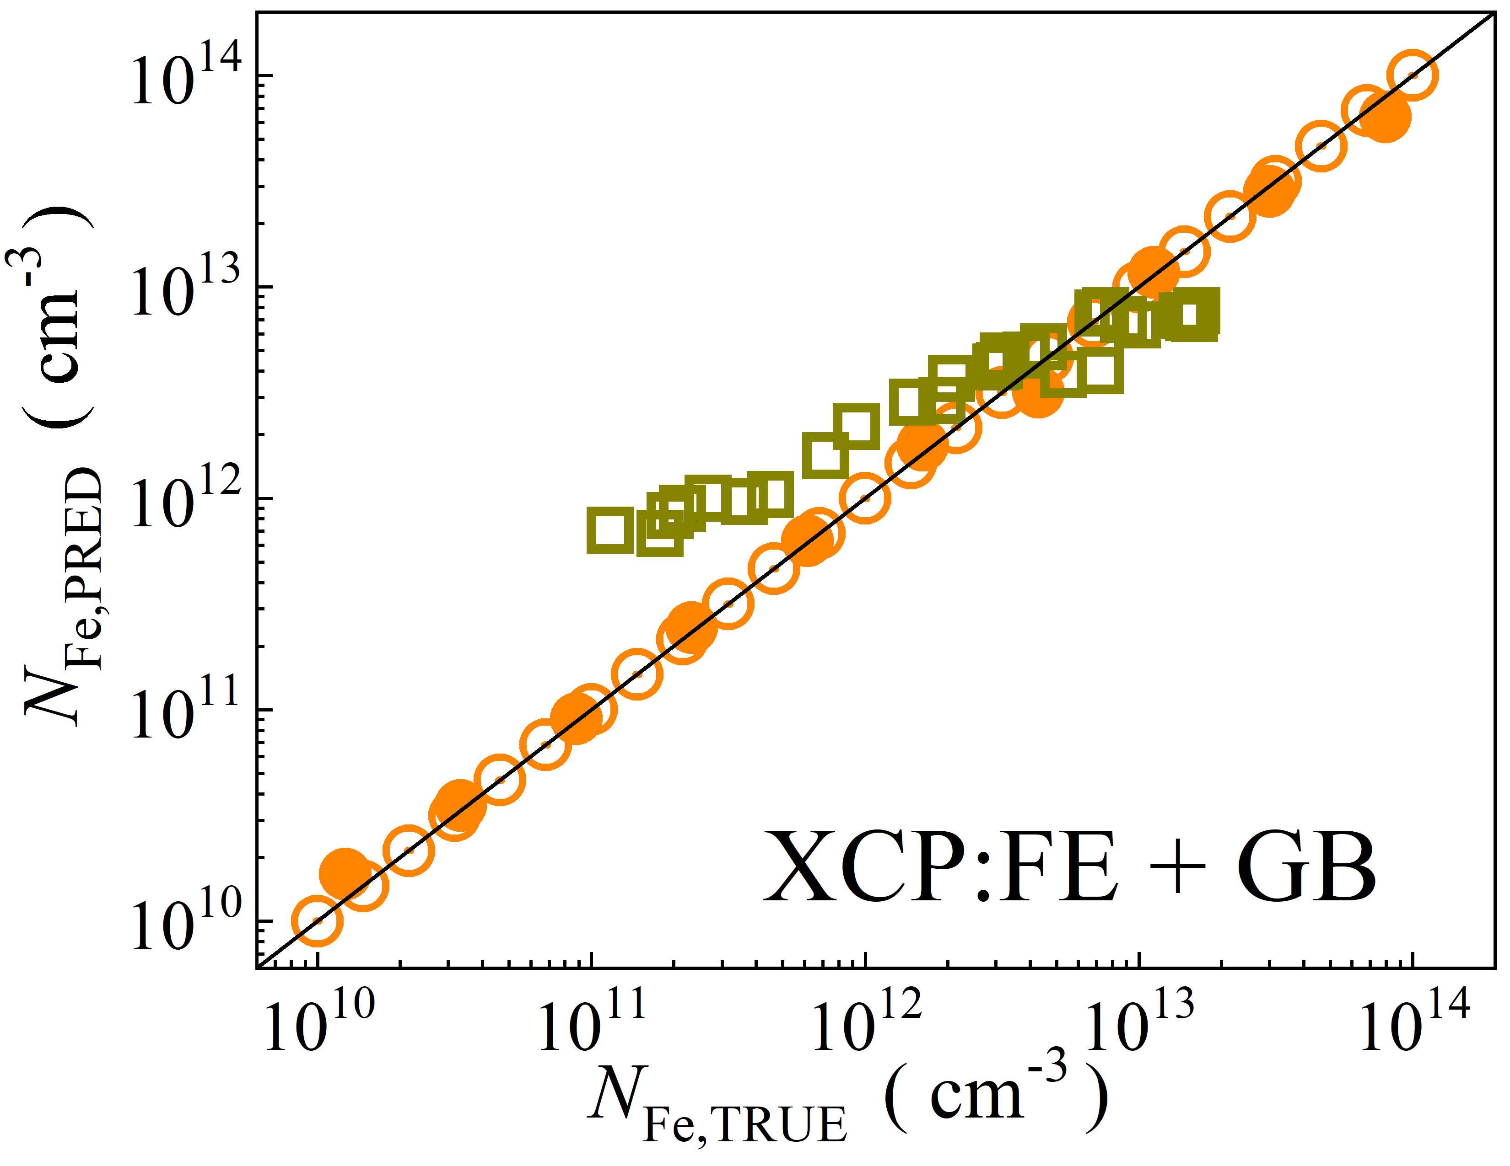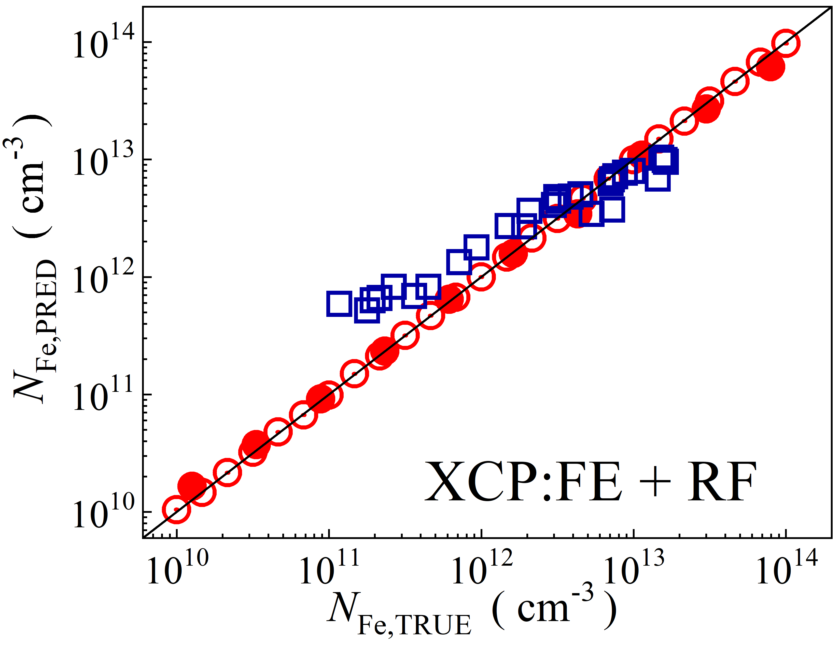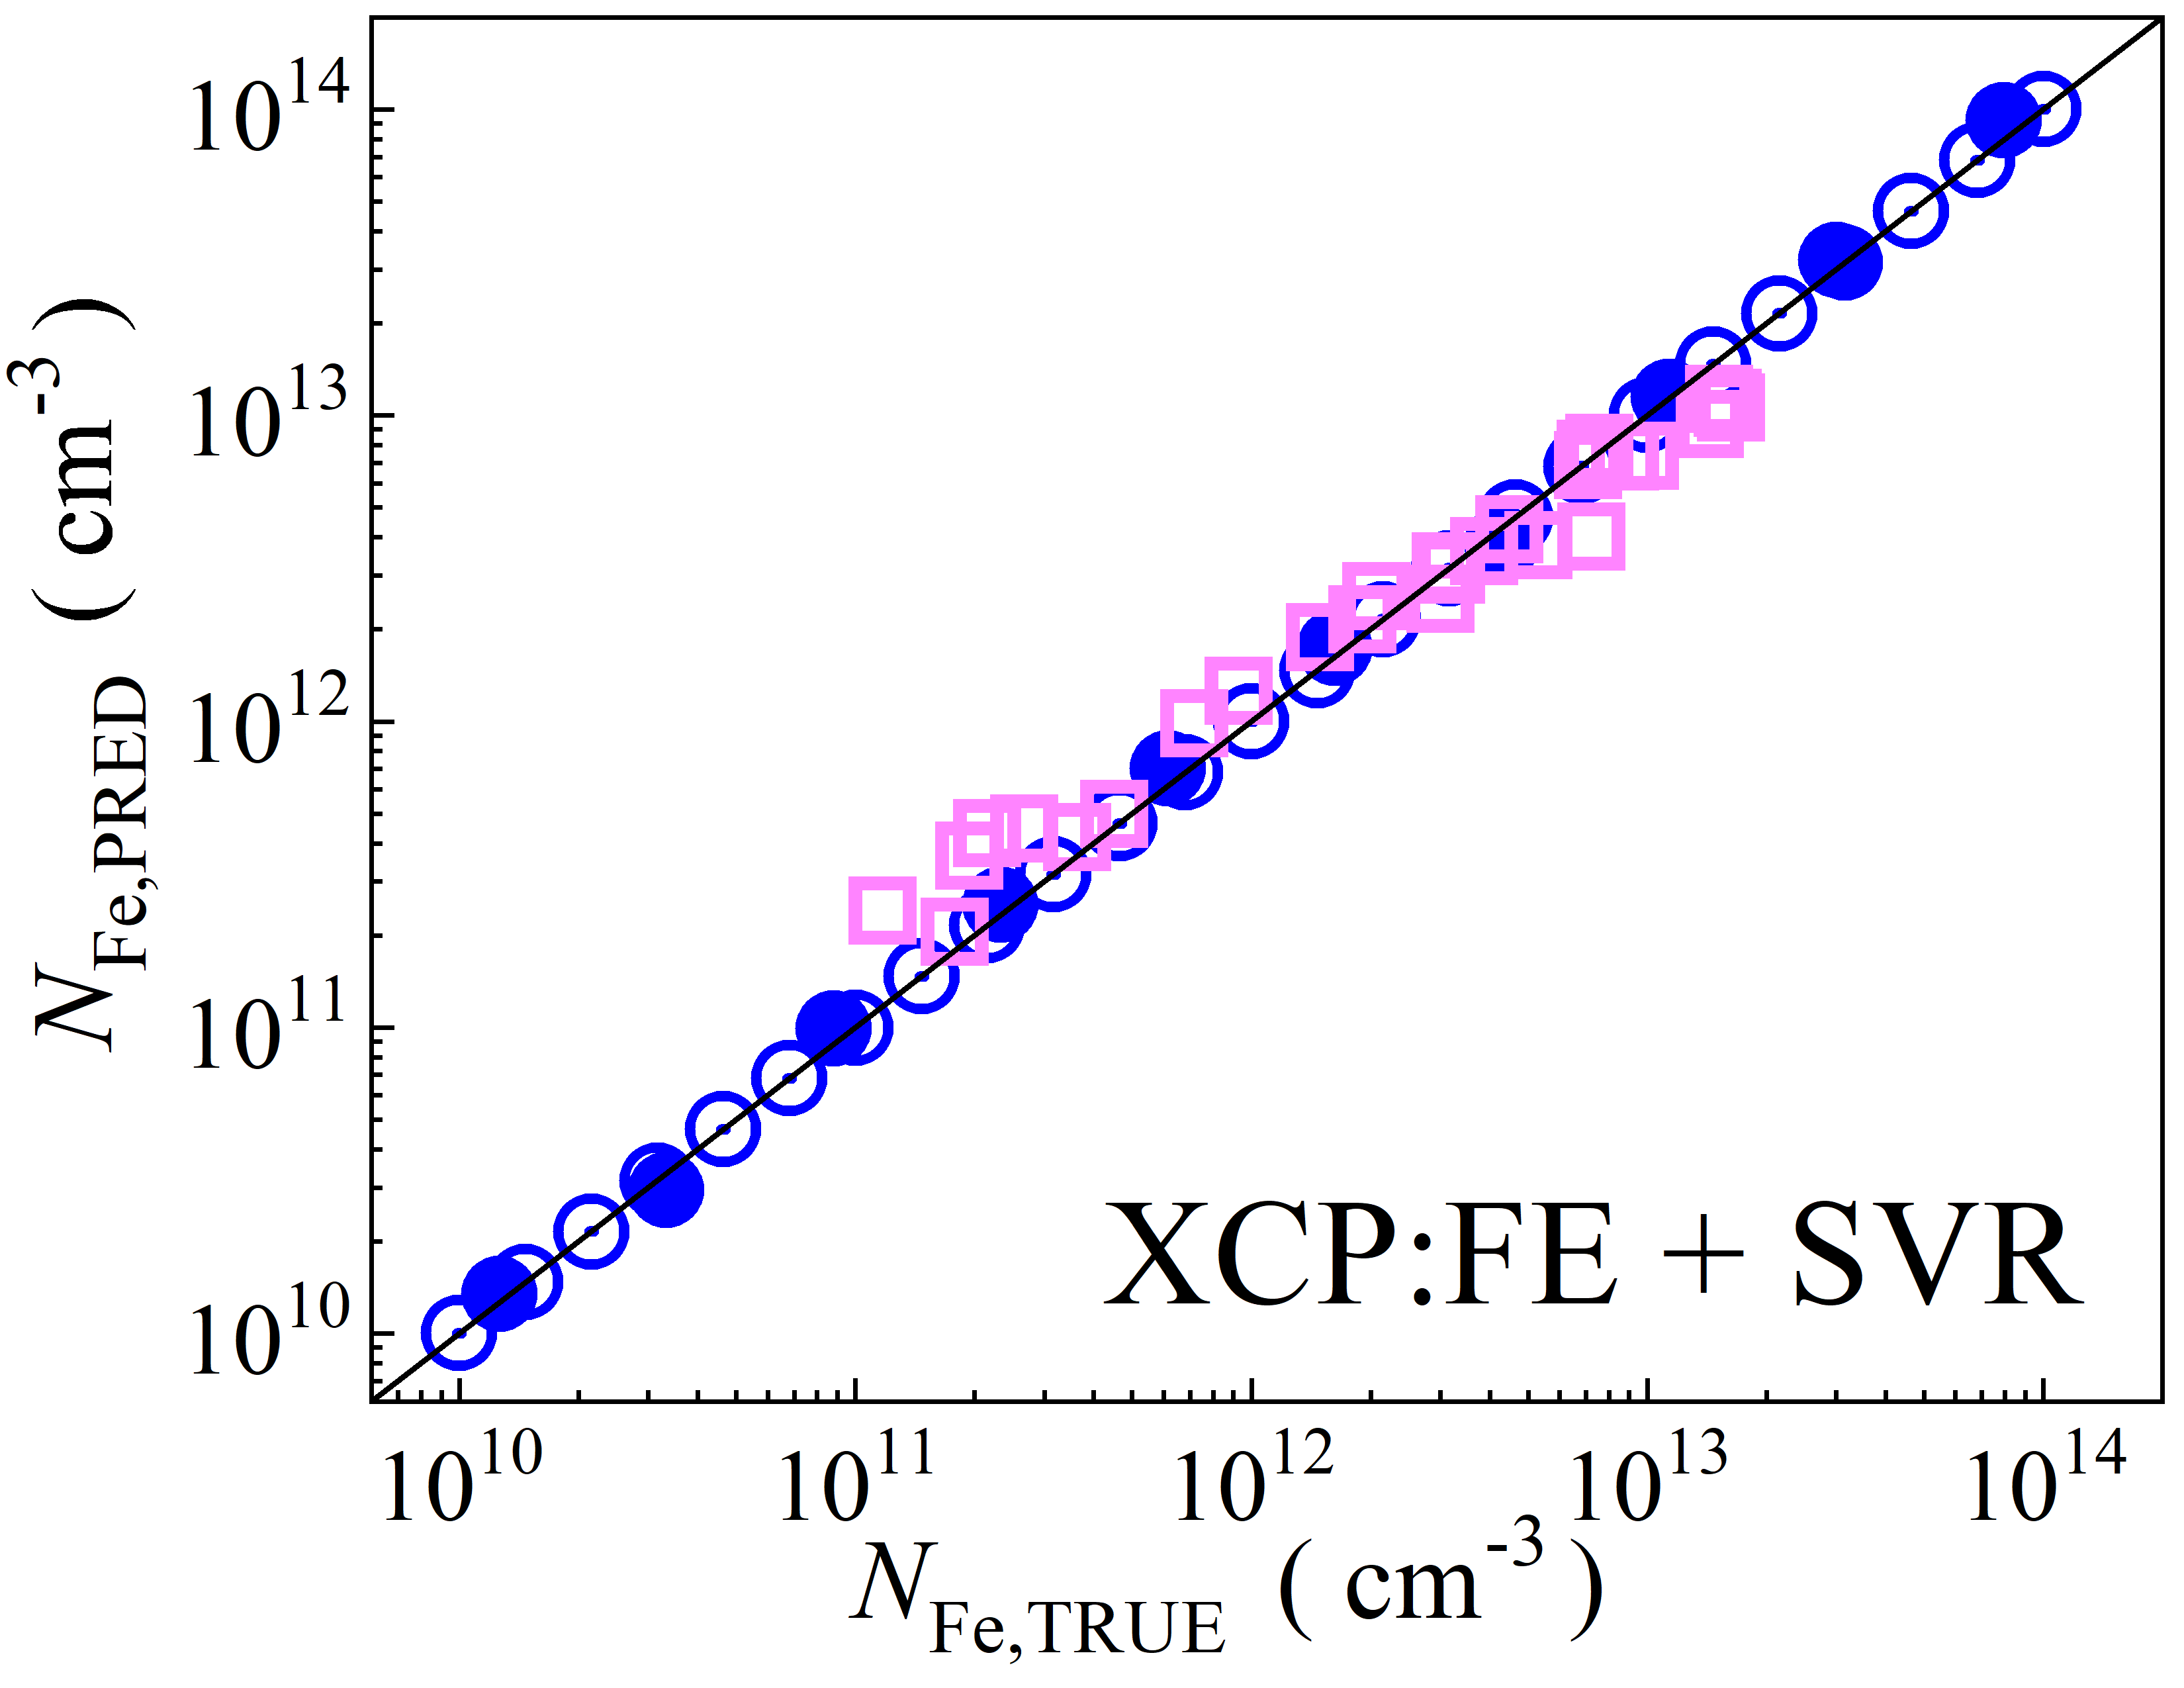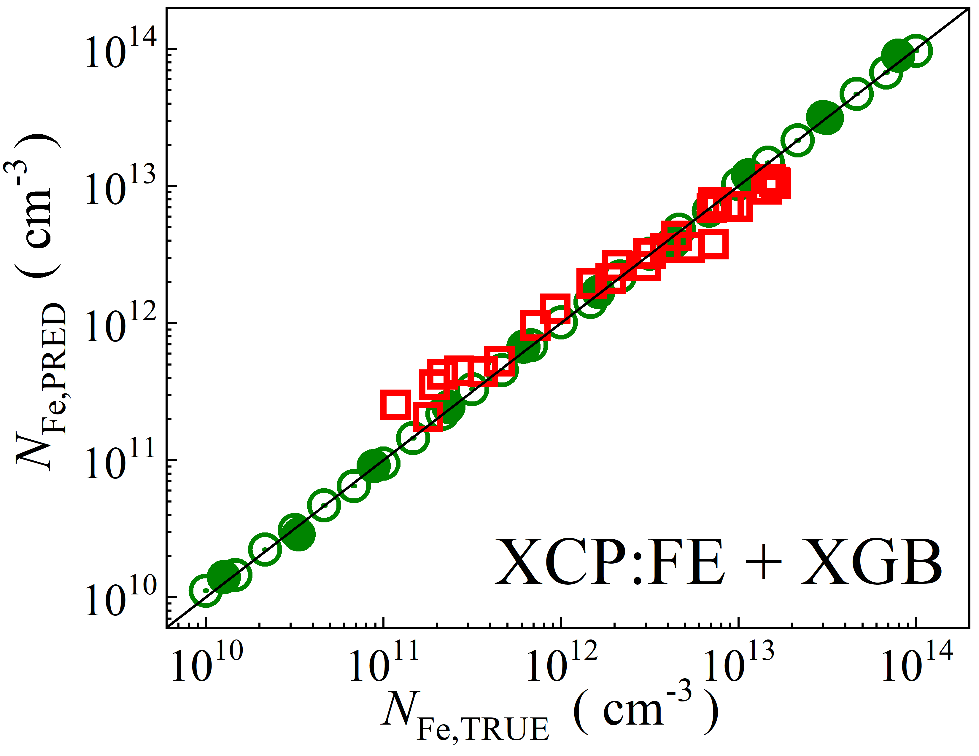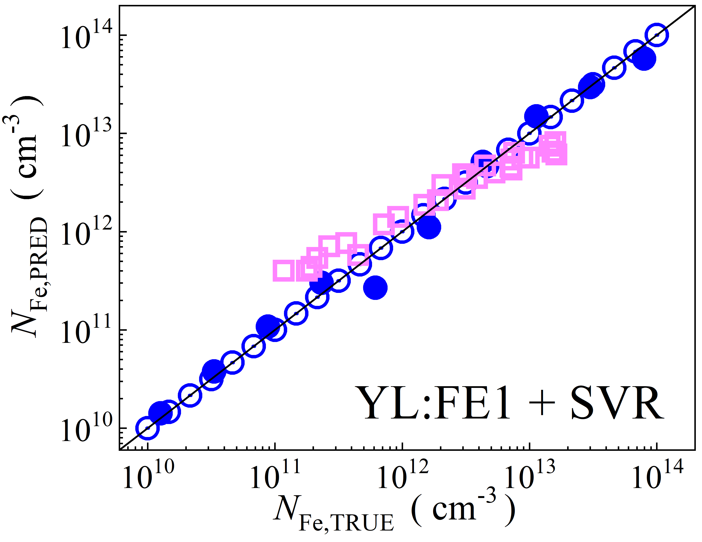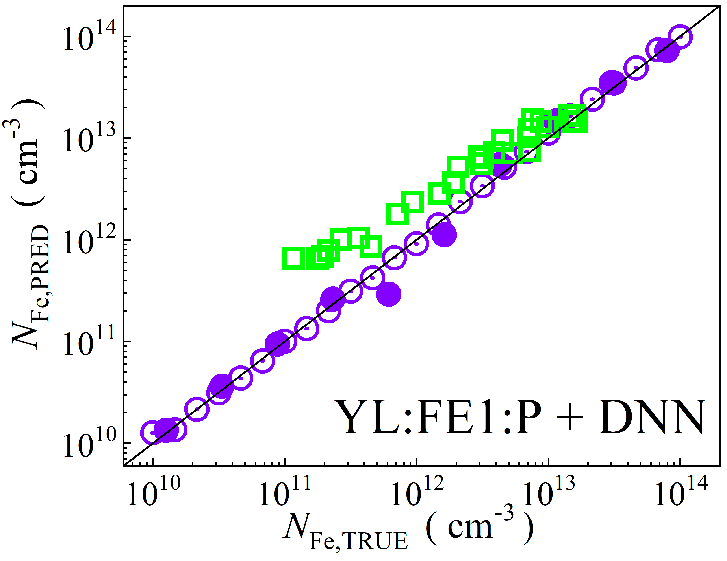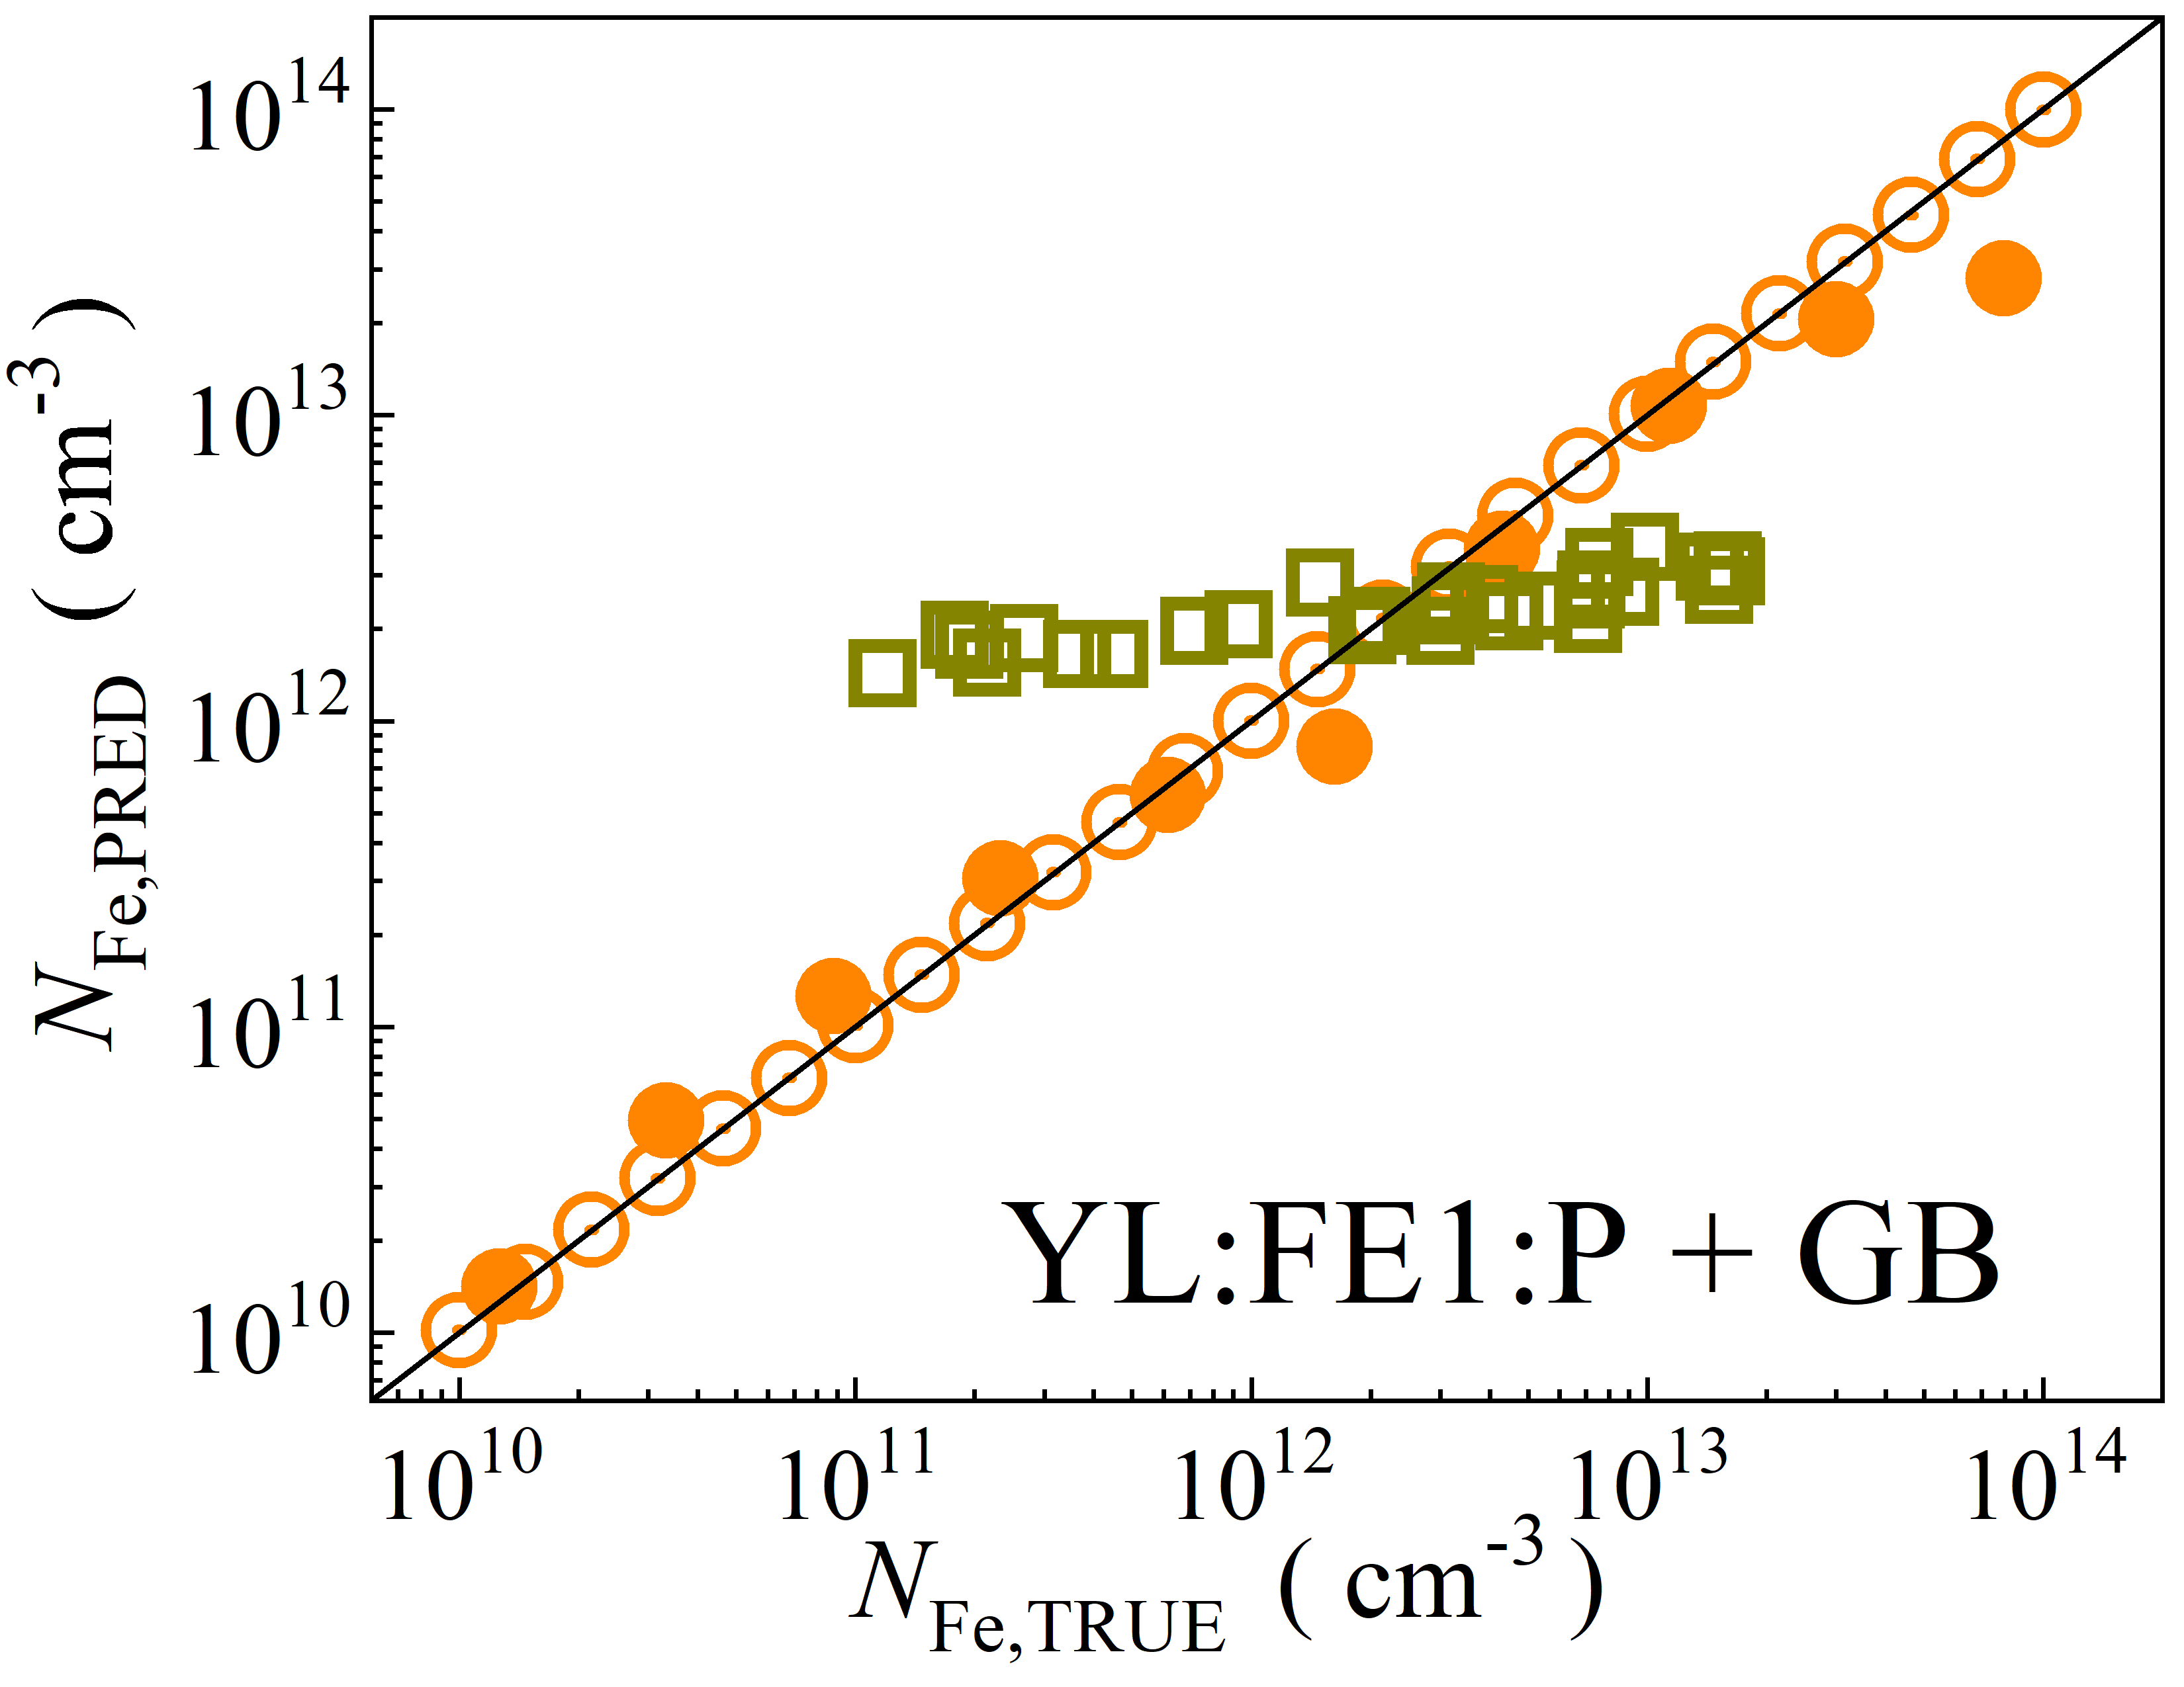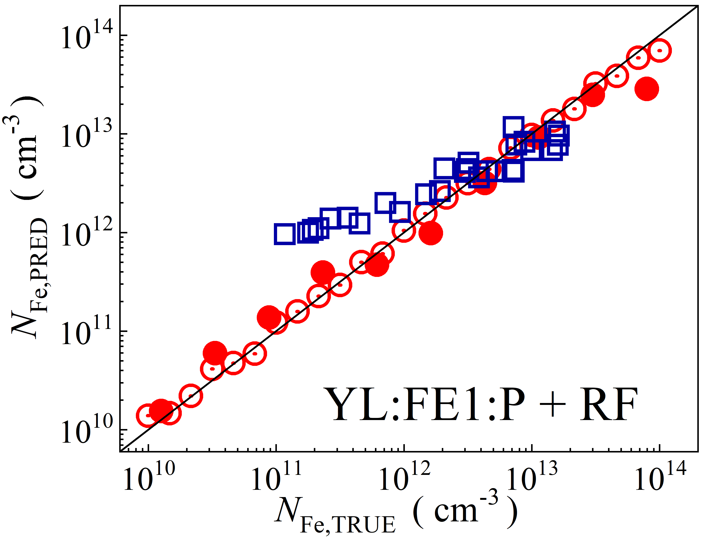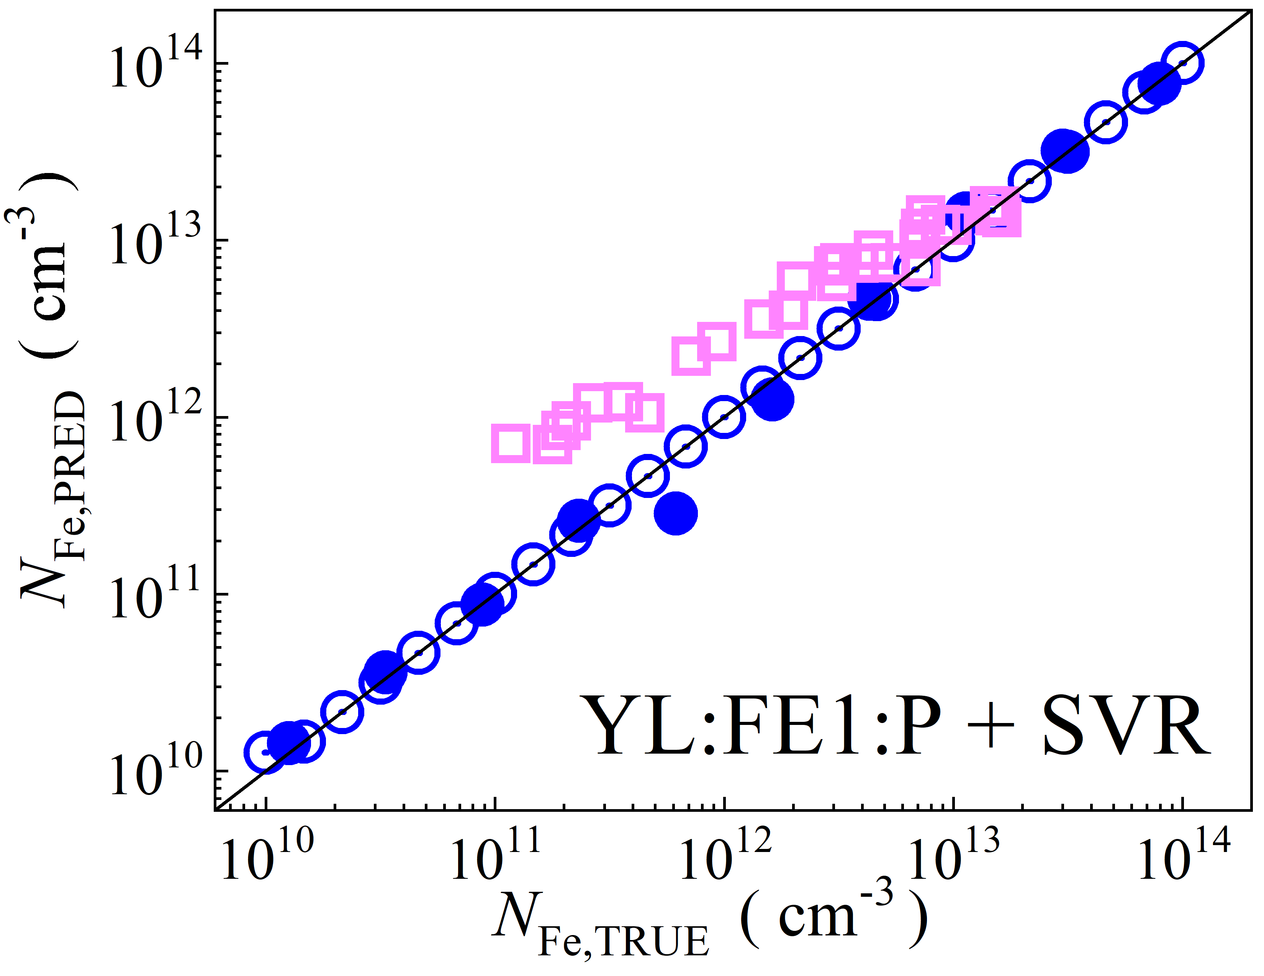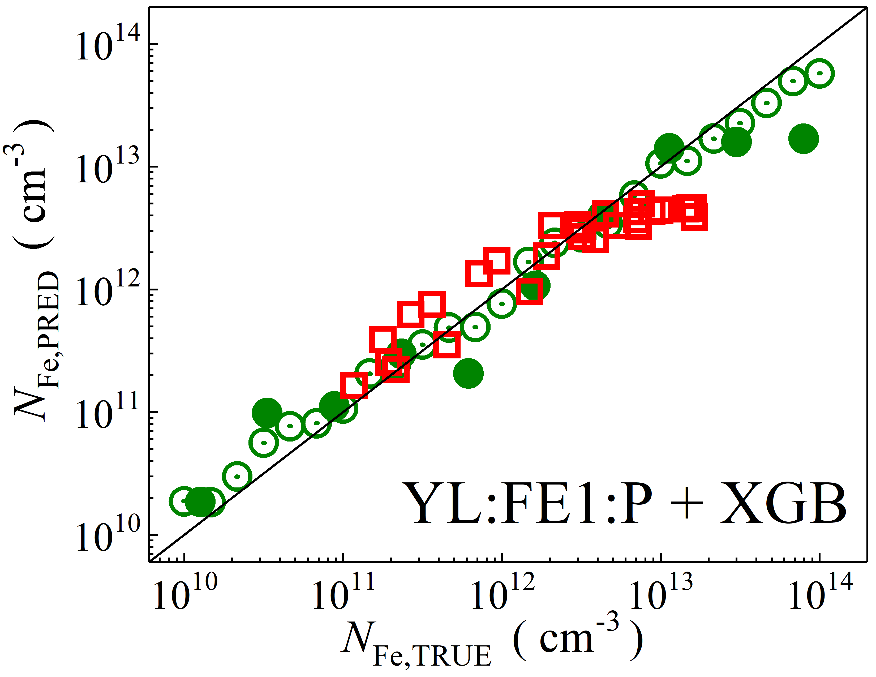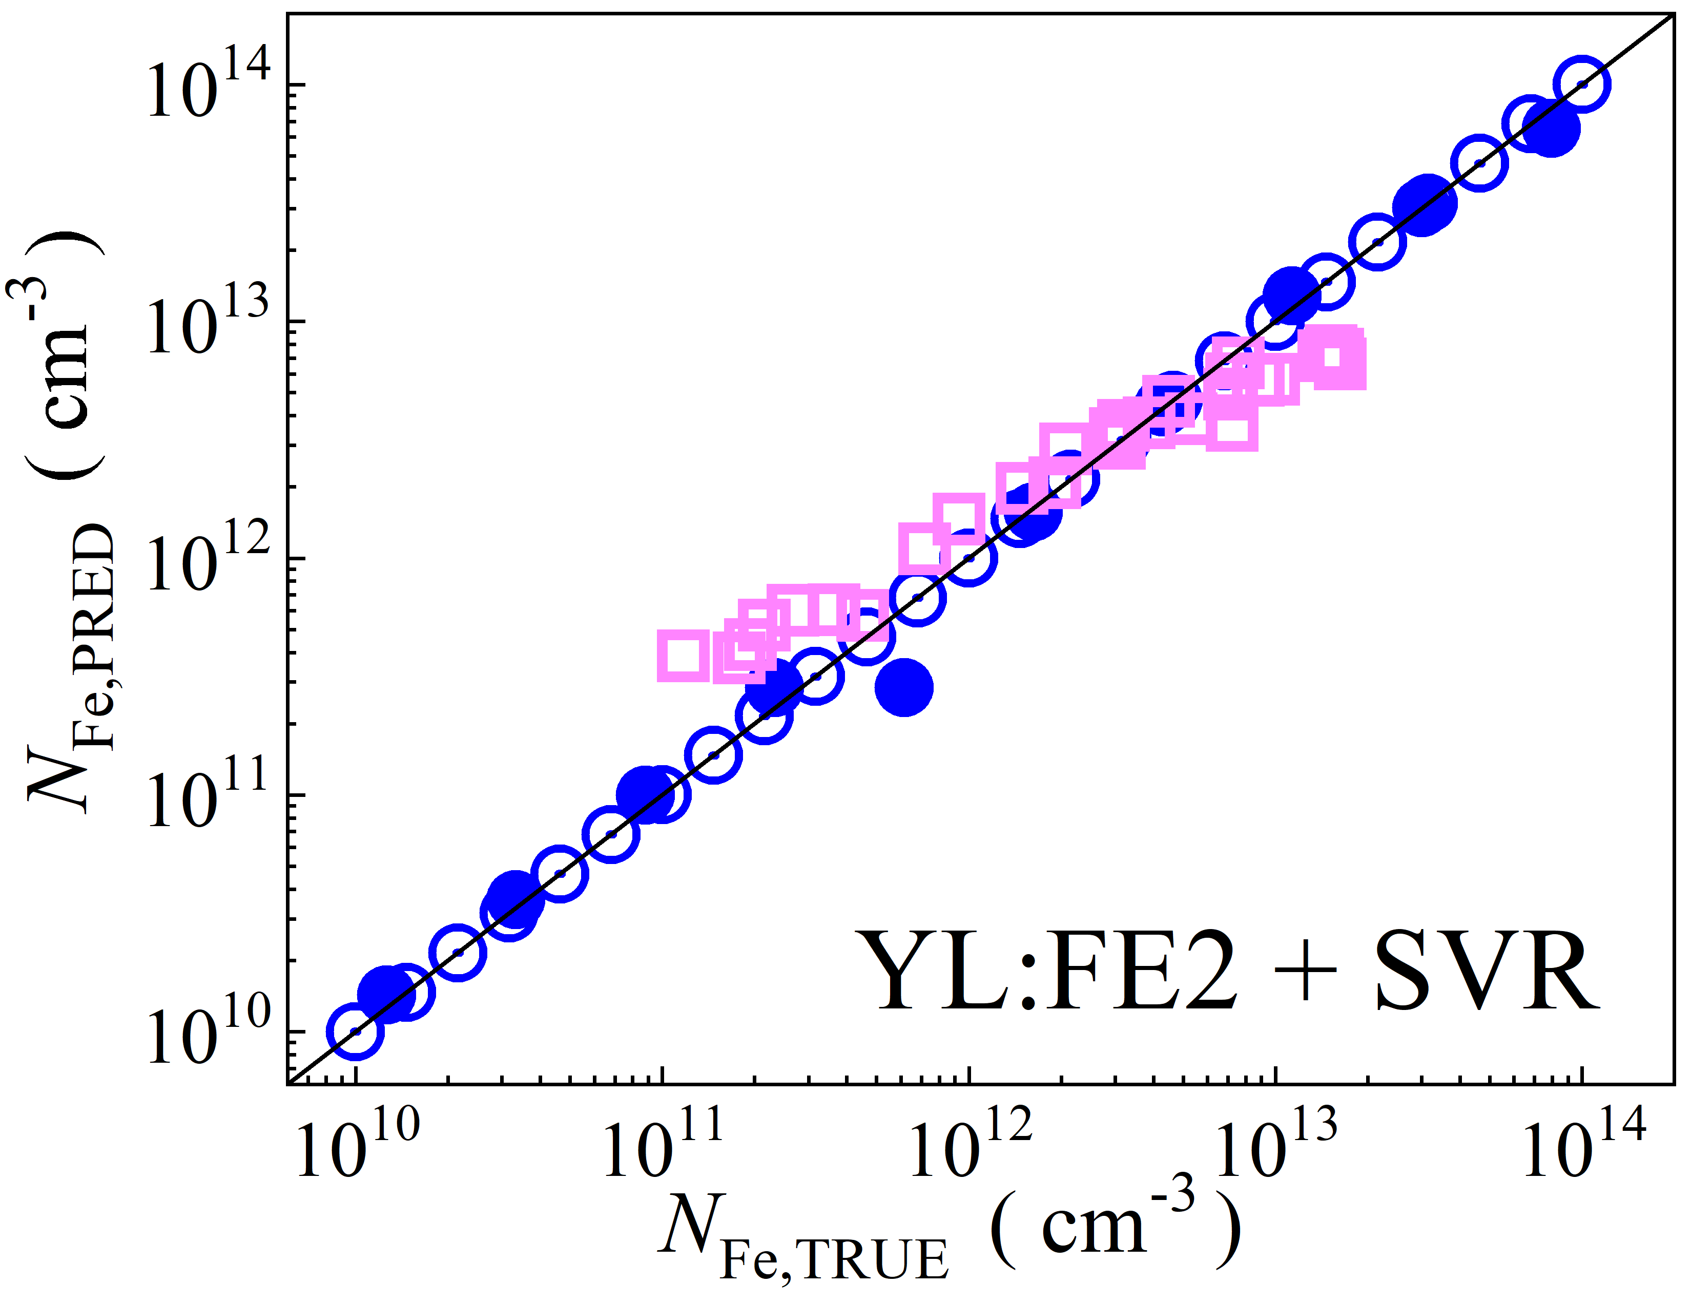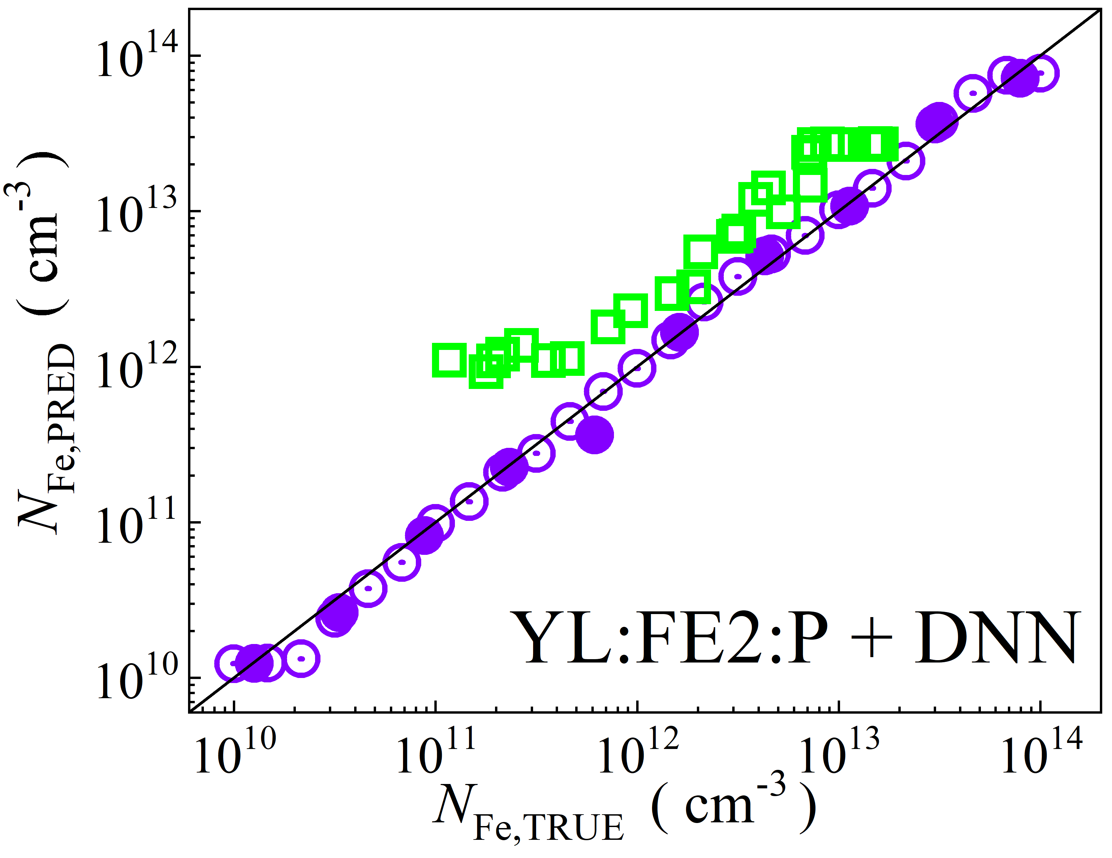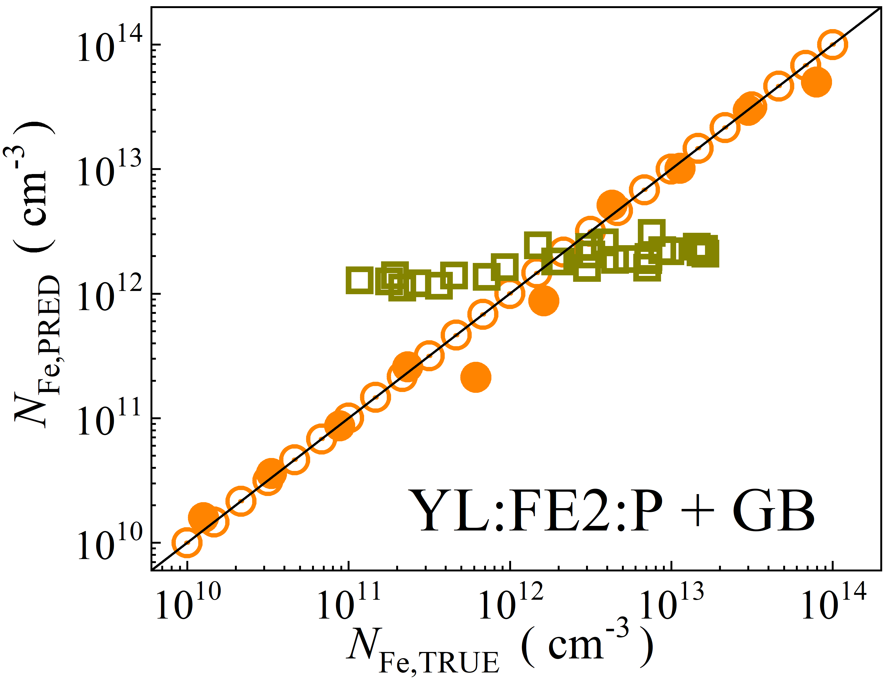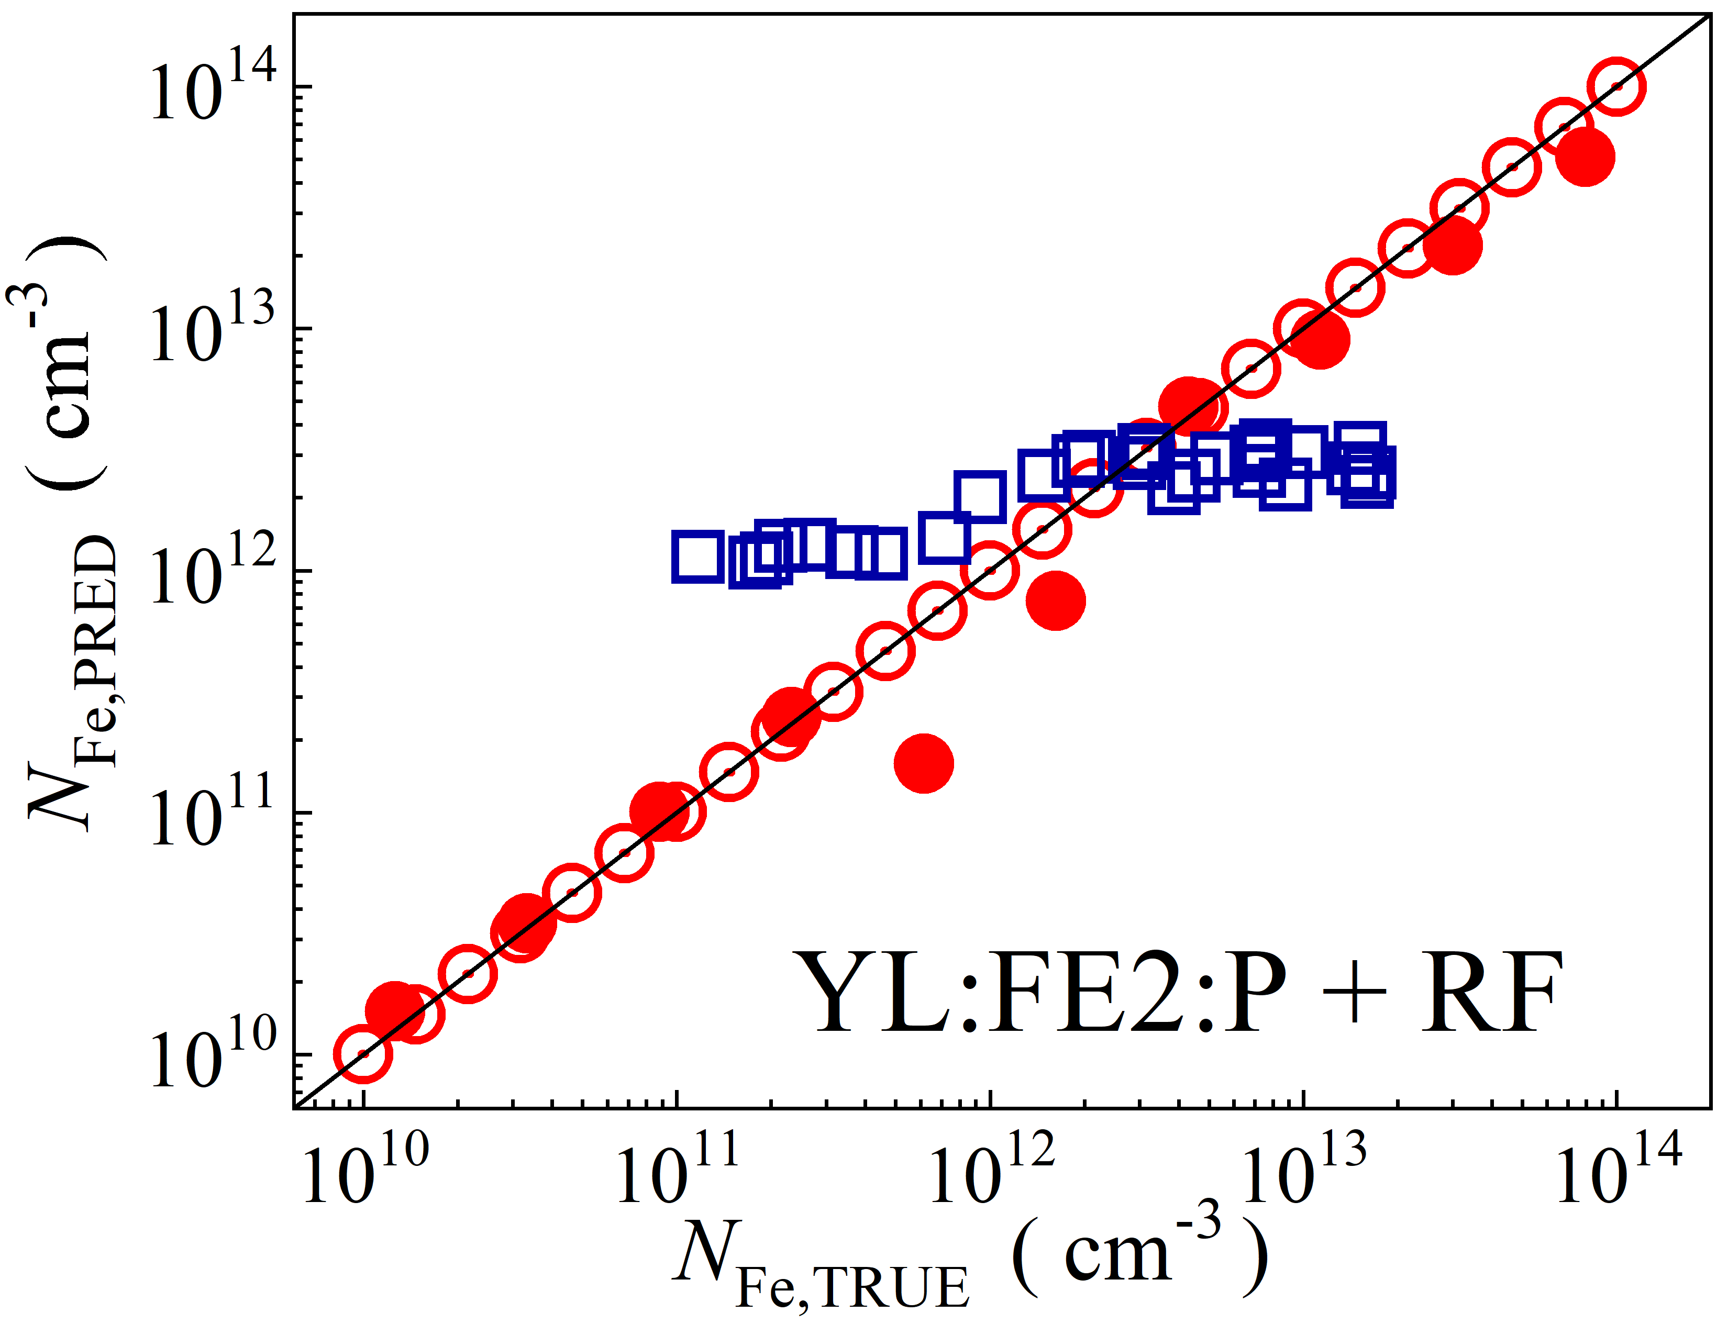

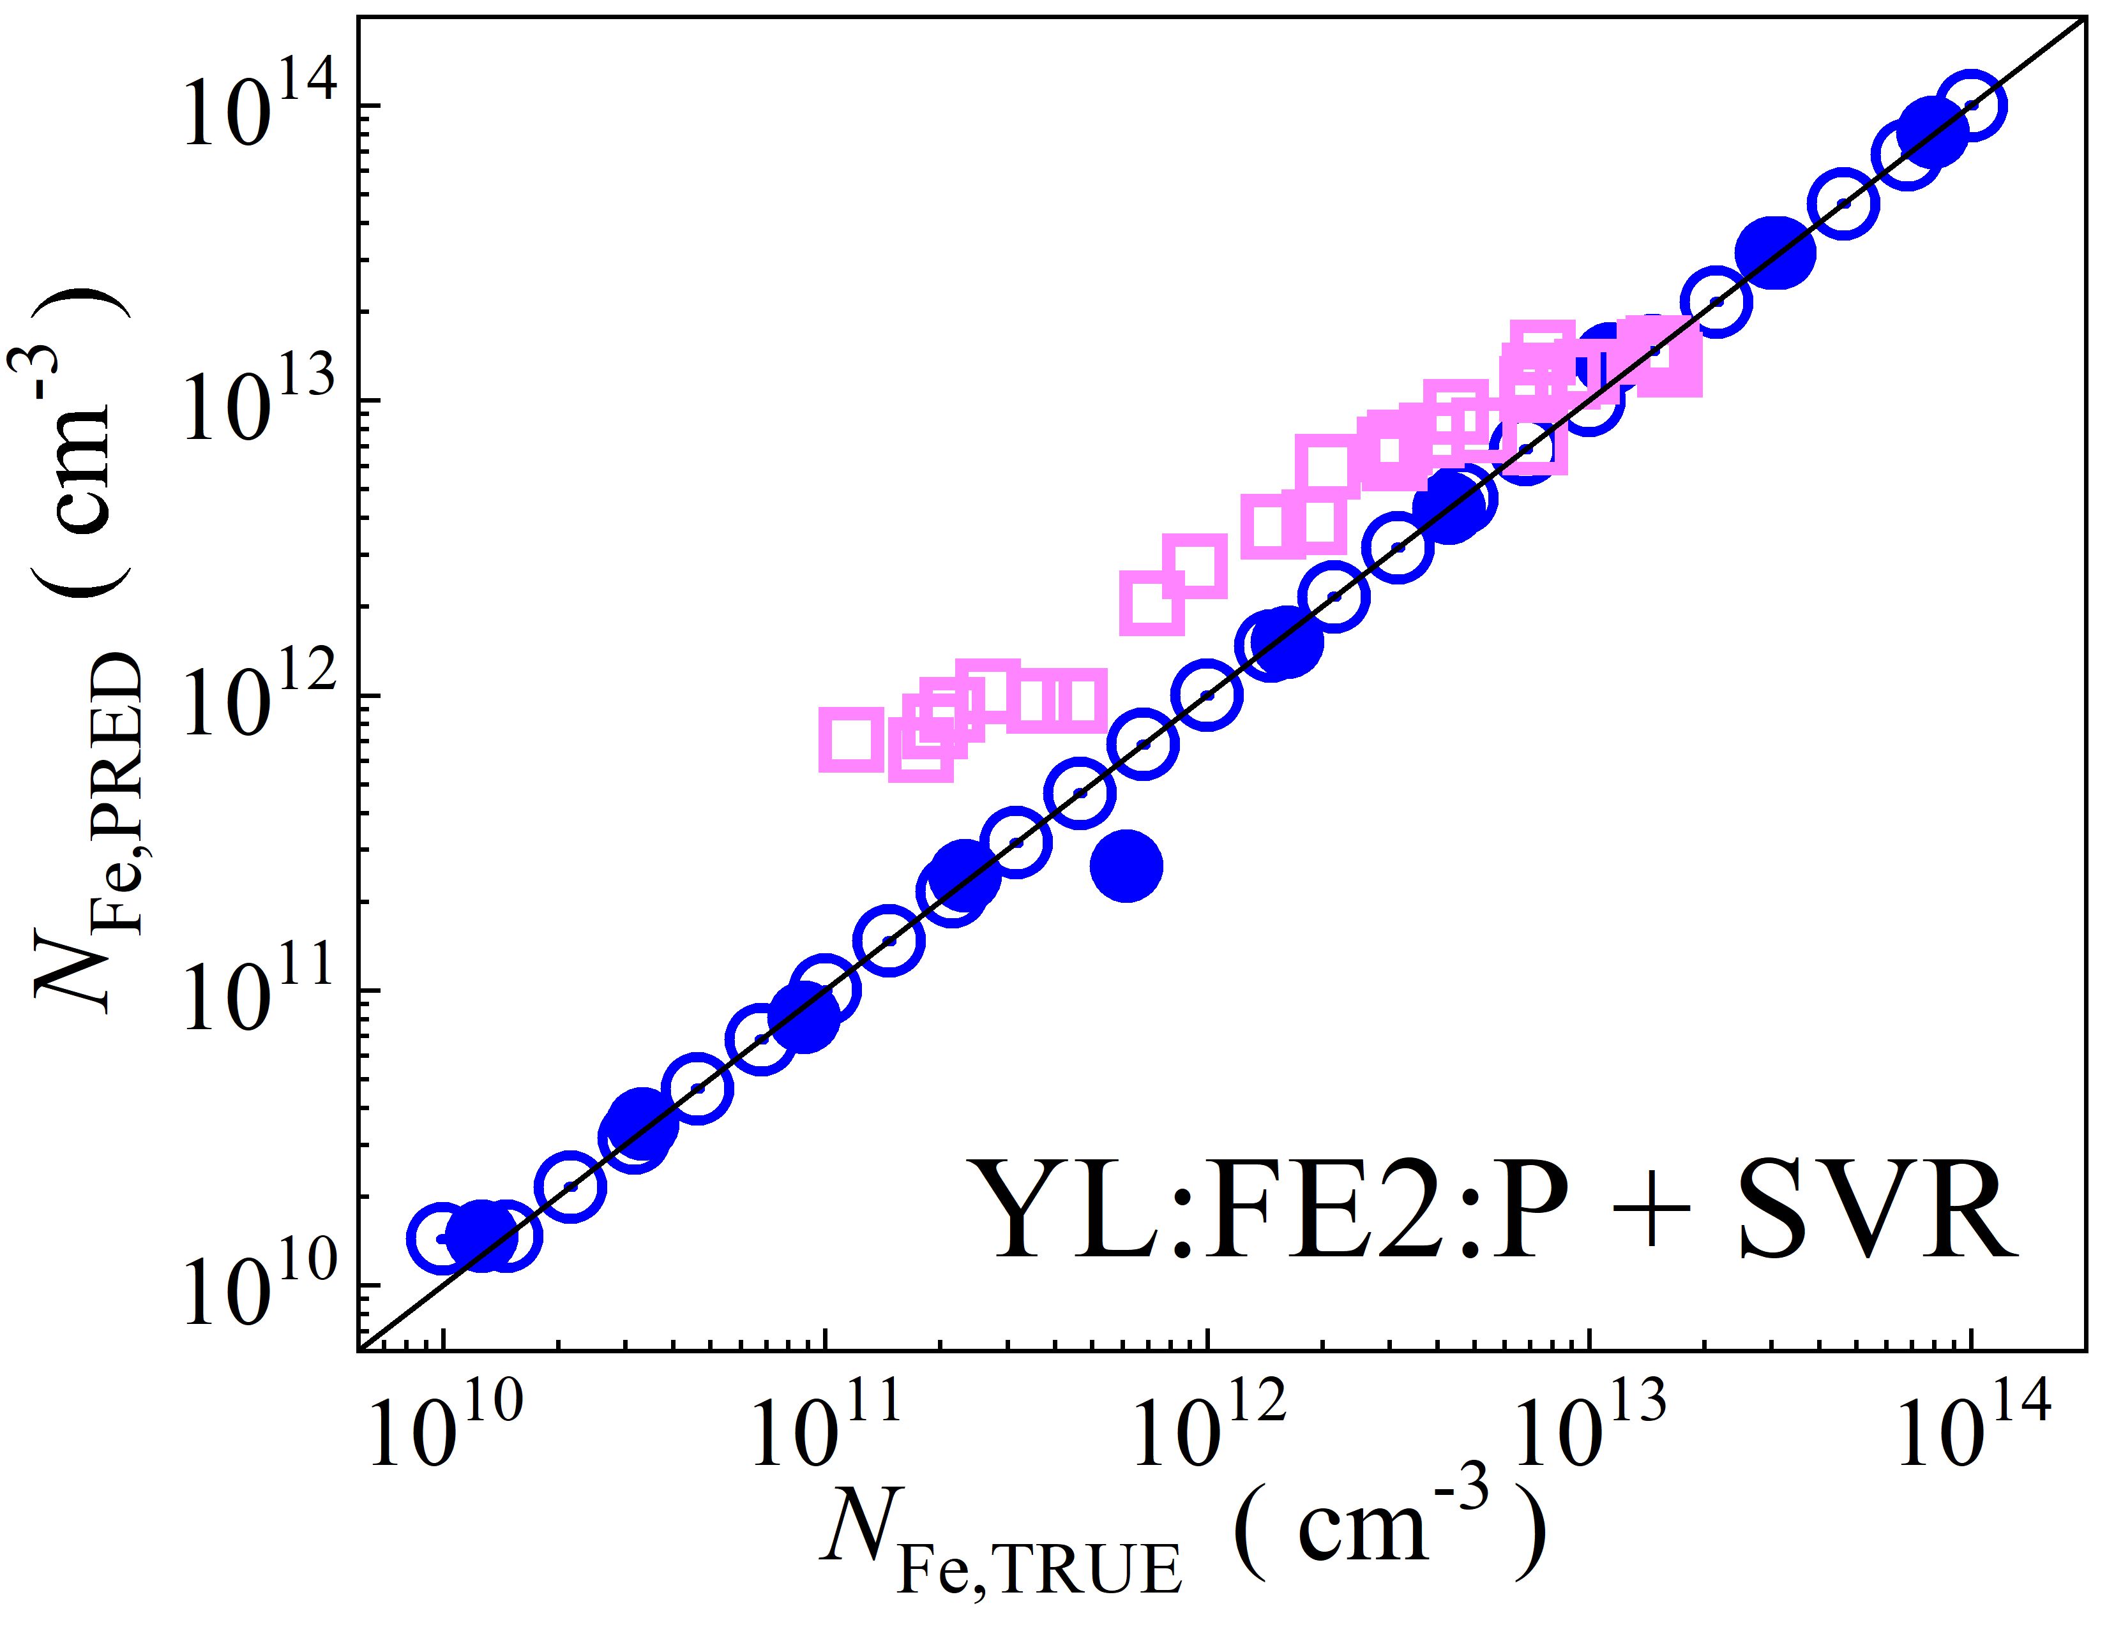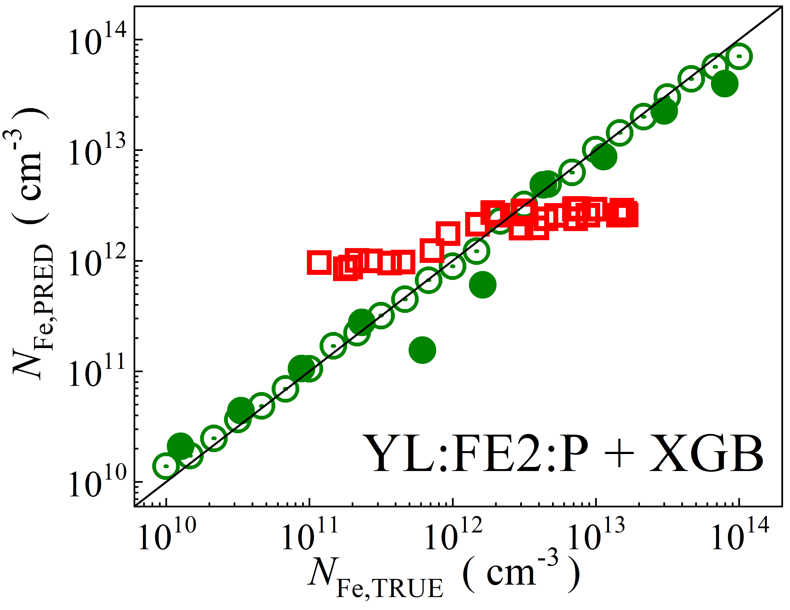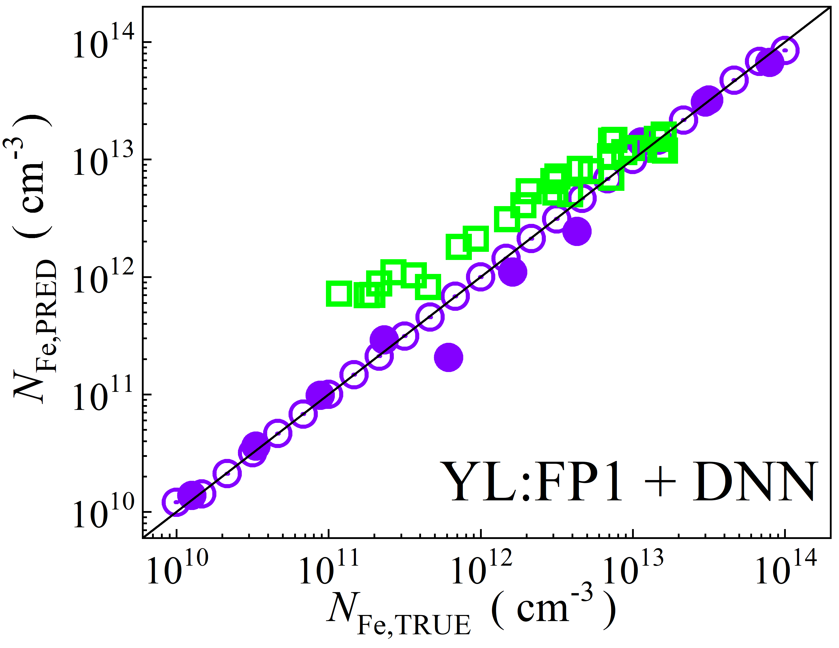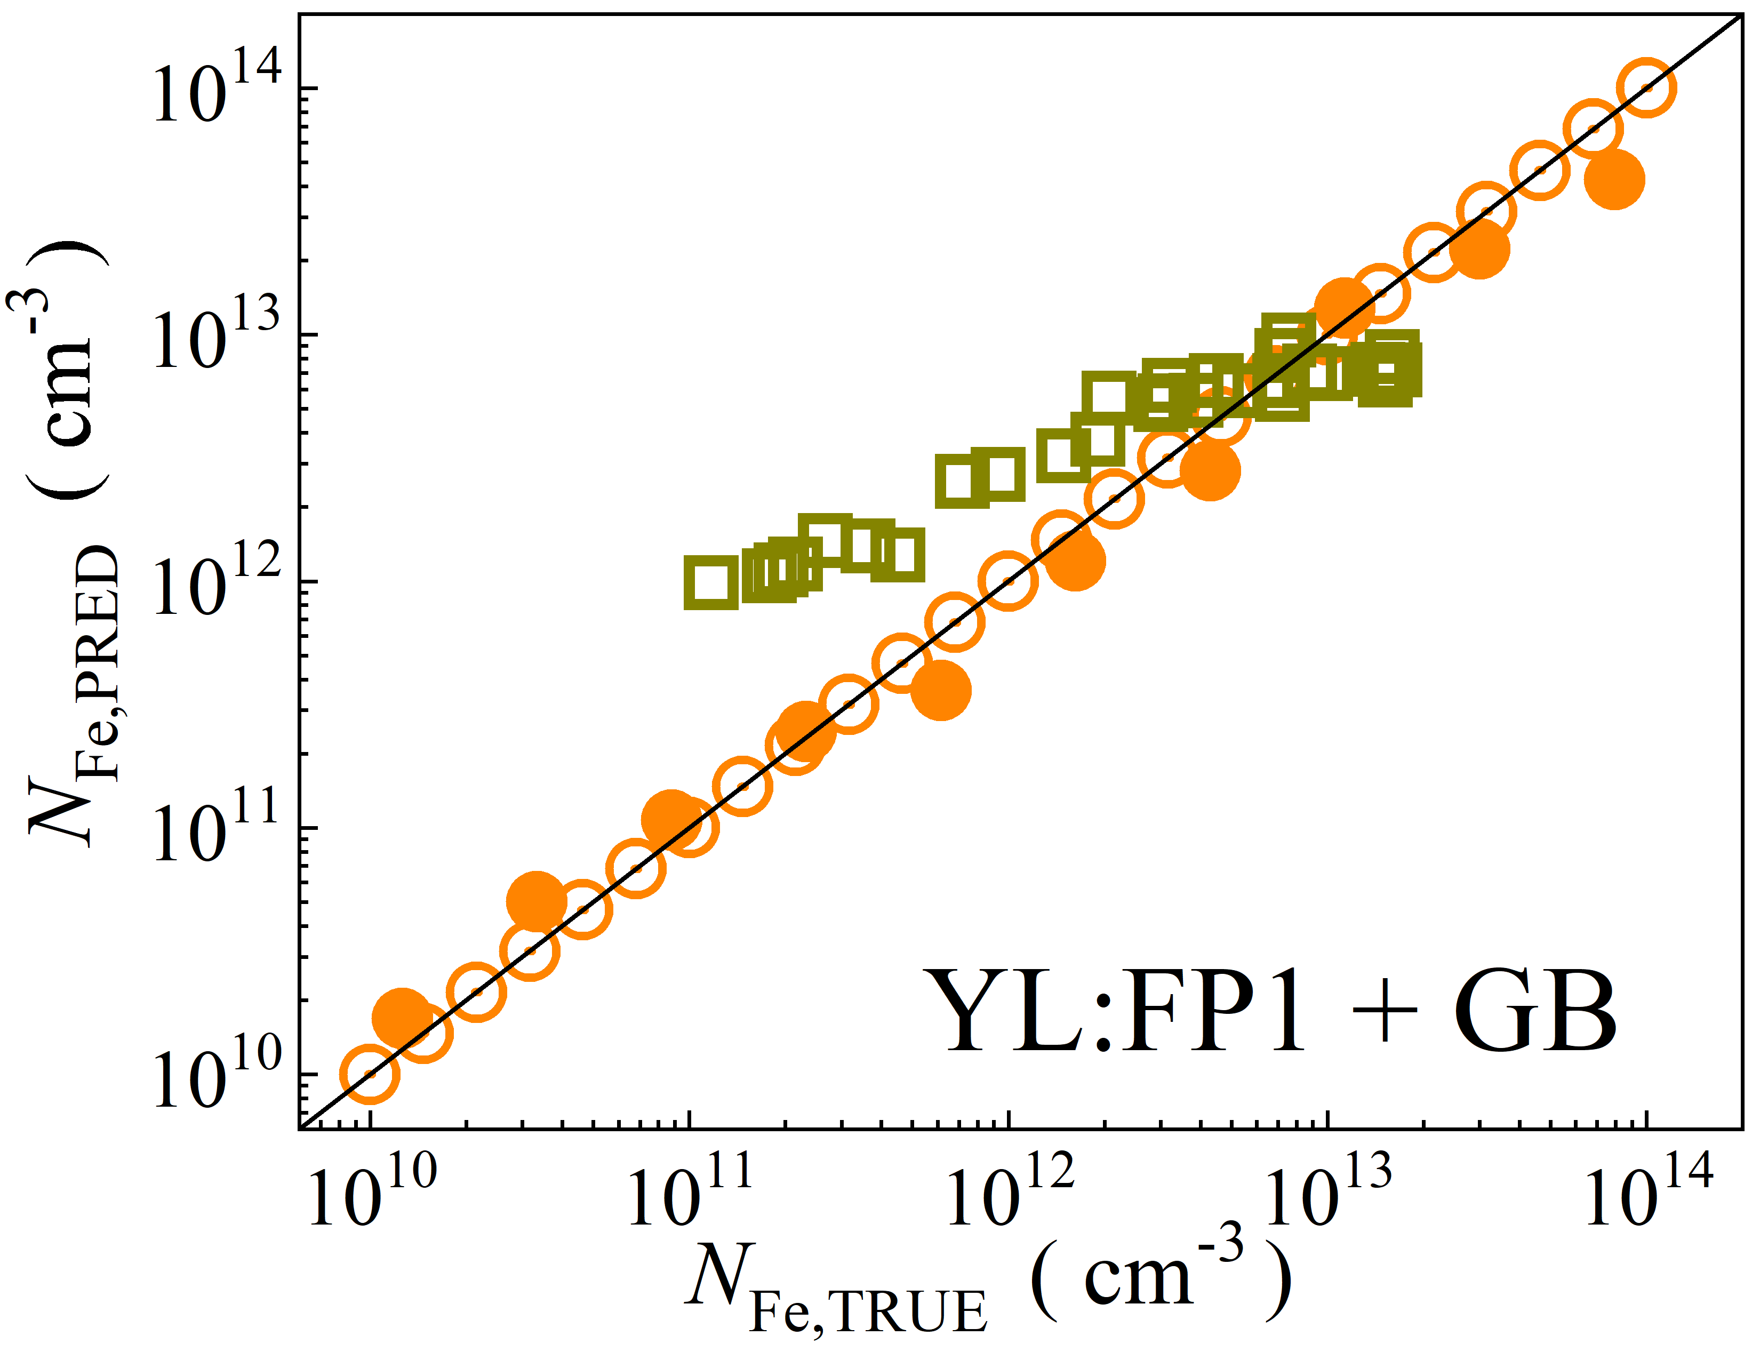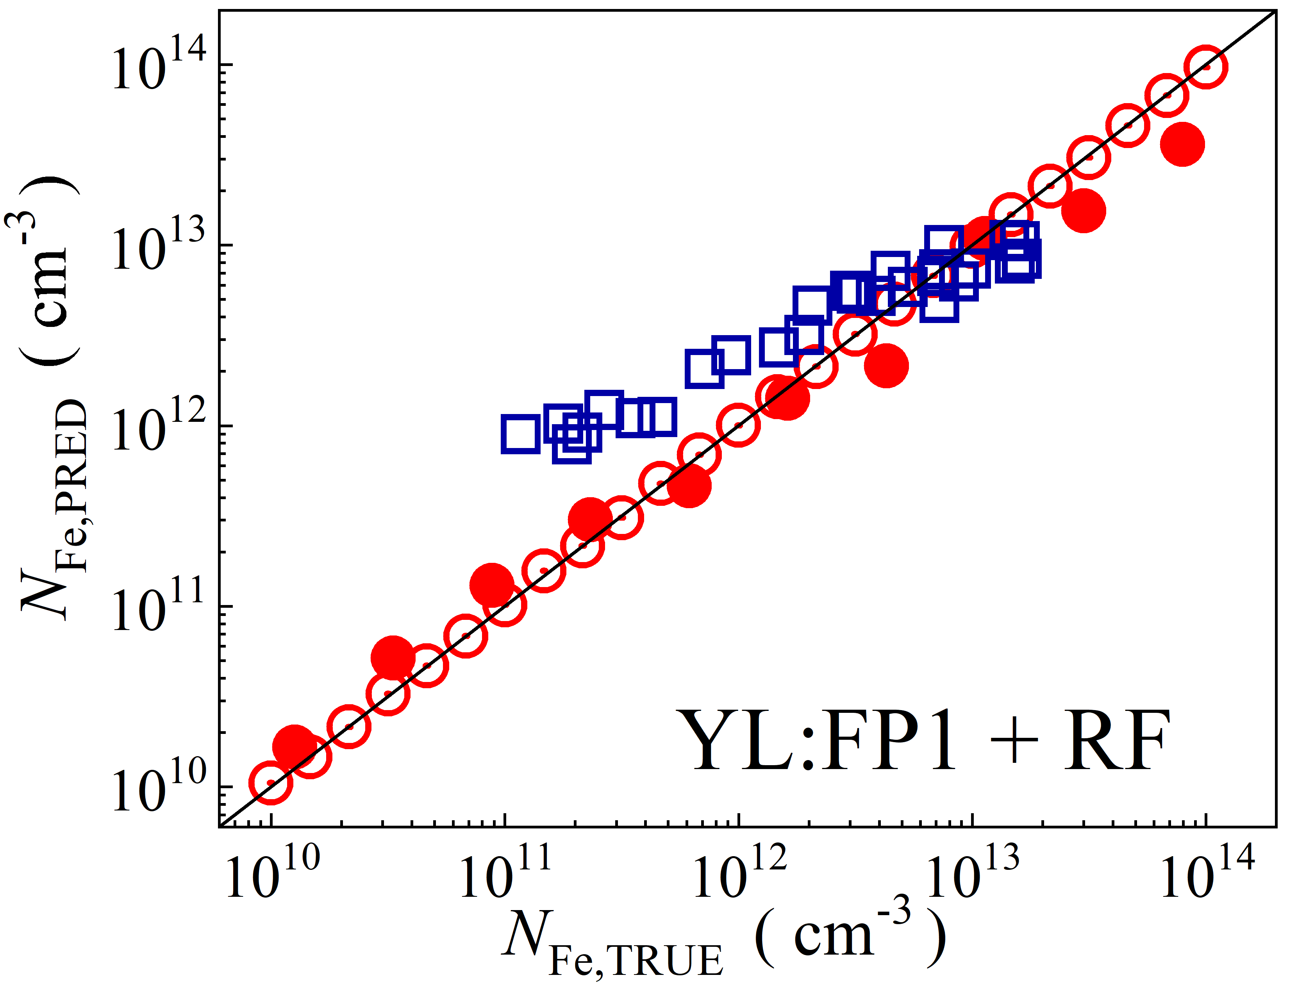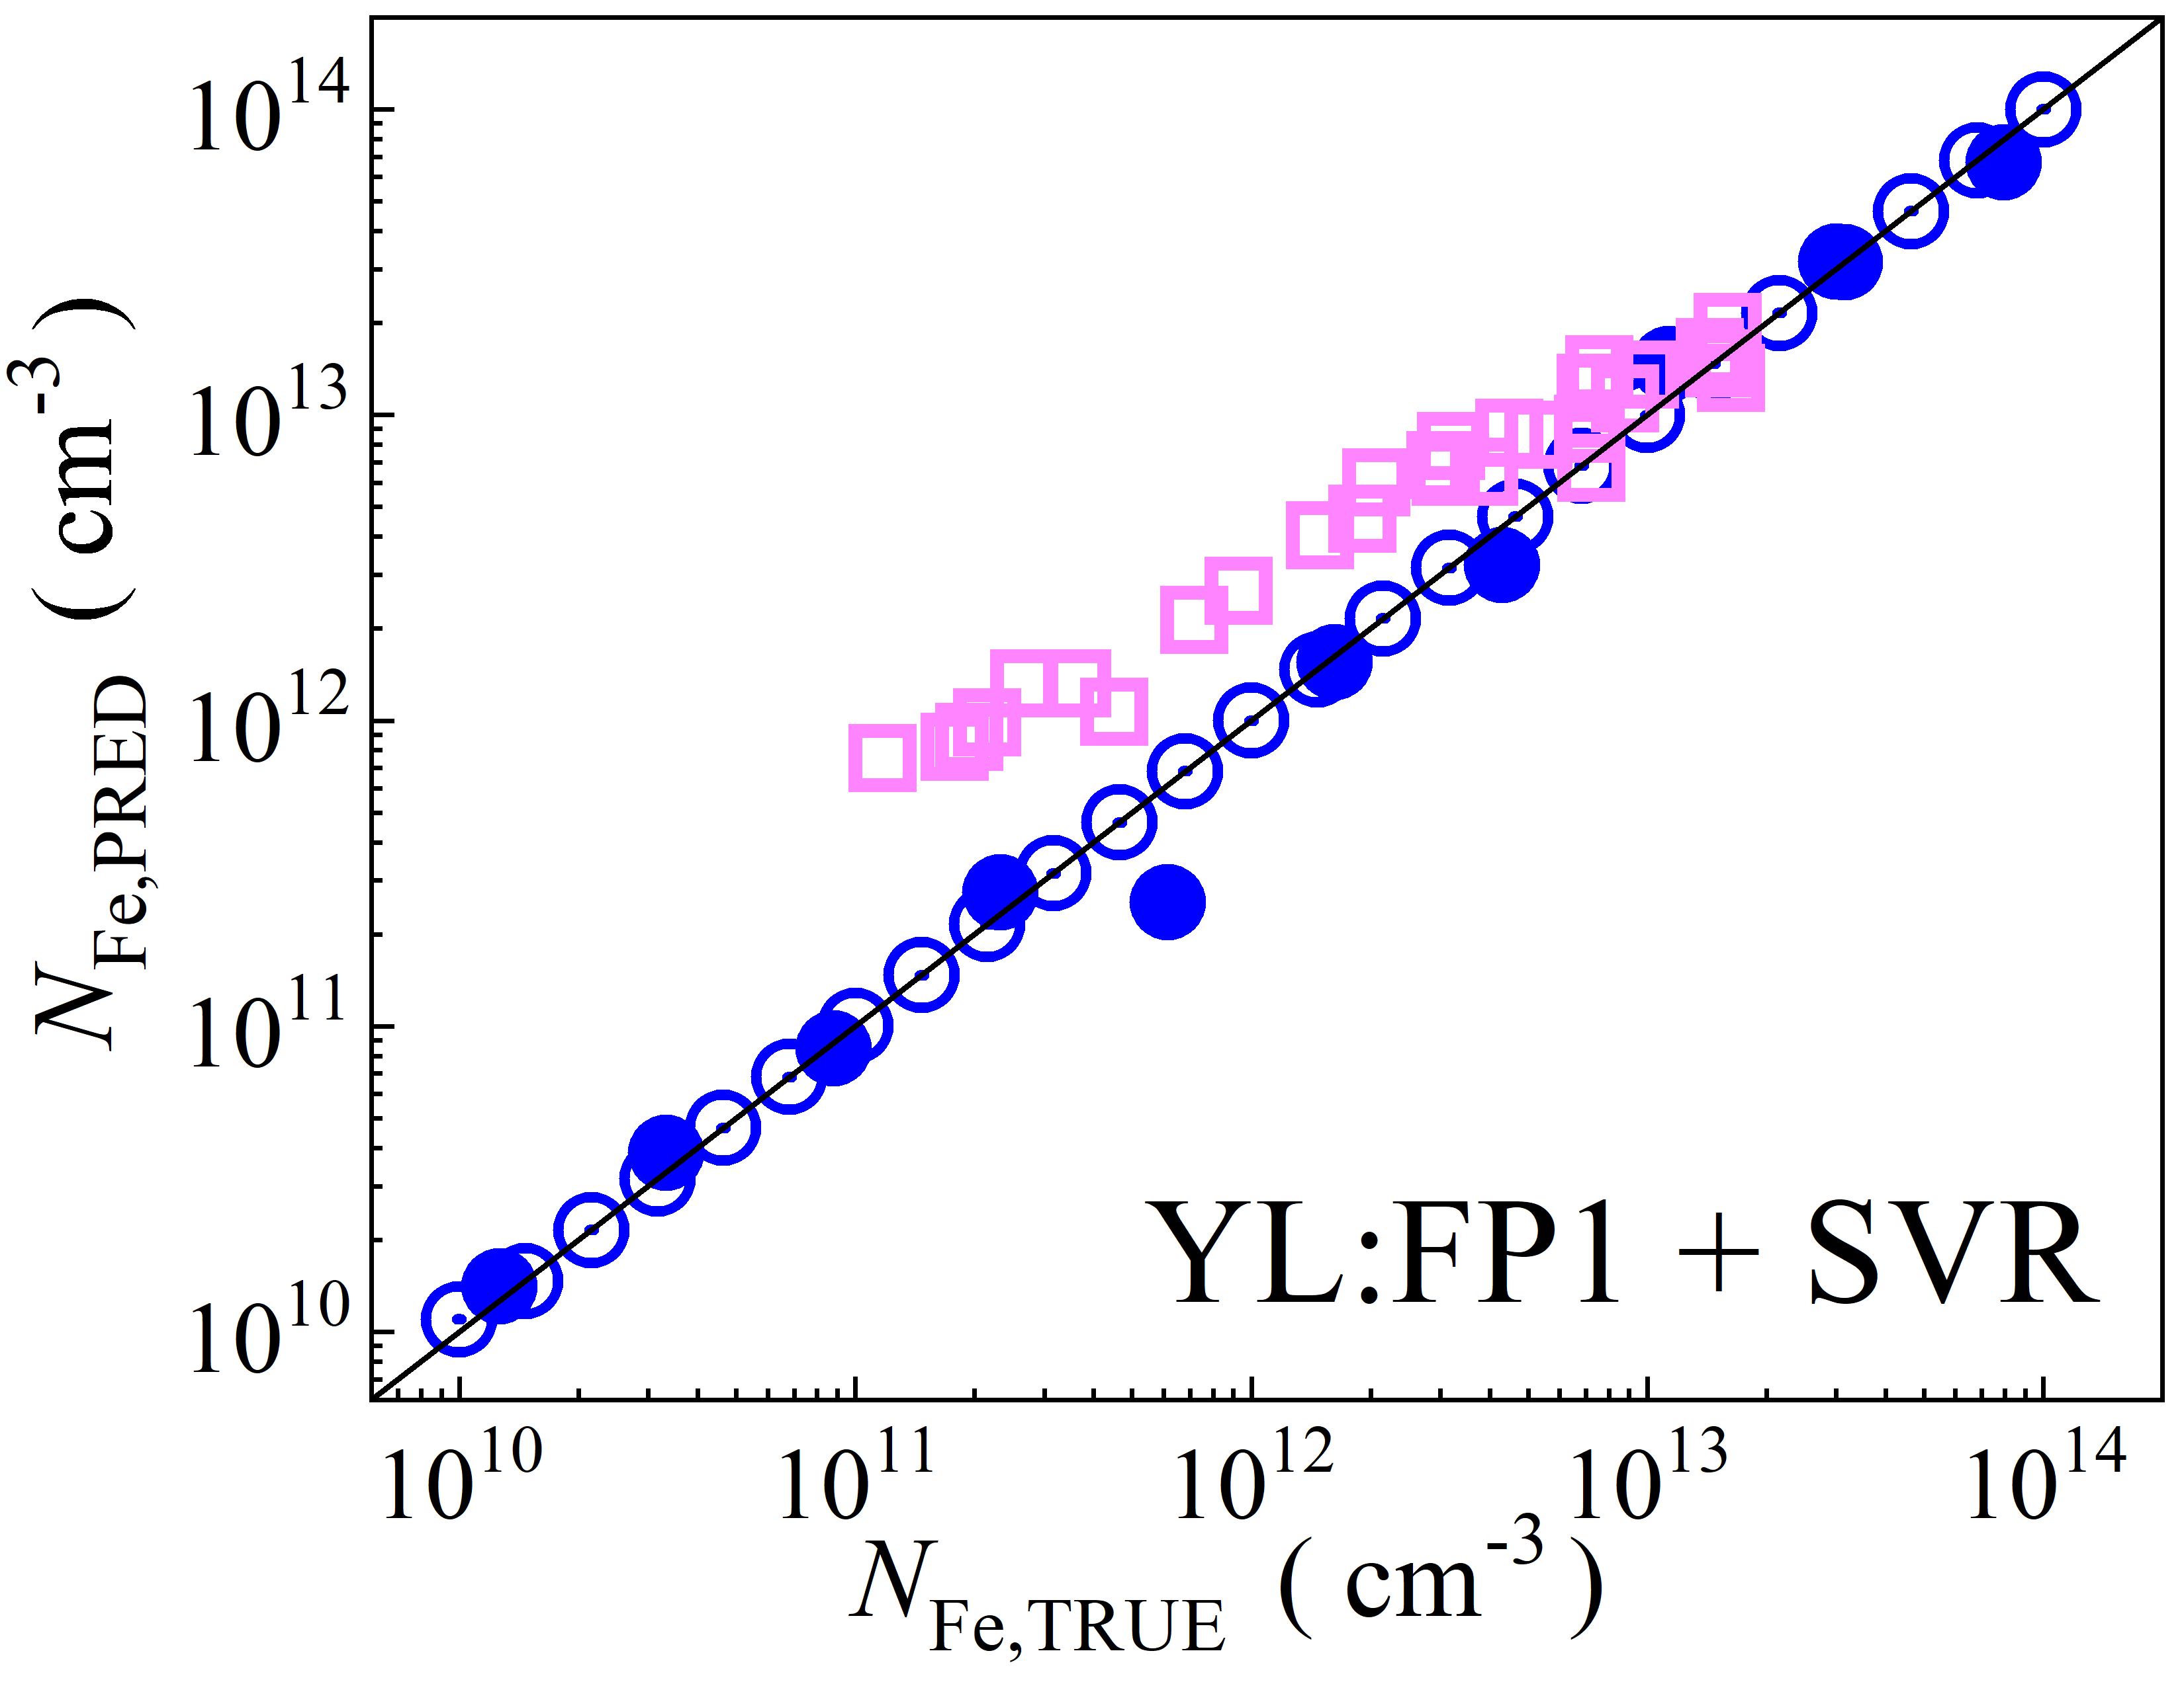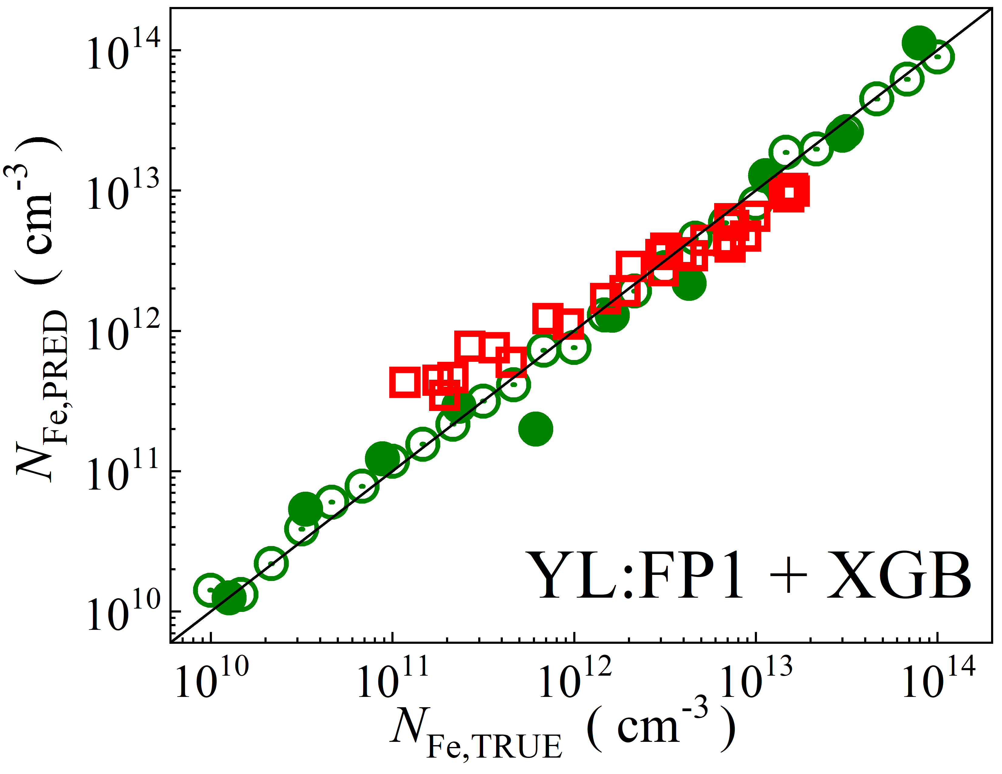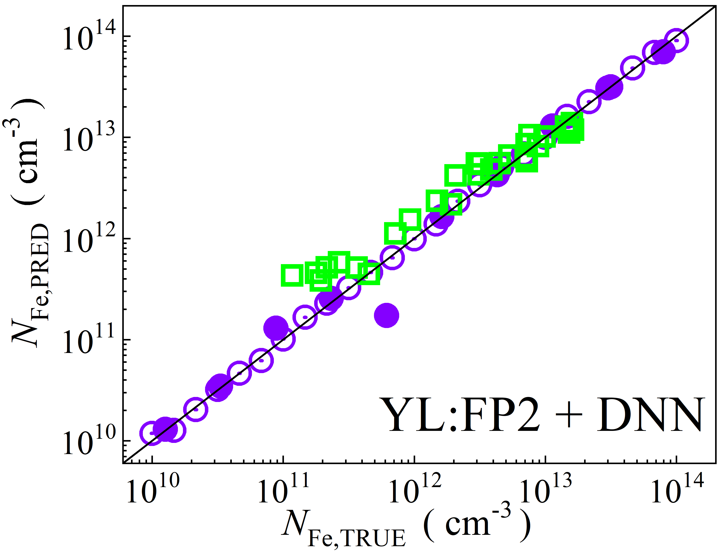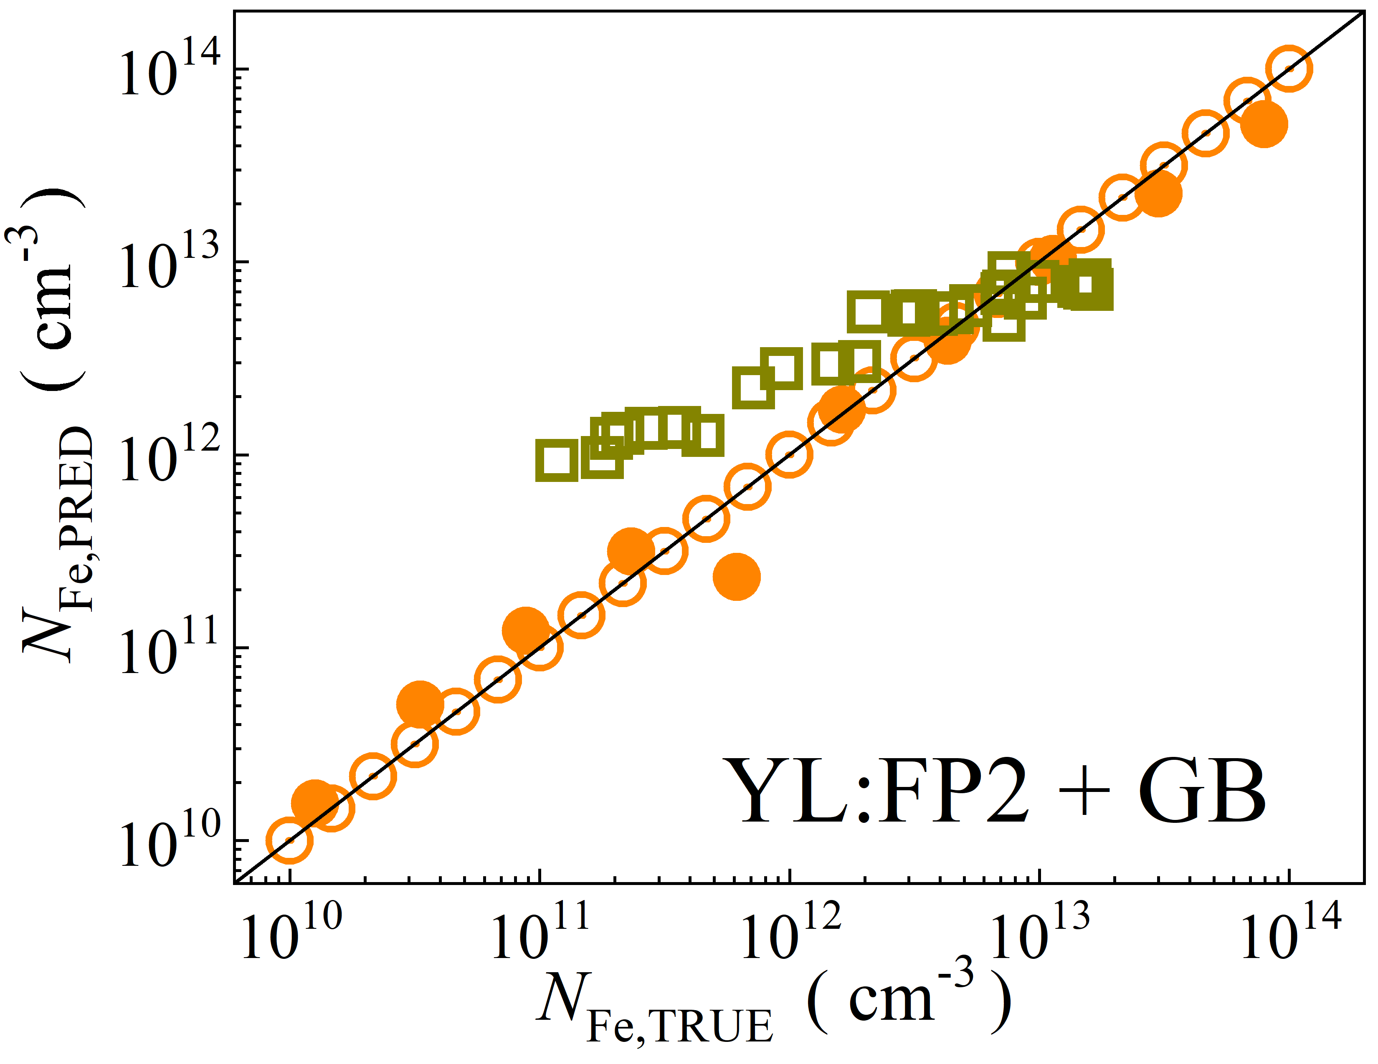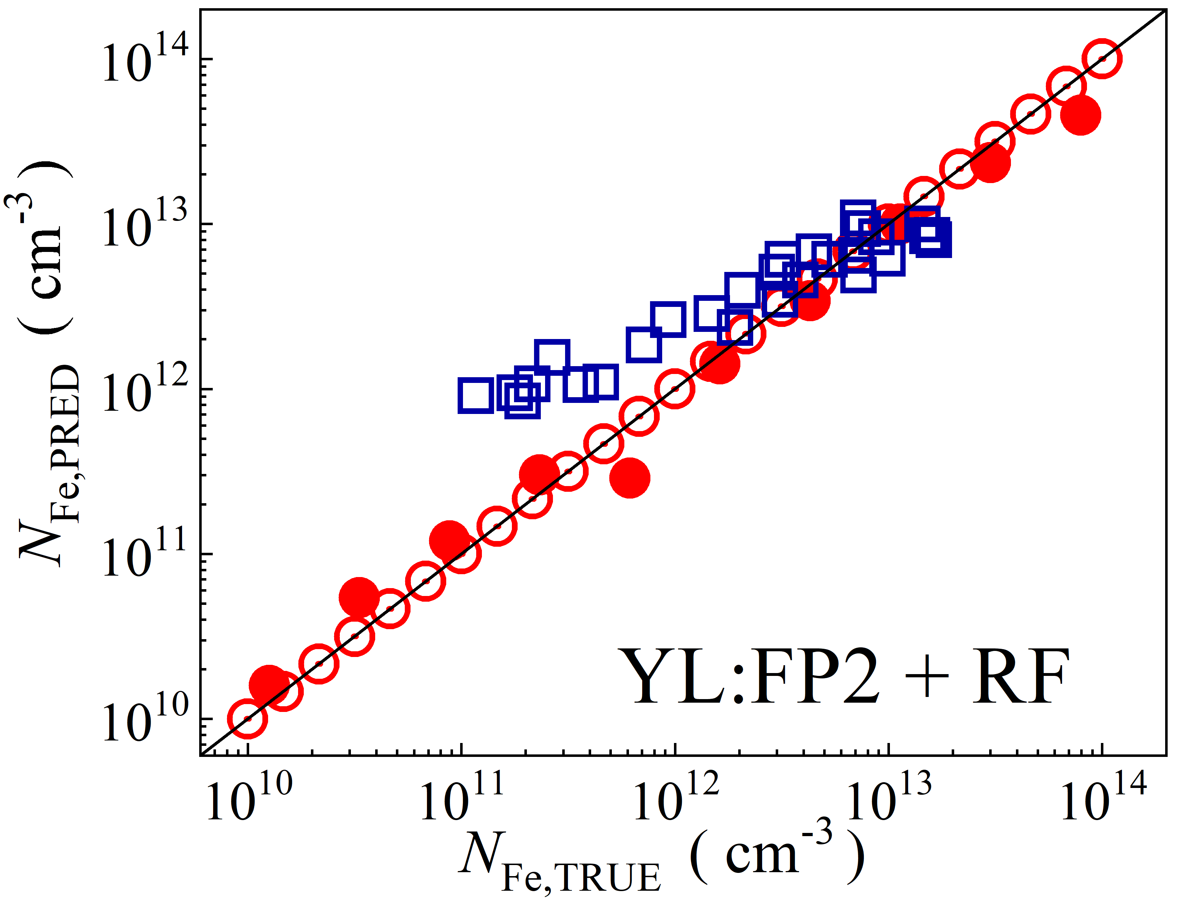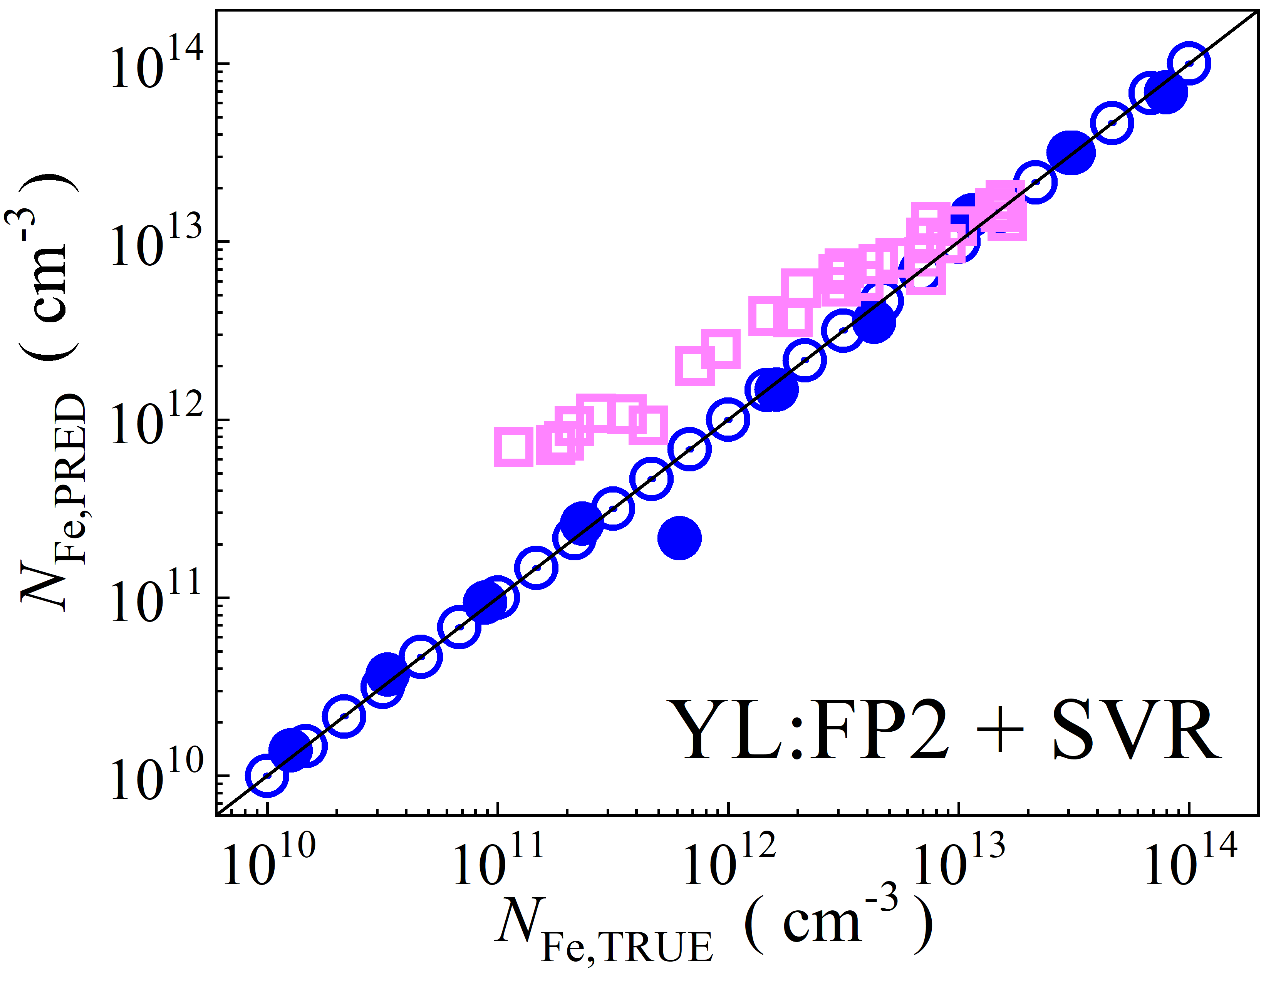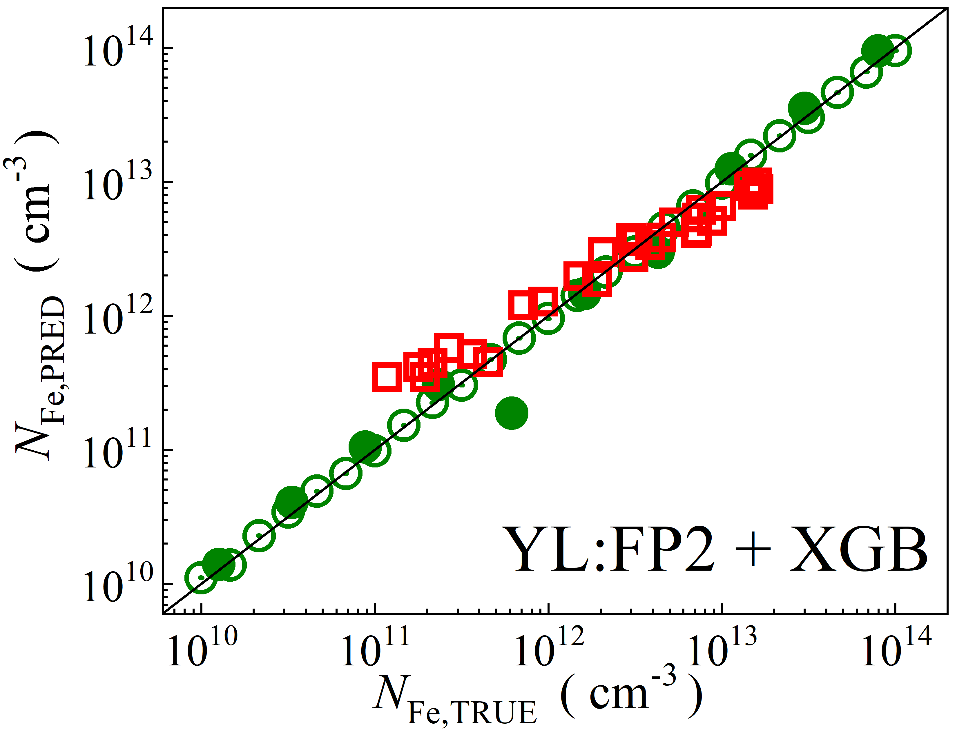

Fig. S1. Scatter plots compare the reference iron *N*Fe,TRUE with ML-predicted values *N*Fe,PRED obtained using feature vectors extracted from various computer vision models combined with different regression algorithms. The ML models were trained on a simulated dataset. The open circles correspond to the training phase, while the filled circles and open squares correspond to the test phase, representing the simulated and experimental datasets, respectively. The black lines are the identified lines serving as the references.

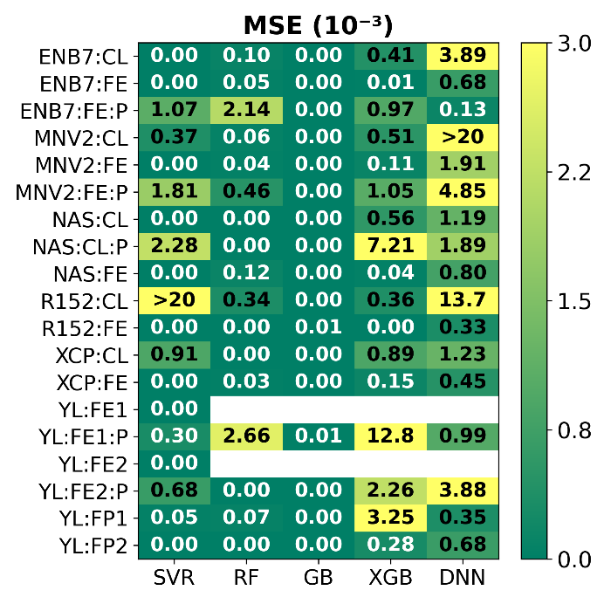

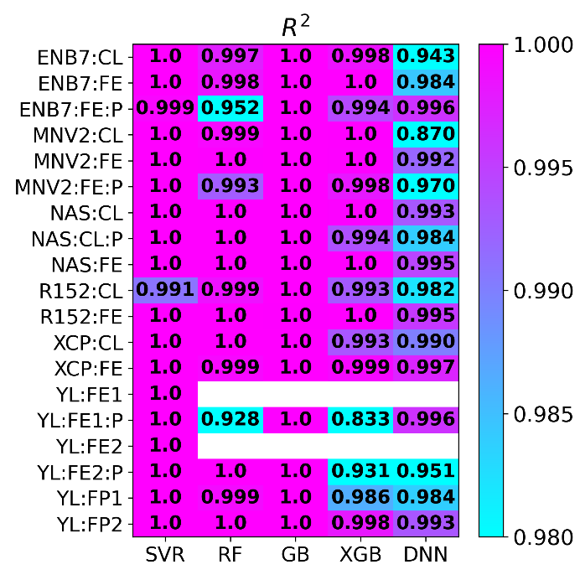

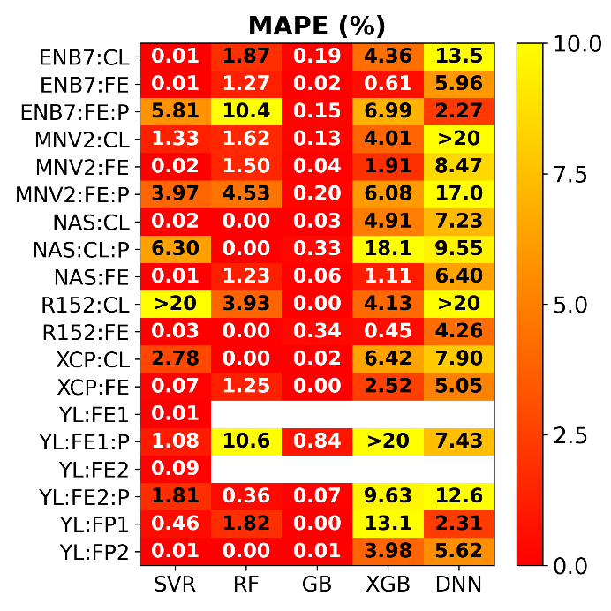

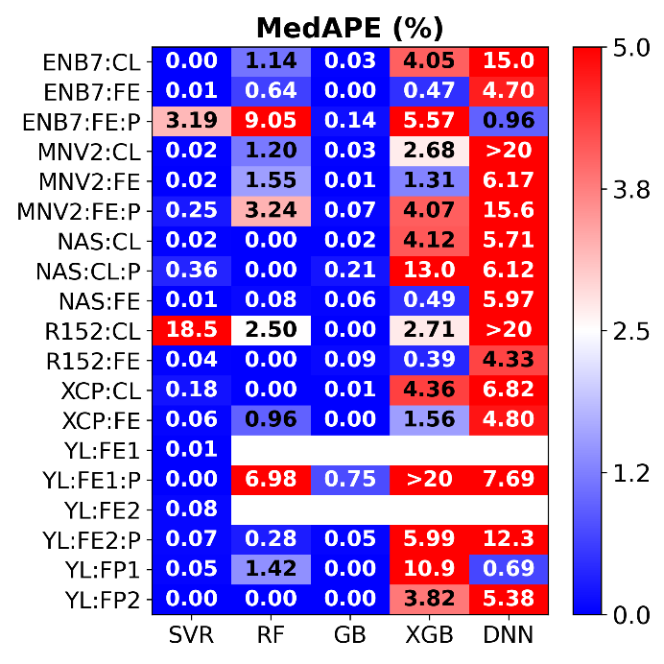

Fig. S2. Mean squared error, coefficient of determination, mean absolute percentage error, and median absolute percentage error for different combinations of computer vision models (vertical axis) and regression models (horizontal axis) during the **training** phase. The models were trained on a **simulated** **dataset**.

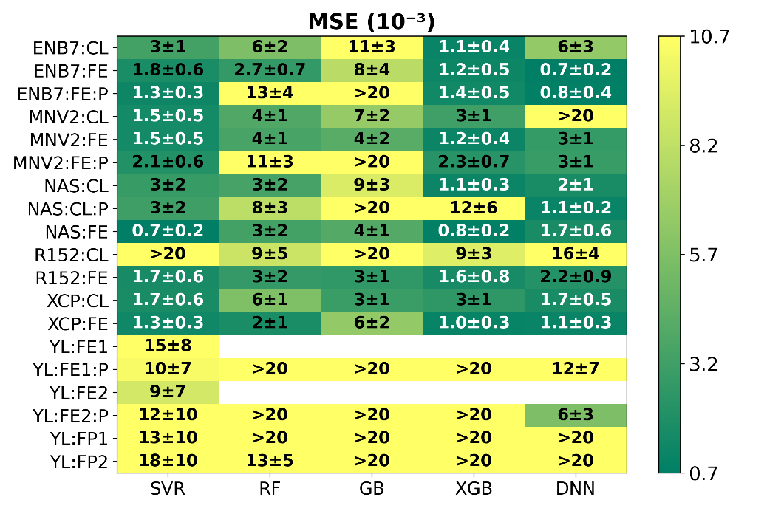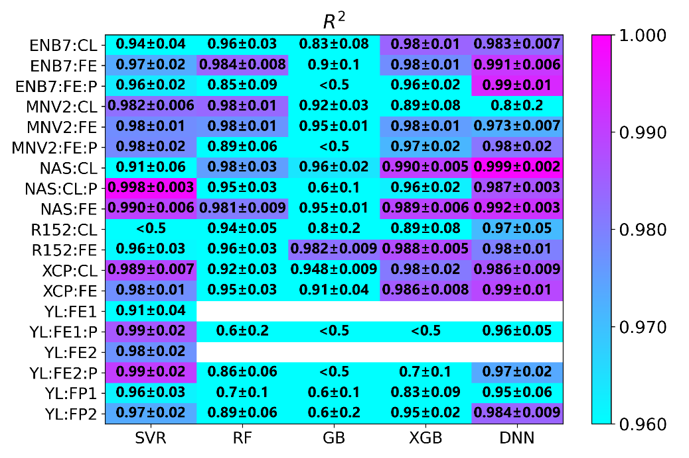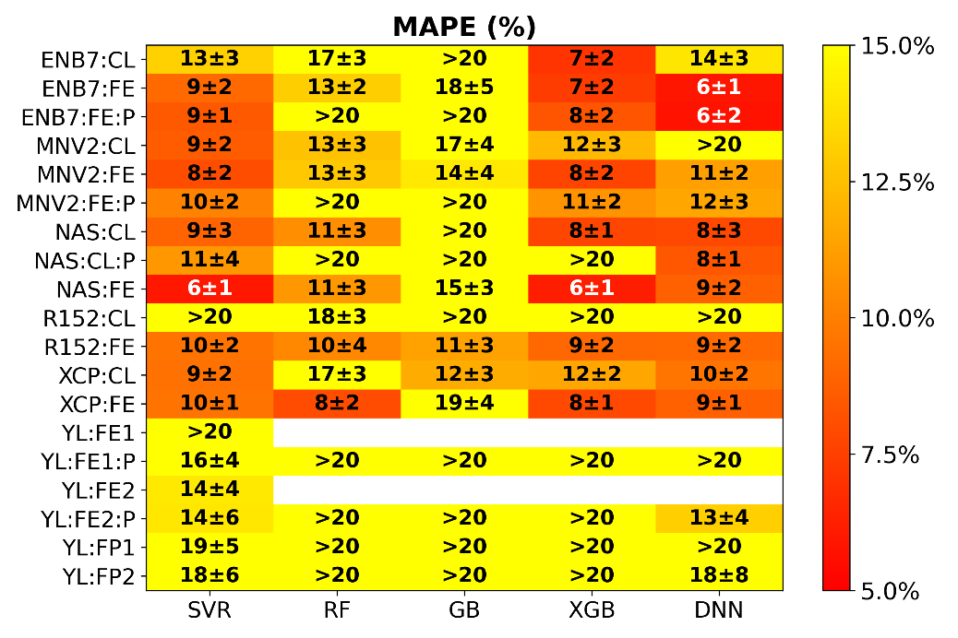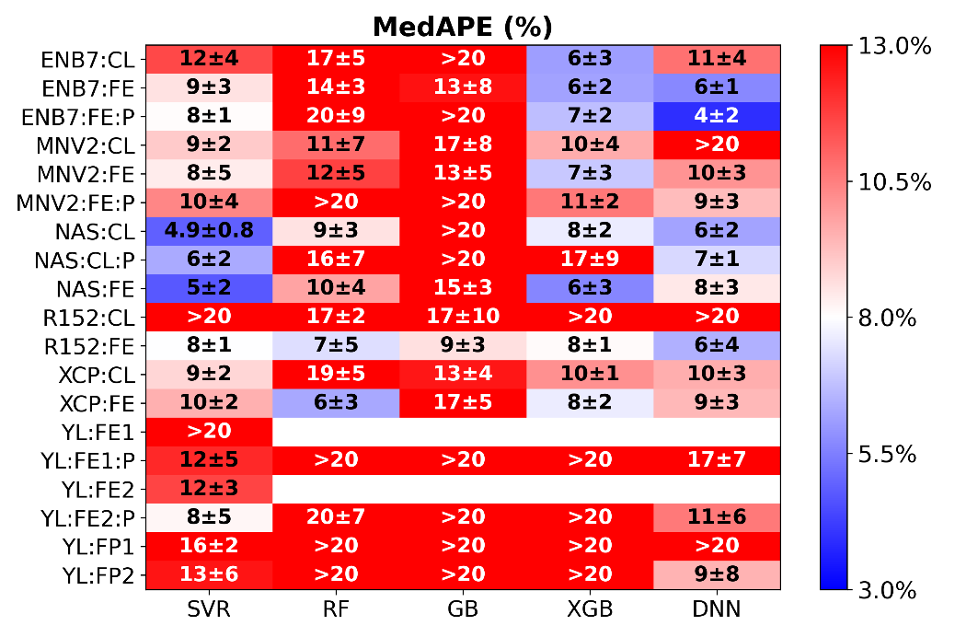

Fig. S3. Mean squared error, coefficient of determination, mean absolute percentage error, and median absolute percentage error for different combinations of computer vision models (vertical axis) and regression models (horizontal axis) during the **test** **phase with simulated** dataset. The models were trained on a **simulated** **dataset**.

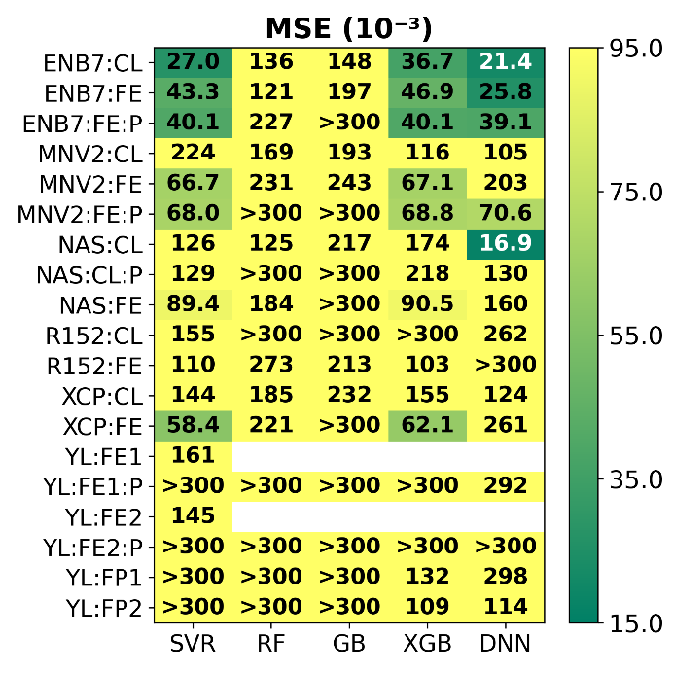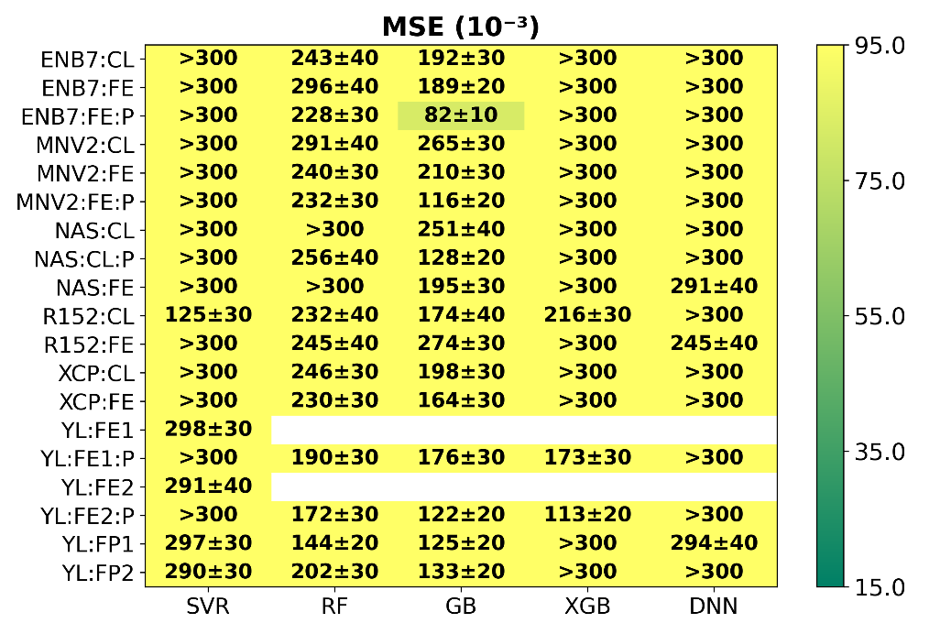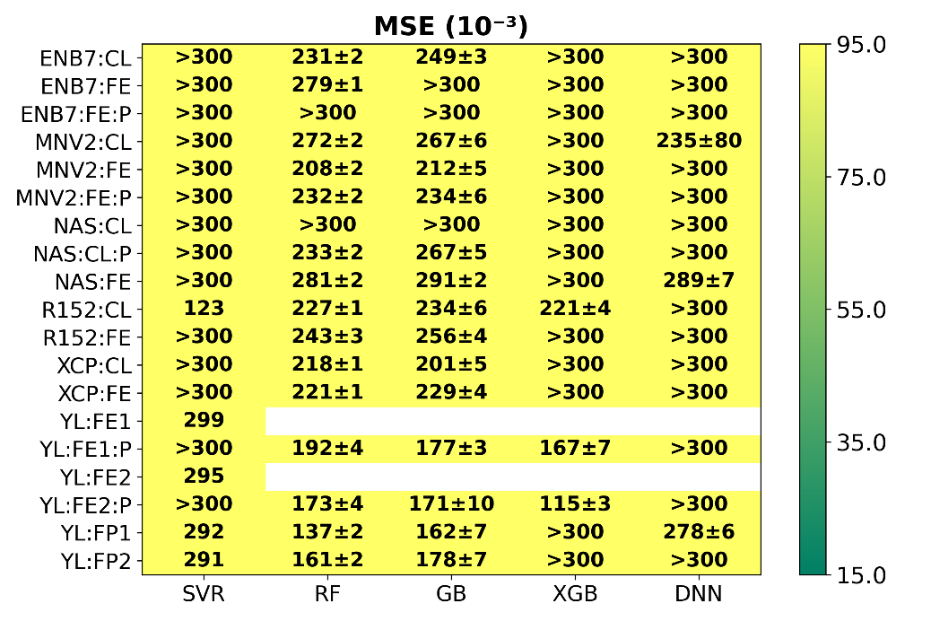

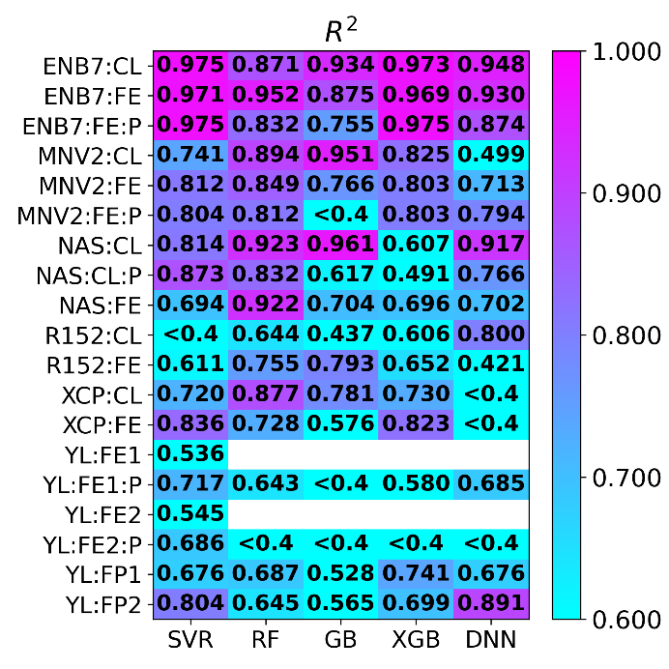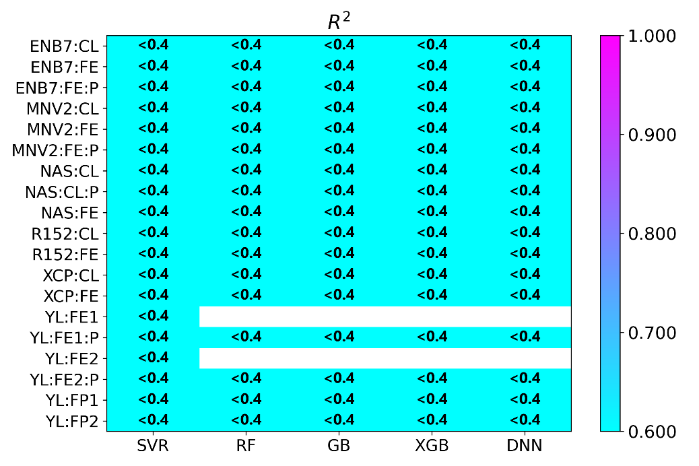8

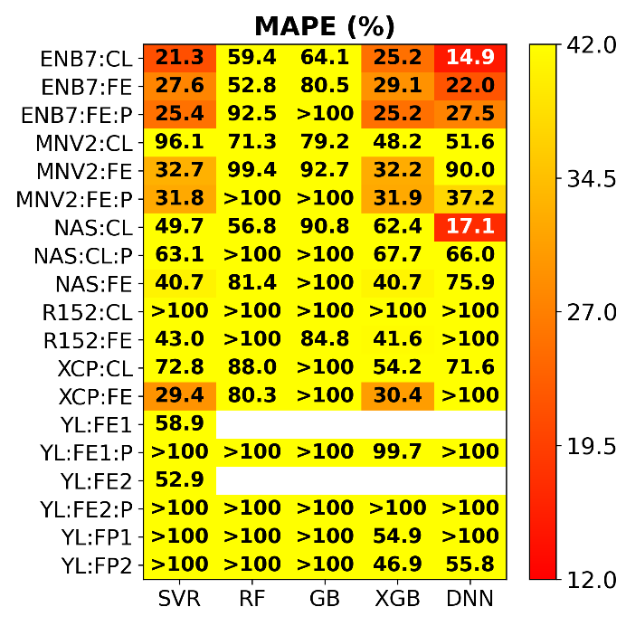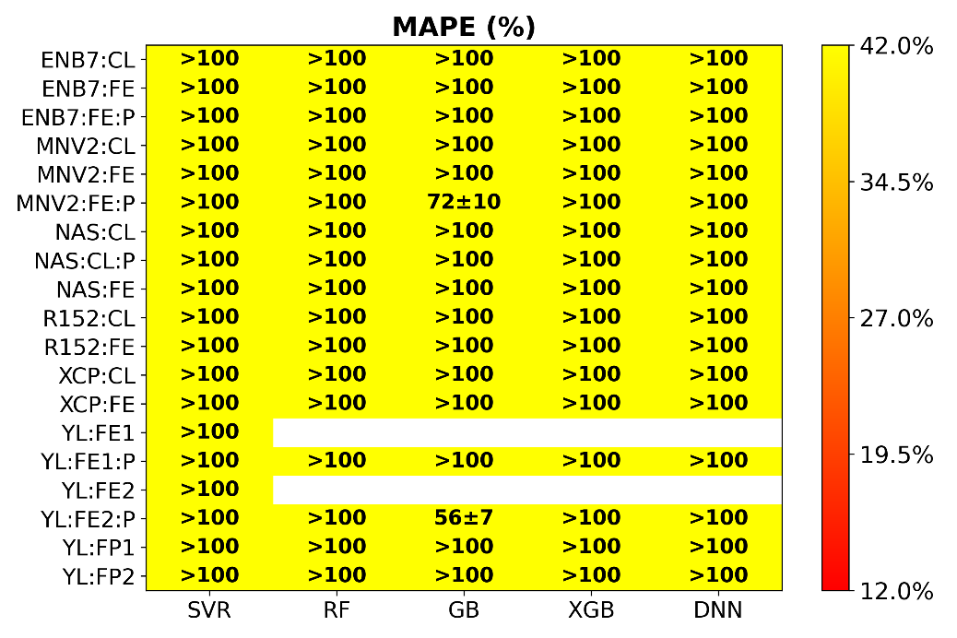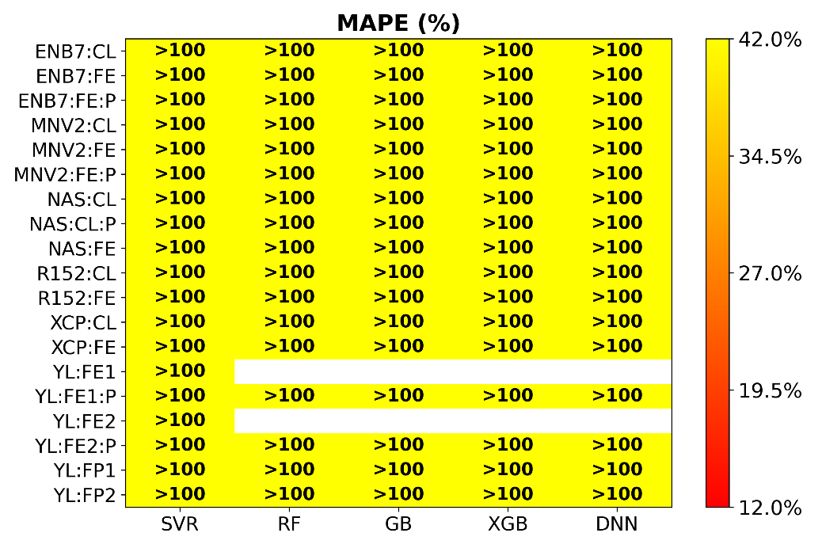

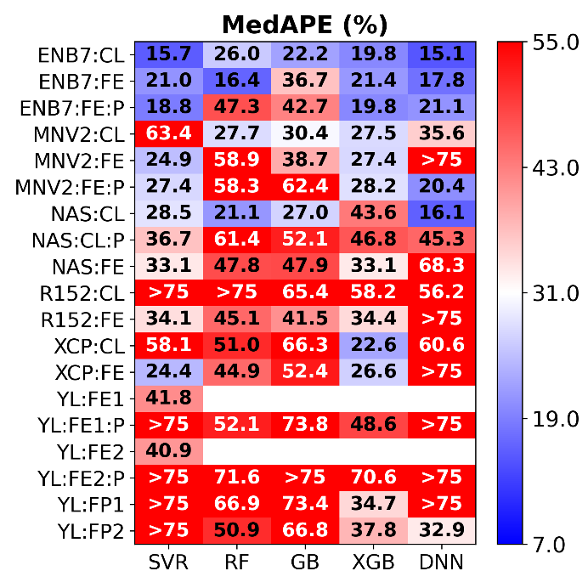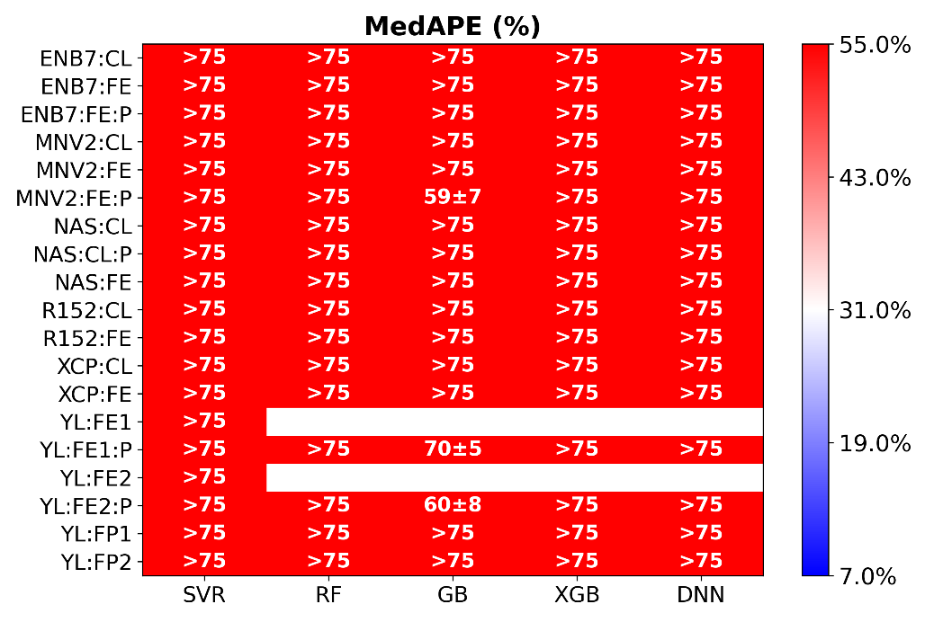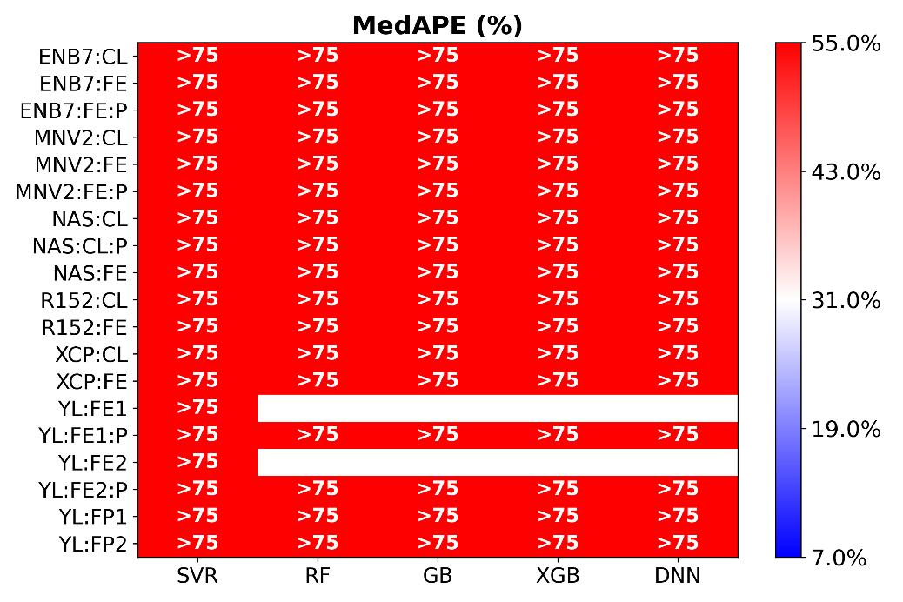

Fig. S4. Mean squared error, coefficient of determination, mean absolute percentage error, and median absolute percentage error for different combinations of computer vision models (vertical axis) and regression models (horizontal axis) during the **test** **phase with experimental** dataset **without post-hoc calibration**. The models were trained on a **simulated** **dataset**.

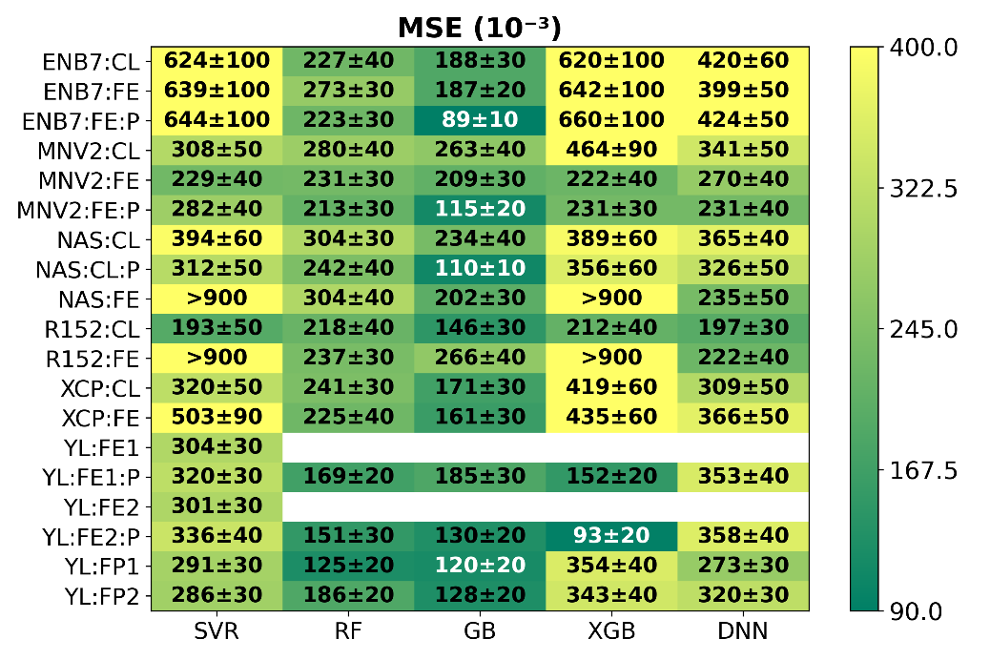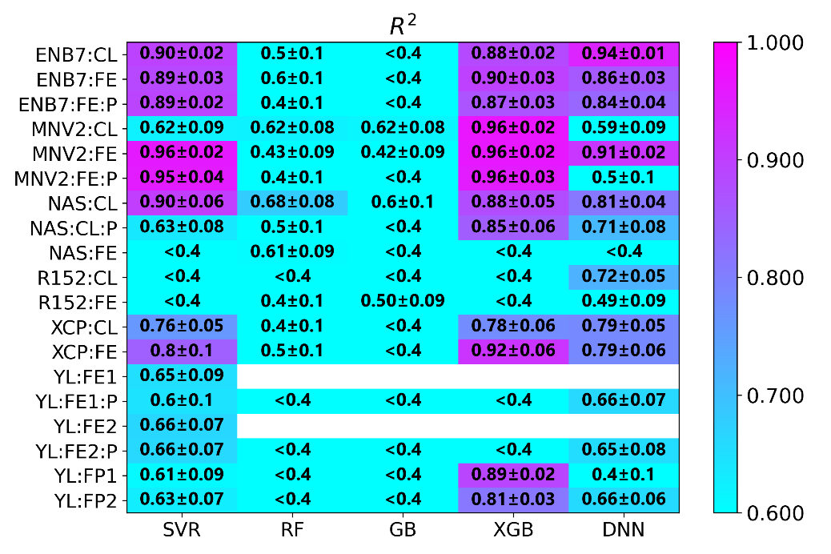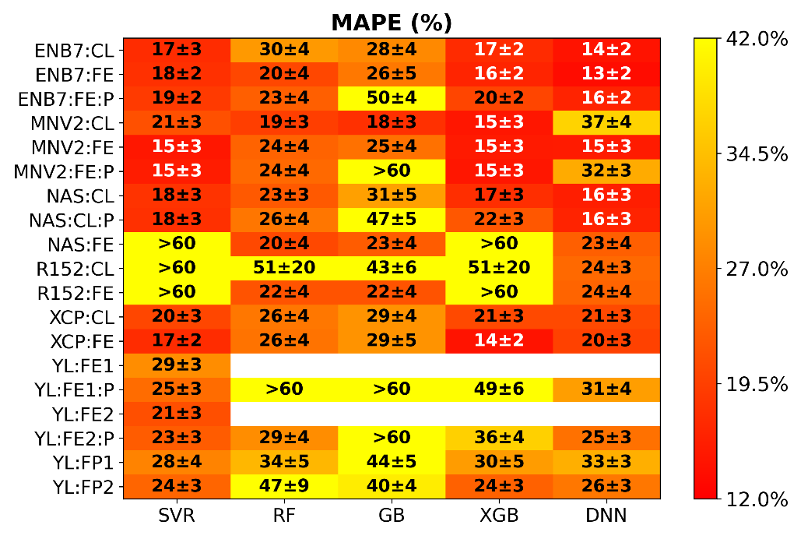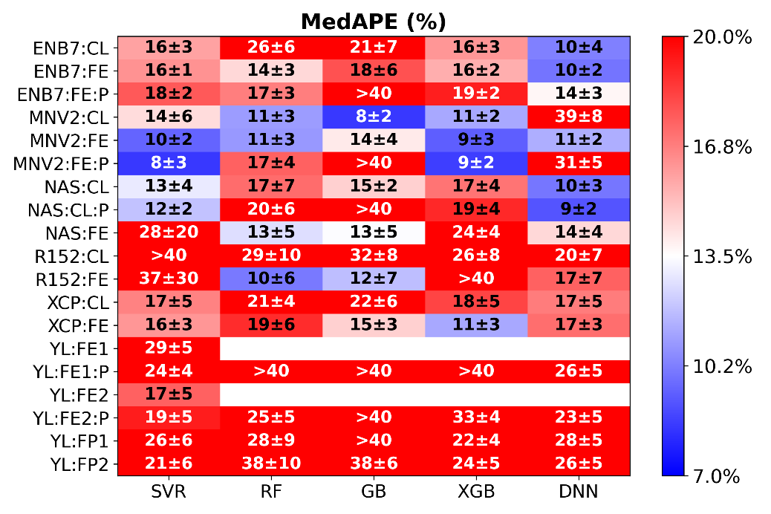

Fig. S5. Mean squared error, coefficient of determination, mean absolute percentage error, and median absolute percentage error for different combinations of computer vision models (vertical axis) and regression models (horizontal axis) during the **test** **phase with experimental** dataset **with post-hoc calibration**. The models were trained on a **simulated** **dataset**.

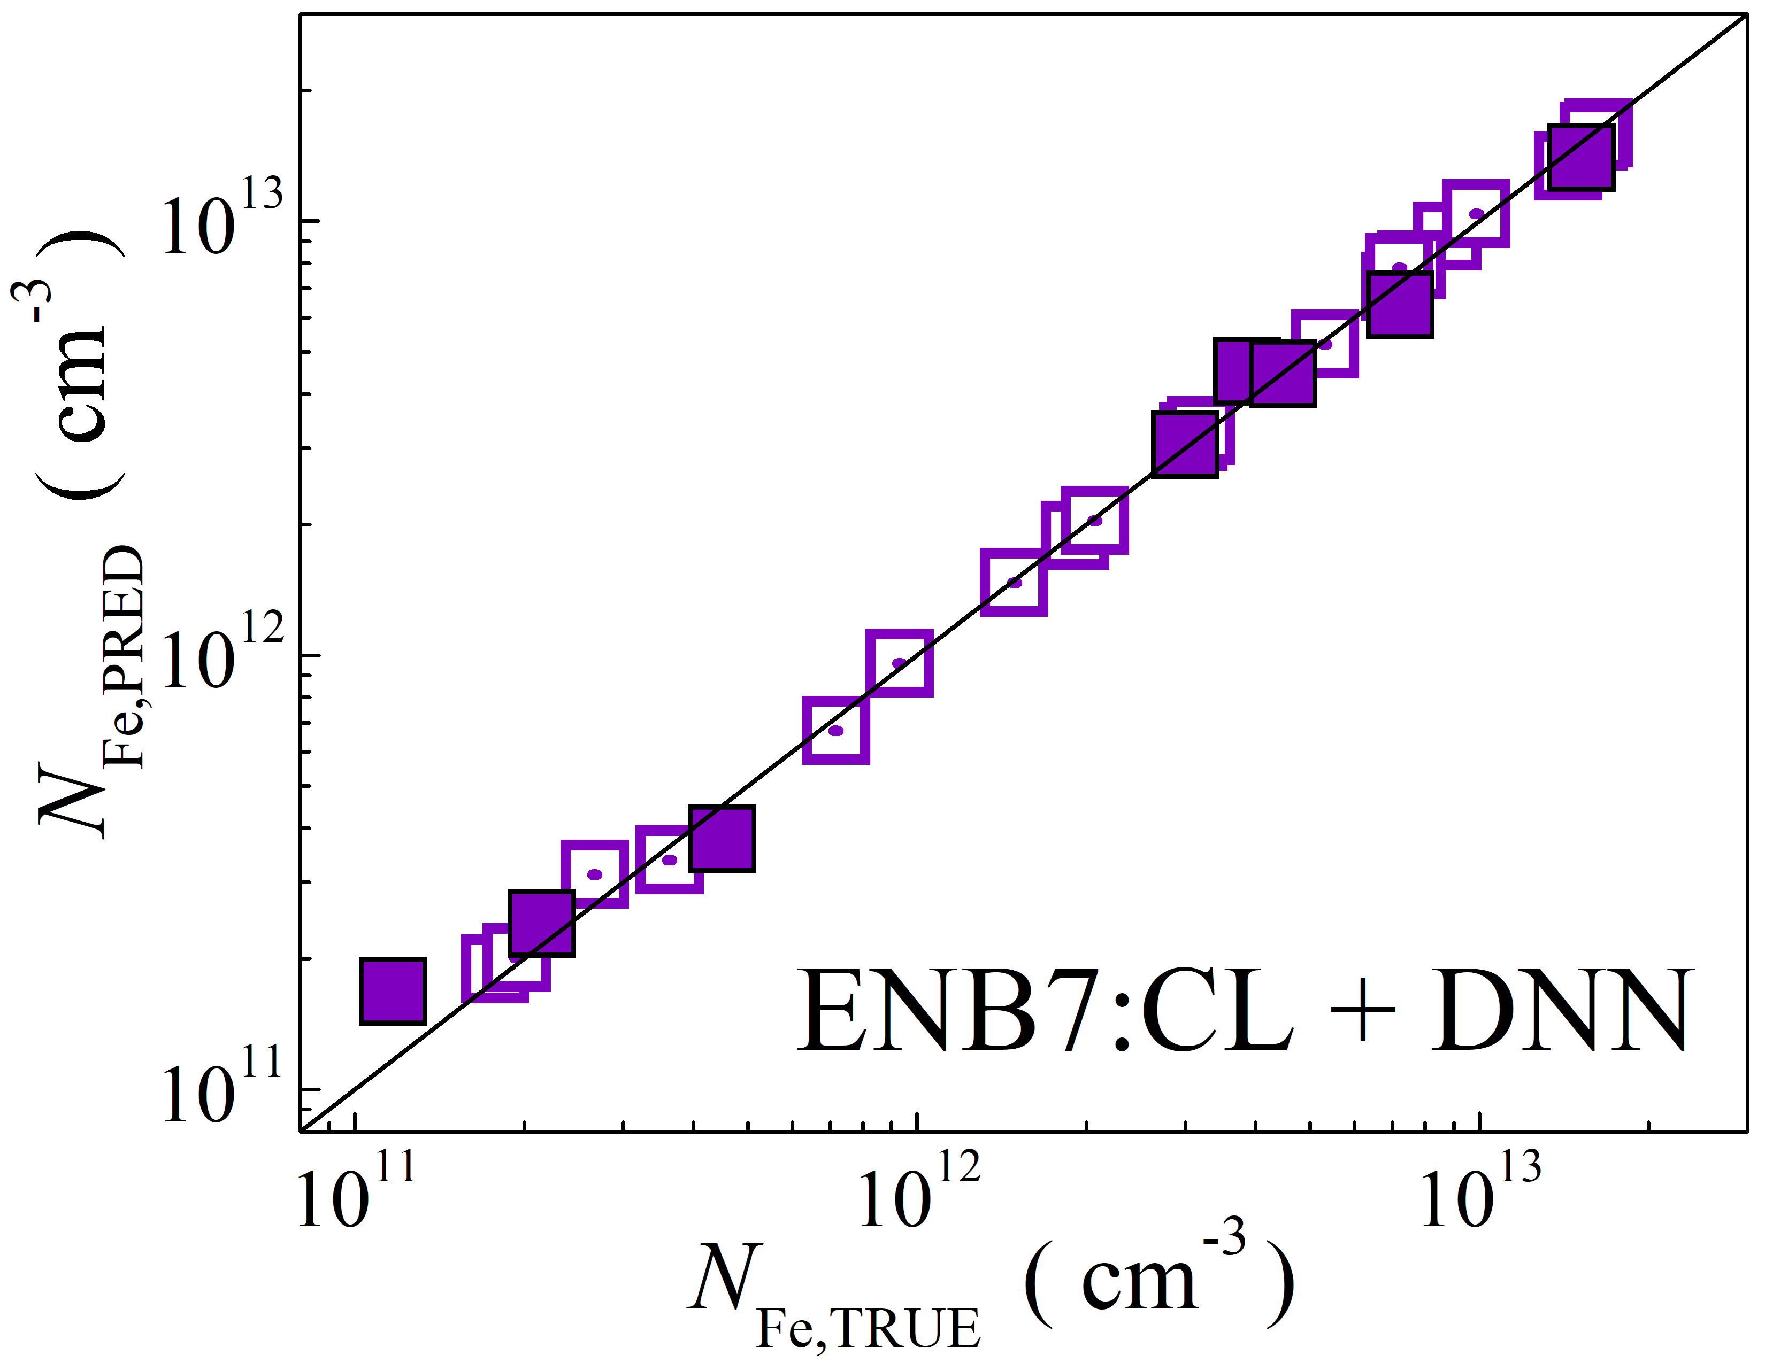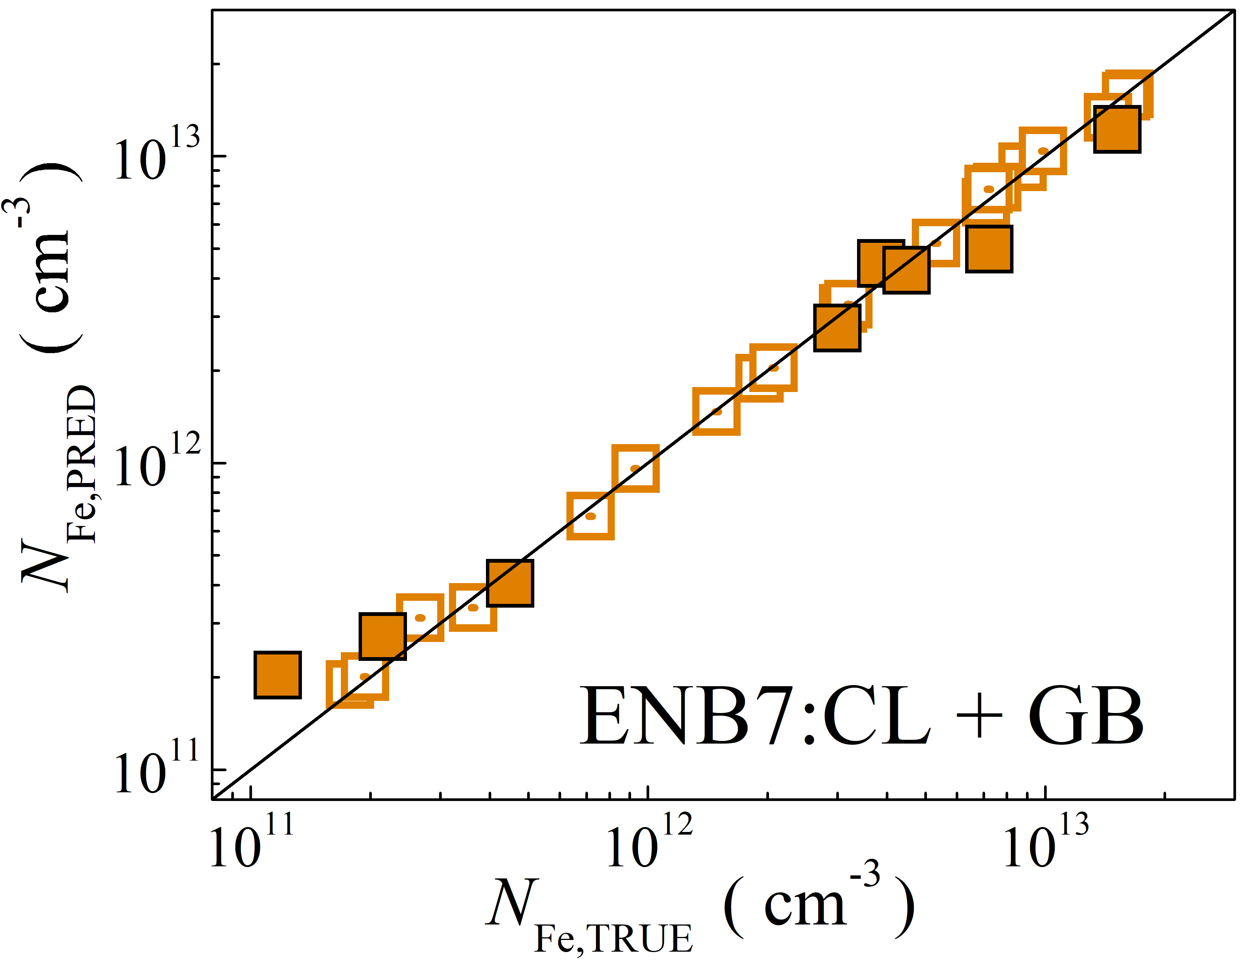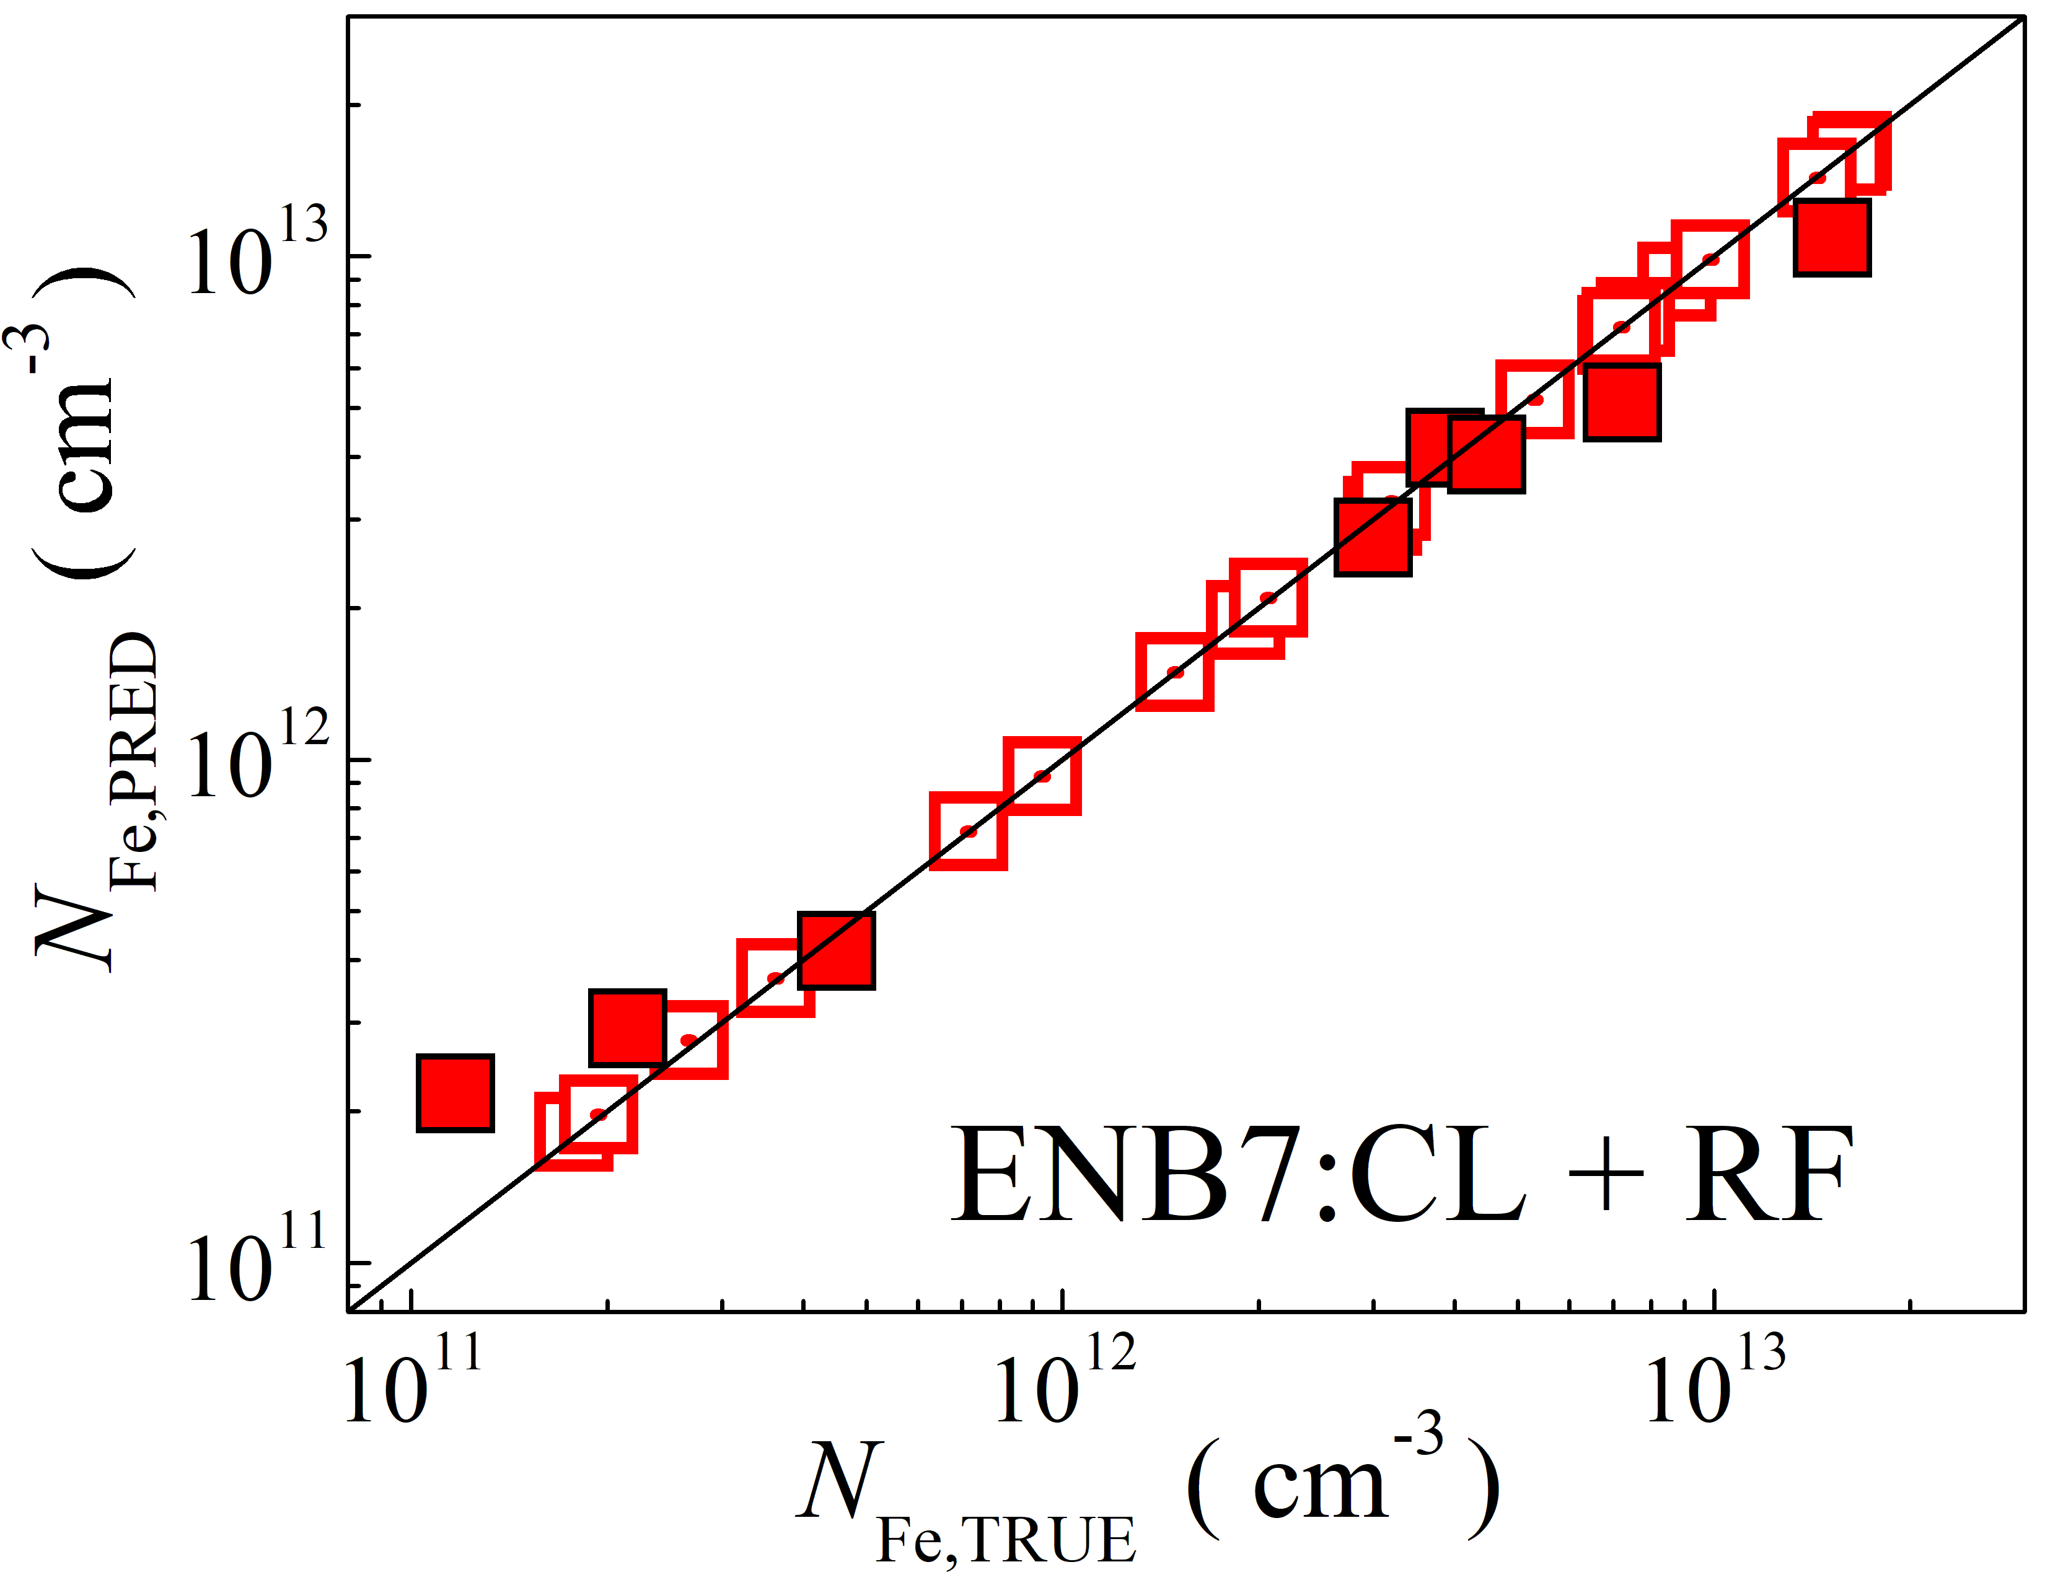

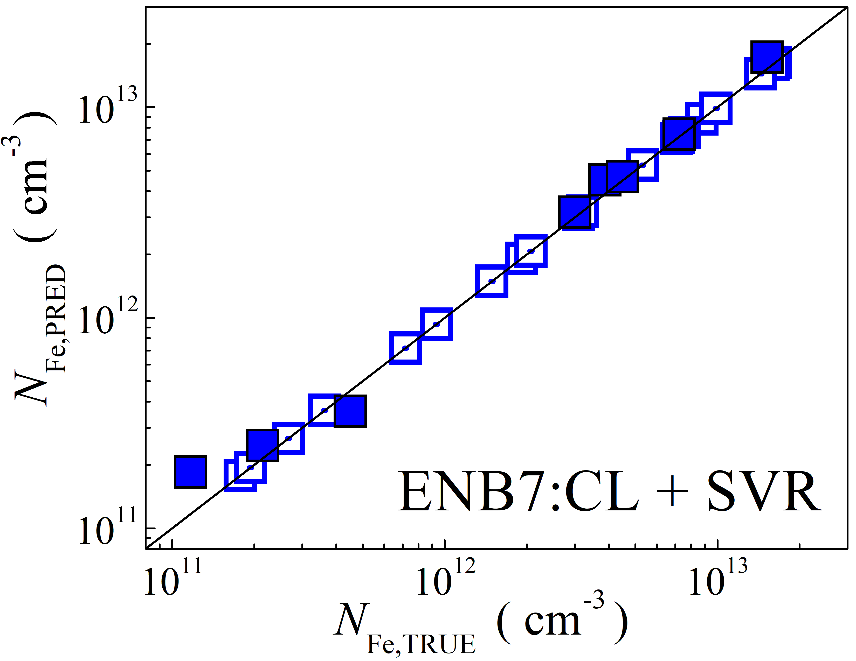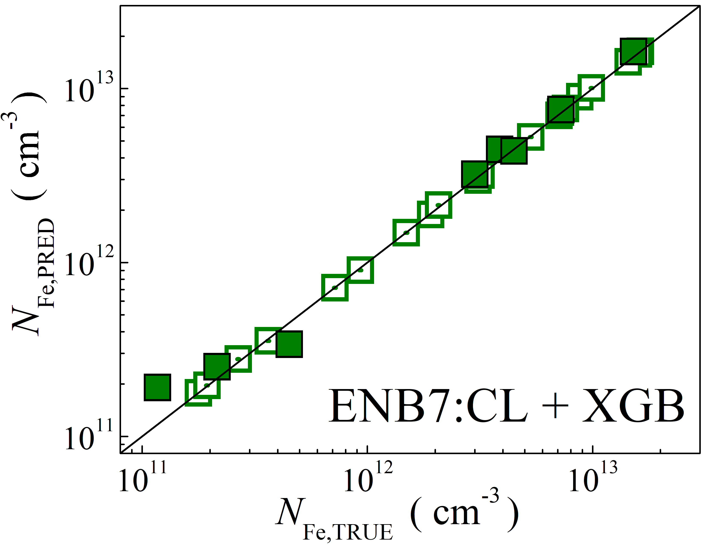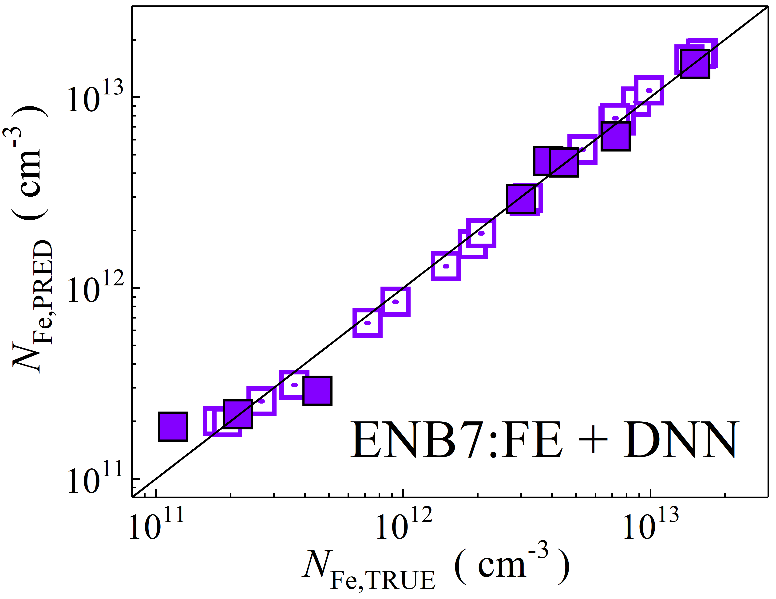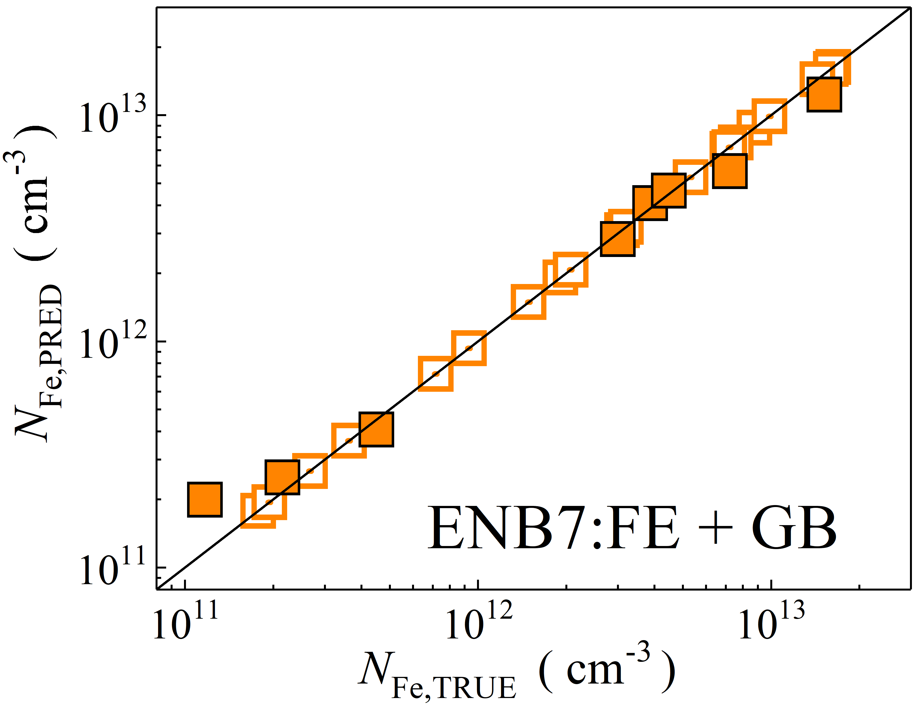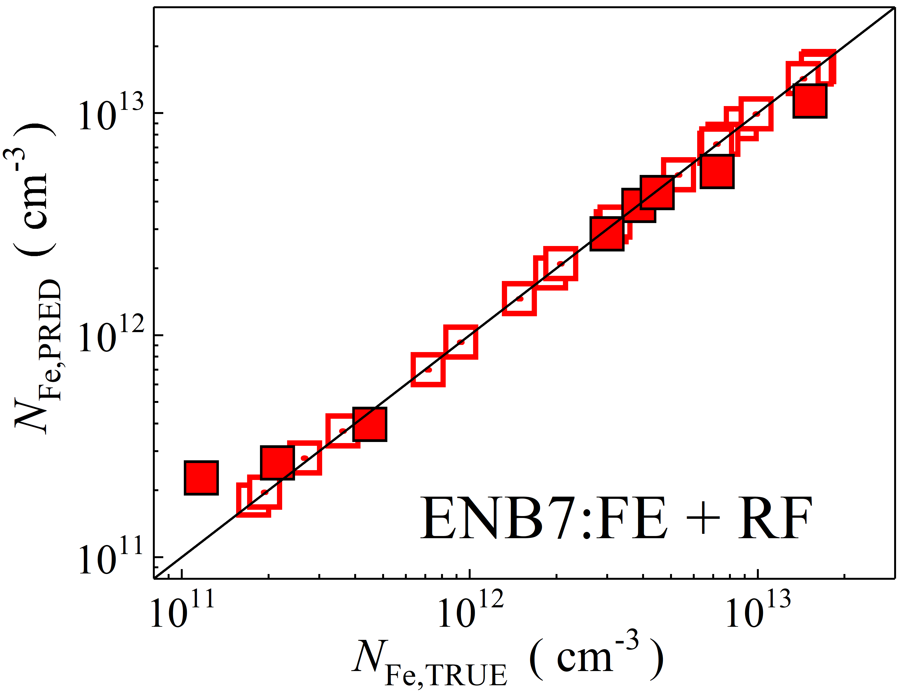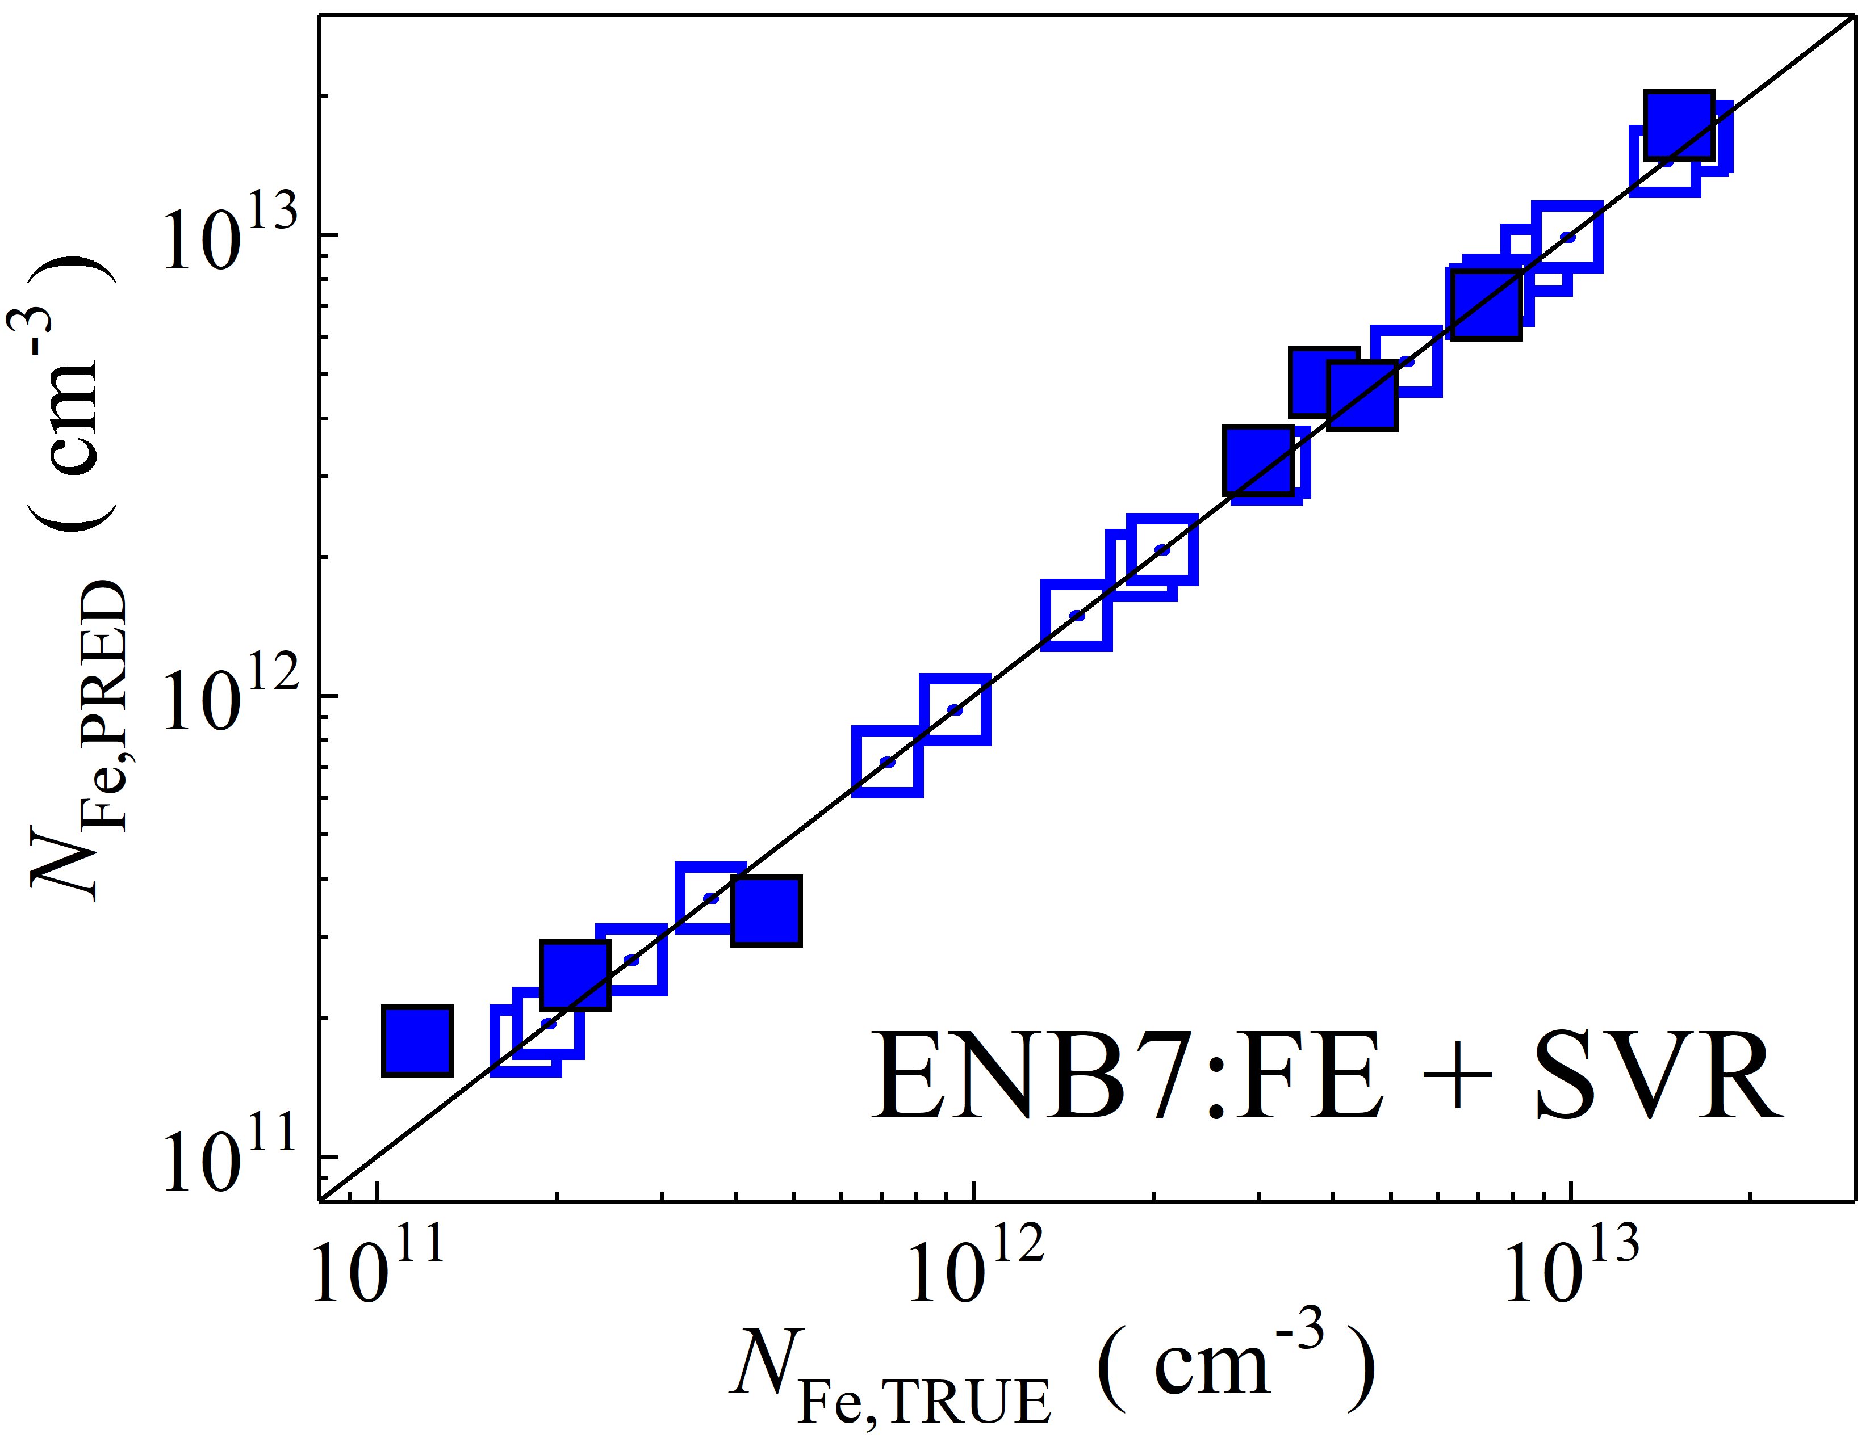

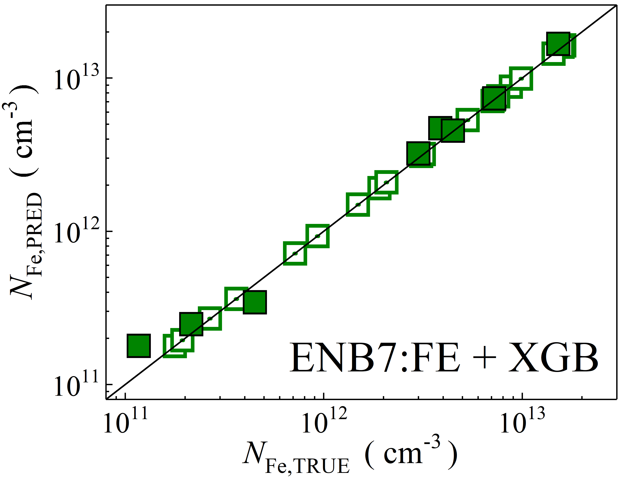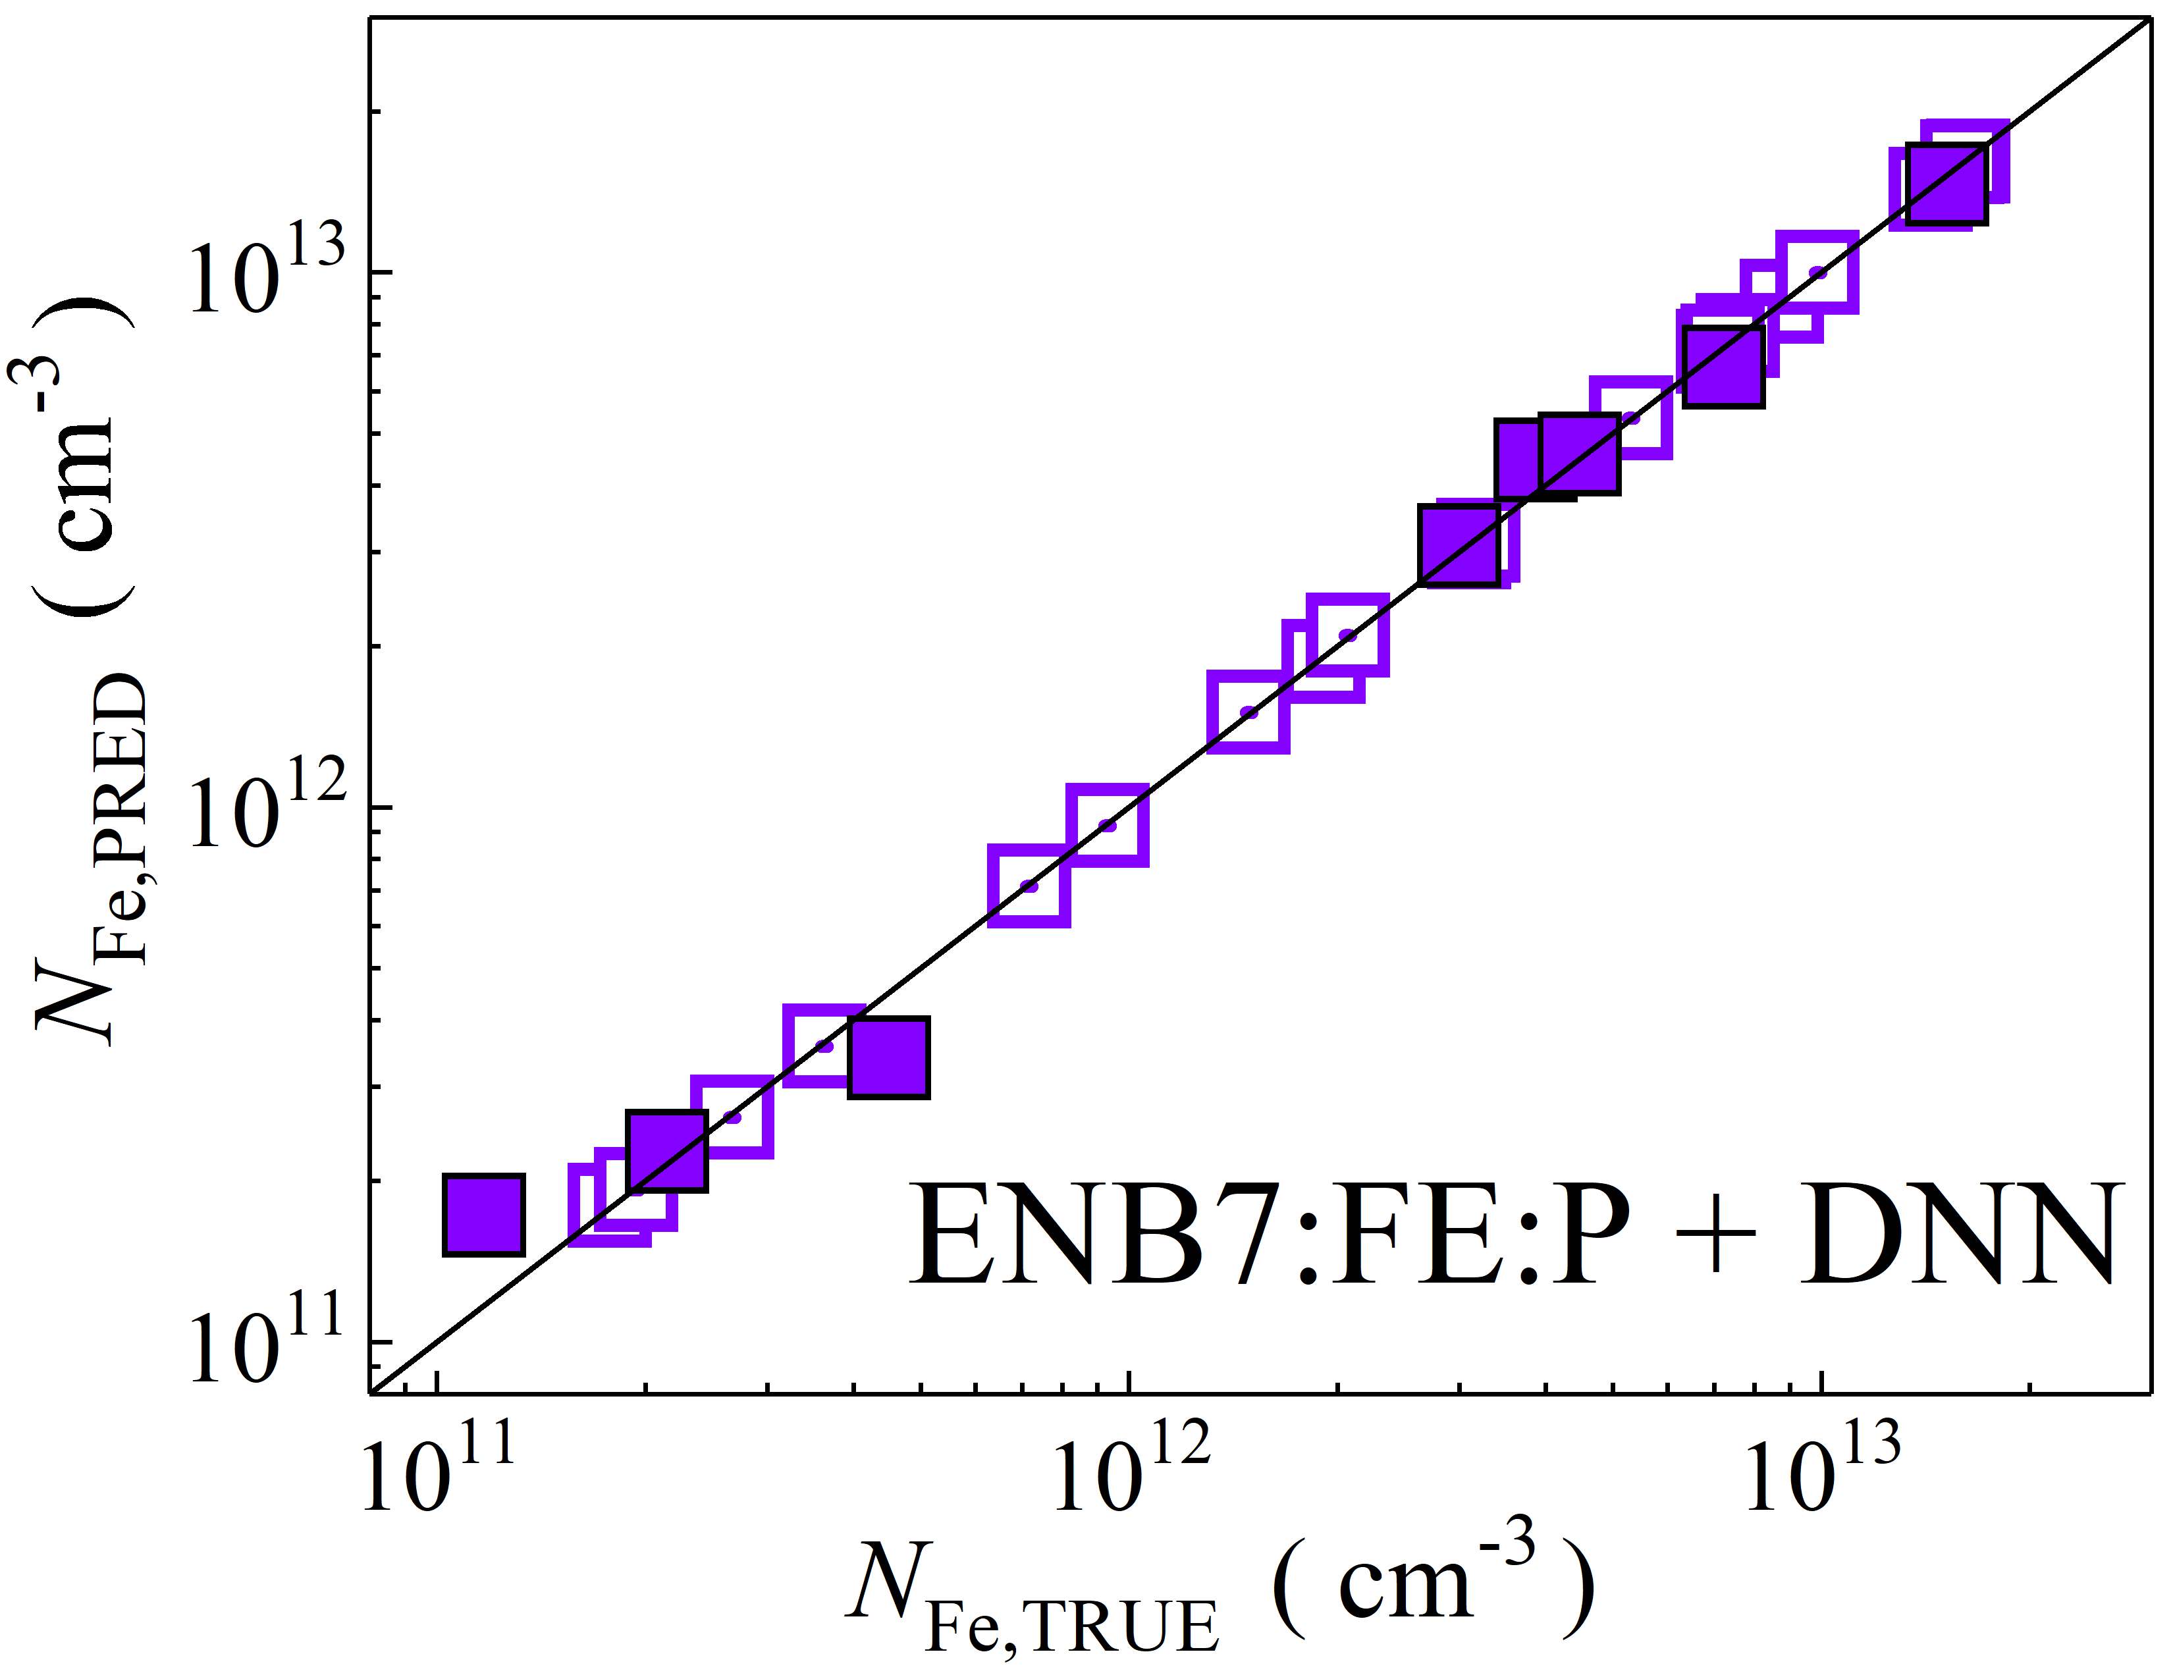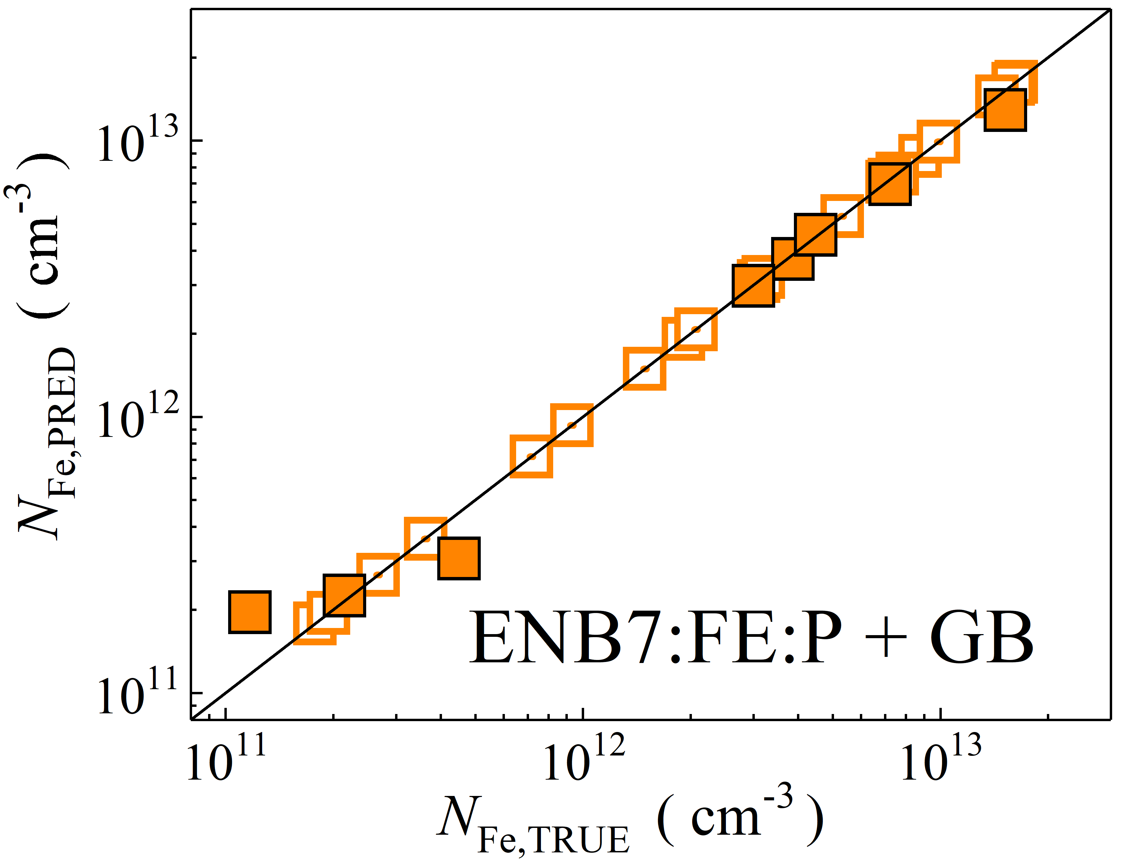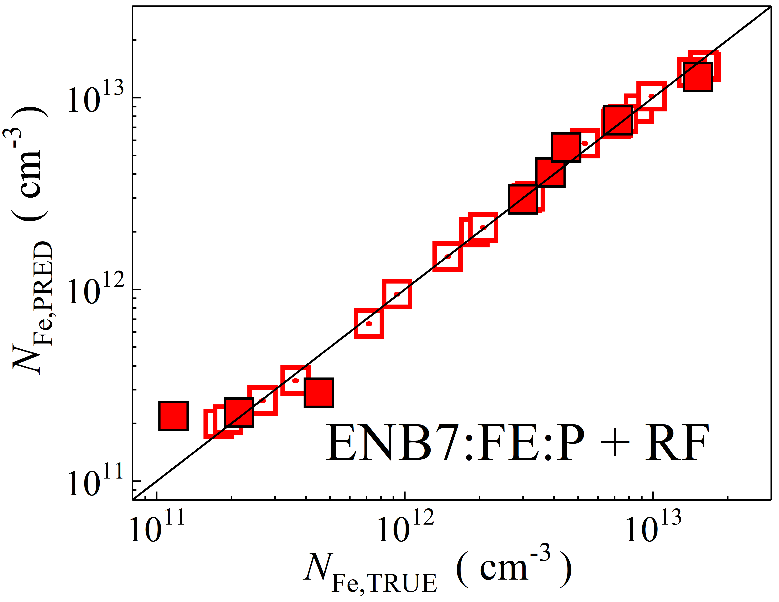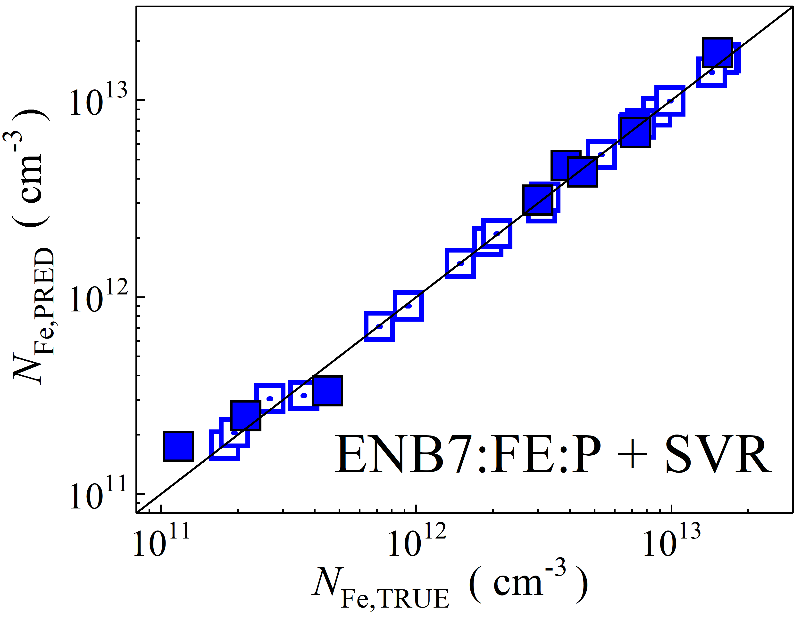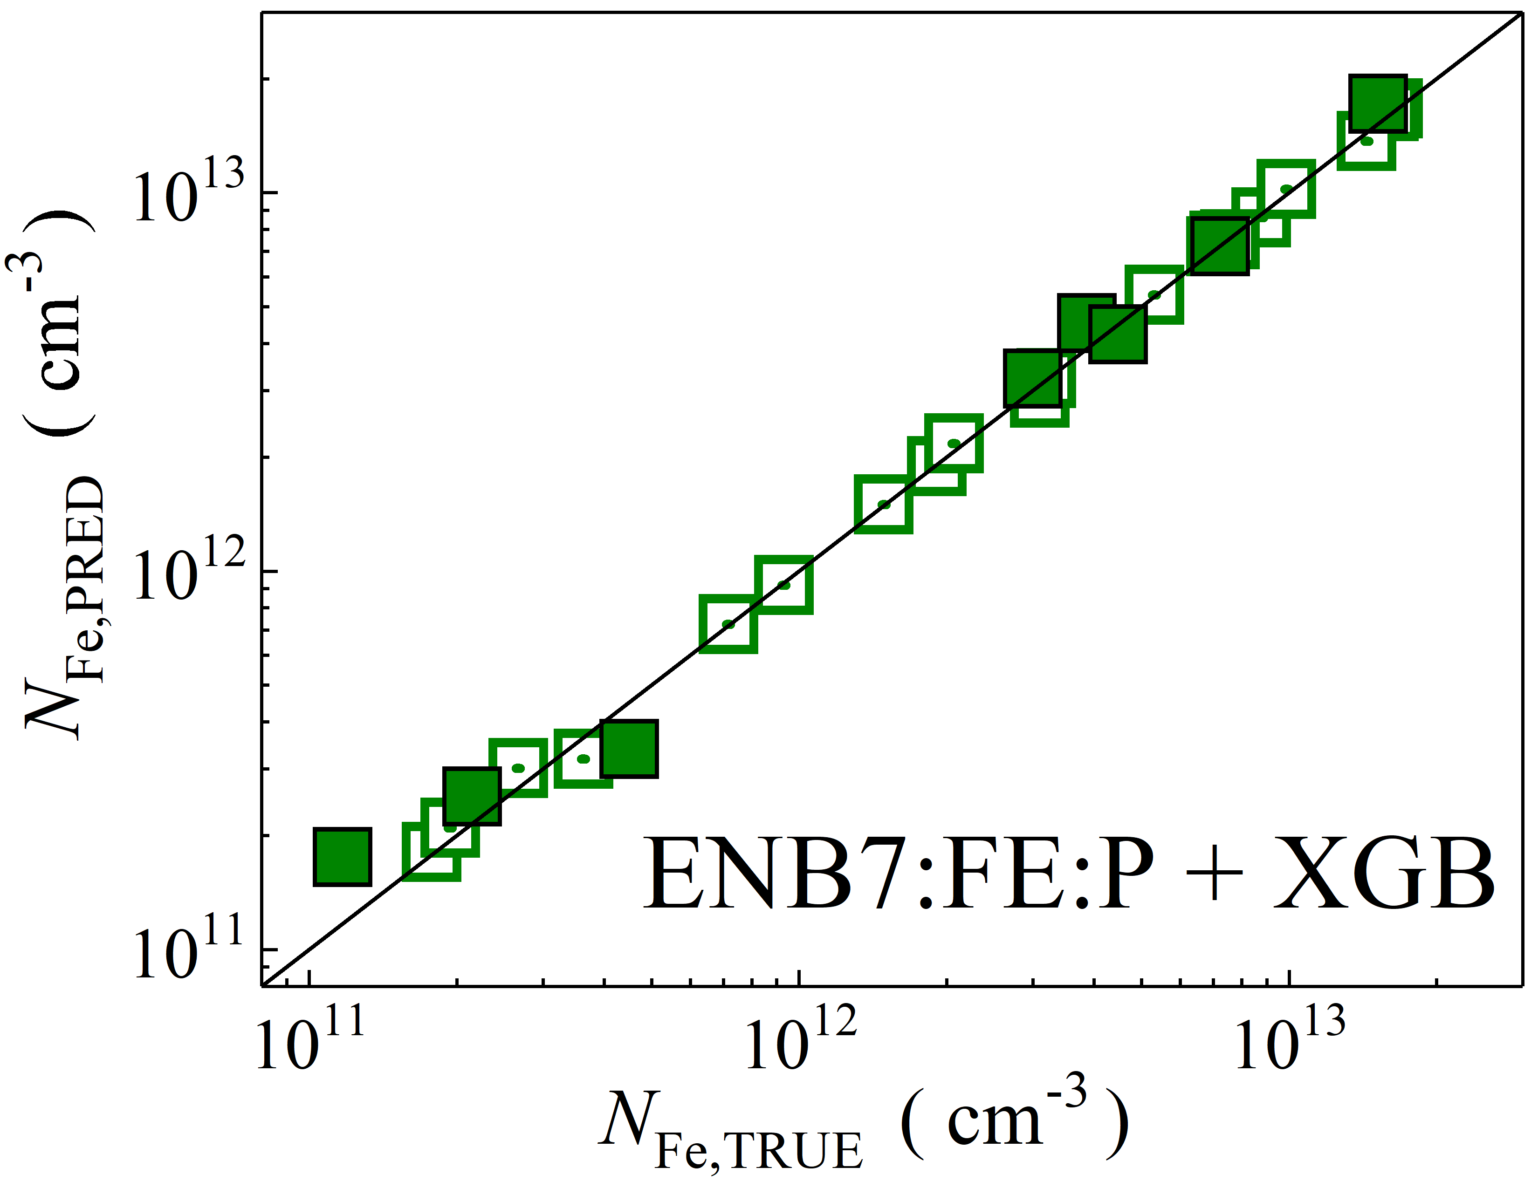

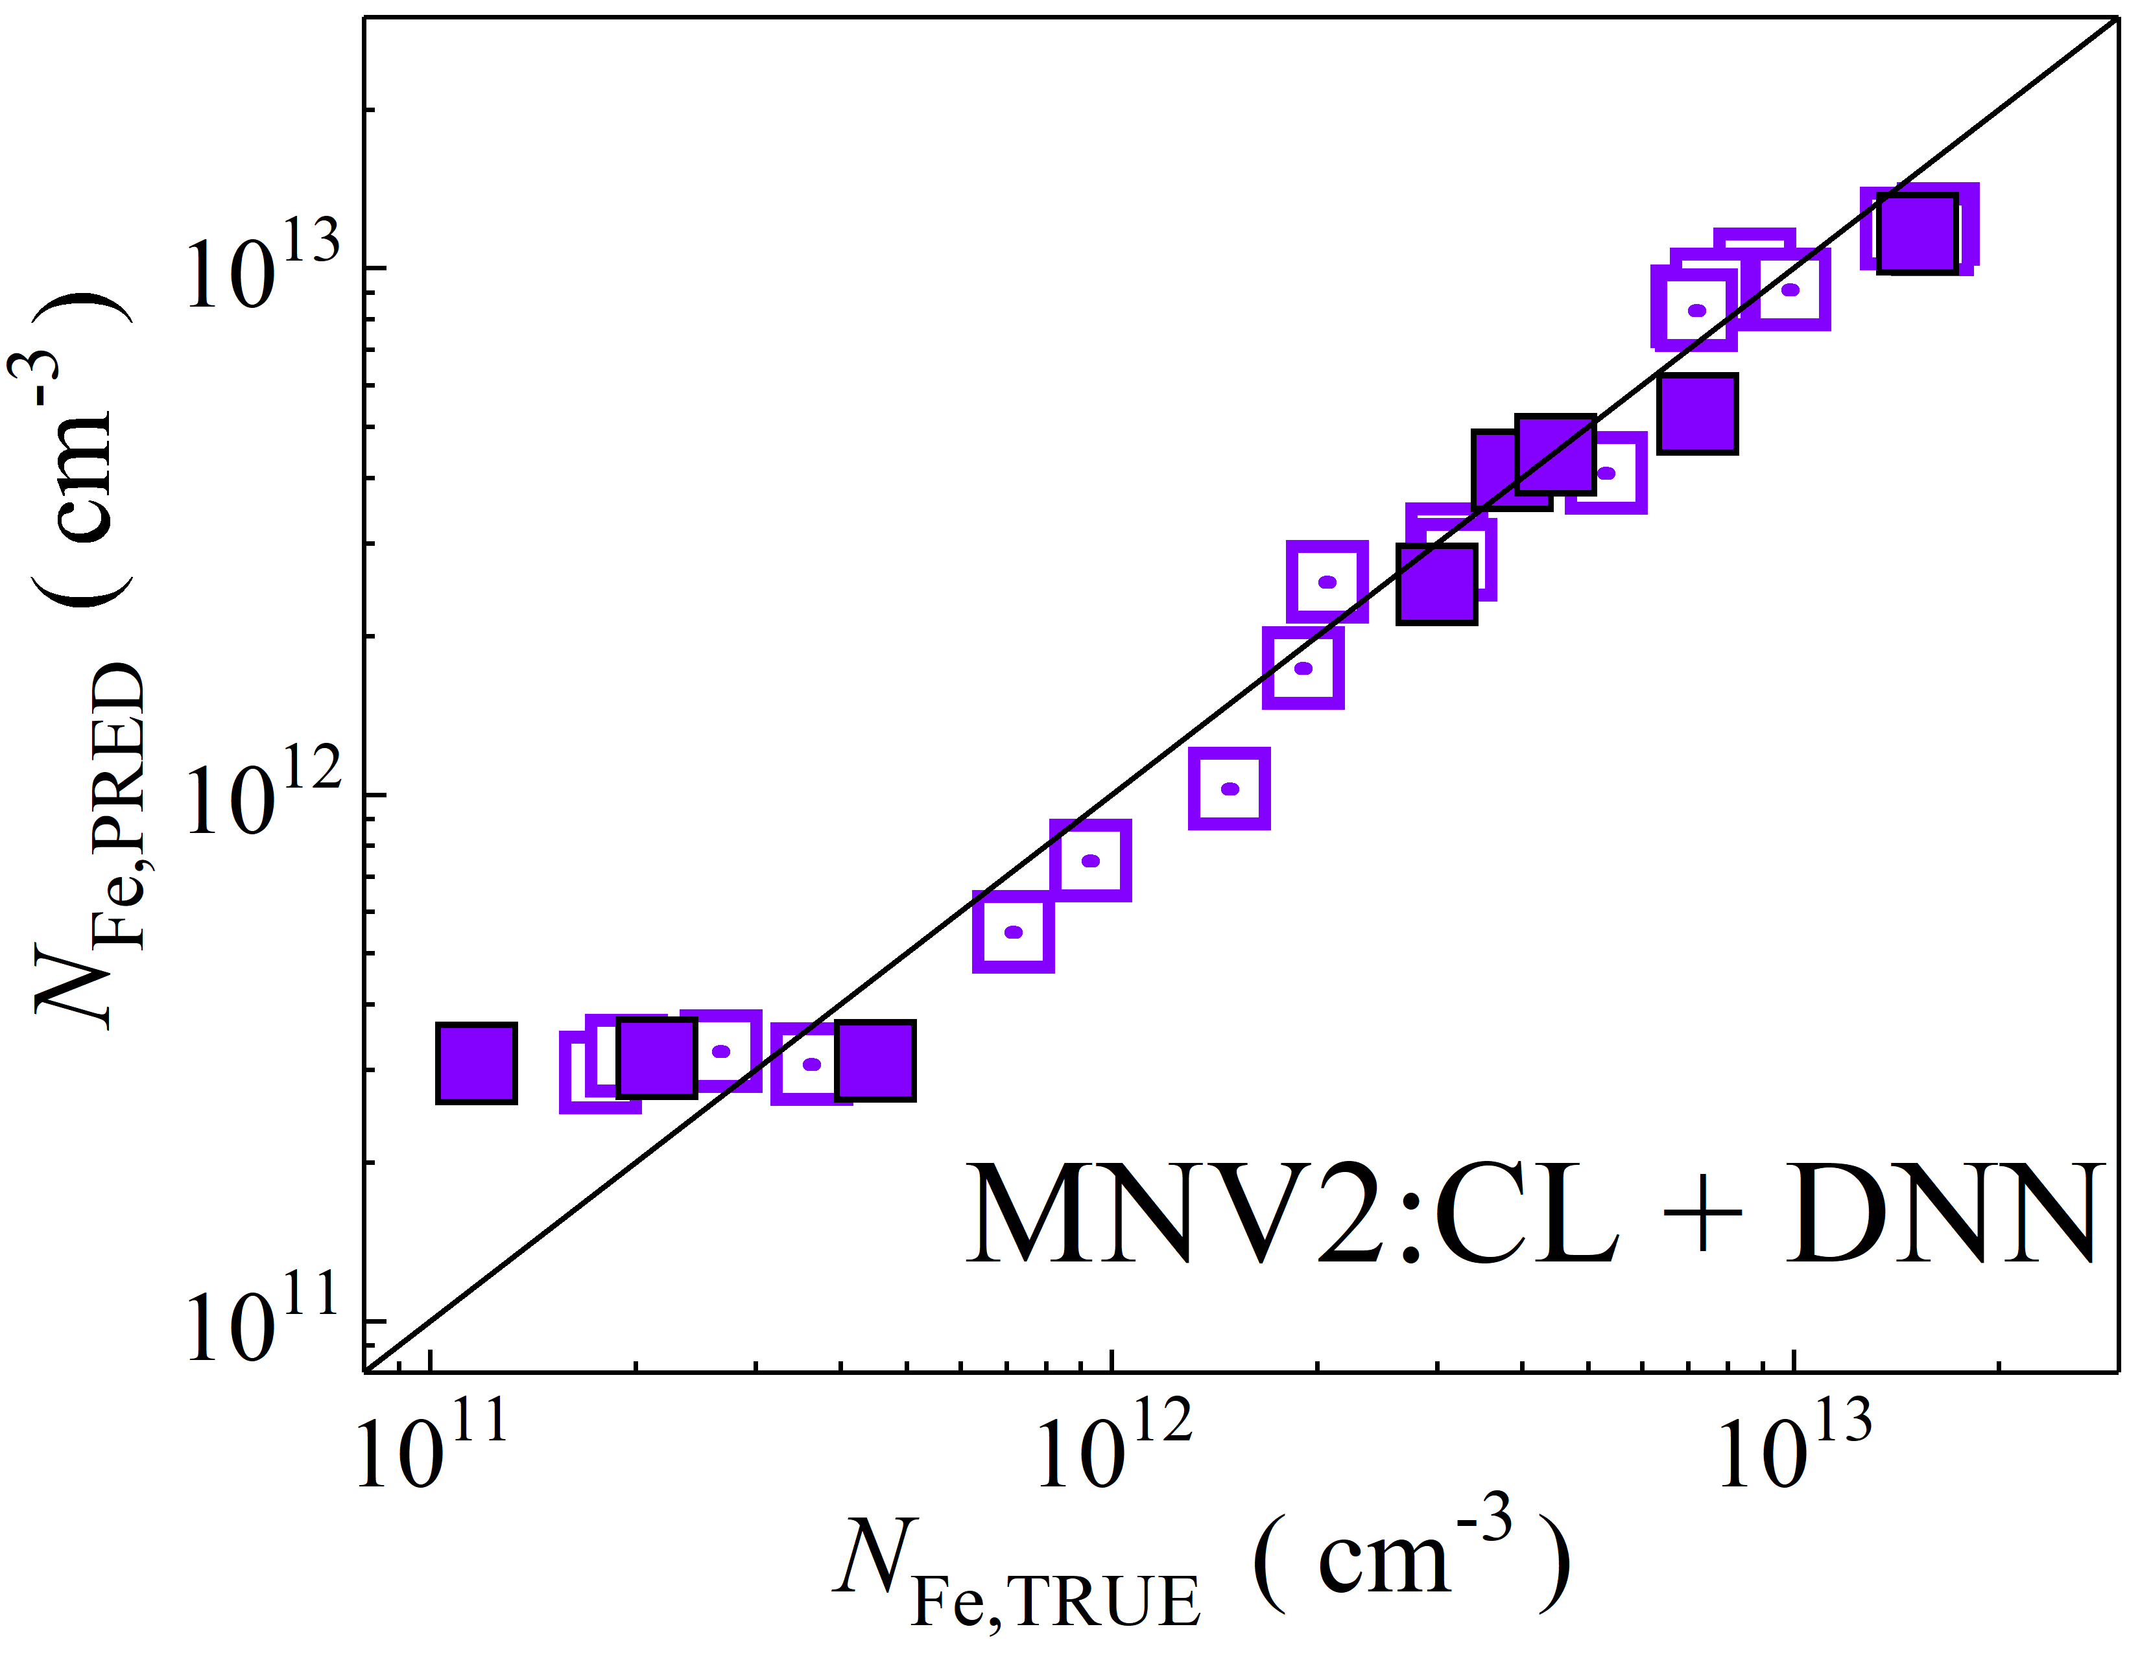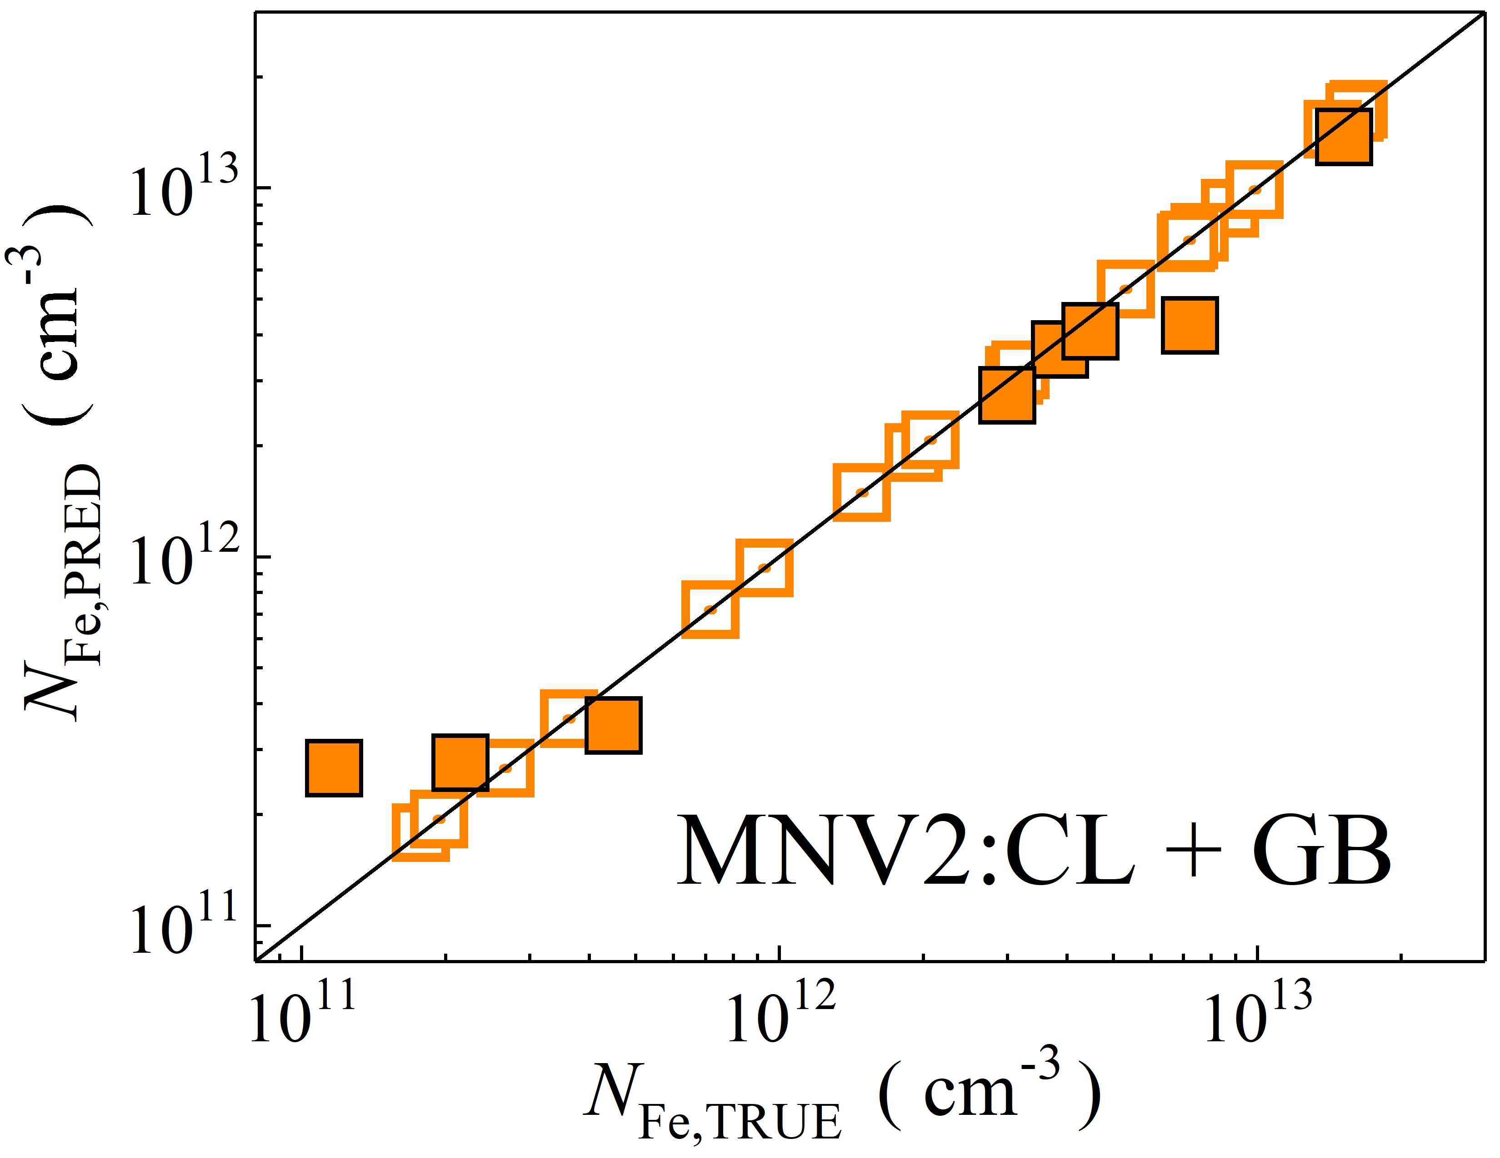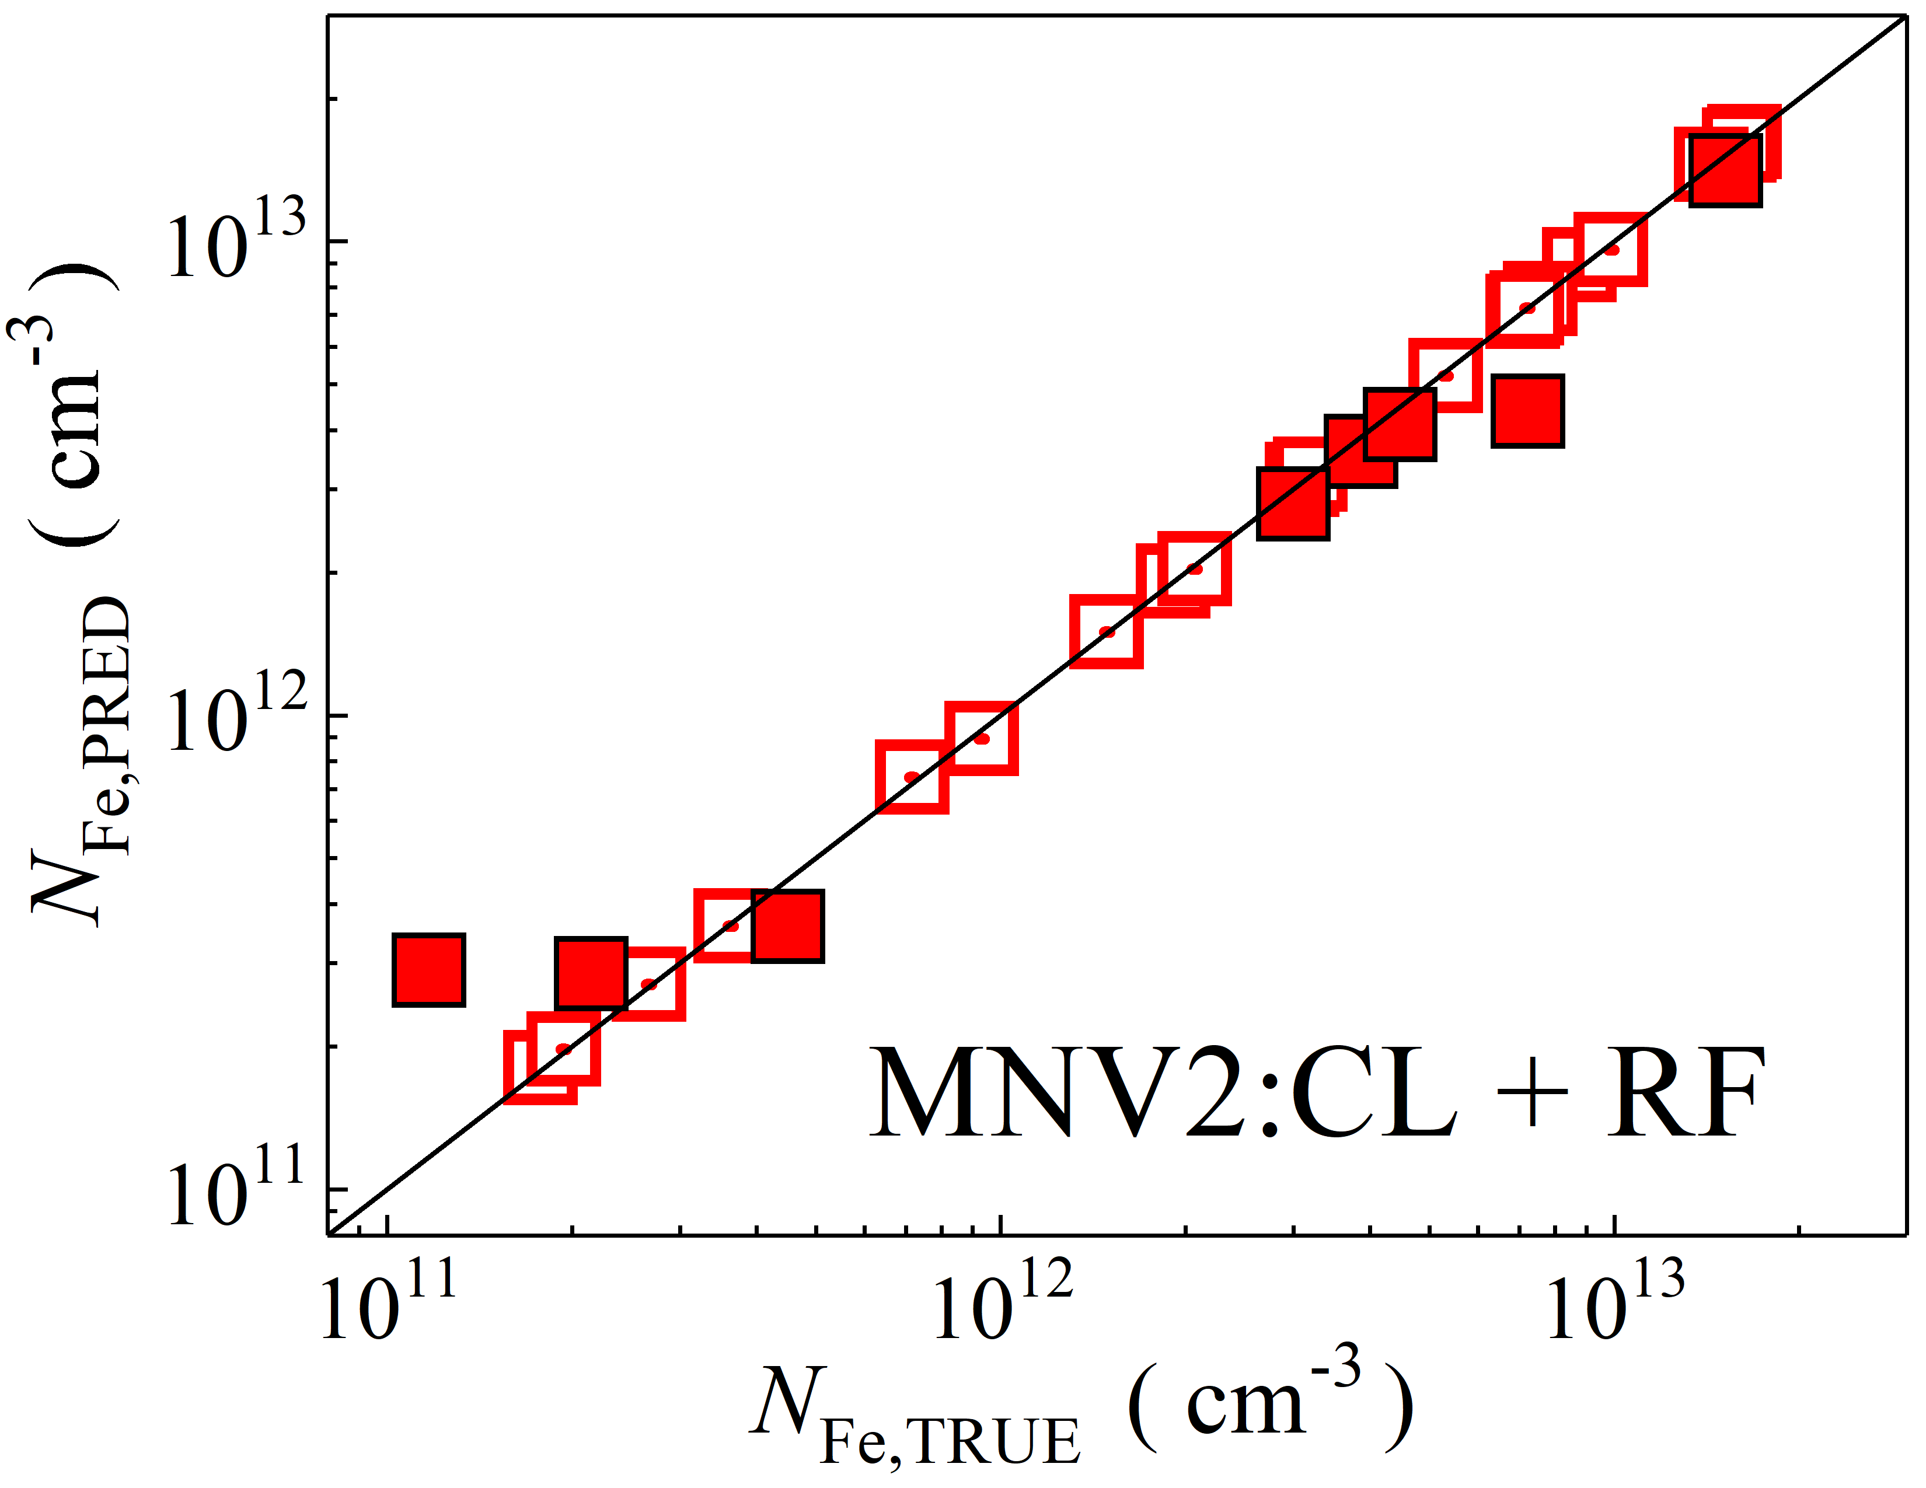

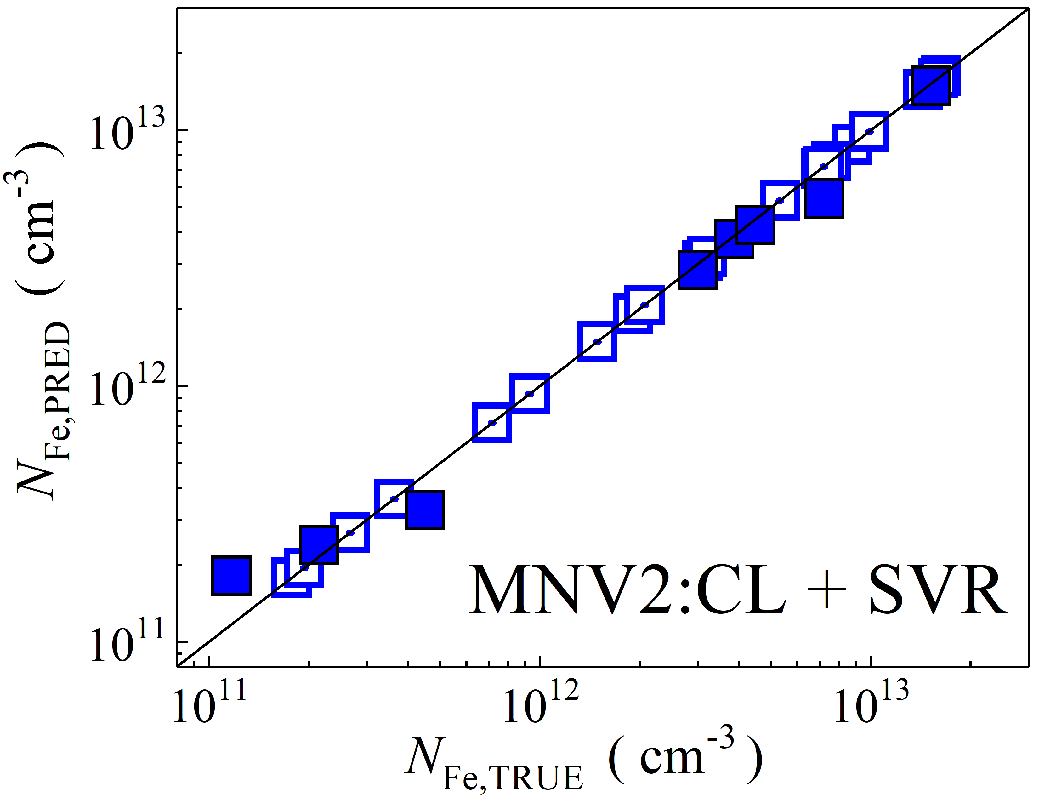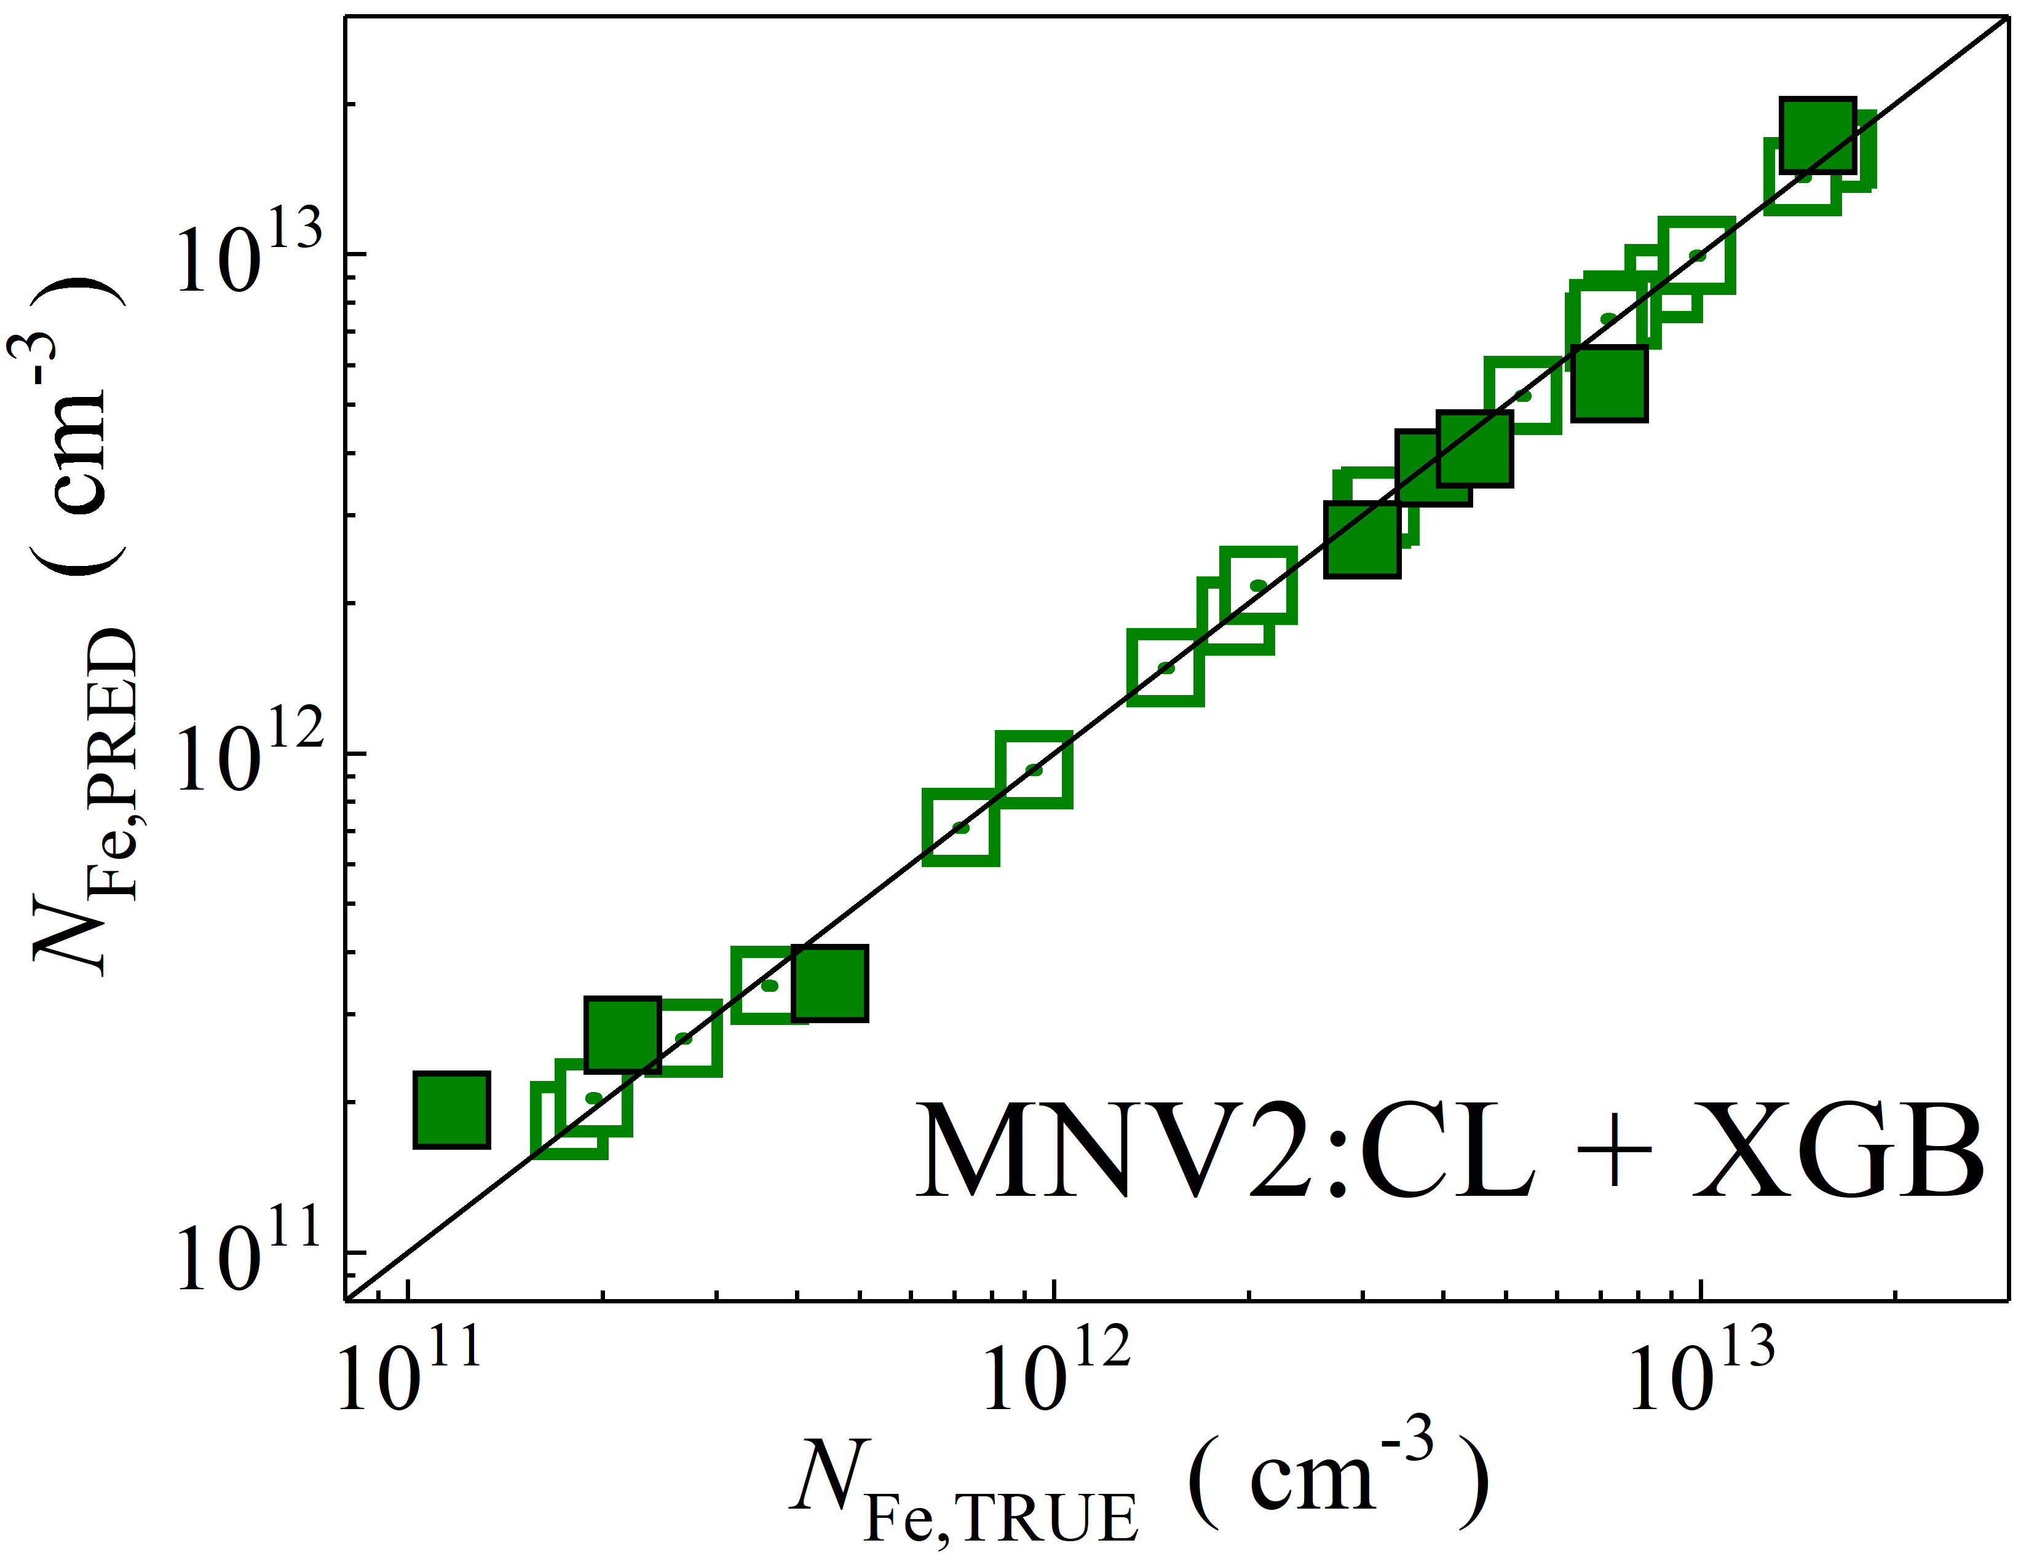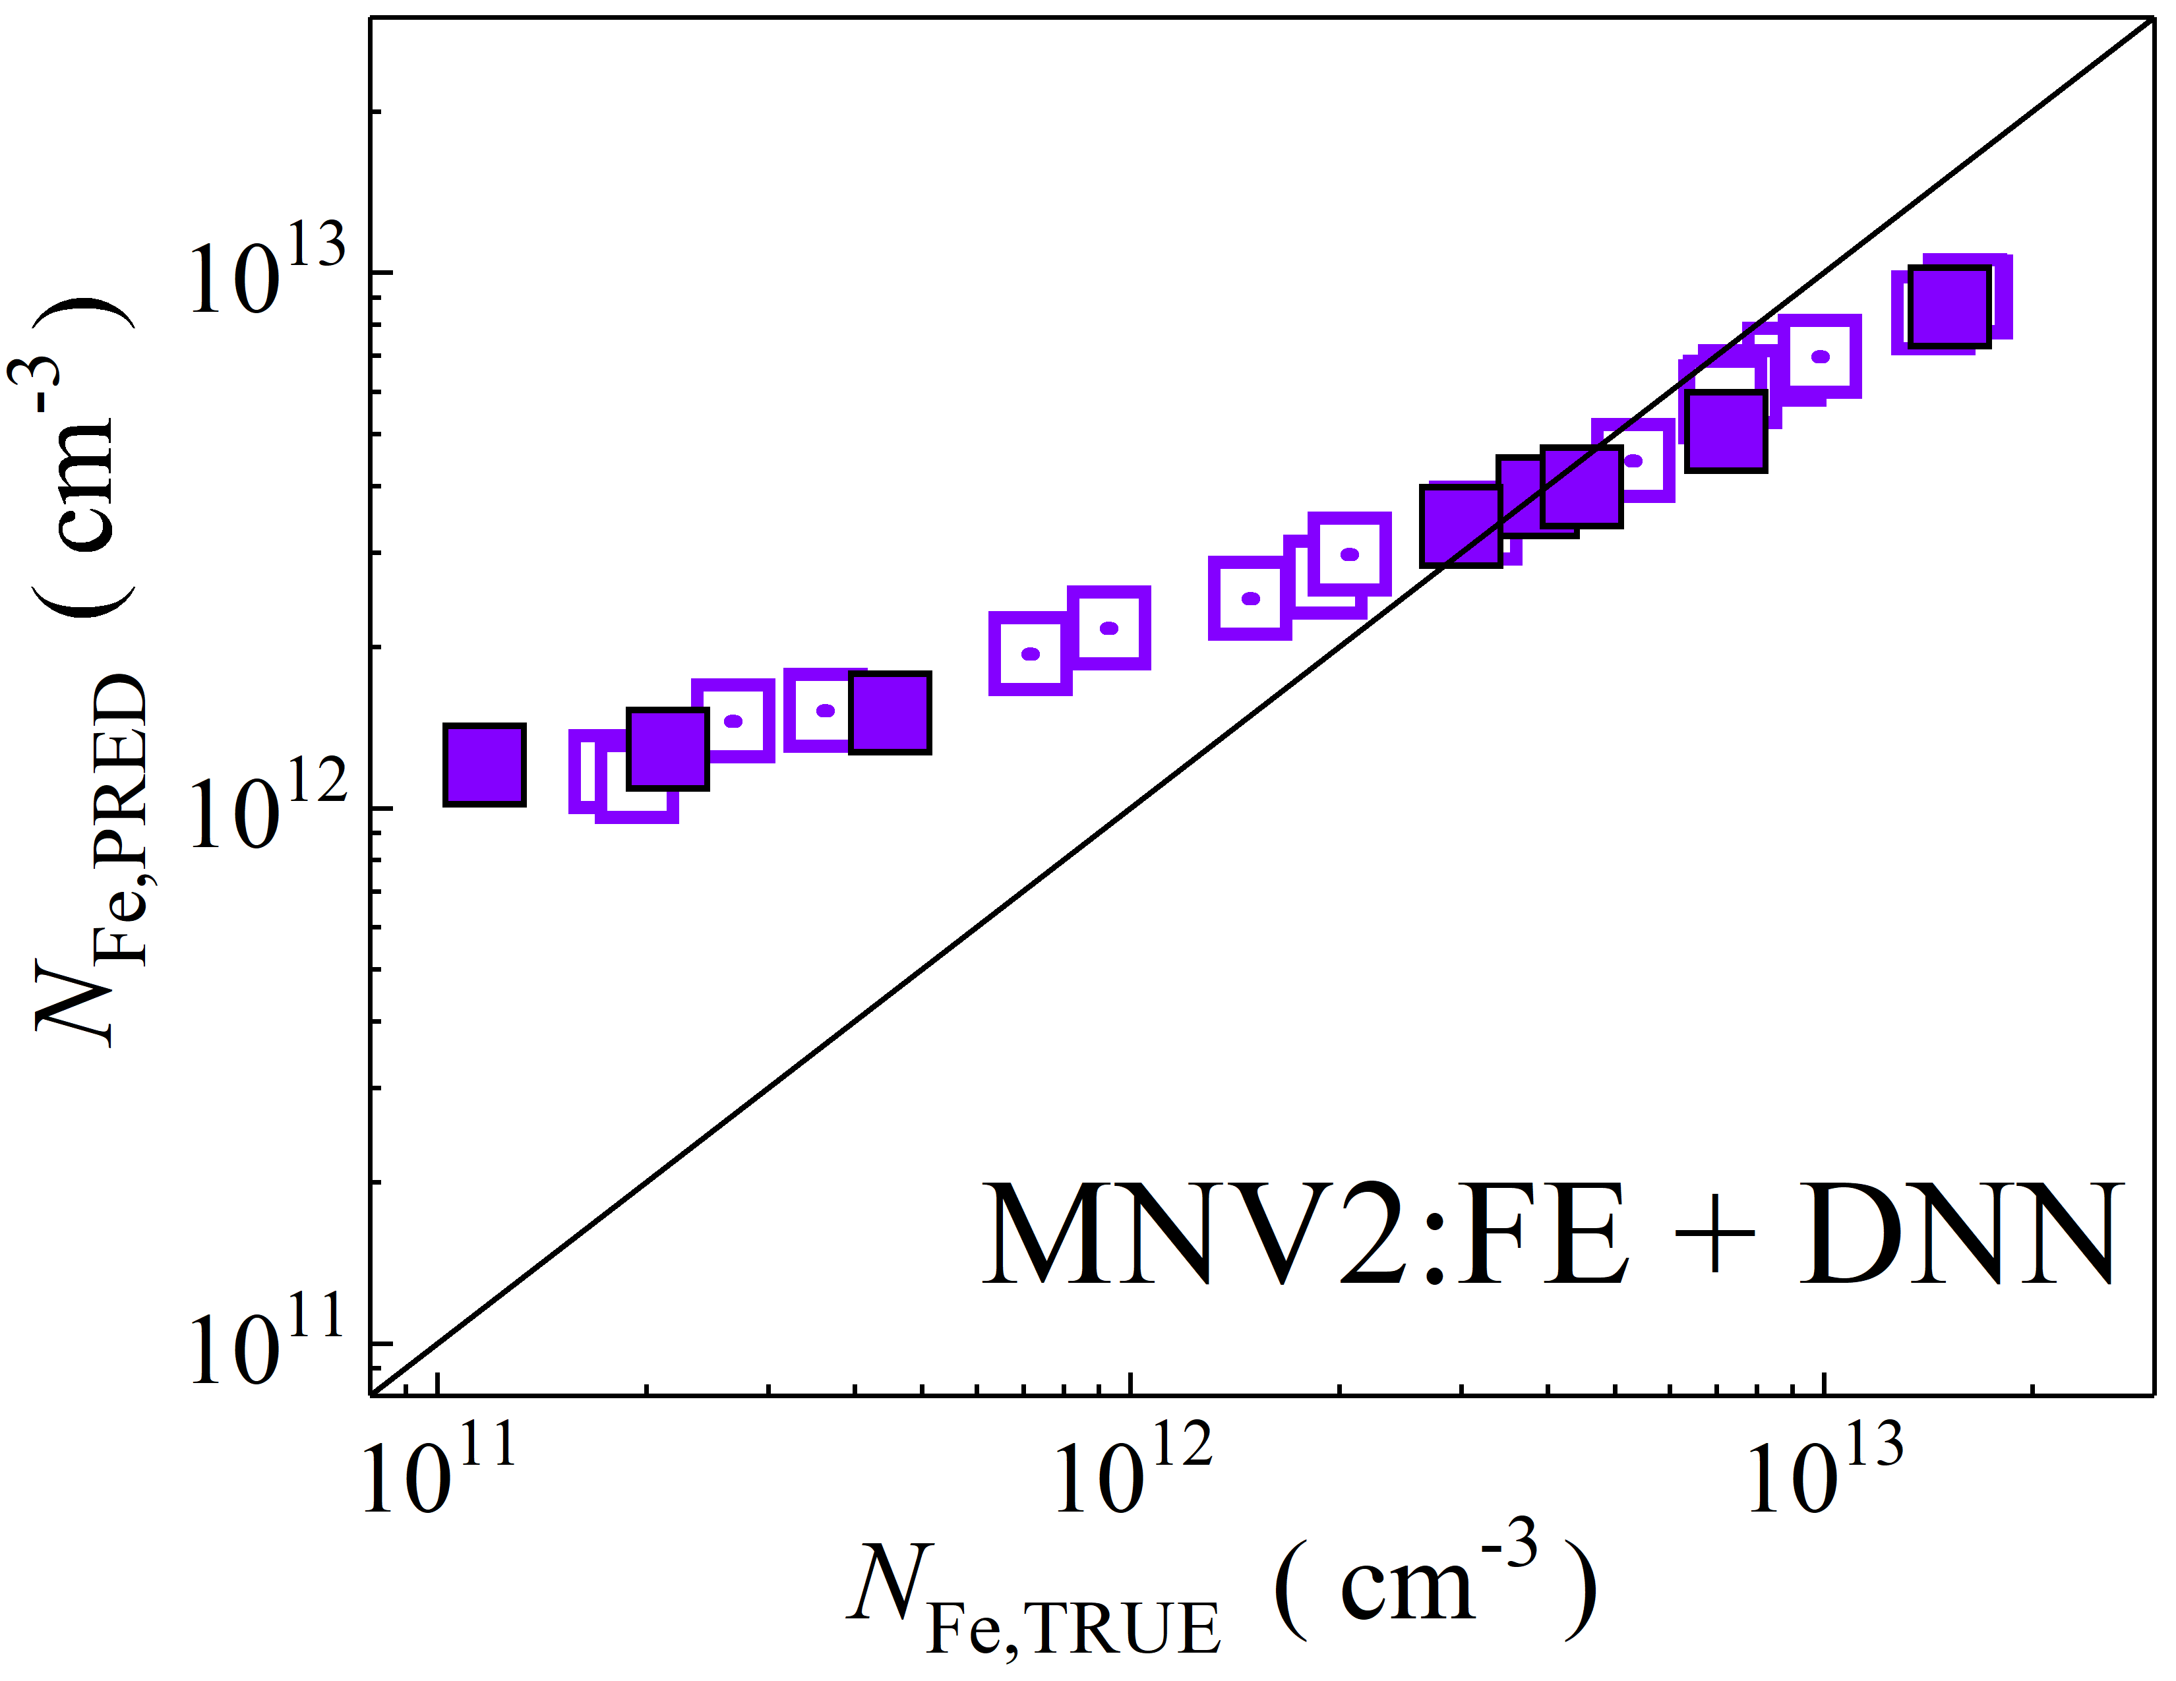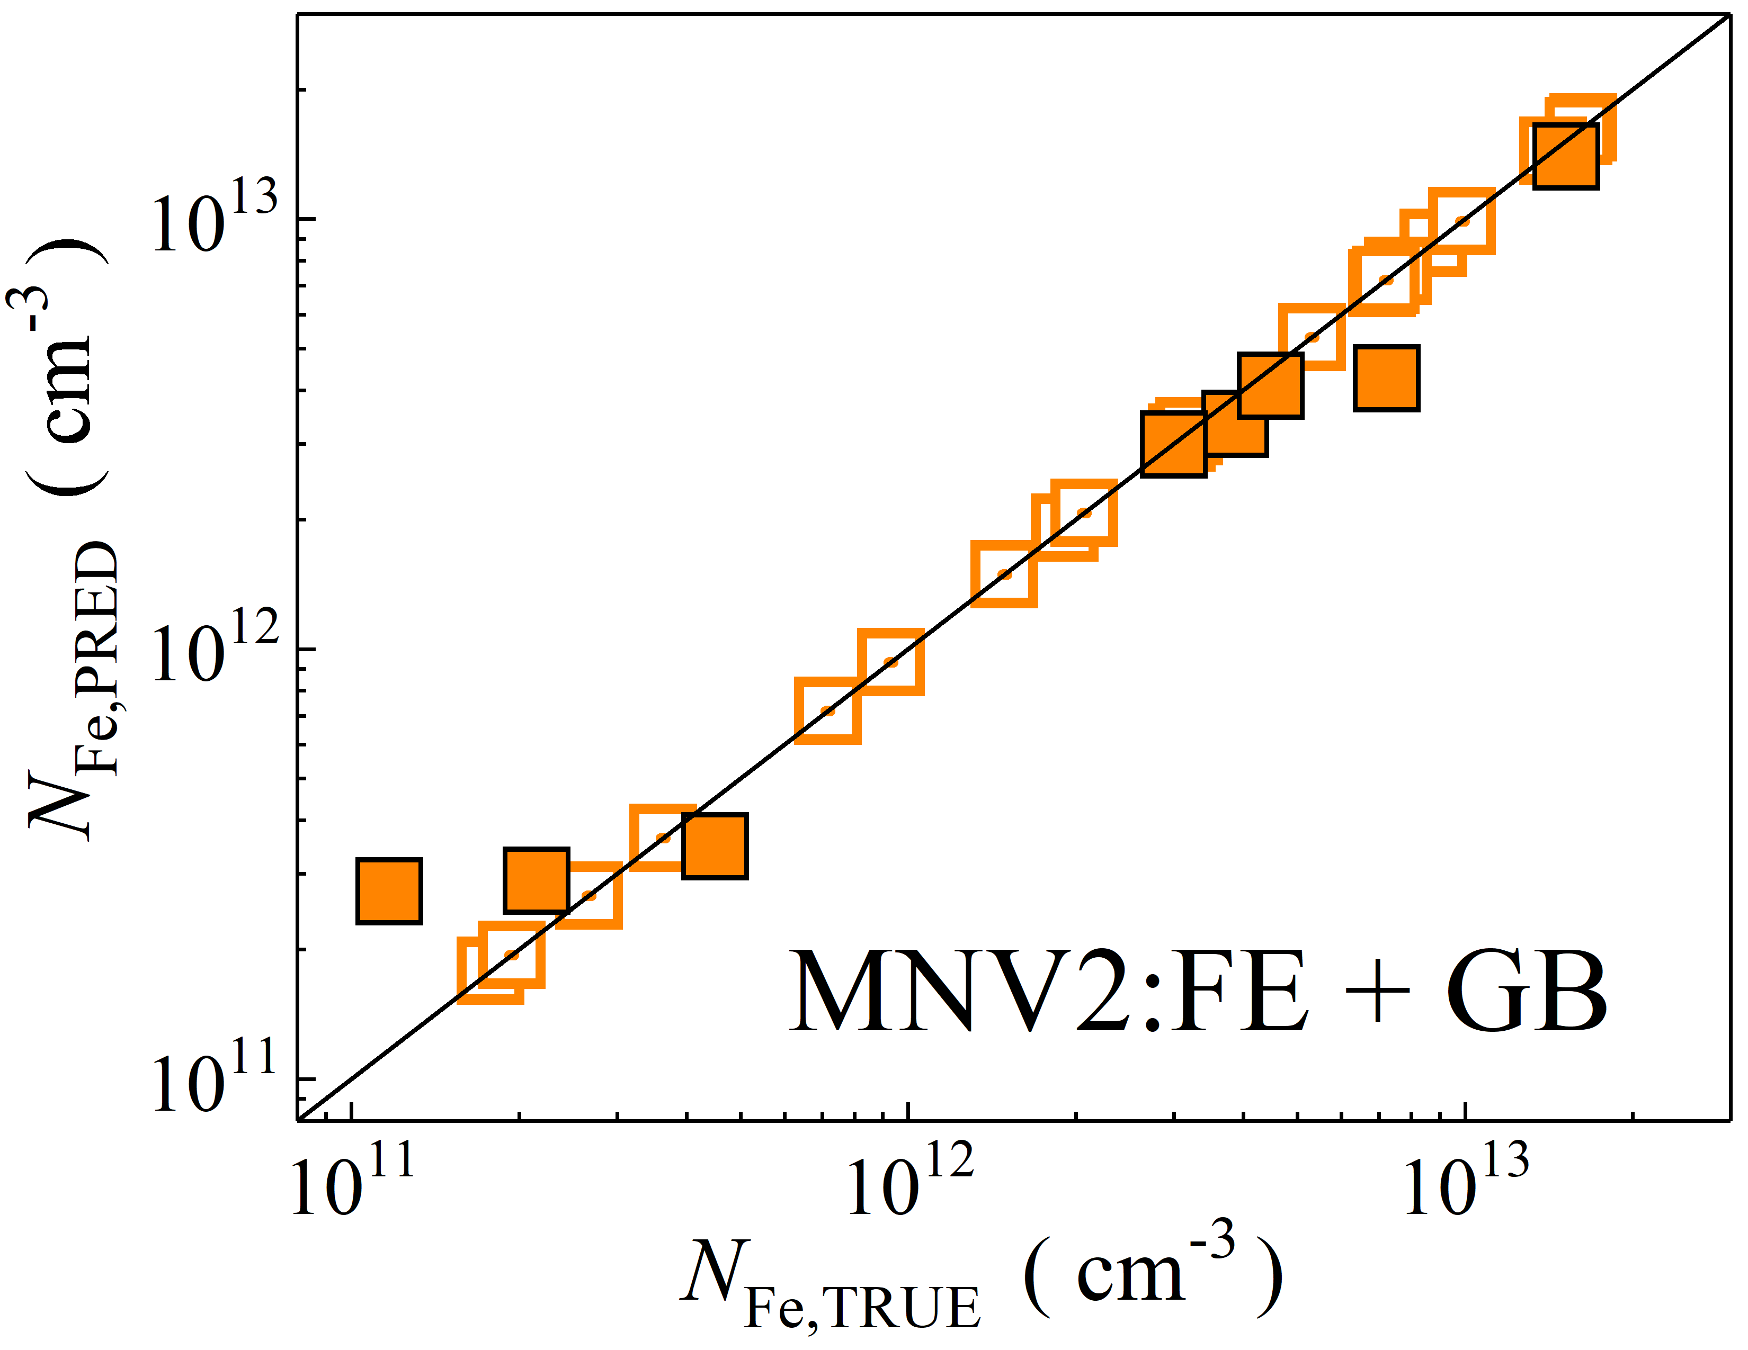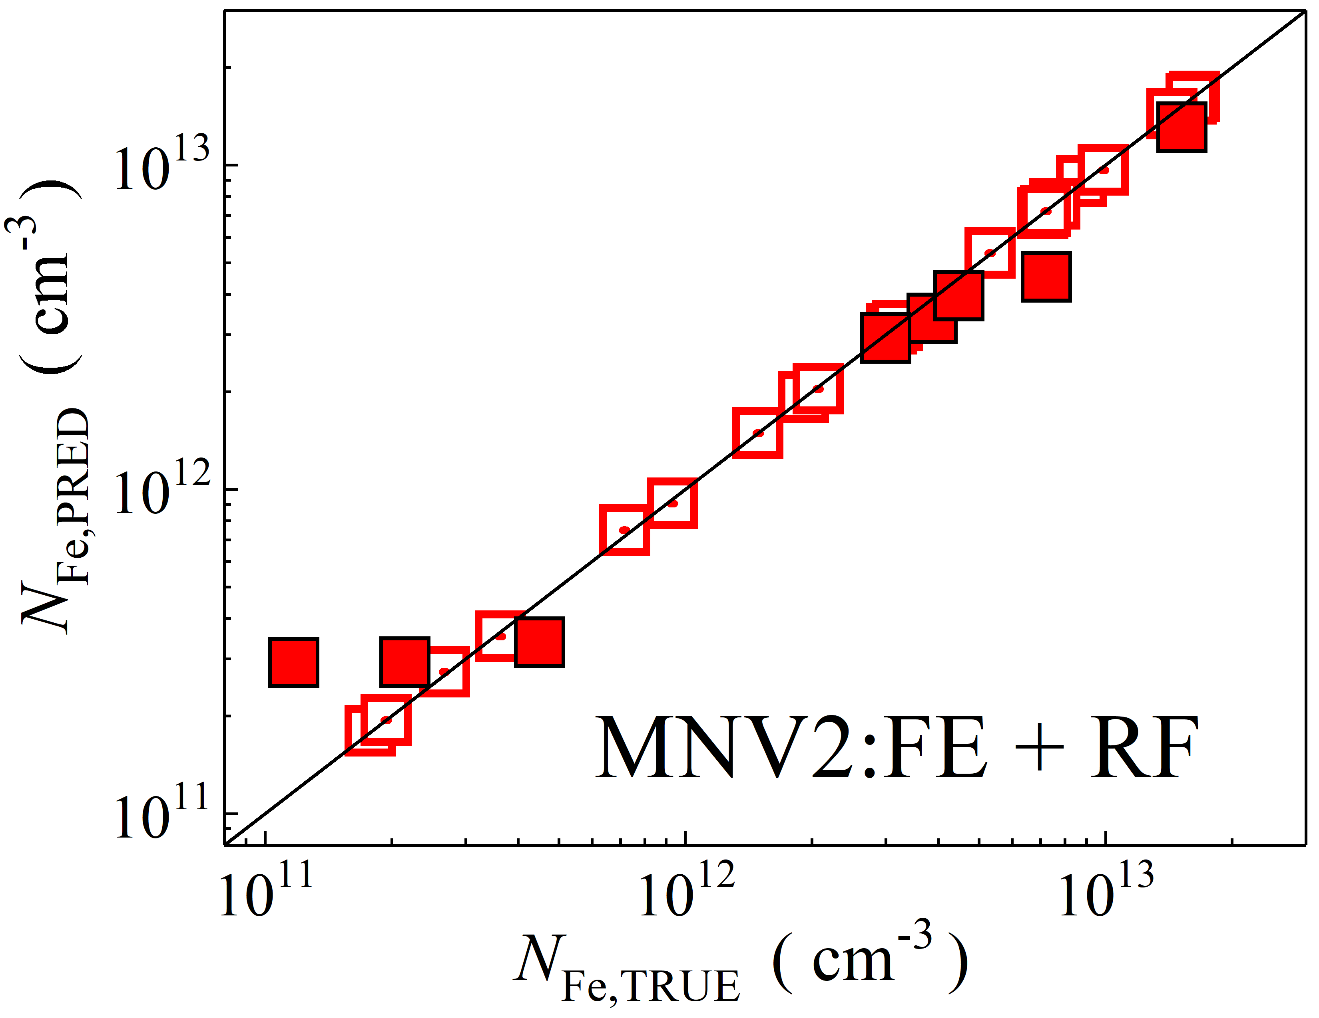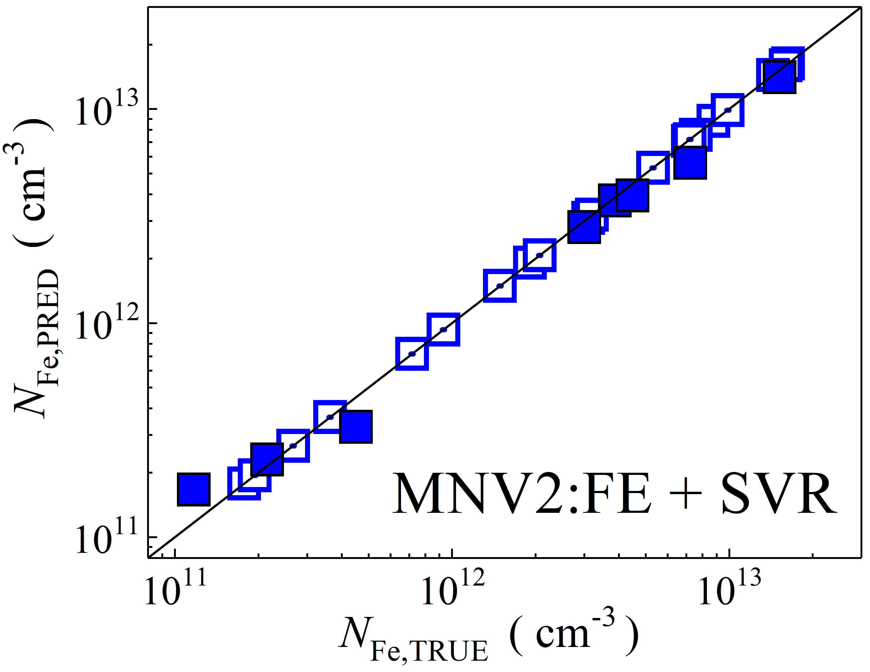

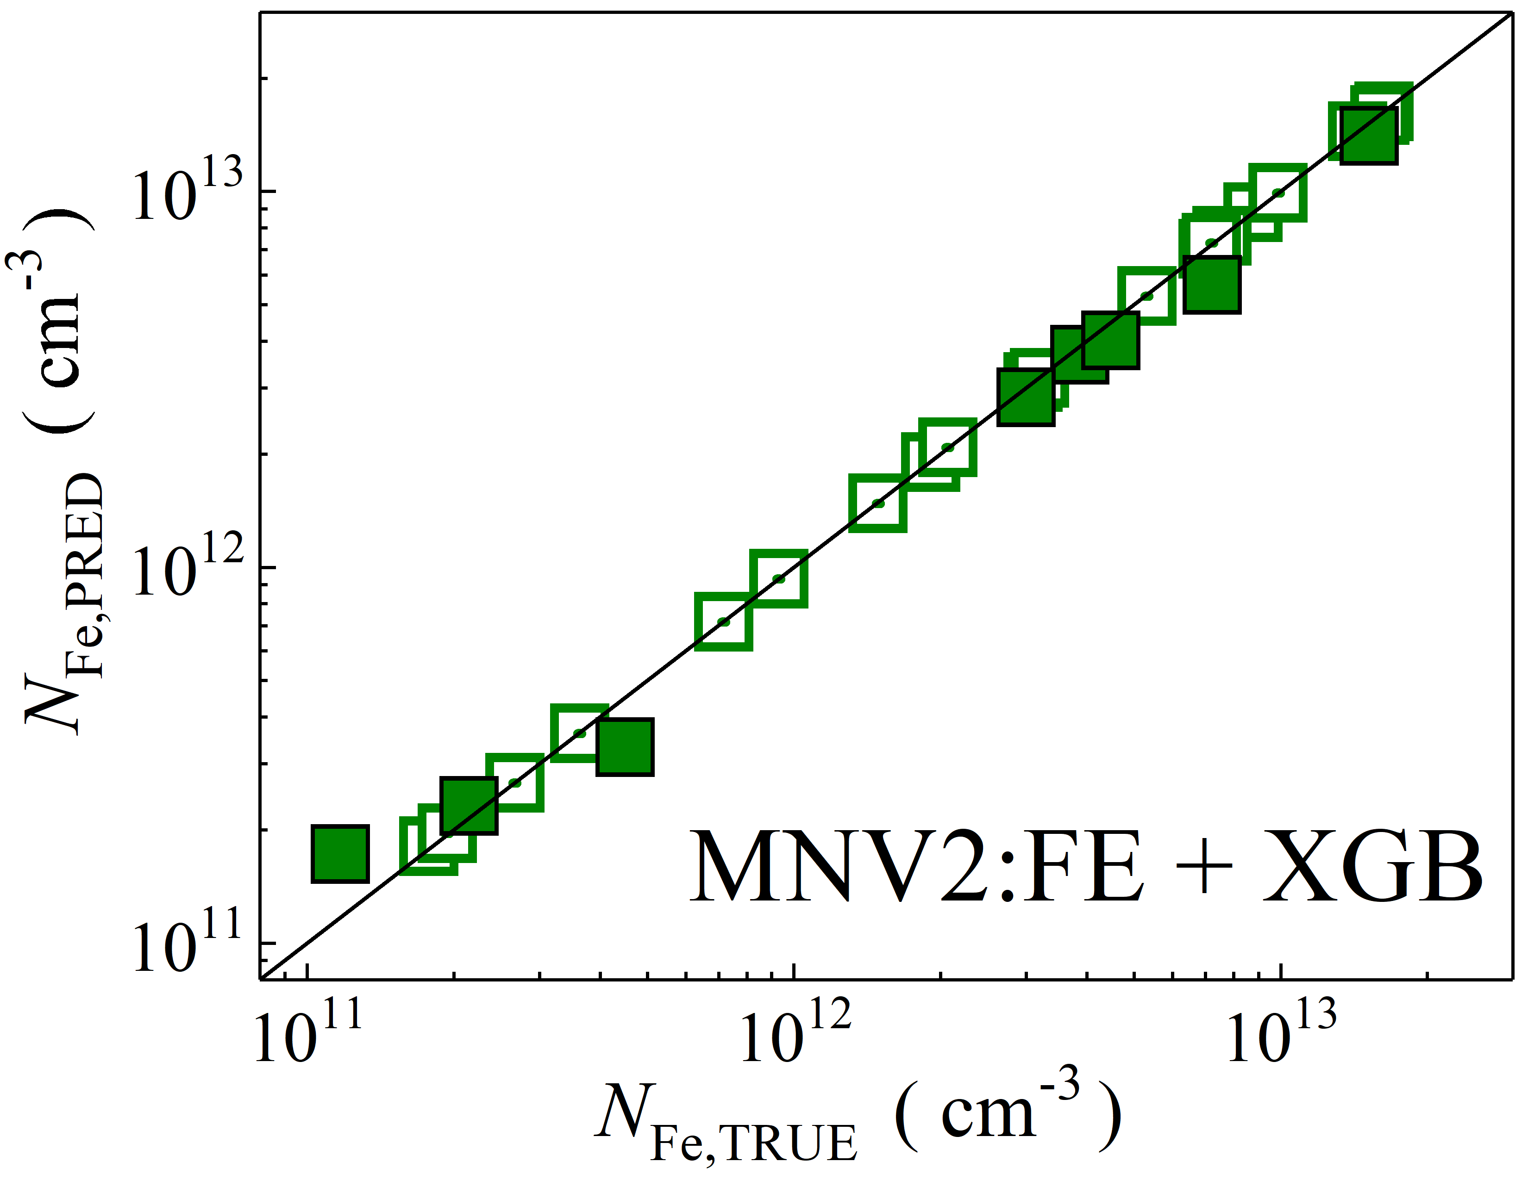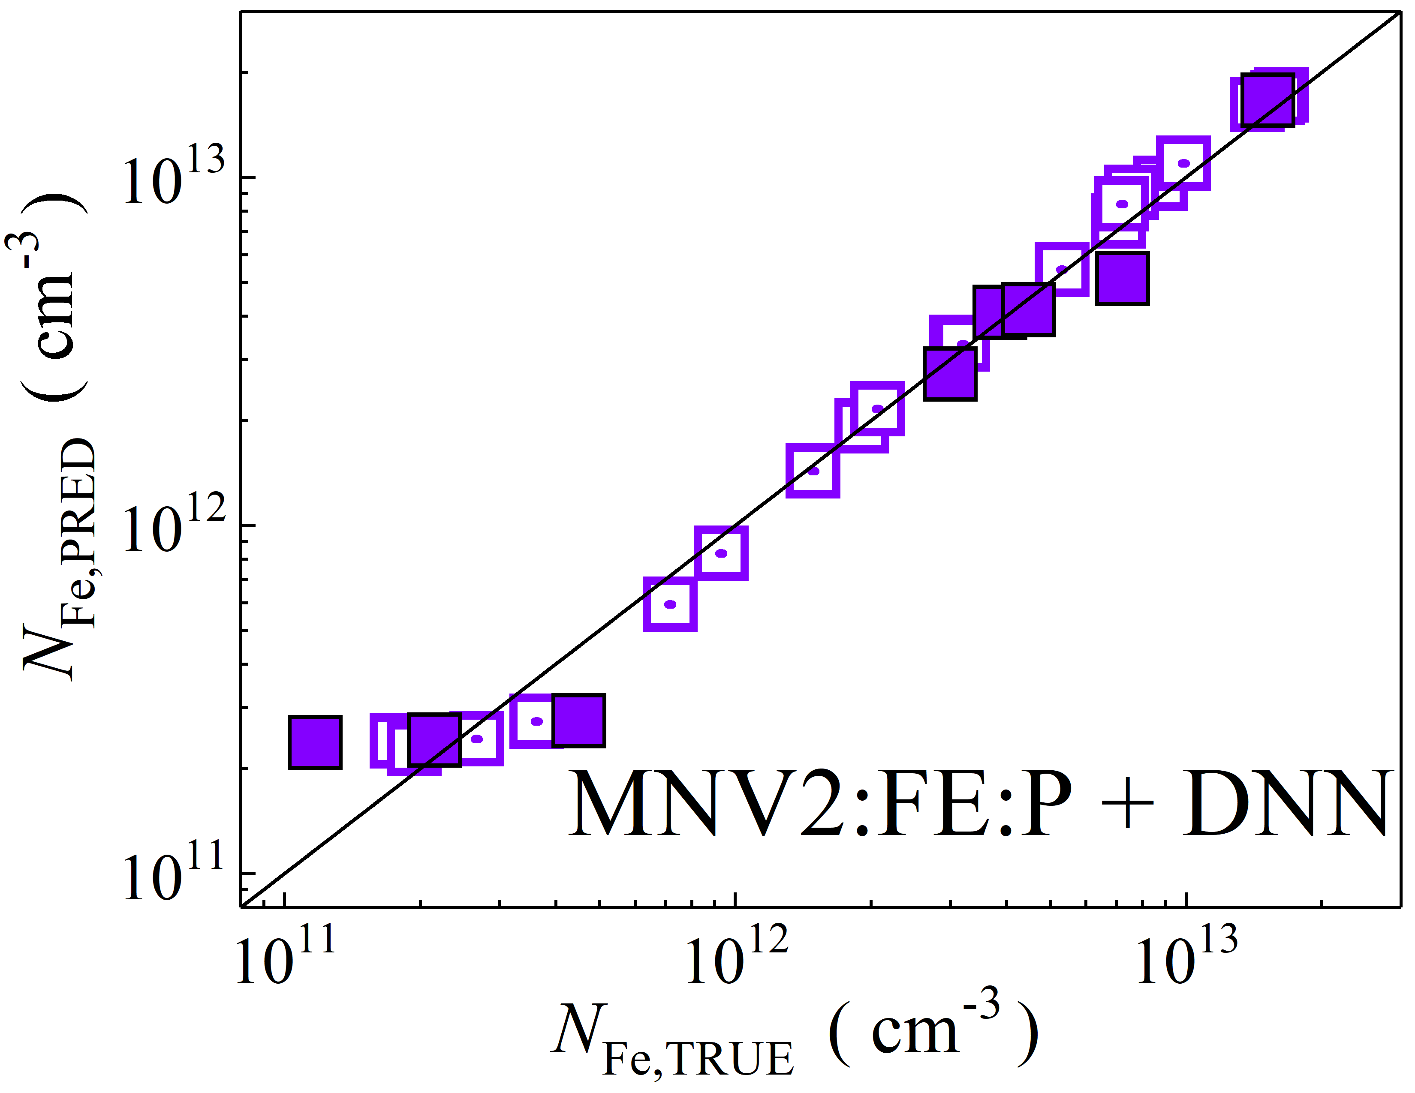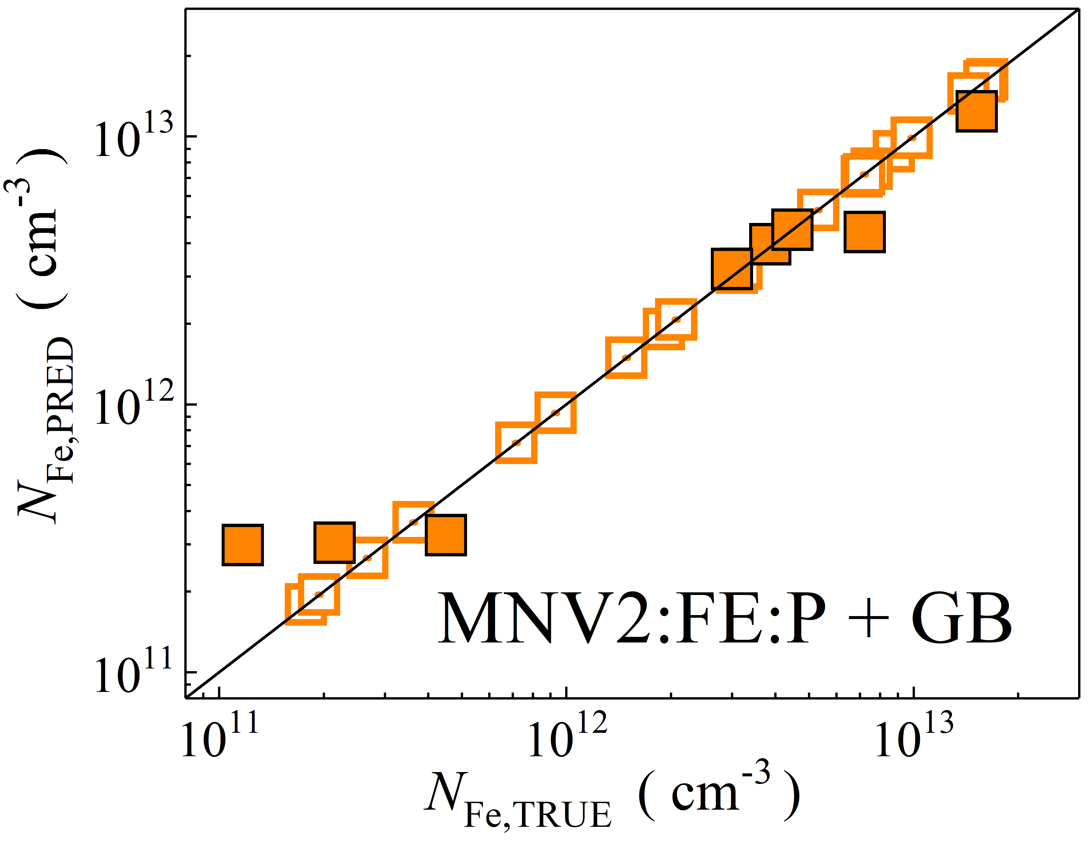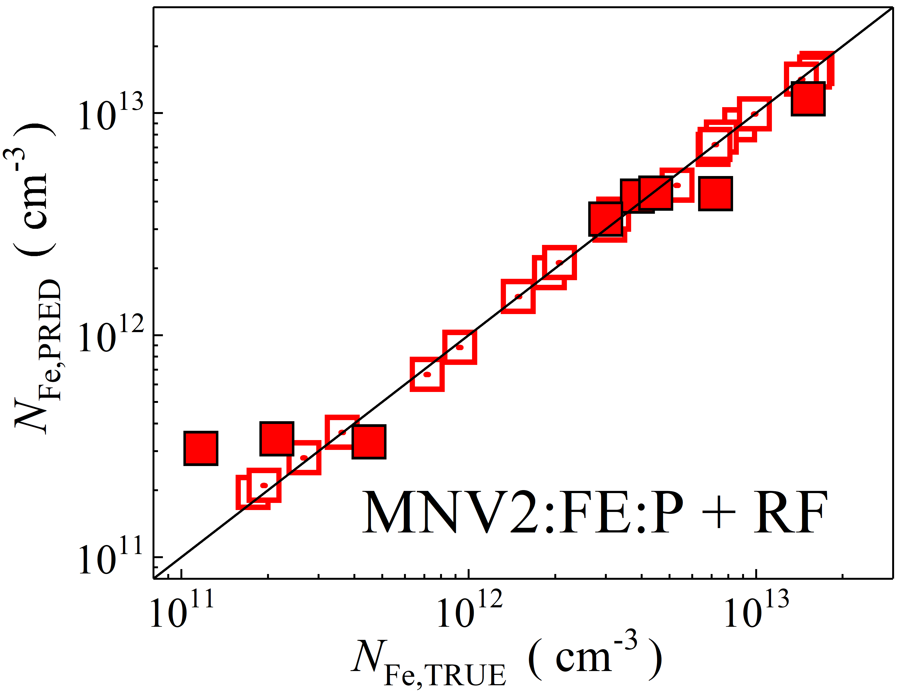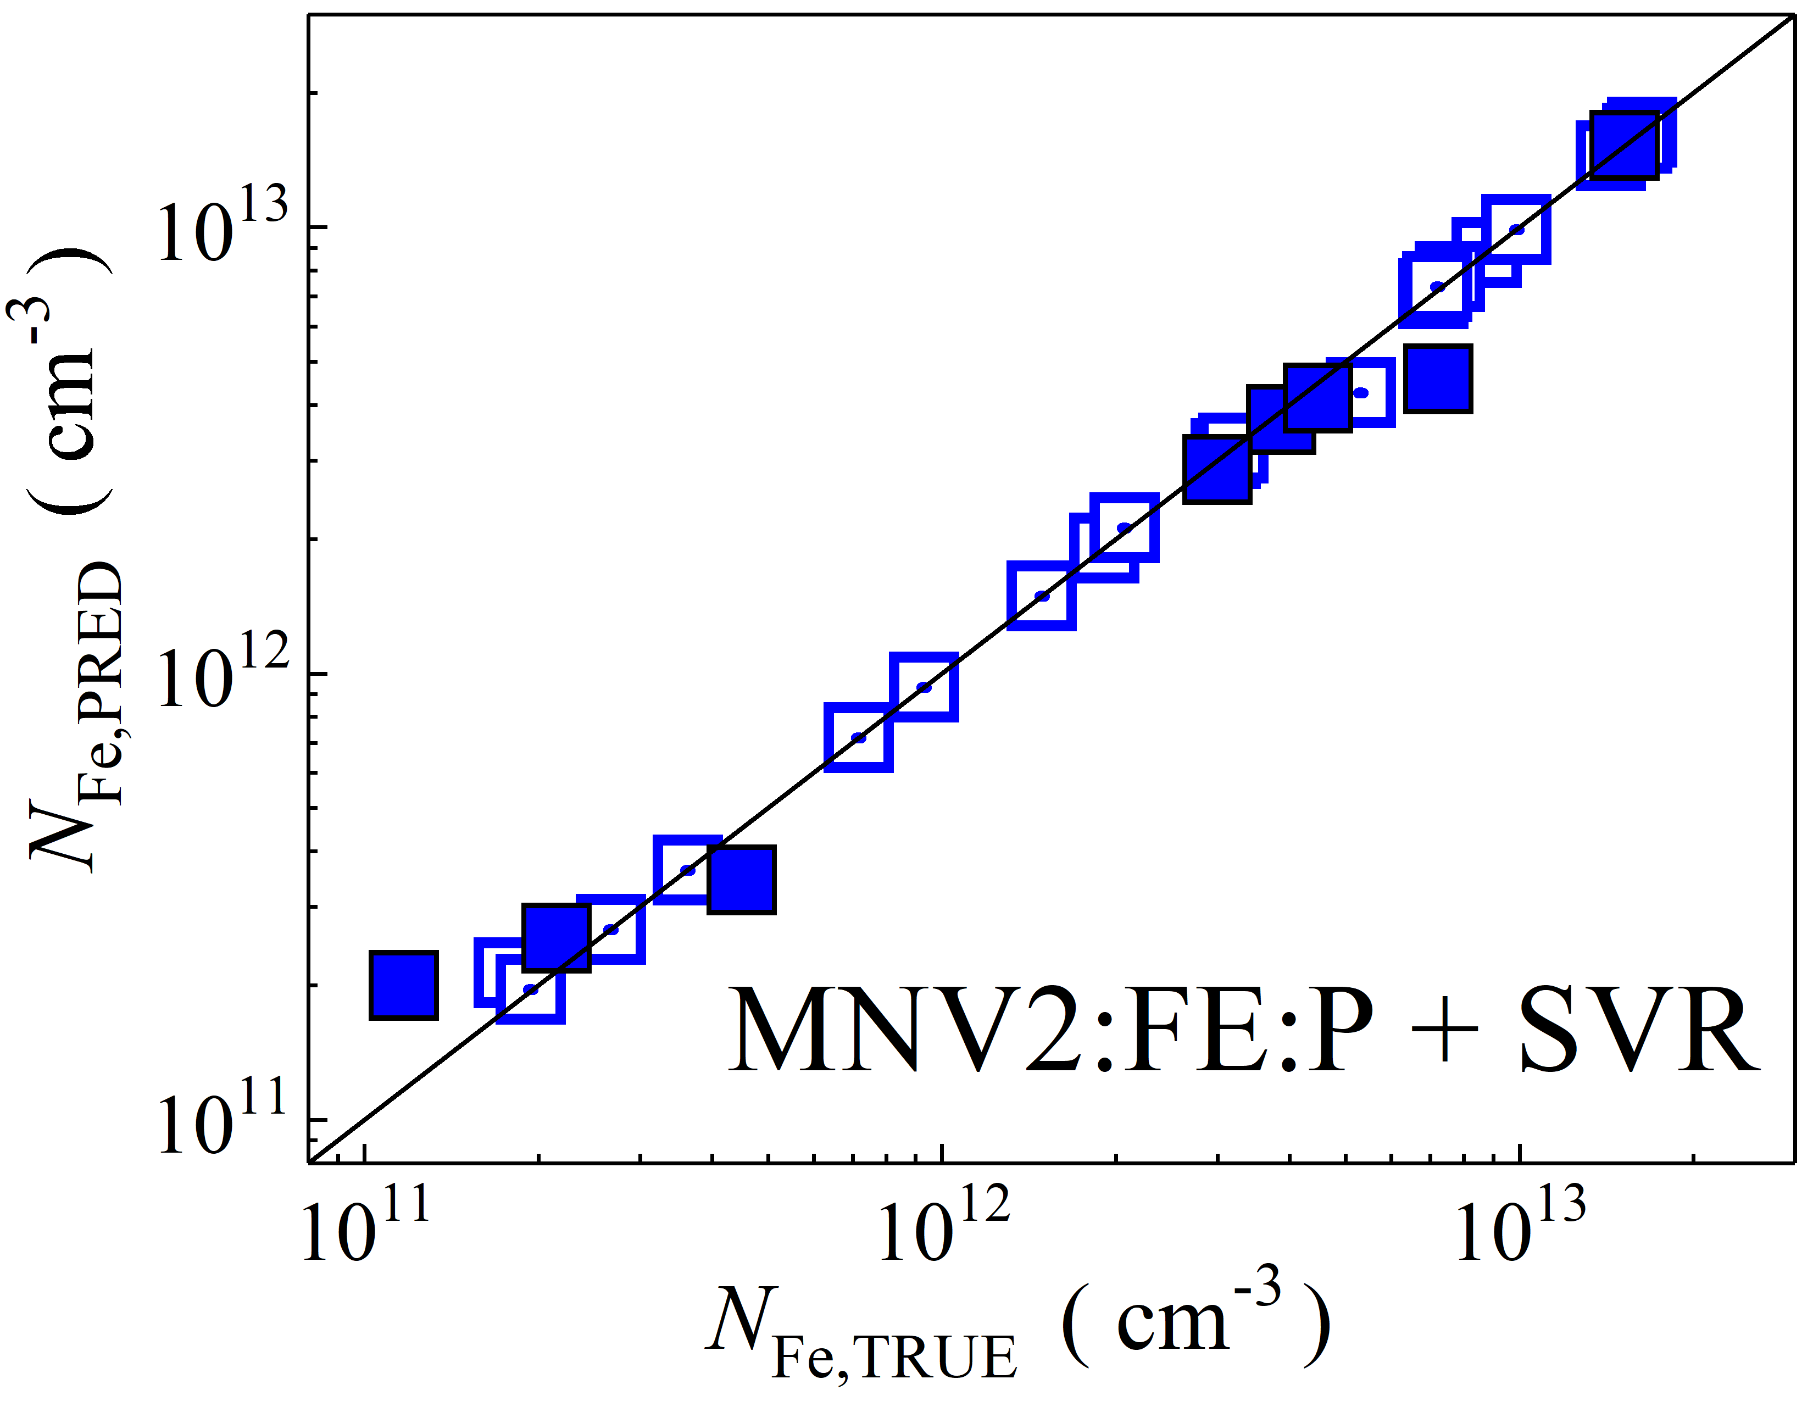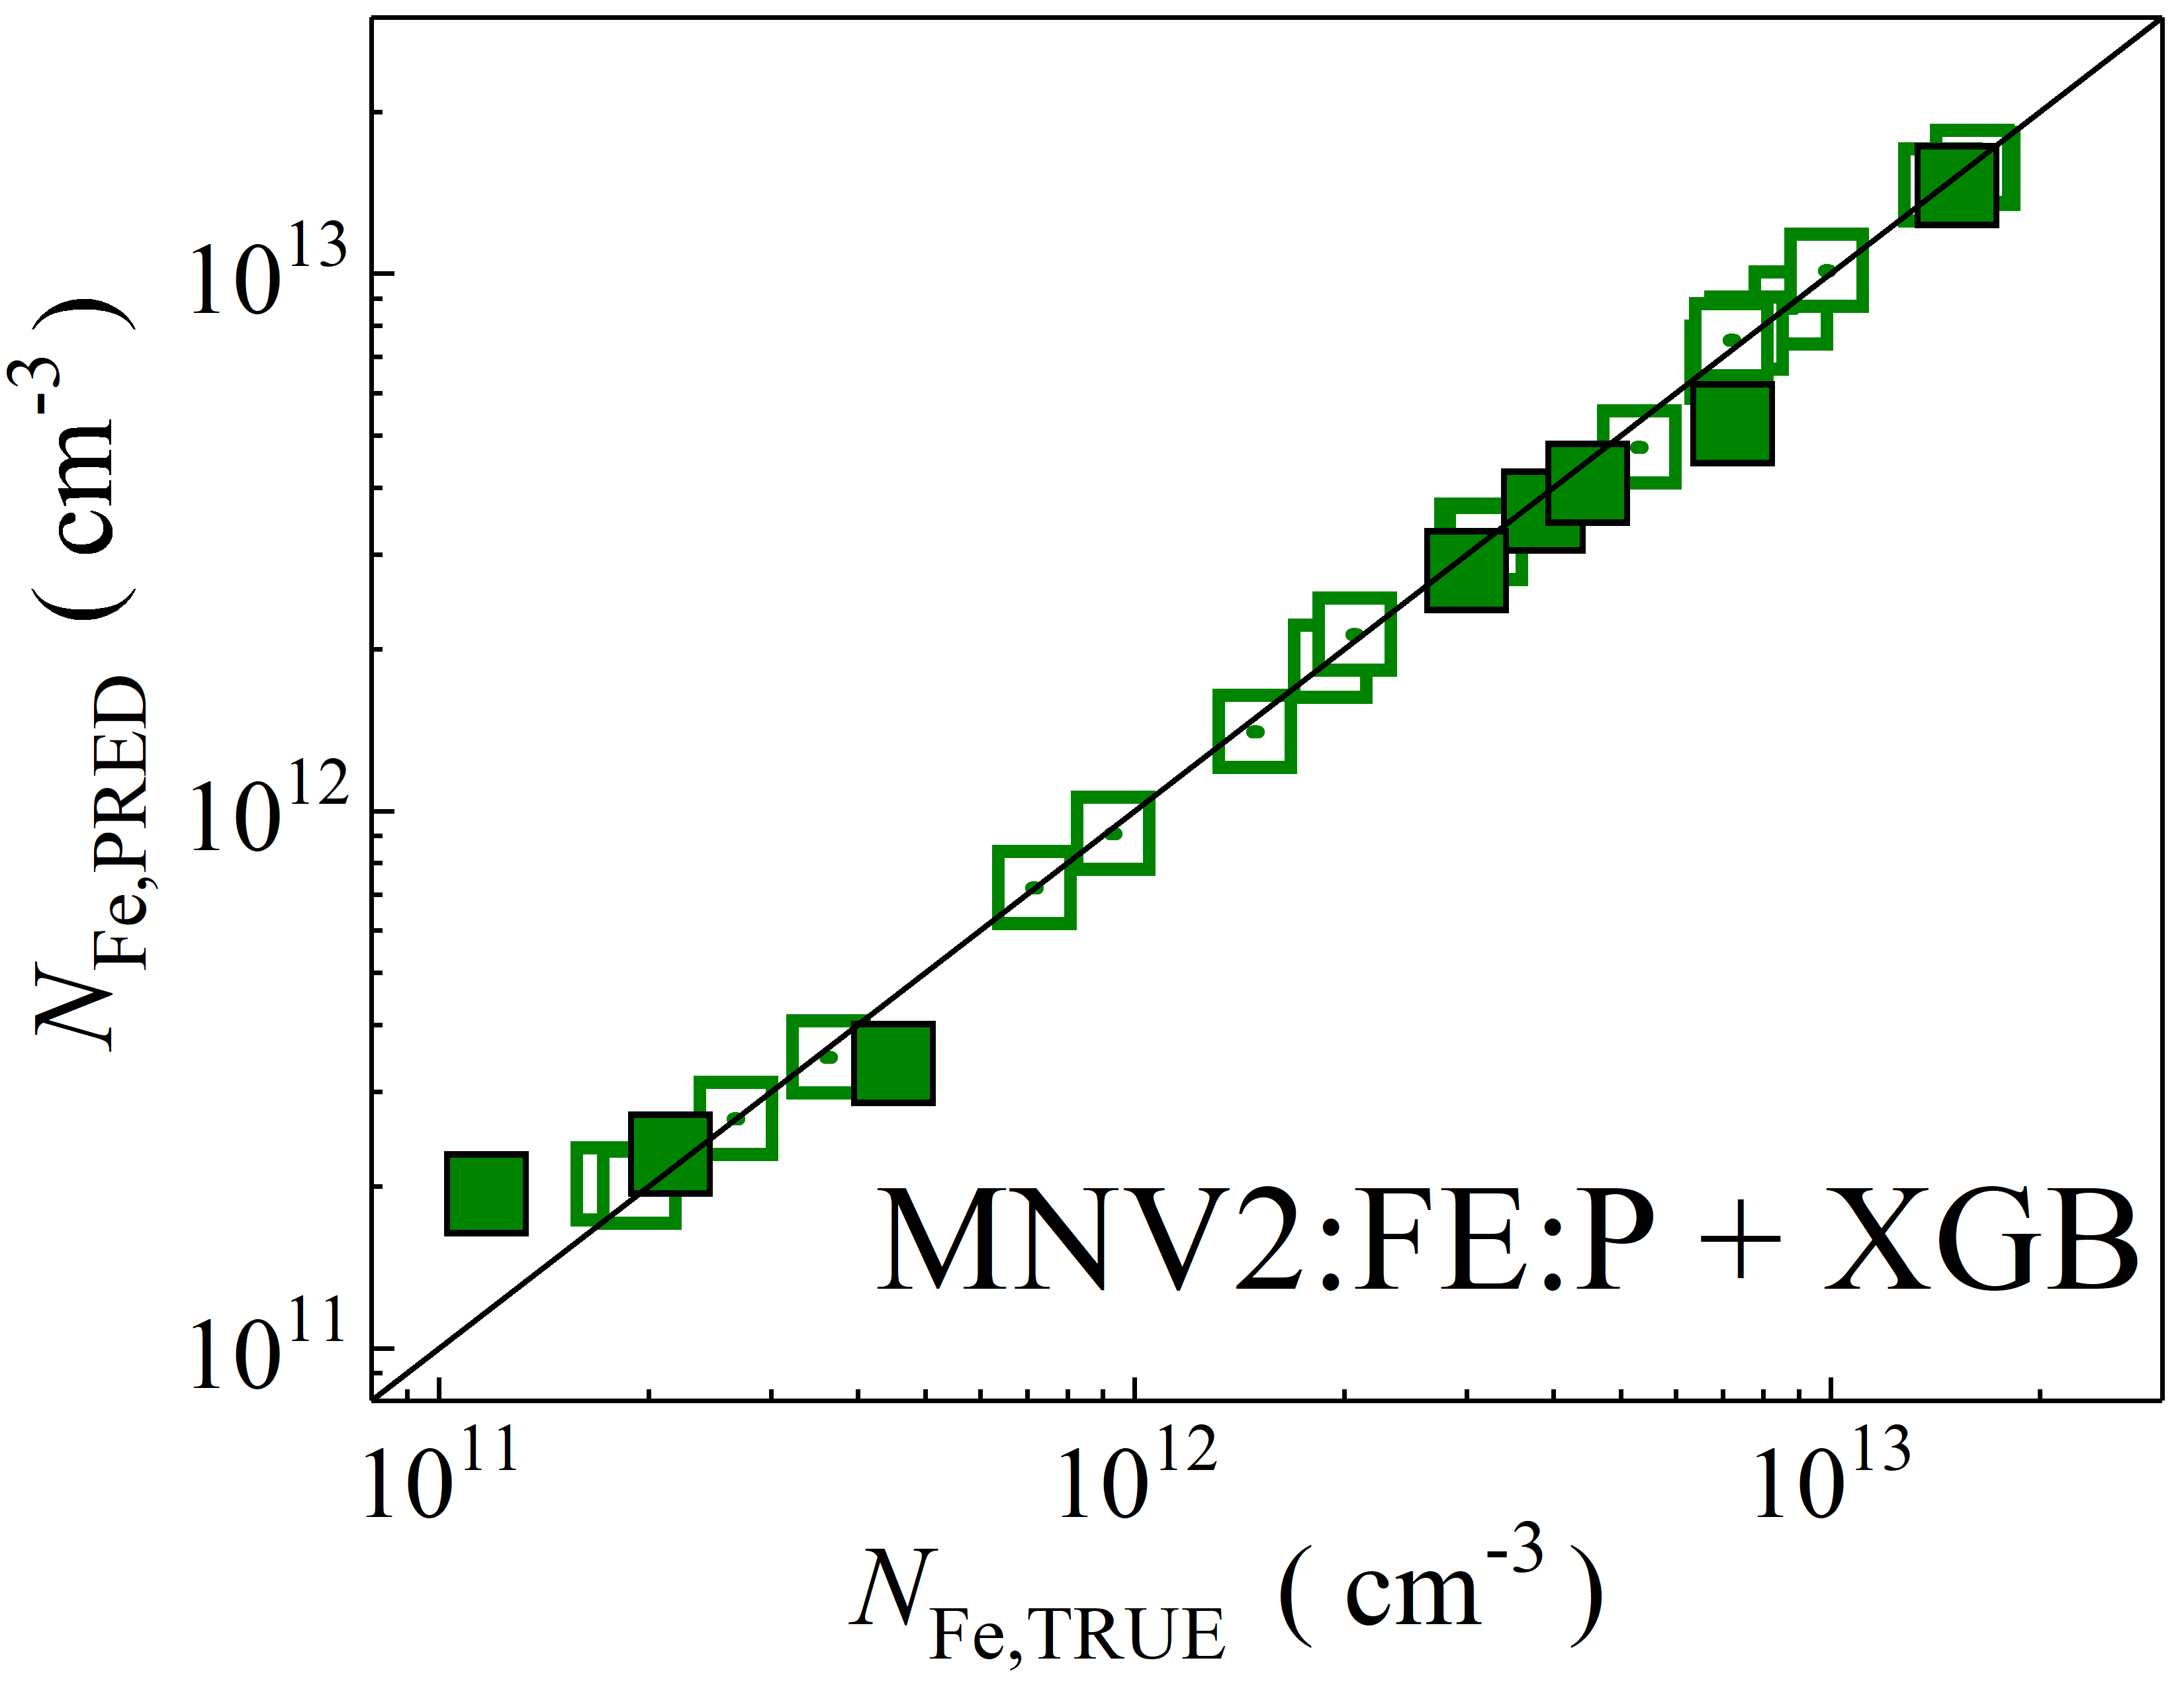

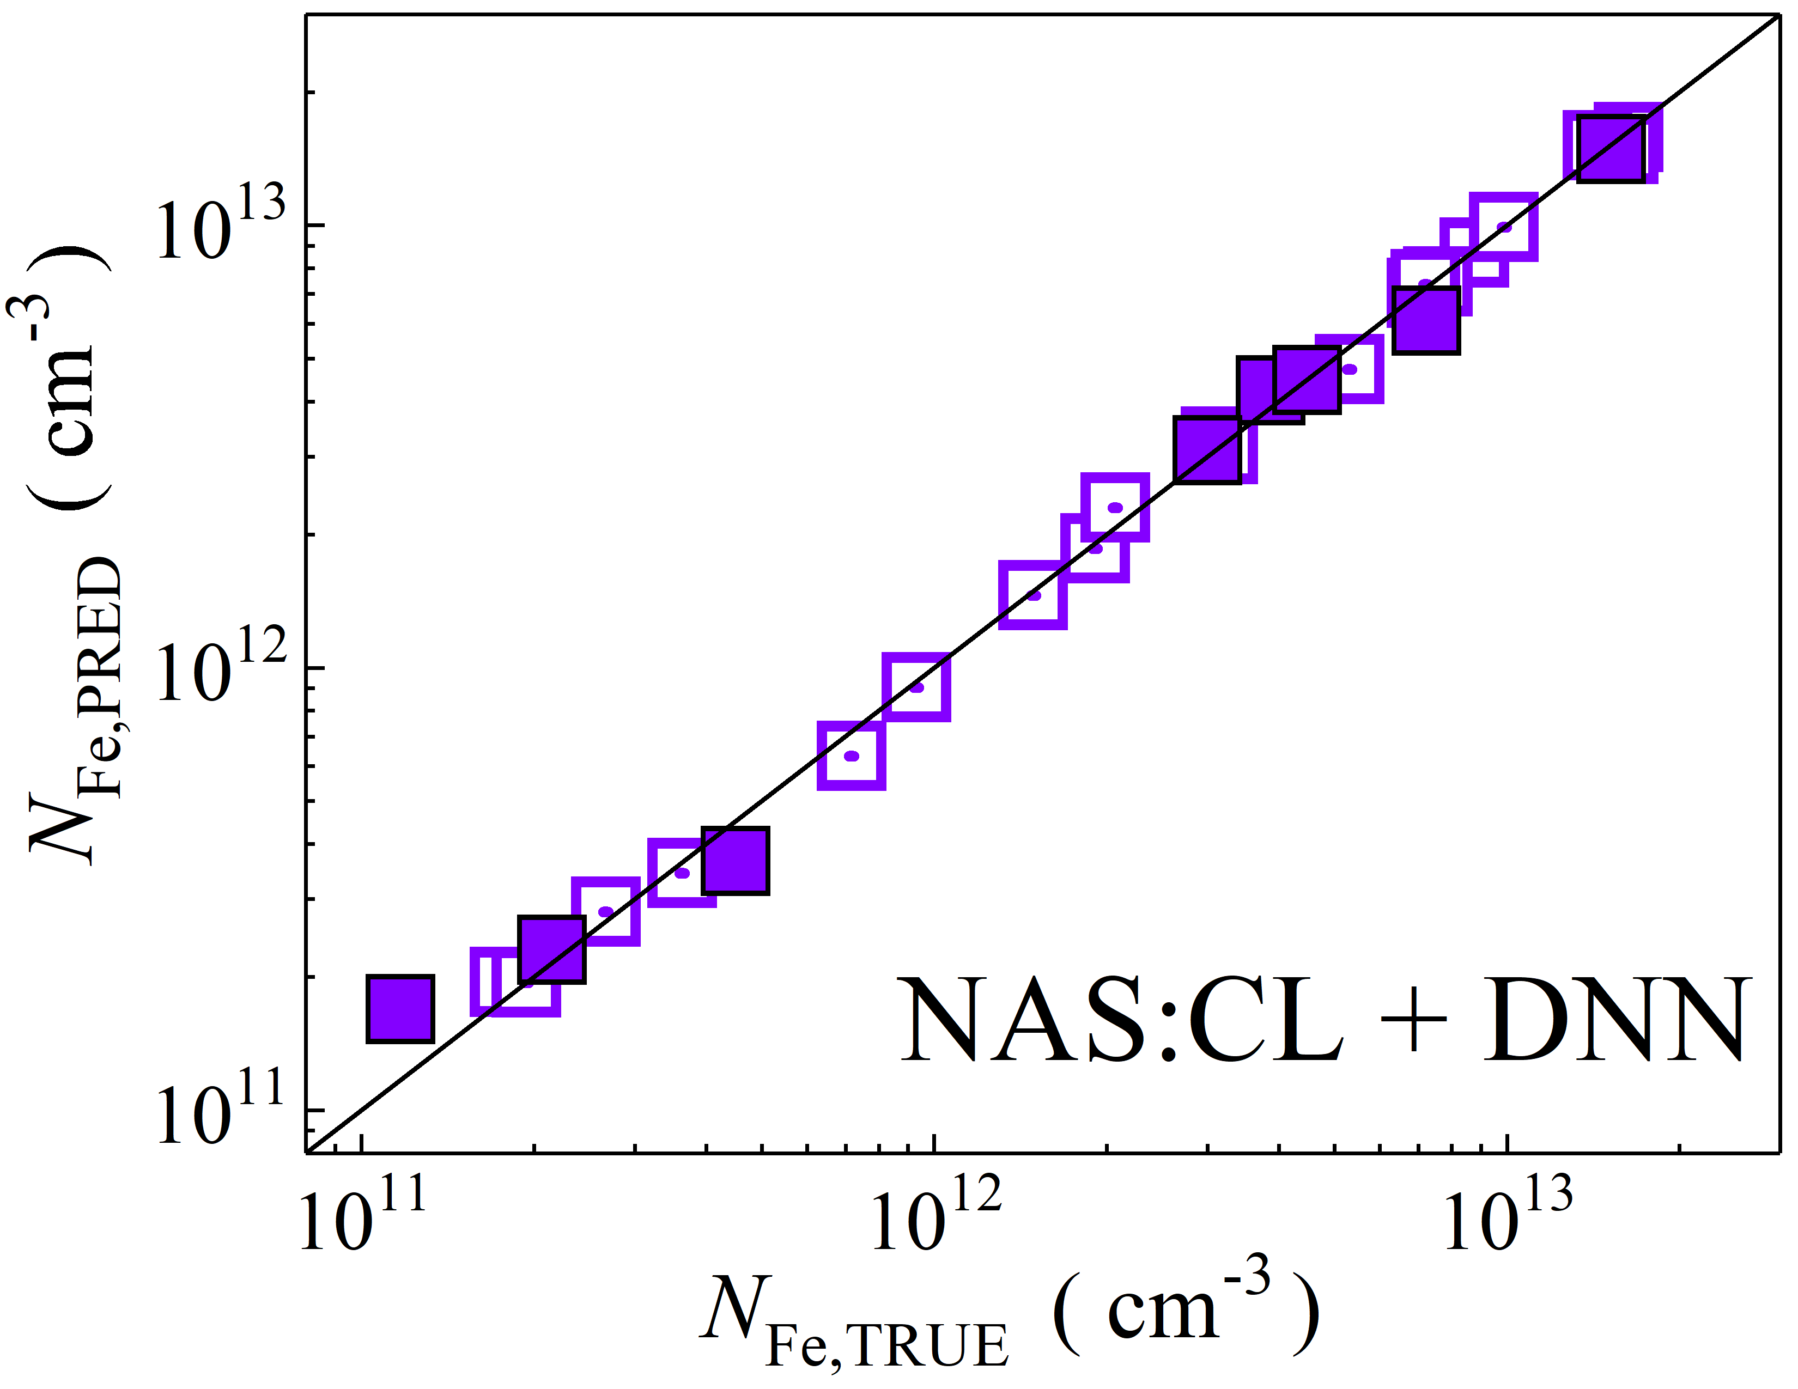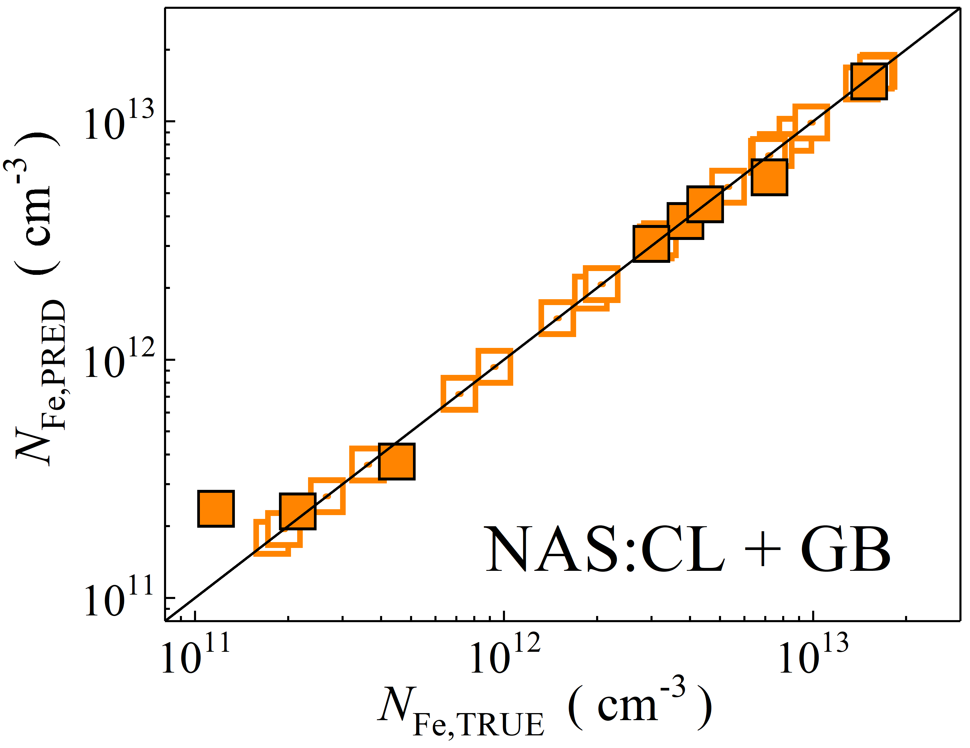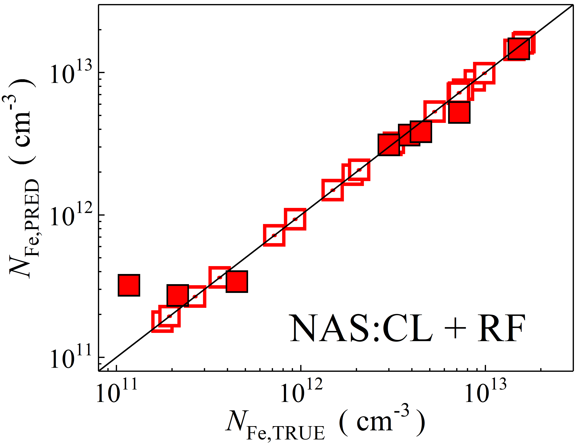

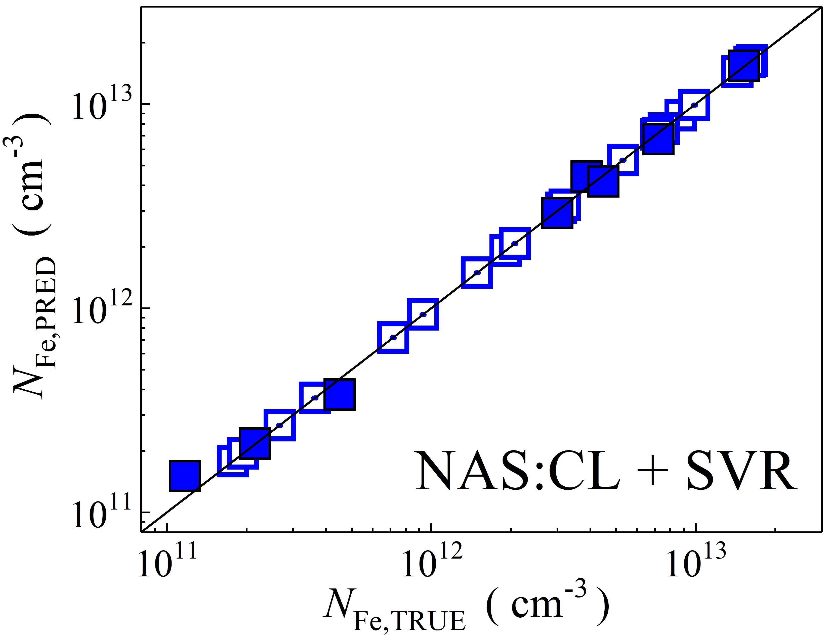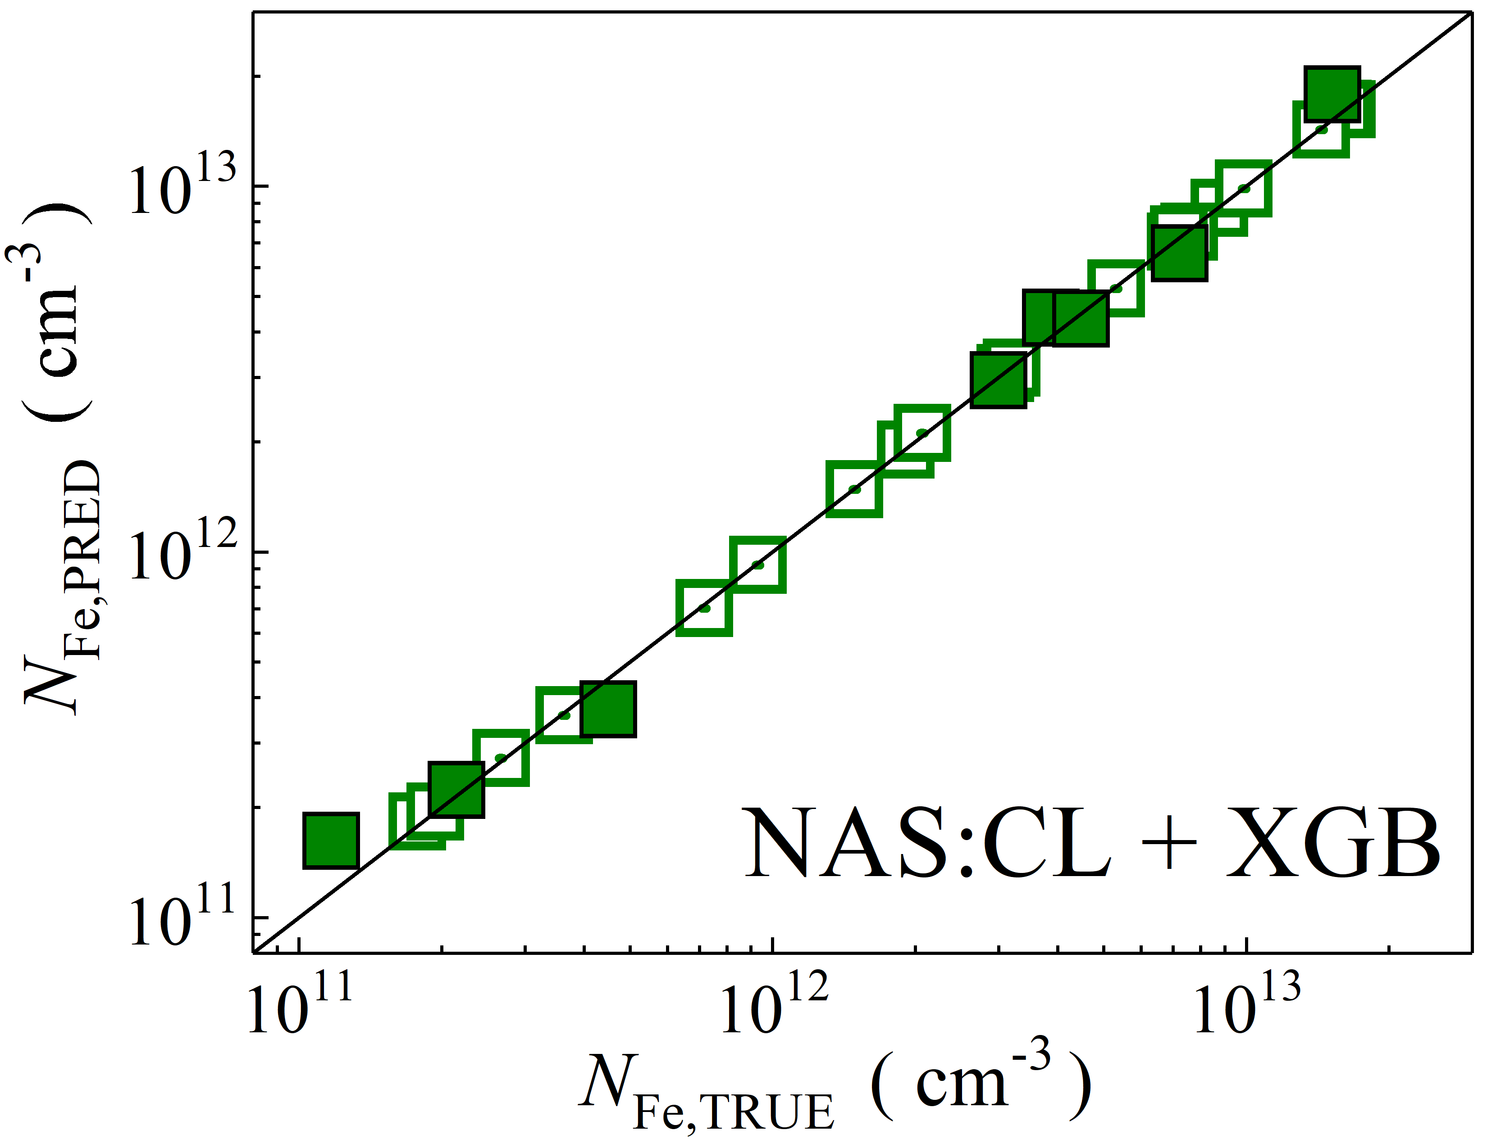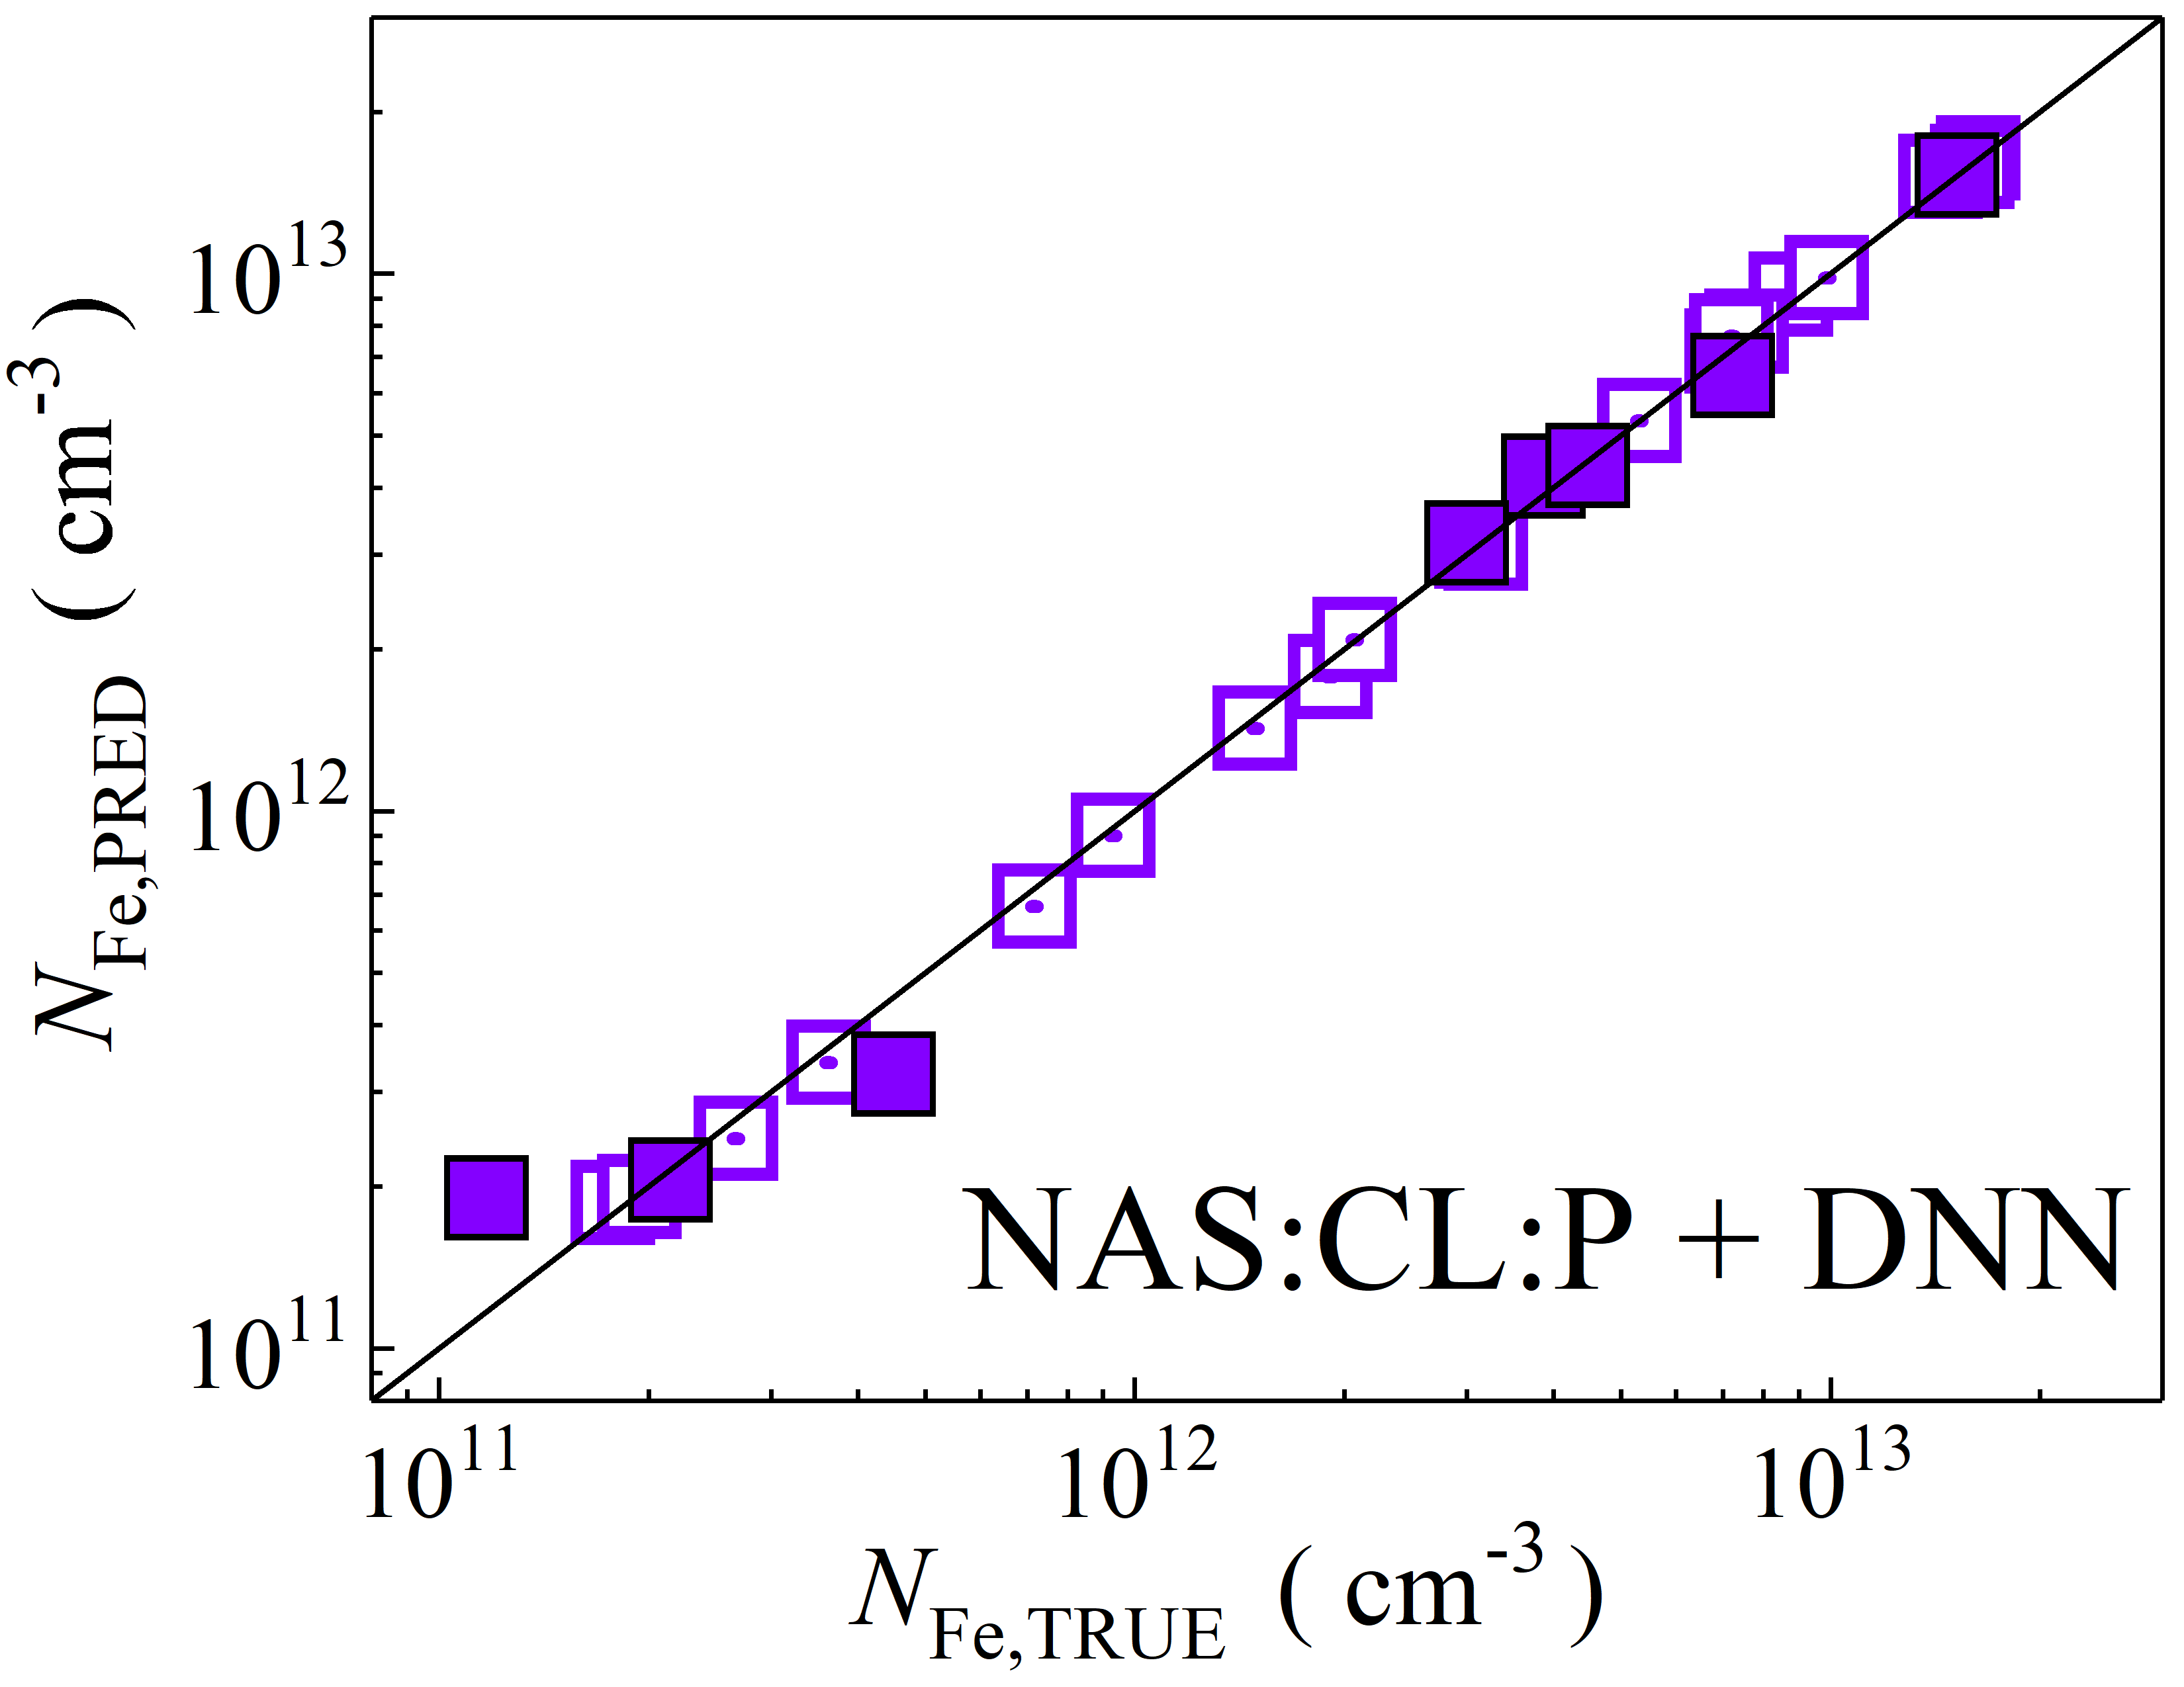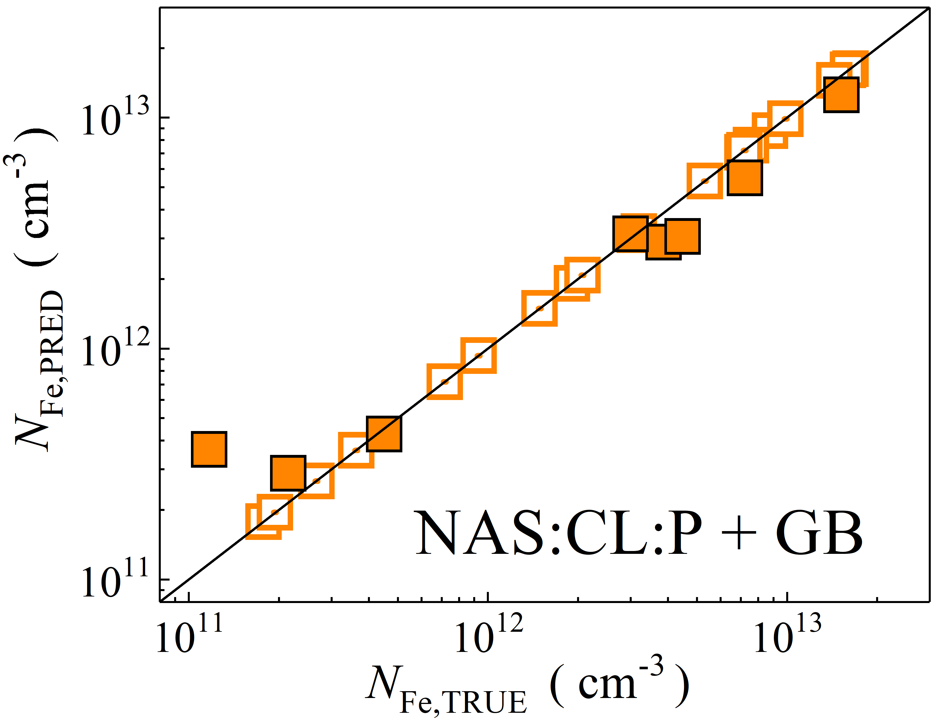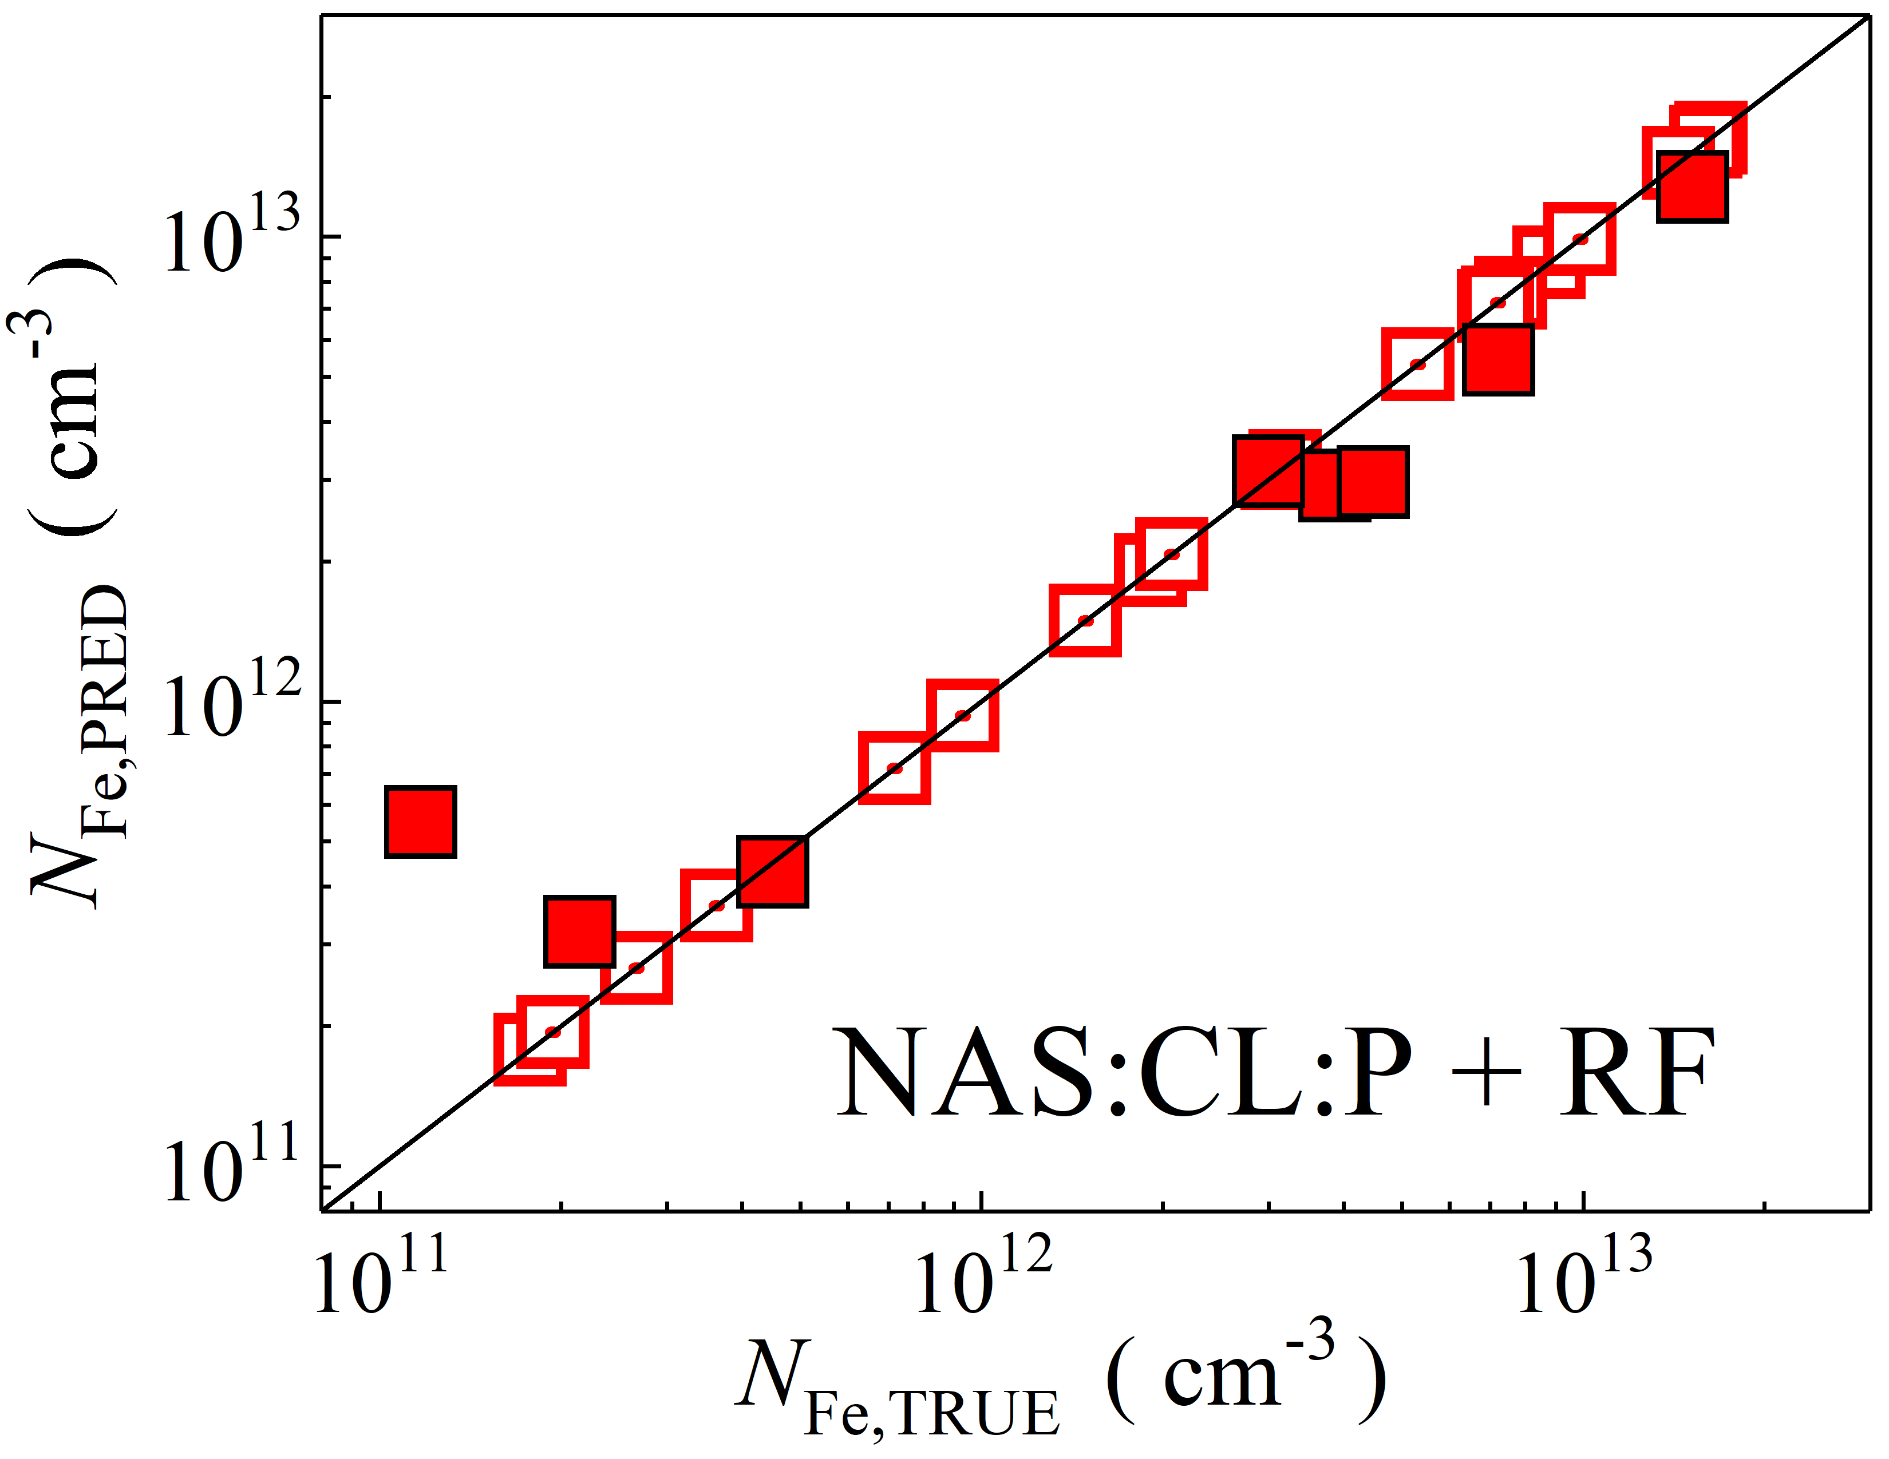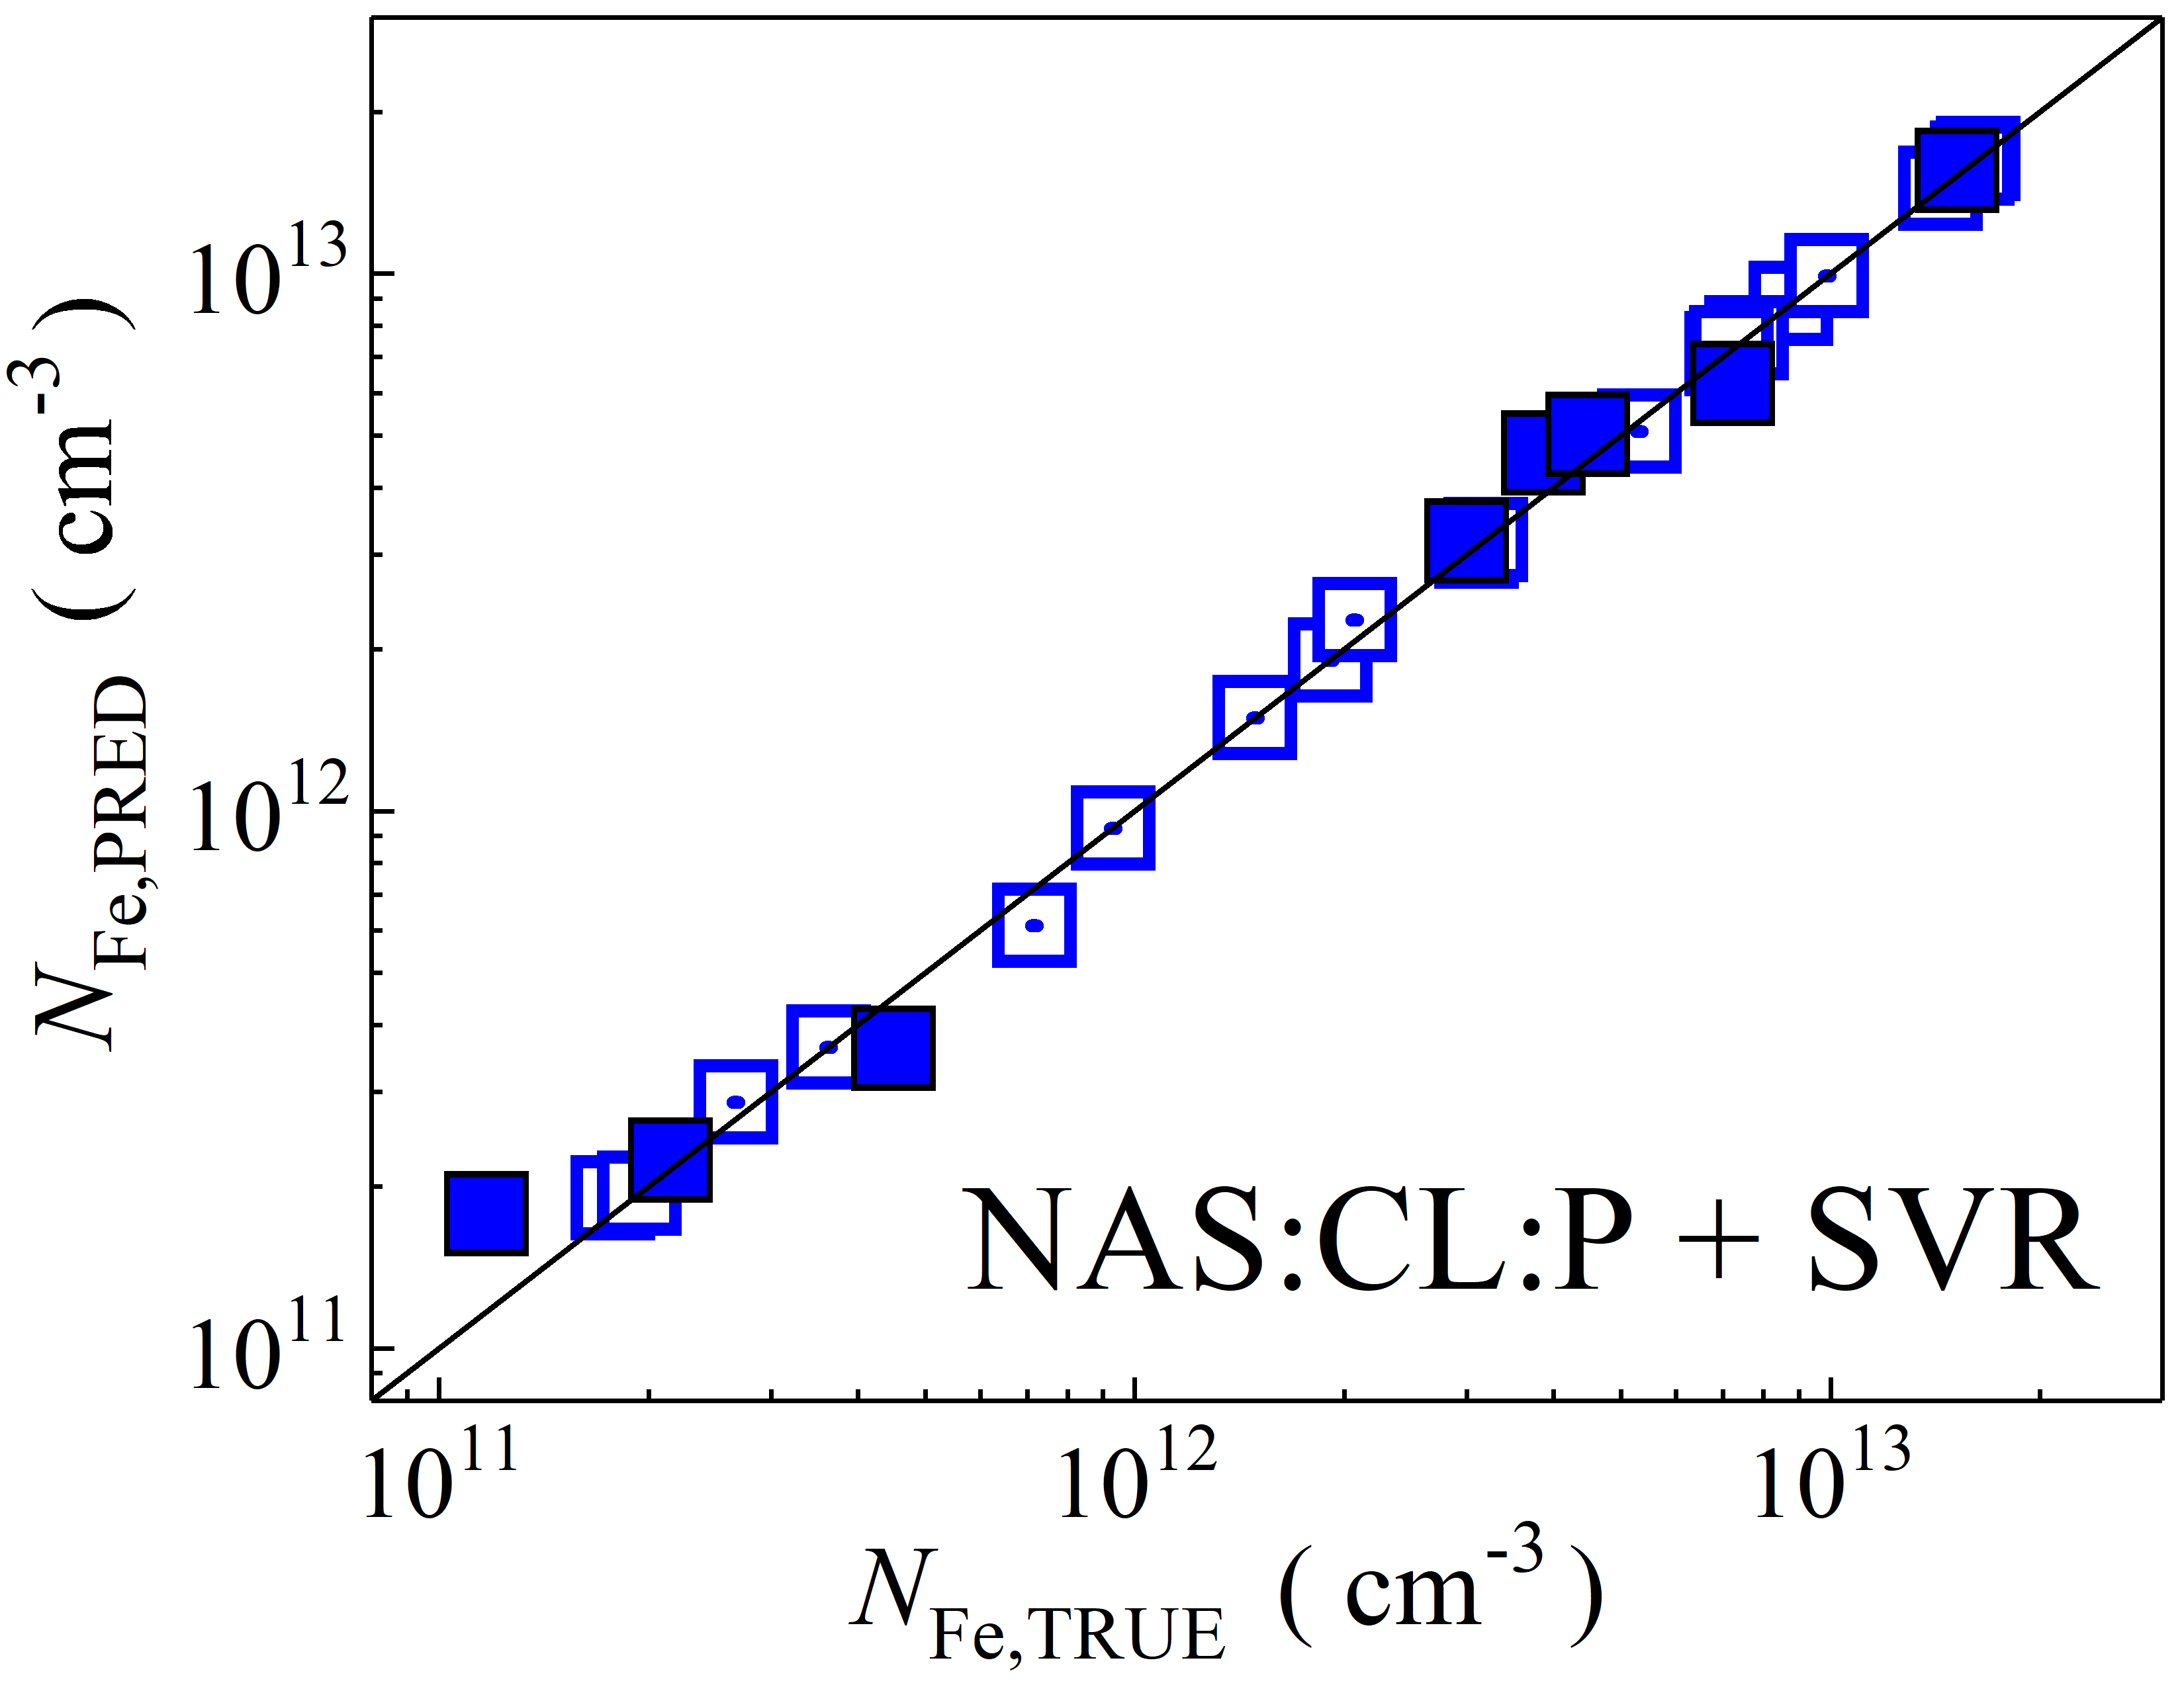

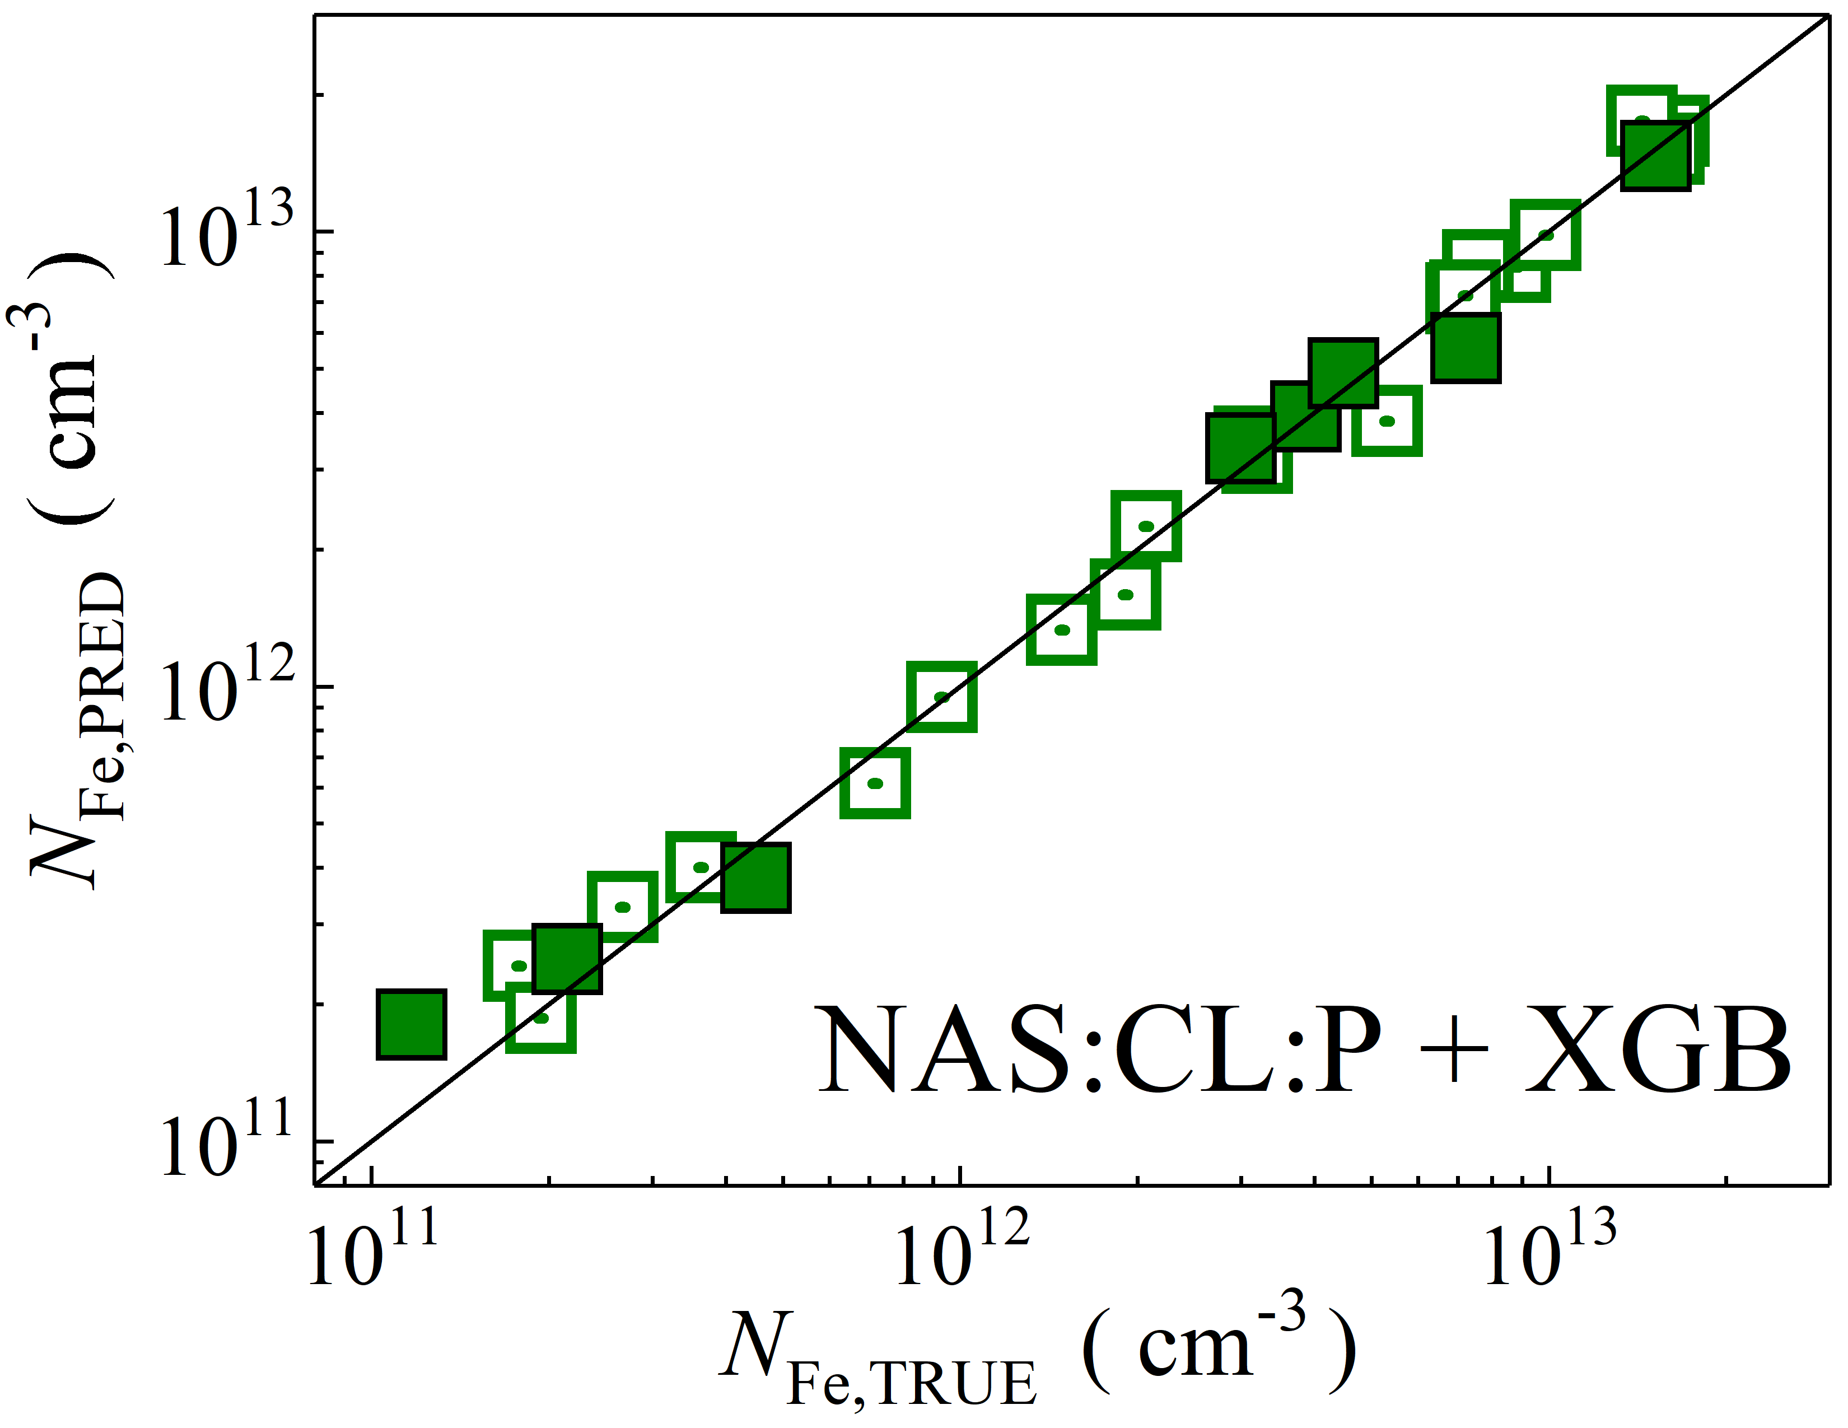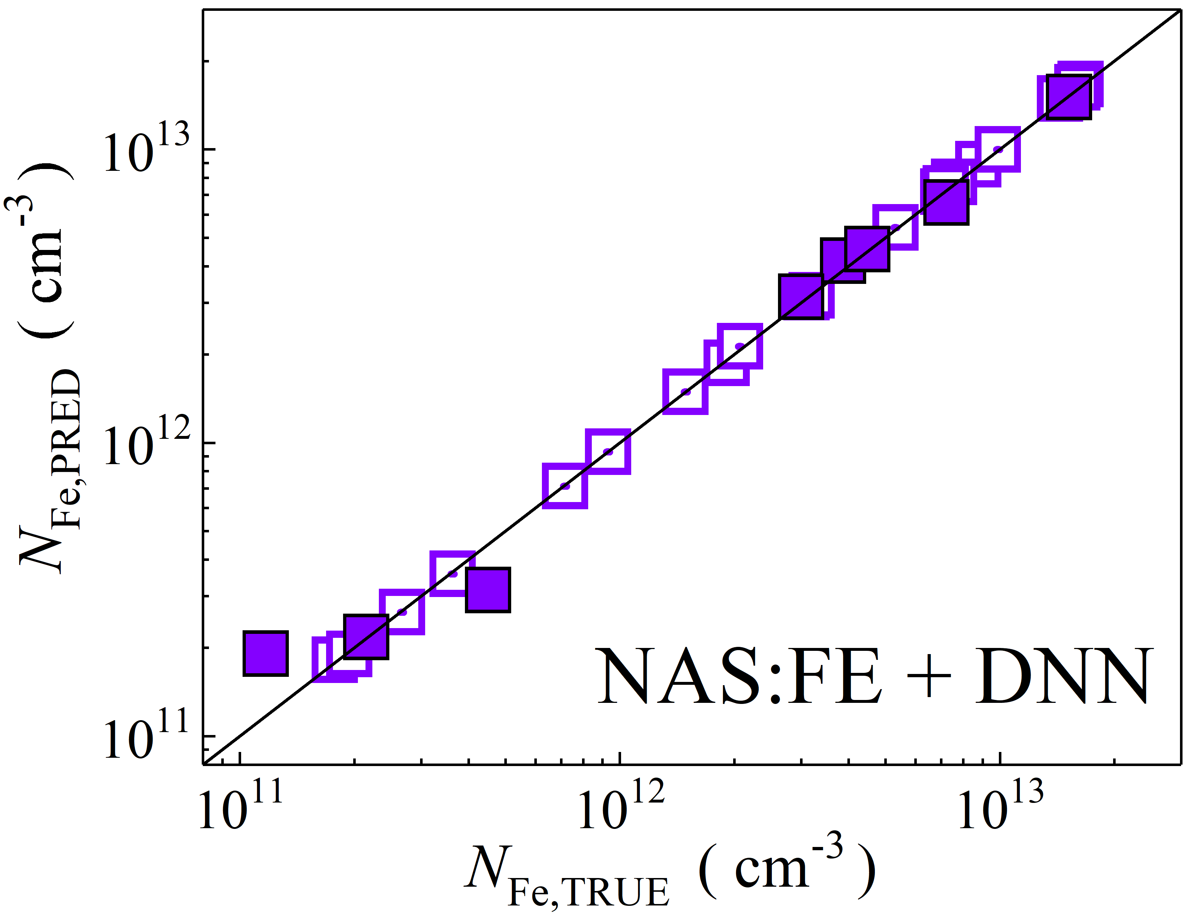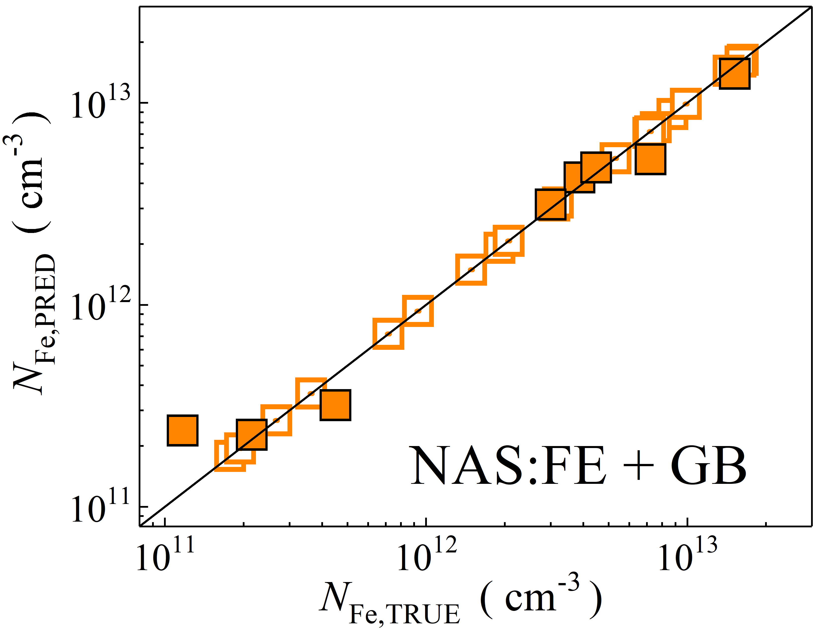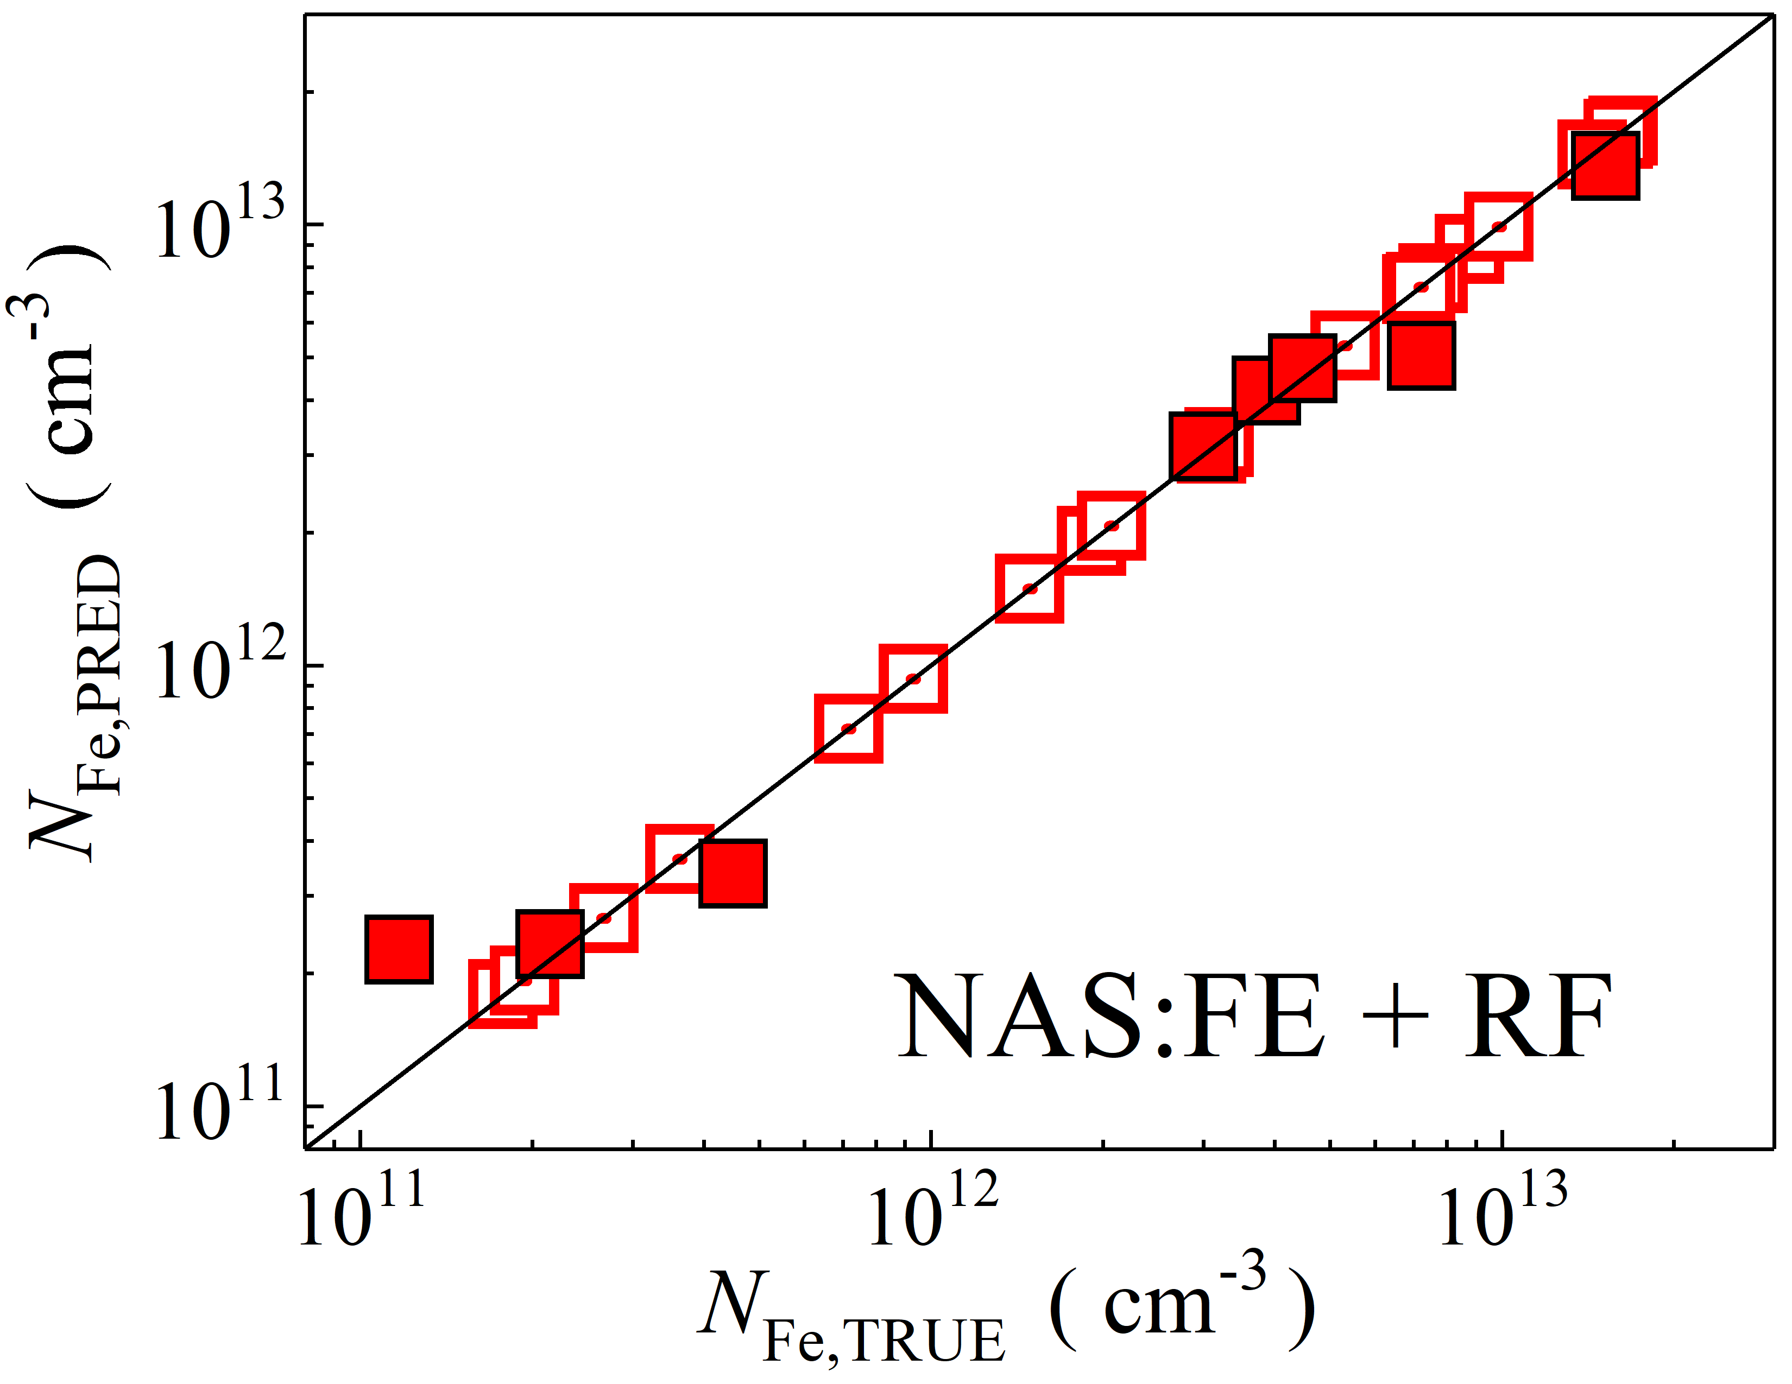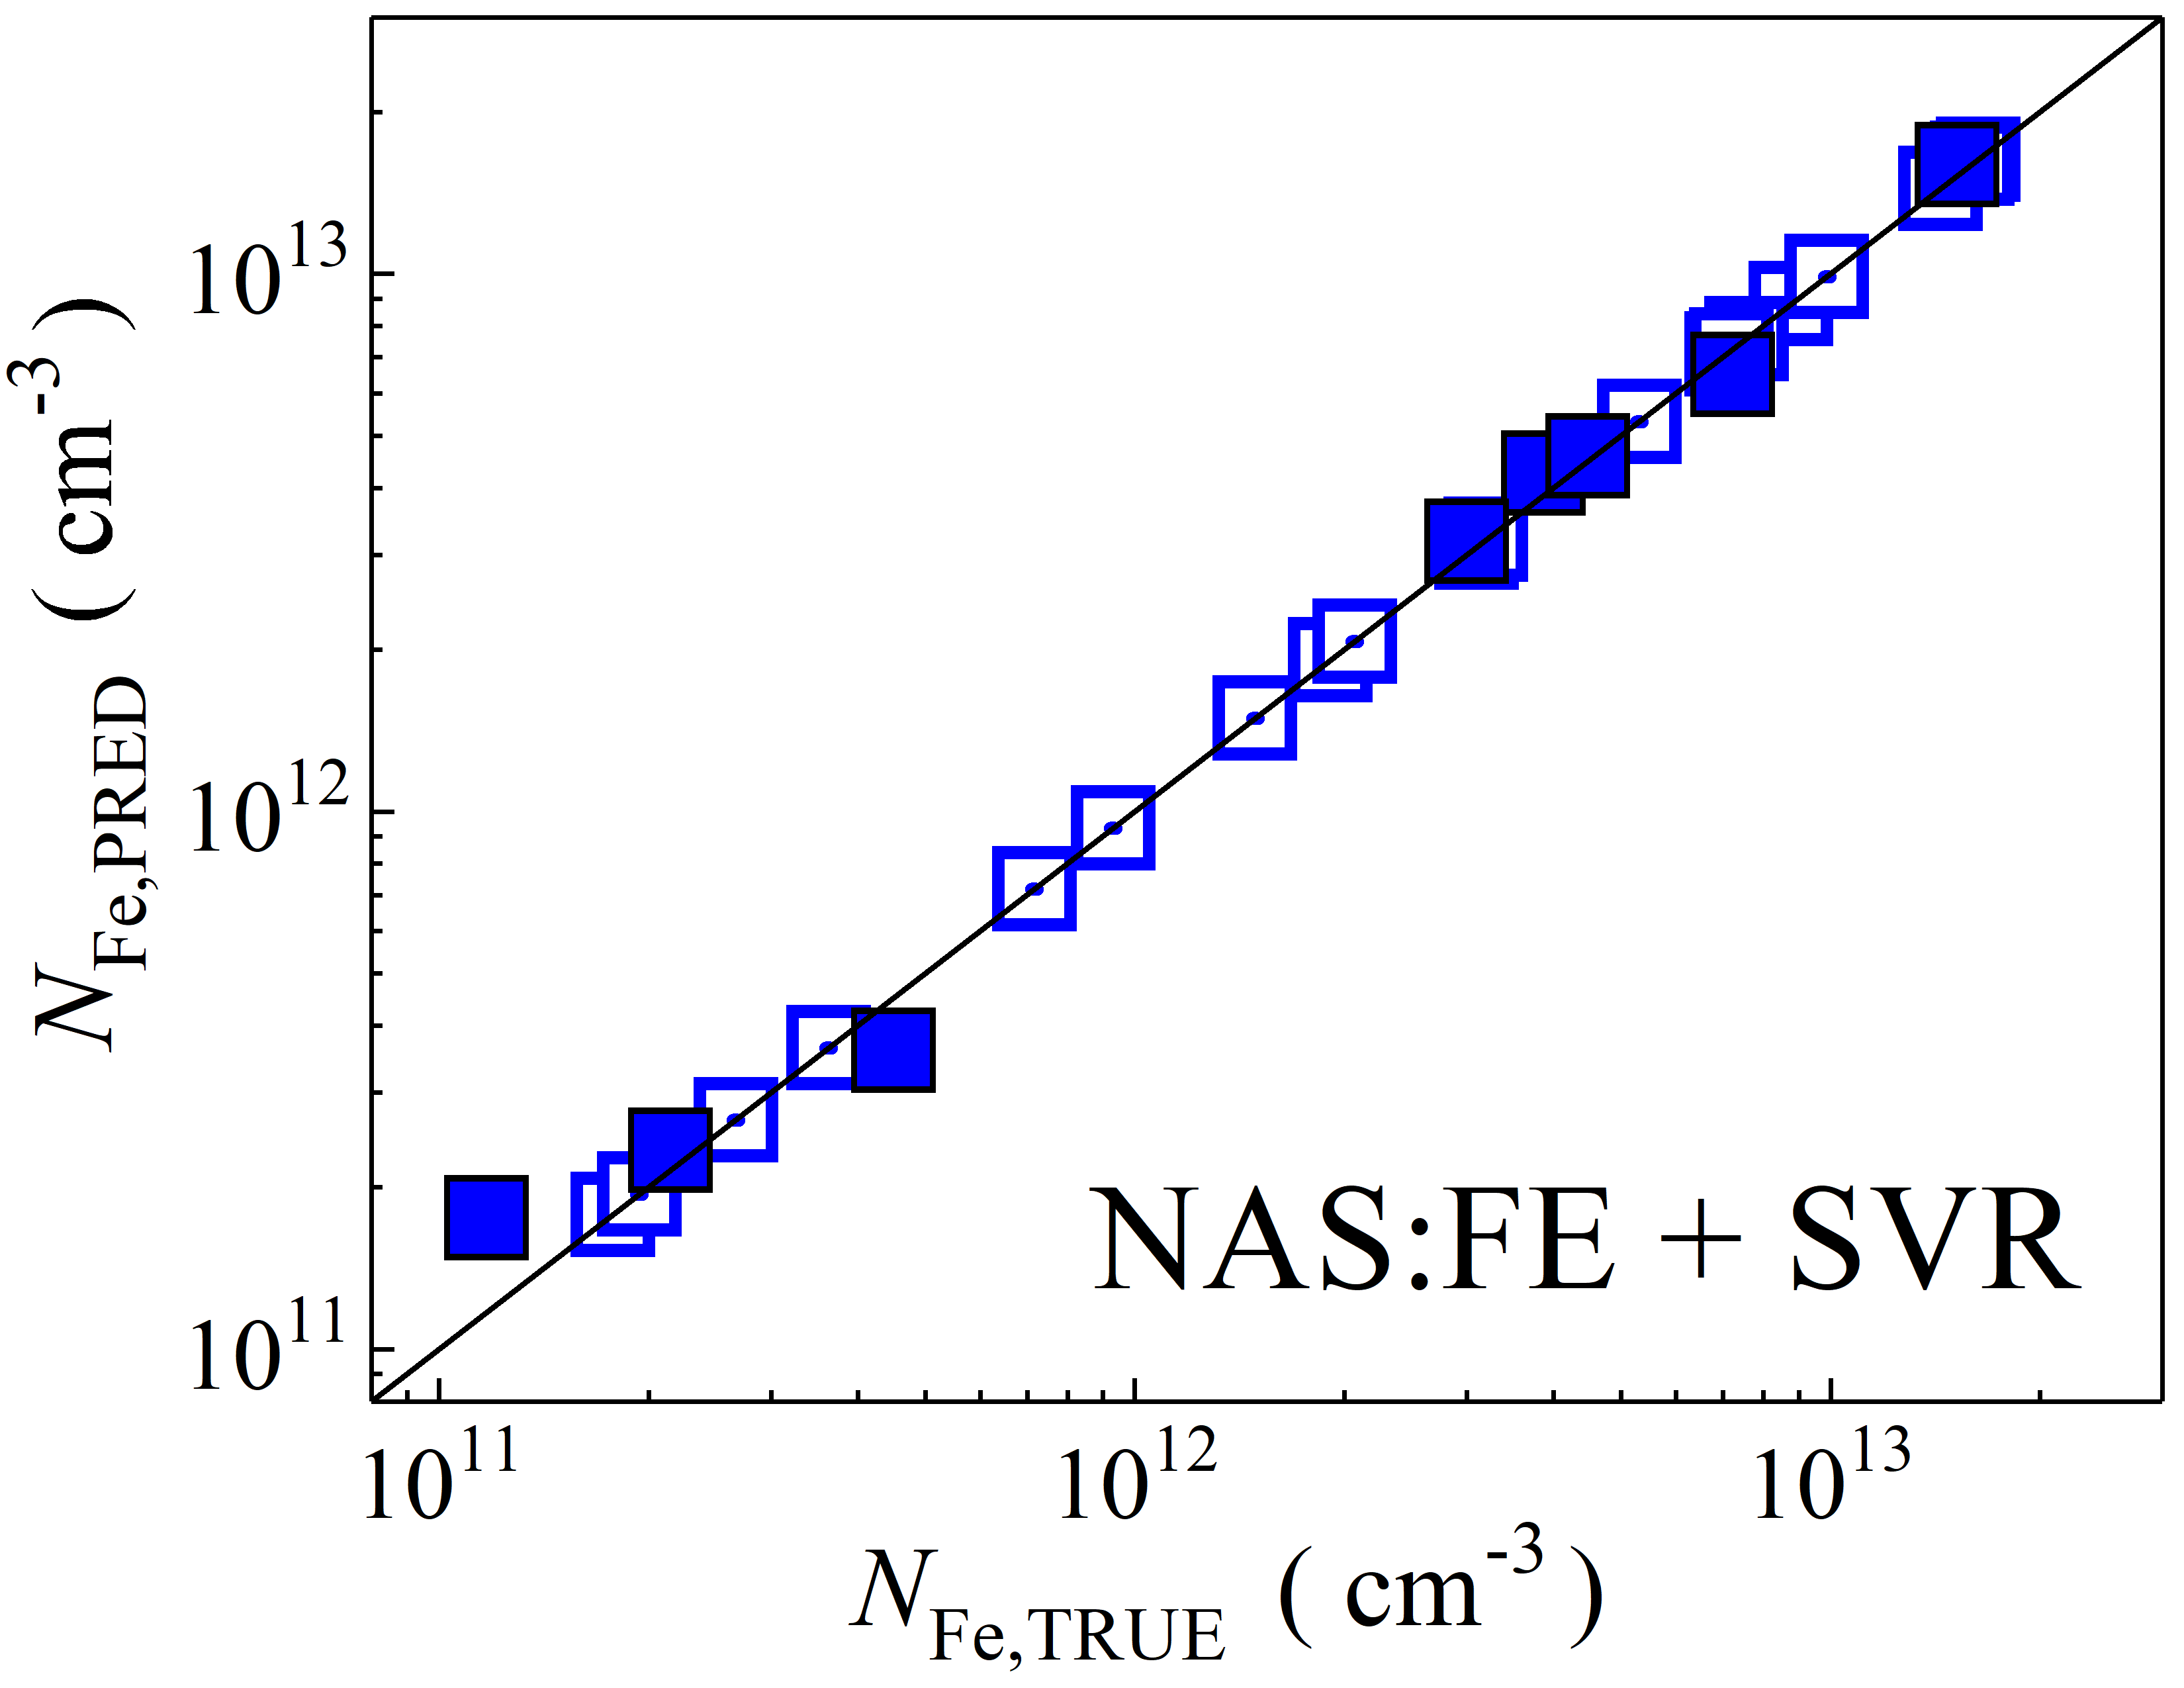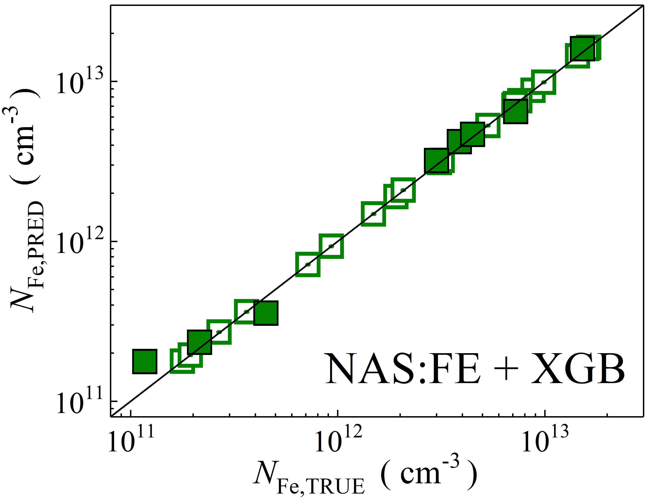

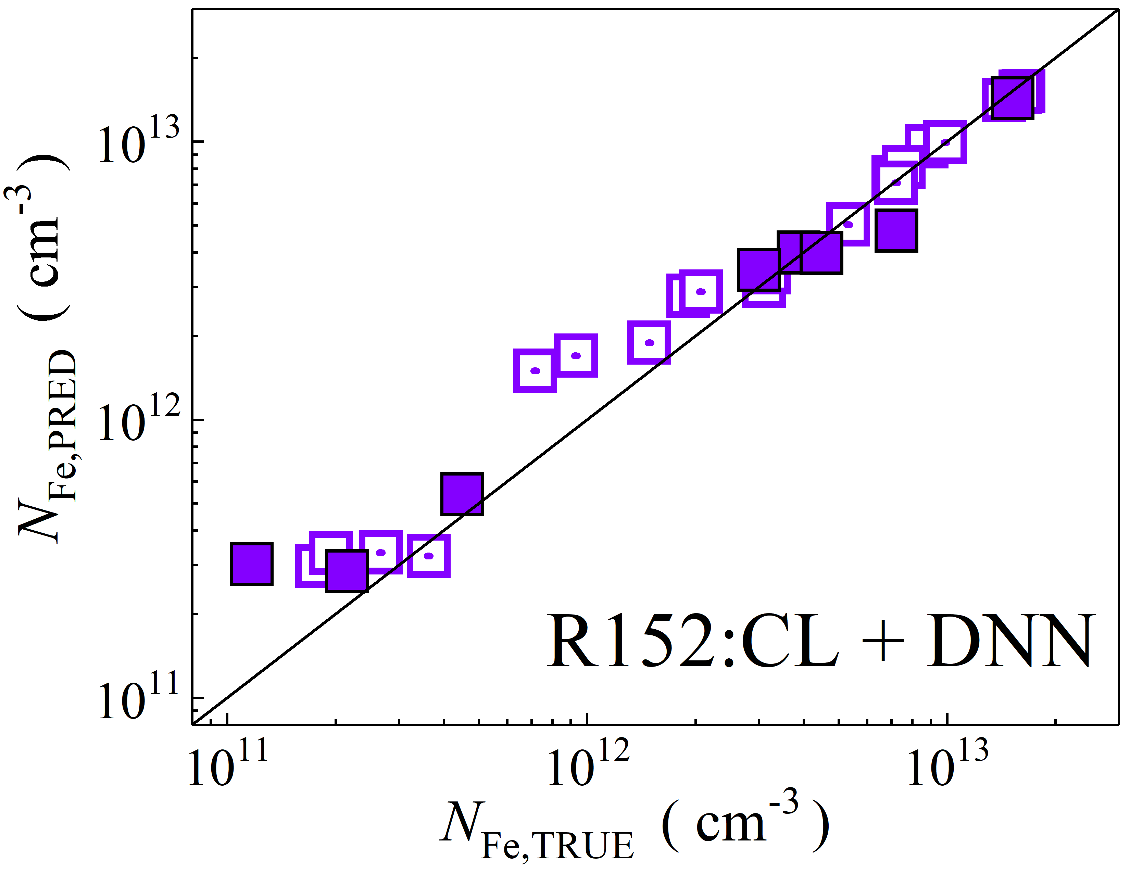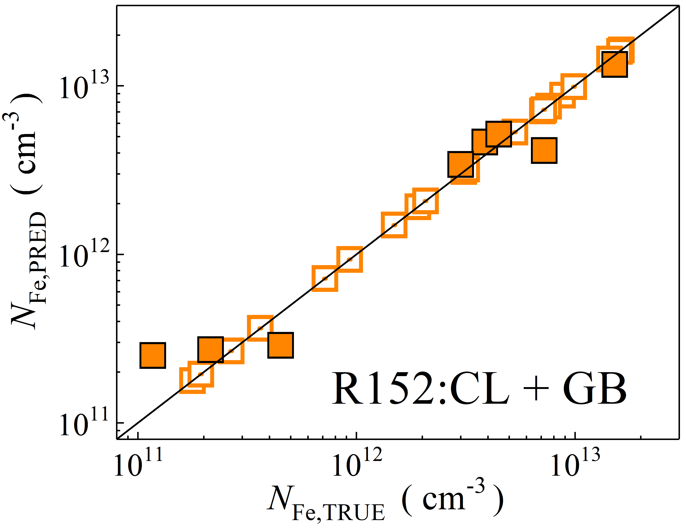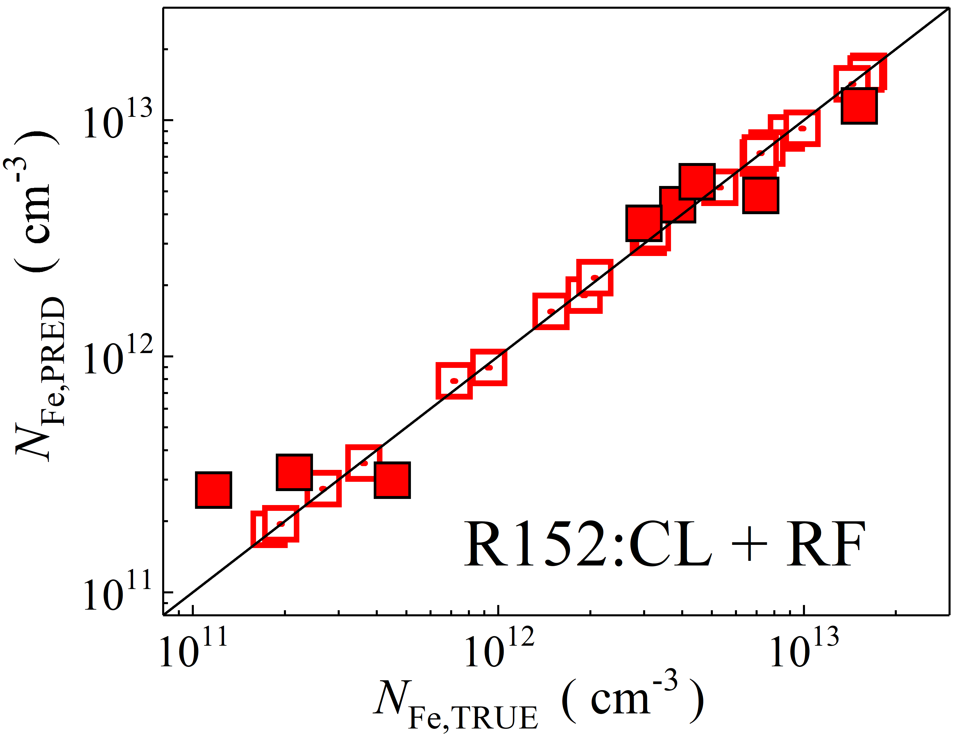

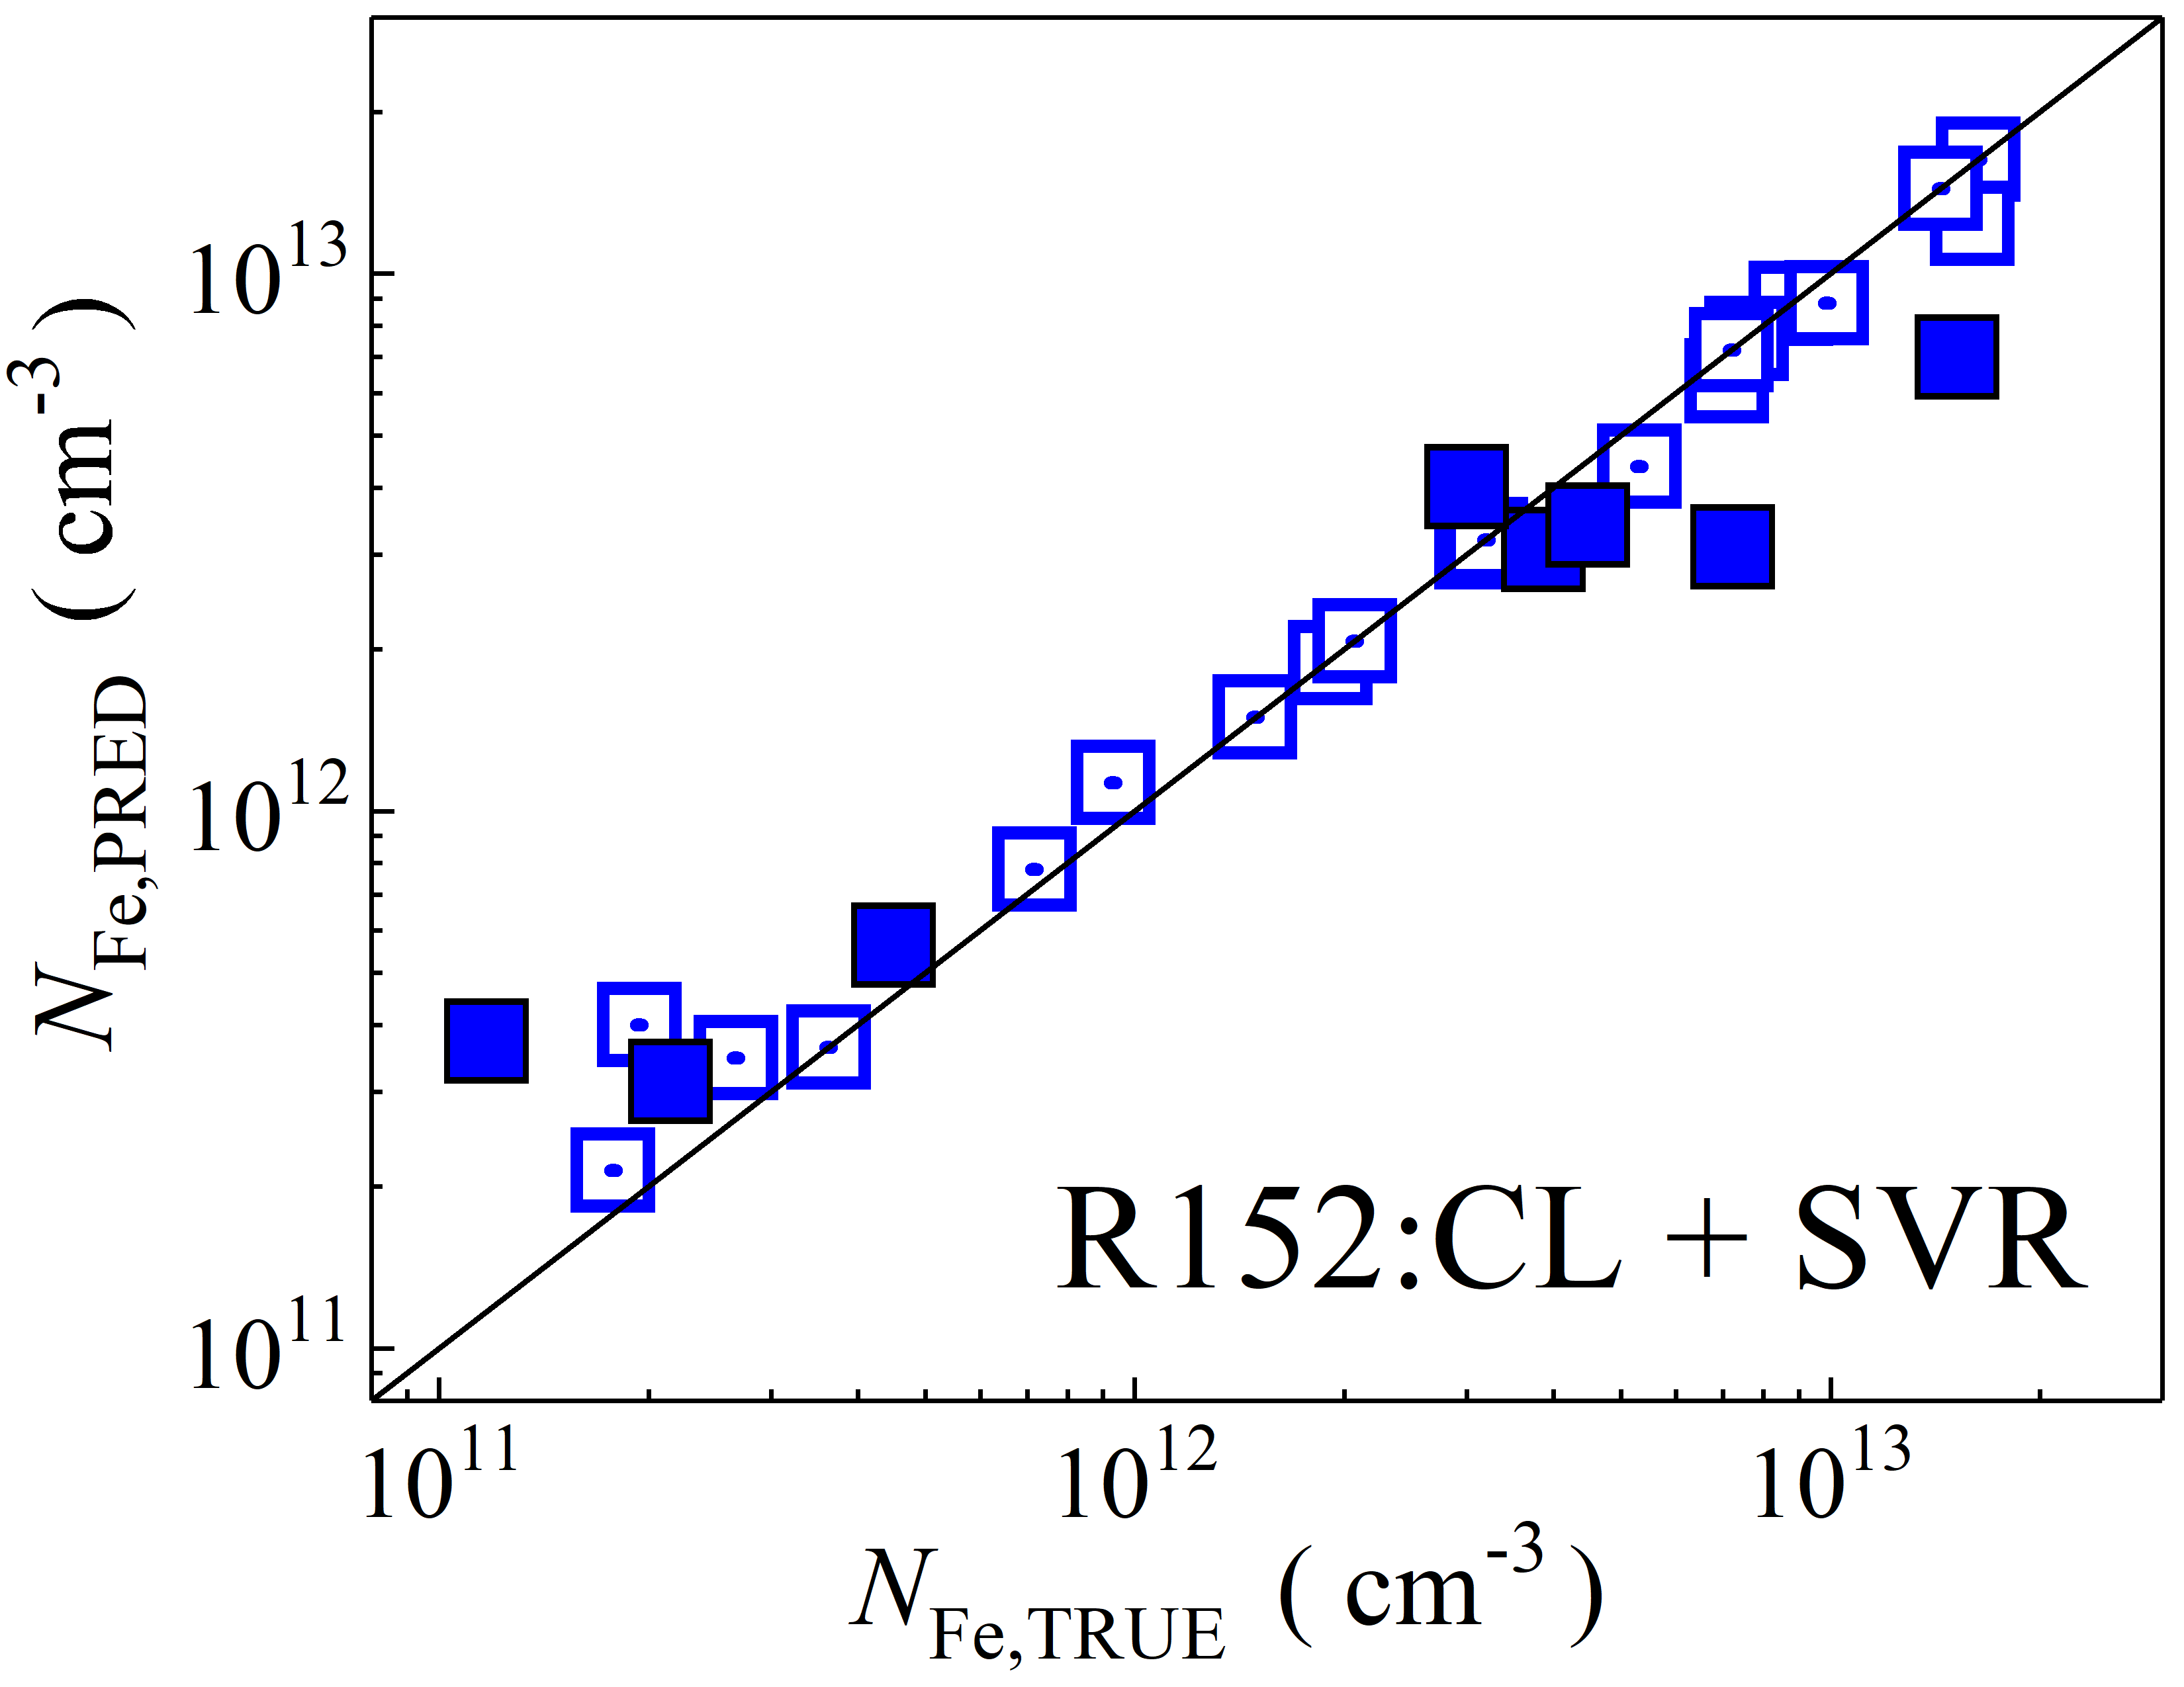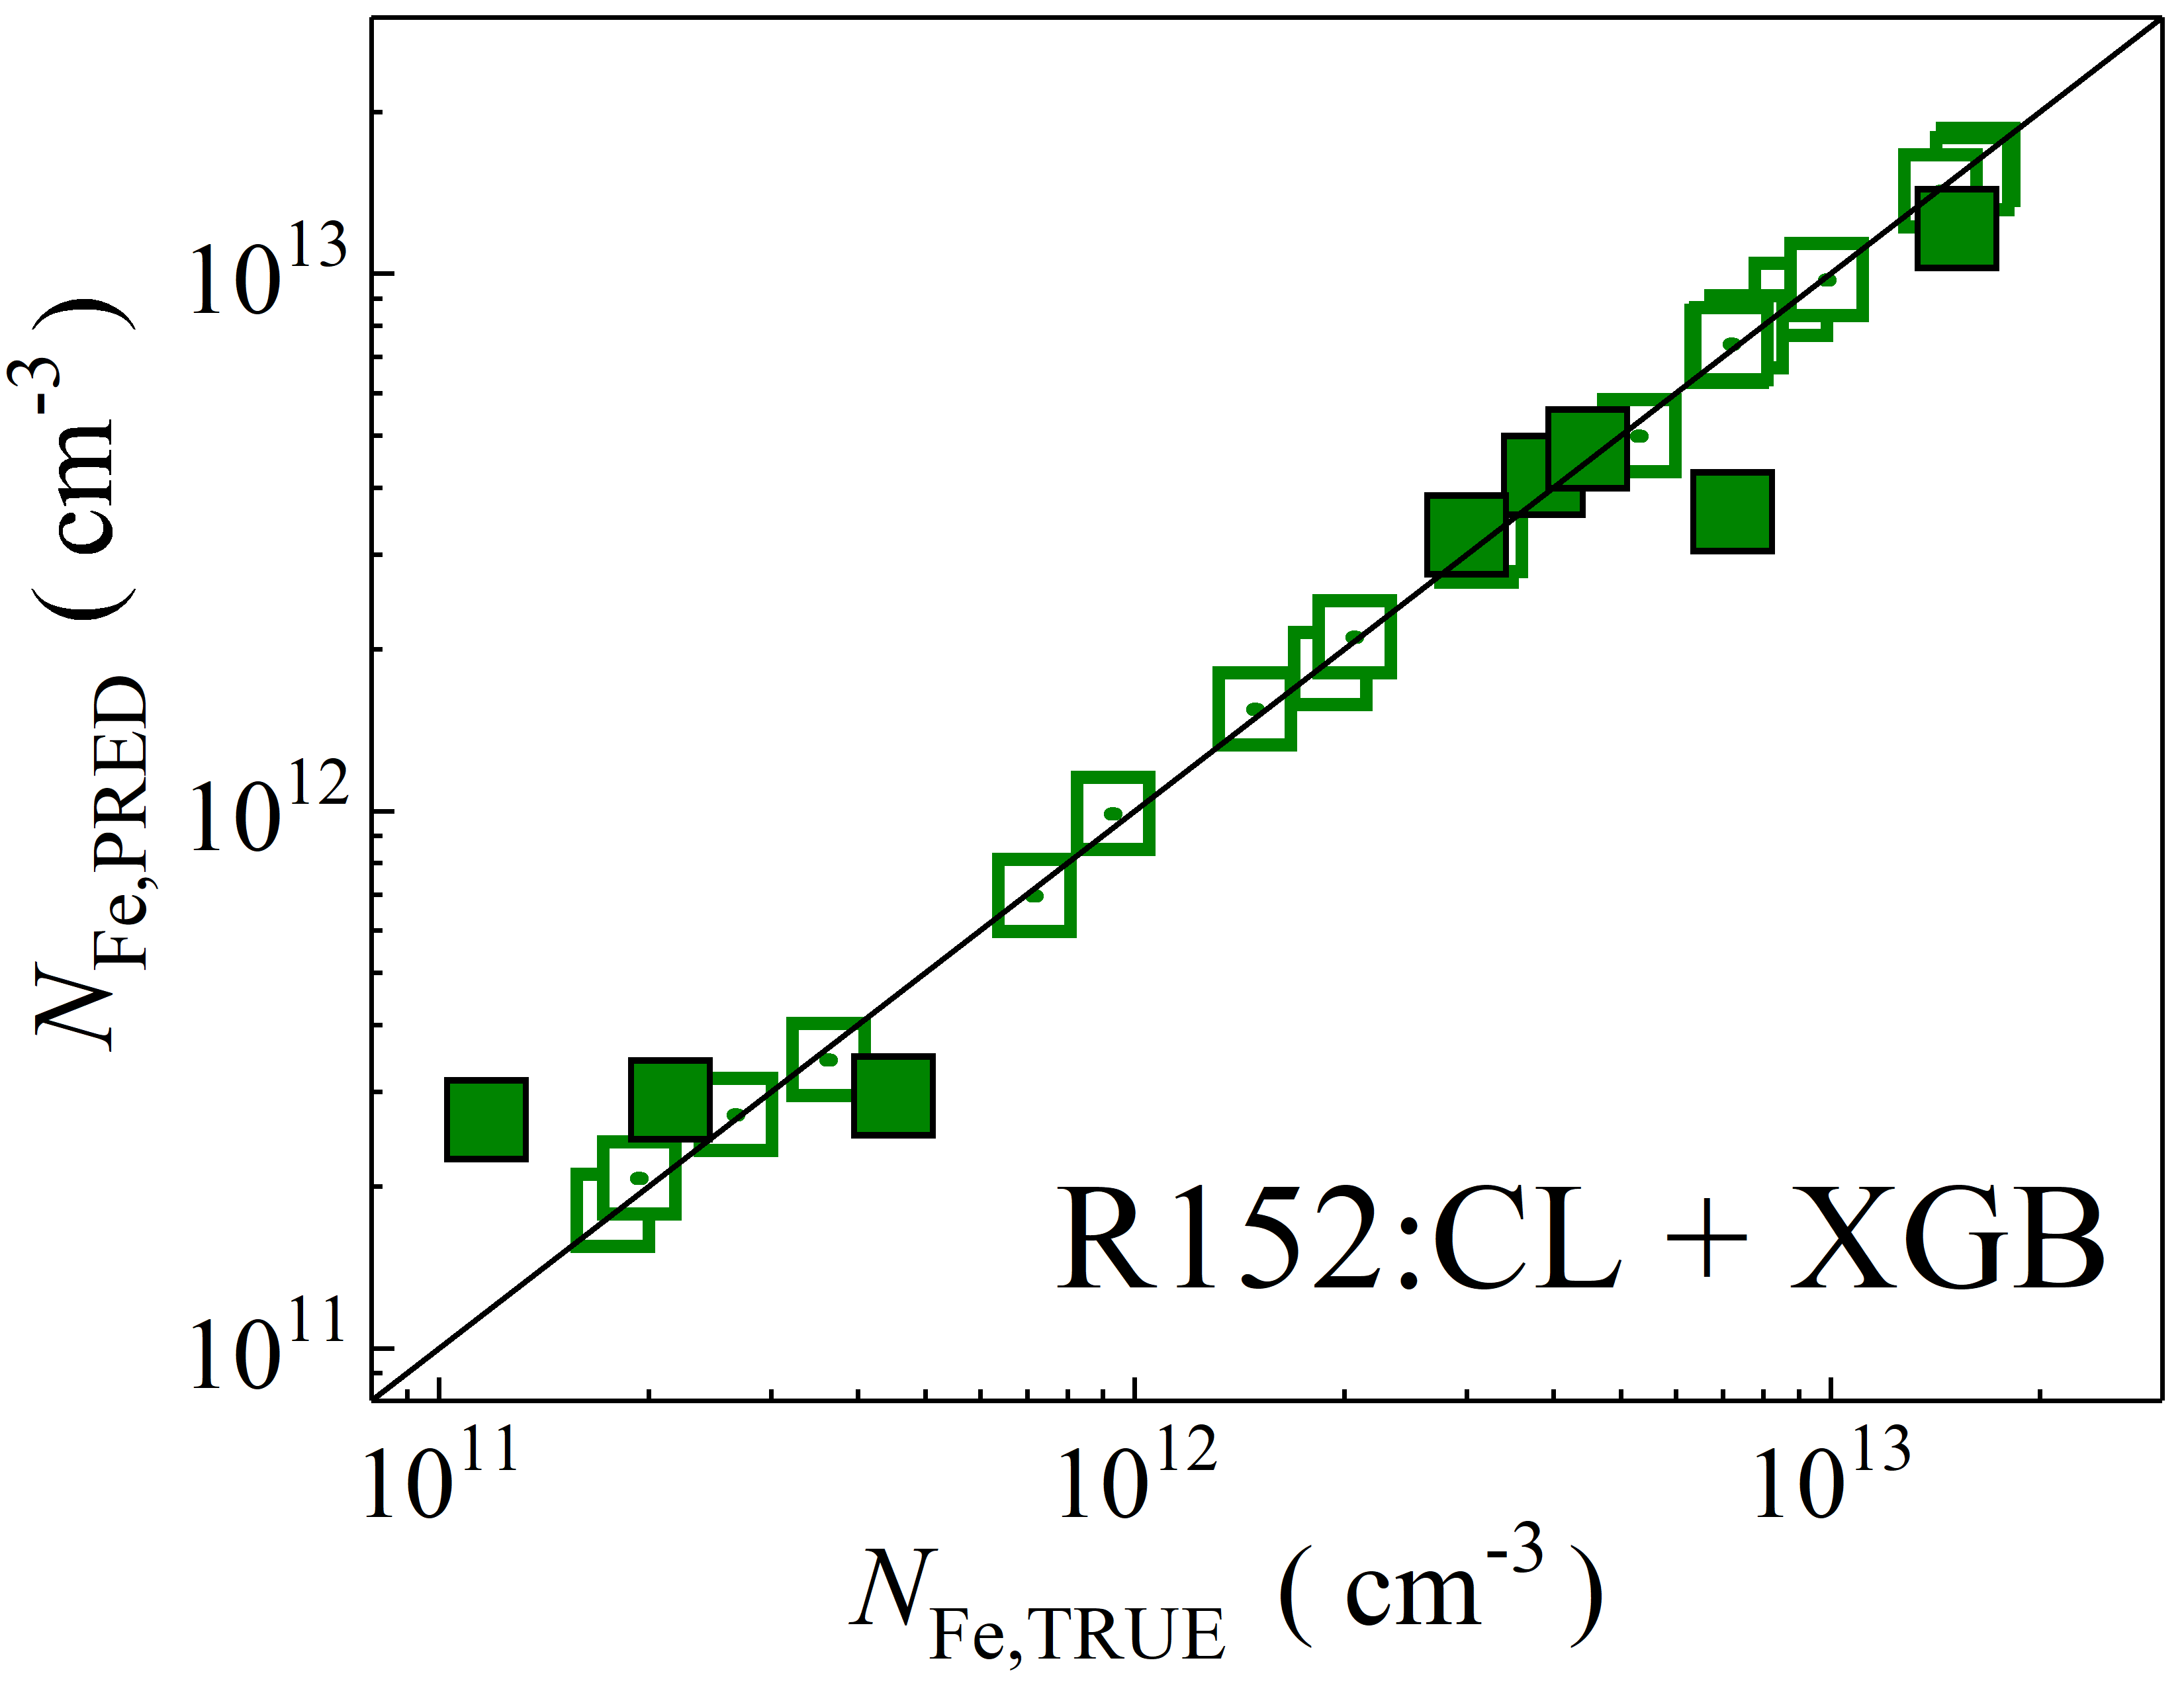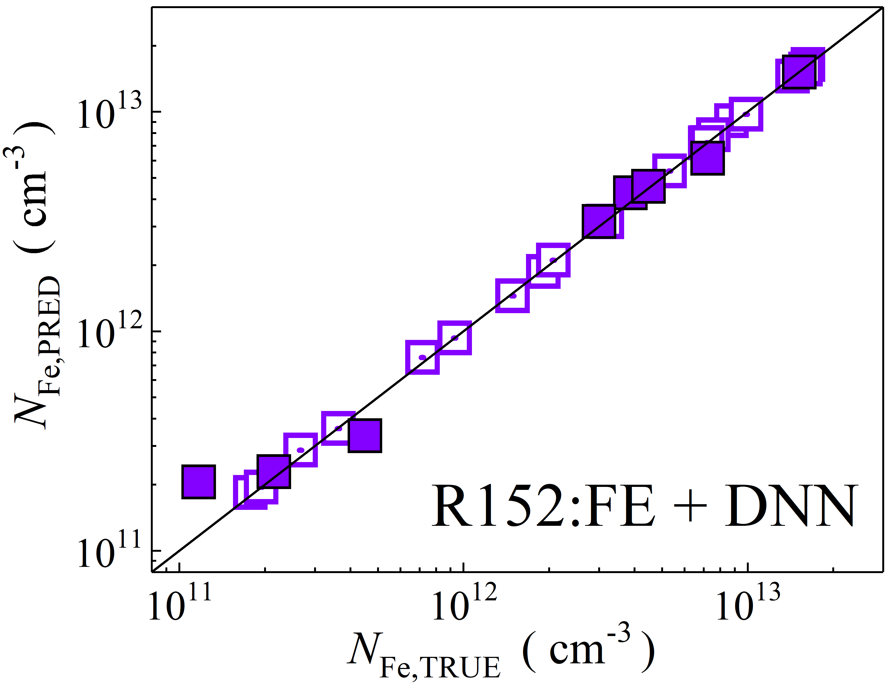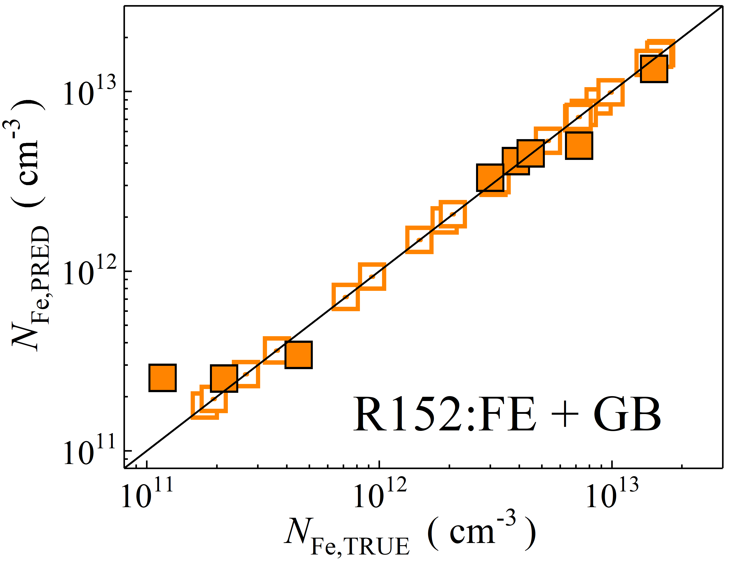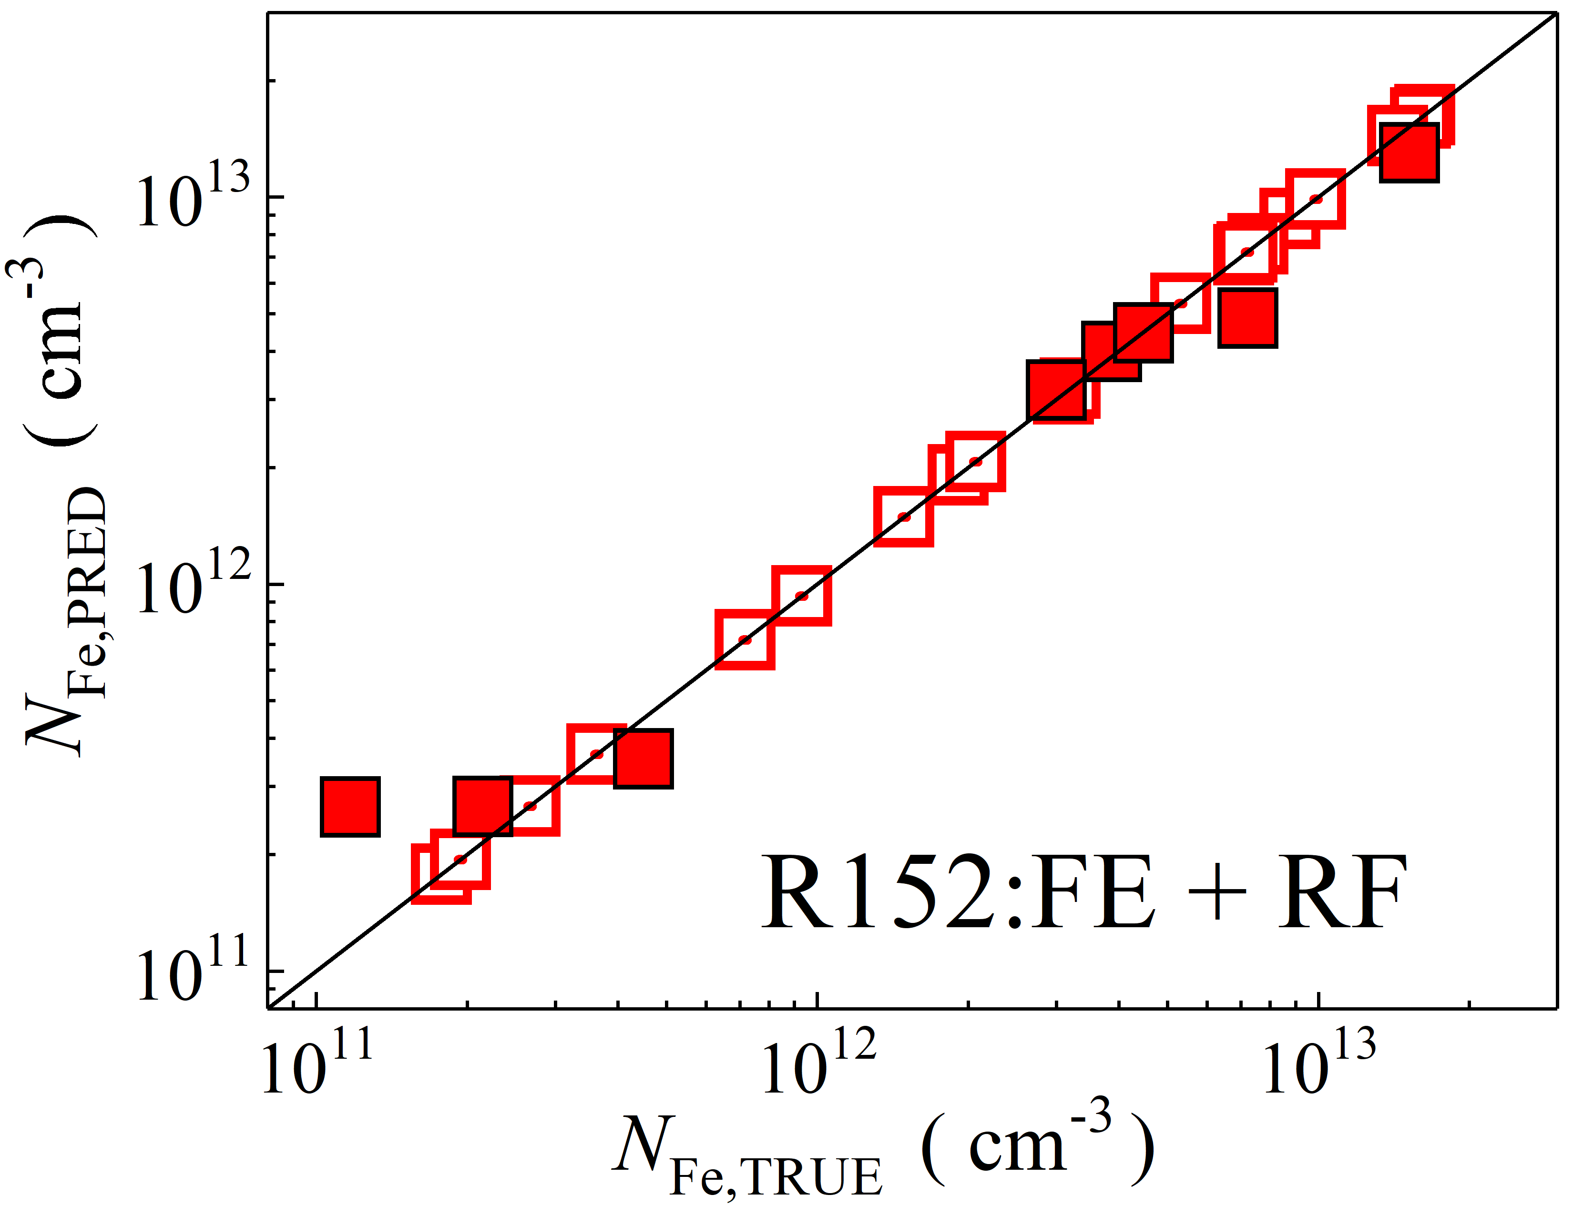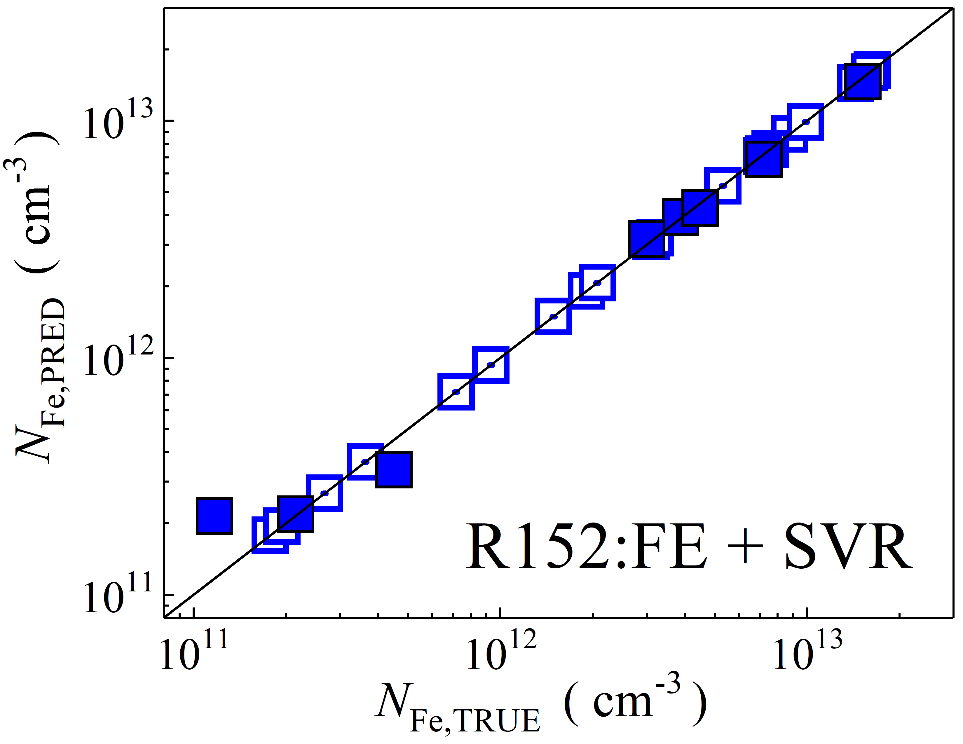

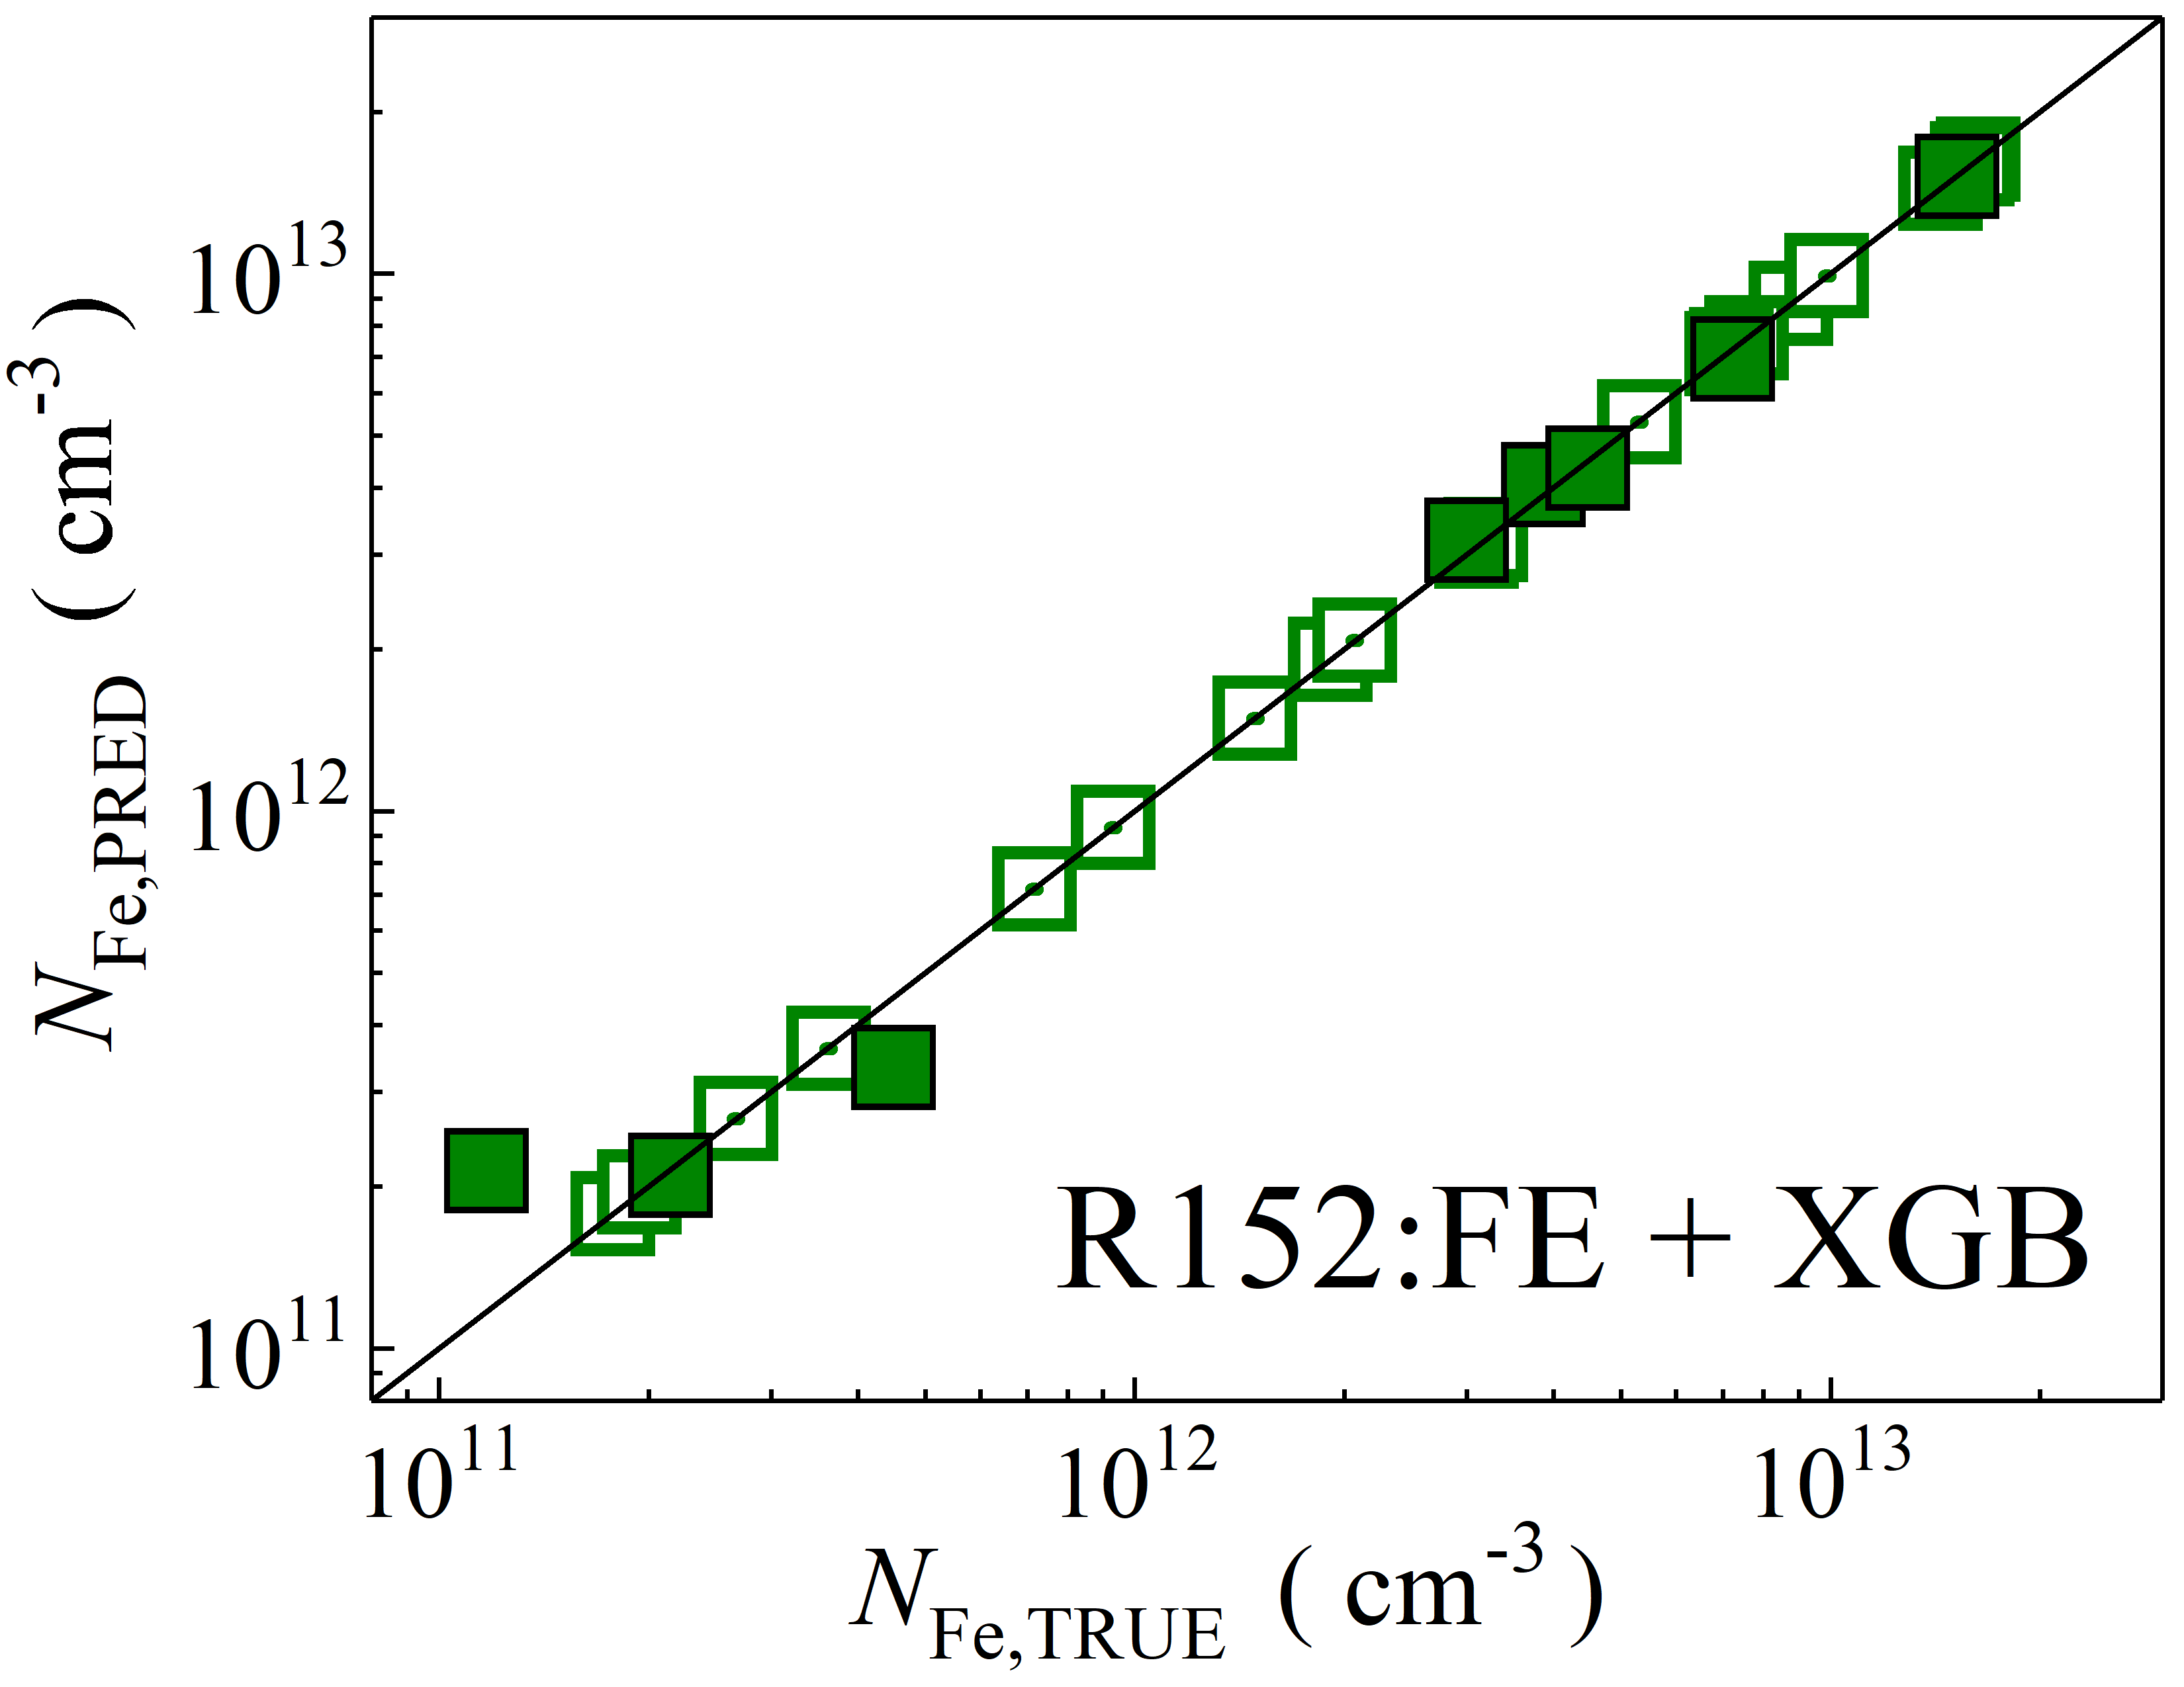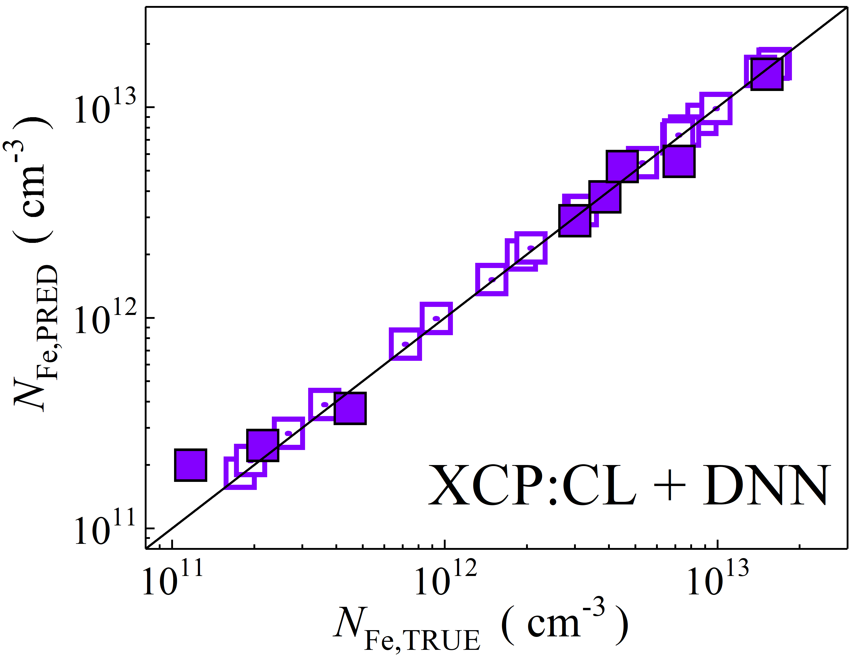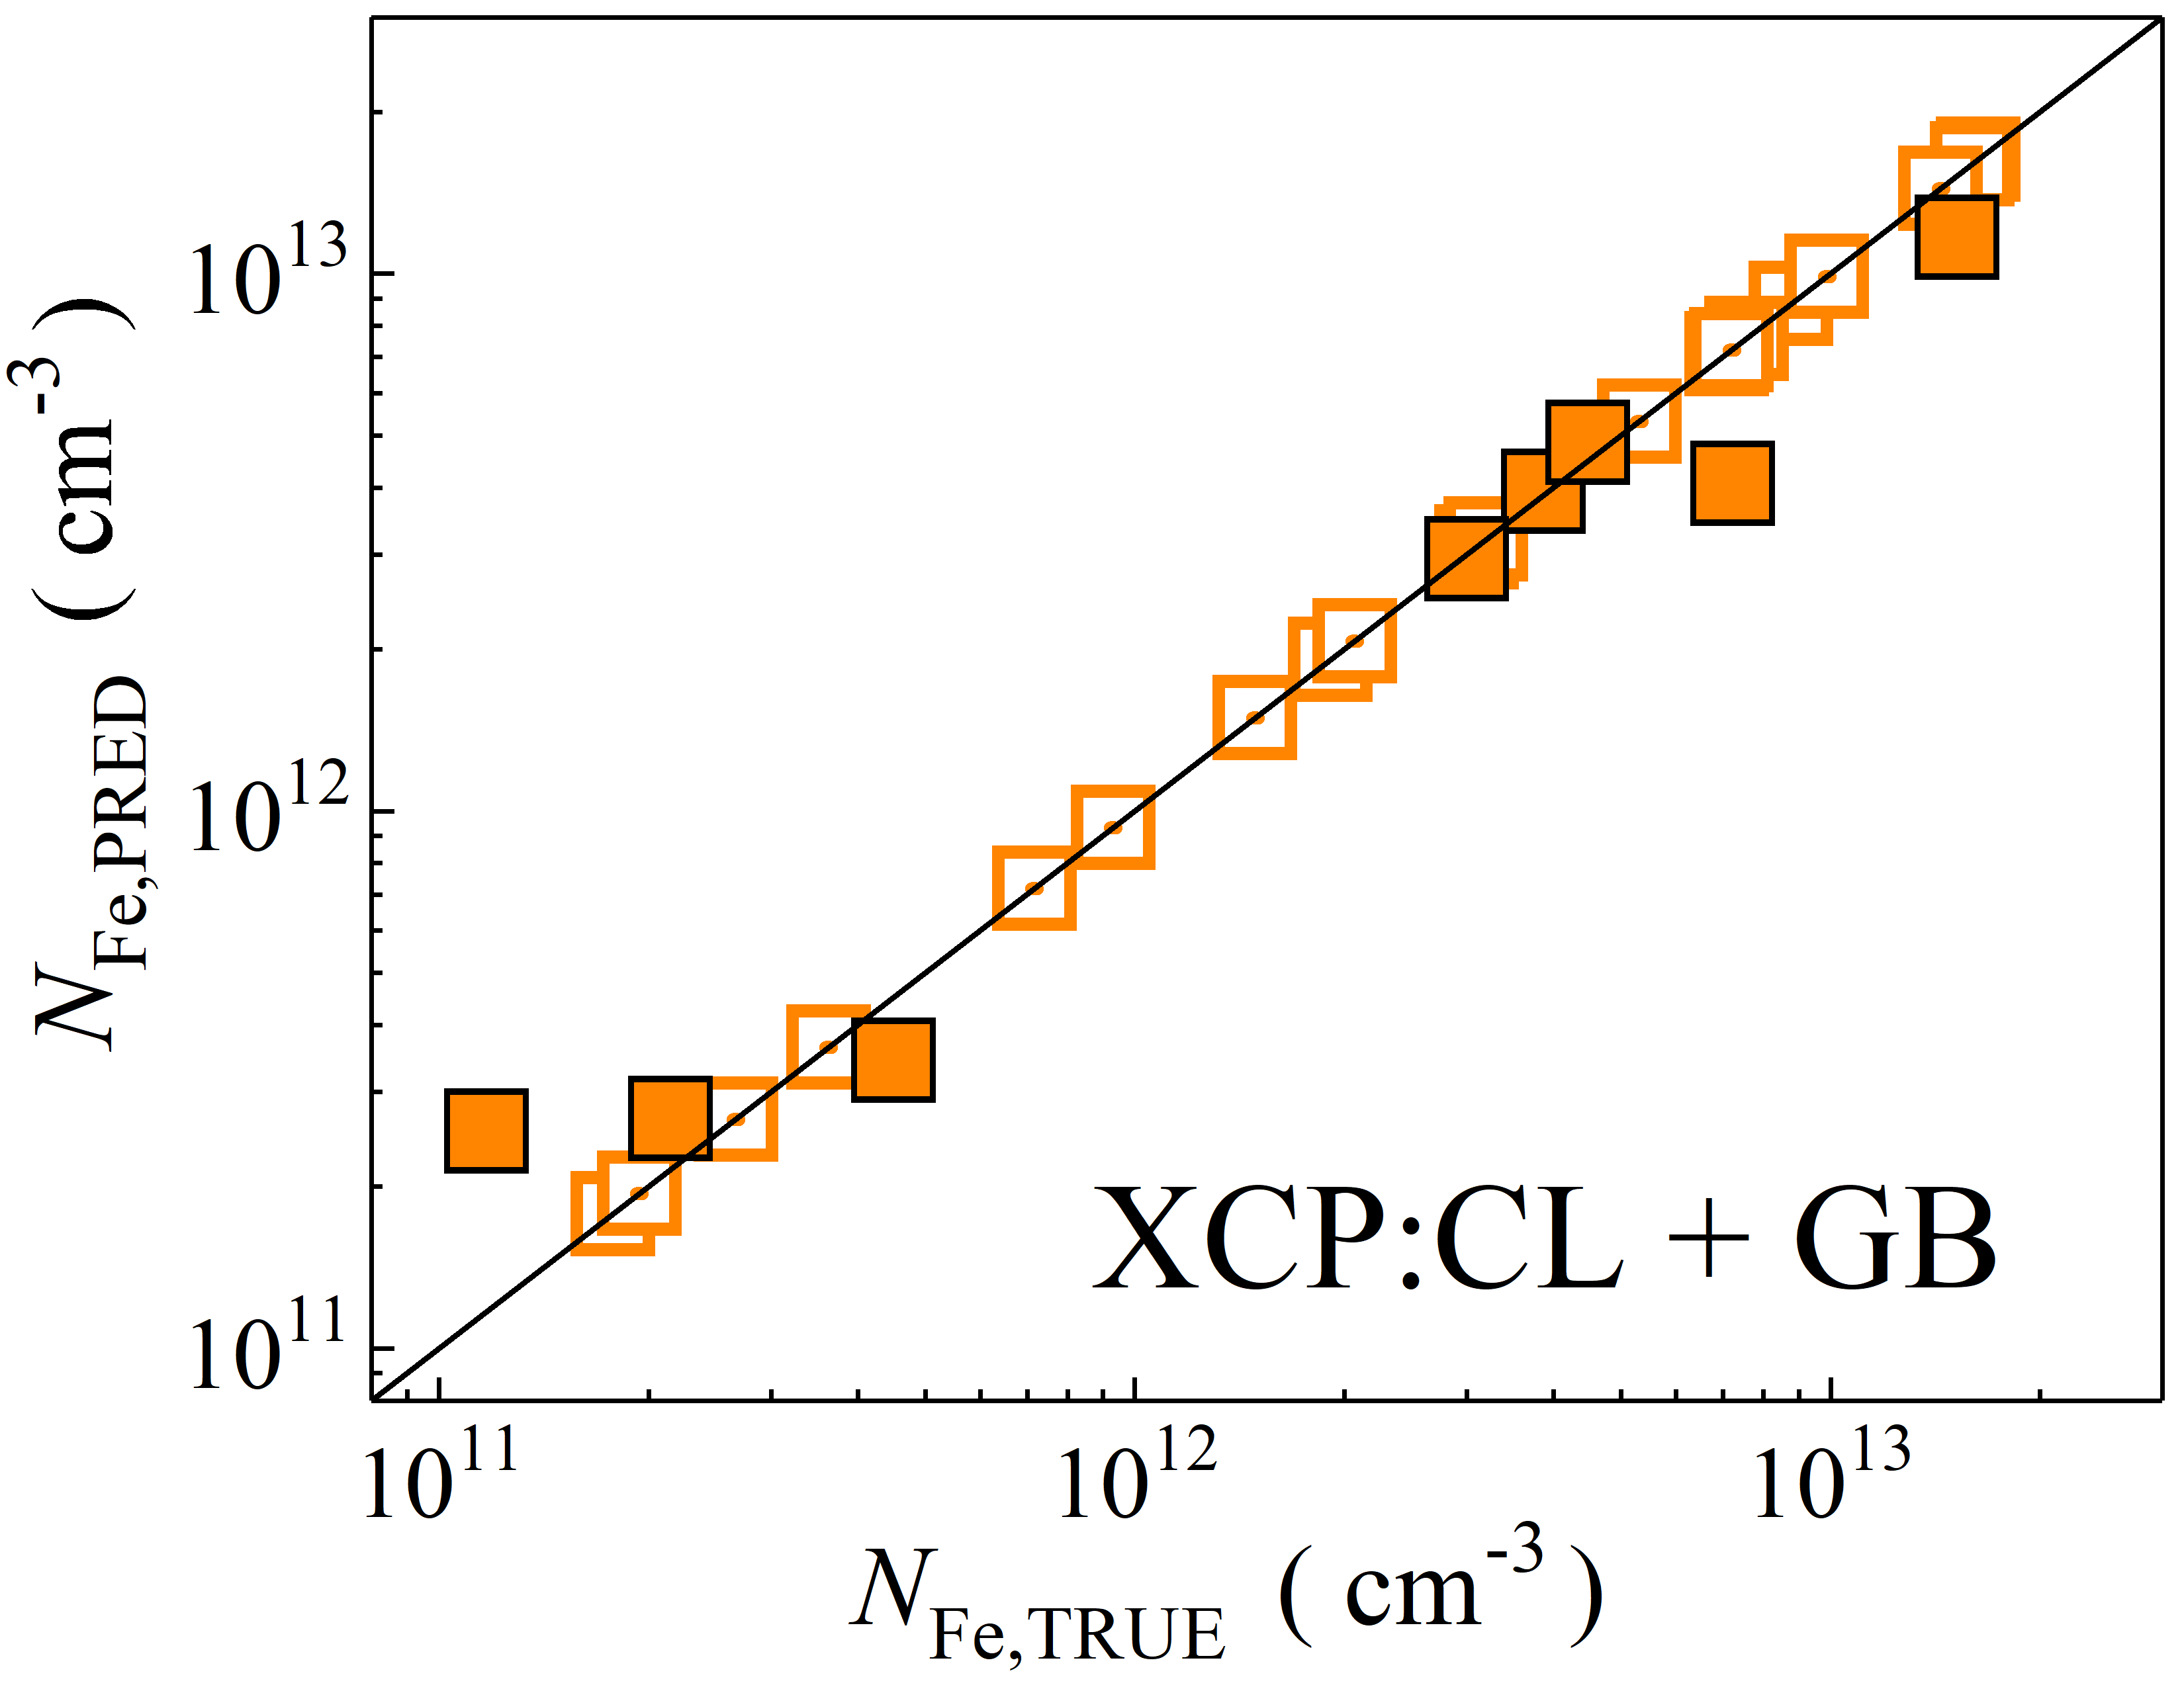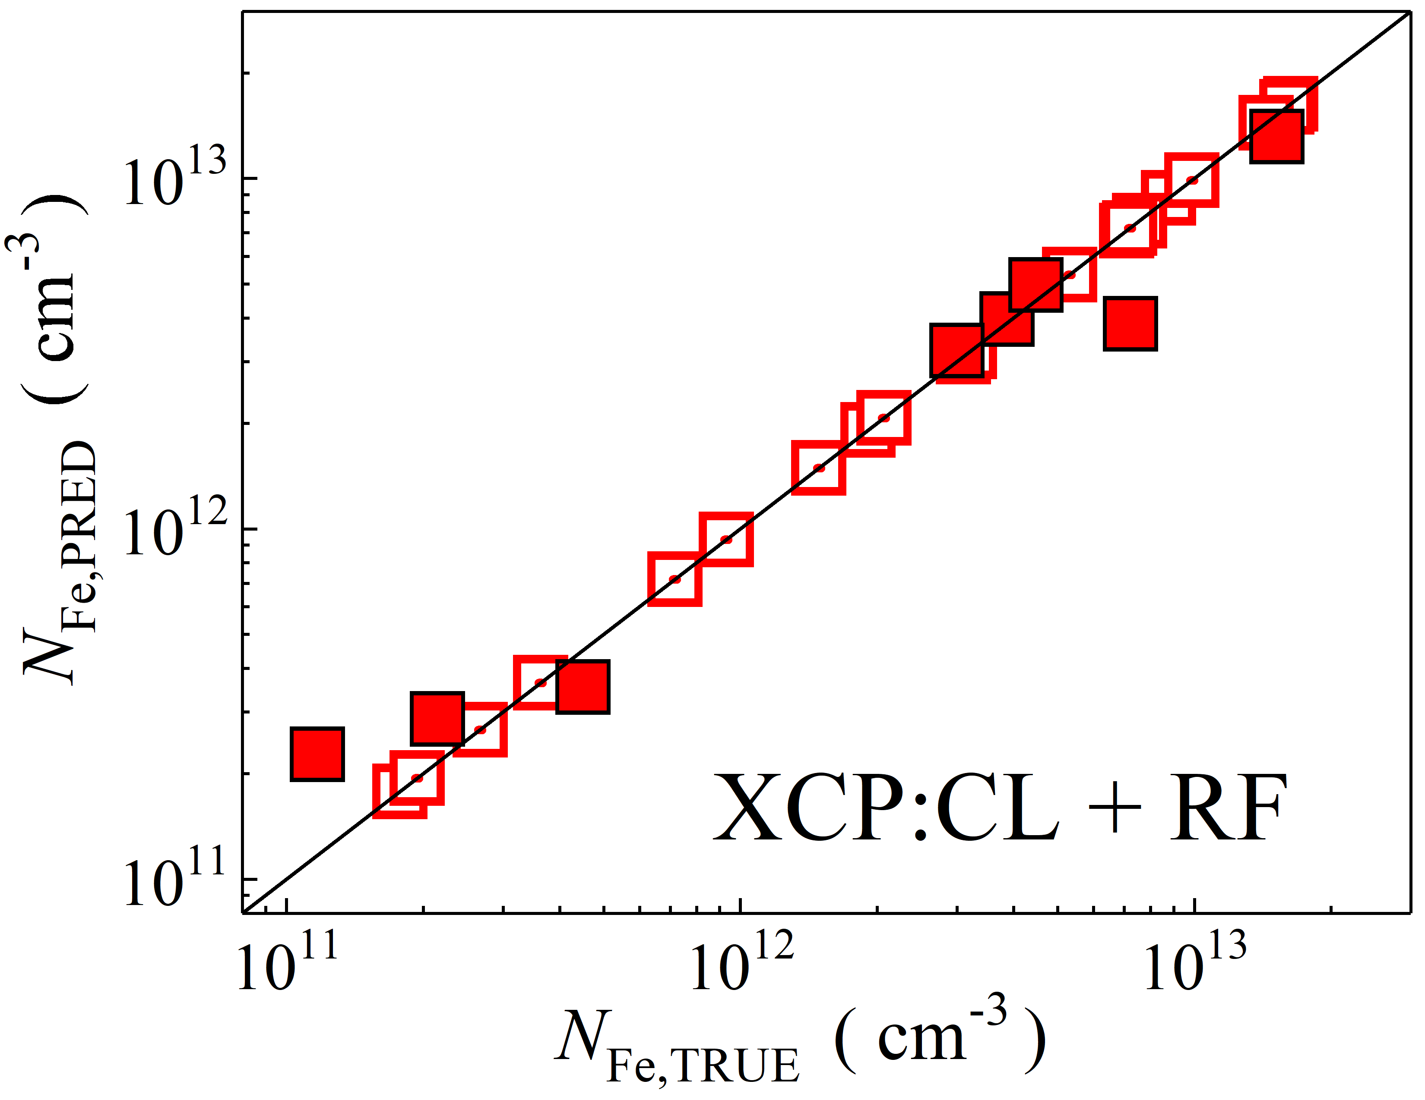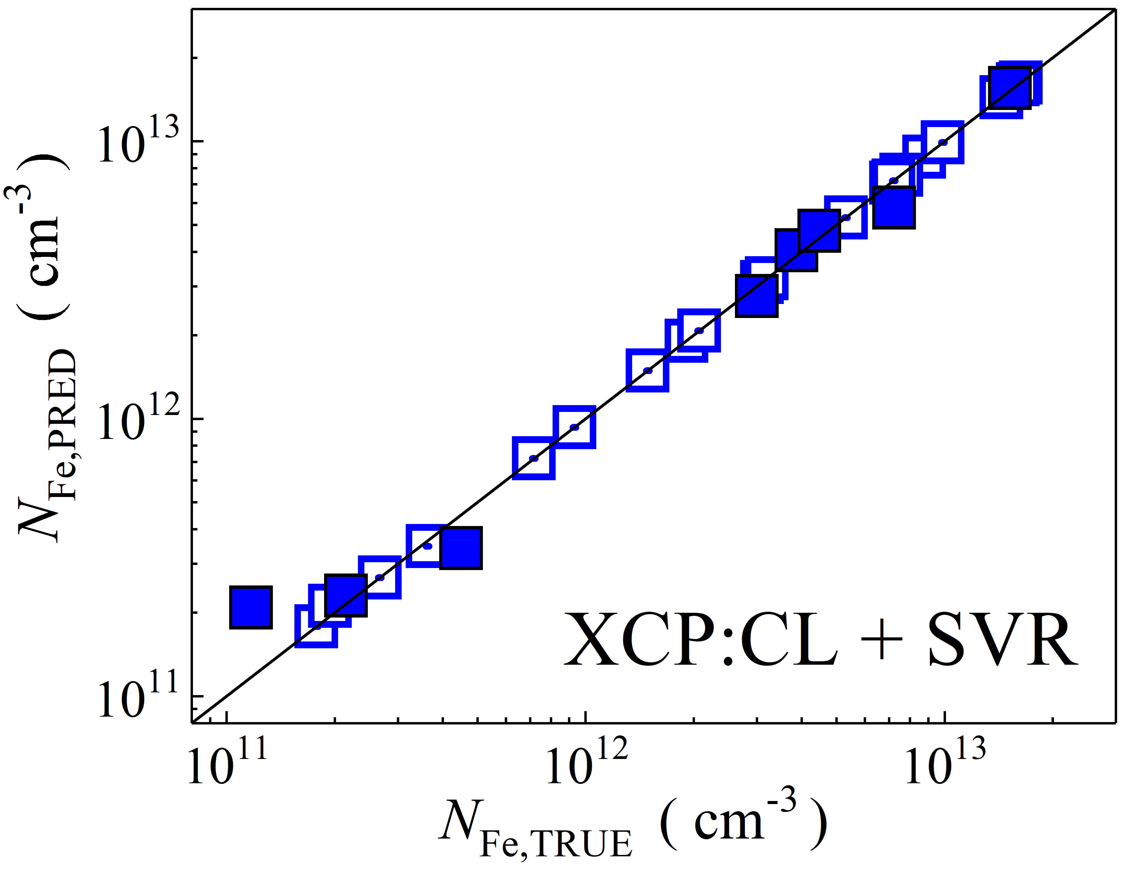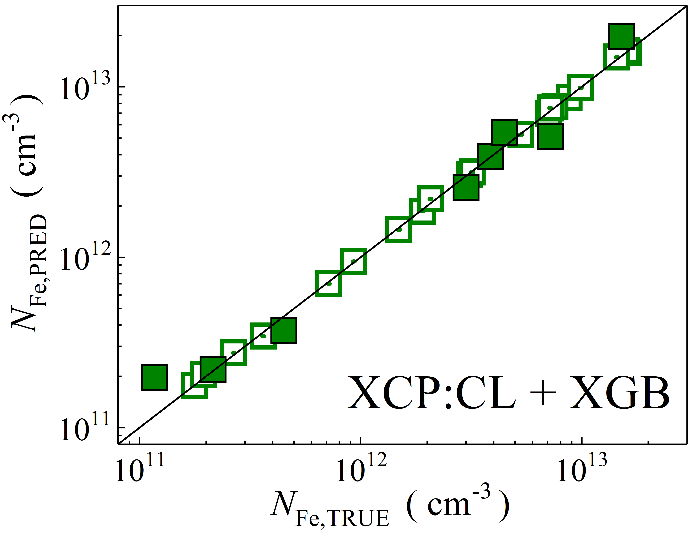

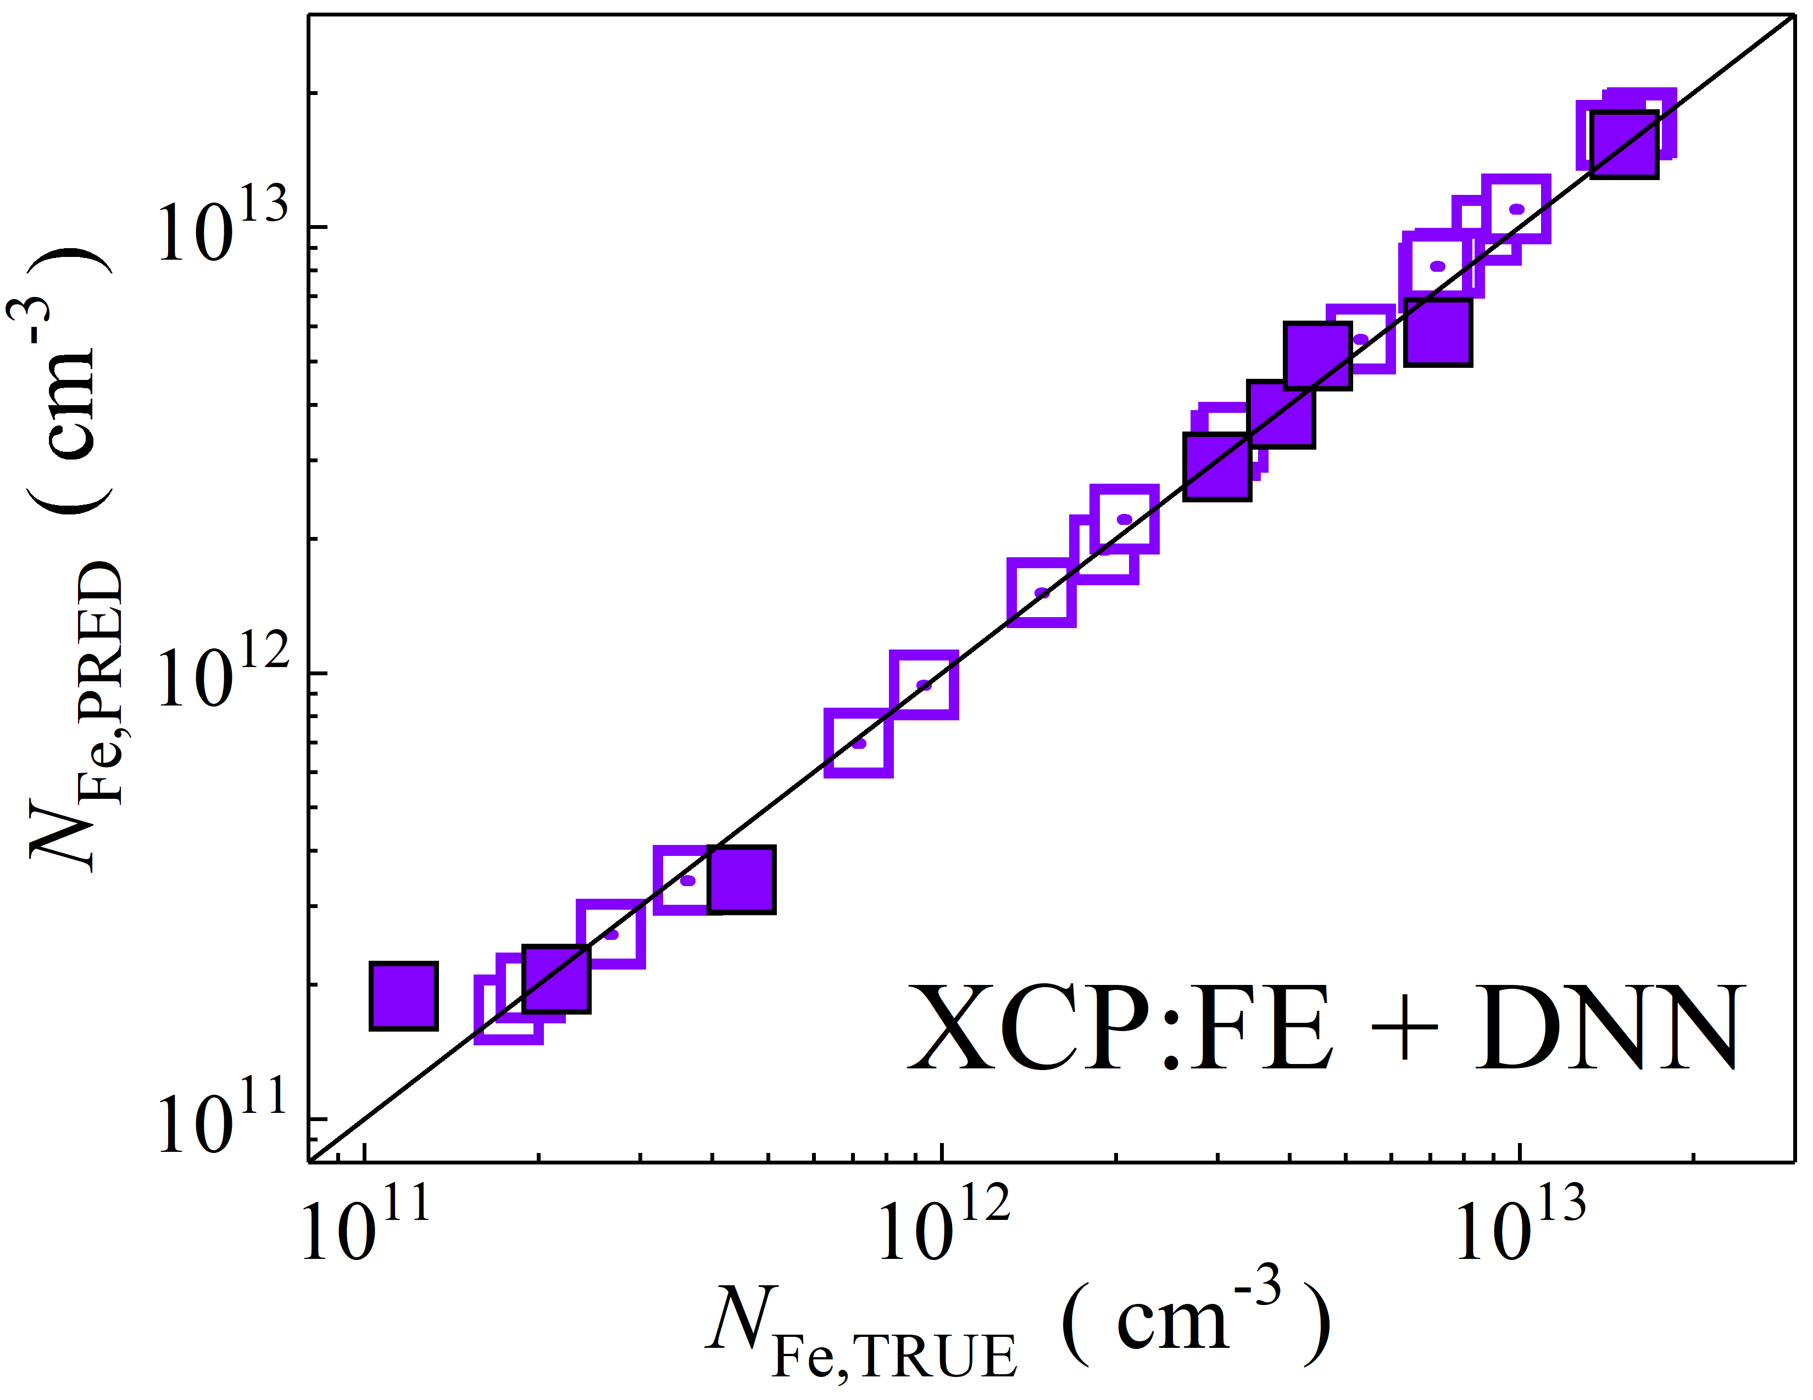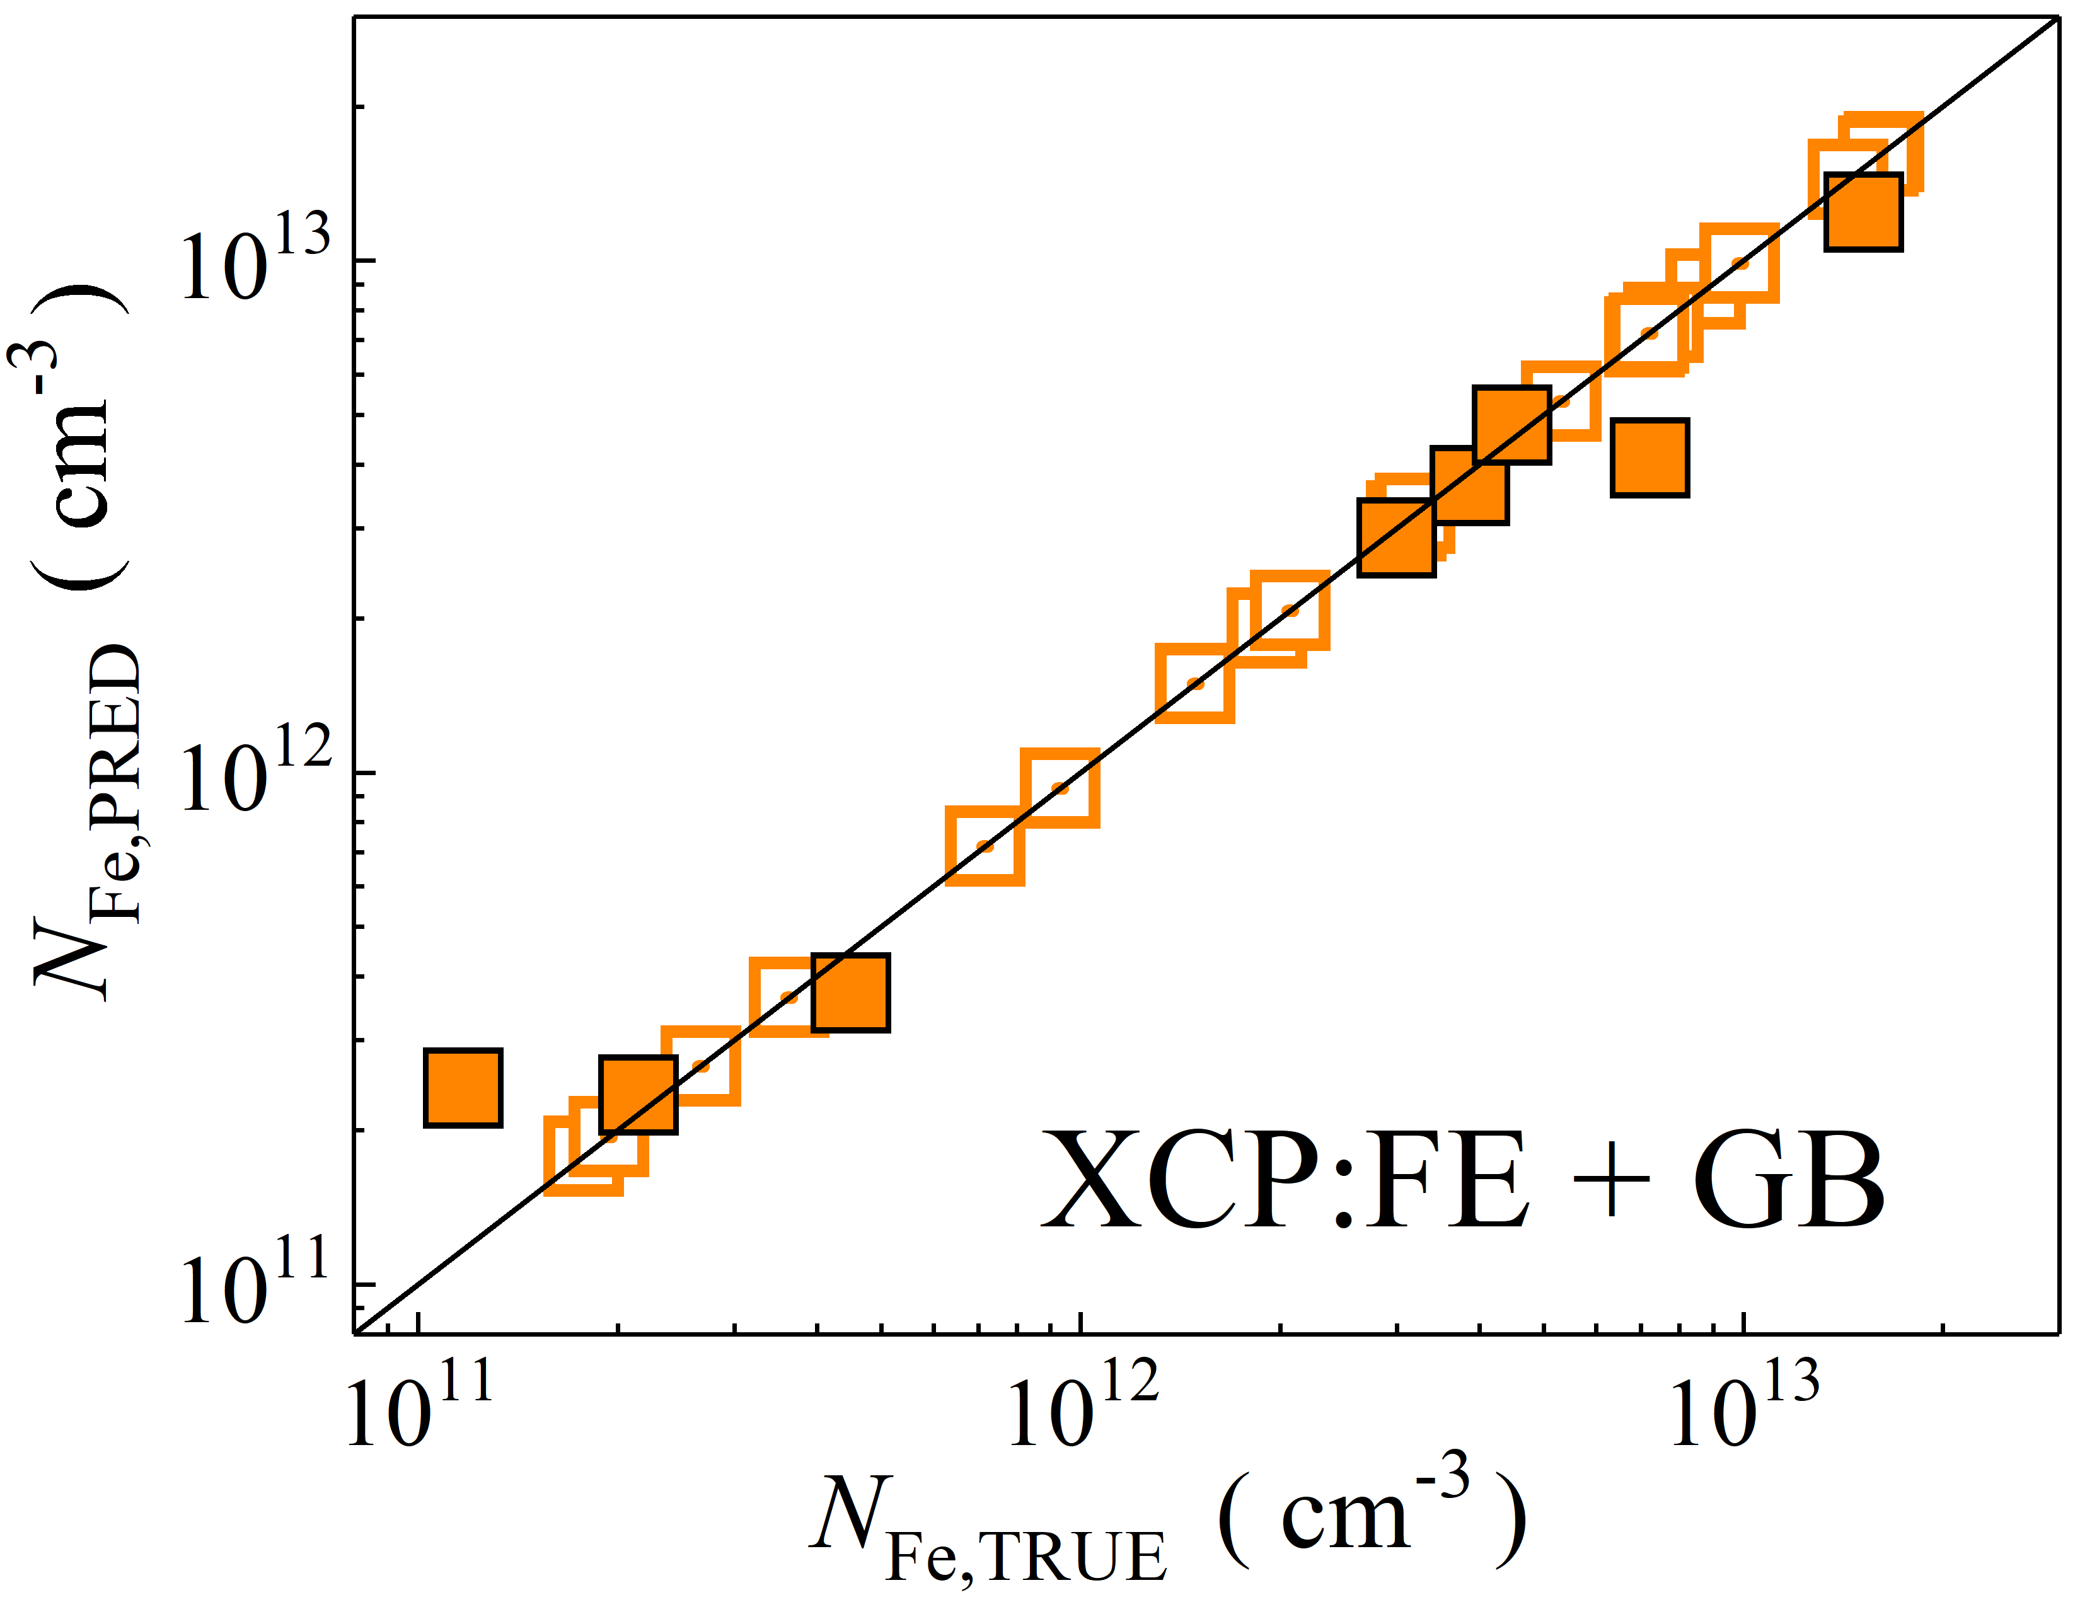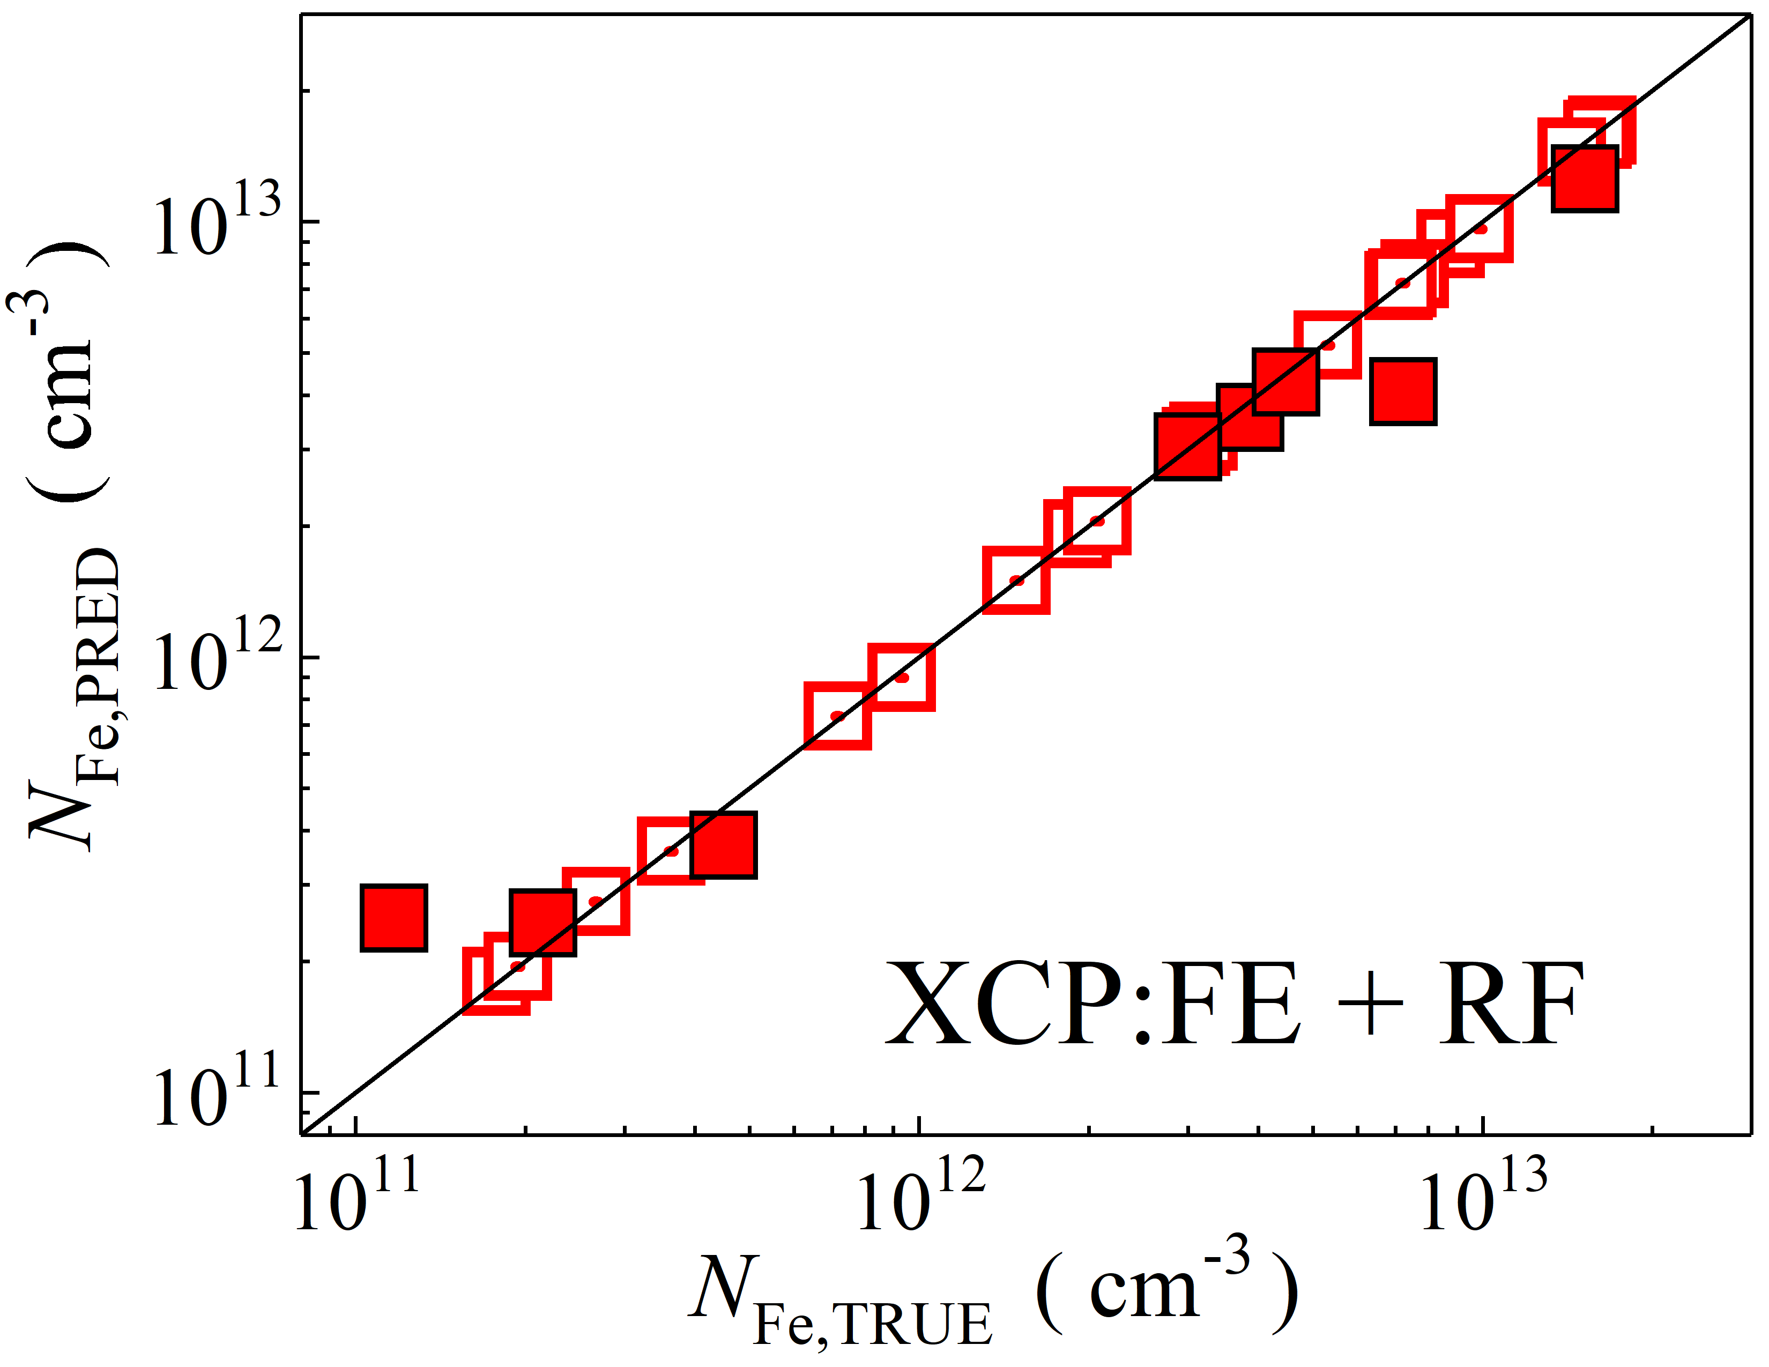

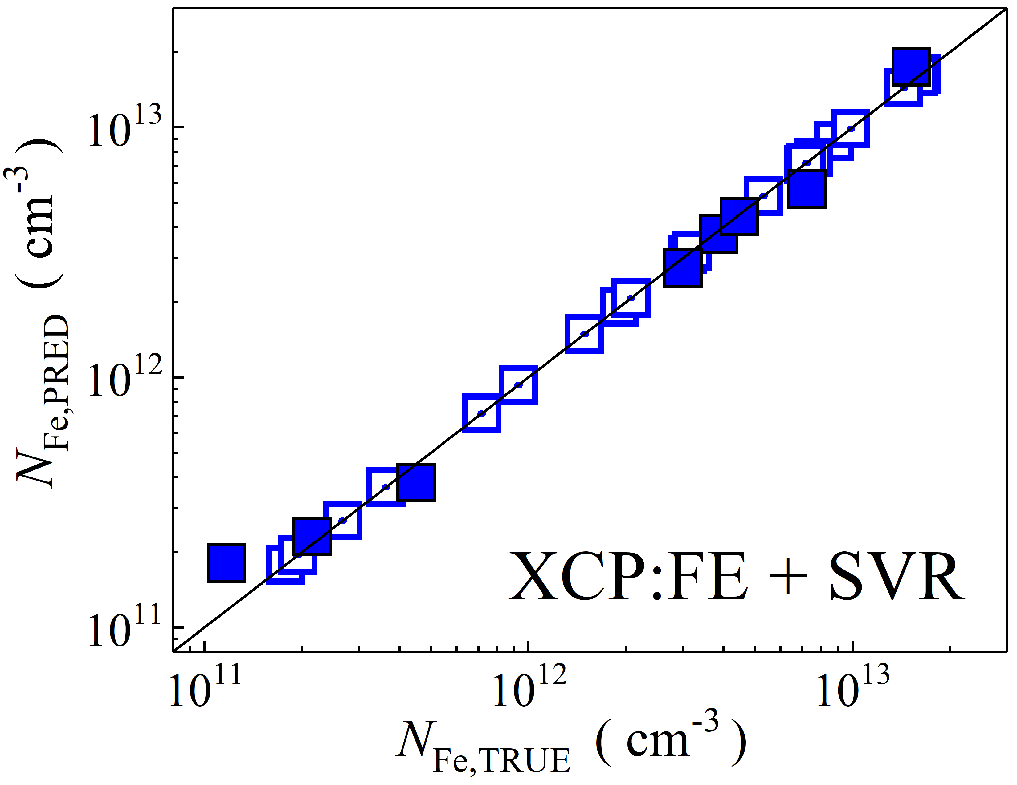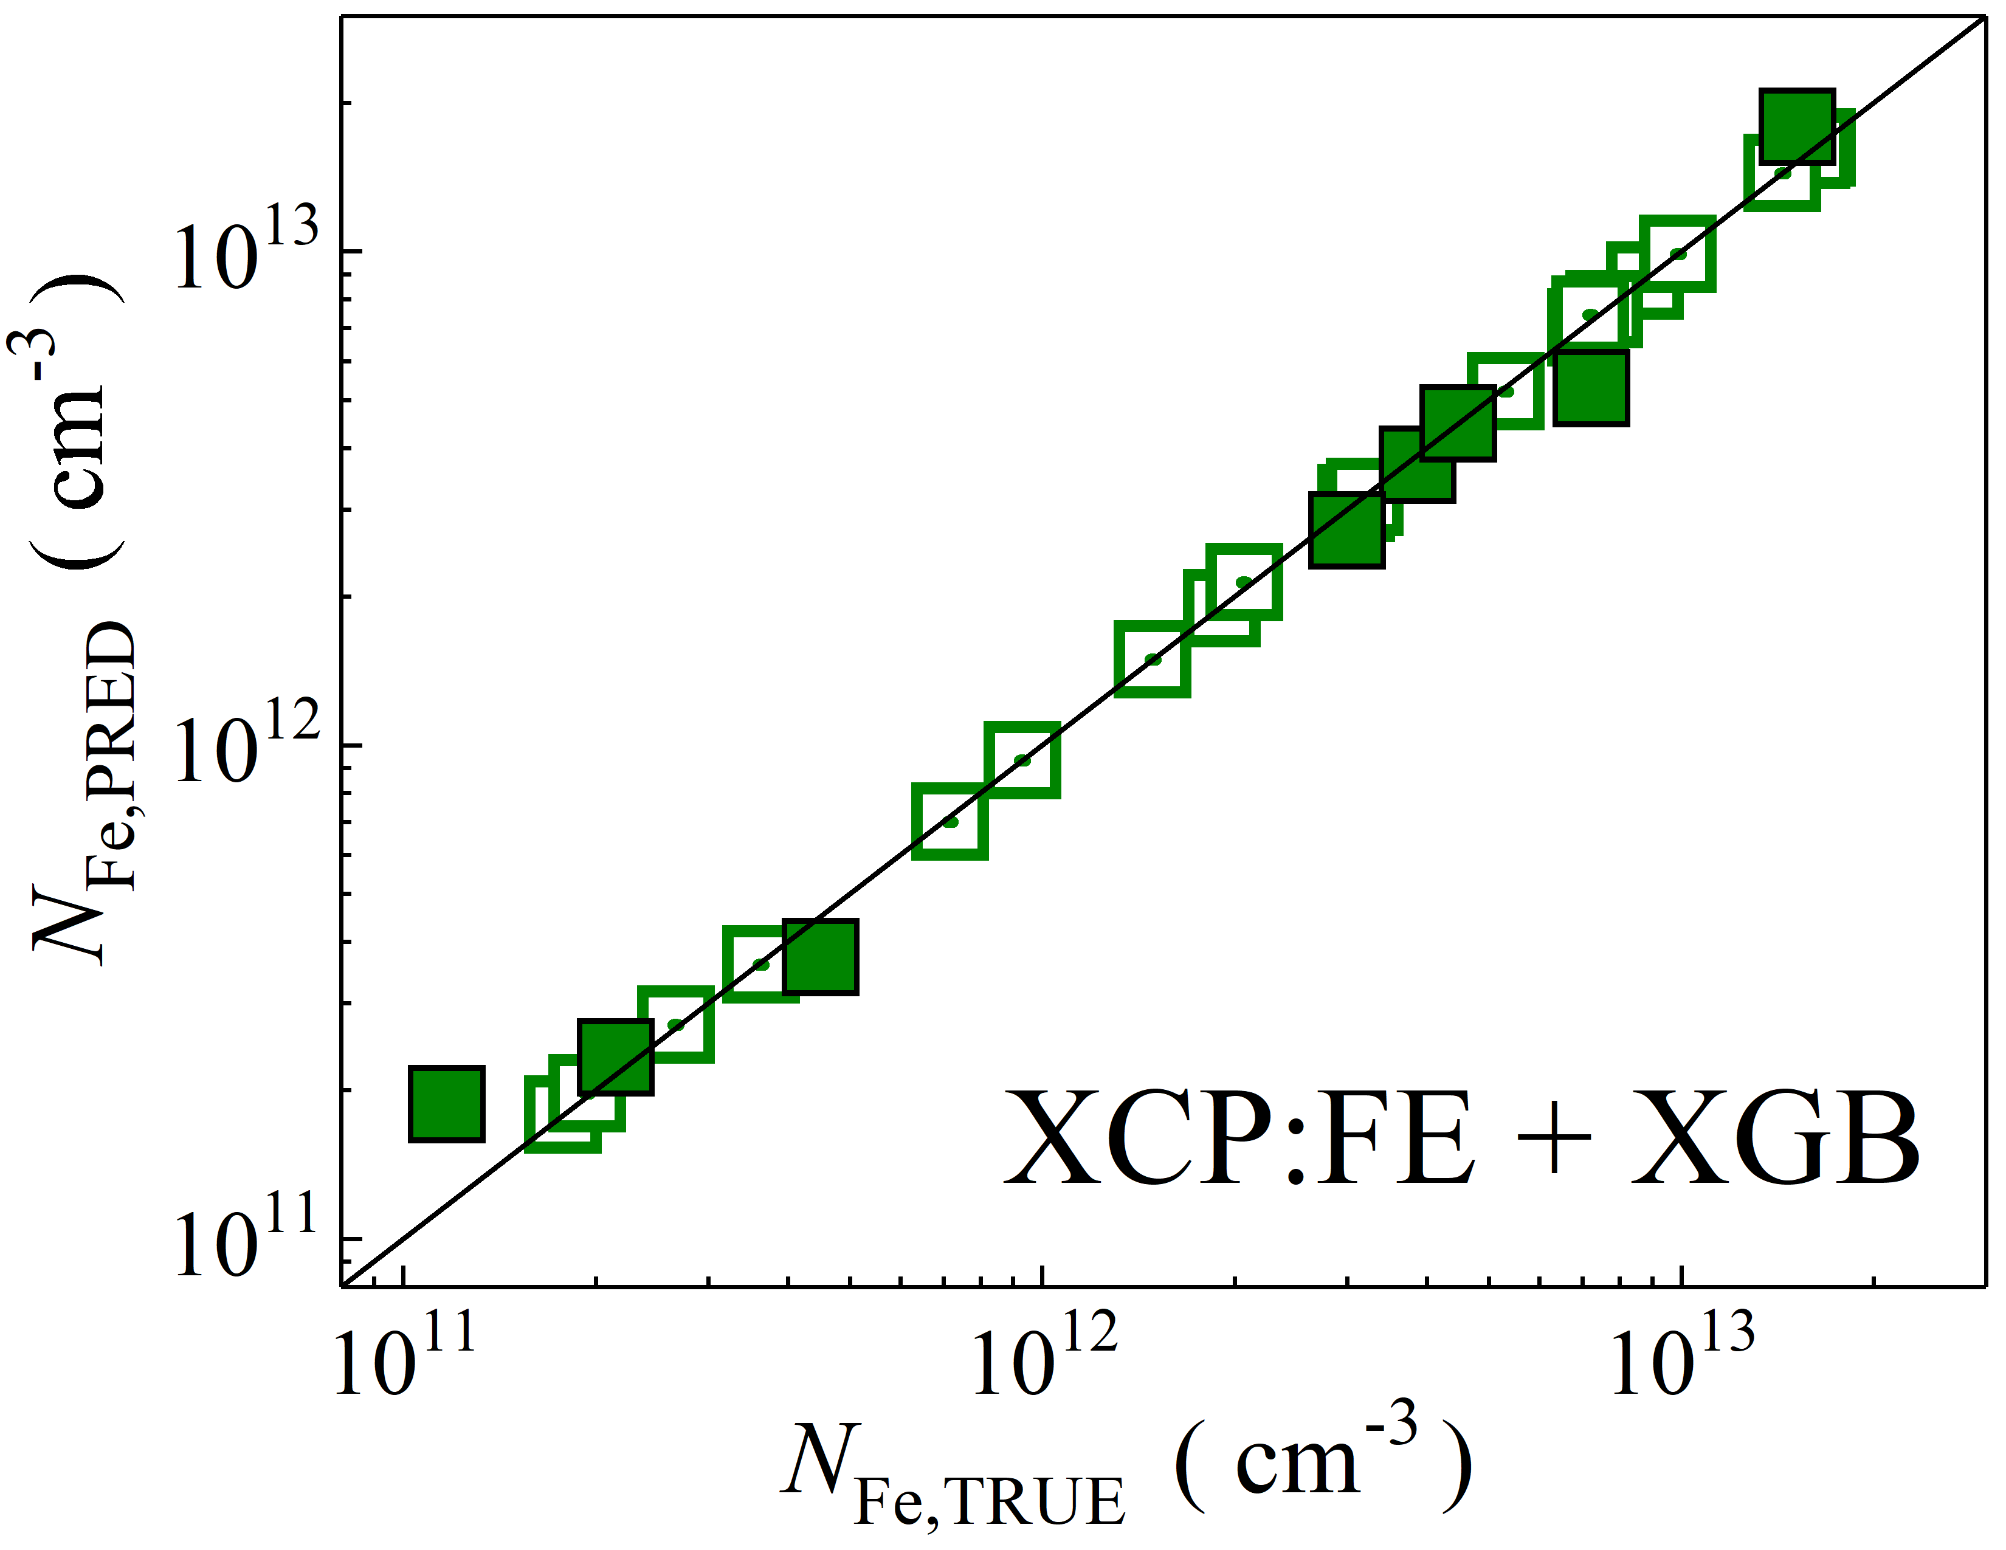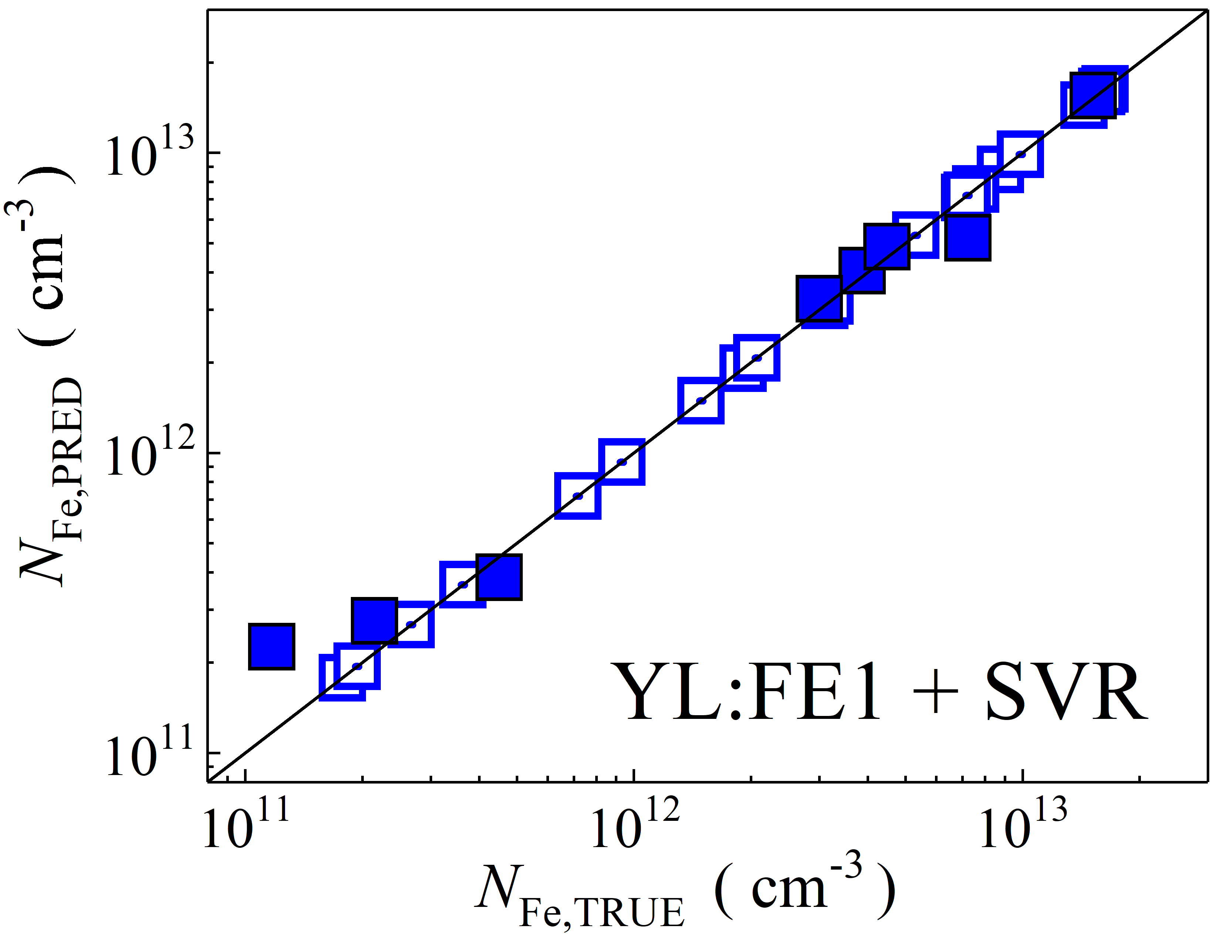

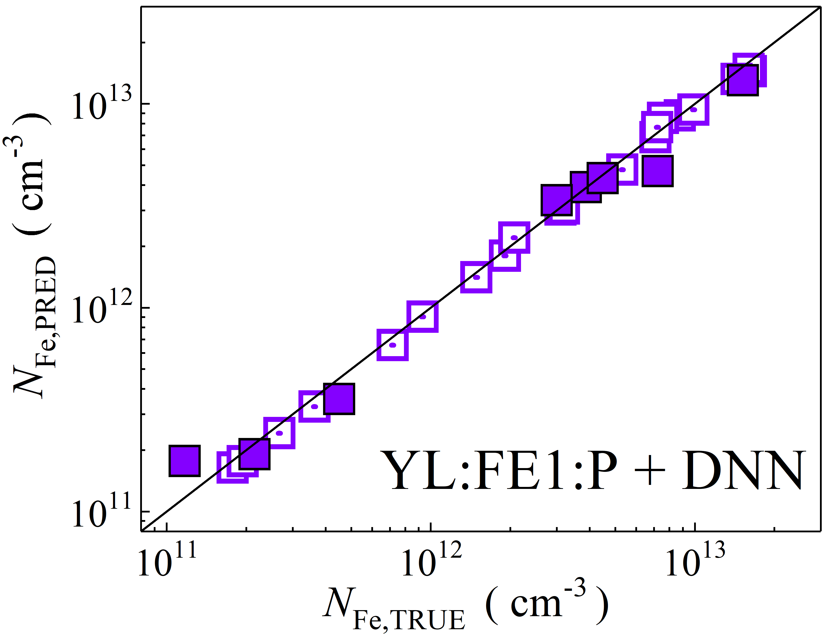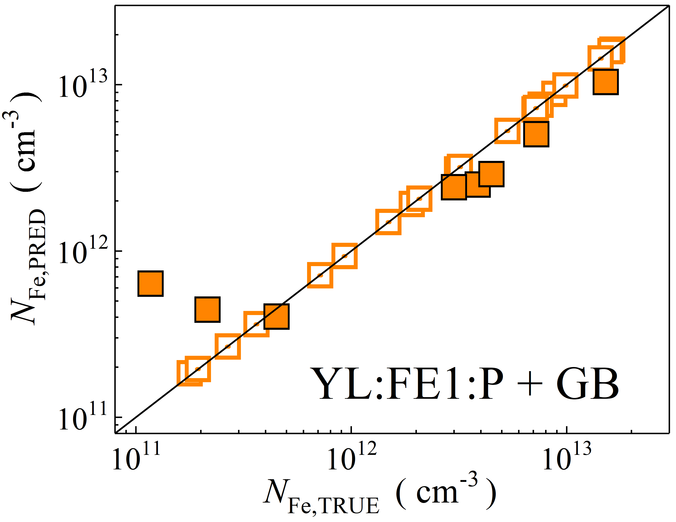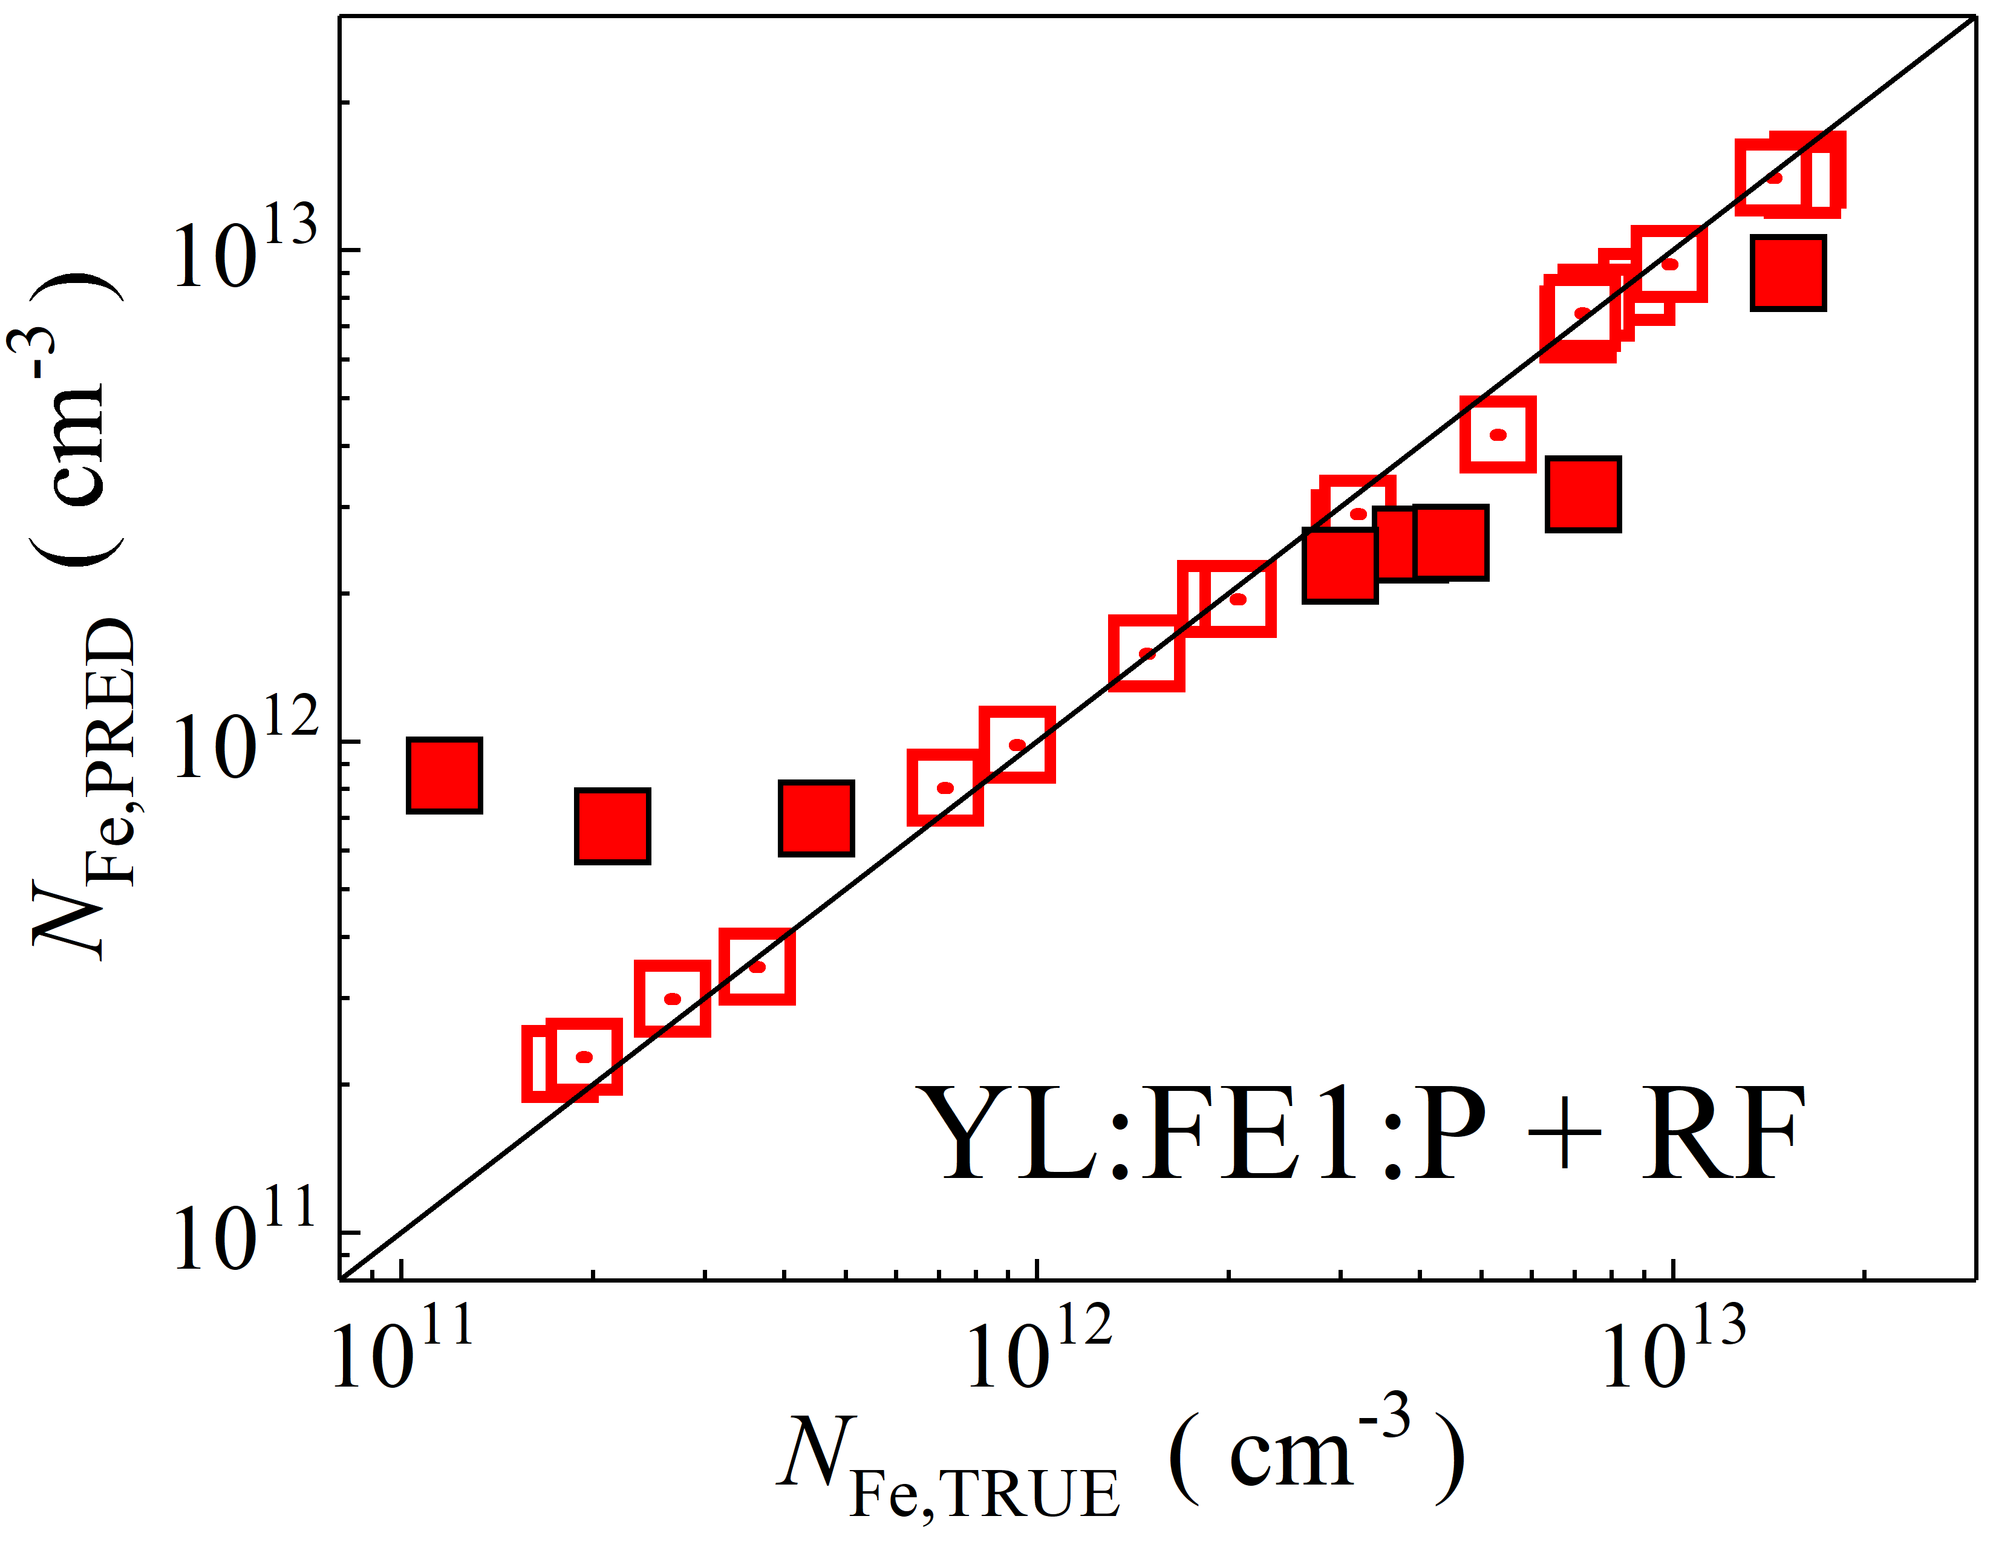

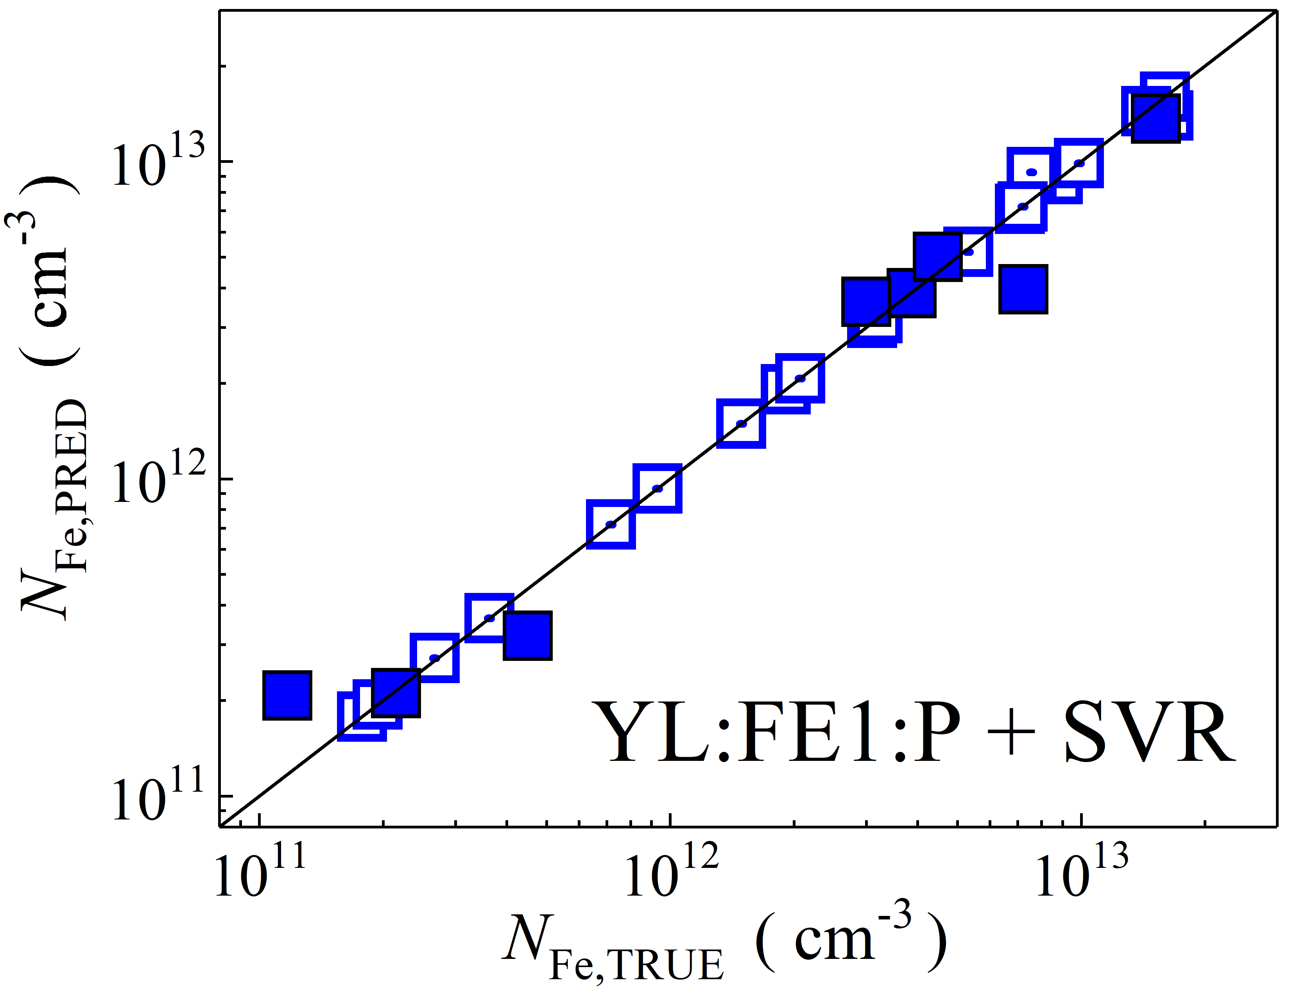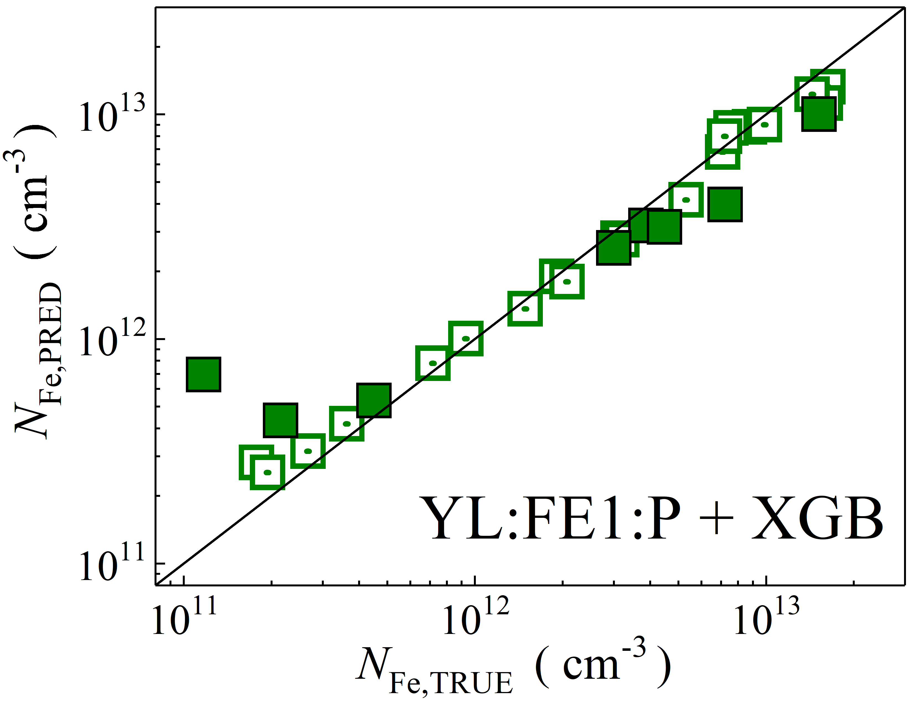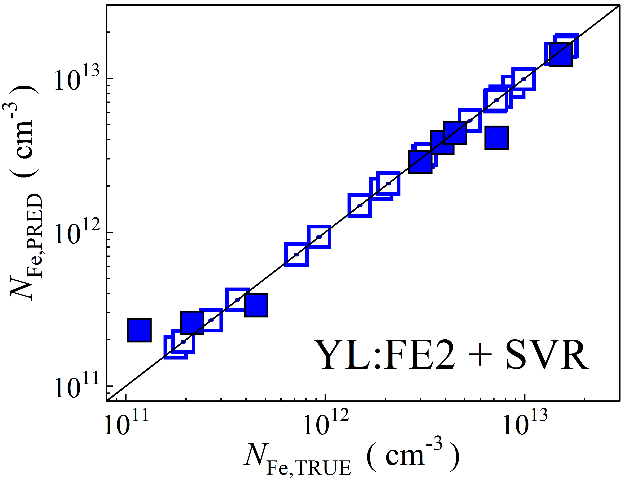

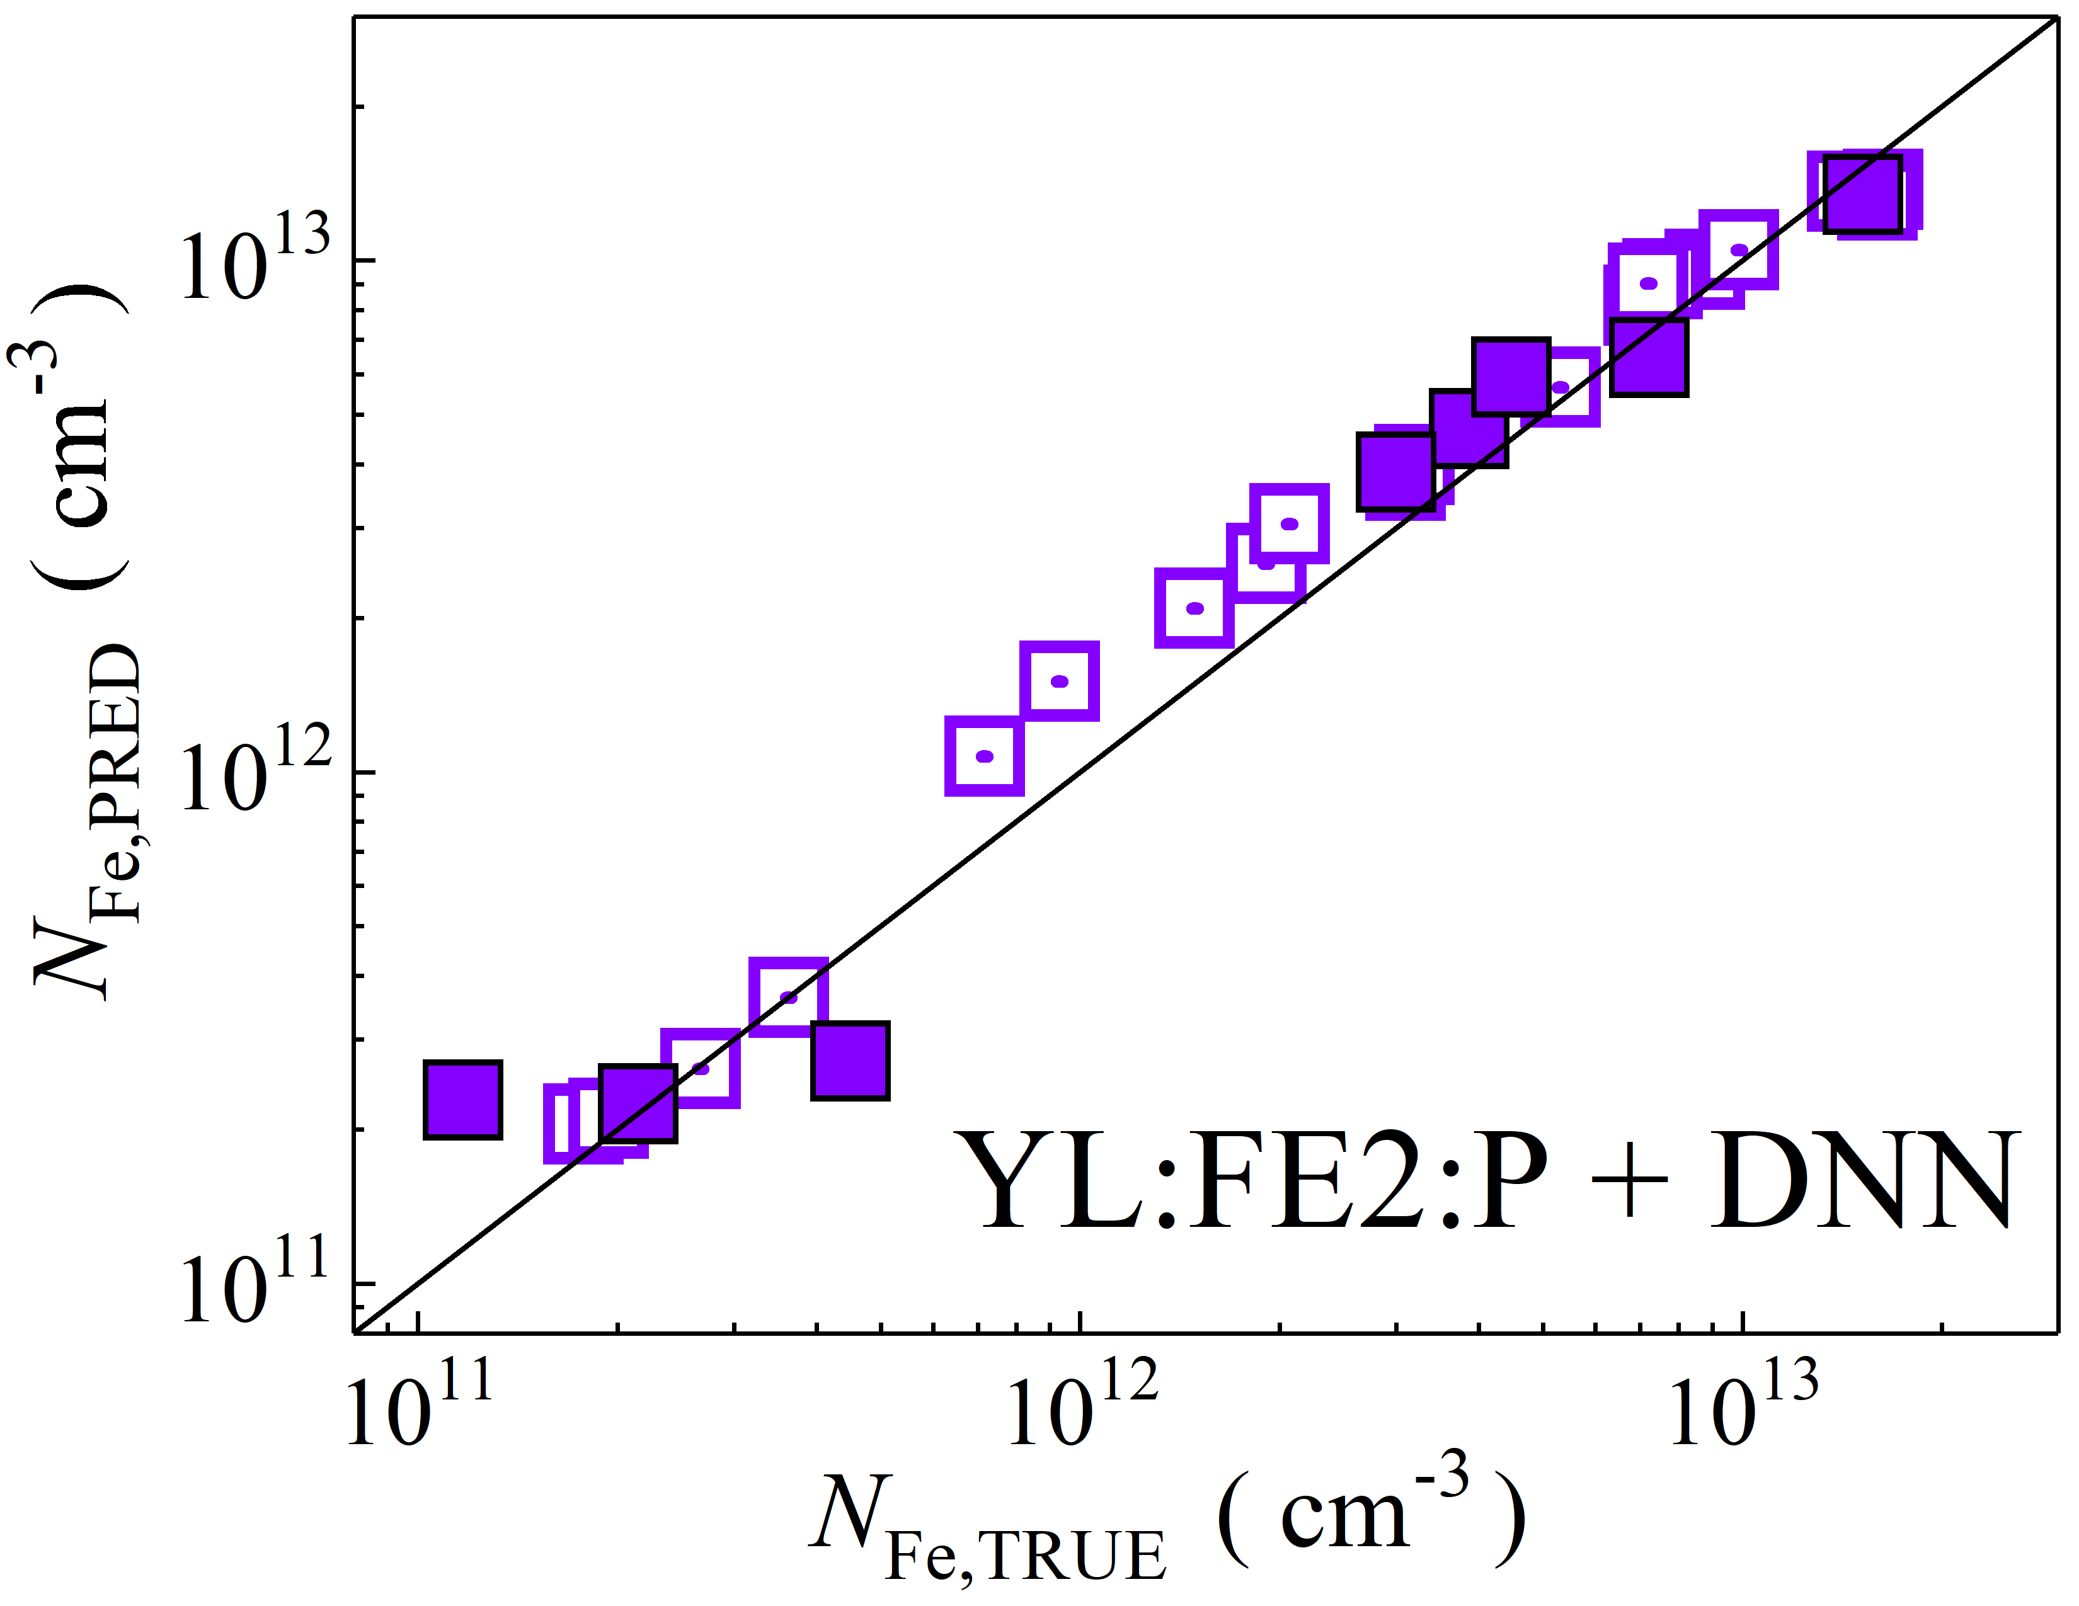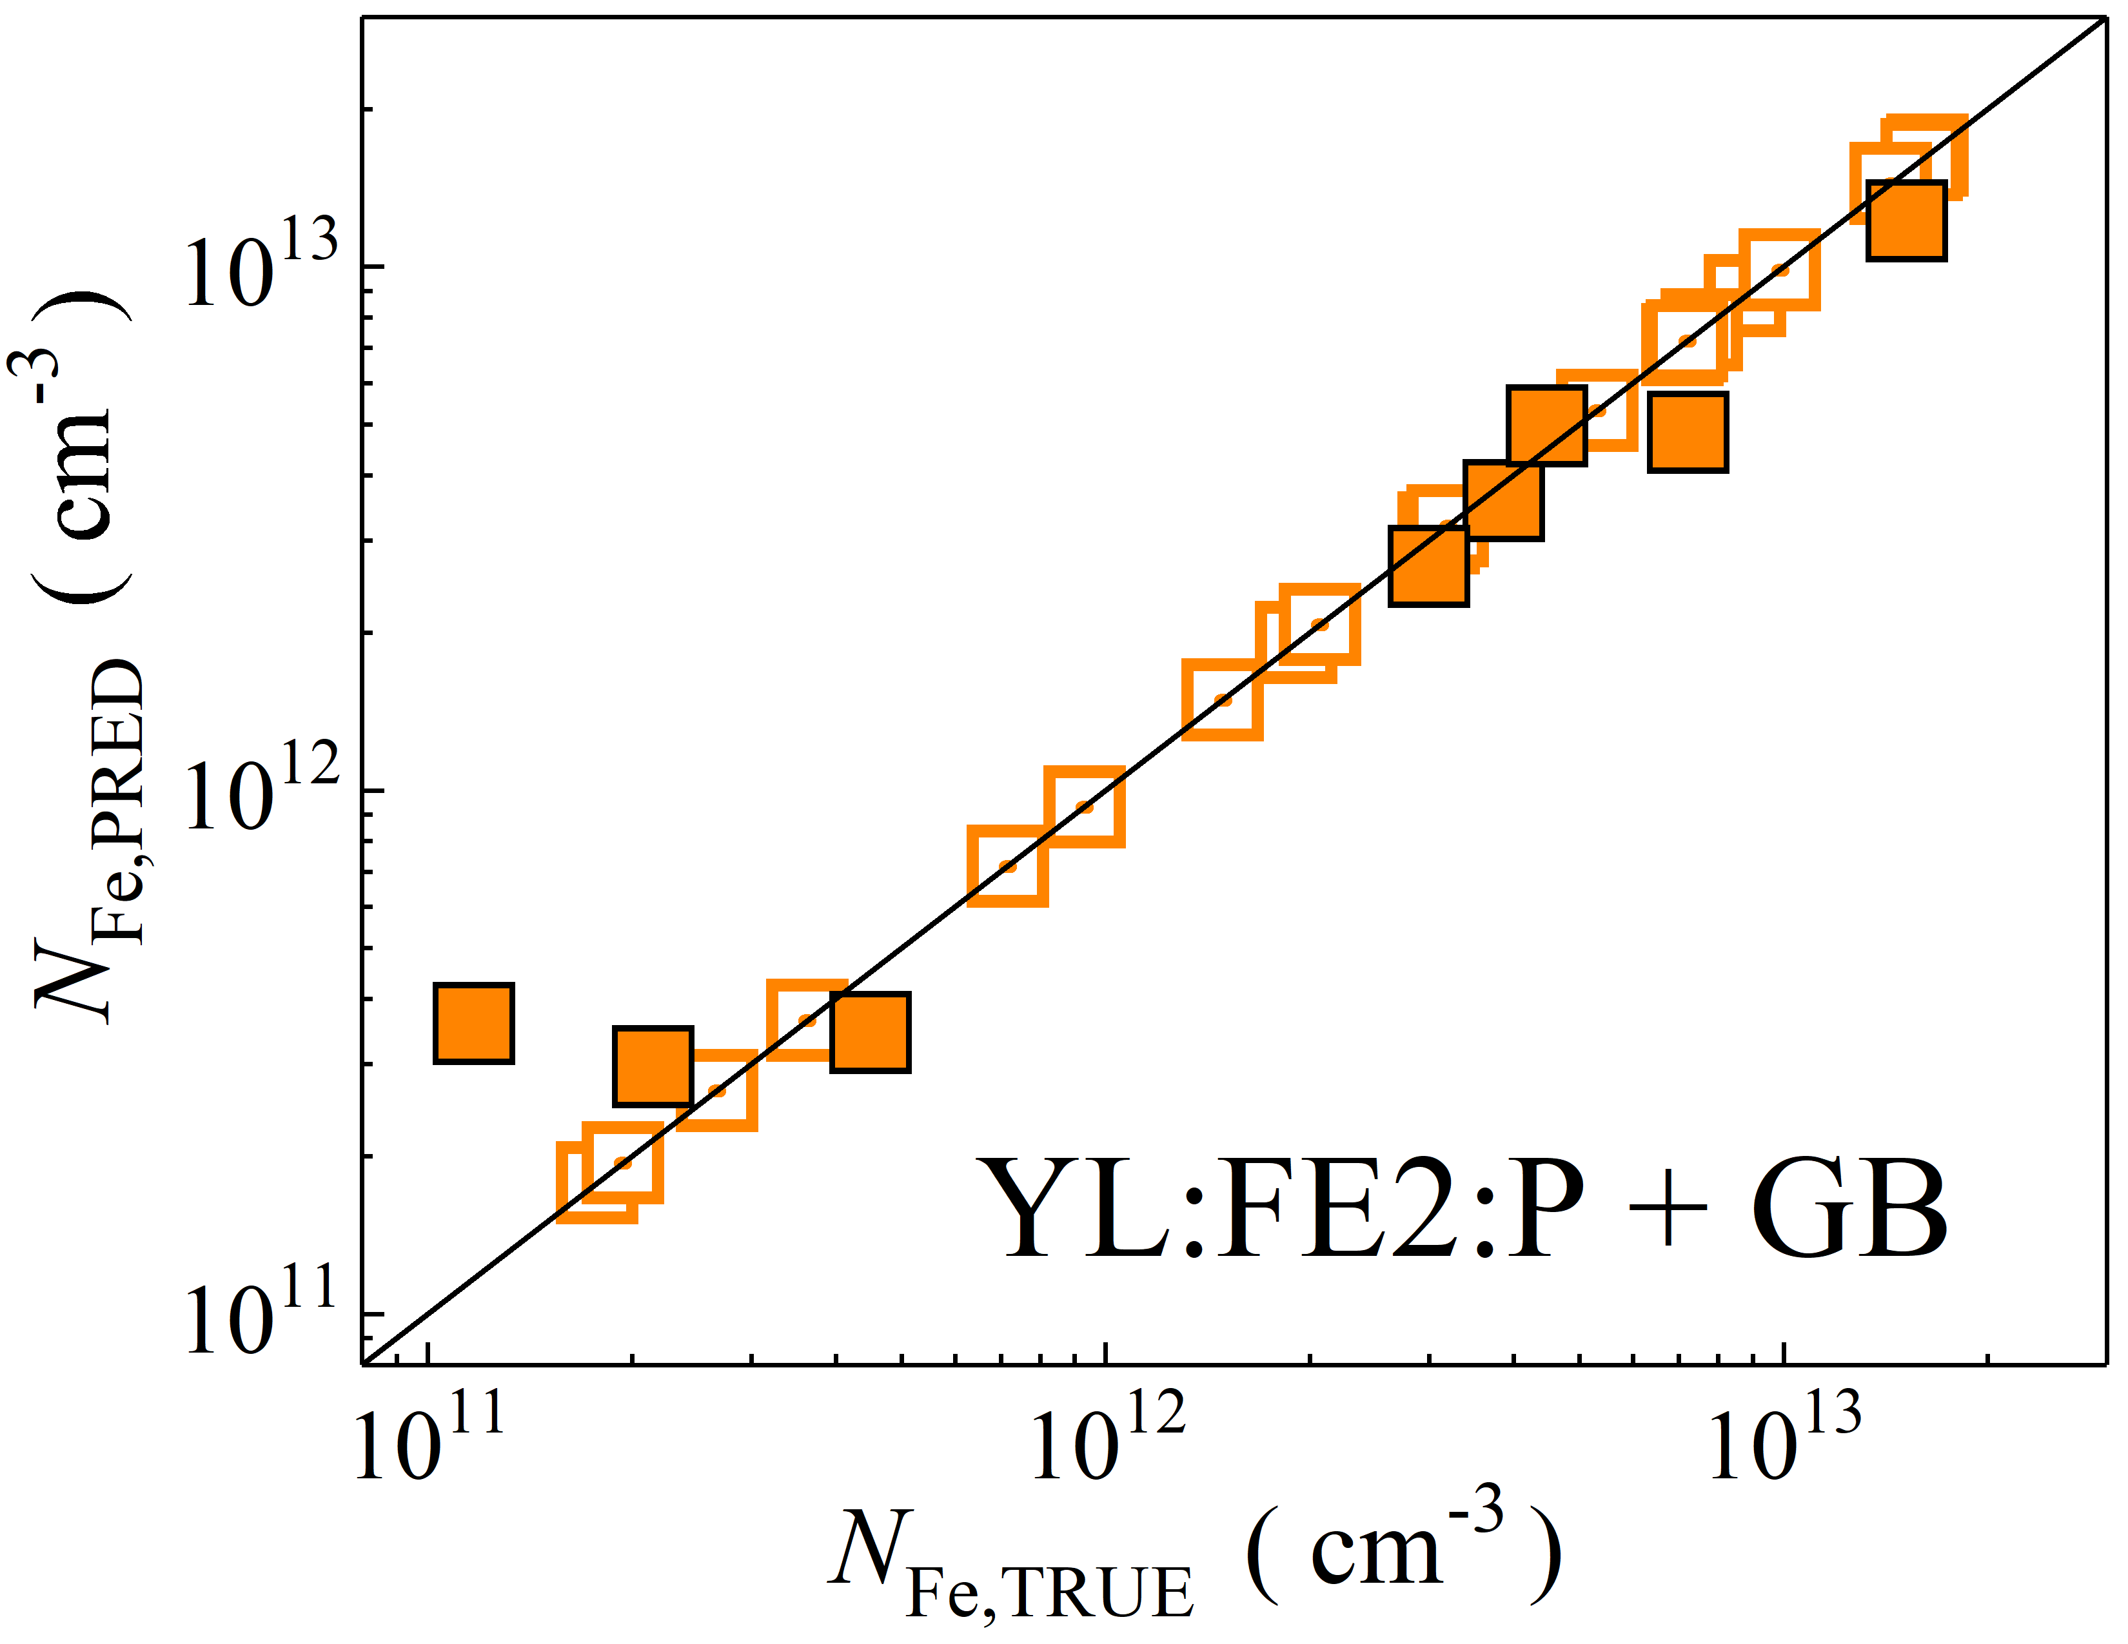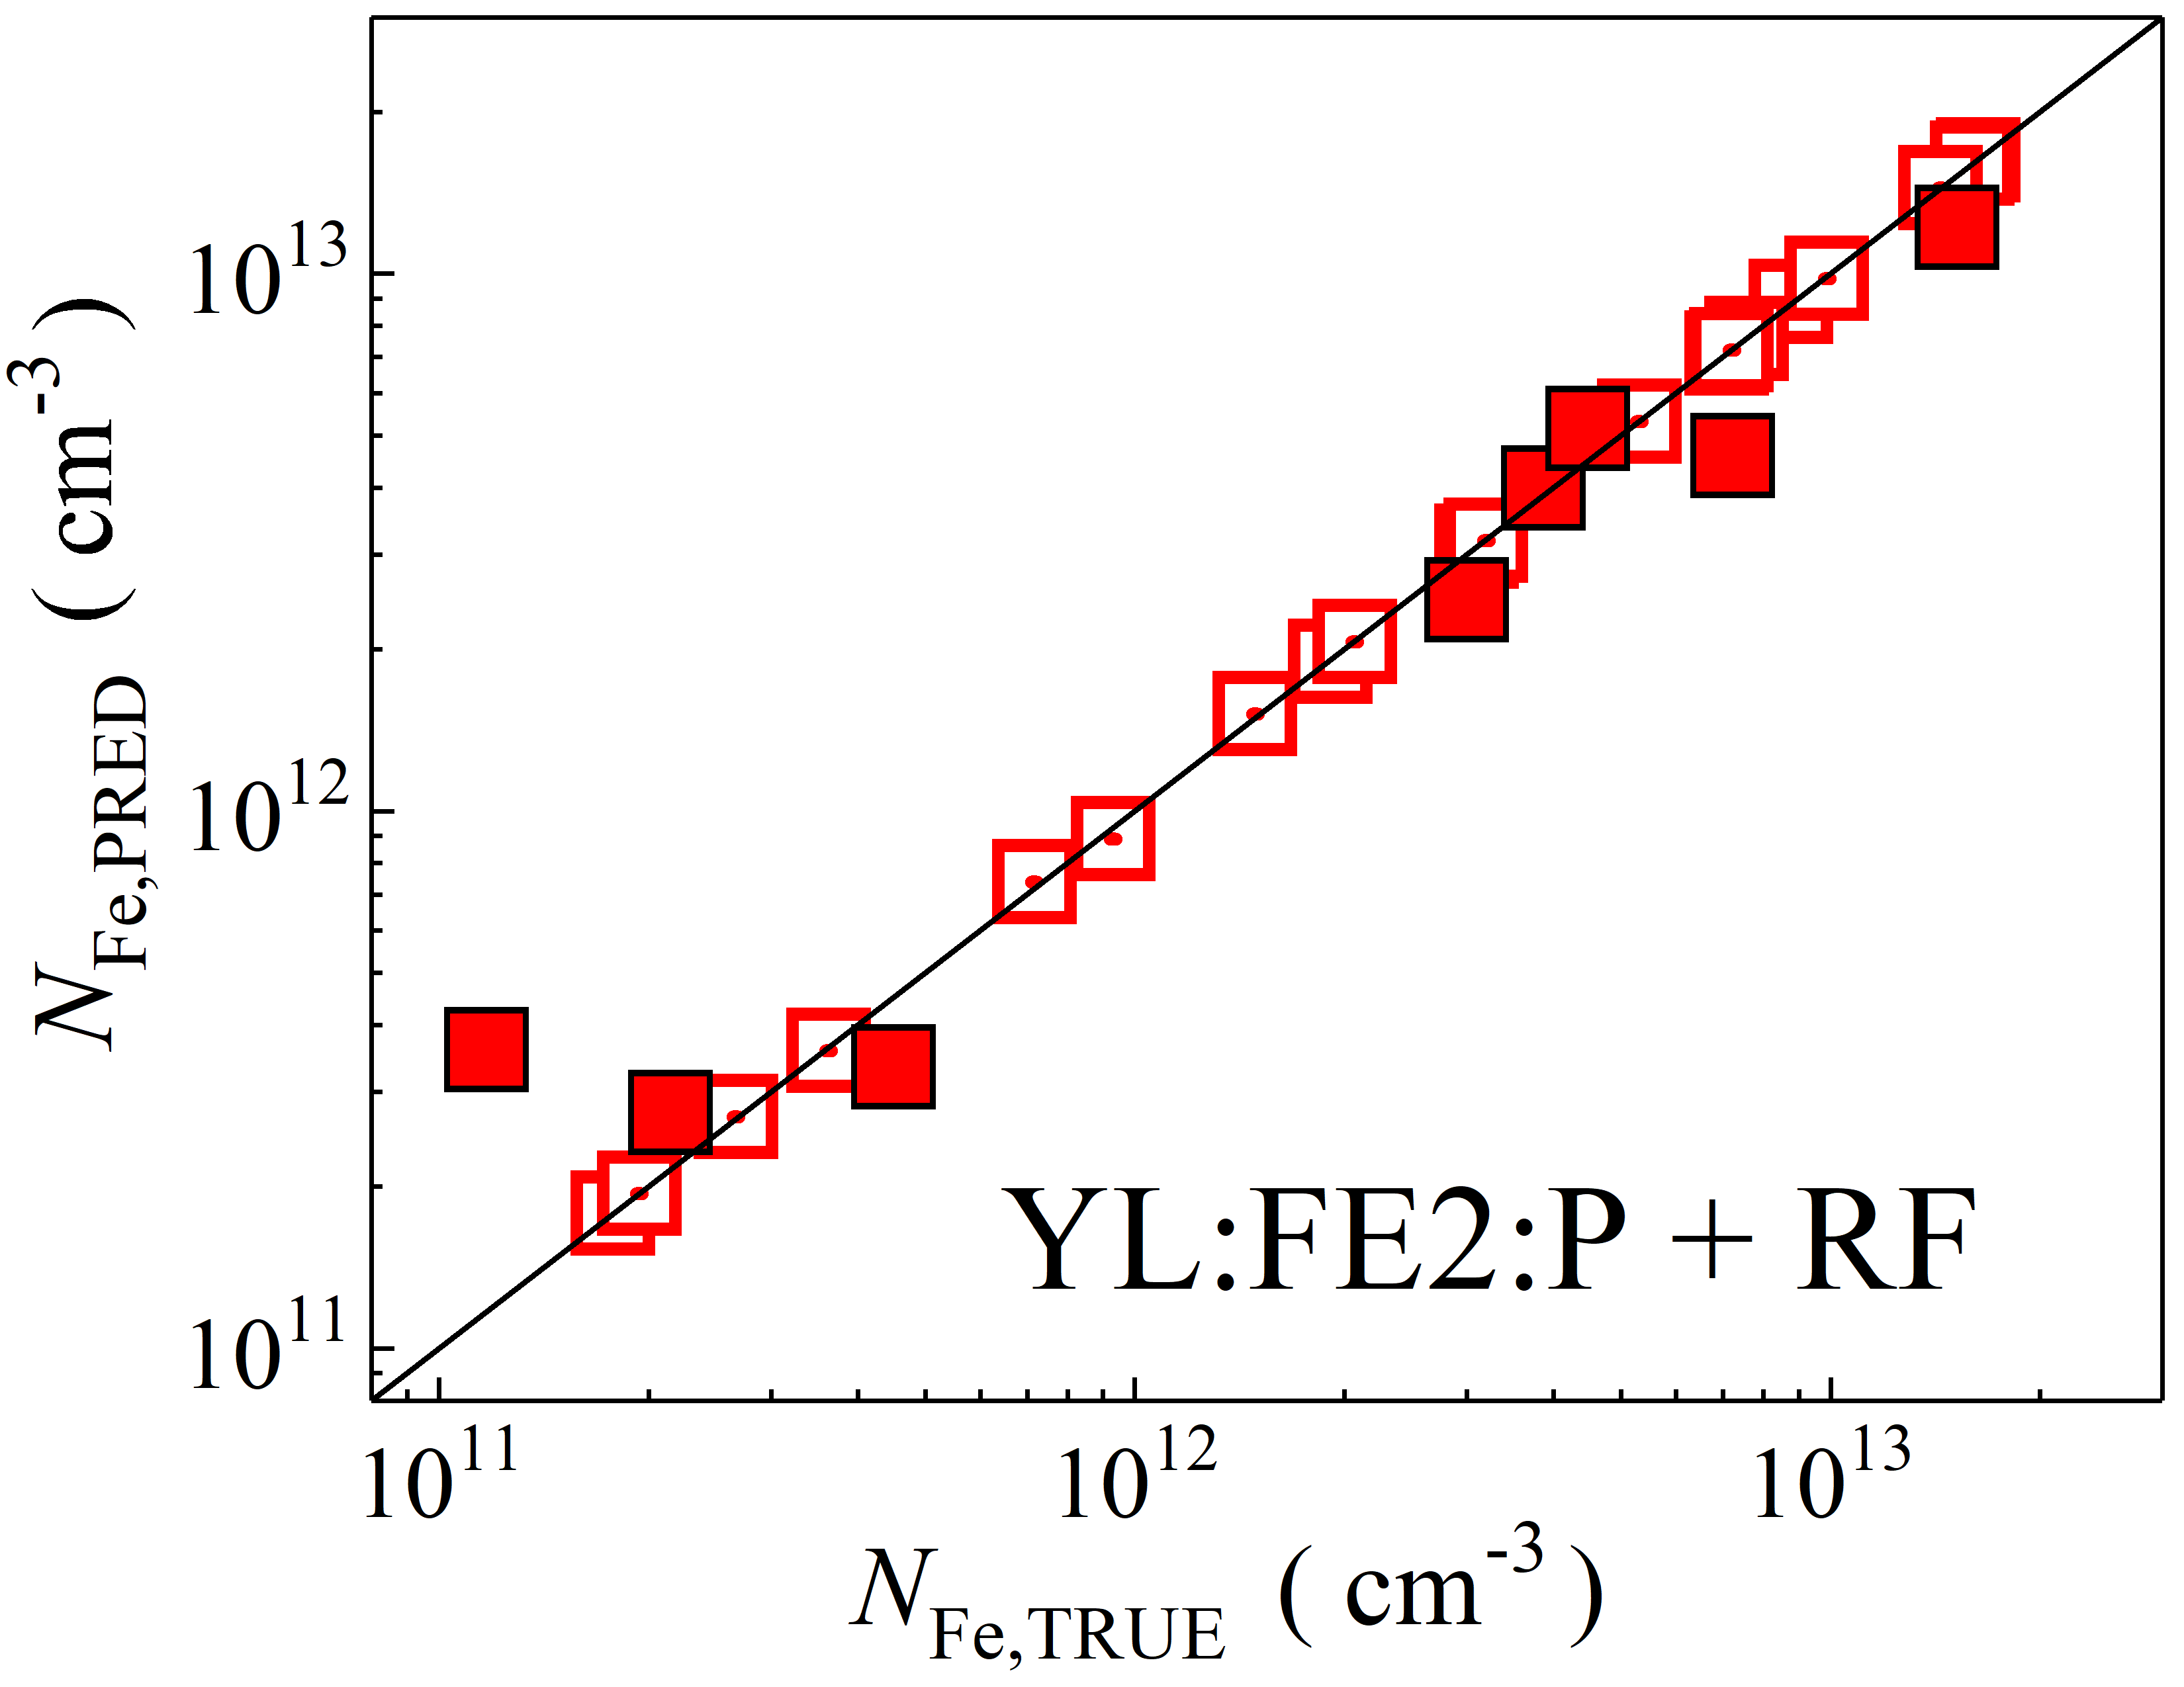

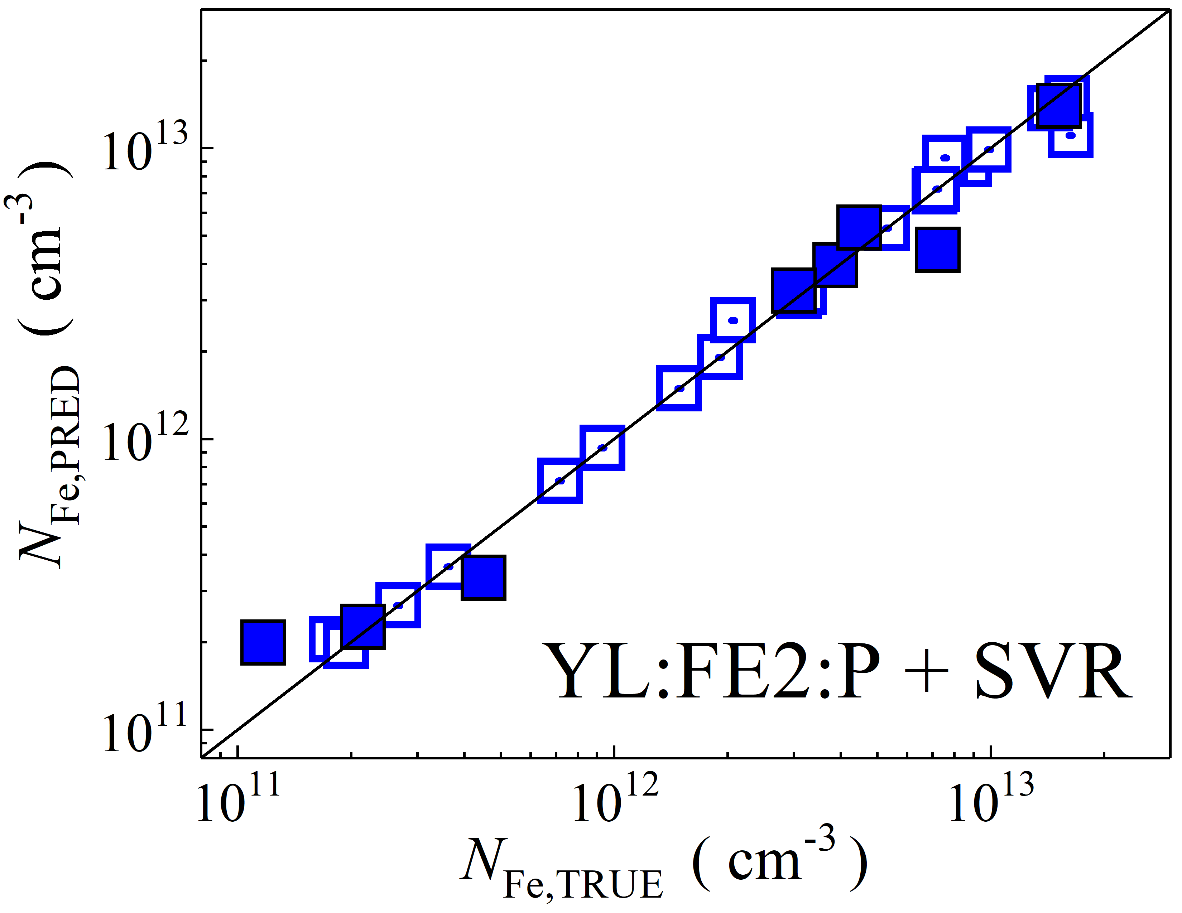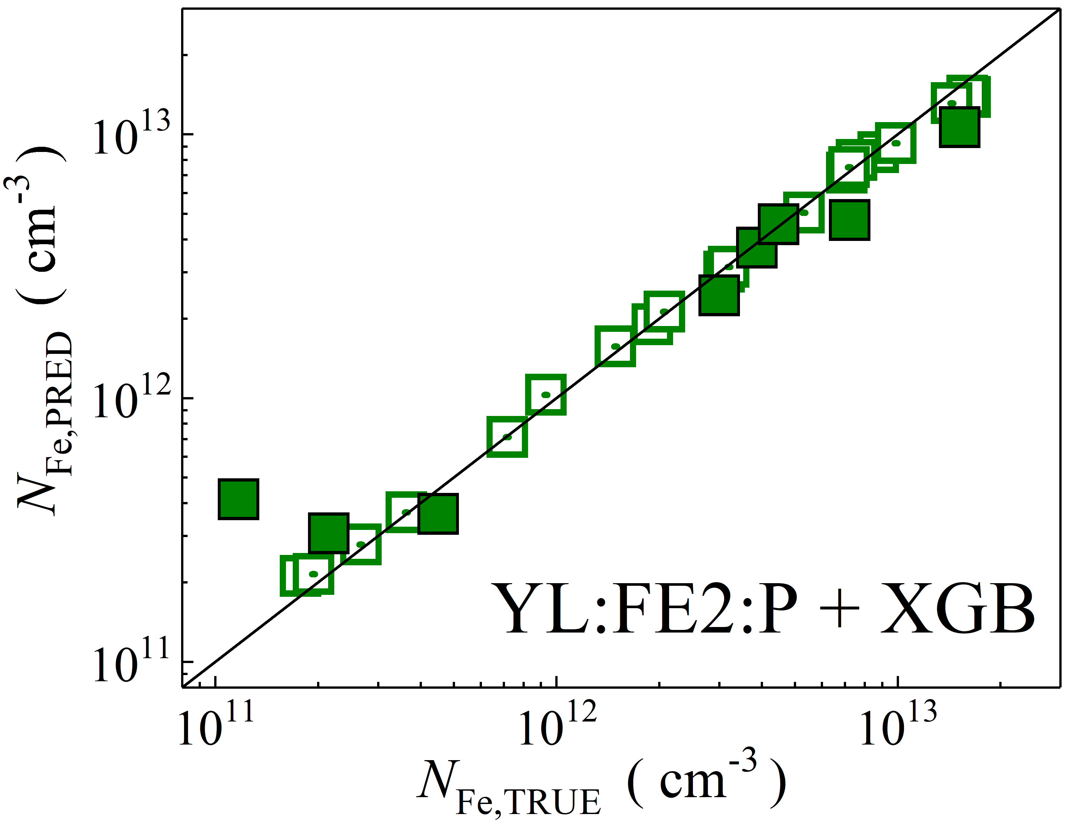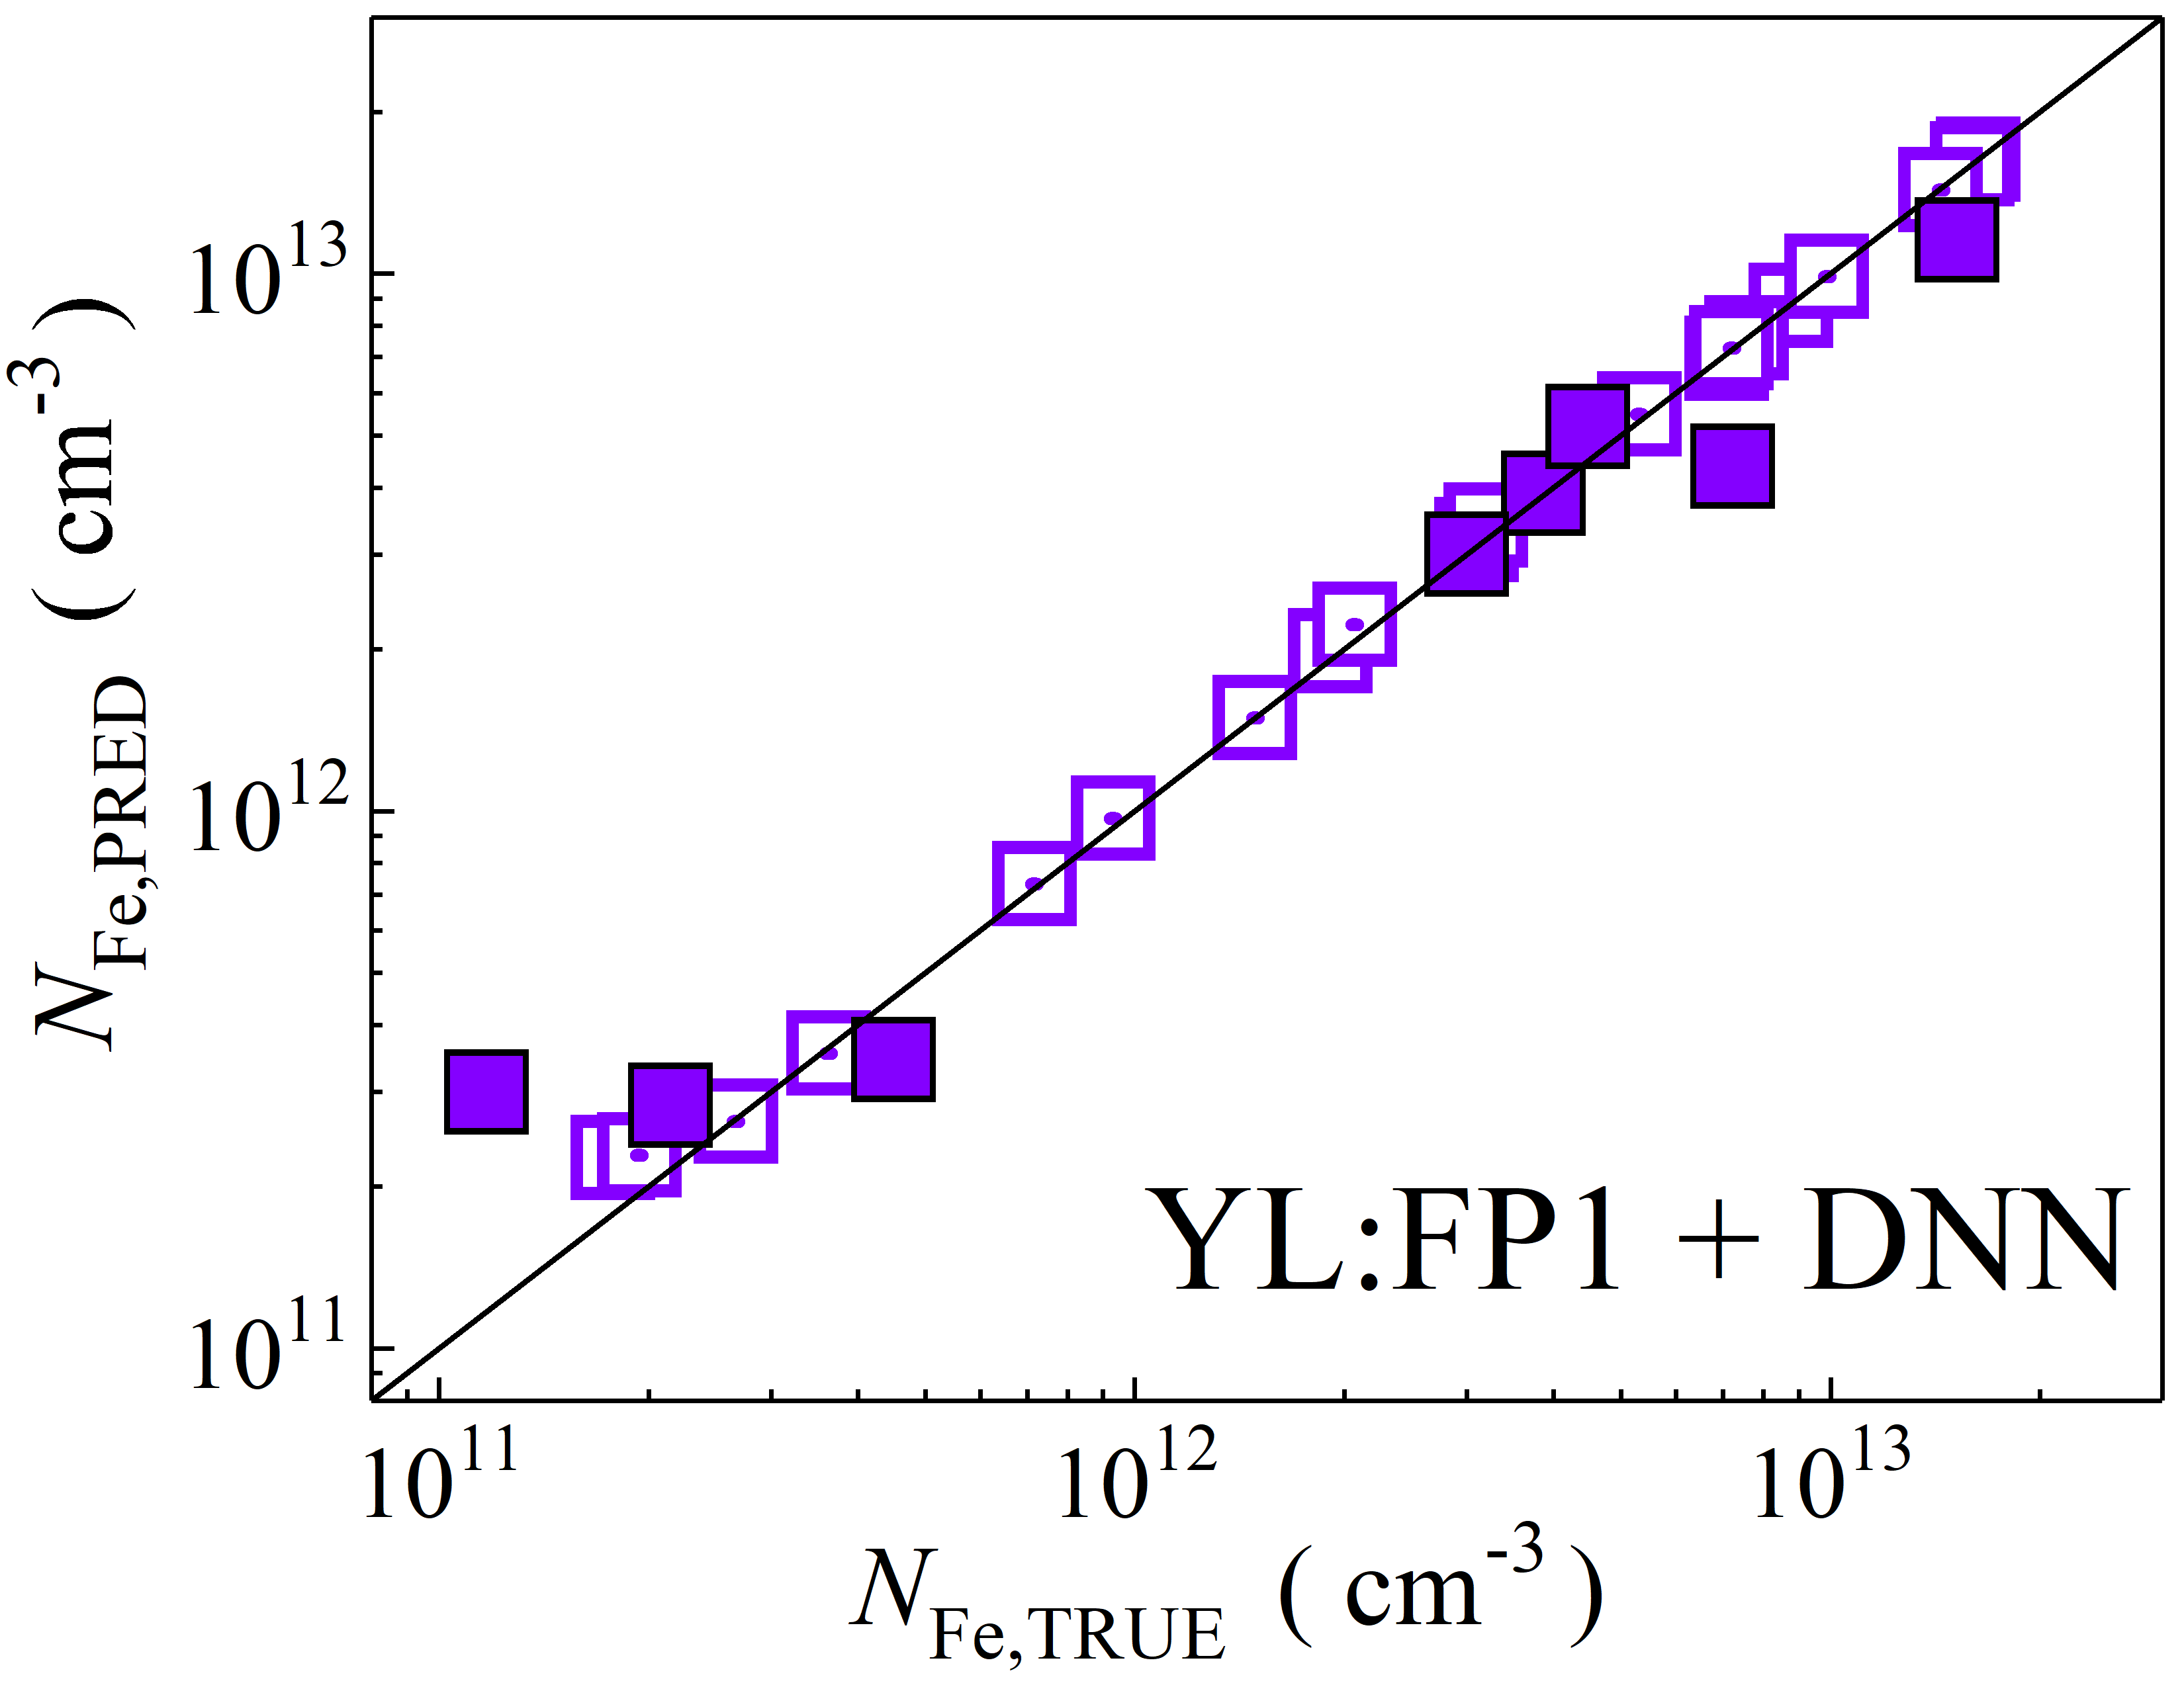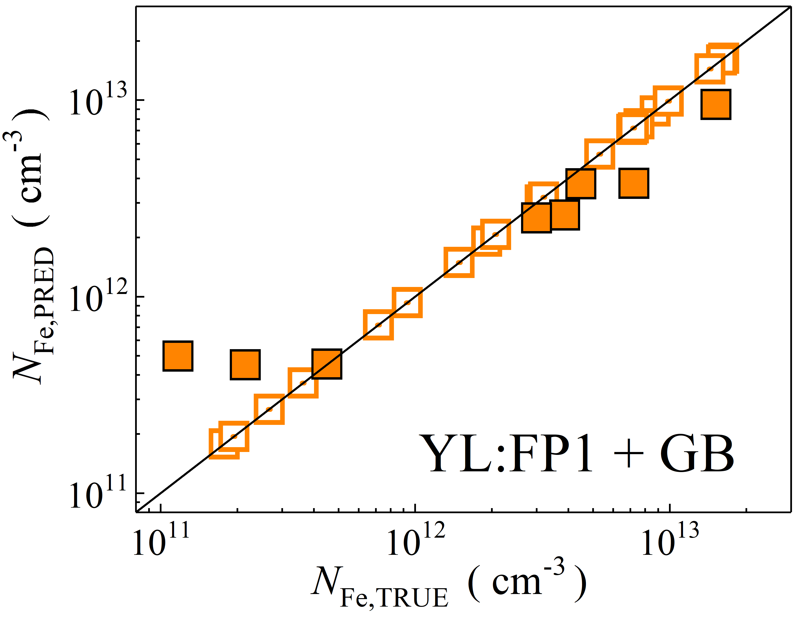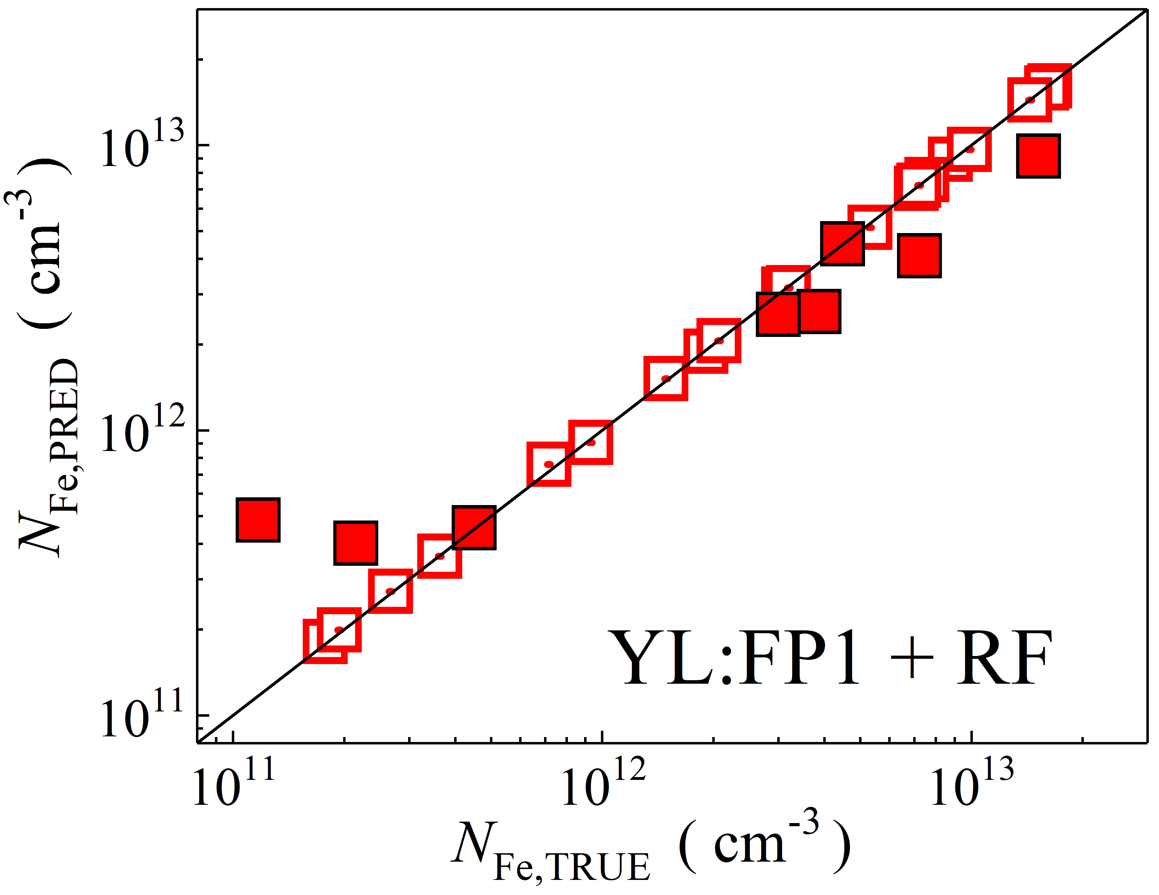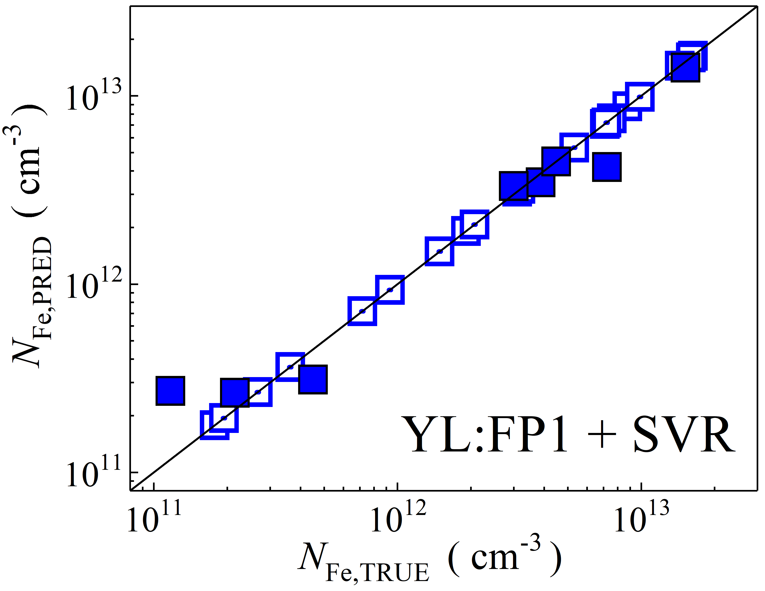

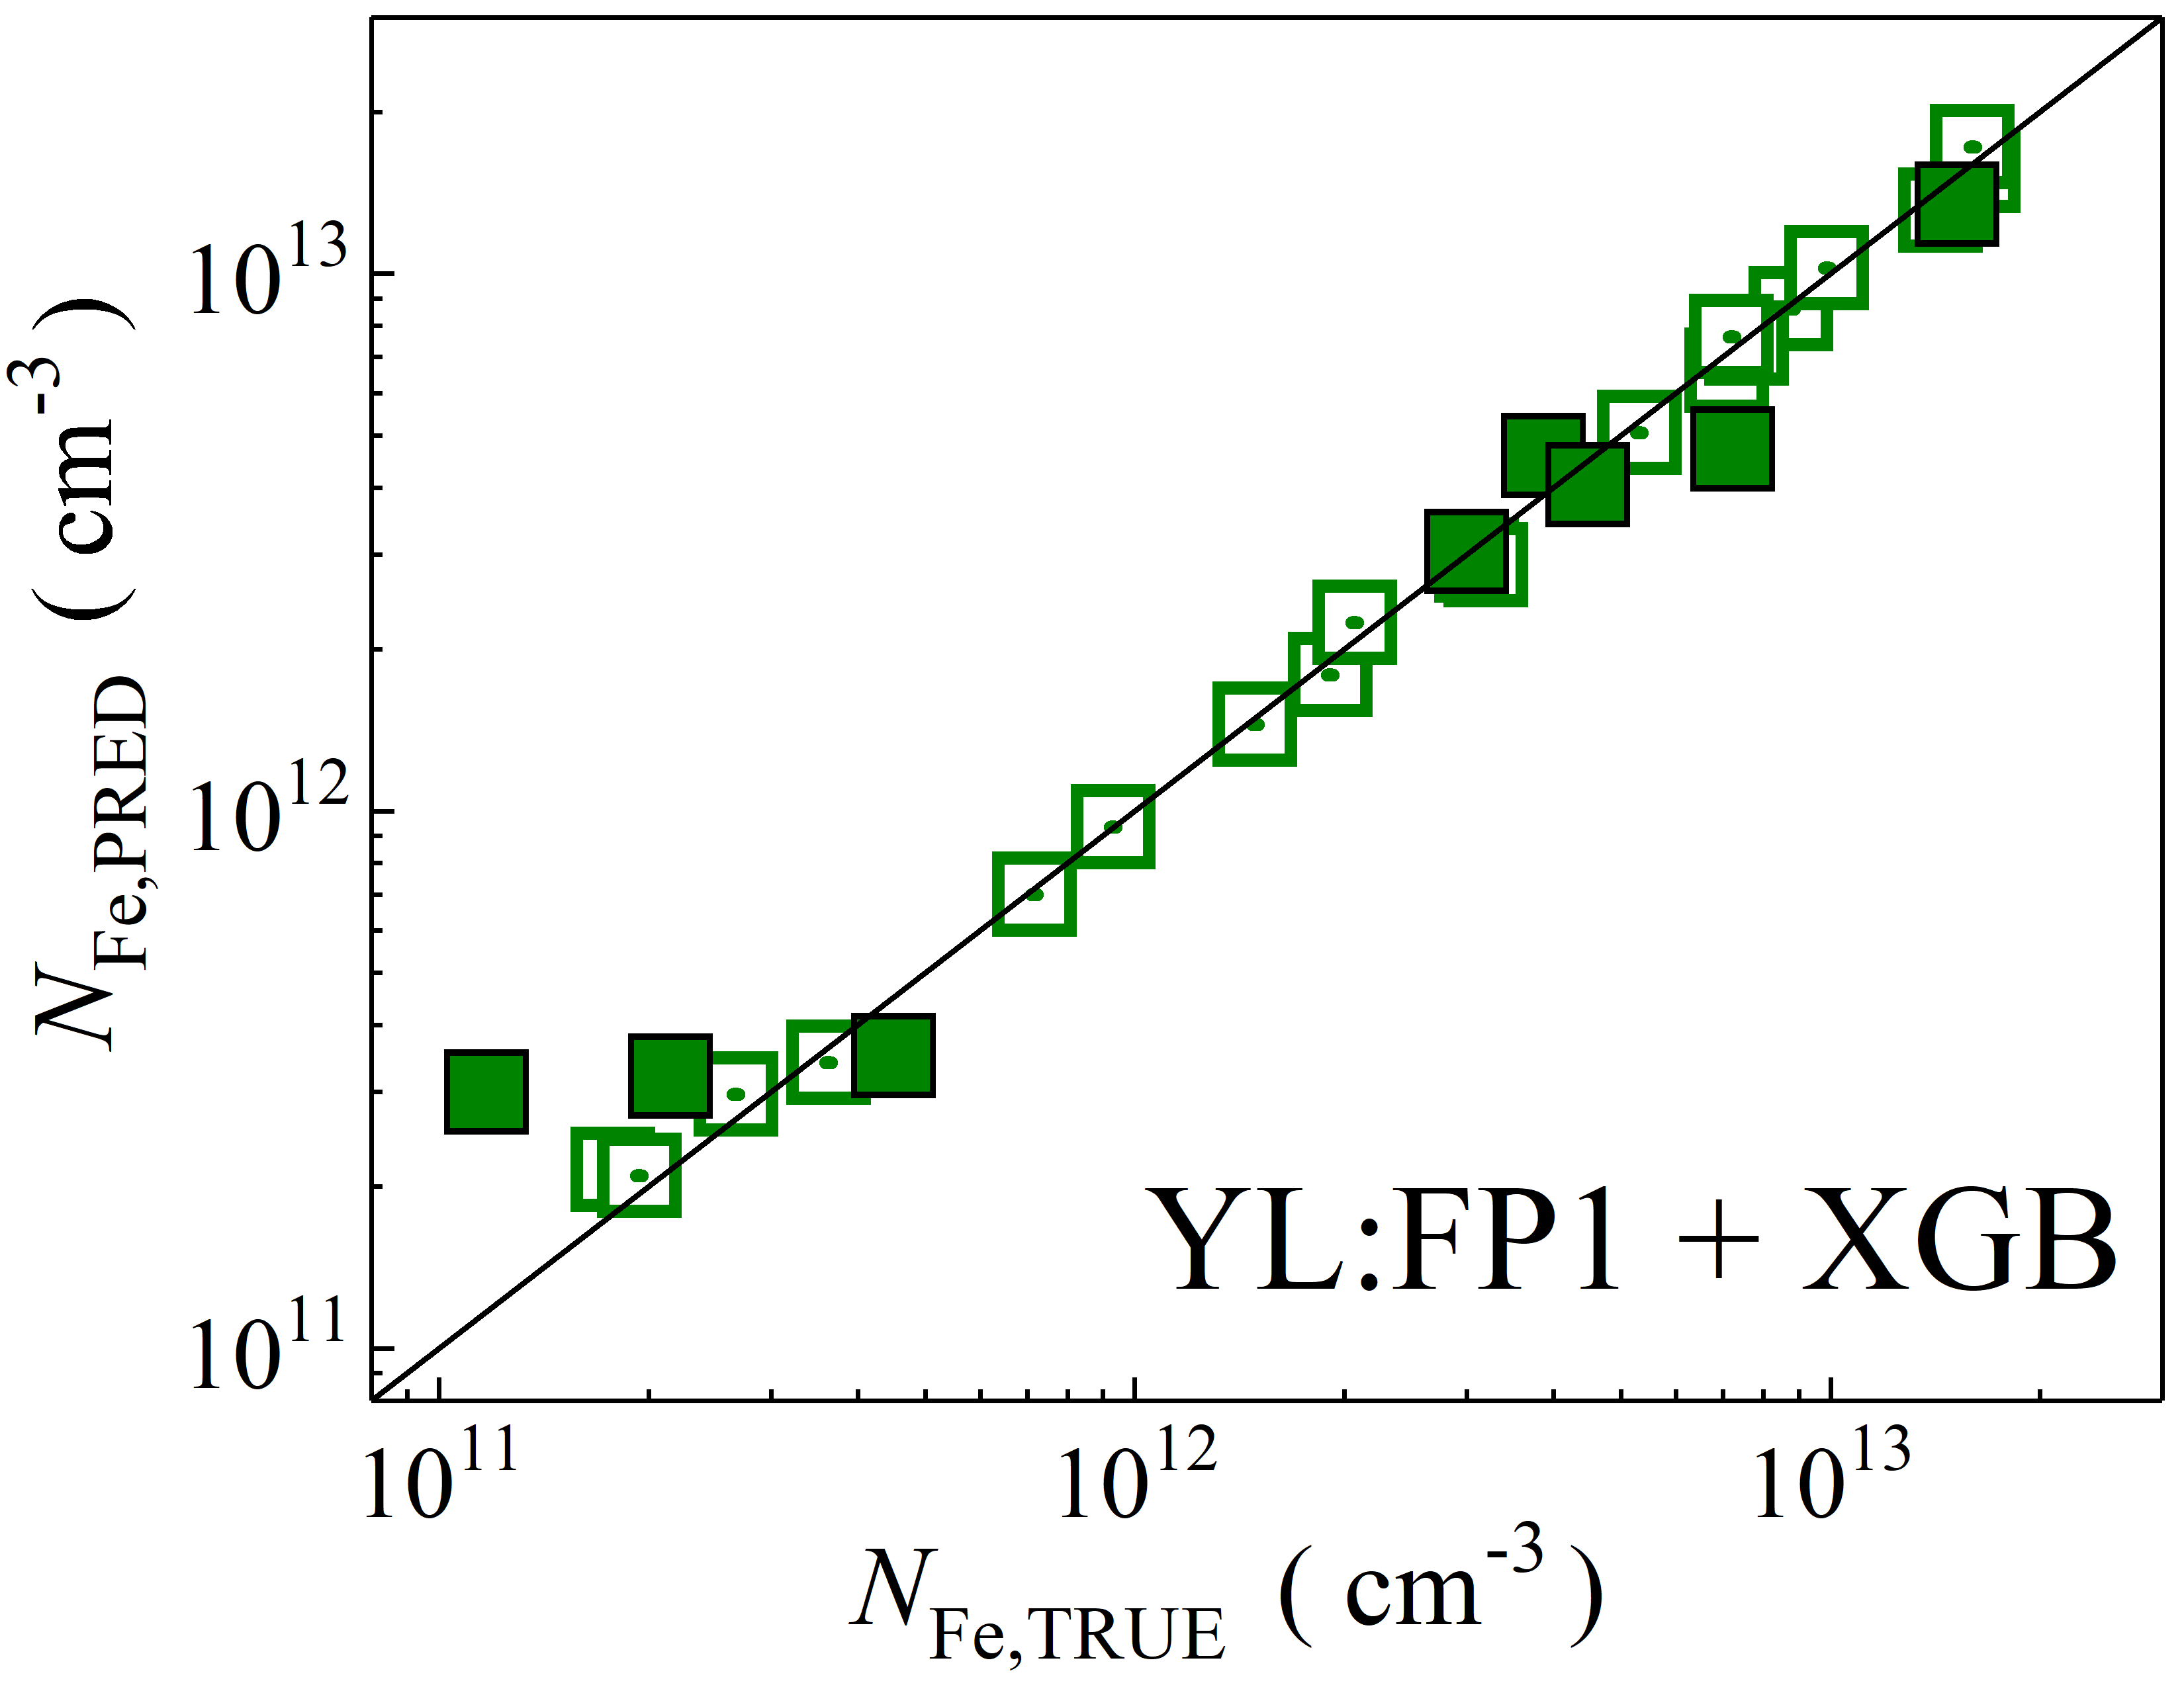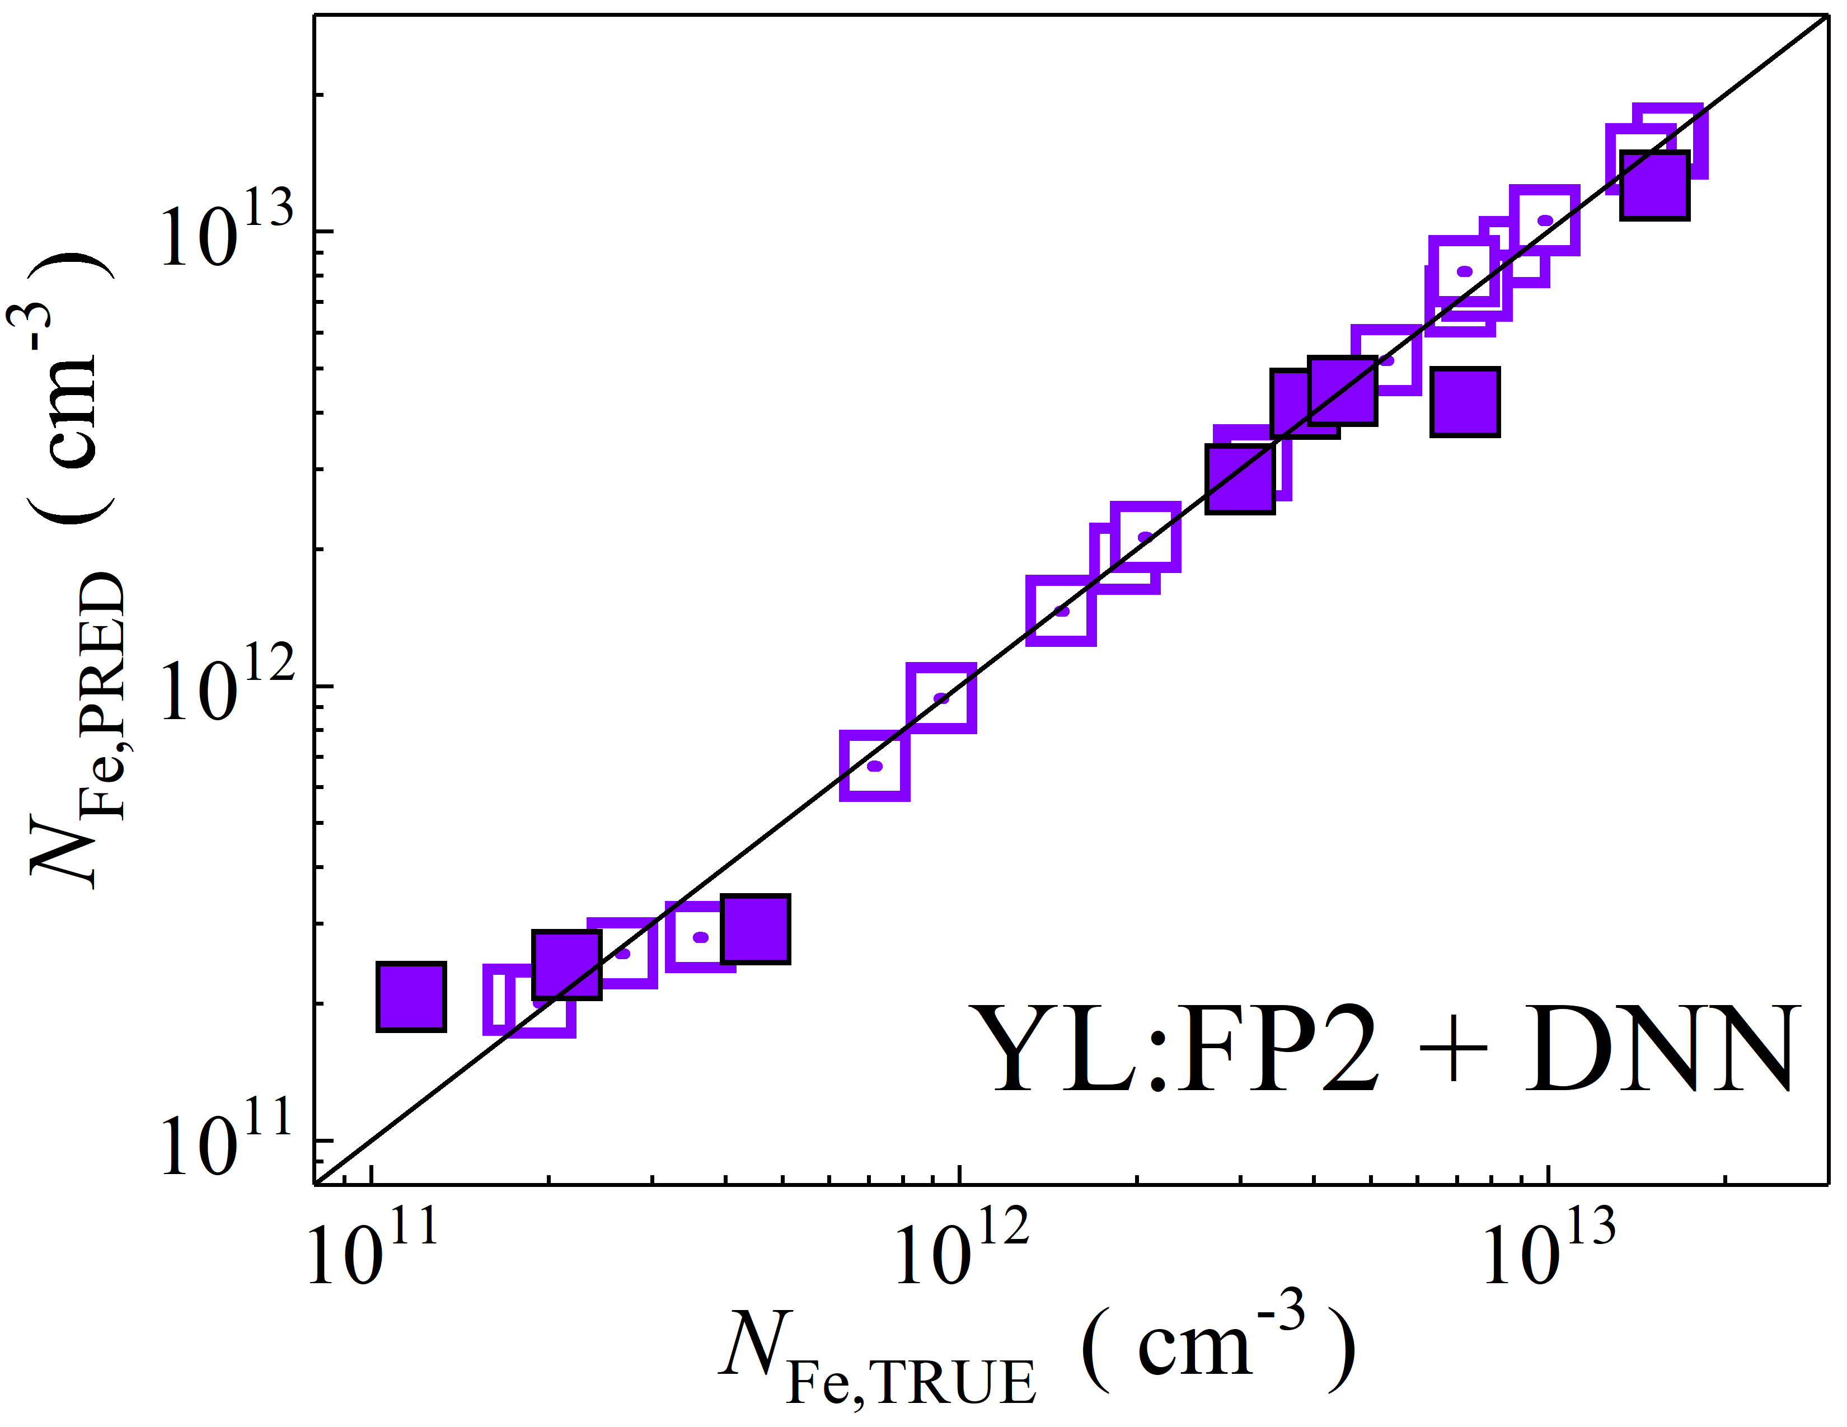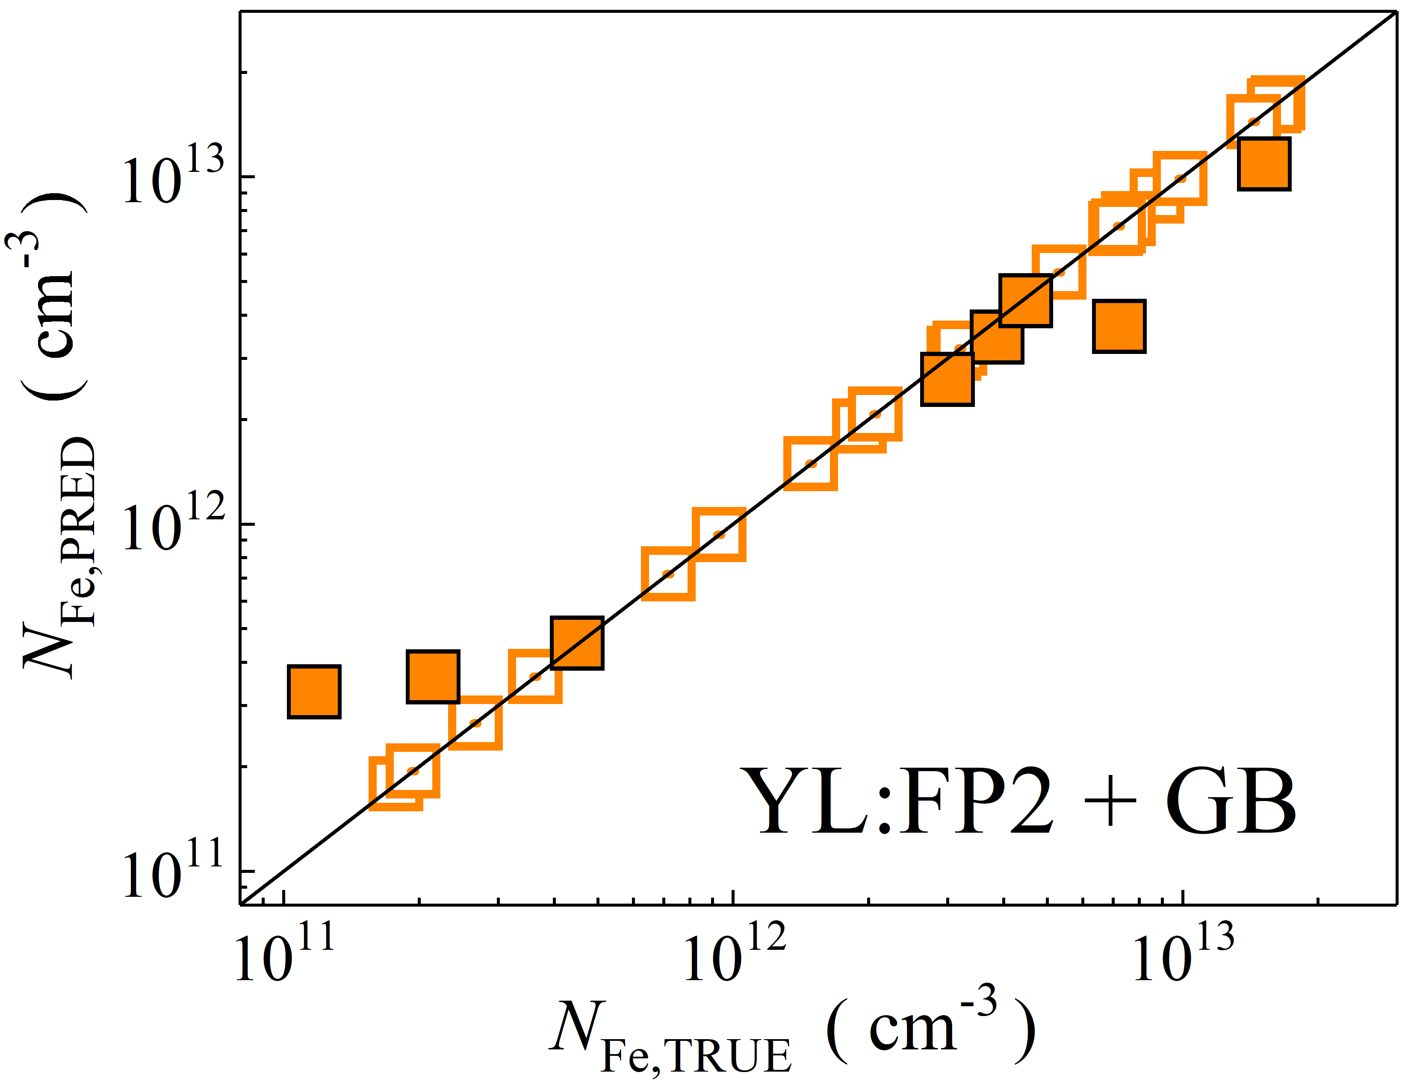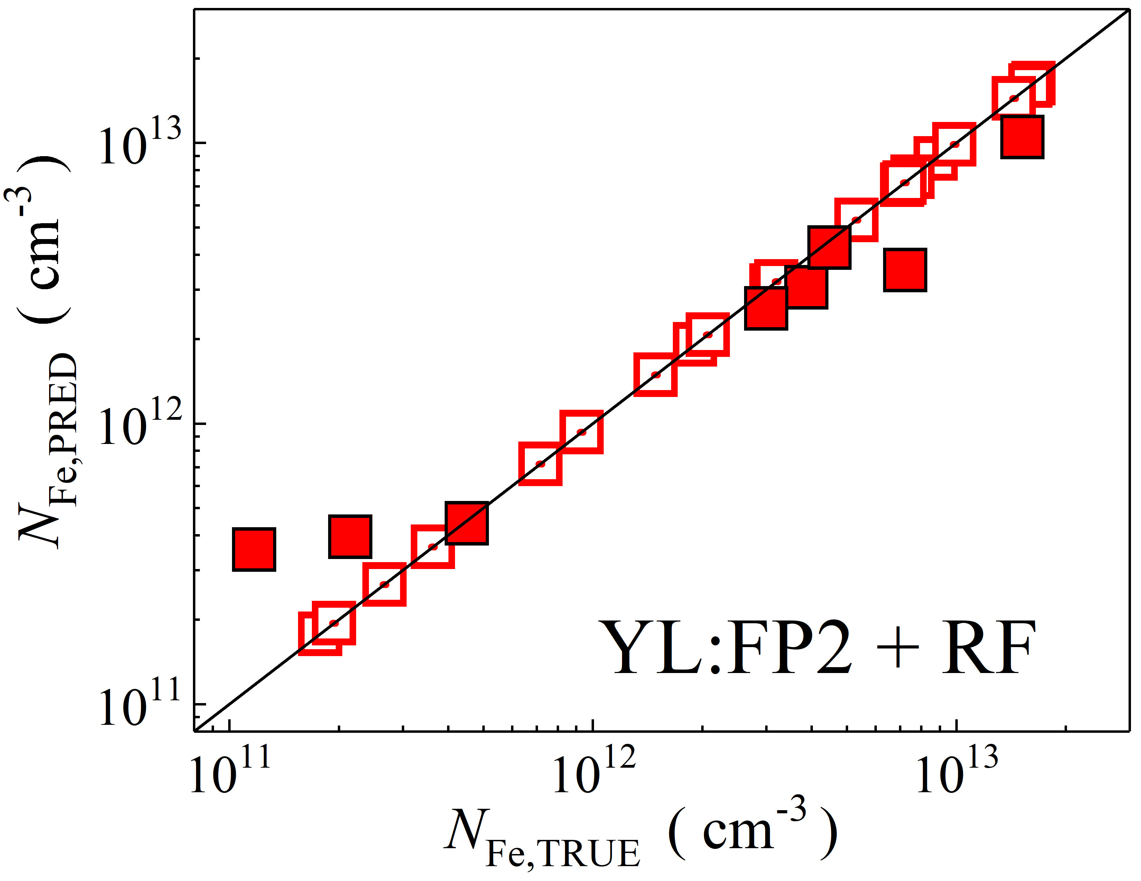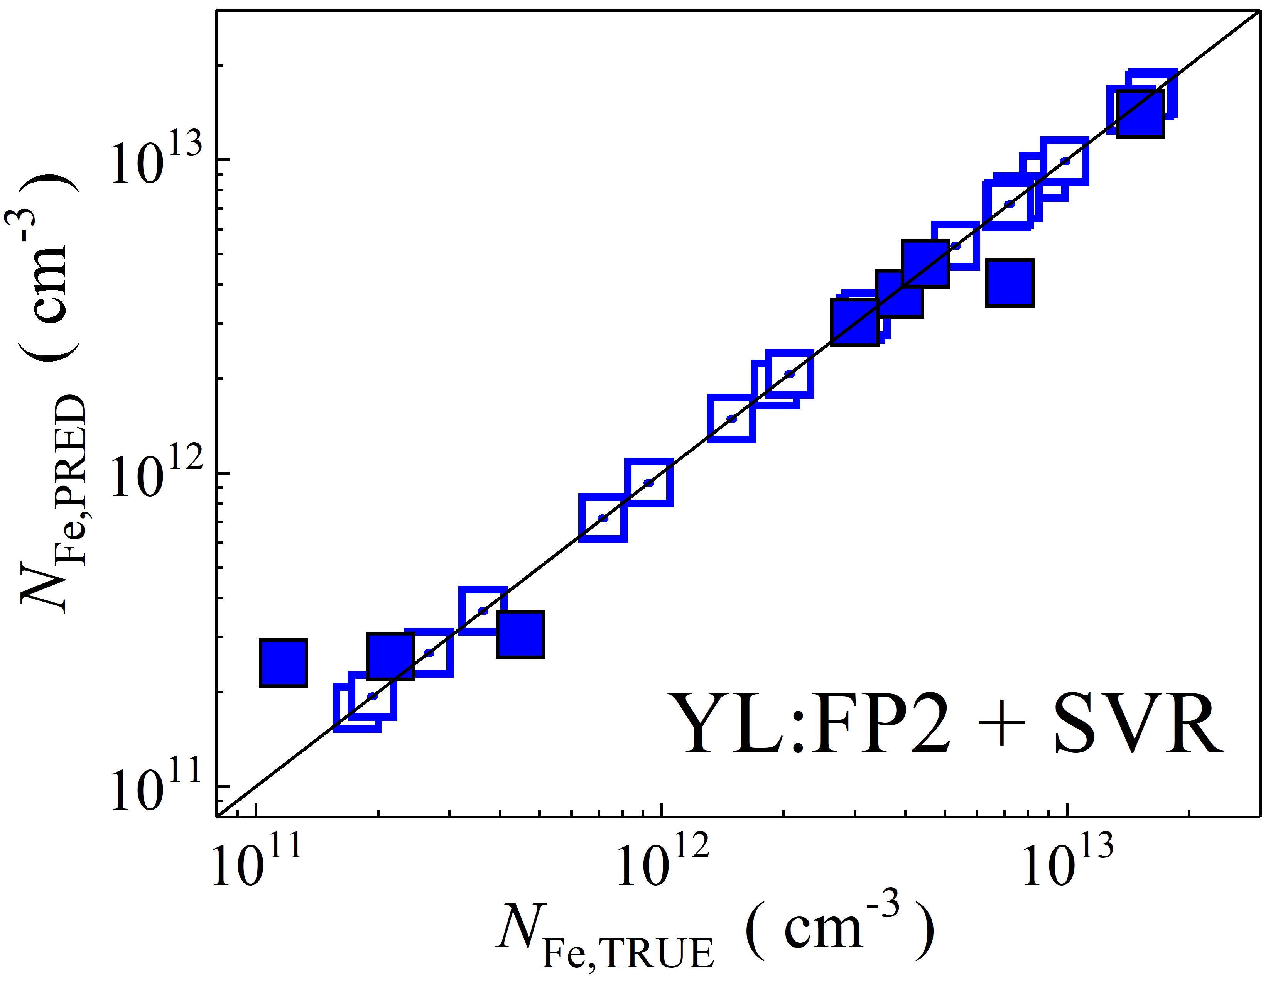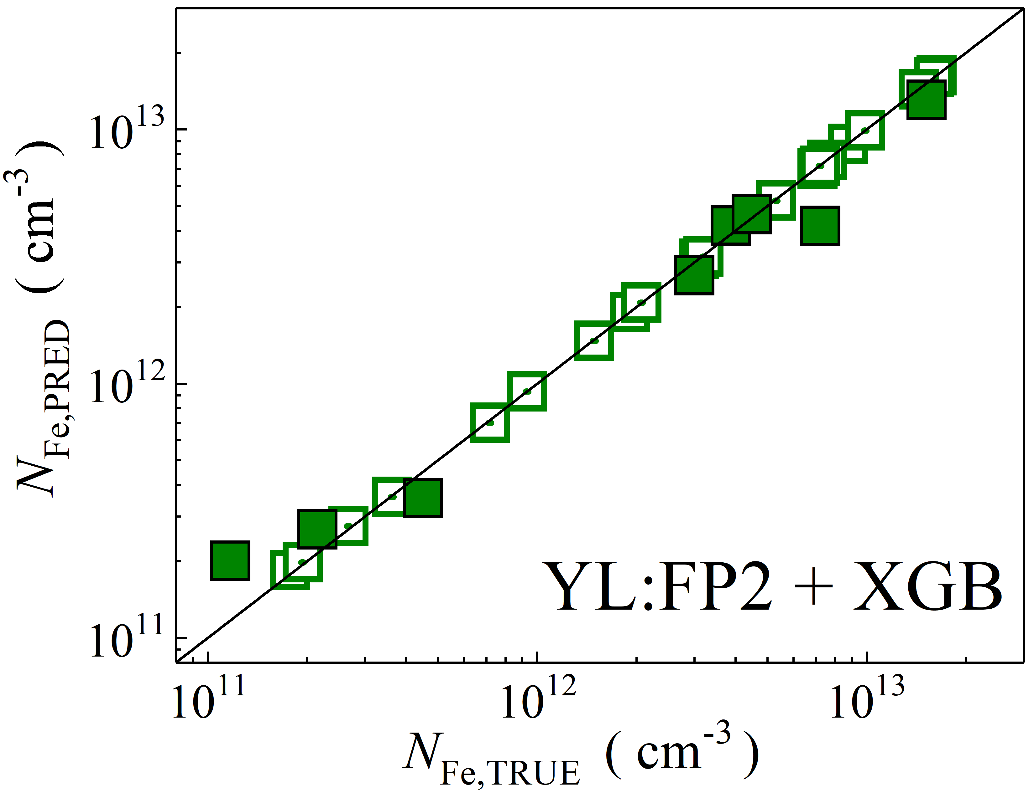

Fig. S6. Scatter plots compare the reference iron concentrations *N*Fe,TRUE with ML-predicted values *N*Fe,PRED, obtained using feature vectors extracted from various computer vision models combined with different regression algorithms. The ML models were trained on a dataset derived from experimental measurements. The open and filled squares correspond to the training and test phases, respectively. The black lines are the identified lines serving as the references.

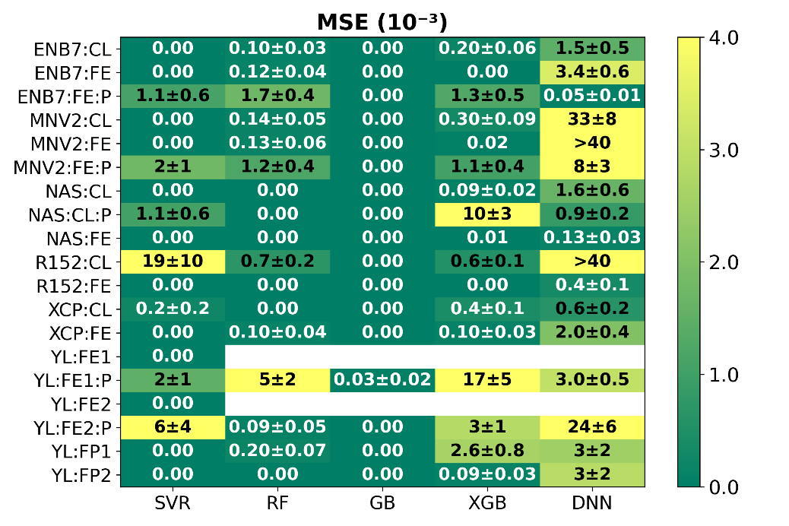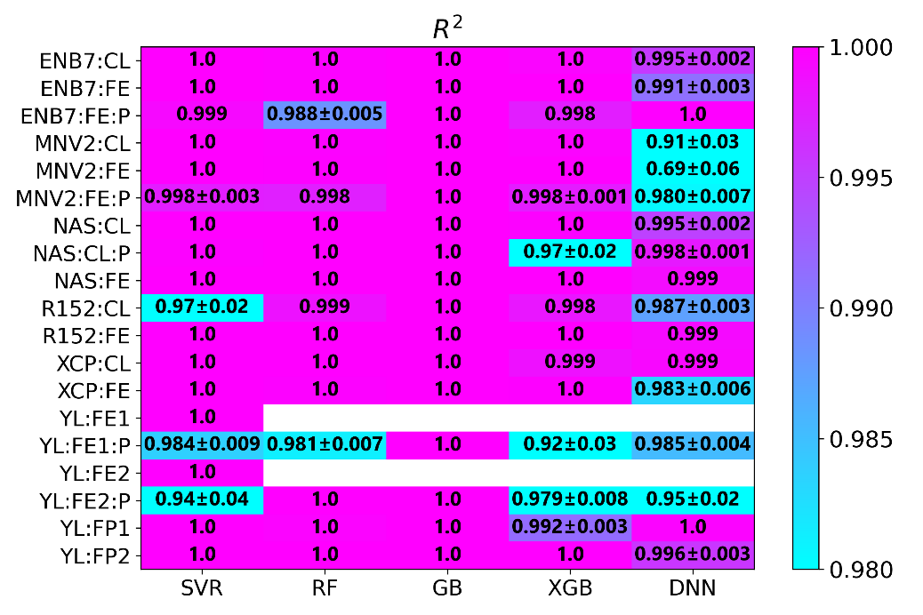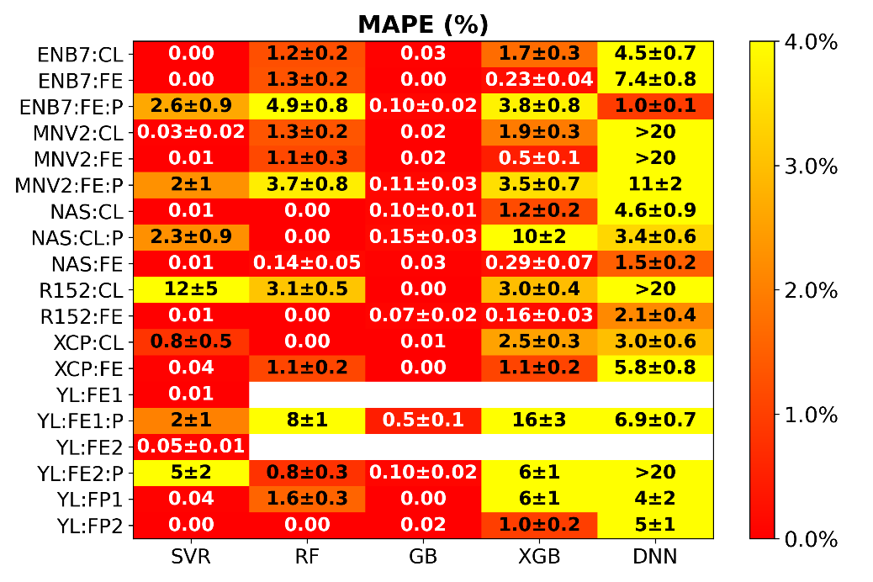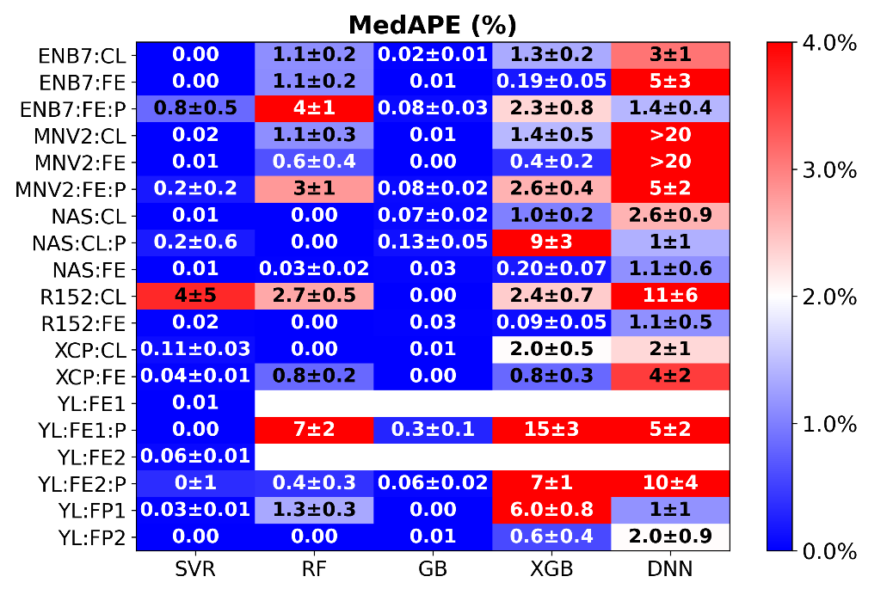

Fig. S7. Mean squared error, coefficient of determination, mean absolute percentage error, and median absolute percentage error for different combinations of computer vision models (vertical axis) and regression models (horizontal axis) during the **training** **phase**. The models were trained on an **experimental** **dataset**.

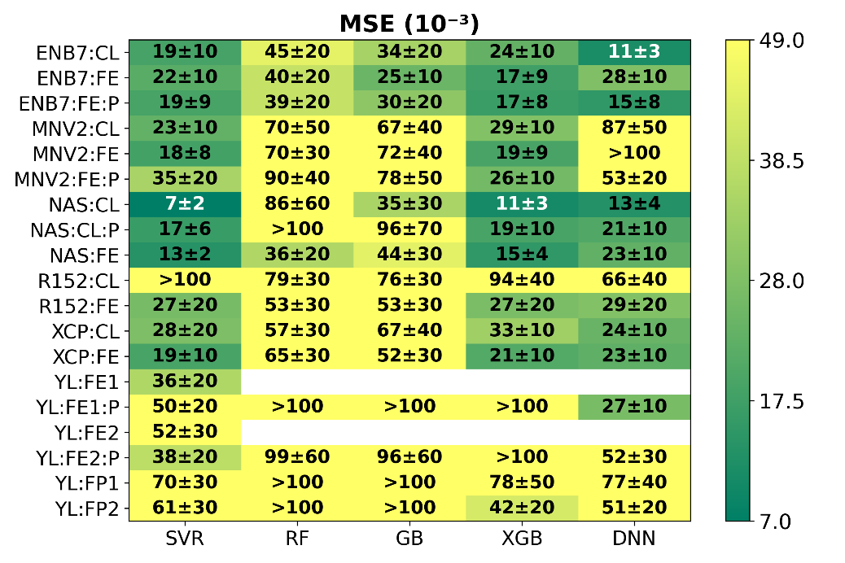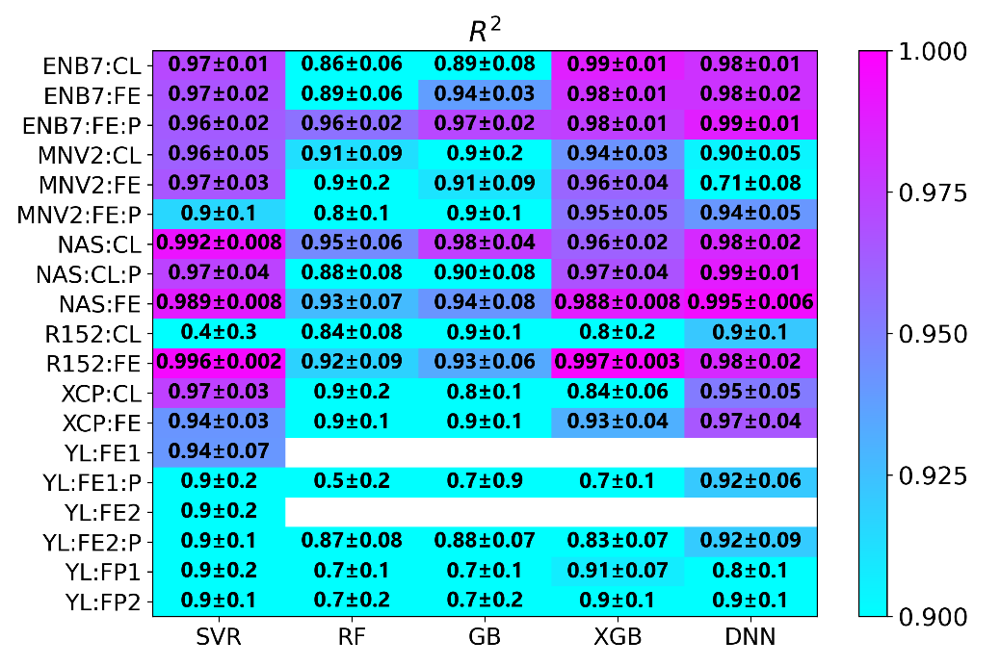 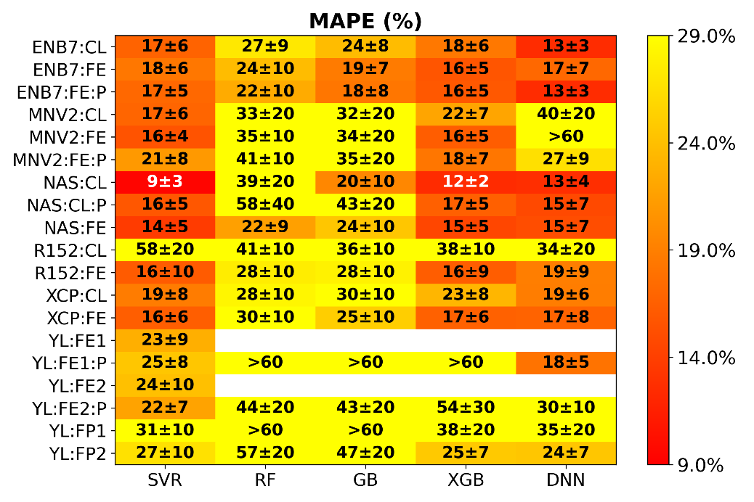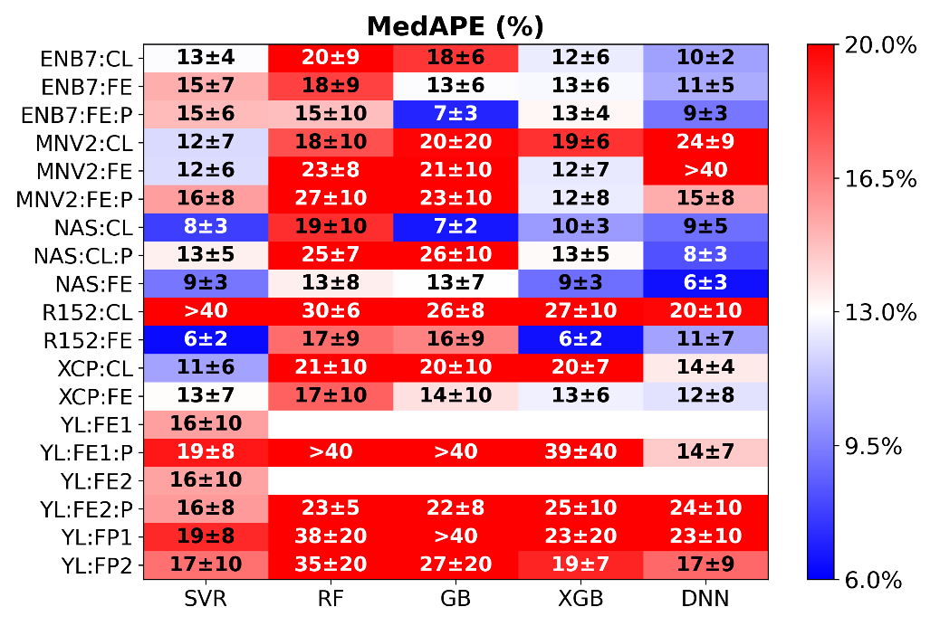

Fig. S8. Mean squared error, coefficient of determination, mean absolute percentage error, and median absolute percentage error for different combinations of computer vision models (vertical axis) and regression models (horizontal axis) during the **test** **phase**. The models were trained on an **experimental** **dataset**.